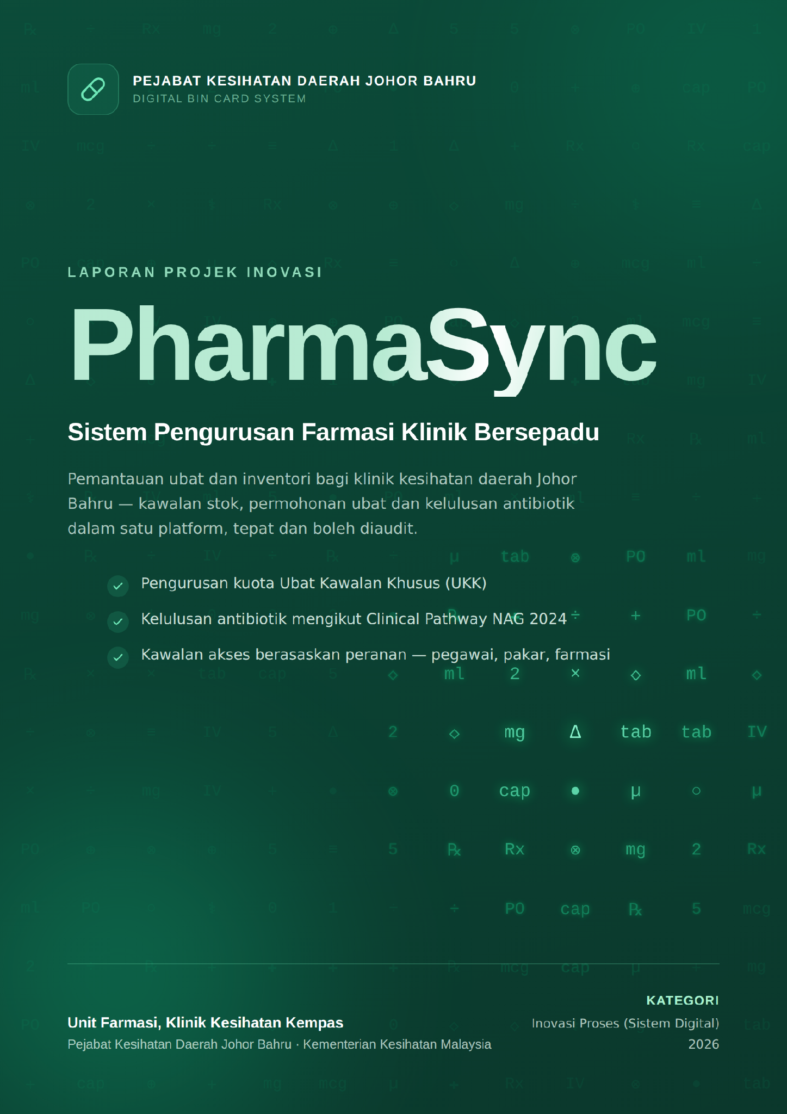
CONTENTS

1. INTRODUCTION

1.1 About the agency
Klinik Kesihatan Kempas is a health clinic under the Johor Bahru District Health Office (PKDJB), Ministry of Health Malaysia (KKM). It provides primary health care to the surrounding community, including general medical treatment and pharmacy services.
The clinic's Pharmacy Unit has four core functions: drug stock management, processing medication requests from medical officers, approving controlled antibiotics under the Clinical Pathway of the National Antimicrobial Guideline (NAG) 2024 together with Family Medicine Specialist (FMS) approval for Controlled Drugs (UKK), and dispensing medication to patients.
The clinic's client charter sets expectations for accuracy, speed and safety in supplying medication. The Innovation Team found that the manual and semi-manual record keeping used until now could no longer meet that charter, and proposed an integrated digital system instead.
[TO COMPLETE] List the full name and position of every Innovation Team member, and state the specific clauses of the clinic's client charter that apply.

1.2 About the innovation

1.2.1 What the innovation does
Innovation category: Process innovation (digital system).
PharmaSync is a web application for clinic pharmacy management, built to bring the whole health clinic pharmacy workflow onto one platform. It covers drug stock management, medication requests and approvals by medical officers, controlled antibiotic approval under the Clinical Pathway NAG 2024, Controlled Drug (UKK) approval by the Family Medicine Specialist together with its annual quota control, and finally dispensing and updating patient records.
Before the innovation, each of these processes ran on paper forms, phone calls and manual arithmetic. The Innovation Team identified the following gaps in the existing workflow:
1.UKK quota balances for each controlled drug were checked and calculated by hand. The work took time and was open to arithmetic error.
2.Controlled antibiotic requests depended on the paper AMS form, while Controlled Drug approval depended on phone calls and screenshots in a WhatsApp group. Both took a long time.
3.There was no central system for tracking the status of antibiotic requests and specialist approvals under the Clinical Pathway NAG 2024, so compliance could not be measured.
4.An average of 10 incomplete AMS forms were found each month, and the patient had to be sent back to the doctor's room to have the form completed.
5.The quota drug patient list and annual quota usage were hard to track accurately, because records were spread across paper forms, Excel files and Google Sheets.
6.There was no complete audit log for drug transactions, which made any later review difficult.
Each of these problems was mapped to a specific solution, which became a feature of the system. Table 1 sets out the mapping.
Table 1: Problems and their solutions in PharmaSync
PROBLEM | SOLUTION IN PHARMASYNC
Issue 1: UKK quota calculated by hand  Quota balances were worked out by hand and could not be checked at the pharmacy counter. | Controlled Drug quota module  The annual quota for each UKK is calculated centrally at district level (PKDJB) and shared among all clinics in that district. The remaining balance appears automatically before a request is submitted, and any request above the allocation is blocked.
Issues 2 and 3: Verbal approval with no tracking  FMS approval came by phone, was screenshotted, and was sent to a WhatsApp group as evidence for the pharmacy unit. There was no official trail and no status anyone could monitor. | Digital request and approval workflow  Requests go straight to the FMS dashboard. The specialist's decision, whether approval or rejection with a reason, is recorded with their identity and a timestamp. Medical officers, the FMS and the pharmacy unit can all see the status of each request as it changes.
Issue 4: Incomplete forms  An average of 10 AMS forms a month were incomplete, so the patient had to be sent back to the doctor's room. | Mandatory field validation  The system checks every mandatory field before a form can be submitted. An incomplete form can no longer be produced, which removes the rework cycle at the pharmacy counter.
Issue 5: Scattered patient records  The quota drug patient list and annual quota usage were hard to track accurately. | Central quota drug patient list  Each dispensing of a quota drug updates the patient list and quota usage automatically, with no manual entry into Excel or Google Sheets. A patient's full medication history is still referred to through PhIS.
Issue 6: No audit log  There was no complete record of drug transactions for later review. | Full audit log  Every drug transaction, specialist approval and use of AI is recorded with the user's name, role and a timestamp, so any action in the system can be traced later.

Three drug safety checks are also built into the prescribing flow: the Clinical Pathway NAG 2024 check for controlled antibiotics, a G6PD deficiency checker that warns automatically about prescriptions carrying that risk, and a weight-based paediatric dose calculator (mg/kg). Antibiotic suggestions and clinical pathway checks with AI assistance are available to support prescriber decisions, and every AI call is written to the audit log.

1.2.2 Main areas of focus
The innovation is aimed at workflow and record management in the clinic pharmacy, specifically:
- Controlled Drug (UKK) quota management.
- The request and approval workflow for Controlled Drugs and controlled antibiotics.
- Patient registration records and the quota drug patient list.
- Drug safety, through the G6PD check, the paediatric dose calculator, specialist approval of controlled antibiotics and quota control.
The full workflow charts for antibiotic and quota drug prescription screening, before and after PharmaSync, are shown in Figures 1 to 4 in Part 2.

1.2.3 Other details
- Implementation site: Klinik Kesihatan Kempas, under the Johor Bahru District Health Office (PKDJB), Johor.
- Start date: 17 March 2026.
- Implementation period and phase: Running from 1 August 2026 to the present as a live clinical trial phase, to assess usability, day-to-day operation and effect before wider rollout.
- Staff involved: 4 Pharmacists, 1 Family Medicine Specialist (FMS) and 1 Medical Officer (MO).
- Function and operation: The system runs 24 hours a day as the single platform for all clinic pharmacy transactions, covering stock management, medication requests and approvals, quota control, dispensing and patient records.
- Components used: A self-hosted private cloud server located in Malaysia, a Supabase (PostgreSQL) database, a React web application, and a local AI model (Ollama) for clinical suggestions.
- Operating cost: The Innovation Team built the application itself at no cost. Recurring costs are RM13 a year for the domain and RM100 a month for the VPS, giving a total operating cost of about RM3.32 a day.
- Data security: All patient data stays inside Malaysia (data residency), in line with the Personal Data Protection Act (PDPA). Access is controlled by user role, covering Administrator, Family Medicine Specialist, Medical Officer, Pharmacist, Logistics Pharmacist and support staff, and every critical transaction is written to the audit log. The AI model runs locally, so clinical data is never sent out of the country.
- Prototype test data: The system was tested directly in live operating conditions at the Pharmacy Unit of Klinik Kesihatan Kempas.
[TO COMPLETE] State the status of the ICT security approval application (JPICT) if applicable, and any collaboration with other units or external agencies.

2. BEFORE AND AFTER THE INNOVATION

2.1 Before the innovation
Before PharmaSync, controlled antibiotic requests were submitted on a paper form, while every Controlled Drug (UKK) request needed discussion with and approval from the Family Medicine Specialist (FMS) by phone or in person before the medication could be supplied. Only controlled antibiotics used a paper form, the AMS form; Controlled Drug requests had no form at all.
Running these processes manually caused the following problems:
1.UKK quota balances for each controlled drug were checked and calculated by hand. The work took time and was open to arithmetic error.
2.Controlled antibiotic requests depended on the paper AMS form, while Controlled Drug approval depended on the specialist being present or reachable by phone. The FMS also could not check the current quota balance before agreeing, because that figure existed only in an Excel sheet at the pharmacy counter.
3.There was no central system for tracking the status of antibiotic requests and specialist approvals under the Clinical Pathway NAG 2024.
4.FMS approval for Controlled Drugs came by phone, was screenshotted, and was sent to a WhatsApp group as evidence for the pharmacy unit. The FMS did countersign the paper prescription, but the method left no trackable status record in any clinic system, and clinical details about patients circulated in a medium with no access control.
5.The quota drug patient list and annual quota usage were hard to track accurately, because records were spread across Excel sheets, Google Sheets and paper forms.
6.There was no complete audit log for drug transactions, which made any later review difficult.
Figure 1 shows the workflow for antibiotic prescription screening and Figure 2 the workflow for requesting and dispensing Controlled Drugs, both as they ran manually before PharmaSync. Each chart contains a rework cycle that leaves the patient waiting at the pharmacy counter.

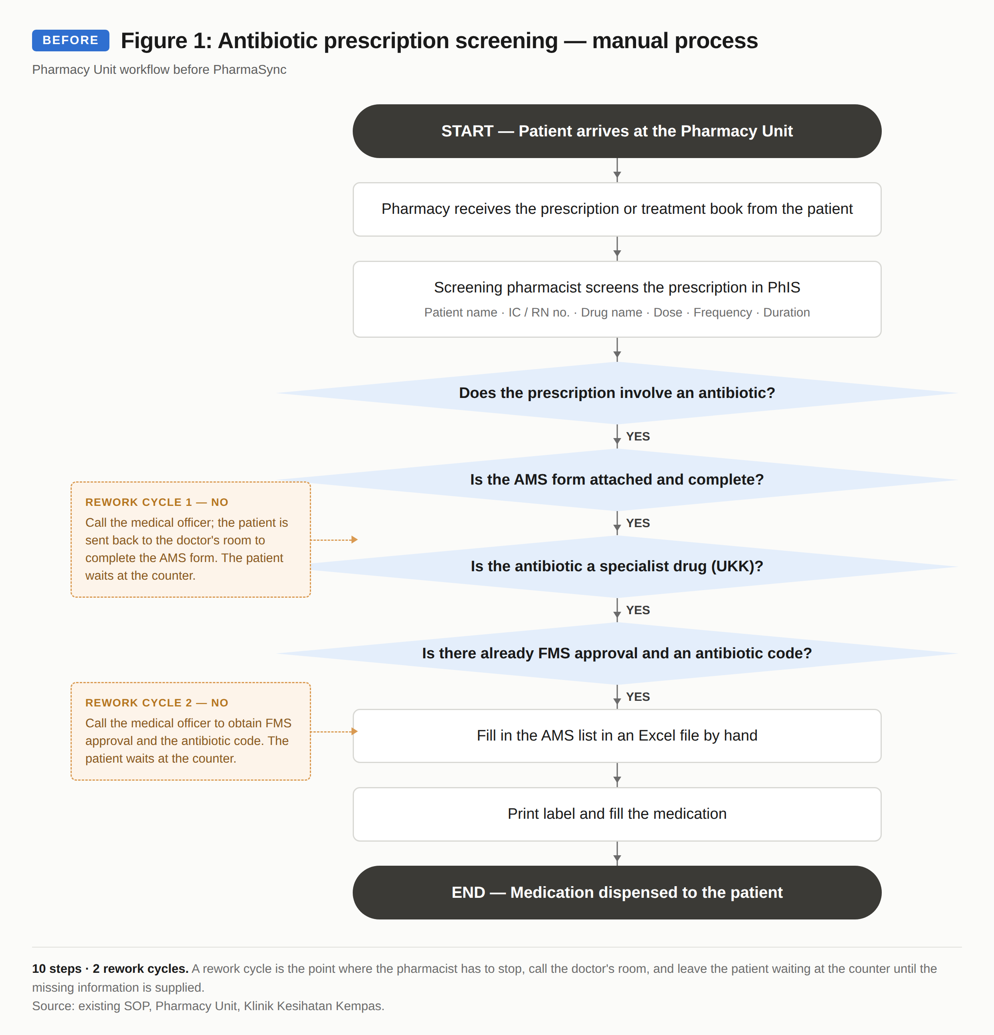

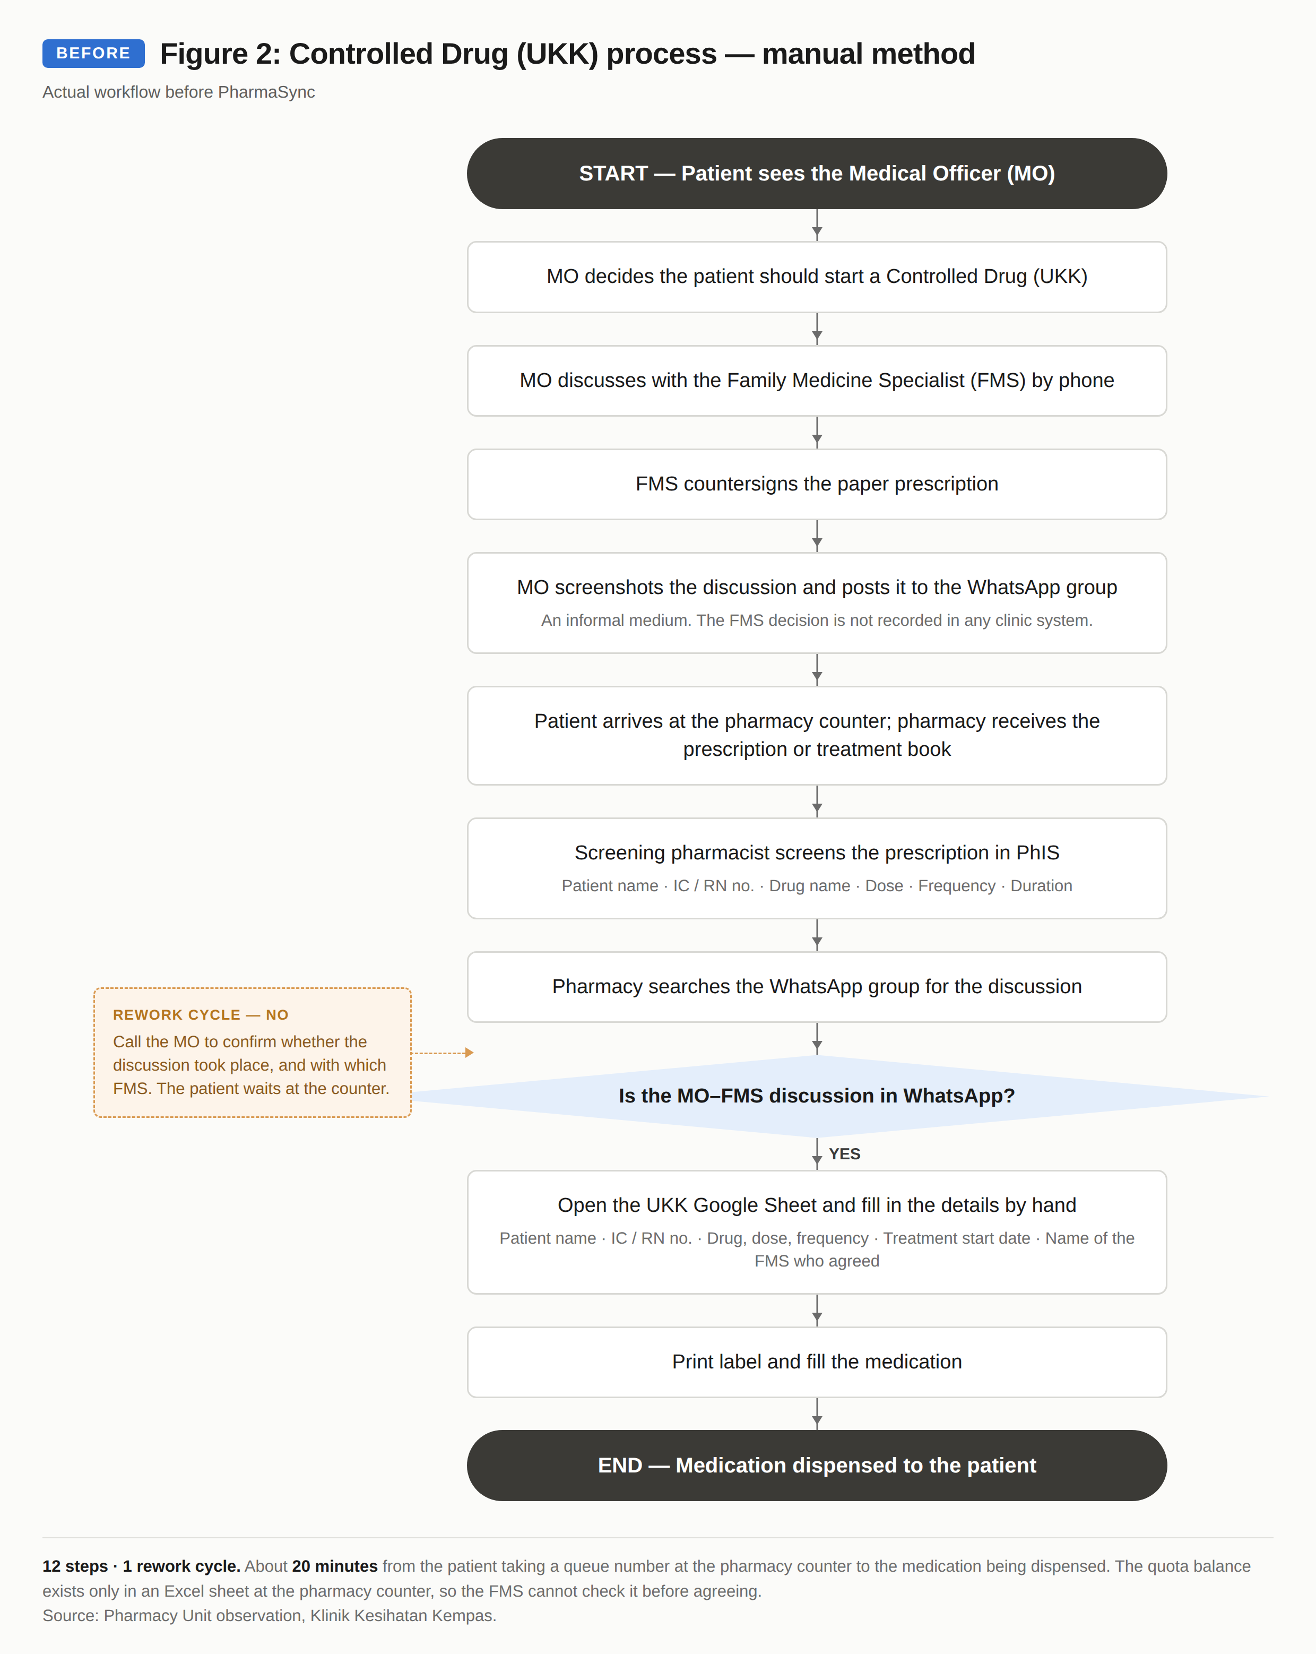

[TO COMPLETE] Attach a copy of the paper AMS form and a screenshot of the Excel quota list used before the innovation, as Appendix B.

2.2 After the innovation
After PharmaSync, these processes run as a single central digital workflow. The benefits are as follows:
1.Medication requests and antibiotic approvals are now submitted and approved online, replacing the paper AMS form and the WhatsApp screenshots. Clinical discussion between the medical officer and the FMS still happens by phone or in person as before; what changed is that the specialist's decision is now recorded directly in the system. Medical officers, the specialist and the pharmacy unit can all see the status of each request as it changes.
2.Every UKK request is submitted and approved in the system, with the specialist's decision recorded alongside their identity and a timestamp. Screenshots and the WhatsApp group are no longer needed, and the pharmacy unit no longer has to call the medical officer to confirm whether a discussion with the FMS took place. The FMS still countersigns the paper prescription as before.
3.The annual quota for each UKK is tracked automatically and centrally at district level. The current balance is shown to the medical officer before a request is submitted and to the FMS before approval is given, which prevents usage above the allocation.
4.The system validates mandatory fields before a form can be submitted, so an incomplete form can no longer be produced and the patient no longer has to be sent back to the doctor's room.
5.The built-in paediatric dose calculator and G6PD contraindication checker reduce the risk of medication error at the prescribing stage, before the drug reaches the patient.
6.Every request, approval and dispensing event is written to a full audit log, and the quota drug patient list updates automatically, which improves accountability and transparency.
Figures 3 and 4 show the same two workflows after PharmaSync. Neither contains a rework cycle.

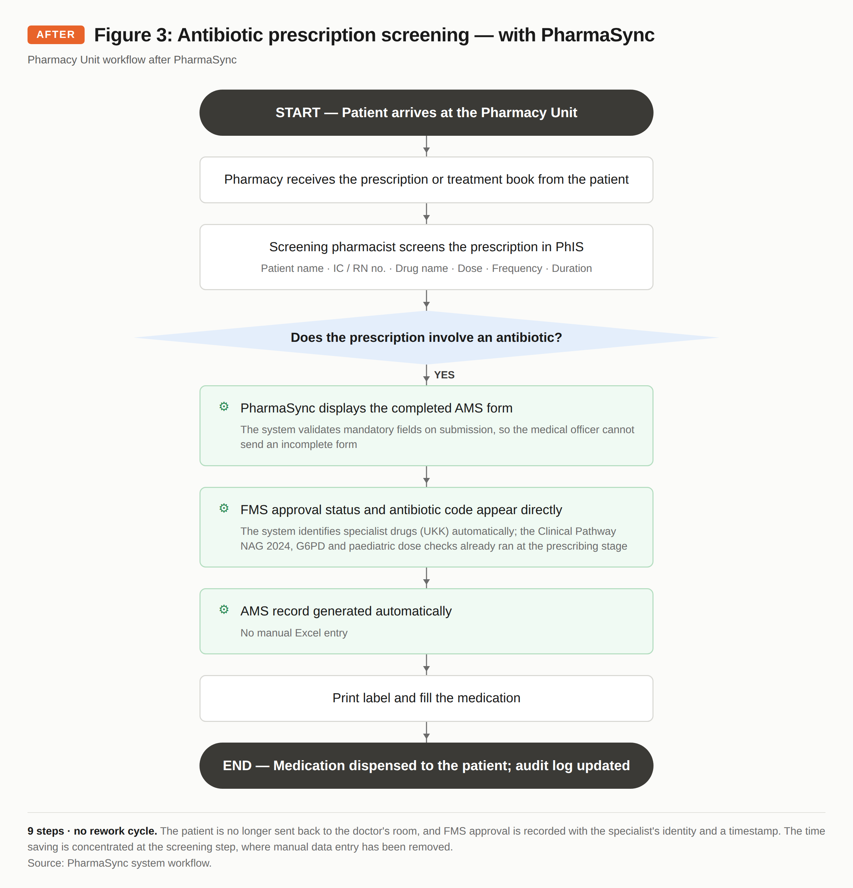

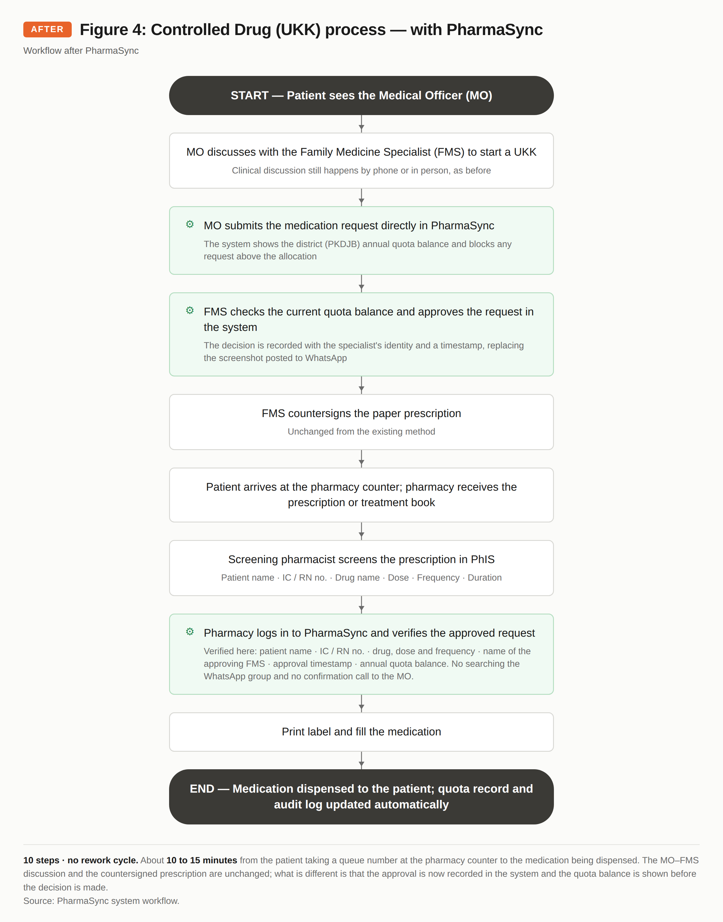

[TO COMPLETE] Attach screenshots of the PharmaSync system as Appendix A, together with the number of requests processed before and after implementation.

2.3 Benefits of the innovation

2.3.1 Cost effectiveness
PharmaSync costs little to run compared with what it adds. The Innovation Team built the application itself at no cost, and recurring costs cover only the domain and the rental of a server based in Malaysia, about RM3.32 a day.
Table 2: Cost and risk compared, manual method against PharmaSync
ASPECT | MANUAL METHOD | PHARMASYNC
Cost | A4 paper, printing and toner for AMS forms and the quota list. | RM13 a year for the domain and RM100 a month for the VPS, about RM3.32 a day.
Availability | Depends on paper forms being stocked in the doctor's room and at the pharmacy counter. | Continuous, 24 hours a day, open to every permitted role.
Risk of waste | Forms printed but never used, and incomplete forms that have to be reprinted. | None.
Risk of error | Quota calculated by hand; an average of 10 incomplete AMS forms each month. | Quota calculated by the system; an incomplete form cannot be submitted.

[TO COMPLETE] Fill in the actual cost of A4 paper and toner (unit price multiplied by estimated annual quantity) from Store records, to show the total saving in Ringgit Malaysia.

2.3.2 Time saved
The measurement runs from the moment the patient takes a queue number at the pharmacy counter until the medication is dispensed to them. Within that window the prescription passes to the screening pharmacist, who checks the AMS form or the UKK request in PharmaSync before the label is printed and the drug is filled. The saving is concentrated at the screening step, because the manual data entry that used to happen there is gone. For a prescription with the correct dose, the time fell from 15 minutes to under 7 minutes, a reduction of about 53%. For a prescription needing a dose review and correction, it fell from up to 25 minutes to within 15 minutes, a reduction of 40%.
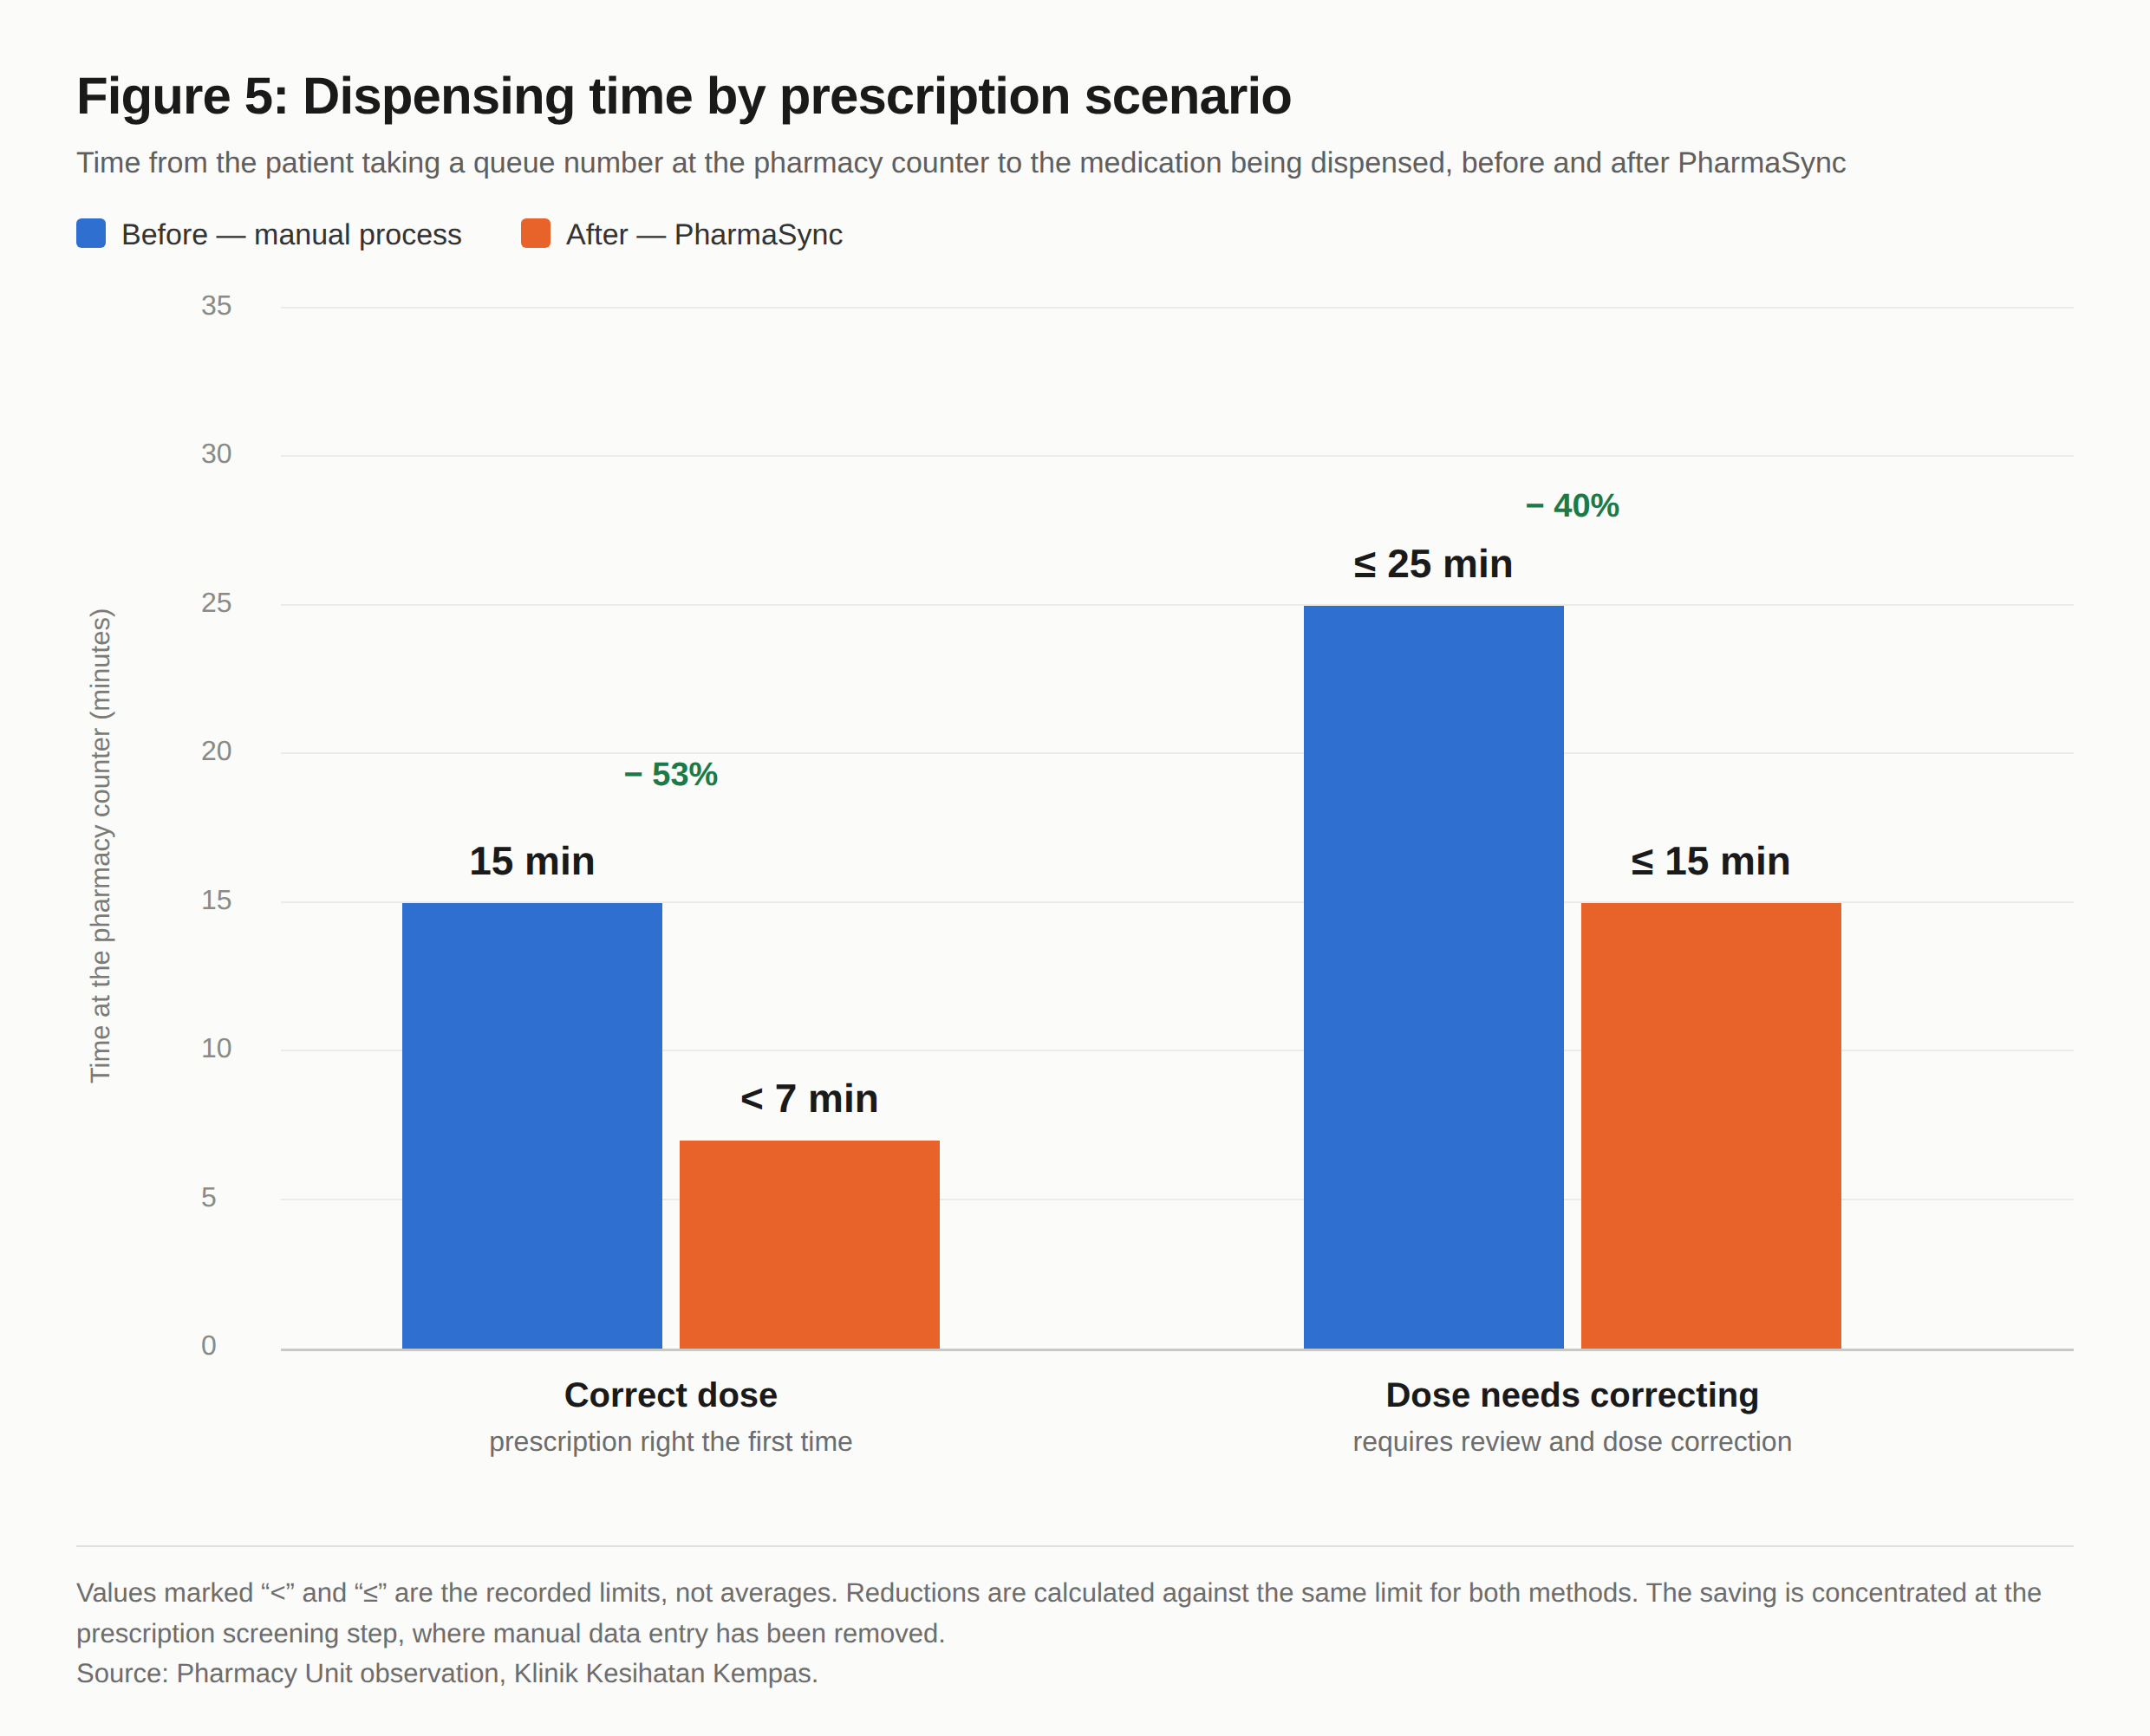

Time savings for Controlled Drugs are measured separately, because the manual process had an extra step that ordinary medication did not: searching the WhatsApp group for the screenshot and filling in a Google Sheet by hand. The time from the patient taking a queue number at the pharmacy counter to the medication being dispensed fell from about 20 minutes to between 10 and 15 minutes, a reduction of between 25% and 50%, or 5 to 10 minutes per patient.
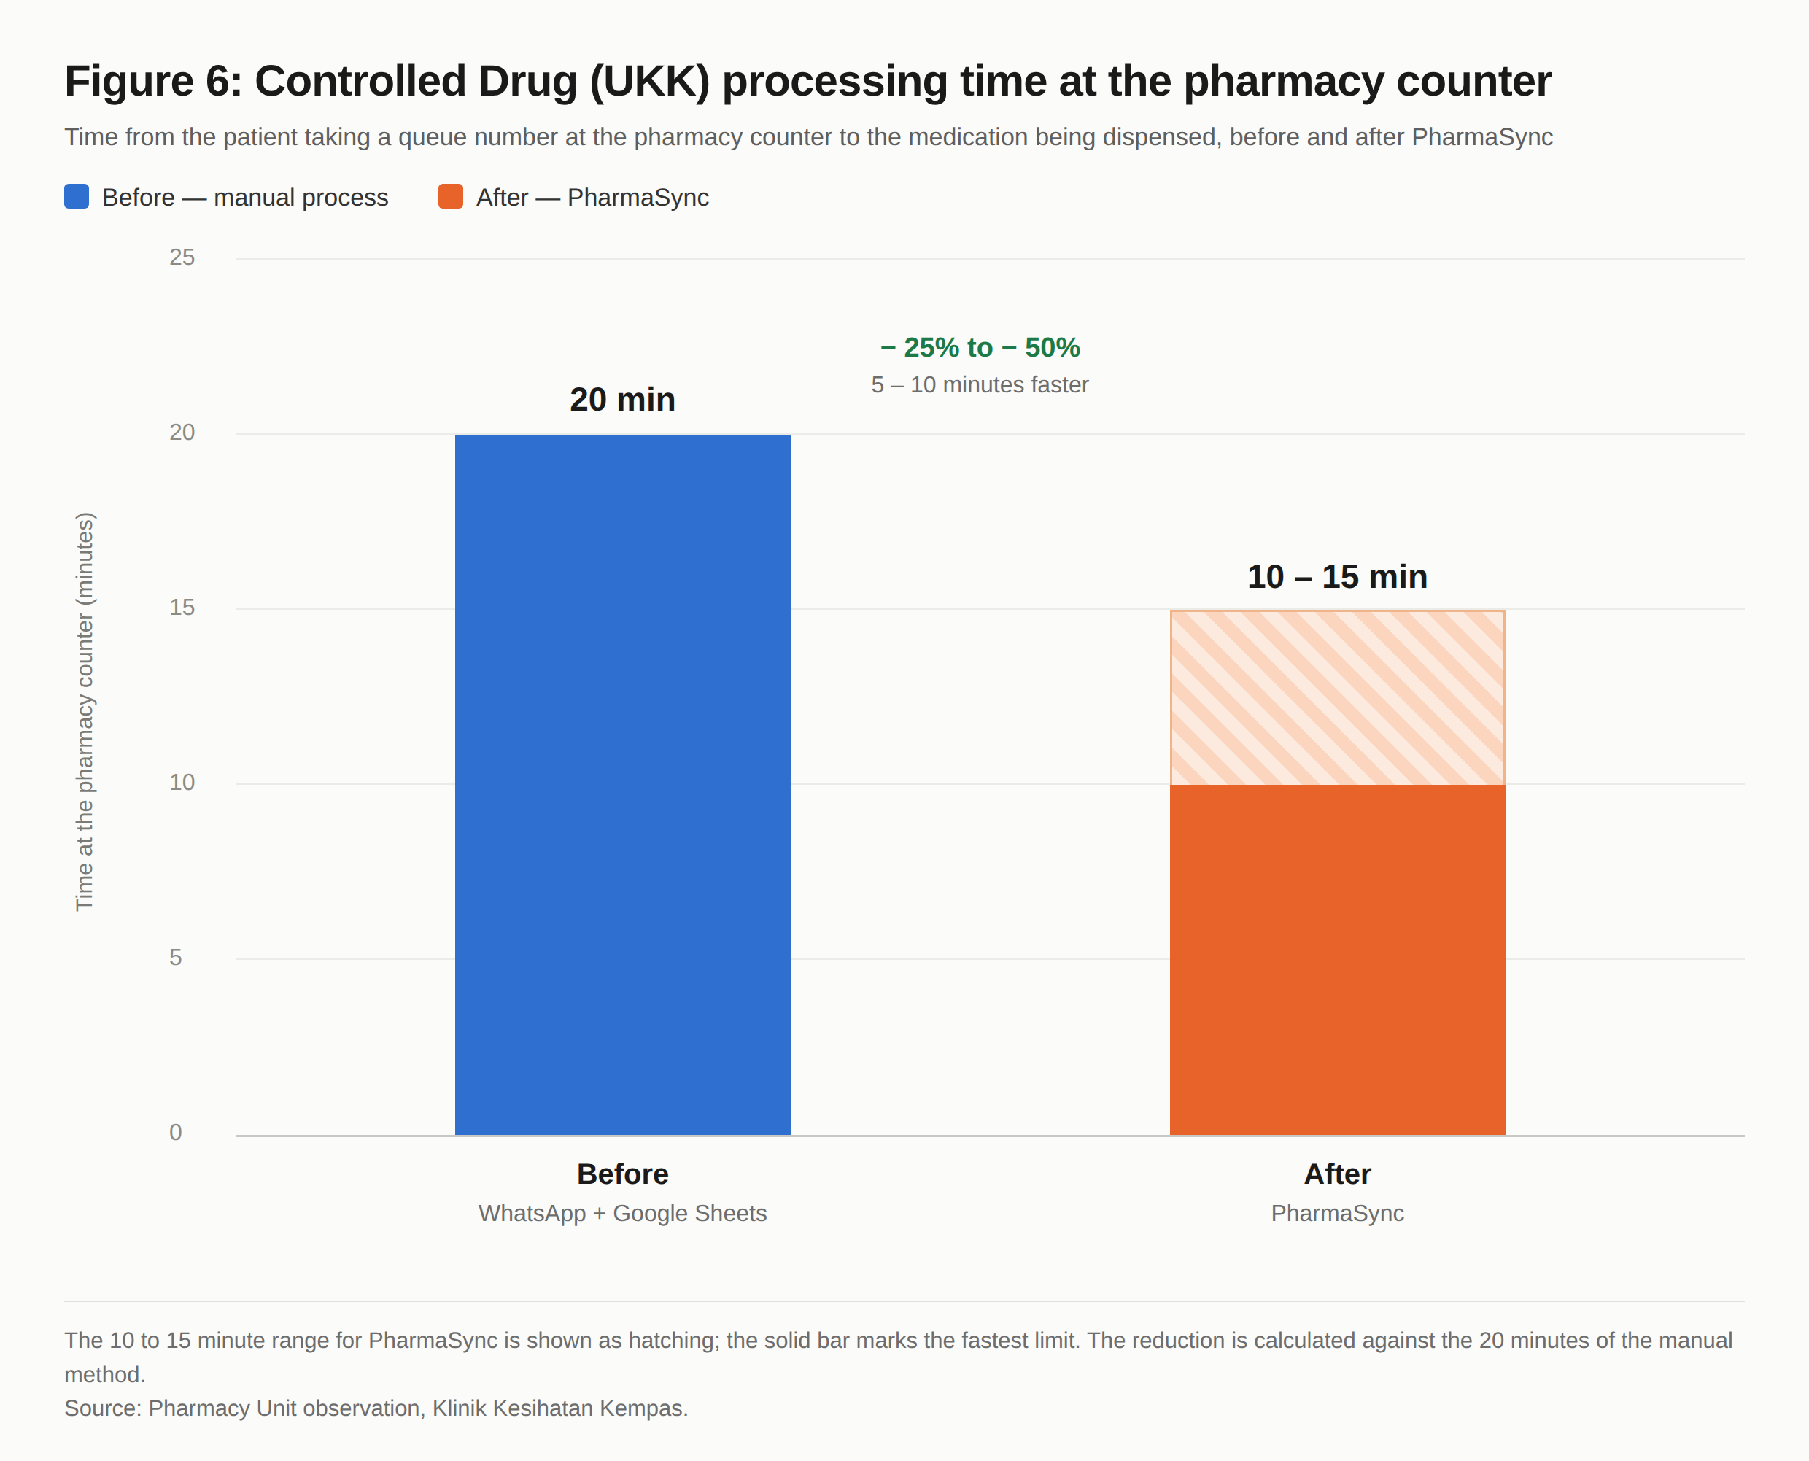

The saving comes from removing the rework cycles and the manual verification steps. In the manual process the antibiotic workflow had two rework cycles and the Controlled Drug workflow had one. Neither digital workflow has any.

2.3.3 More accurate and complete records
Before implementation, an average of 10 incomplete AMS forms were found each month. Each one required a Pharmacist to call the medical officer and send the patient back to the doctor's room. After implementation, the system requires every mandatory field to be filled in before a form can be submitted, which prevents an incomplete form from being produced.
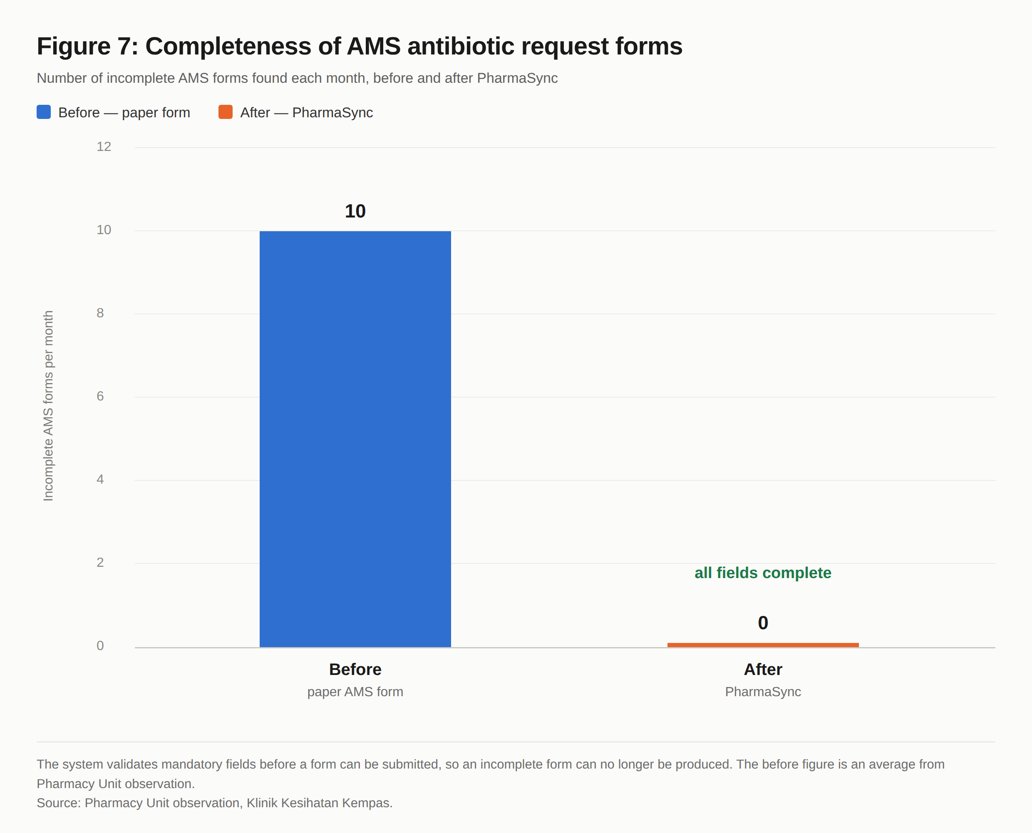

2.3.4 Higher productivity
Pharmacy staff no longer calculate stock and quota balances by hand, collect paper forms from several places, or enter data into an Excel file during prescription screening before the label is printed. The time saved goes to clinical work of more value, such as counselling patients on their medication.
[TO COMPLETE] Attach supporting productivity data, for example the number of requests processed per staff member before and after implementation, or findings from a staff survey.

2.3.5 Manpower saved
Writing records straight into a digital database removes the staff effort needed to collect paper screening forms and key in data by hand. The system now calculates quota balances, updates the quota drug patient list and generates the audit log on its own, with no manual action from pharmacy staff.
[TO COMPLETE] Estimate the staff hours per month previously spent on clerical work and manual records, to quantify the manpower saved.

2.3.6 Higher client satisfaction
Patients receive their medication faster and more accurately because the workflow is streamlined. They no longer wait for specialist approval to be obtained in person, and they are no longer sent back to the doctor's room over an incomplete form.
[TO COMPLETE] Attach findings from a patient or staff satisfaction survey. The 13-item survey instrument in the system's Survey module can be used to collect data before and after implementation.

2.3.7 Drug safety and clinical compliance
The system allows compliance with the Clinical Pathway NAG 2024 to be monitored for every controlled antibiotic prescription. The G6PD check and the paediatric dose calculator help reduce the risk of prescribing error. Family Medicine Specialist approval for each UKK supply is recorded systematically, and annual quota usage can be monitored more effectively.

3. EVALUATION CRITERIA

3.1 High impact
PharmaSync affects the three most critical parts of the health clinic pharmacy service: patient waiting time, record accuracy and prescribing safety.
- Dispensing time at the pharmacy counter, measured from the queue number to the medication being dispensed, fell by about 53% for prescriptions with the correct dose and by 40% for prescriptions needing a dose correction.
- Processing time for Controlled Drugs at the pharmacy counter fell from about 20 minutes to between 10 and 15 minutes, which is 5 to 10 minutes faster per patient.
- Incomplete request forms fell from an average of 10 AMS forms a month to none, because the system requires every mandatory field before a form can be submitted.
- Clinical details about patients no longer circulate as screenshots in a WhatsApp group. FMS approvals are now held in a clinic system with access control and a full audit trail.
- Every Family Medicine Specialist approval is now recorded in the system with the specialist's identity and a timestamp. The FMS still countersigns the paper prescription as before; what is new is the digital record that can be audited, since the specialist's decision previously existed only as a phone conversation and a WhatsApp screenshot.
- Compliance with the Clinical Pathway NAG 2024 can now be monitored and measured for each prescription through central records, which were not available before.
- Annual Controlled Drug quota usage is tracked automatically at district level (PKDJB), which prevents usage above the allocation. Previously it could only be detected after the fact.
- The G6PD deficiency check and the paediatric dose calculator reduce the risk of medication error at the prescribing stage, before the drug reaches the patient.
These results were achieved within a short implementation period, at an operating cost of about RM3.32 a day.
[TO COMPLETE] Strengthen this section with live operating data from the system, for example the total number of requests processed, the number of recorded FMS approvals, and the percentage of requests that passed the NAG 2024 clinical pathway check.

3.2 Creativity
PharmaSync is the Innovation Team's own work, built in-house at no development cost. Several things set it apart:
- It brings together four workflows that used to run separately: stock management, medication requests, specialist approval and quota control. All four are modules within PharmaSync itself, rather than one form turned digital.
- The district Controlled Drug quota is allocated as a rate per Family Medicine Specialist, multiplied by the number of FMS in the district, instead of a fixed figure that has to be recalculated by hand each year.
- Drug safety checks sit inside the prescribing flow, namely the NAG 2024 clinical pathway check, the G6PD deficiency checker and the paediatric dose calculator, rather than as separate references the user has to go and find.
- The system offers AI-based antibiotic suggestions using a local model (Ollama) hosted within the country, which keeps clinical data in the local environment. Every use of AI is written to the audit log automatically, so it can be traced and monitored.
- Mandatory field validation makes sure the information is complete before the process continues, which avoids rework at the pharmacy counter.

3.3 Efficiency
The innovation is cost effective, at an operating cost of about RM3.32 a day, with no new hardware and no extra software to install. Staff reach the web-based system through the browser already on the clinic computers, which saves time, cost and manpower.
In workflow terms, the antibiotic process went from 10 steps to 9, and the Controlled Drug process from 12 steps to 10. The step count matters less than the removal of the rework cycle, the point where the pharmacist has to stop, call the doctor's room, and leave the patient waiting at the counter until the missing information is supplied. The manual antibiotic workflow had two of these and the Controlled Drug workflow had one. Neither digital workflow has any. That is why counter time fell from 20 minutes to between 10 and 15 minutes.

3.4 Replicability
PharmaSync is designed for use across several clinics, with records separated by clinic and the Controlled Drug quota shared at district level. Other clinics can therefore adopt the system without it having to be rebuilt.
The role-based access control used here, covering Administrator, Medical Officer, Family Medicine Specialist, Pharmacist, Logistics Pharmacist and support staff, is matched to the existing staffing structure of KKM health clinics. Implementing the system at another facility therefore requires no change to the existing organisational structure.
[TO COMPLETE] State any discussions, demonstrations or feedback from other health clinics or from the District Pharmacy Officer about using PharmaSync at their facility.

3.5 Top management commitment
[TO COMPLETE] State the support given by top management, for example approval or funding from the Johor Bahru District Health Office (PKDJB) for the RM100 monthly server rental, a letter of support from the District Health Officer, presentation sessions to management, or the status of the ICT Steering Committee (JPICT) approval application. Attach copies as Appendix C.

4. CONCLUSION
PharmaSync improves the whole chain of pharmacy management at Klinik Kesihatan Kempas, from stock management and the request and approval workflow for controlled antibiotics and Controlled Drugs through to prescribing safety and patient records.
At an operating cost of about RM3.32 a day, the innovation improves operational efficiency and accountability, and strengthens compliance with clinical standards, quota control and patient data security. Approvals that used to be given verbally are now recorded in full, incomplete information is caught before the process continues, and patients wait noticeably less time at the pharmacy counter.
With a scalable architecture, support for multi-clinic use and data that stays within the country, PharmaSync can be extended to other health clinics under the Ministry of Health Malaysia. It could then become a model for digital transformation in primary care pharmacy services.

REFERENCES
1.Pharmaceutical Services Division, Ministry of Health Malaysia. National Antimicrobial Guideline (NAG). Putrajaya: Ministry of Health Malaysia.
2.Laws of Malaysia. Act 709 — Personal Data Protection Act 2010. Putrajaya: Percetakan Nasional Malaysia Berhad; 2010.
[TO COMPLETE] Complete the reference list in Vancouver style and confirm the edition and year of each document before submission. Further references worth including: KKM guidelines on Controlled Drug management and annual quotas; the Clinical Pathway NAG 2024 the system refers to; any KKM circular or information security policy behind the data residency requirement; and the internal clinic data used in this report (Pharmacy Unit records and the PharmaSync database).

ACRONYMS
ACRONYM | MEANING
AI | Artificial Intelligence
AMS | Antimicrobial Stewardship
FMS | Family Medicine Specialist
G6PD | Glucose-6-Phosphate Dehydrogenase
JPICT | ICT Steering Committee (Jawatankuasa Pemandu ICT)
KK | Health Clinic (Klinik Kesihatan)
KKM | Ministry of Health Malaysia (Kementerian Kesihatan Malaysia)
MO | Medical Officer
NAG | National Antimicrobial Guideline
PDPA | Personal Data Protection Act
PF | Pharmacist (Pegawai Farmasi)
PhIS | Pharmacy Information System
PKDJB | Johor Bahru District Health Office (Pejabat Kesihatan Daerah Johor Bahru)
RN | Registration Number
UKK | Controlled Drug (Ubat Kawalan Khusus)
VPS | Virtual Private Server

APPENDICES

Appendix A: PharmaSync system screenshots
[TO COMPLETE] Attach screenshots of the main system screens: the Medical Officer dashboard (request form and quota balance display), the FMS dashboard (requests awaiting approval), the Pharmacy Unit dashboard (dispensing), the antibiotic form with the Clinical Pathway NAG 2024 check, the G6PD checker, the paediatric dose calculator, and the audit log view.

Appendix B: Conditions before the innovation
[TO COMPLETE] Attach a copy of the paper AMS form used before the innovation, and screenshots of the Excel AMS list and the quota drug list filled in by hand.

Appendix C: Management support and approvals
[TO COMPLETE] Attach a copy of the approval or letter of support from the Johor Bahru District Health Office, evidence of funding for the server rental, and the status of the ICT security approval application (JPICT) if applicable.

Appendix D: Supporting data
[TO COMPLETE] Attach the raw data tables behind Figures 5, 6 and 7: the recorded dispensing times by dose scenario, the recorded Controlled Drug processing times at the pharmacy counter, and the monthly count of incomplete forms, each with its sample size (n) and data collection period.

