Name: Abhishek Obla Hema
Email: oh_abhishek@yahoo.com

Spark Assignment-1(Marketing Campaign Analysis) Documentation

This file details and describes all the attached files for the Spark Assignment- 1

Tools Used:
- Python3 – Microsoft VScode
- Apache Spark (On GCP Cluster)
- GCP services – DataProc/GCS
- Jupyter Lab
- Apache Hive

Files Attached:
- Spark_Ass1.pdf – This file
- Spark_Marketingdata– Pyspark File that details all the analysis
- HQL_datastore.txt – HQL commands used to create external tables off the data

Process and File Descriptions:

Step 1:

First I created three dataframes:
- Campaigns
- Users
- Stores
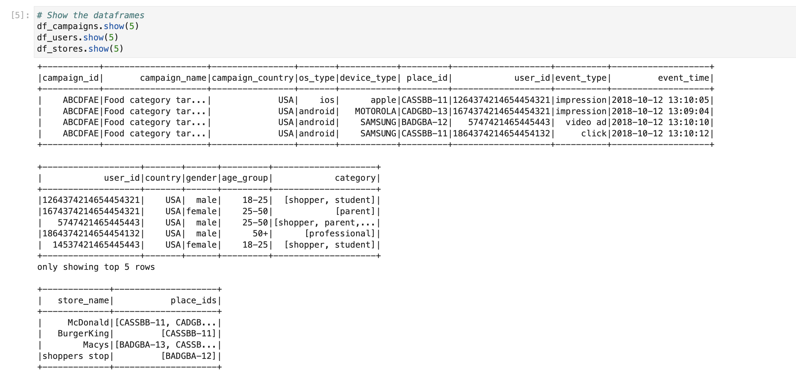

Step 2:

I then performed the necessary transformations that has been asked in the question and placed the output in separate directories in the HDFS .

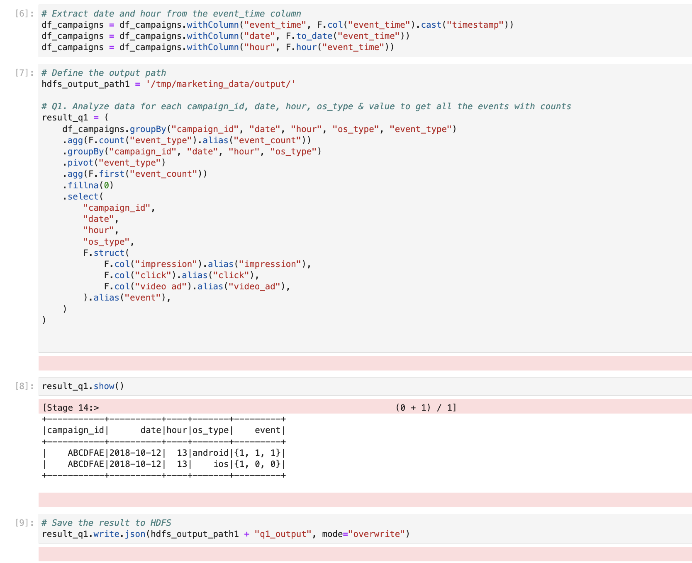

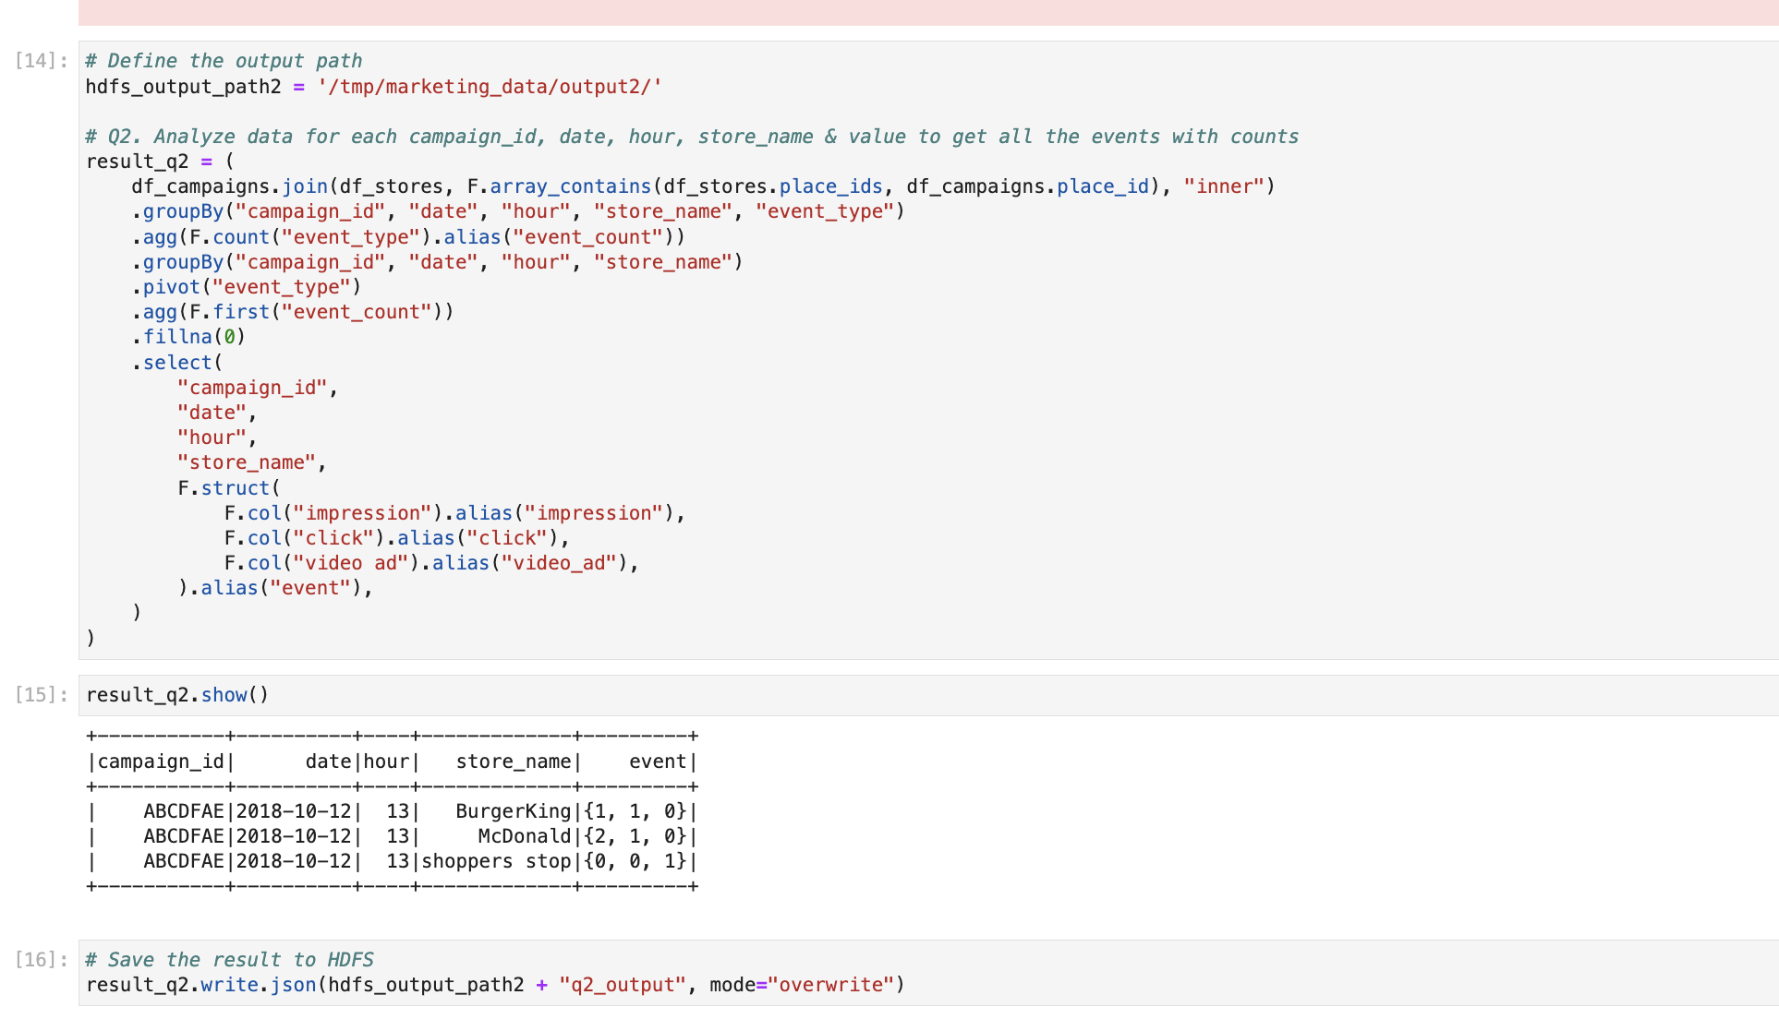

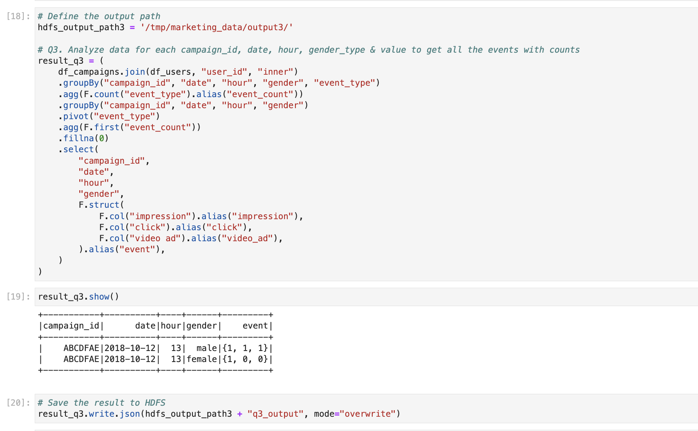

Step 3:
We can check the output has been saved using the UI

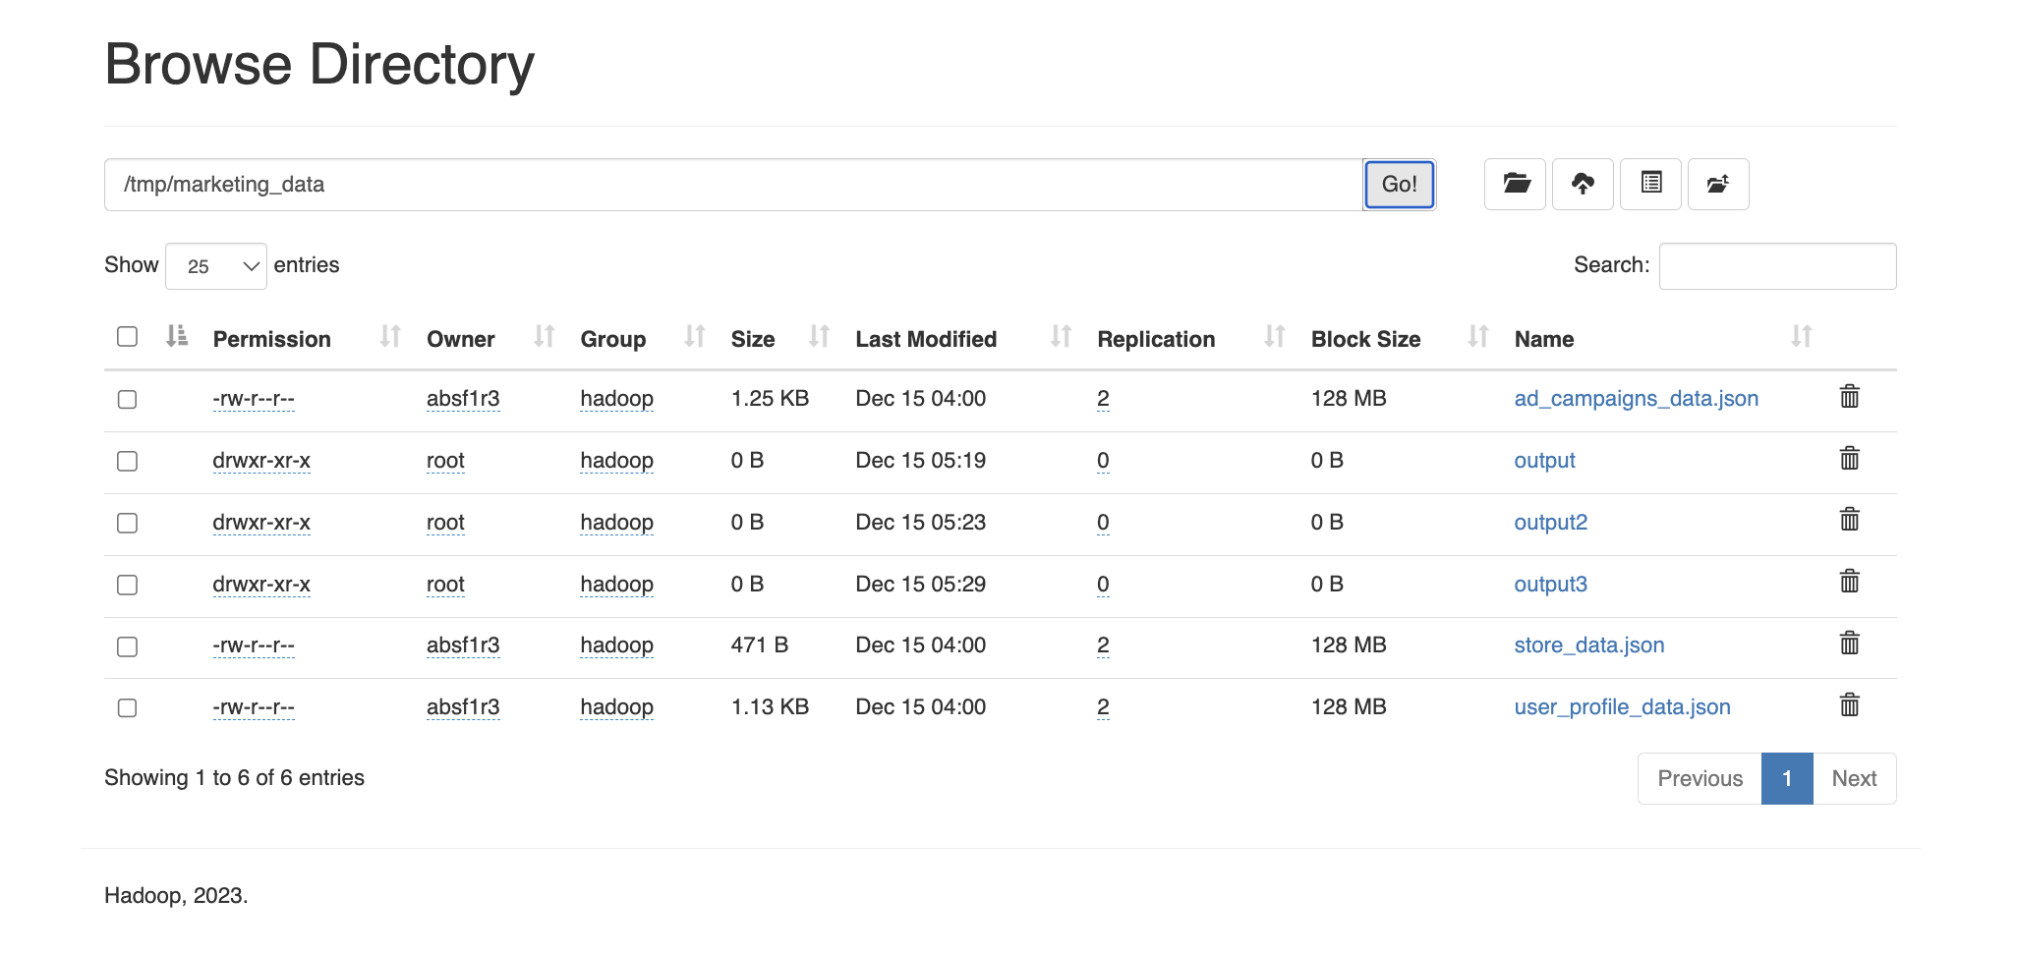

Step 4:

Using HQL statements I then created Hive external tables using JSON serde.

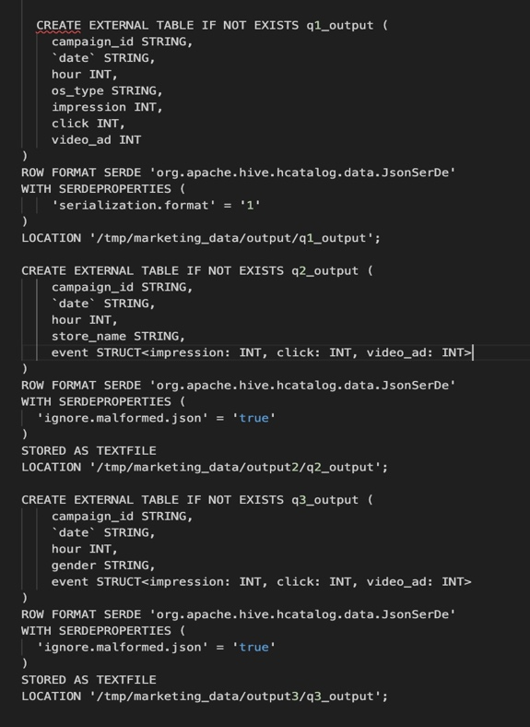

Step 5:

Querying Hive tables to check the output data to make sure

