Name: Abhishek Obla Hema
Email: oh_abhishek@yahoo.com

Spark Assignment-2(Movie Data Analysis) Documentation

This file details and describes all the attached files for the Spark Assignment-2

Tools Used:
- Python3 – Microsoft VScode
- Apache Spark (On GCP Cluster)
- GCP services – DataProc/GCS
- Jupyter Lab
- Apache Hive

Files Attached:
- Spark_Ass2.pdf – This file
- Spark_MovieRating.– Pyspark File that details all the analysis

Process and File Descriptions:

Step 1:

I placed the three csv files in the HDFS location and ingested them into their respective spark dataframes. The three frames being
- Movies
- Ratings
- Tags

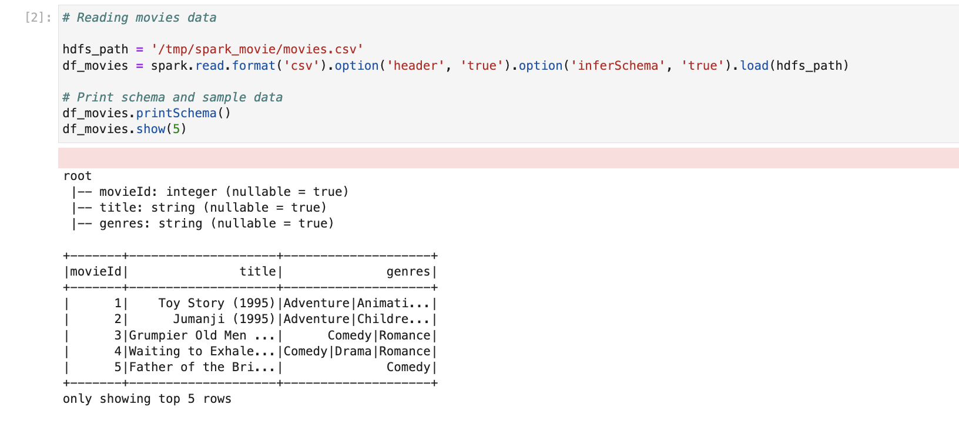

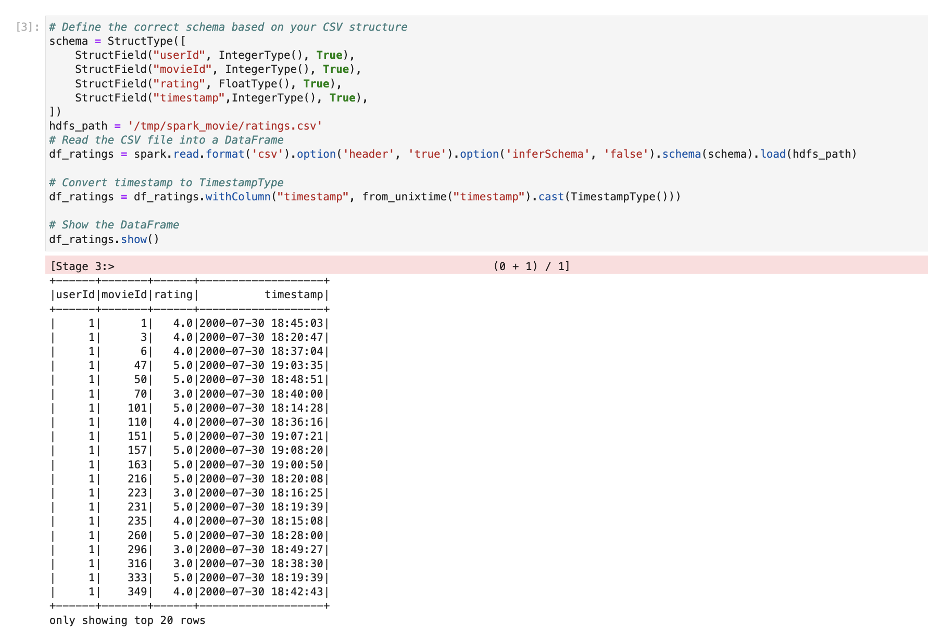

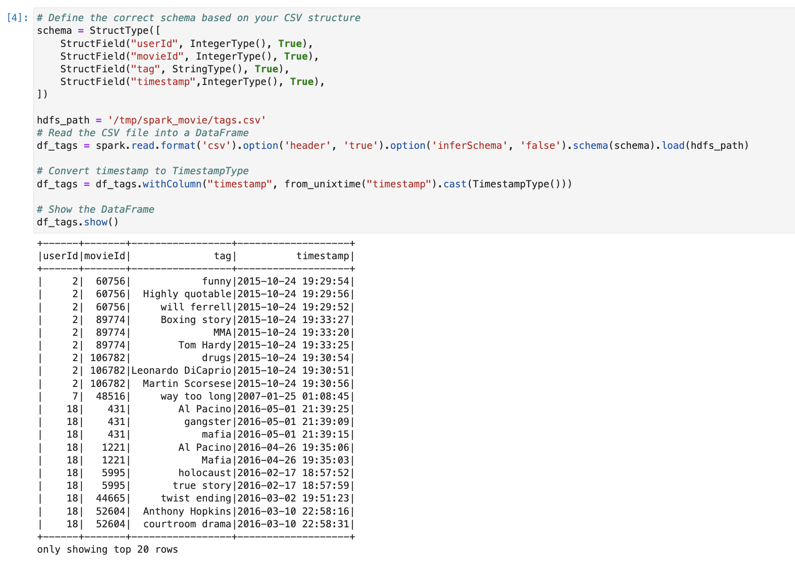

Step 2:
I then used spark SQL to query the dataframes to get the required outputs. This involved creating tempviews of movies,ratings and tags

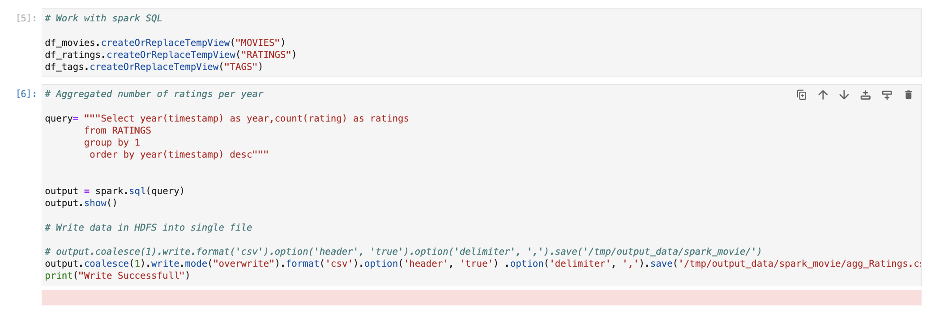

Step 3:

I made sure to save the output in a HDFS location. I also checked the files in the HDFS Namenode using the UI.

