FPT UNIVERSITY — PRACTICAL REPORT
LAB 5: STUDENT FEEDBACK & COURSE REVIEW
Subject code: FER202 - ReactJS Application Development
Student Name: Vo Van Thanh Phong (vvtPhongdev)
Technology Stack: React 18 · Vite · Bootstrap · useContext + useReducer · JSON Server
__________________________________________________________________

LIST OF CONTENTS
1. Project Initialization & Package Setup 4
2. Database Initialization (db.json) 4
3. Form & Date Validation Utilities 4
4. Authentication and Validation Steps 4
5. Feedback Management Operations 6
6. Core Source Code Details 10

LIST OF FIGURES
Figure 1 : Empty login form validation 5
Figure 2 : Invalid email format validation 5
Figure 3 : Invalid credentials validation 6
Figure 4 : Homepage dashboard after successful login 6
Figure 5 : Add feedback form validation 7
Figure 6 : Feedback added successfully 7
Figure 7 : Edit Feedback modal with populated values 8
Figure 8 : Feedback updated successfully 8
Figure 9 : Confirm Delete modal 9
Figure 10 : Feedback deleted successfully 9
Figure 11 : Logout and redirect to the login page 10

1. Project Initialization & Package Setup
Initialize the Vite React project, install required dependencies (react-router-dom, axios, react-bootstrap, bootstrap, concurrently, and json-server). Configured development scripts in package.json to concurrently launch Vite Dev Server and JSON Server.
{
"scripts": {
"dev": "vite",
"build": "vite build",
"server": "json-server --watch db.json --port 3001",
"start": "concurrently \"npm run server\" \"npm run dev\""
}
}

2. Database Initialization (db.json)
Placed the given db.json file in the root of the project to initialize the database containing users and existing feedbacks. The server runs at http://localhost:3001.

3. Form & Date Validation Utilities
Defined utilities for form input validations (email requirements, empty checks, rating bounds) and date formatting in the src/utils directory.
validate.js
export const validateLogin = (email, password) => {
if (!email.trim() || !password.trim()) {
return 'Email and password are required'
}
if (!email.includes('@')) {
return 'Email must contain @'
}
return null
}

export const validateFeedback = ({ course, rating }) => {
if (!course || !course.trim()) return 'Course name is required'
const r = Number(rating)
if (!rating || isNaN(r) || r < 1 || r > 5) return 'Rating must be between 1 and 5'
return null
}

4. Authentication and Validation Steps
Step 4.1: Submit empty login form. The client-side validation errors 'Email and password are required' are displayed in red alerts.
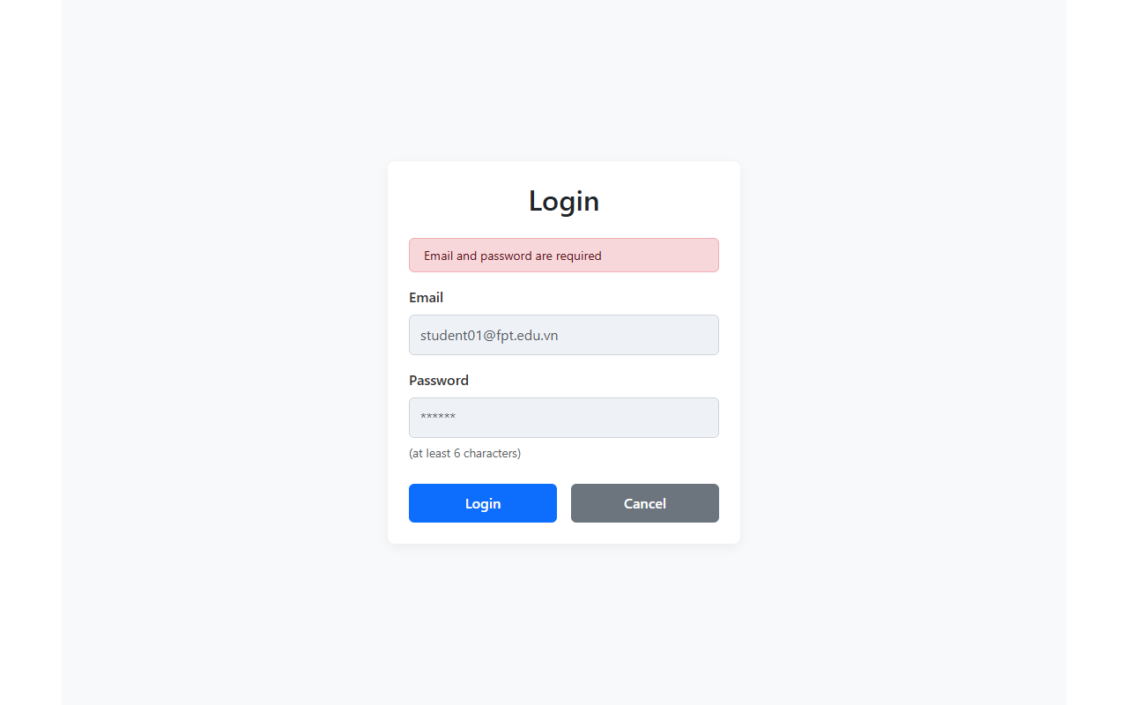
Figure 1: Empty login form validation
Step 4.2: Submit login with an email format missing '@' symbol. The validation error 'Email must contain @' is displayed.
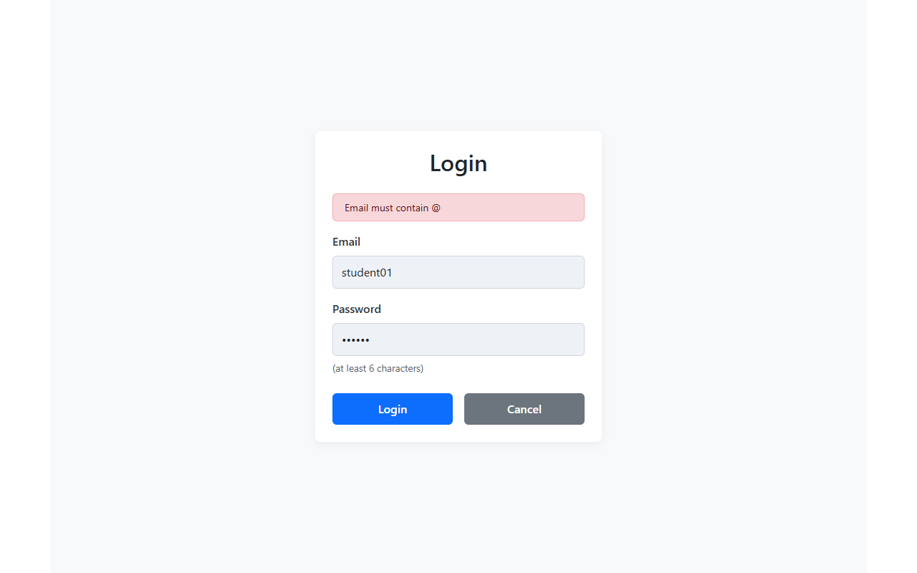
Figure 2: Invalid email format validation
Step 4.3: Submit credentials that do not match the database users. The authentication fails and shows 'Invalid email or password'.
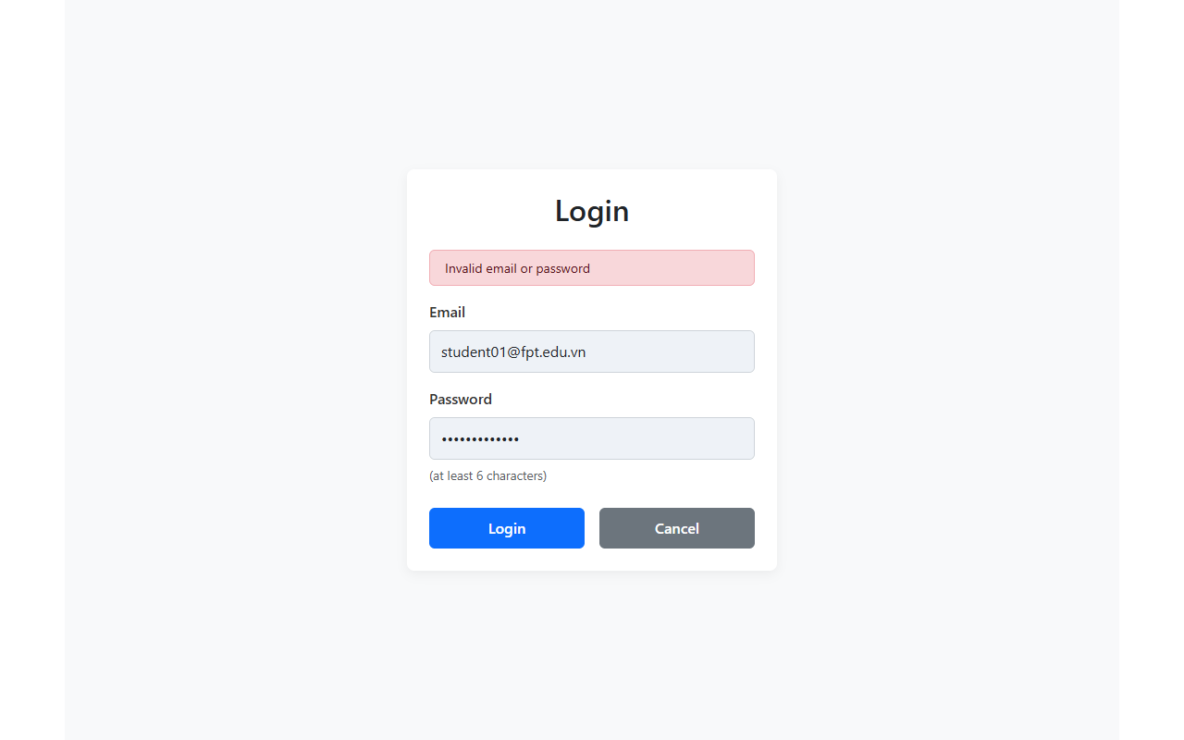
Figure 3: Invalid credentials validation
Step 4.4: Login successfully with credentials student01@fpt.edu.vn and password 123456. The application redirects to the Homepage dashboard showing course management header and existing feedback list.
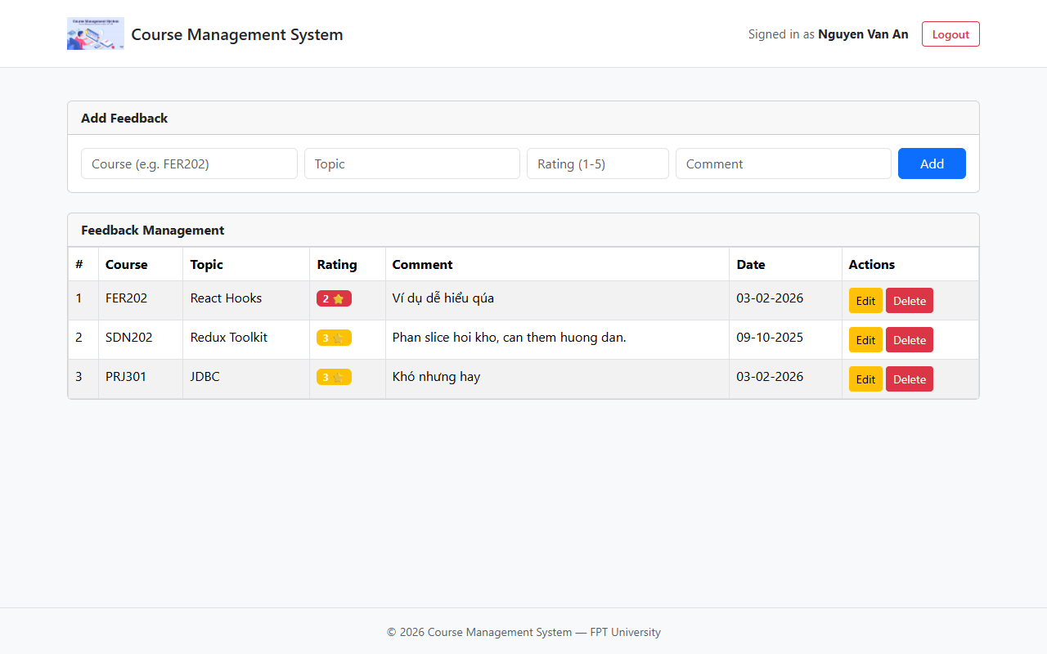
Figure 4: Homepage dashboard after successful login

5. Feedback Management Operations
Step 5.1: Add feedback validation. Trying to add a feedback without Course and with Rating = 6 shows inline invalid feedbacks: 'Course name is required' and 'Rating must be between 1 and 5'.
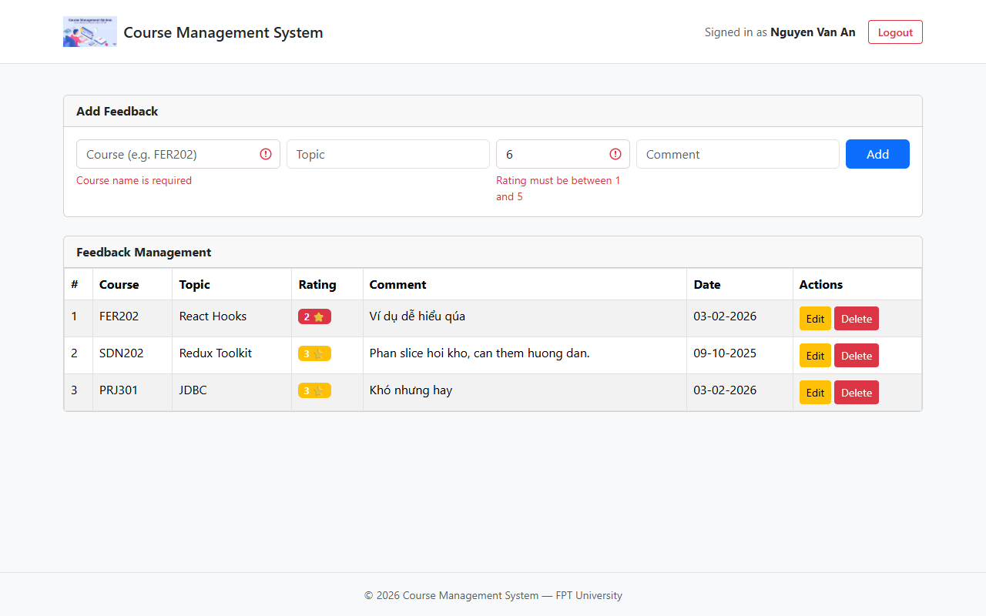
Figure 5: Add feedback form validation
Step 5.2: Add feedback successfully. Course: FER202, Topic: React Context, Rating: 5, Comment: Excellent explanation! A success alert appears at the top, and the item is added to the table immediately.
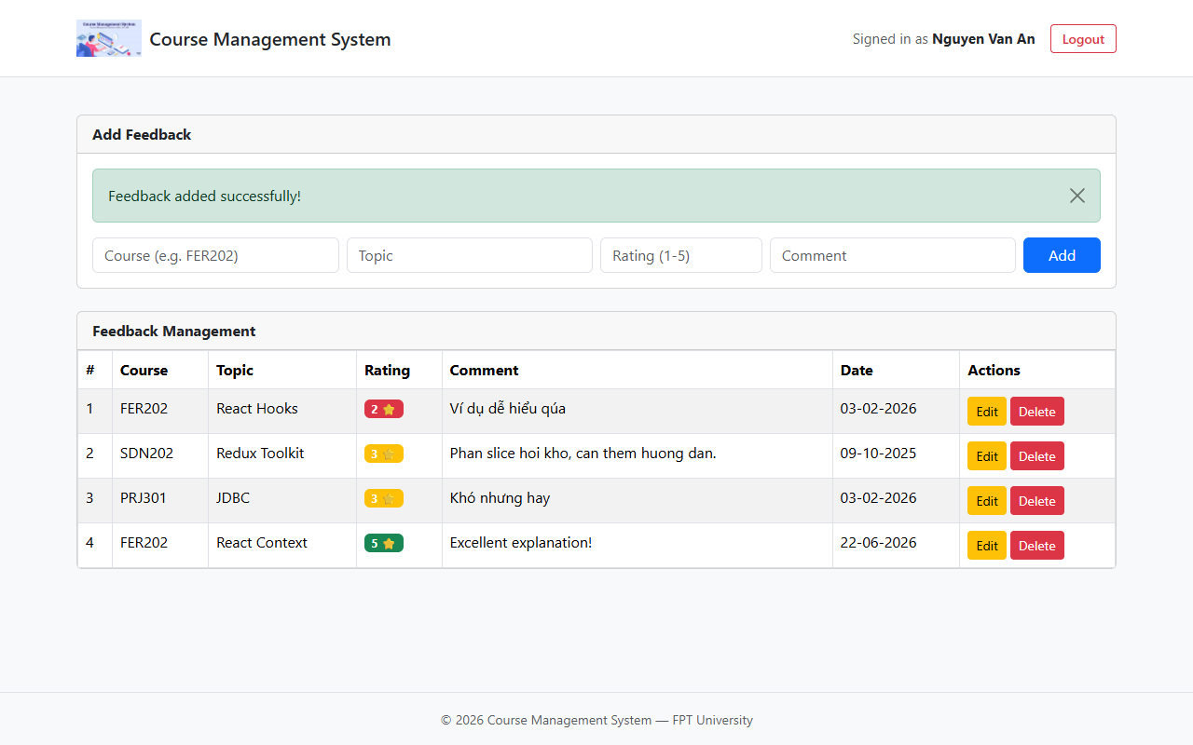
Figure 6: Feedback added successfully
Step 5.3: Click 'Edit' button on a feedback row. The Edit Feedback Modal opens, populated with the row's values.
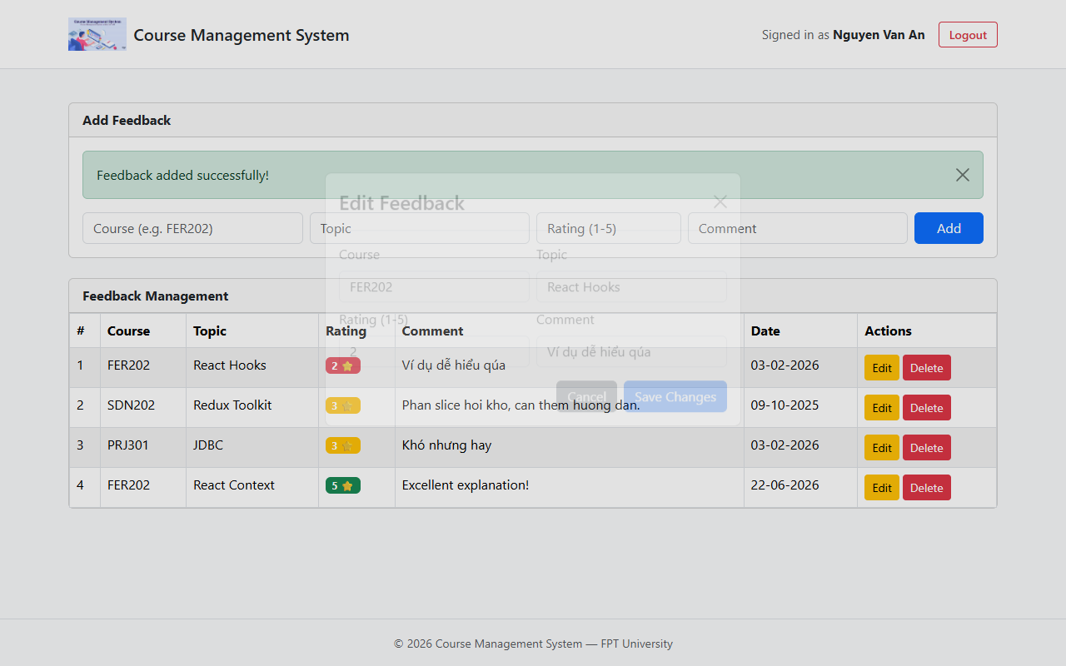
Figure 7: Edit Feedback modal with populated values
Step 5.4: Save changes in the modal (change Rating to 4, comment to 'Very good explanation!'). The modal closes and updates the table row in real time.
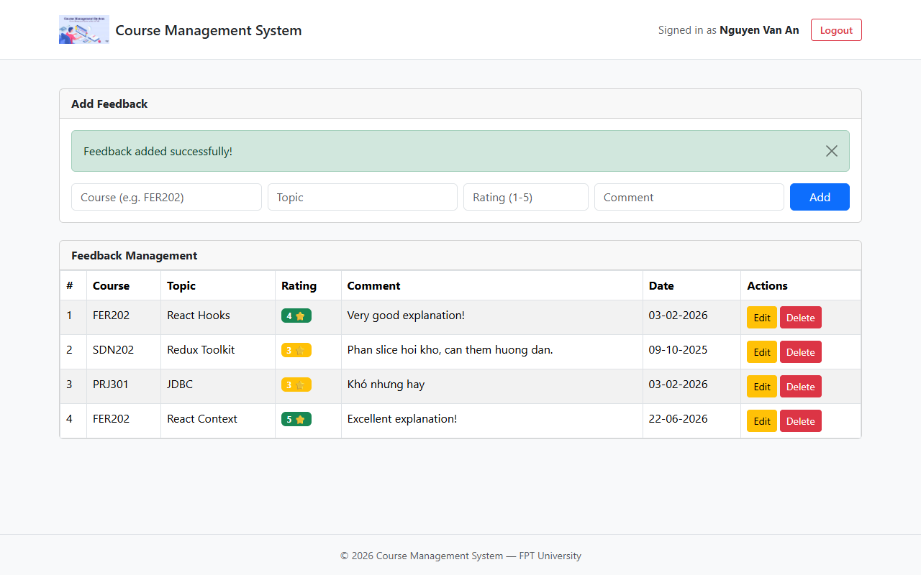
Figure 8: Feedback updated successfully
Step 5.5: Click 'Delete' button. The 'Confirm Delete' modal pops up.
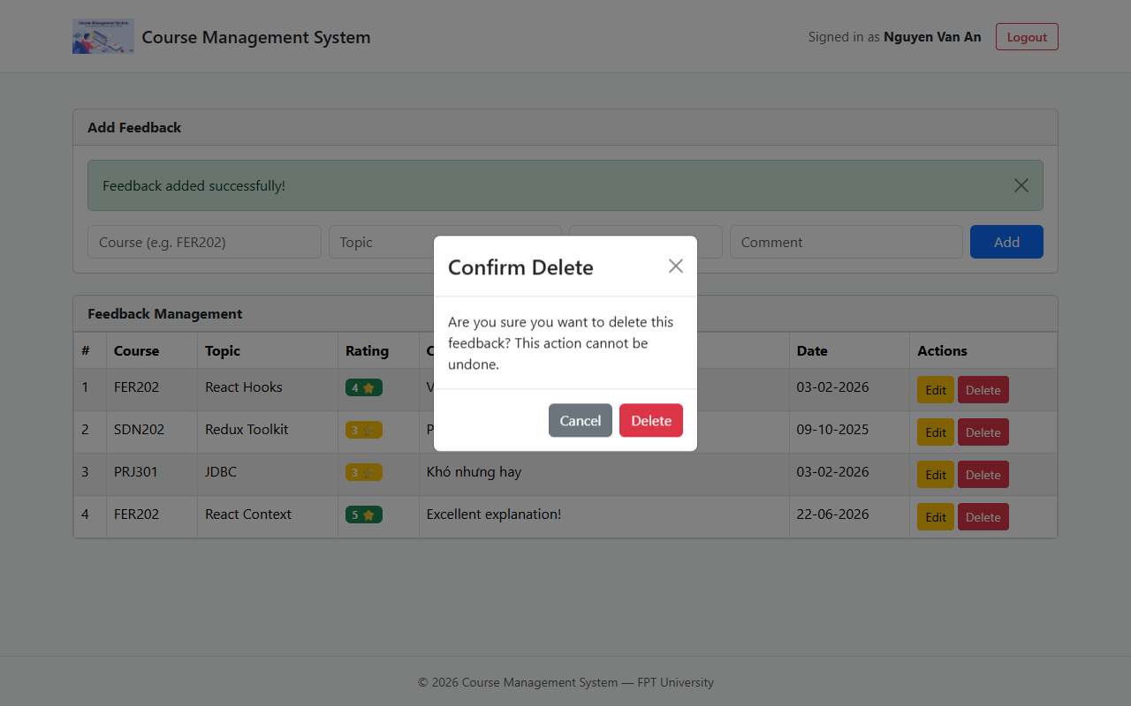
Figure 9: Confirm Delete modal
Step 5.6: Click 'Delete' in the modal. The feedback is successfully deleted, and the row disappears from the table.
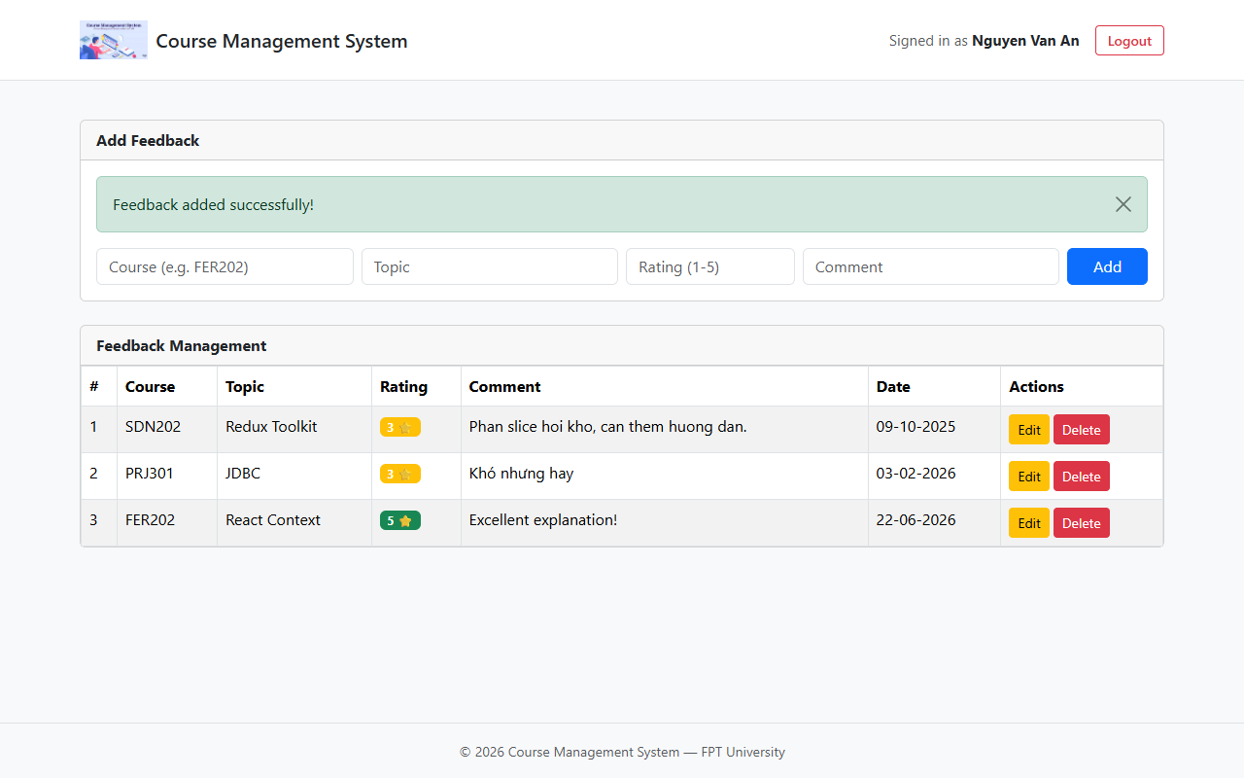
Figure 10: Feedback deleted successfully
Step 5.7: Click 'Logout' button in the header. The session is cleared, and the application redirects back to the login page.
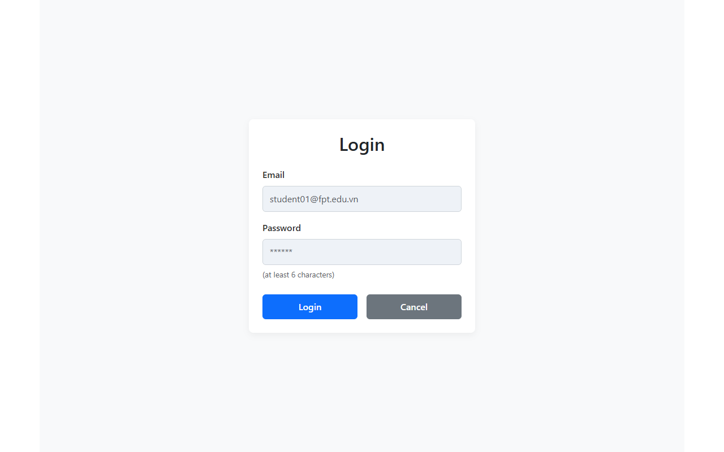
Figure 11: Logout and redirect to the login page

6. Core Source Code Details
FeedbackContext.jsx
import { createContext, useContext, useReducer } from 'react'
import {
FEEDBACK_ACTIONS,
feedbackReducer,
initialFeedbackState,
} from '../reducer/feedbackReducer'
import {
createFeedback,
getFeedbacksByUser,
removeFeedback,
updateFeedback,
} from '../api/feedbackApi'

const FeedbackContext = createContext(null)

export function FeedbackProvider({ children }) {
const [state, dispatch] = useReducer(feedbackReducer, initialFeedbackState)

const fetchFeedbacks = async (userId) => {
dispatch({ type: FEEDBACK_ACTIONS.FETCH_START })

try {
const data = await getFeedbacksByUser(userId)
dispatch({ type: FEEDBACK_ACTIONS.FETCH_SUCCESS, payload: data })
} catch (err) {
dispatch({ type: FEEDBACK_ACTIONS.FETCH_FAIL, payload: err.message })
}
}

const addFeedback = async (data) => {
const newItem = await createFeedback(data)
dispatch({ type: FEEDBACK_ACTIONS.ADD, payload: newItem })
}

const editFeedback = async (id, data) => {
const updated = await updateFeedback(id, data)
dispatch({ type: FEEDBACK_ACTIONS.EDIT, payload: updated })
}

const deleteFeedback = async (id) => {
await removeFeedback(id)
dispatch({ type: FEEDBACK_ACTIONS.DELETE, payload: id })
}

return (
<FeedbackContext.Provider
value={{
...state,
fetchFeedbacks,
addFeedback,
editFeedback,
deleteFeedback,
}}
>
{children}
</FeedbackContext.Provider>
)
}

export const useFeedback = () => useContext(FeedbackContext)

feedbackReducer.js
export const FEEDBACK_ACTIONS = {
FETCH_START: 'FETCH_START',
FETCH_SUCCESS: 'FETCH_SUCCESS',
FETCH_FAIL: 'FETCH_FAIL',
ADD: 'ADD',
EDIT: 'EDIT',
DELETE: 'DELETE',
}

export const initialFeedbackState = {
items: [],
loading: false,
error: null,
}

export const feedbackReducer = (state, action) => {
switch (action.type) {
case FEEDBACK_ACTIONS.FETCH_START:
return { ...state, loading: true, error: null }

case FEEDBACK_ACTIONS.FETCH_SUCCESS:
return { ...state, loading: false, items: action.payload }

case FEEDBACK_ACTIONS.FETCH_FAIL:
return { ...state, loading: false, error: action.payload }

case FEEDBACK_ACTIONS.ADD:
return { ...state, items: [...state.items, action.payload] }

case FEEDBACK_ACTIONS.EDIT:
return {
...state,
items: state.items.map((feedback) =>
feedback.id === action.payload.id ? action.payload : feedback
),
}

case FEEDBACK_ACTIONS.DELETE:
return {
...state,
items: state.items.filter((feedback) => feedback.id !== action.payload),
}

default:
return state
}
}

HomePage.jsx
import { useEffect, useState } from 'react'
import { Alert, Container, Spinner } from 'react-bootstrap'
import Header from '../components/Header'
import Footer from '../components/Footer'
import AddFeedbackForm from '../components/AddFeedbackForm'
import FeedbackTable from '../components/FeedbackTable'
import EditFeedbackModal from '../components/EditFeedbackModal'
import { useAuth } from '../context/AuthContext'
import { useFeedback } from '../context/FeedbackContext'

function HomePage() {
const { user } = useAuth()
const { items, loading, error, fetchFeedbacks } = useFeedback()
const [editTarget, setEditTarget] = useState(null)

useEffect(() => {
if (user) fetchFeedbacks(user.id)
}, [user])

return (
<div className="d-flex flex-column" style={{ minHeight: '100vh', backgroundColor: '#f8f9fa' }}>
<Header />
<Container className="my-3 flex-grow-1">
{loading && (
<div className="text-center my-5">
<Spinner animation="border" />
</div>
)}
{error && <Alert variant="danger">{error}</Alert>}
{!loading && (
<>
<AddFeedbackForm />
<FeedbackTable
feedbacks={items}
onEdit={setEditTarget}
/>
</>
)}
</Container>
<Footer />

<EditFeedbackModal
show={!!editTarget}
feedback={editTarget}
onHide={() => setEditTarget(null)}
/>
</div>
)
}

export default HomePage

