**De 1 : Recreational and Wellness management application for employee**  
  
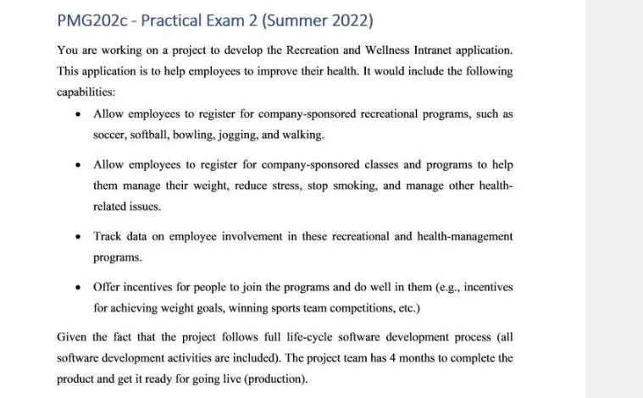  
  


**Smart goal 1 :** Once our product released, it will be applied to 20% of all company in our city by the end of the year

Specific : the team knows what they’re building : an app that helps employees care for their health and reminds them to do so

Measurable : Once the app has been completed and sold to the market, it will be bought by at least 20% of all company in local city

Attainable : Our team has a strong dev team, and a long-term sale and marketing strategy to develop this product .

Relevant : This product will bring more revenue for our company

Time-bound : The team needs 4 months to complete this application and 6 months for marketing.

**Smart goal 2:** By the time our partner uses this product, it will be compatible with 100% employee in their company

Specific: the team knows what they’re building : an app that helps employees care for their health and reminds them to do so

Measurable : The product will be applicable when it includes 100% data of employees.

Attainable : Our team has a strong dev team, and a long-term sale and marketing strategy to develop this product

Relevant : The administrator can manage their employee better by having their heath data .

Time-Bound : The team needs 4 months to complete this application



RACI Chart :

|  |  |  |  |  |  |  |  |
| --- | --- | --- | --- | --- | --- | --- | --- |
|  | PM- Project manager | BA – Business analysist | UI/UX Designer | Senior Developer | Tester | Product Owner | Stakeholder |
| Create project charter | R | C | C | C | I | A | I |
| Create SRS (software requirement specification ) | A | R | C | C | I | I | I |
| Design wireframe | I | A | R | C | I | I | I |
| Implement coding | A | C | C | R | C | I | I |
| Perform testing | A | I | I | C | R | I | I |

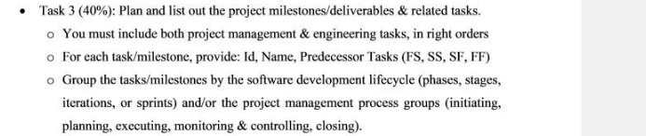

|  |  |  |  |
| --- | --- | --- | --- |
| EPIC | User story title | User Story | Acceptance criteria |
| Authentication Feature | More option to log-in , register | As an employee, I want to log-in through/via my personal social media account in order to safe time while logging in with no need to fill in the password | When user register to the system, the system will automatically recommend the option “Register by email “  - With the user that registered with email, they can log – in via email to safe time and do not have to enter password |
| Employee manage controller | More health data in our employee profile such as blood pressure, medical history | As an administrator, I want to see more health related data in our employee profile in order to manage them better and give them proper job | - When employee register to the system, they will be asked to give more specific information about their medical history - This type of information will be public in their profile |

Task 3 : Iterative – incremental, each iteration includes a small waterfall model



|  |  |  |
| --- | --- | --- |
| ID | TASK | PREDECESSOR |
| 1 | Phase 1 |  |
| 1.1 | Milestone: Initiating |  |
| 1.1.1 | Create Project charter | 1.1.2SF |
| 1.1.2 | Get the project charter approval | 1.1.1 FS |
| 1.1.3 | Kick-off meeting | 1.1.2 FS |
| 1.1.4 | Create stakeholder Register | 1.1.3SS |
| 2 | Phase 2 |  |
| 2.1 | **Milestone 2 : planning** |  |
| 2.1.1 | Create Scope management plan |  |
| 2.1.2 | Create Time management plan | 2.1.1 SS |
| 2.1.3 | Create Cost management plan | 2.1.1SS |
| 2.1.4 | Create Risk management plan | 2.1.1SS |
|  | Meeting with the team to discuss about plan |  |
|  | Deliver project management plan |  |
| 3 | Phase 3 |  |
| 3.1 | Milestone: Executing |  |
| 3.1.1 | Iteration 1 |  |
|  | 3.1.1.1 analysis  i . Create feasibility report  ii. Create use-case diagram and use-case description  iii. Create SRS documentation  3.1.1.2 Design  i. create design for wireframe  ii. create UI/UX design  iii. create mock-up screen  3.1.1 3 Implementing  i. implement coding for authentication feature  ii. implement coding for employee management controller  3.1.1.4 Testing  i. Perform unit testing  ii. Perform integration testing  iii. Perform part of system testing |  |
| 3.1.2 | Iteration 2 : |  |
|  | 3.1.2.1 analysis  i. Update feasibility report  ii. Update use-case diagram and use-case description  iii. Update SRS docs  3.1.2.2 Design  i. Update design for wireframe  ii. Update UI/UX design  iii. Update mock-up screen design  3.1.2.3 Implementing  i. implement coding for recreational program controller  ii. implement coding for admin role  3.1.2.4 Testing  i. Perform unit testing  ii. Perform integration testing  iii. Perform part of system testing |  |
| 3.1.2 | Iteration 3: |  |
|  | 3.1.2.1 analysis  i. Update feasibility report  ii. Update use-case diagram and use-case description  iii. Update SRS docs  3.1.2.3 Design  iv. Update design for wireframe  v. Update UI/UX design  vi. Update mock-up screen design  3.1.2.5 Implementing  iii. implement coding for healthcare program controller  iv. implement coding for payment function  3.1.2.6 Testing  iv. Perform unit testing  v. Perform integration testing  vi. Perform system testing  vii. Perform acceptance testing |  |
| 4 | Phase 4 |  |
| 4.1 | Milestone: Monitoring and controlling |  |
| 4.1.1 | Control scope |  |
| 4.1.2 | Track progress | 4.1.1SS |
| 4.1.3 | Perform cost control | 4.1.2SS |
| 4.1.4 | Monitor and control risk | 4.1.3SS |
| 5 | Phase 5 |  |
| 5.1 | Milestone : Closing |  |
| 5.1.1 | Create lesson learn |  |
| 5.1.2 | Create project final report |  |
| 5.1.3 | Close project ceremony |  |