Chữa đề Fall – 2022

1.

Stakeholder description

Product Owner : Providing all the resources and approve the Project charter. PO works with stakeholders such as customers, business owners, development departments, etc. to ensure that the product meets the needs and creates value for the company with the specified goals. PO plays a role like a customer in the team.

Project manager: Internal stakeholder, planning and organizing, managing tasks, budgeting, controlling costs and other factors. Everything they do helps make sure the project can be completed on time and on budget, and more importantly, profitable.

BA: bridges the gap between external stakeholders and the development team, interpreting business requirements into understandable development tasks to match a final software product with the expected business value

Developer team : internal stakeholder , He writes, debugs and executes the source code of a software application.

Designer team : internal stakeholder A UI/UX designer’s job is to create user-friendly interfaces that enable users to understand how to use complex technical products

Tester team : Internal stakeholder. The role of a tester is to test out products for bug and provide reports to the project teams about any issues or improvements that the product may require

Project sponsor : primary shareholders that keep companies financially viable and make projects possible by [providing funds](https://www.masterclass.com/articles/how-to-fund-your-small-business). They can also directly impact project when they are dissatisfied with its [business plan](https://www.masterclass.com/articles/what-is-a-business-plan-learn-how-to-write-a-business-plan-in-8-steps)

Customer : external stakeholder who experience the software and they give unbiased reviews

RACI Chart Responsible >Accountable >Consult >Inform

|  |  |  |  |  |  |  |  |  |  |
| --- | --- | --- | --- | --- | --- | --- | --- | --- | --- |
|  | Task | PM- Project manager | BA – Business analysist | Designer  Team | Developer  Team | Tester  Team | Product Owner | Project sponsor | Customer |
| Phase 1 initiation phase | Create project charter | R | C | C | C | I | A | C | I |
| Phase 2  Planning | Create time management plan | R | C | C | C | C | A | I | I |
|  | Create risk management plan | R | C | C | C | I | A | I | I |
| Phase 3 Executing | Implement coding | A | C | C | R | C | I | I | I |
|  | Perform testing | A | I | I | C | R | I | I | I |
|  | Collect feedback | R | I | I | I | I | R/A | I | C |

Task 2 - Để ý cách chia ID khi vào dạng WBS , chia level 3-4

*cách 1 – waterfall truyền thống

1. Software Project Defect tracking system (level 1)
   1. **Phase 1: Initiating (level 2)** 
      1. Create Project Charter (level 3)
         1. Solidifying the project scope (in-scope item, out of scope item , deliverable ( level 4 )/ Write down the project scope statement
         2. Determine resources needed  (level 4 )

1.1.1.3Define project SMART goal and deliverables (level 4 )

* + 1. Hold a kick-off meeting (level 3)
    2. Get project charter approval (level 3)
    3. Perform a cost - benefit analysis for the project- - level 3
    4. Create stakeholder Register (level 3)
  1. **Phase 2: Planning (level 2)** 
     1. Create Project management plan ( level 3 )
        1. Create Scope Management Plan (level 4)
        2. Create Time Management Plan (level 4)
        3. Create Cost Management Plan (level 4)
        4. Create Risk Management Plan (level 4)
        5. Create Resource Management Plan (level 3)
     2. Meeting with team to discuss about plans (level 3)
     3. Deliver Project Management Plan (level 3)
  2. **Phase 3 Executing (level 2) (Analysis , Design, Code , Test )** 
     1. Analysis (level 3)
        1. Create Feasibility Report (level 4)
        2. Create Use-case diagram and use-case description (level 4)
        3. Create Software Requirement Specification (level 4)
        4. Perform Requirement validation (level 4)
        5. Perform Requirement management (level 4)
     2. Design (level 3)
        1. Create High level design / Create Architecture design (level 4)
        2. Create Low level design / Create detail design (level 4)
     3. Prototyping (level 3)
        1. Create prototype for module 1 (level 4)
        2. Review prototype for module 1 with customer (level 4)
        3. Create prototype for module 2 (level 4)
        4. Review prototype for module 2 with customer (level 4)
        5. Create prototype for module 3 (level 4)
        6. Review prototype for module 3 with customer (level 4)
     4. Implementing (level 3)
        1. Implement coding for module 1 : User management (level 4)
        2. Implement coding for module 2 : Requirement management (level 4)
        3. Implement coding for module 3 : Defect tracking and reporting (level 4)
     5. Testing (level 3)
        1. Perform unit testing (level 4)
        2. Perform integration testing (level 4)
        3. Perform system testing (level 4)
        4. Perform acceptance testing (level 4)
     6. Support (level 3)
        1. Training (level 4)
        2. Documentation (level 4)
        3. User support (level 4)
        4. Enhancements (level 4)
  3. **Phase 4: Monitoring and Controlling (level 2)**
     1. Control scope (level 3)
     2. Track progress (level 3)
     3. Perform Cost control (level 3)
     4. Monitor and control Risk (level 3)
  4. **Phase 5: Closing (level 2)**

1.5.1 Create Lesson learn (level 3)

* + 1. Create Project Final Report (level 3)
    2. Create Project Archive (level 3)
    3. Hold close Project Ceremony (level 3)

Task 3

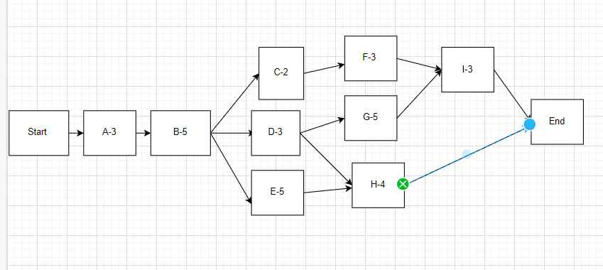

Path 1 Start -> A -> B -> C-> F -> I -> End 3+5+2+3+3 = total 16days

Path 2 Start -> A->B->D->G->I->End 3+5+3+5+3 total 19 days -> critical path , 19days are the minimum duration to complete that deliverable

Path 3 Start -> A->B->D->H->End total 15days

Path 4 Start -> A->B->E->H->End total 17 days

**fast-tracking method**

Arrange task I so that it overlaps task G. After task G had started for 2 days, then task I will start . Besides, start the task H at the 5th day of task E in order to reduce the task H by 1 day

This may increase risk, so that require more attention to communication.

**Crashing method: -> will increase cost**

Solution 1 - Recruit more people to join project to complete task G earlier than 3 days

Recruit more people to join project to complete task H earlier than 1 days

Solution 2 Force team to work overtime on task G to complete it earlier than 3 days

Force team to work overtime on task H to complete it earlier than 1 days

Explanation:

If you want to shorten the project time by 3 days, you need to shorten the time of a task on the critical path, but now 8 days have passed (the end of time for task A, task B and project have been in task D ) so we have a way to shorten the time in tasks G or I. The appropriate choice is left with task G with duration of 5 days because a task with a duration of 5 days should be prioritized to shorten the time over a task with a duration of 3 days.

Not only that , we also have to reduce task H by 1 day due to the fact that when the critical path had been reduced to 16 days (before is 19 days) , no other path can exceed this quantity of day (path 4 now is over schedule – 17 days) .

Critical path method – Critical chain method

ES – early start

EF – early finish

LS – Late start

LF – Late finish

Forward pass

Backward pass

Float do tre = LS – ES = LF – EF

Task co float = 0 -> critical task

Đường full critical task -> critical path

**TH1:** ES = 0 – 0 based planning

EF = ES+ Duration , ES task sau bằng EF task trước

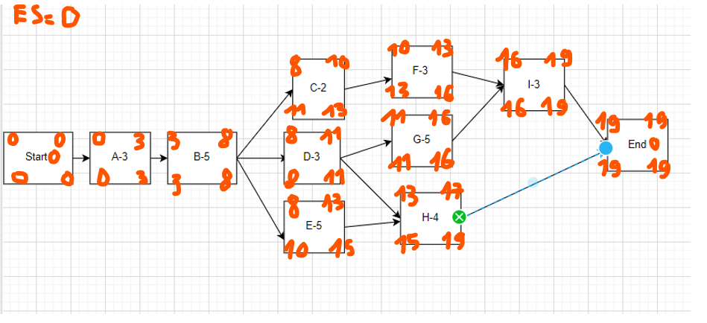

**TH2**

ES = 1 , 1- based planning

EF = ES + Duration – 1

LS = LF- Duration + 1

ES task sau (B) bằng EF task trước (A) + 1

LF task trước (A) bằng LS task sau(B) – 1

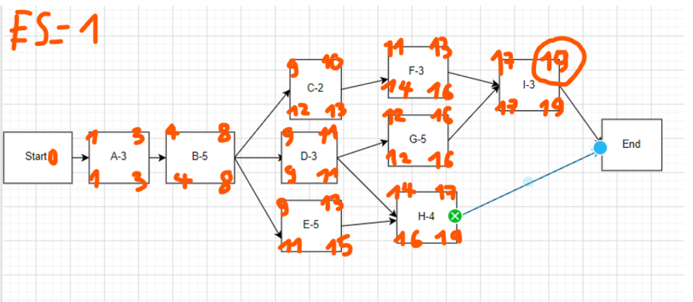

Task 4 *chỉ cần ghi 2 cái

|  |  |  |
| --- | --- | --- |
| Risk | Possibility | Mitigation Plan |
| The team lack the required skills for website testing | HIGH | Plan training course to skill up your member |
| Wrong budget estimate and cost overruns | EXTREME | Establish the scope before beginning work, pay a lot of attention to project planning and constantly track and measure the progress |
| The project schedule is too tight; it’s hard to complete this project on time | HIGH | Set Test priority for each of the test activity |
| Test manager has poor management skill | MODERATE | Plan leadership training for manager |
| A lack of cooperation negatively affects your employees productivity | MODERATE | Encourage each team member in his task, and inspire them to greater efforts |