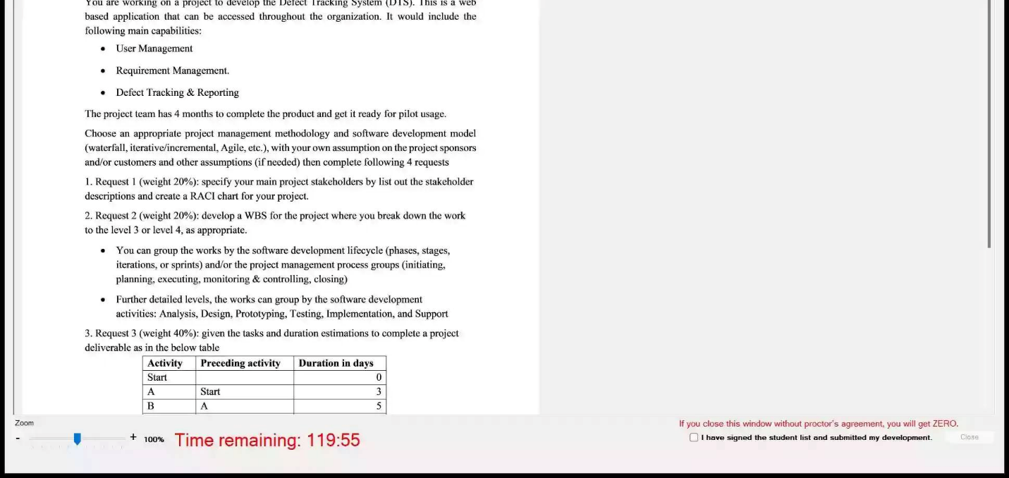

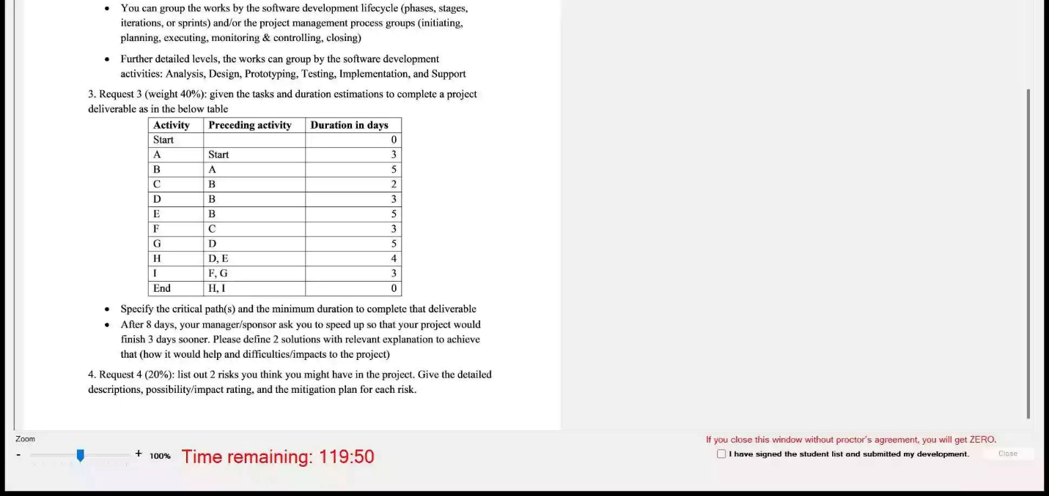

1.

Stakeholder description

Product Owner : Providing all the resourse and approve the Project charter, but don’t appear to have specific requirement

Project manager: Internal stakeholder, planning and organizing, managing tasks, budgeting, controlling costs and other factors. Everything they do helps make sure the project can be completed on time and on budget.

BA: bridges the gap between external stakeholders and the development team, interpreting business requirements into understandable development tasks to match a final software product with the expected business value

Developer: internal stakeholder , He writes, debugs and executes the source code of a software application.

UI/UX designer : internal stakeholder A UI/UX designer’s job is to create user-friendly interfaces that enable users to understand how to use complex technical products

Project tester: Internal stakeholder. The role of a tester is to test out products for bug and provide reports to the project teams about any issues or improvements that the product may require

Project sponsor : primary shareholders that keep companies financially viable and make projects possible by [providing funds](https://www.masterclass.com/articles/how-to-fund-your-small-business). They can also directly impact project when they are dissatisfied with its [business plan](https://www.masterclass.com/articles/what-is-a-business-plan-learn-how-to-write-a-business-plan-in-8-steps)

RACI Chart R->A->C->I

R- Responsible : trách nhiệm thực thi – trực tiếp làm nhiệm vụ đó

1. Accountable : giám sát R, Chịu trách nhiệm cho kết quả công việc của R - chỉ duy nhất 1 người , cấp trên của R

C-Consult Tham vấn , R sẽ tham vấn C, hỏi ý kiến C để cùng thực thi công việc đó

I-Inform – Thông báo – được cập nhật thông tin

|  |  |  |  |  |  |  |  |
| --- | --- | --- | --- | --- | --- | --- | --- |
|  | PM- Project manager | BA – Business analysist | UI/UX Designer | Senior Developer | Tester | Product Owner | Project sponsor |
| Create project charter | R | C | C | C | I | A | I |
| Create SRS (software requirement specification ) | A | R | C | C | I | I | I |
| Design wireframe | I | A | R | C | I | I | I |
| Implement coding | A | C | C | R | C | I | I |
| Perform testing | A | I | I | C | R | I | I |

Task 2

Software Development Life cycle – Defect Tracking system (level 1)

Phase 1 : Initiating (level 2)

1. Create Project Charter (level 3)
2. Kick-off meeting (level 3)
3. Get project charter approval (level 3)
4. Create stakeholder Register (level 3)

Phase 2: Planning (level 2) - Project management Plan

1. Create Scope Management Plan (level 3)
2. Create Time Management Plan (level 3)
3. Create Cost Management Plan (level 3)
4. Create Risk Management Plan (level 3)
5. Create Resource Management Plan (level 3)
6. Meeting with team to discuss about plans (level 3)
7. Deliver Project Management Plan (level 3)

Phase 3 Executing (level 2)

1. Analysis (level 3)
2. Create Feasibility Report (level 4)
3. Create Use-case diagram and use-case description (level 4)
4. Create Software Requirement Specification (level 4)
5. *Perform Requirement validation (level 4)*
6. *Perform Requirement management (level 4)*
7. Design (level 3)
8. Create design for module 1 (level 4)
9. Create design for module 2 (level 4)
10. Create design for module 3 (level 4)
11. Prototyping (level 3)
12. Create prototype for module 1 (level 4)
13. Review prototype for module 1 with customer (level 4)
14. Create prototype for module 2 (level 4)
15. Review prototype for module 2 with customer (level 4)
16. Create prototype for module 3 (level 4)
17. Review prototype for module 3 with customer (level 4)
18. Implementing (level 3)
19. Implement coding for user management controller 1 (level 4)
20. Implement coding for require management controller 2 (level 4)
21. Implement coding for defect tracking function (level 4)
22. Testing (level 3)
23. Perform unit testing (level 4)
24. Perform integration testing (level 4)
25. Perform system testing (level 4)
26. Perform acceptance testing (level 4)
27. Support (level 3)
28. Training (level 4)
29. Documentation (level 4)
30. User support (level 4)
31. Enhancements (level 4)

Phase 4 Monitoring and Controlling (level 2)

1. Control scope (level 3)
2. Track progress (level 3)
3. Perform Cost control (level 3)
4. Monitor and control Risk (level 3)

Phase 5 Closing (level 2)

1. Create Lesson learn (level 3)
2. Create Project Final Report (level 3)
3. Create Project Archive (level 3)
4. Close Project Ceremony (level 3)

Task 3

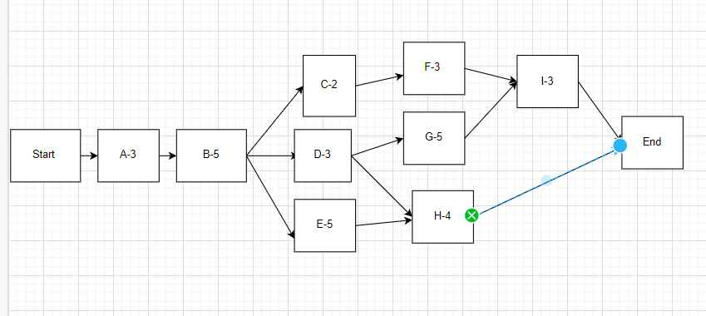

Path 1 A -> B -> C-> F -> I -> End 3+5+2+3+3 = 16 total 16days

Path 2 A->B->D->G->I->End total 19 days

Path 3 A->B->D->H->End total 15days

Path 4 A->B->E->H->End total 17 days

-> Critical path is path 2 and minimum duration is 19 days

Solution:

- Recruit more people to join project to complete task G earlier than 3 days

- Force team to work overtime on task G to complete it earlier than 3 days

Explaination:

If you want to shorten the project time by 3 days, you need to shorten the time of a task on the critical path, but now 8 days have passed (the end of time for task A, task B and project have been in task D ) so we have a way to shorten the time in tasks G or I. The appropriate choice is left with task G with duration of 5 days because a task with a duration of 5 days should be prioritized to shorten the time over a task with a duration of 3 days

Task 4

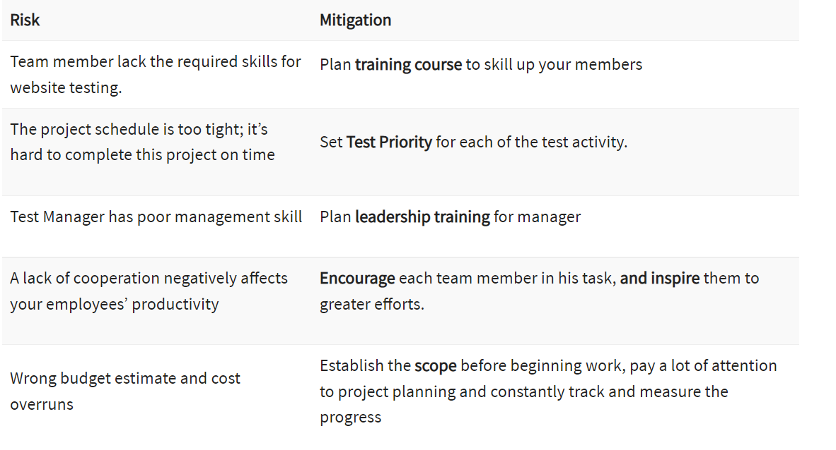

Thêm cột level of risk ở giữa

