PMG202C PRACTICAL EXAM 2 ANSWER

1.REQUEST 1 :

|  |  |
| --- | --- |
| ROLE NAME | DESCRIPTION |
| PROJECT MANAGER | RESPONSIBLE FOR OVERSEEING THE ENTIRE PROJECT AND IT STAYS ON TRACK AND WITHIN BUDGET. THE PROJECT MANAGER WILL RESPONSIBLE FOR COORDINATING WITH ALL STAKEHOLDERS AND ENSURING THAT EVERYONE WILL FOLLOW THE SAME GOALS |
| BUSINESS ANALYST | RESPONSIBLE FOR GATHERING REQUIREMENTS AND TRANSFORM THEM INTO ACTIONABLE TASKS FOR THE DEVELOPMENT TEAM. THE BUSINESS ANALYST WILL WORK CAREFULLY WITH STAKEHOLDERS TO IDENTIFY BUSINESS’S NEEDS , DOCUMENT REQUIREMENTS AND CREATE USER STORIES |
| DEVELOPER | RESPONSIBLE FOR BUILDING THE SOFTWARE PRODUCT BASE ON THE REQUIREMENTS GIVEN FROM THE BUSINESS ANALYSTS. DEVELOPERS WILL WORK TOGETHER WITH OTHER MEMBERS OF THE DEVELOPMENT TEAM TO ENSURE THAT THE SOFTWARE PRODUCT WILL BE BULIT CORRECTLY WITH INDUSTRIAL STANDARDS AND BEST PRACTICE |
| TECHNICAL WRITER | RESPONSILE FOR CREATING DOCUMENTATIONS AND OTHER MATERIALS TO SUPPORT THE SOFTWARE DEVELOPMENT PROCESS. THEY WILL WORK TIGHTLY WITH DEVELOPERS, BUSINESS ANALYSTS, PROJECT MANAGERS TO CREATE USER’S MATERIAL , MANUAL FILES AND USER MANUALS |
| QUALITY ASSURANCE CONTROLER | RESPONSILE FOR TESTING THE SOFTWARE PRODUCT TO ENSURE THAT IT MEETS REQUIREMENTS AND SPECIFICATIONS OUTLINED BY THE BUSINESS ANALYSTS. QA WILL REPORT BUGS AND WORK CLOSELY WITH DEVELOPER TEAMS TO ENSURE THAT THE SOFTWARE WILL BE TOTALLY PERFECT WHEN RELEASING TO CLIENT |

2.REQUEST 2

+AS A TEAM MEMBERS, I WANT TO VIEW MY TASKS THAT ARE ASSIGNED FOR ME, SO THAT I CAN PRIORTIE MY WORK AND STAY ON TRACK

+AS A TEAM MEMBER, I WANT TO TRACK TIME WILL BE SPENT ON EACH TASK , SO THAT I CAN ACCURATELY FOLLOW THE PROGRESS AND MAKE SURE THAT I CAN DEAL WITH PROJECT TIMELINES

+AS A TEAM MEMBER, I WANT TO UPDATE PROGRESS ON ASSIGNED TASK. SO THAT THE PROJECT MANAGER AND STAKEHOLDERS WILL HAVE VISIBILITY TO TRACK MY WORK AND CAN ISSUING ON ANY PROBLEM RELATED TO ME

+AS A TEAM MEMBER, I WANT TO VIEW AND UPDATE PROJECT SCOPE AMD REQUIREMENTS SO THAT I CAN ENSURE MY WORK ALIGNS WITH THE OVERAL PROJECT’S GOAL

+AS A TEAM MEMBER, I WANT TO REPORT EXPENSES AND VIEW THE PROJECT BUDGETS AND FINANCIAL REPORT SO THAT I CAM STAY WITHIN ALL OF THEM

+AS A TEAM MEMBER, I WANT TO CONTRIBUTE TO THE SOFTWARE TESTING PROCESS BY TESTING THE SOFTWARE ( BOTH MANUAL AND AUTOMATION ) AND REPORTING ANY ISSUES, SO THAT THE FINAL PRODUCT IS IN GOOD QUALITY AND MEET CUSTOMER’S NEED

3.REQUEST 3

LEVEL 1 : PROJECT STATES/PHASES

+PLANNING PHASE

+DEVELOPMENT PHASE

+TESTING PHASE

+RELEASE PHASE

LEVEL 2 : INTERATIONS AND SPRINTS

+PLANNING PHASE :

_INTERATION 1 : PROJECT CHAPTER

_INTERATION 2 : PROJECT PLAN

+DEVELOPMENT PHASE

_INTERATION 3 : UI/UX DESIGN

_INTERATION 4 : FRONTEND DEVELOPMENT

_INTERATION 5 : BACKEND DEVELOPMENT

+TESTING PHASE

_INTERATION 6 : UNIT TESTING

_INTERATION 7 : INTERGRATION TESTING

_INTERATION 8 : SYSTEM TESTING

+RELEASE PHASE

_INTERATION 9 : DEPLOYMENT

_INTERATION 10 : POST_RELEASE SUPPORT AND CUSTOMER’S CARING PROCESS

LEVEL 3 : PROJECT DOCUMENTS AND DELIVERABLES

+PLANNING PHASE

_INTERATION 1 : PROJECT CHARTER WITH PROJECT CHARTER DOCUMENT

_INTERATION 2 : PROJECT PLAN WITH PROJECT PLAN DOCUMENT

+DEVELOPMENT PHASE

_INTERGRATION 3 : UI/UX DESIGN WITH UI/UX DOCUMENT

_INTERGRATION 4 : FRONTEND DEVELOPMENT

. WEBSITE HOMEPAGE

. ABOUT US PAGE

. CONTACT PAGE

_INTERATION 5 : BACKEND DEVELOPMENT

. LOGIN FUNCTIONALITY

. USER REGISTERATION FUNCTIONALITY

. PROFILE MANGEMENT FUNCTIONALITY

+TESTING PHASE

_INTERATION 6 : UNIT TESTING WITH UNIT TEST’S DOCUMENT

_INTERATION 7 : INTERGRATION TESTING WITH INTERGRATION TEST’S DOCUMENT

_INTERATION 8 : SYSTEM TESTING WITH SYSTEM TEST CASES DOCUMENT

+RELEASE PHASE

_INERATION 9 : DEPLOYMENT WITH DEPLOYING THE WEBSITE TO THE INTERNET

_INTERATION 10 : POST_RELEASE SUPPORT AND CUSTOMER’S CARING PROCESS

. BUG REPORT DOCUMENTS

LEVEL 4 : WORK PACKAGES FOR TEAM MEMBER’S ACTOR_RELATED USER CASES

+DEVELOPMENT PHASE

_INTERATION 3 : UI/UX DESIGN

. SCREEN DESIGN FOR TEAM MEMBER’S ACTOR_RELATED USER CASES

_INTERATION 4 : FRONTEND DEVELOPMENT

. FUNTIONS FOR TEAM MEMBER’S ACTOR_RELATED USER CASES

_INTERATION 5 : BACKEND DEVELOPMENT

. DATABASE SCHEMA FOR TEAM MEMBER’S ACTOR_RELATED USER CASES

. APIs FOR TEAM MEMBER’S ACTOR_RELATED USER CASES

5.REQUEST 5 :

BASE ON THE INFORMATION GIVEN, WE HAVE AS FOLLOWS:

SCHELDUDE PERFORMANCE

PLANNED VALUE (P) : 5000$

EARNED VALUE (EV) : 80% OF P SO THAT 80% OF 5000$ IS 4000$

SCHELDUDE PERFORMANCE INDEX ( SPI ) IS EV/P SO THAT 4000$/5000$ INTO 0.8

COST PERFORMANCE INDEX (CPI) IS EV/AC SO THAT 4000$/6500$ INTO AVERGAE OF 0.615

THE CPI OF 0.615 INDICATES THAT THE PROJECT IS OVERBUDGETING SINCE THE ACTUAL COST IS HIHER THAN THE EARNED VALUE

BASED ON THE CURRENT STATUS OF THE PROJECT , IT IS BEHIND SCHELDUDE AND OVERBUDGET . IF THIS TREND CONTINUES, THE PROJECT WILL BE DELAYED AND BUDGET IS EXCEDDED

TO IMPROVE THE SCHELDUDE PERFORMANCE, POSSIBLE ACTIONS WILL BE TAKEN INCLUDE INCRASING THE RESOURCE AND REVISING THE PROJECT’S PLAN TO ENSURE THAT THE REMAINING WORK IS COMPLETED ON TIME. TO IMPROVE THE COST PERFORMANCE, POSSIBLE ACTIONS INCLUDING REDUCING EXPENSES RE_NEGOTIATING CONTACTS WITH VENDORS AND SUPPILERS

IN SUMMARY, BASED ON THE CURRENT STATUS OF THE PROJECT, IT IS IMPORTANT TO TAKE CORRECTIVE MEASURES IN ORDER TO GET THE PROJECT BACK ON TRACK. IT IS RECOMMENDED TO MONITOR THE PROJECT CLOSELY AND TAKE APPOINTMENTS WITH ACTION TO ENSURE THAT THE PROJECT WILL STAY ON TRACK WITHIN SCOPE, SCHELDUDE AND BUDGET CONSTRAINTS

4.REQUEST 4/

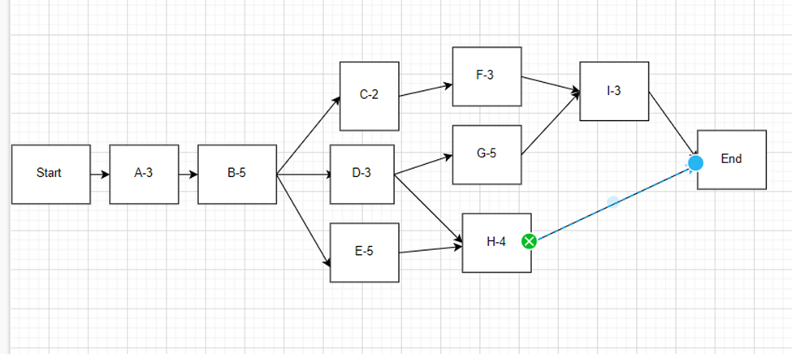

PATH 1 A -> B -> C-> F -> I ->END 3+5+2+3+3 = TOTAL 16 WEEKS

PATH 2 A->B->D->G->I->END 3+5+3+5+3 TOTAL 19 WEEKS

PATH 3 A->B->D->H->END TOTAL 15 WEEKS

PATH 4 A->B->E->H->END TOTAL 17 WEEKS

-> CRITICAL PATH IS PATH 2 AND MINIMUM DURATION TO COPLETE THE DELIVERABLES ARE 19 WEEKS

SOLUTION : WE WILL APPLY THE CRASHING METHOD TO SHORTEN THE DURATION IN CRITICAL PATH

.RECUIRT MORE EMPLOYEES TO HELP THE PROJECT TO COMPLETE TASK G EARLIER THAN 3 WEEKS

.FORCE TEAM TO WORK ON OVERTIME ON TASK G TO COMPLETE IT EARLIER THAN 3 WEEKS

EXPLAIN THEM : IF YOU WANT TO SHORTEN THE PROJECT TIME BY 3 WEEKS, WE NEED TO SHORTEN THE TIME OF A TASK IN THE CRITICAL PATH, BUT 8 WEEKS HAVE PASSED ( THE END OF TASK A,B AND PROJECT HAVE BEEN IN TASK D) SO WE HAVE ANOTHER WAY TO CUT THE TIME IN TASK G OR I. THE APPROPRIATE CHOICE IS LEFT WITHIN TASK G WITH DURATION OF 5 WEEKS SO AS WITH THE DURATION OF 5 WEEKS AND IT SHOULD BE CONCENTRATED FOR CUTTING THE OVERTIME IN A TASK WITH DURAITION OF 3 WEEKS