1.

Stakeholder description

Product Owner : Providing all the resources and approve the Project charter. PO works with stakeholders such as customers, business owners, development departments, etc. to ensure that the product meets the needs and creates value for the company with the specified goals. PO plays a role like a customer in the team.

Project manager: Internal stakeholder, planning and organizing, managing tasks, budgeting, controlling costs and other factors. Everything they do helps make sure the project can be completed on time and on budget, and more importantly, profitable.

BA: bridges the gap between external stakeholders and the development team, interpreting business requirements into understandable development tasks to match a final software product with the expected business value

Developer team : internal stakeholder , He writes, debugs and executes the source code of a software application.

Designer team : internal stakeholder A UI/UX designer’s job is to create user-friendly interfaces that enable users to understand how to use complex technical products

Tester team : Internal stakeholder. The role of a tester is to test out products for bug and provide reports to the project teams about any issues or improvements that the product may require

Project sponsor : primary shareholders that keep companies financially viable and make projects possible by [providing funds](https://www.masterclass.com/articles/how-to-fund-your-small-business). They can also directly impact project when they are dissatisfied with its [business plan](https://www.masterclass.com/articles/what-is-a-business-plan-learn-how-to-write-a-business-plan-in-8-steps)

Customer : external stakeholder who experience the software and they give unbiased reviews

RACI Chart

|  |  |  |  |  |  |  |  |  |  |
| --- | --- | --- | --- | --- | --- | --- | --- | --- | --- |
|  | Task | PM- Project manager | BA – Business analysist | Designer  Team | Developer  Team | Tester  Team | Product Owner | Project sponsor | Customer |
| Phase 1 initiation phase | Create project charter | R | C | C | C | I | A | C | I |
| Phase 2  Planning | Create time management plan | R | C | C | C | I | A | I | I |
|  | Create risk management plan | R | C | C | C | I | A | I | I |
| Phase 3 Executing | Implement coding | A | C | C | R | C | I | I | I |
|  | Perform testing | A | I | I | C | R | I | I | I |
|  | Collect feedback | R | I | I | I | I | R/A | I | C |

Task 2 - Để ý cách chia ID khi vào dạng WBS , chia level 3-4

*cách 1 – waterfall truyền thống

1. Software Project Defect tracking system (level 1)
   1. **Phase 1: Initiating (level 2)** 
      1. Create Project Charter (level 3)
         1. Solidifying the project scope (in-scope item, out of scope item , ( level 4 )
         2. Write down the project scope statement
         3. Determine resources needed  (level 4 )
      2. Define project SMART goal and deliverables (level 4)
      3. Kick-off meeting (level 3)
      4. Get project charter approval (level 3)
      5. Perform a cost - benefit analysis for the project- - level 3
      6. Create stakeholder Register (level 3)
   2. **Phase 2: Planning (level 2)** 
      1. Create Project management plan ( level 3 )
         1. Create Scope Management Plan (level 4)
         2. Create Time Management Plan (level 4)
         3. Create Cost Management Plan (level 4)
         4. Create Risk Management Plan (level 4)
         5. Create Resource Management Plan (level 3)
      2. Meeting with team to discuss about plans (level 3)
      3. Deliver Project Management Plan (level 3)
   3. **Phase 3 Executing (level 2)**
      1. Analysis (level 3)
         1. Create Feasibility Report (level 4)
         2. Create Use-case diagram and use-case description (level 4)
         3. Create Software Requirement Specification (level 4)
         4. Perform Requirement validation (level 4)
         5. Perform Requirement management (level 4)
      2. Design (level 3)
         1. Create High level design (level 4)
         2. Create Low level design (level 4)
      3. Prototyping (level 3)
         1. Create prototype for module 1 (level 4)
         2. Review prototype for module 1 with customer (level 4)
         3. Create prototype for module 2 (level 4)
         4. Review prototype for module 2 with customer (level 4)
         5. Create prototype for module 3 (level 4)
         6. Review prototype for module 3 with customer (level 4)
      4. Implementing (level 3)
         1. Implement coding for module 1 (level 4)
         2. Implement coding for module 2 (level 4)
         3. Implement coding for module 3 (level 4)
      5. Testing (level 3)
         1. Perform unit testing (level 4)
         2. Perform integration testing (level 4)
         3. Perform system testing (level 4)
         4. Perform acceptance testing (level 4)
      6. Support (level 3)
         1. Training (level 4)
         2. Documentation (level 4)
         3. User support (level 4)
         4. Enhancements (level 4)
   4. **Phase 4: Monitoring and Controlling (level 2)**
      1. Control scope (level 3)
      2. Track progress (level 3)
      3. Perform Cost control (level 3)
      4. Monitor and control Risk (level 3)
   5. **Phase 5: Closing (level 2)**

1.5.1 Create Lesson learn (level 3)

* + 1. Create Project Final Report (level 3)
    2. Create Project Archive (level 3)
    3. Hold close Project Ceremony (level 3)

Task 3

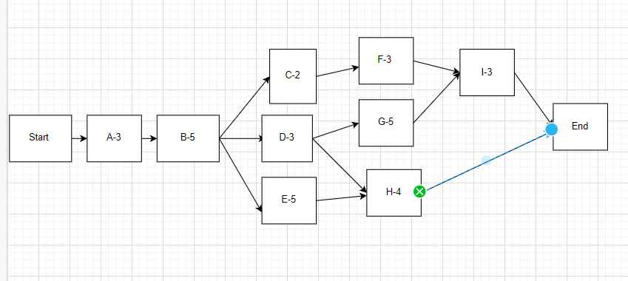

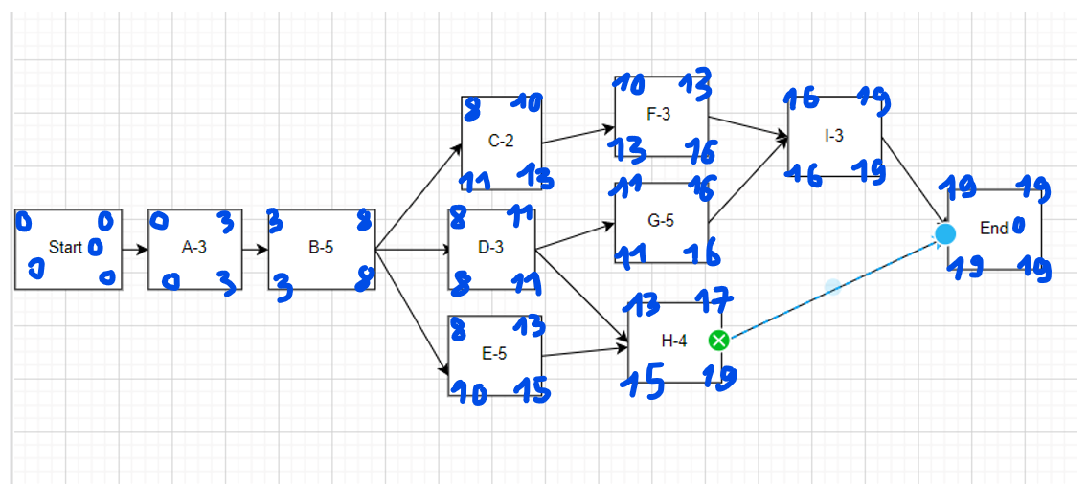

Duration du an – dinh nghia quang thoi gian ngan nhat ma du an day can de hoan thanh tat ca cac dau viec trong du an do

Project duration is the longest path duration

CACH 2 – Critical path method – Critical chain method

Forward pass s->e

Backward e->s

Float do tre = LS – ES = LF - EF

Task co float = 0 -> critical task

Path ma chi toan critical task la critical path

ES : early start

EF early finish

LS: late start

LF late finish

Path 1 A -> B -> C-> F -> I -> End 3+5+2+3+3 = total 16days

Path 2 A->B->D->G->I->End 3+5+3+5+3 total 19 days

Path 3 A->B->D->H->End total 15days

Path 4 A->B->E->H->End total 17 days

-> Critical path is path 2 and minimum duration to complete this deliverables is 19 days

Solution:

we apply the crashing method to shorten the duration in critical path

**fast-tracking method**

Arrange task I so that it overlaps task G. After task G had started for 2 days, then task I will start . This may increase risk, so that require more attention to communication

**Crashing method: -> will increase cost**

Solution 1 - Recruit more people to join project to complete task G earlier than 3 days

Solution 2 Force team to work overtime on task G to complete it earlier than 3 days

Explanation:

If you want to shorten the project time by 3 days, you need to shorten the time of a task on the critical path, but now 8 days have passed (the end of time for task A, task B and project have been in task D ) so we have a way to shorten the time in tasks G or I. The appropriate choice is left with task G with duration of 5 days because a task with a duration of 5 days should be prioritized to shorten the time over a task with a duration of 3 days

Task 4 *chỉ cần ghi 2 cái

|  |  |  |
| --- | --- | --- |
| Risk | Possibility | Mitigation Plan |
| The team lack the required skills for website testing | HIGH | Plan training course to skill up your member |
| Wrong budget estimate and cost overruns | EXTREAM | Establish the scope before beginning work, pay a lot of attention to project planning and constantly track and measure the progress |
| The project schedule is too tight; it’s hard to complete this project on time | HIGH | Set Test priority for each of the test activity |
| Test manager has poor management skill | MODERATE | Plan leadership training for manager |
| A lack of cooperation negatively affects your employees productivity | MODERATE | Encourage each team member in his task, and inspire them to greater efforts |

Request 2 đề 1 : Define Scope statement for this project

Project in-scope item : our team will develop an website - Job board system for people who need to apply for jobs and companies have recruitment needs. . This website will have the homepage with post controller related function for recruiter and recruitment manager, job management feature for candidate , a dashboard for administrator with user management feature, job category management feature, authorization management feature

Project deliverables : project schedule , project charter ,project management plan (scope, time, quality, resource, communication, risks, stakeholder, procurement ) test plan, code package for module 1-2-3, meeting minutes, project final report

Out of scope item : This project will not include payment to external vendors

Acceptance criteria : there should be no defects that prevent customer from using three main functionality. Visually and functionally, the site should look and perform as described in Specifications and designs

Request 2 Defect tracking system – Agile SCRUM

**Cách 2 - Agile Scrum**

**Defect tracking system - level 1**

1. Project Initiation – level 2

1.1 Define project scope and objectives – level 3

1.2 Identify stakeholders and their requirements– level 3

1.3 Create project charter– level 3

1.4 Define project team roles and responsibilities– level 3

1.5 Conduct project kickoff meeting– level 3

2. Sprint 0: Planning and Setup– level 2

2.2 Create product backlog and prioritize features– level 3

2.3 Define sprint cycles and timelines– level 3

2.4 Set up development environment and tools– level 3

2.5 Define Definition of Done (DoD) – level 3

2.6 Develop release plan– level 3

3. Sprint 1– level 2

3.1 Sprint planning meeting– level 3

3.2 Develop user stories for sprint – level 3

3.3 Define sprint backlog and tasks– level 3

3.4 Develop software architecture and design– level 3

3.5 Implement core functionalities of DTS– level 3

3.6 Conduct daily scrum meetings– level 3

3.7 Test and validate sprint deliverables– level 3

3.8 Conduct sprint review and retrospective– level 3

4. Sprint 2– level 2

4.1 Sprint planning meeting– level 3

4.2 Develop user stories for sprint– level 3

4.3 Define sprint backlog and tasks– level 3

4.4 Implement additional functionalities of DTS– level 3

4.5 Conduct daily scrum meetings– level 3

4.6 Test and validate sprint deliverables– level 3

4.7 Conduct sprint review and retrospective– level 3

5. Sprint 3– level 2

5.1 Sprint planning meeting– level 3

5.2 Develop user stories for sprint– level 3

5.3 Define sprint backlog and tasks– level 3

5.4 Implement remaining functionalities of DTS– level 3

5.5 Conduct daily scrum meetings– level 3

5.6 Test and validate sprint deliverables– level 3

5.7 Conduct sprint review and retrospective– level 3

6. Sprint 4: Release and Deployment– level 2

6.1 Conduct final sprint planning meeting– level 3

6.2 Test and validate final release– level 3

6.3 Conduct final sprint review and retrospective– level 3

6.4 Deploy DTS to production environment– level 3

6.5 Conduct post-release testing and monitoring– level 3

6.6 Close out project– level 3