電通二乙微處理器實驗 實驗結報

實驗名稱 | Arduino-Lab01
組別 | 11 | 組員 | 謝祥郁

- 實驗目的
使用Tinkercad模擬Arduino UNO電路及程式
繪製電路圖
觀察Arduino Uno之輸出
學習將程式碼及實驗報告上傳至Github

- 實驗步驟
填寫分組表單
啟動Arduino IDE,載入Blink程式碼
至www.tinkercad.com註冊帳號,啟動Arduino模擬器
接上LED電路
修改程式,將LED輸出改為Pin9
觀察LED之閃爍間隔
修改程式,使LED閃爍間格分別增加為2倍及1/2倍,重新量測並結圖
畫出電路圖

- 程式碼
int LED = 13;
// the setup function runs once when you press reset or power the board
void setup() {
// initialize digital pin LED_BUILTIN as an output.
pinMode(LED, OUTPUT);
}

// the loop function runs over and over again forever
void loop() {
digitalWrite(LED, HIGH); // turn the LED on (HIGH is the voltage level)
delay(1000); // wait for a second
digitalWrite(LED_BUILTIN, LOW); // turn the LED off by making the voltage LOW
delay(1000); // wait for a second
}
- 實驗結果及分析
觀察LED的閃爍,在修改數值後,觀察LED閃爍間隔時間

- 心得討論

這次實驗還不錯玩,以後可以會去練練預習實驗的東西
- 修正電路圖

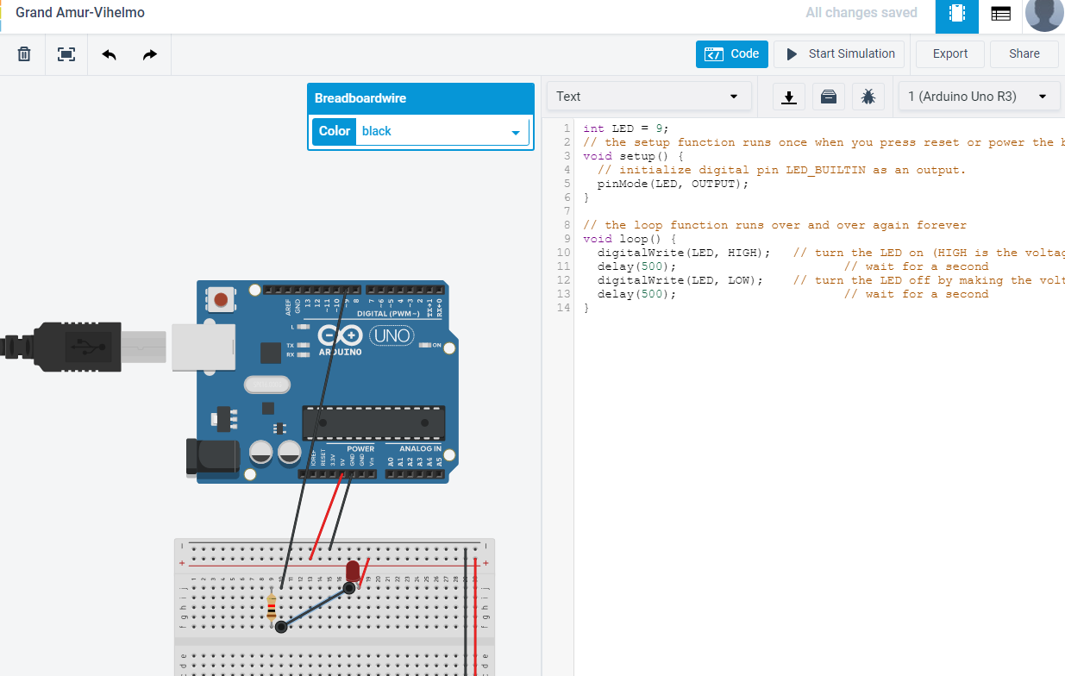
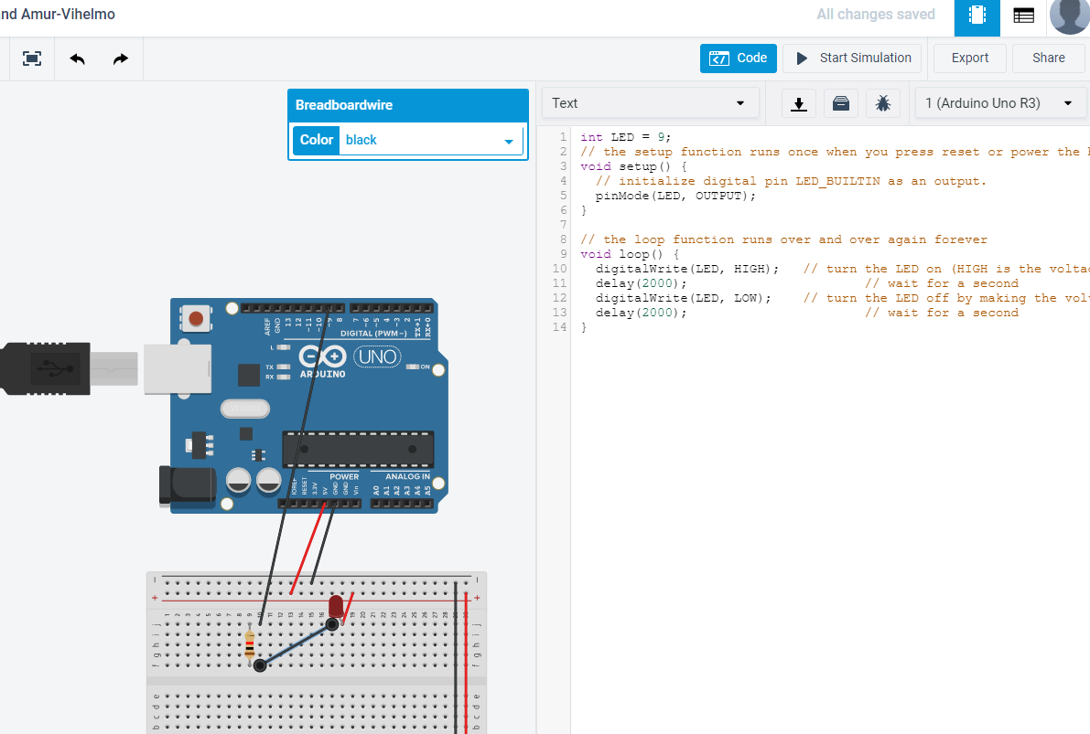
修正程式碼
int LED = 9;
// the setup function runs once when you press reset or power the board
void setup() {
// initialize digital pin LED_BUILTIN as an output.
pinMode(LED, OUTPUT);
}

// the loop function runs over and over again forever
void loop() {
digitalWrite(LED, HIGH); // turn the LED on (HIGH is the voltage level)
delay(500); // wait for a second
digitalWrite(LED, LOW); // turn the LED off by making the voltage LOW
delay(500); // wait for a second
}

int LED = 9;
// the setup function runs once when you press reset or power the board
void setup() {
// initialize digital pin LED_BUILTIN as an output.
pinMode(LED, OUTPUT);
}

// the loop function runs over and over again forever
void loop() {
digitalWrite(LED, HIGH); // turn the LED on (HIGH is the voltage level)
delay(2000); // wait for a second
digitalWrite(LED, LOW); // turn the LED off by making the voltage LOW
delay(2000); // wait for a second
}

