DSP mid-term exam. Class:__電通三甲______, Student ID:______01050435___, Name:___闕源均______

- (a) Determine whether the system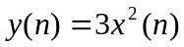is linear.
(b) Determine whether the system 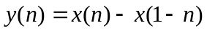is time-invariant.

- Given x(n)={1, 2, 3, 4, 5}, h(n)={6, 7, 8, 9}, (a) calculate and (b) plot the convolution y(n)=x(n)*h(n) using the conv_m function
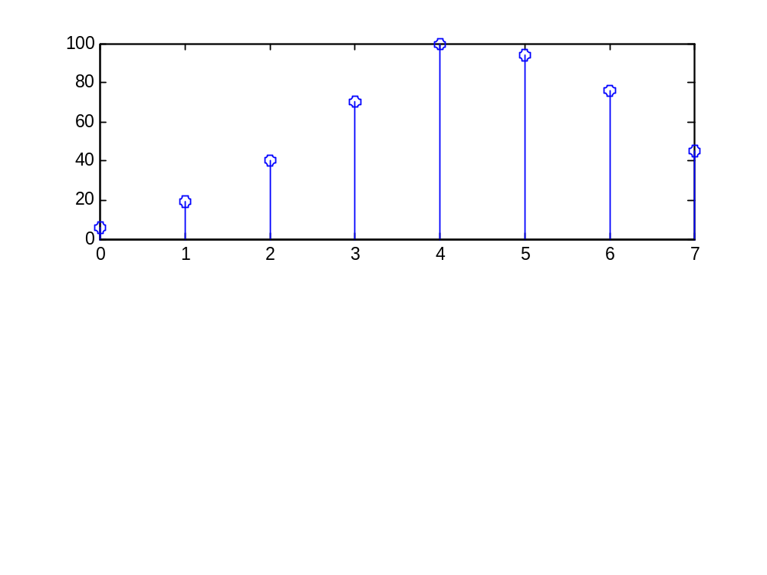
close all; clear all;
n1=0:4;
x=[1 2 3 4 5];
n2=0:3;
h=[6 7 8 9];
[y,ny]=conv_m(x,n1,h,n2);
subplot(2,1,1);
stem(ny,y);

3. (a) Determine the DTFT of the sequence x(n)={1, 2, 3, 4, 5}by hand.
(b) Plot the magnitude, angle, real, and imaginary parts of 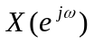at 501 equispaced points between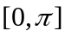.
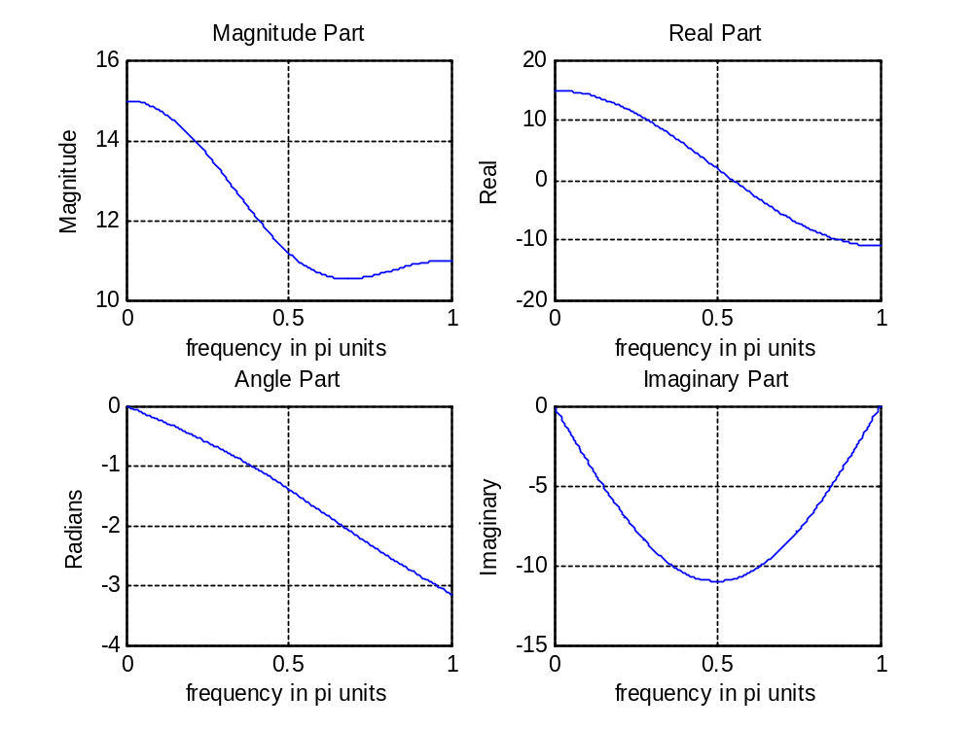

close all; clear all;
w = [0:1:500]*pi/500;
X = exp(j*w) +2 +3*exp(-j*w) +4*exp(-j*w) +5*exp(-j*w)
magX = abs(X); angX = angle(X);realX = real(X);imagX = imag(X);
subplot(2,2,1); plot(w/pi,magX); grid
xlabel('frequency in pi units'); title('Magnitude Part'); ylabel('Magnitude')
subplot(2,2,3); plot(w/pi,angX); grid
xlabel(' frequency in pi units '); title('Angle Part'); ylabel('Radians')
subplot(2,2,2); plot(w/pi,realX); grid
xlabel(' frequency in pi units '); title('Real Part'); ylabel('Real')
subplot(2,2,4); plot(w/pi,imagX); grid
xlabel(' frequency in pi units '); title('Imaginary Part'); ylabel('Imaginary')

4. Using the inverse DTFT, determine the sequences x(n) corresponding to the following DTFTs:
(a)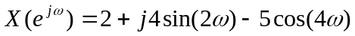
(b) 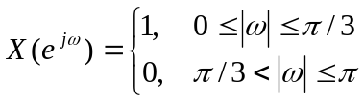

5. An LTI system is specified by the difference equation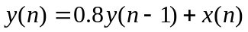
- Determine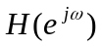.
- If the input is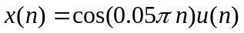, plot the output y(n), n=0, 1, …, 100

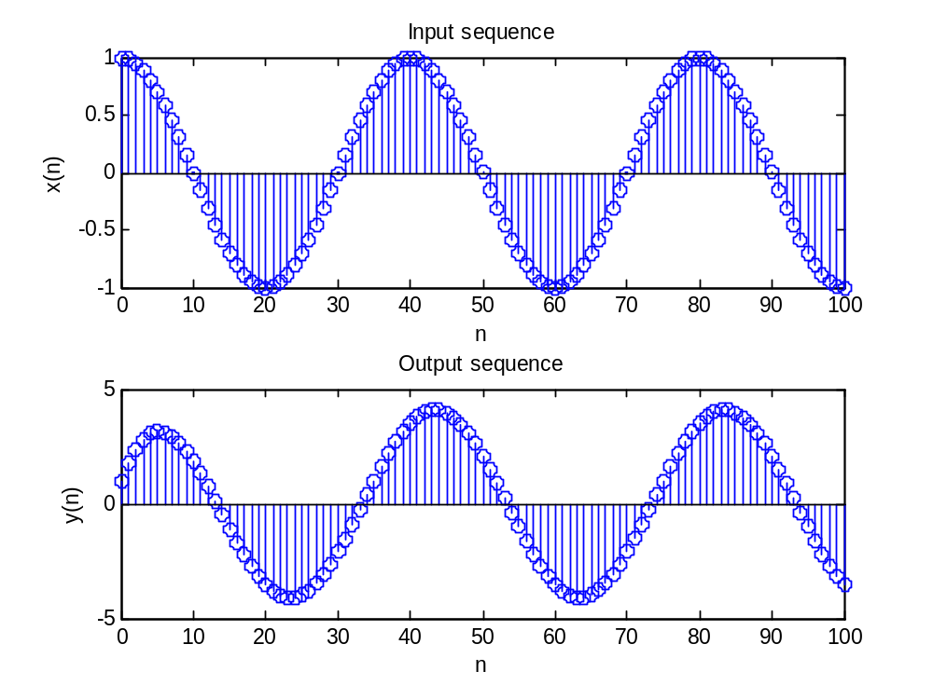

6. Consider an analog signal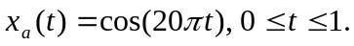It is sampled at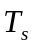= 0.05 sec to obtain x(n).
(a) plot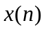using the stem function
B Reconstruct the analog signal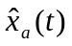from the samplesusing the (i) ZOH, (ii) FOH, and (iii) cubic spline function. Superimpose these plots on the plots of x(n).

Ts = 0.05; n = -25:1:25; nTs = n*Ts;
x = cos(20*pi*nTs);
subplot(2,1,1); stairs(nTs*0.05,x);
Xlabel('t in msec'); ylabel('xa(t)')
title('Reconstructed Signal from x1(n) using ZOH'); hold on
stem(n*Ts*0.05,x); hold off
%
subplot(2,1,2); plot(nTs*0.05,x);
xlabel('t in msec '); ylabel('xa(t)')
title(' Reconstructed Signal from x1(n) using FOH '); hold on
stem(n*Ts*0.05,x); hold off

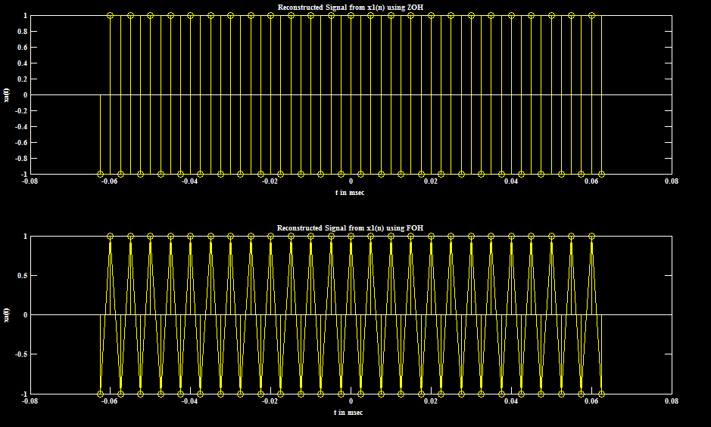

7. Determine the z-transform of the following sequences. Indicate the ROC for each sequence.
- x(n)={3, 2, 1, -2, -3}

- 