DSP mid-term exam. Class:__電通三乙__, Student ID:_02050311_, Name:__鄭若涓__

- (a) Determine whether the system y(n)=x(2n) is linear.
(b) Determine whether the system 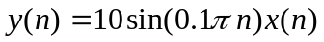is time-invariant.

- Given x(n)={1, 2, 3, 4, 5}, h(n)={6, 7, 8, 9}, (a) calculate and (b) plot the convolution y(n)=x(n)*h(n) using the conv_m function

close all;
clear all;

x = [1,2,3,4,5];
h = [6,7,8,9];
n1 = -2:2;
n2 = -1:2;
[y,ny] = conv_m(x,n1,h,n2);

stem(ny,y);

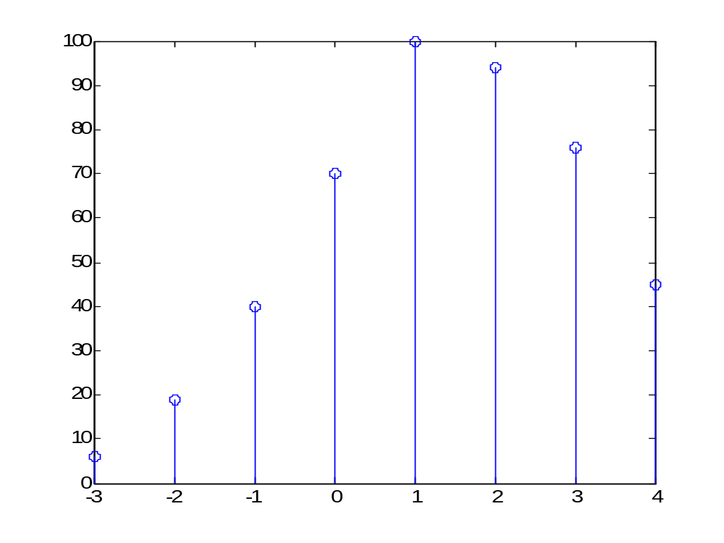

3. (a) Determine the DTFT of the sequence 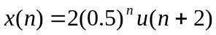by hand.
(b) Plot the magnitude and angle of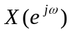over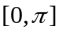.

close all;
clear all;

d= pi/500;
w=0:d:pi;
H=(8*exp(j*2*w)./1-0.5*exp(-j*w));
magH = abs(H);
angH = angle(H);

subplot(2,1,1);
plot(w/pi,magH);
grid;
xlabel(' frequency in pi units ');
ylabel('|H|');
title('Magnitude Response');

subplot(2,1,2);
plot(w/pi,angH/pi);
grid;
xlabel(' frequency in pi units ');
ylabel('Phase in pi Radians');
title('Phase Response');
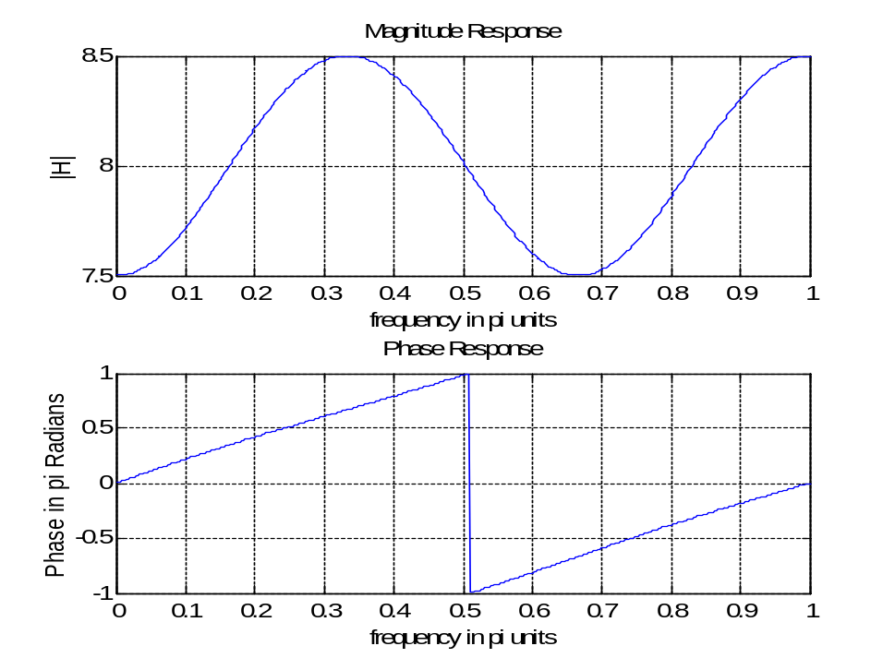

4. Using the inverse DTFT, determine the sequences x(n) corresponding to the following DTFTs:
(a)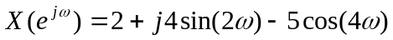
(b) 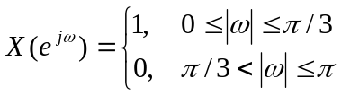

5. An LTI system is specified by the difference equation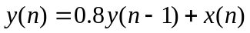
- Determine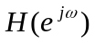.
- If the input is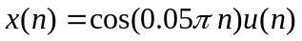, plot the output y(n), n=0, 1, …, 100

close all;
clear all;

b = 1;
a = [1,-0.8];
n=[0:100];
x = cos(0.05*pi*n);
y = filter(b,a,x);

subplot(2,1,1);
stem(n,x);
xlabel('n');
ylabel('x(n)');
title('Input sequence');

subplot(2,1,2);
stem(n,y);
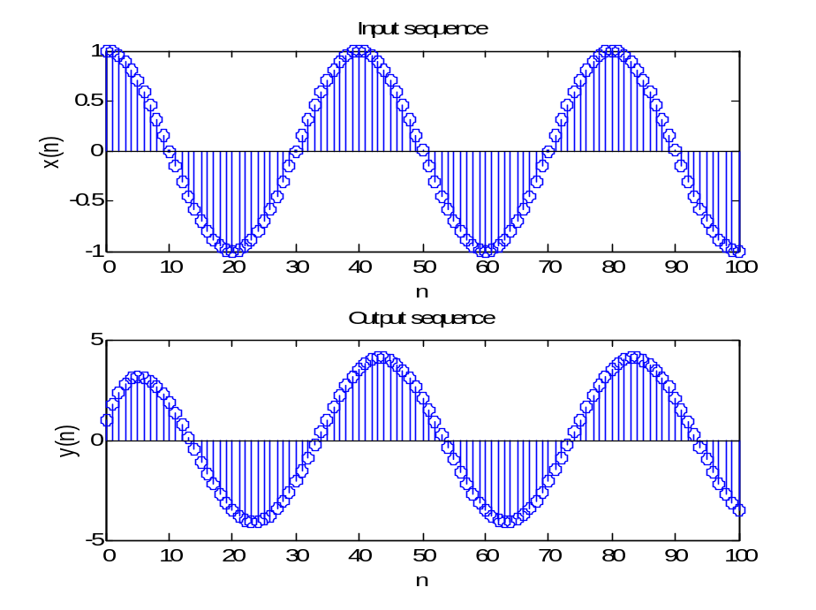
xlabel('n');
ylabel('y(n)');
title('Output sequence');

- Consider an analog signal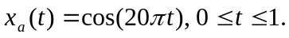It is sampled at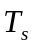= 0.01 sec to obtain x(n).
  - plot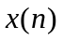using the stem function

clear all;
close all;

Ts = 0.01;
Fs = 1/Ts;
n = -25:1:25;
nTs = n*Ts;
x = exp(-1000*abs(nTs));
Dt = 0.00005;
t = -0.005:Dt:0.005;
xa = x * sinc(Fs*(ones(length(nTs),1)*t-nTs'*ones(1,length(t))));
error = max(abs(xa - exp(-1000*abs(t))));

subplot(1,1,1);
plot(t*1000,xa);
xlabel('t in msec');
ylabel('xa(t)')
title('Reconstructed Signal from x1(n) using sinc function');
hold on;
stem(n*Ts*1000,x);
hold off;

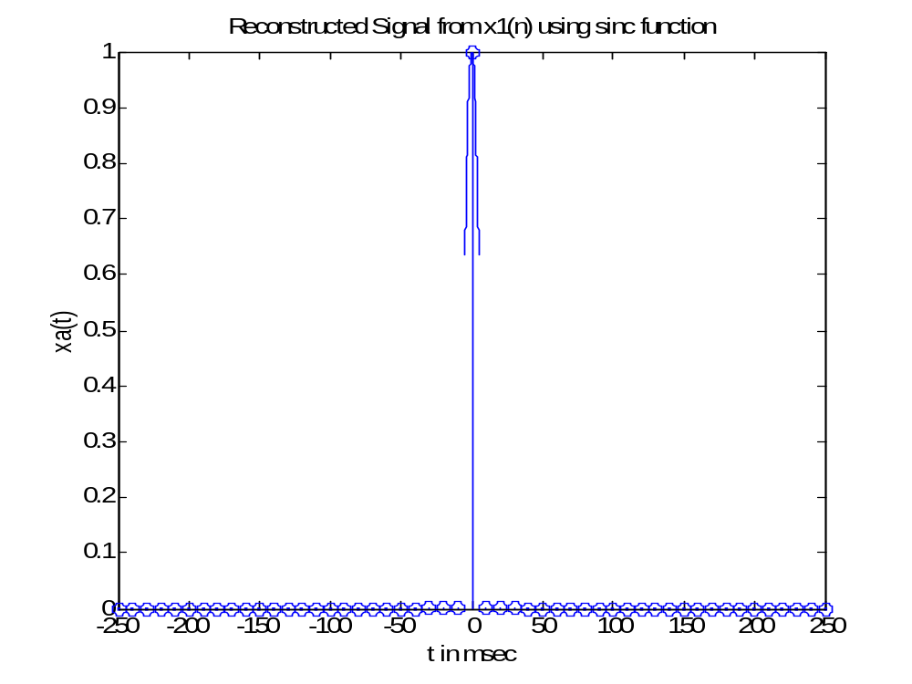
  - Reconstruct the analog signal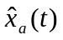from the samplesusing the (i) ZOH, (ii) FOH, and (iii) cubic spline function. Superimpose these plots on the plots of x(n).

clear all;
close all;

Ts = 0.01;
n = -25:1:25;
nTs = n*Ts;
x = exp(-1000*abs(nTs));

subplot(2,1,1);
stairs(nTs*1000,x);
Xlabel('t in msec');
ylabel('xa(t)');
title('Reconstructed Signal from x(n) using ZOH');
hold on;
stem(n*Ts*1000,x);
hold off;

subplot(2,1,2);
plot(nTs*1000,x);
xlabel('t in msec ');
ylabel('xa(t)');
title('Reconstructed Signal from x(n) using FOH');
hold on;
stem(n*Ts*1000,x);
hold off;
