DSP quiz1 Class:_電通三甲___, Student ID:__05051035_, Name:_謝應鋒________

1. Generate and plot the following sequences over the indicated interval.

(a) x(n)=3δ(n+2)+2δ(n)-δ(n-3)+5δ(n-7), 

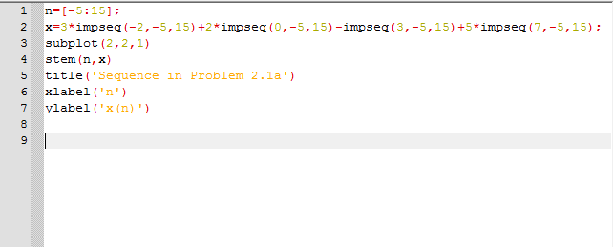

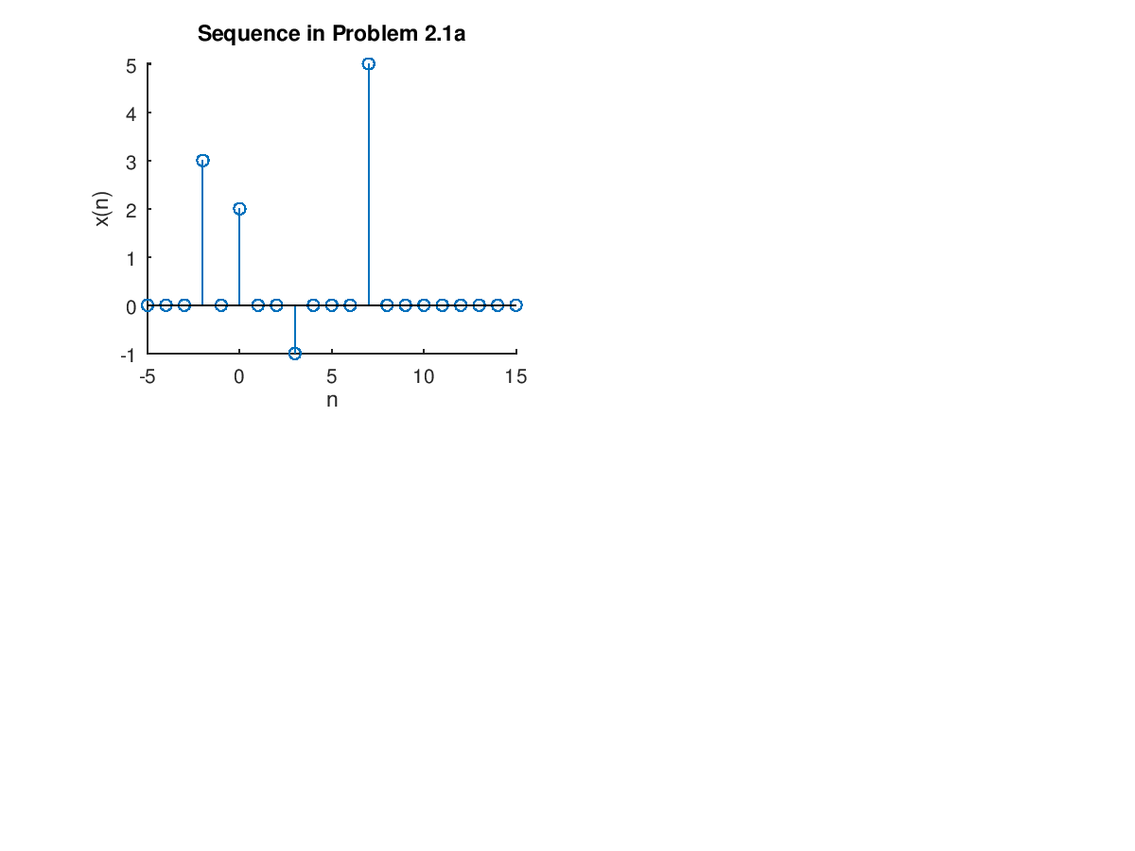

(b) 

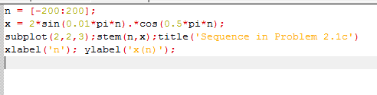

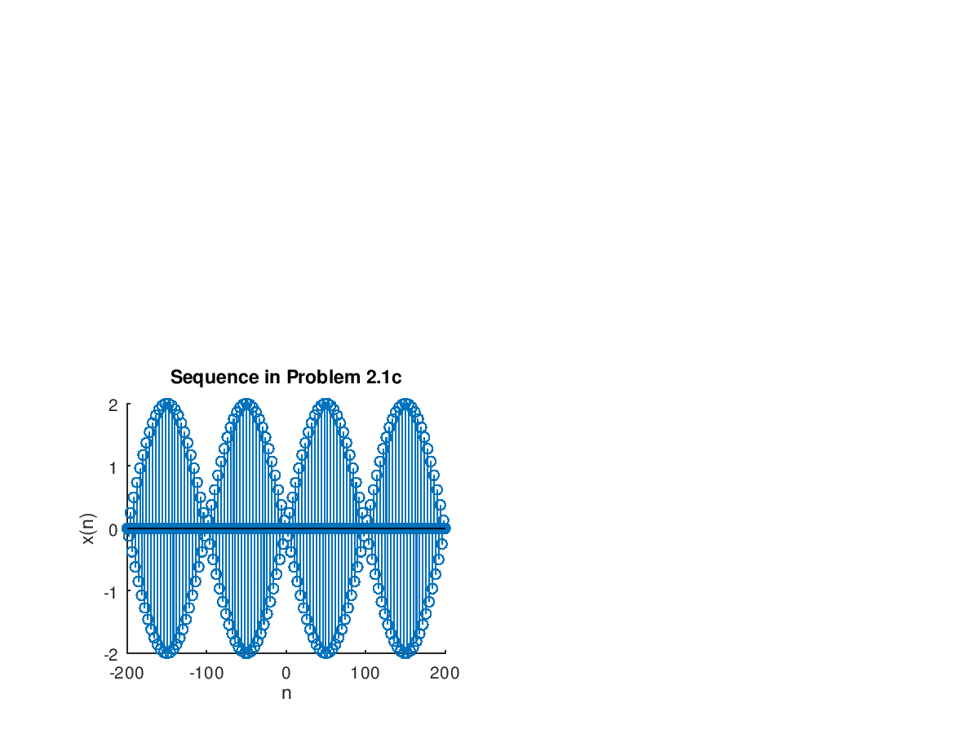

1. Let *x*(*n*)= {2, 4, -3, 1, -5, 4, 7}. Generate and plot the samples (use the stem function) of the sequence: *y*(*n*)=2*x*(*n*-3)+3*x*(*n*+4)-*x*(*n*) , $-3≤n≤3$

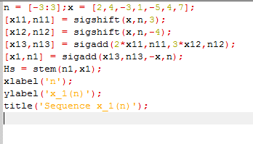

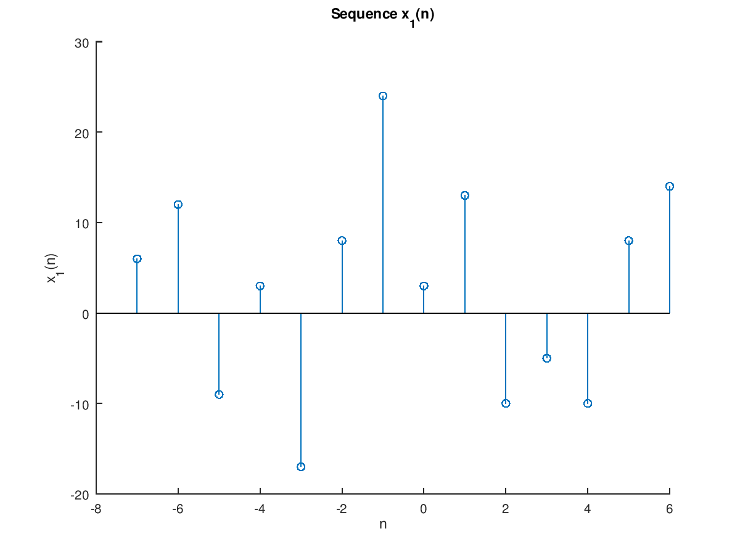

1. (a) Determine whether the following system is linear:

(i), (ii)

(b) Determine whether the following system is time-invariant:

(i), (ii)

4. An LTI system is described by the following difference equation.



* 1. Find and plot the impulse response *h*(*n*) over
  2. Is the system stable?
  3. If the input to this system is determine the response *y*(*n*) over 

5. Let the rectangular pulse *x*(*n*)=*u*(*n*)-*u*(*n*-10) be an input to the LTI system with impulse response. (a) Determine the output *y*(*n*)=*x*(*n*)\**h*(*n*) by hand, and (b) generate the following figure.

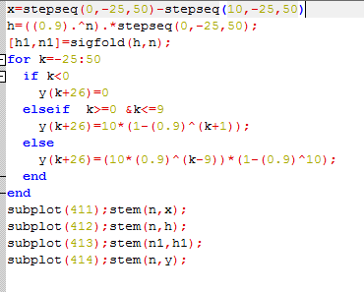

1. Given *x*(*n*)={2, -4, 5, 3, -1, -2, 6} and *h*(*n*)={1, -1, 1, -1, 1}, determine the convolution(a) by using the function conv_m( ), and (b) by hand.

