**2019/2/22**

clear,close all;

n=[-3:4];

x=[2,1,-1,0,1,4,3,7];

stem(n,x,'ro')

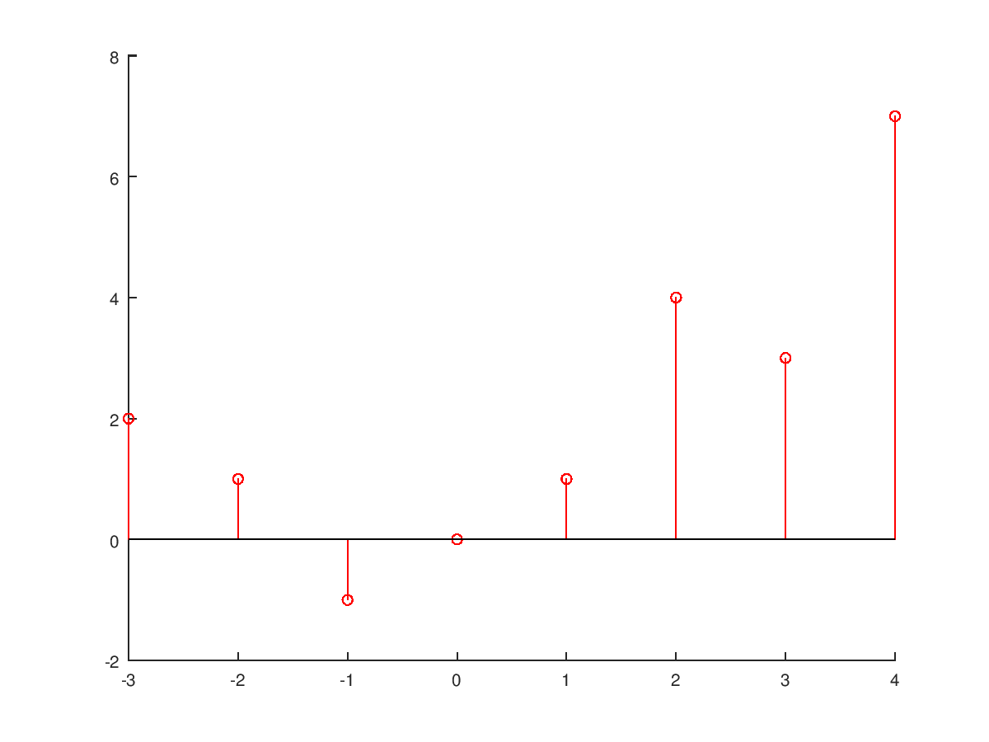

clear,close all;

n0=0;

n1=-3;

n2=3;

n=[n1:n2];

x=zeros(1,n2-n1+1);

x(n0-n1+1)=1;

n=[n1:n2];

x=[(n-n0)==0];

stem(n,x,'ro')

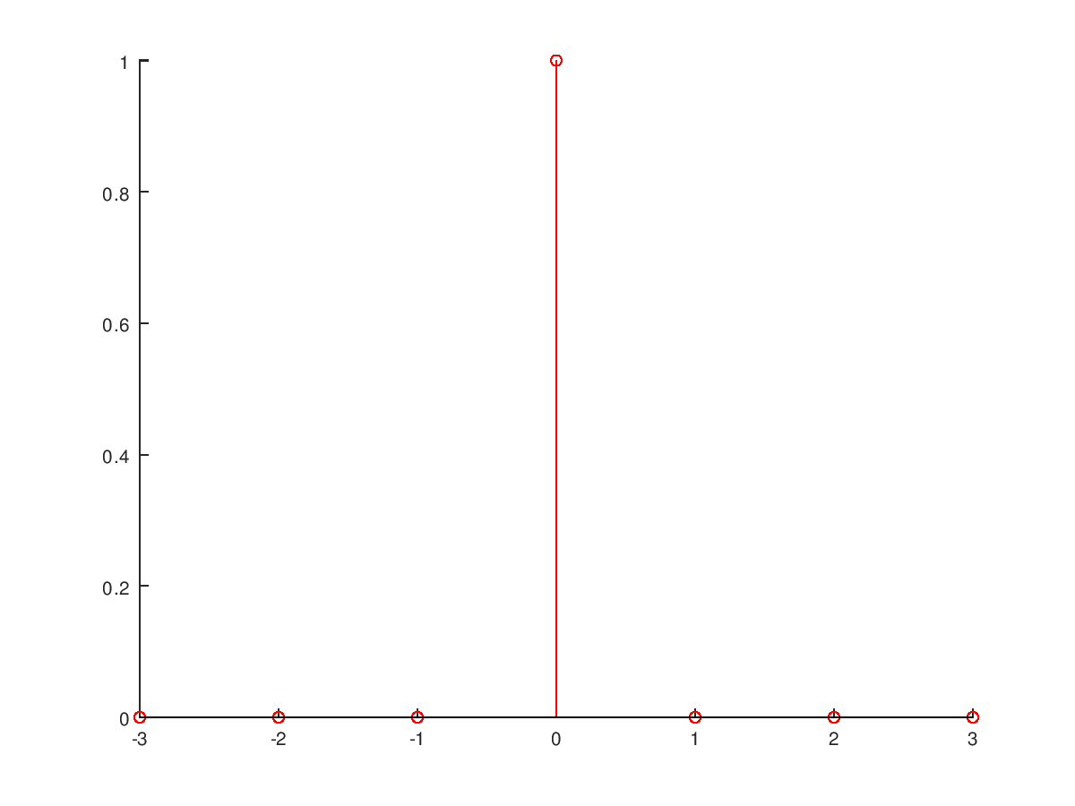

clear,close all;

n0=0;

n1=-3;

n2=3;

n=[n1:n2];

x=zeros(1,n2-n1+1);

x(n0-n1+1:end)=1;

n=[n1:n2];

x=[(n-n0)>=0];

stem(n,x,'ro')

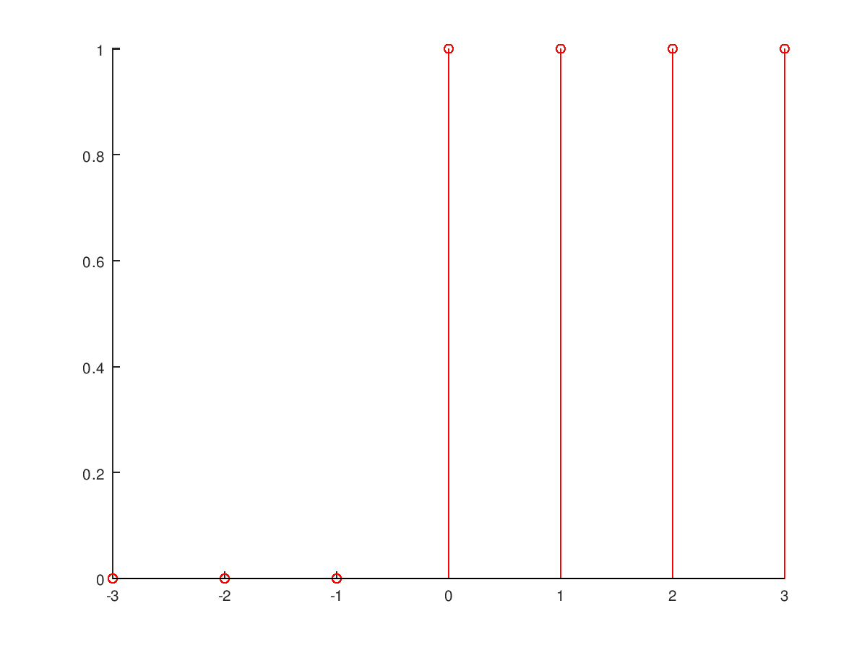

**指數衰減**

n=[0:10];

x=(0.9).^n;

stem(n,x,'ro')

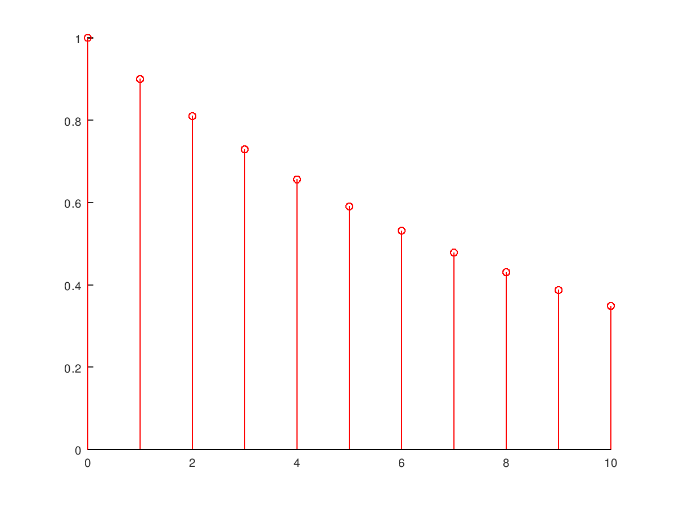

clear,close all;

n=[0:10];

x=real((2+3j)*n);%取實部

% x=imag((2+3j)*n);取虛部

stem(n,x,'ro')

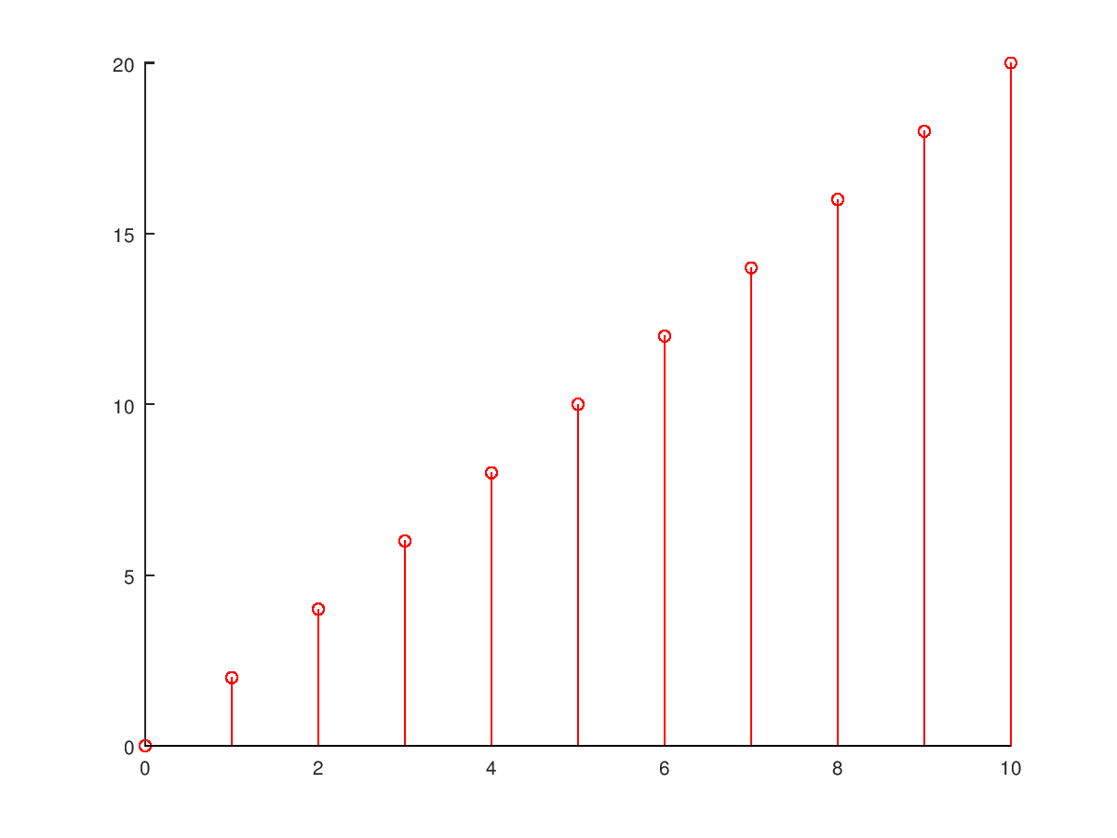

**週期性函數**

clear,close all;

x=[1 2 3];

xtilde=[x];

p=5;

xtilde=x'*ones(1,p);

xtilde=xtilde(:);

xtilde=xtilde';;

stem(xtilde,'ro')

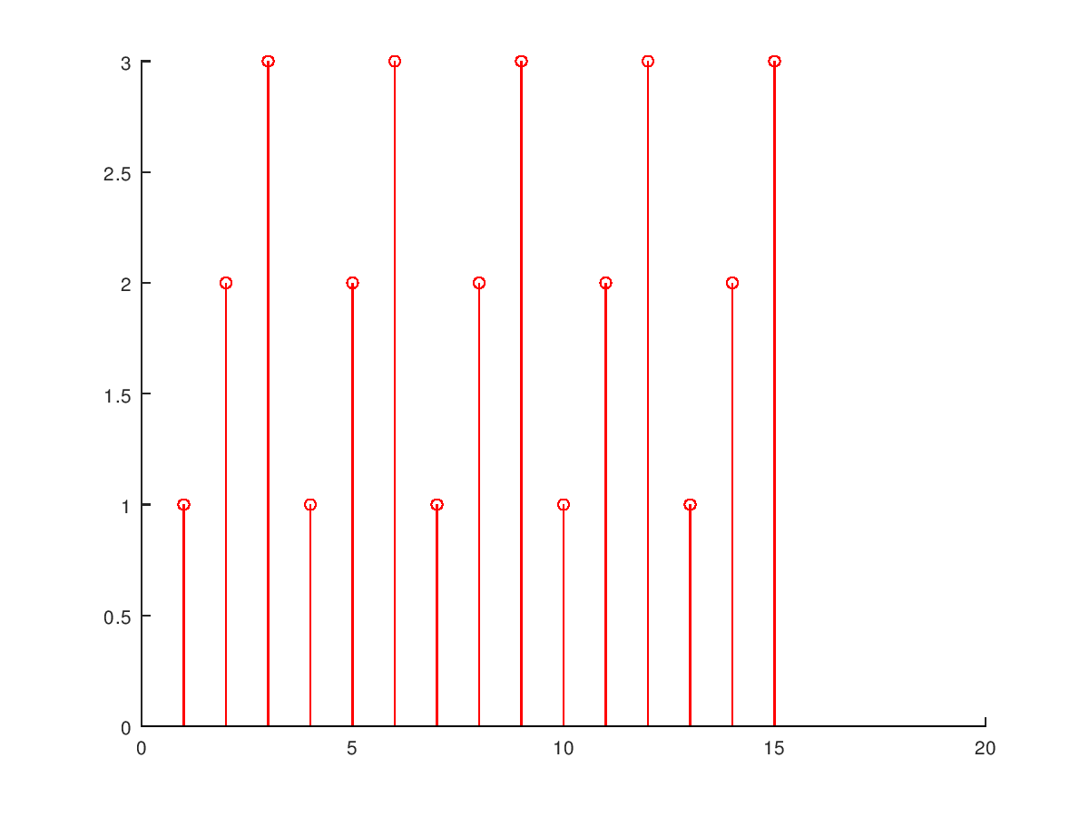

**信號相乘**

Function [y,n]=sigadd(x1,n1,x2,n2)

n=min(min(n1),min(n2)): max(max(n1),max(n2));

y1=zeros(1,length(n)); y2=y1;

y1(find((n>=min(n1)) & (n<=max(n1))==1))=x1;

y2(find((n>=min(n2)) & (n<=max(n2))==1))=x2;

Y=y1 + y2;

**a). x(n)=2*δ(n+2)- δ(n-4). -5<=n<=5**

n=[-5:5];

x=2*impseq(-2,-5,5)-impseq(4,-5,5);

subplot(2,2,1)

stem(n,x)

title('Sequence in Problem 2.1a')

xlabel('n')

ylabel('x(n)')

**b). x(n)=n[u(n)-u(n-10)]+10exp(-0.3(n-10))[u(n-10)-u(n-20)]. 0<=n<=20**

n = [0:20];

x1 = n.*(stepseq(0,0,20)-stepseq(10,0,20));

x2 = 10*exp(-0.3*(n-10)).*(stepseq(10,0,20)-stepseq(20,0,20));

x = x1+x2;

subplot(2,2,2);stem(n,x);

title('Sequence in Problem 2.1b')

xlabel('n'); ylabel('x(n)');

**c). x(n)=cos(0.04πn)+0.2w(n)). 0<=n<=50**

n = [0:50];

x = cos(0.04*pi*n)+0.2*randn(size(n));

subplot(2,2,3);stem(n,x);title('Sequence in Problem 2.1c')

xlabel('n'); ylabel('x(n)');

**d). x(n)=[...,5,4,3,2,1,5,4,3,2,1,5,4,3,2,1...]. -10<=n<=9**

n=[-10:9];

x=[5,4,3,2,1];

xtilde=x' * ones(1,4);

xtilde=(xtilde(:))';

subplot(2,2,4);stem(n,xtilde);title('Sequence in Problem 2.1d')

xlabel('n'); ylabel('xtilde(n)');

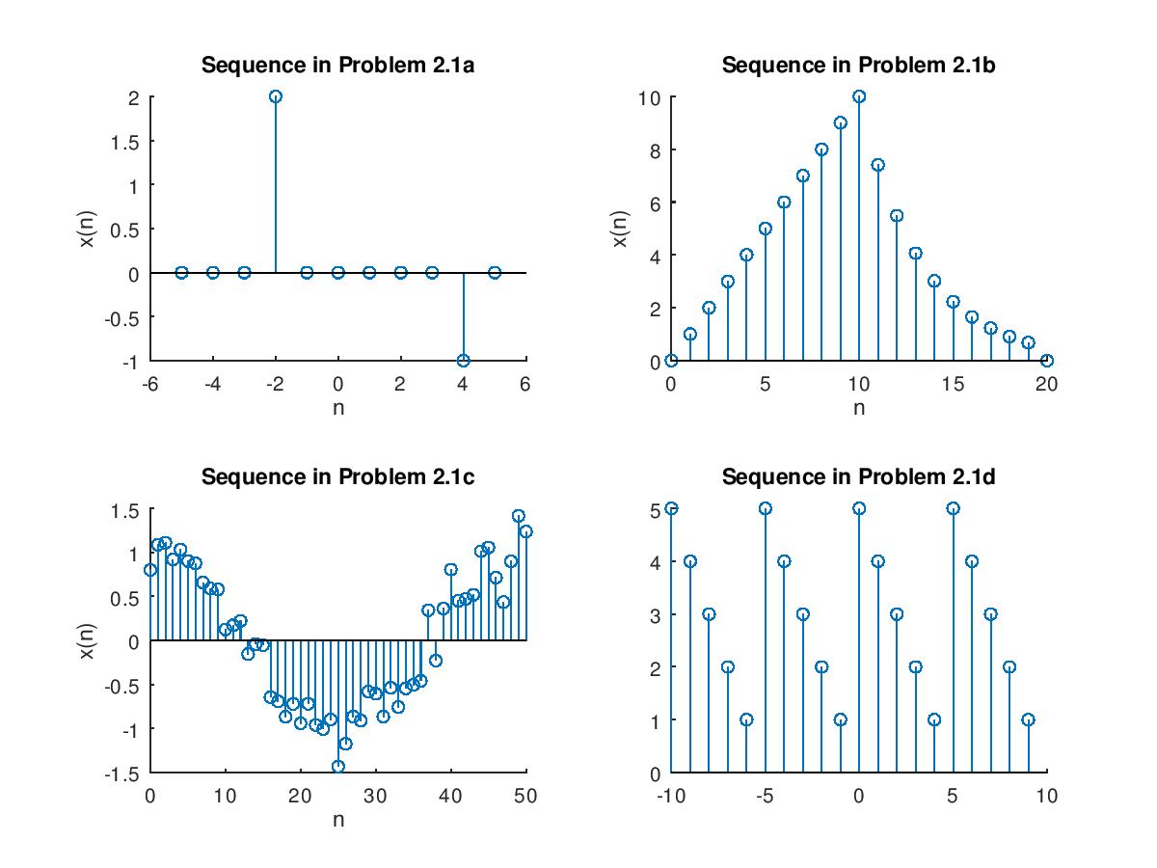

**a) x1(n) = 2x(n-5) - 3x(n+4)**

n = -2:10; x = [1:7,6:-1:1];

[x11,n11] = sigshift(x,n,5); [x12,n12] = sigshift(x,n,-4);

[x1,n1] = sigadd(2*x11,n11,-3*x12,n12);

subplot(2,1,1); stem(n1,x1); title('Sequence in Problem 2.2a')

xlabel('n'); ylabel('x1(n)');

**b) x2(n) = x(3-n) + x(n)x(n-2)**

[x21,n21] = sigfold(x,n); [x21,n21] = sigshift(x21,n21,3);

[x22,n22] = sigshift(x,n,2); [x22,n22] = sigmult(x,n,x22,n22);

[x2,n2] = sigadd(x21,n21,x22,n22);

subplot(2,1,2); stem(n2,x2); title('Sequence in Problem 2.2b')

xlabel('n'); ylabel('x2(n)');

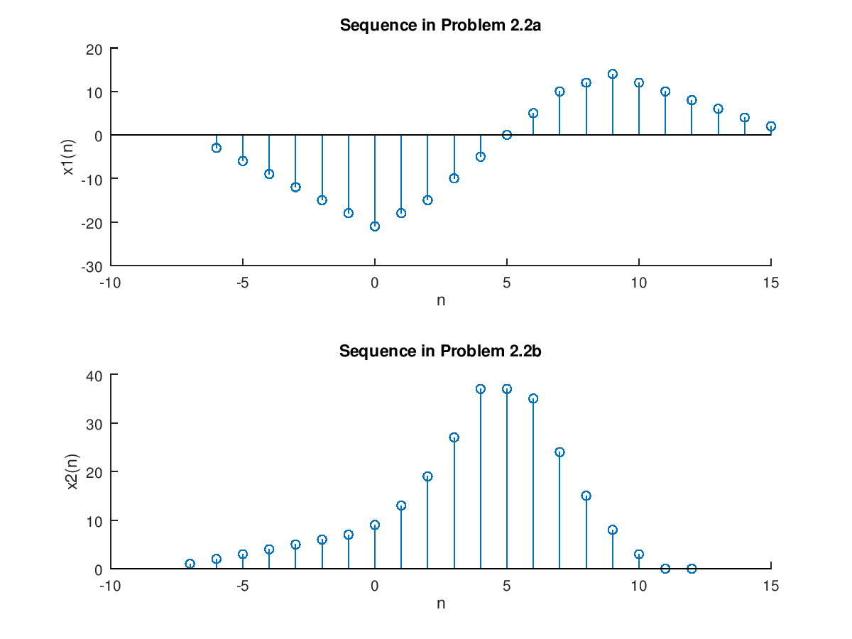

**ex 2.3 Generate the complex-valued signal   
x(n) = exp((-0.1+j0.3)n), -10 <= n <= 10; and plot its magnitude, phase, real part, and imaginary part**

clear,close all;

n = [-10:1:10]; alpha = -0.1+0.3j;

x = exp(alpha*n);

subplot(2,2,1); stem(n,real(x));title('real part'); xlabel('n');

subplot(2,2,2); stem(n,imag(x));title('imaginary part'); xlabel('n');

subplot(2,2,3); stem(n,abs(x));title('magnitude part');xlabel('n');

subplot(2,2,4); stem(n,(180/pi)*angle(x));title('phase part'); xlabel('n');

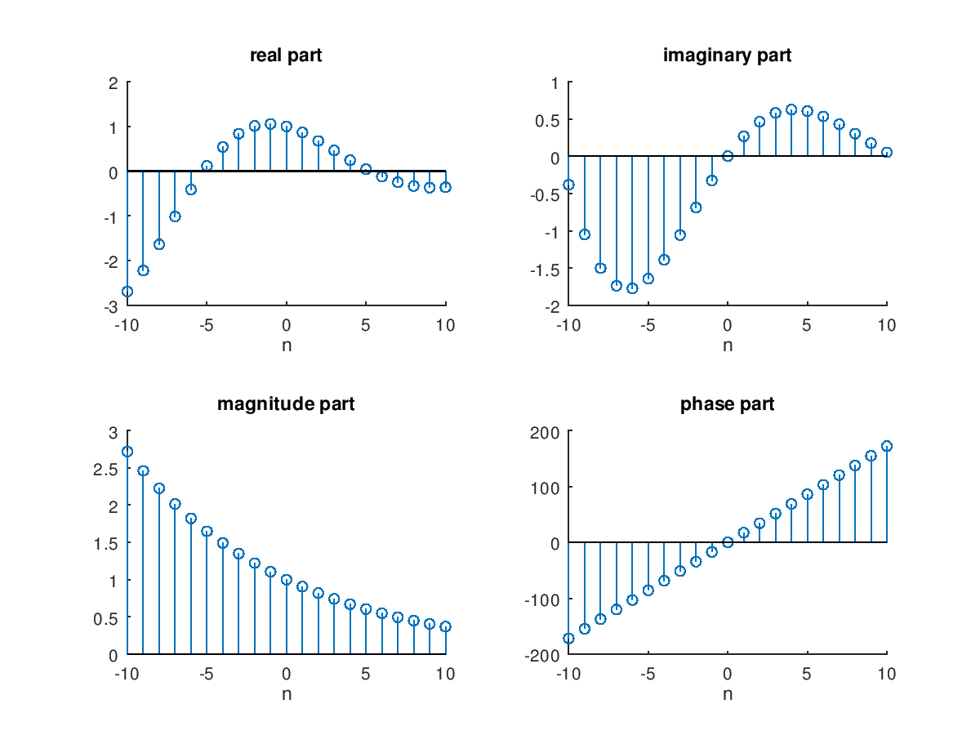

**2019/2/23**

n = [0:10];

x = stepseq(0,0,10)-stepseq(10,0,10);

[xe,xo,m] = evenodd(x,n);

subplot(2,2,1); stem(n,x); title('Rectangular pulse')

xlabel('n'); ylabel('x(n)'); axis([-10,10,0,1.2])

subplot(2,2,2); stem(m,xe); title('Even Part')

xlabel('n'); ylabel('xe(n)'); axis([-10,10,0,1.2])

subplot(2,2,4); stem(m,xo); title('Odd Part')

xlabel('n'); ylabel('xe(n)'); axis([-10,10,-0.6,0.6])

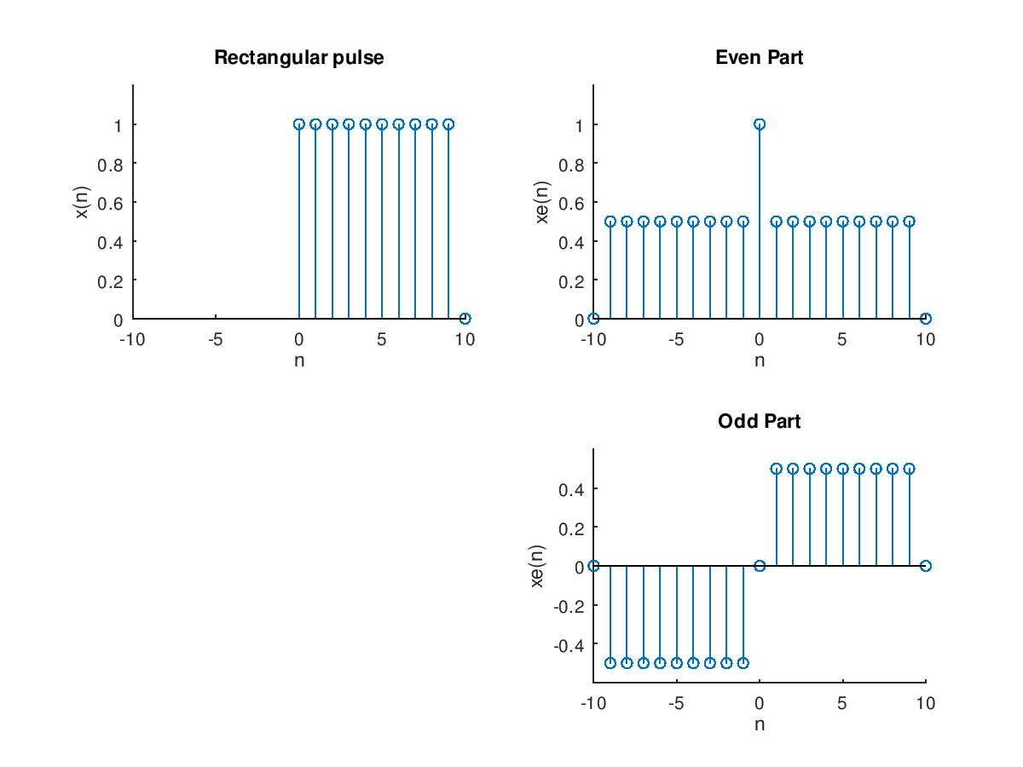

**2.5).x(n)={…,-2,-1,0,1,2,…} plot 5個週期**

clc;close all;

n1 = [-12:12];x1 = [-2,-1,0,1,2];

x1 = x1'*ones(1,5);

x1 = (x1(:))';

Hs = stem(n1,x1,'filled');

set(Hs,'markersize',2);

xlabel('n');

ylabel('x_1(n)');

title('Sequence x_1(n)');

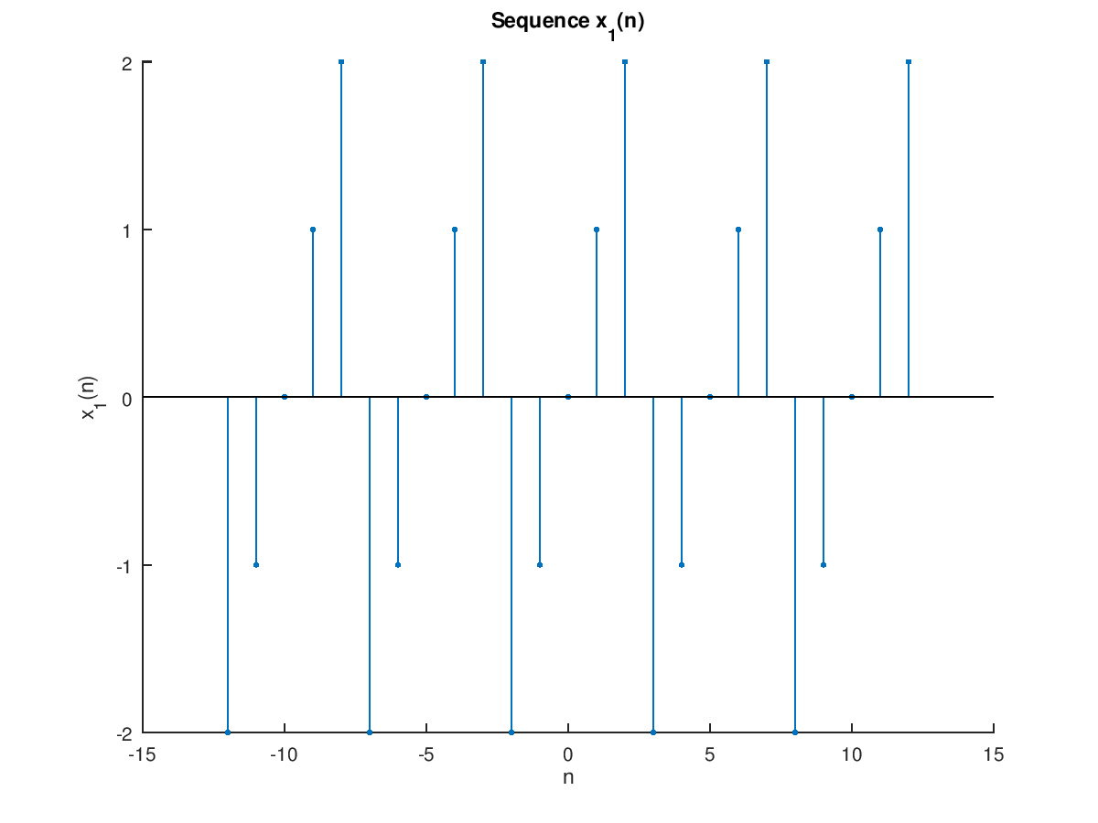

**2.6).x(n)={2,4,-3,1,-5,4,7} plot x,(n)=2x(n-3)+3x(n+4)-x(n)**

clear;clc;close all;

n = [-3:3];x = [2,4,-3,1,-5,4,7];

[x11,n11] = sigshift(x,n,3);

[x12,n12] = sigshift(x,n,-4);

[x13,n13] = sigadd(2*x11,n11,3*x12,n12);

[x1,n1] = sigadd(x13,n13,-x,n);

Hs = stem(n1,x1);

xlabel('n');

ylabel('x_1(n)');

title('Sequence x_1(n)');

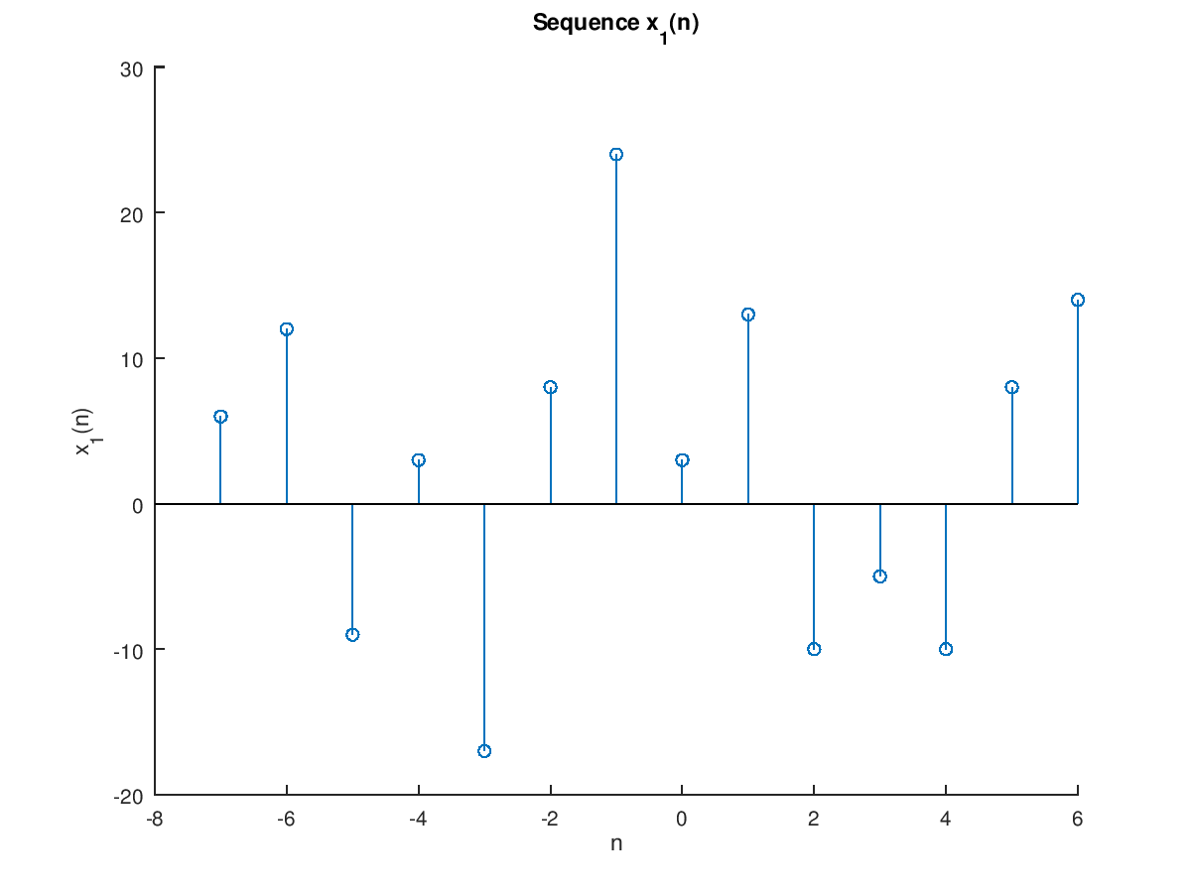

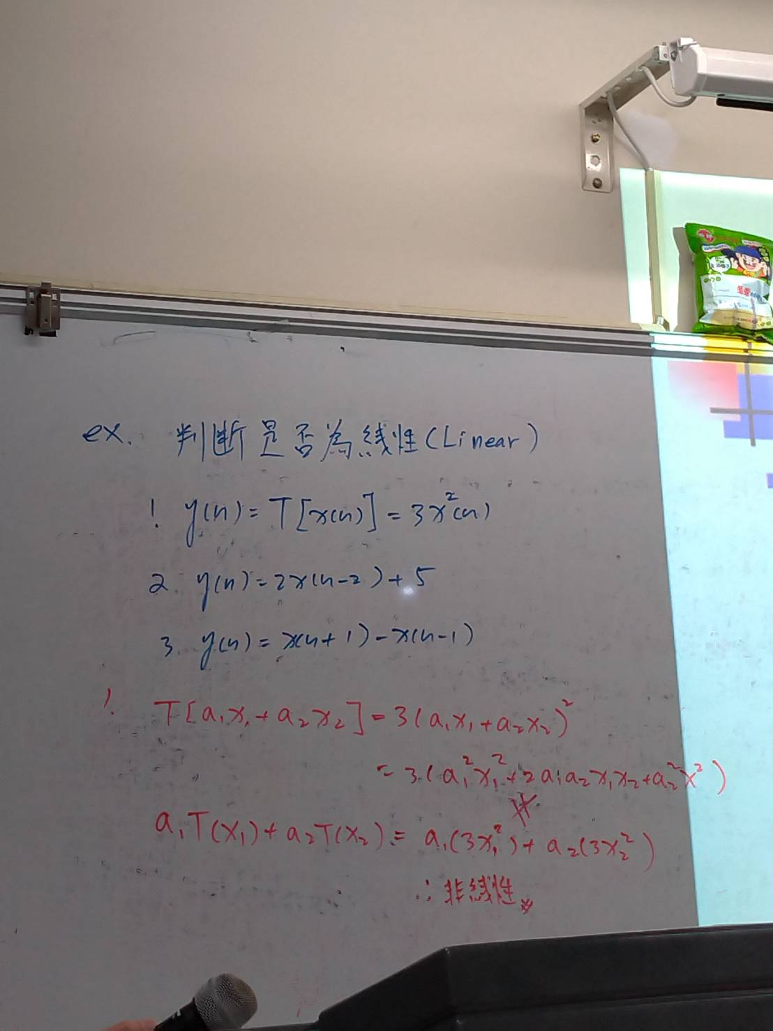

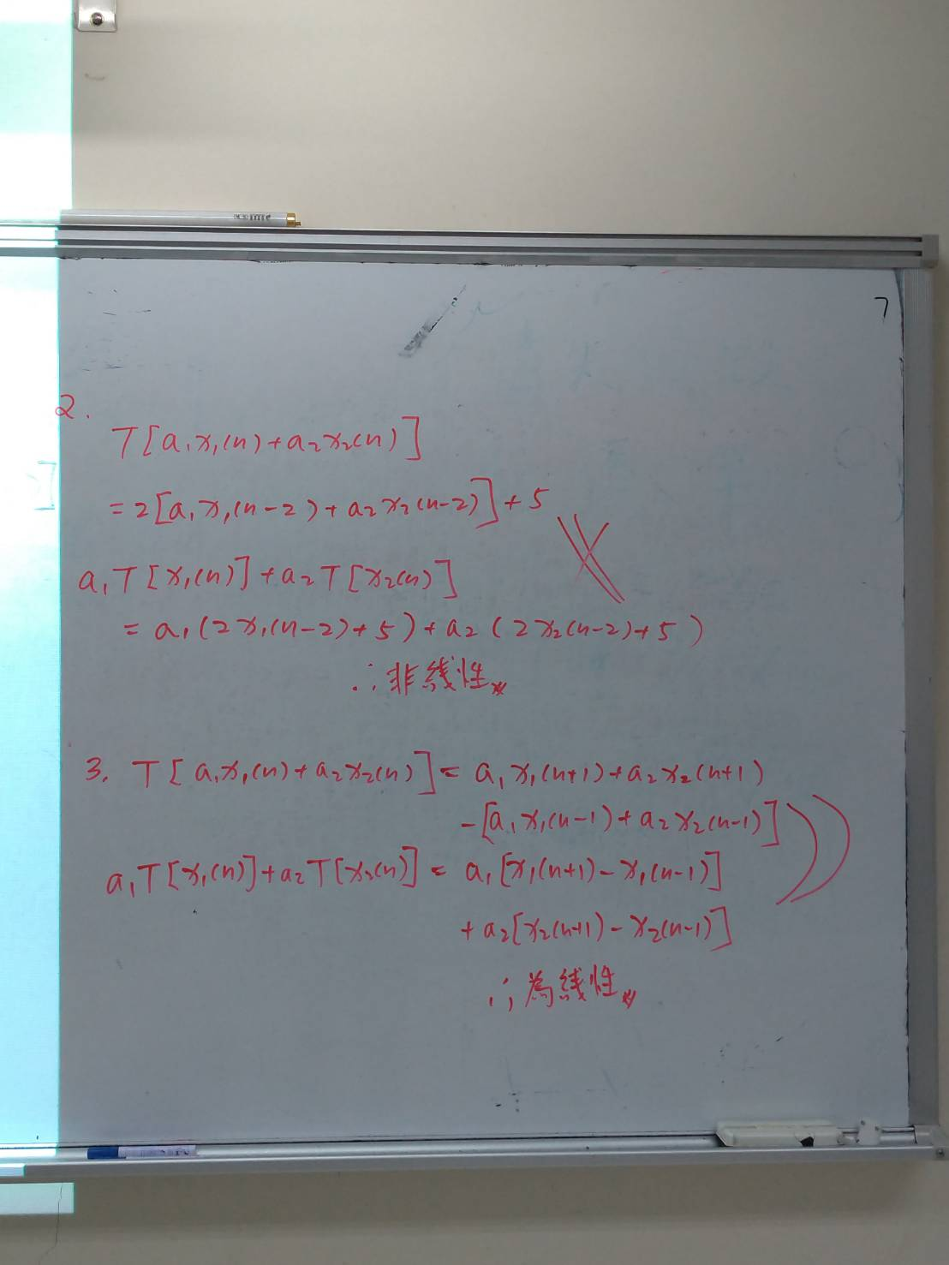

**PPT 36頁**

------------------------------------------------我是分割線-------------------------------------------

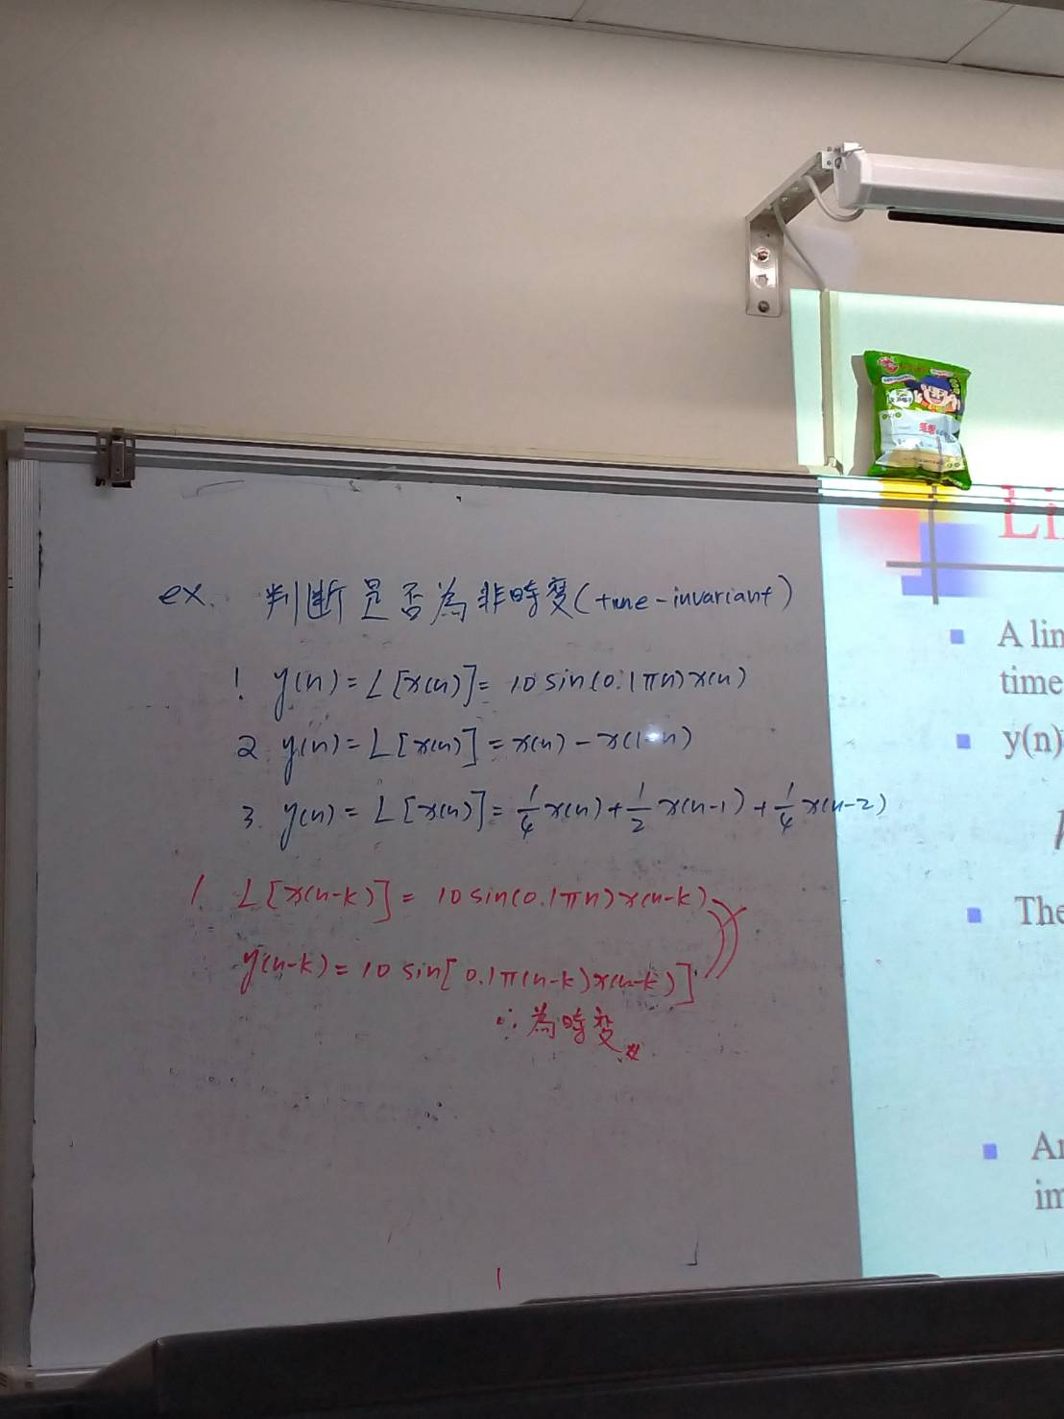

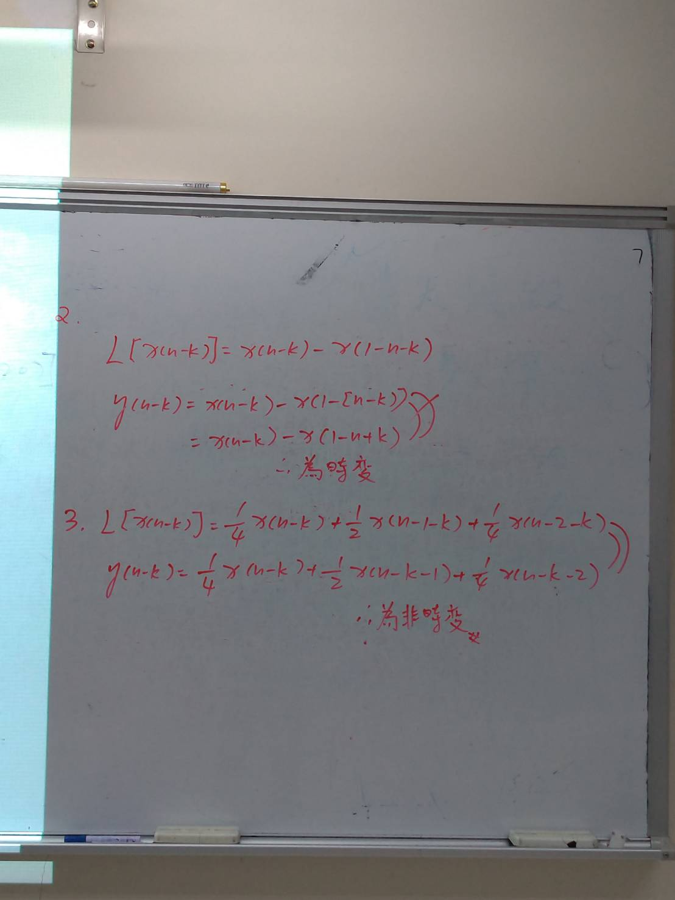

**PPT 37頁**

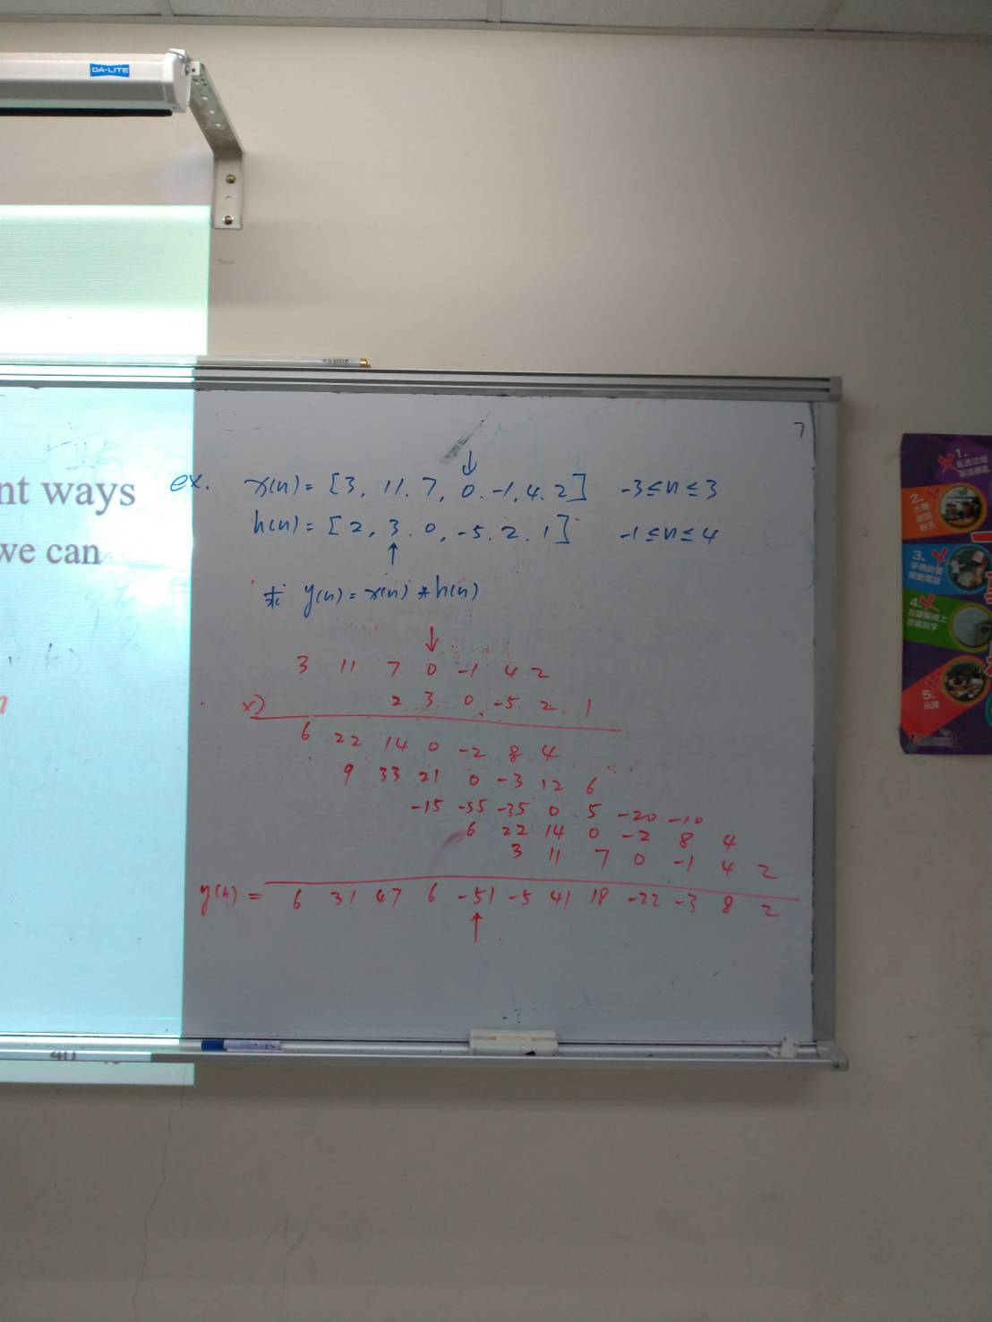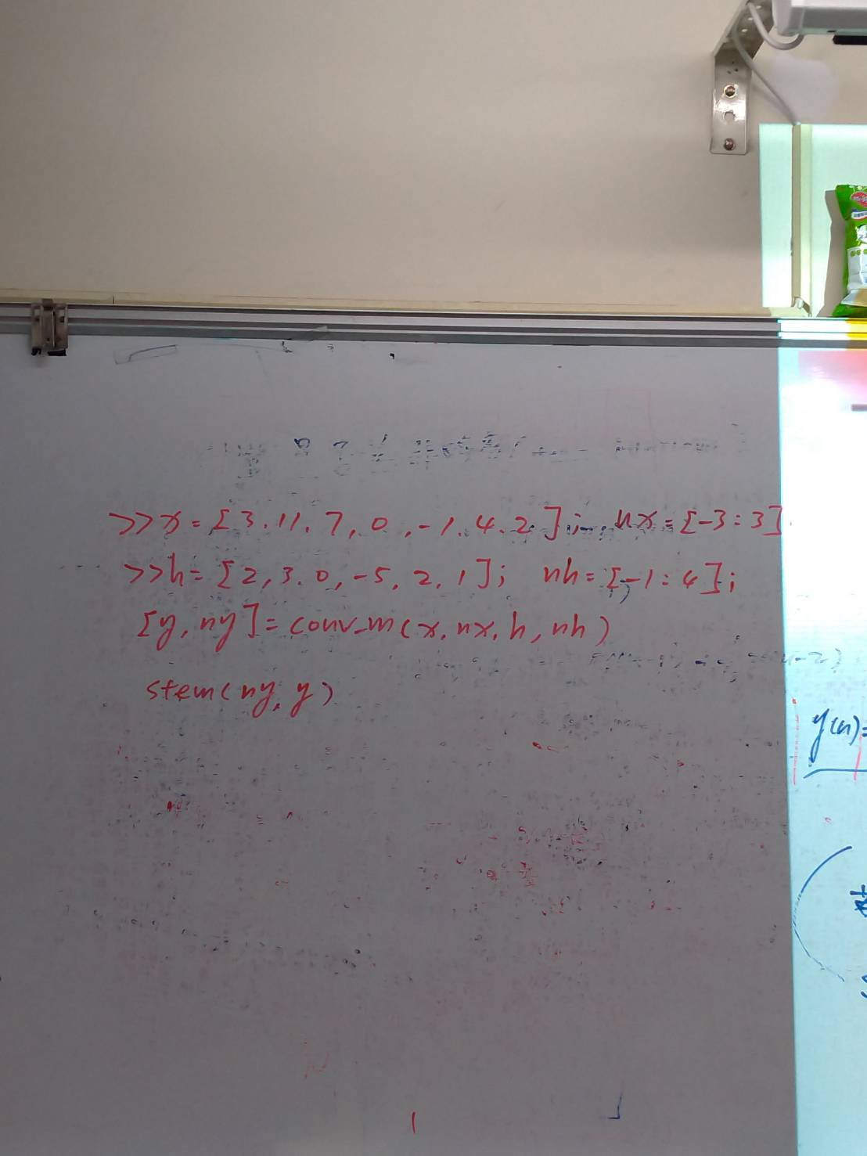

**PPT 40頁**

**2019/3/8**

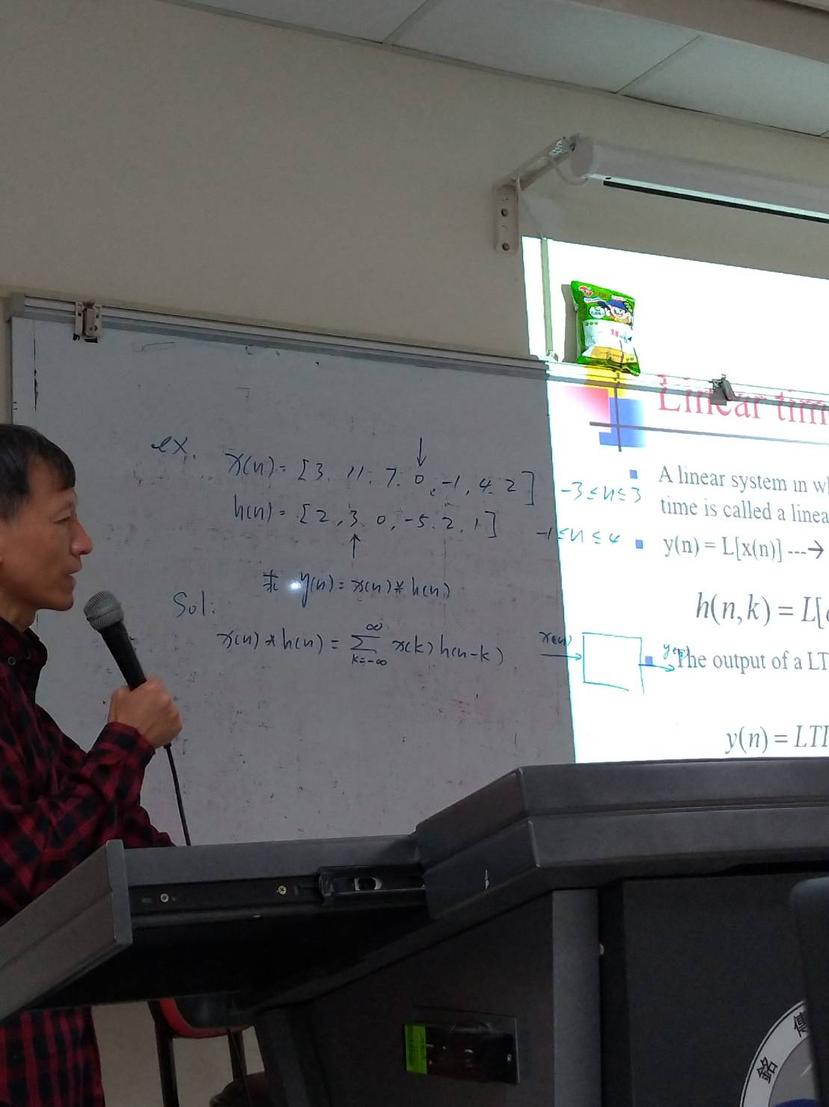

x=[3 11 7 0 -1 4 2];

nx=[-3:3];

h=[2 3 0 -5 2 1];

nh=[-1:4];

[y,ny]=conv_m(x,nx,h,nh)

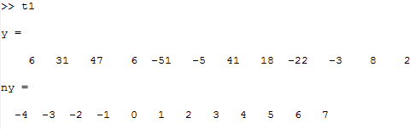

**PPT 36.37頁**

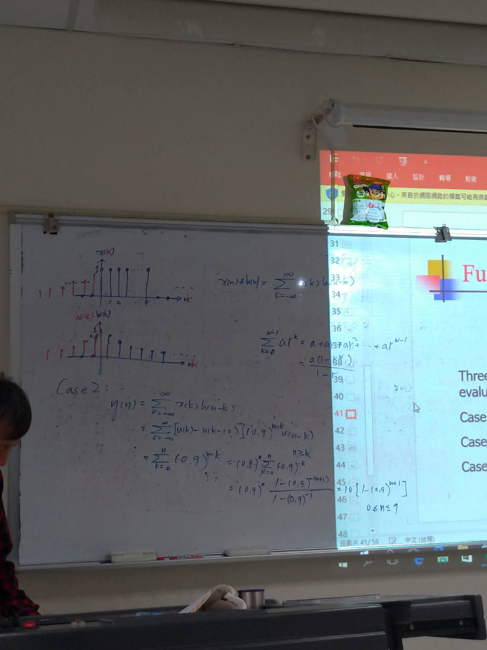

**PPT 41頁**

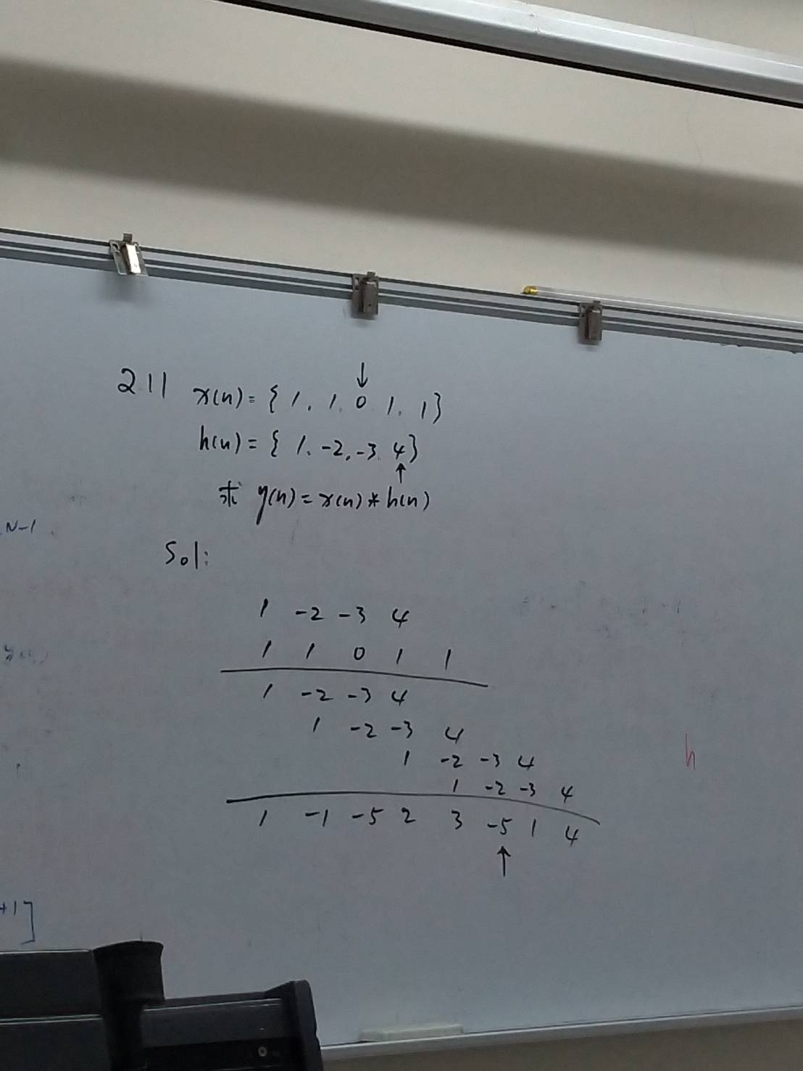

clear,close all;

x=[1 1 0 1 1];

nx=-2:2;

h=[1 -2 -3 4];

nh=-3:0;

[y,ny]=conv_m(x,nx,h,nh)

%ny為對應的時間資訊,y為conversion結果

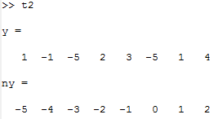

clear,close all;

n=[0:50];

x=0.8.^n;

h=0.9.^n;

y1=((0.8).^(n+1)-(-0.9).^(n+1))/(0.8+0.9);

subplot(1,3,1);

Hs1=stem(n,y1,'filled');

set(Hs1,'markersize',2);

title('Analytical');

xlabel('n');

ylabel('y(n)');

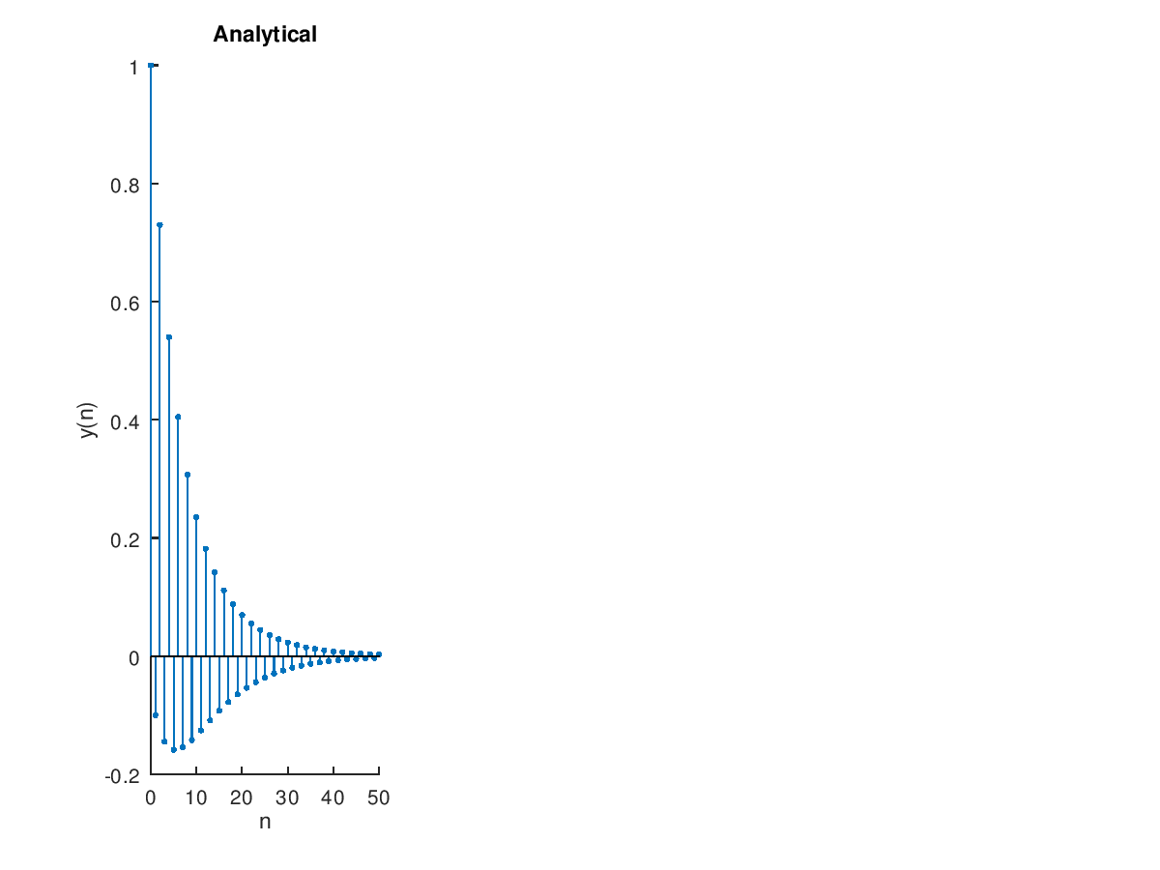

clear,close all;

a=[1,-1,0.9];b=1; n=[-20:120];

[h,n]=impz(b,a);

subplot(2,1,1);stem(n,h)

axis([-20,120,-1.1,1.1])

title('Impulse Response');xlabel('n');ylabel('h(n)')

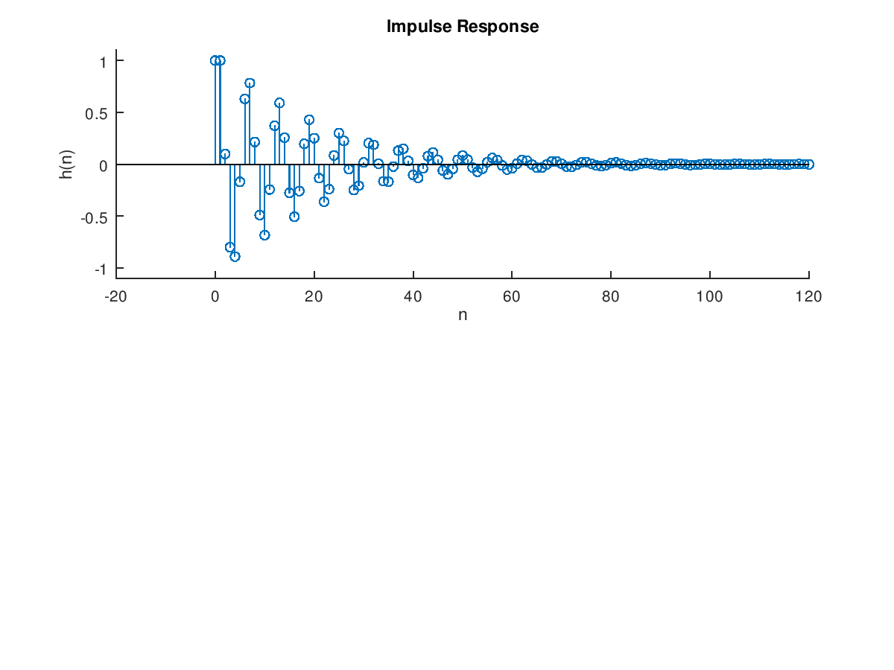

a=[1,-1,0.9];b=1; n=[-20:120];

x=stepseq(0,-20,120);

s=filter(b,a,x);

subplot(2,1,2);stem(n,s)

axis([-20,120,-.5,2.5])

title('Step Response');xlabel('n');ylabel('s(n)')

