Ex 3.3 Determine the DTFT of ex 3.1 at 501 equispaced points between [0, pi]

|  |
| --- |
| w = [0:1:500]*pi/500;  X = exp(j*w) ./ (exp(j*w) - 0.5*ones(1,501));  magX = abs(X); angX = angle(X);  realX = real(X);imagX = imag(X);  subplot(2,2,1); plot(w/pi,magX);  grid  xlabel('frequency in pi units');  title('Magnitude Part'); ylabel('Magnitude')  subplot(2,2,3); plot(w/pi,angX);  grid  xlabel(' frequency in pi units ');  title('Angle Part'); ylabel('Radians')  subplot(2,2,2); plot(w/pi,realX);  grid  xlabel(' frequency in pi units ');  title('Real Part'); ylabel('Real')  subplot(2,2,4); plot(w/pi,imagX);  grid  xlabel(' frequency in pi units ');  title('Imaginary Part');  ylabel('Imaginary') |

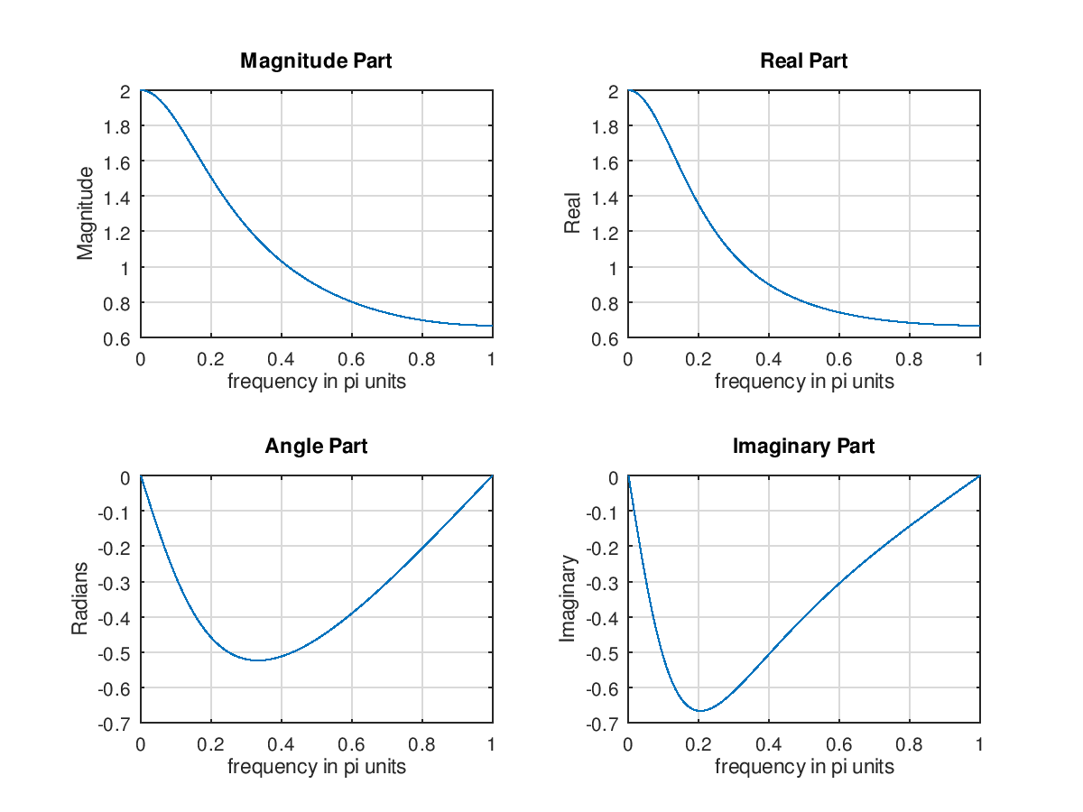

**Ex 3.4 Determine the DTFT of *x*(n)={1,2,3,4,5}by MATLAB**

|  |
| --- |
| **n=-1:3; x=1:5;**  **k=0:500; w=(pi/500)*k;**  **X=x*(exp(-j*pi/500)).^(n'*k);**  **magX=abs(X); angX=angle(X);**  **realX = real(X); imagX = imag(X);**  **subplot(2,2,1);**  **plot(k/500,magX);**  **grid;**  **xlabel('frequency in pi units');**  **title('Magnitude Part'); ylabel('Magnitude')**  **subplot(2,2,3); plot(w/pi,angX);**  **grid**  **xlabel(' frequency in pi units ');**  **title('Angle Part'); ylabel('Radians')**  **subplot(2,2,2); plot(w/pi,realX);**  **grid**  **xlabel(' frequency in pi units ');**  **title('Real Part'); ylabel('Real')**  **subplot(2,2,4); plot(w/pi,imagX);**  **grid**  **xlabel('frequency in pi unit'); title('Magnitude Part');** |

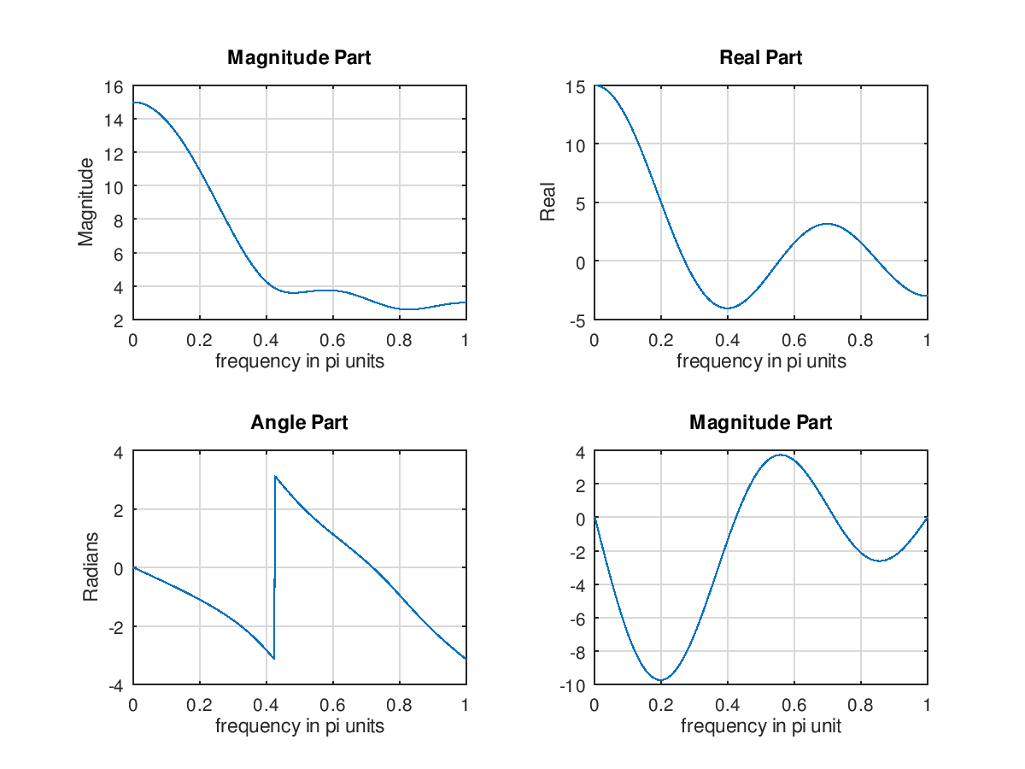

**Ex 3.5 Find the DTFT of x(n)=(0.9exp(j*pi/3))^n, 0<=n<=10 and investigate its periodicity**

|  |
| --- |
| **n = 0:10; x = (0.9*exp(j*pi/3)).^n;**  **k = -200:200; w = (pi/100)*k;**  **X = x * (exp(-j*pi/100)) .^ (n'*k);**  **magX = abs(X); angX =angle(X);**  **subplot(2,1,1); plot(w/pi,magX);**  **grid**  **xlabel('frequency in units of pi');**  **ylabel('|X|')**  **title('Magnitude Part')**  **subplot(2,1,2);**  **plot(w/pi,angX/pi);grid**  **axis([-2,2,-1,1])**  **xlabel(' frequency in units of pi');**  **ylabel('radians/pi')**  **title('Angle Part')** |

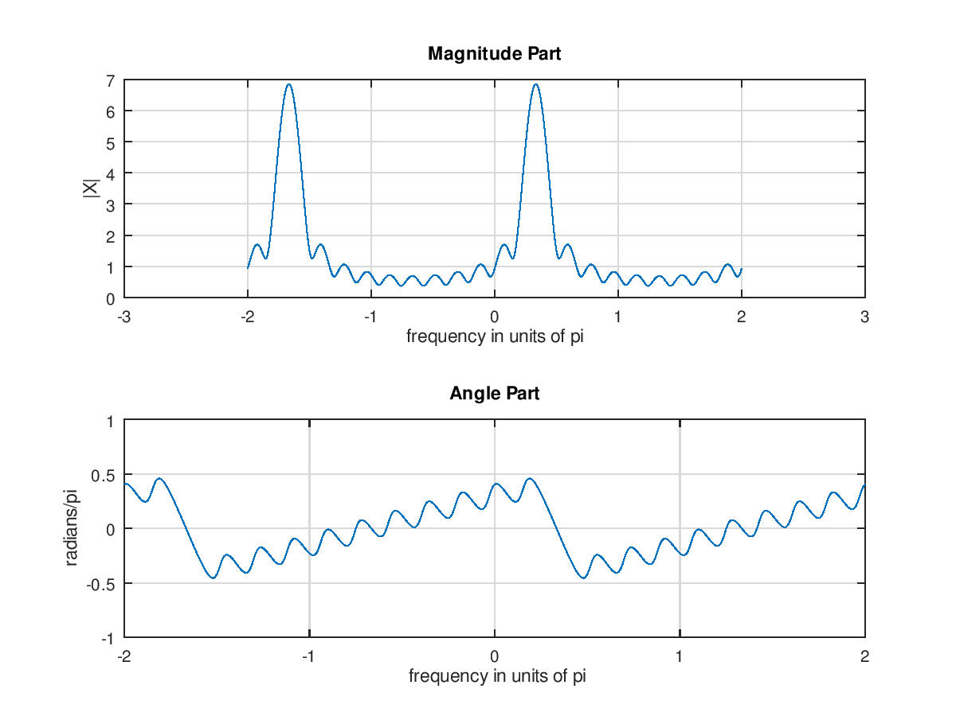

**Ex 3.5 Find the DTFT of x(n)=(0.)^n, -10<=n<=10 and investigate its periodicity**

|  |
| --- |
| n = -10:10; x = (0.9).^n;  k = -200:200; w = (pi/100)*k;  X = x * (exp(-j*pi/100)) .^ (n'*k);  magX = abs(X); angX =angle(X);  subplot(2,1,1); plot(w/pi,magX);  grid  xlabel('frequency in units of pi');  ylabel('|X|')  title('Magnitude Part')  subplot(2,1,2);  plot(w/pi,angX/pi);grid  axis([-2,2,-1,1])  xlabel(' frequency in units of pi');  ylabel('radians/pi')  title('Angle Part') |

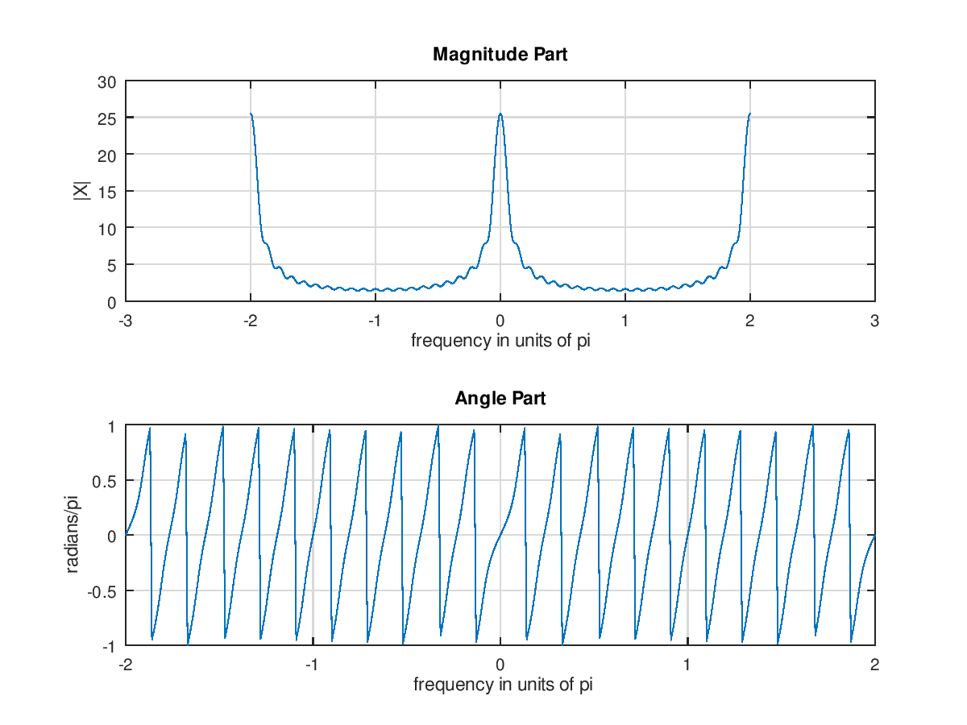

3.3

h(n)=(0.9)^|n|

求H(e^jw)，並劃出其大小與相位，- $π$ ~ $π$

|  |
| --- |
| W=[-300:300]*pi/100;  H=0.19*ones(size(W))./(1.81-1.8*cos(W));  magH=abs(H);  phaH=angle(H)*180/pi;  subplot(2,1,1);  plot(W/pi,magH,'LineWidth',1.5);  axis([-1 1 0 20]);  subplot(2,1,2);  plot(W/pi,phaH,'LineWidth',1.5);  axis([-1 1 -180 180]); |

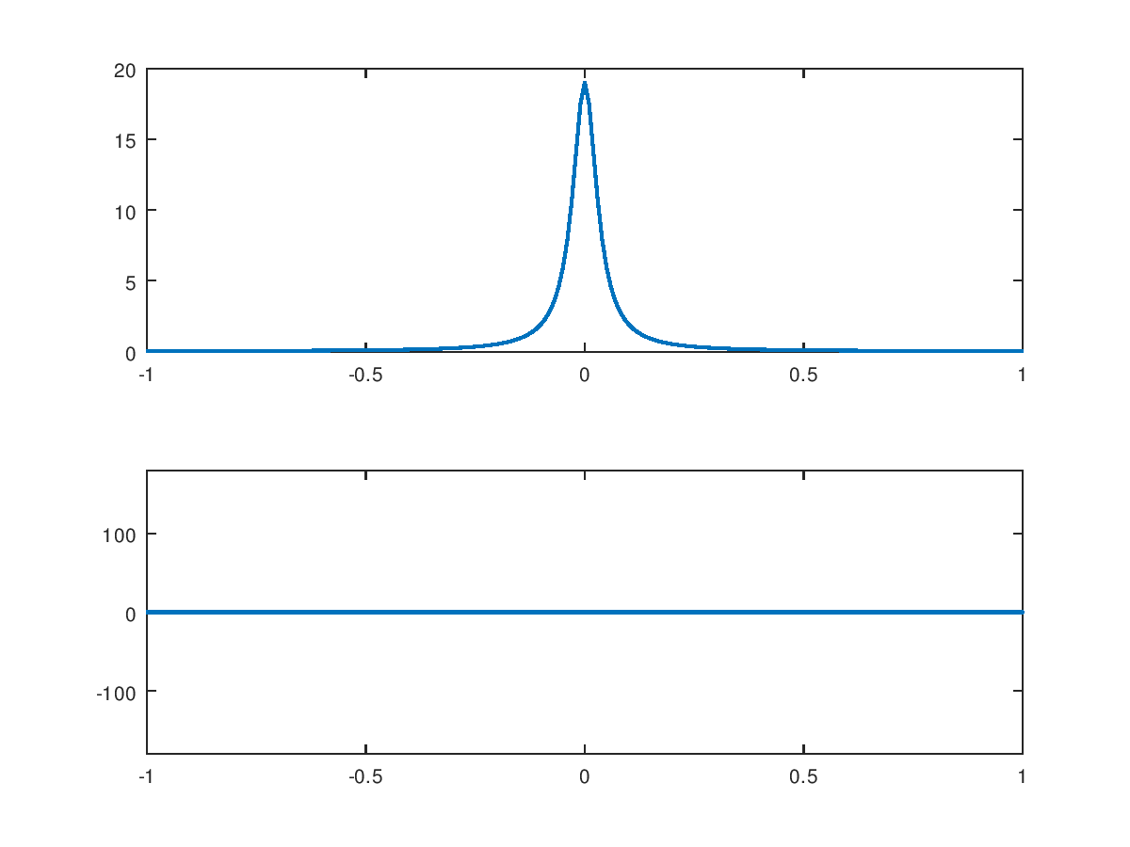

3.11

X(n)=2(0.5)^n*u(n+2)

Plot X(e^jw)之大小與相位，- $π$ ~ $π$

|  |
| --- |
| w1=linspace(0,pi,501);  X1=8*exp(j*2*w1)./(1-0.5*exp(-j*w1));  magX1=abs(X1);  phaX1=angle(X1);  subplot(2,1,1);  plot(w1/pi,magX1,'LineWidth',1.5);  axis([0 1 0 20]);  subplot(2,1,2);  plot(w1/pi,phaX1*180/pi,'LineWidth',1.5);  axis([0 1 -200 200]); |

