DSP 2/23 練習題

2.5

X(n)={….-2,-1,0,1,2,…..} plot 5個週期

Ch2-22(例題)

|  |
| --- |
| n=[-3:21];  x=[0,1,2,-2,-1];  xtilde=x' * ones(1,5);  xtilde=(xtilde(:))';  stem(n,xtilde);  title('Sequence in Problem 2.1d')  xlabel('n');  ylabel('xtilde(n)'); |

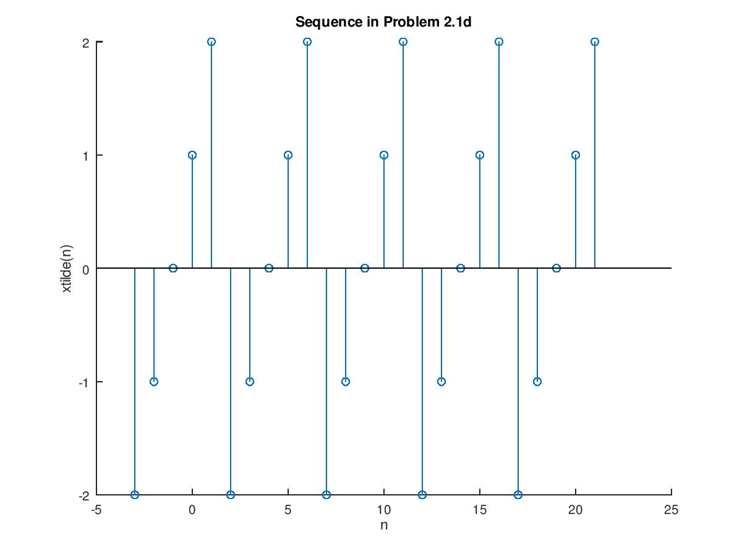

2.6

X(u)={2,4,-3,1,-5,4,7}

Plot X(n)=2x(n-3)+3x(n+4)-x(n)

Sigadd只能加兩個

Ch2-24(例題)

|  |
| --- |
| n = -3:3;  x = [2,4,-3,1,-5,4,7];  [x11,n11] = sigshift(x,n,3);  [x12,n12] = sigshift(x,n,-4);  [x13,n13] = sigshift(x,n,0);  [x1,n1] = sigadd(2*x11,n11,3*x12,n12);  [x2,n2] = sigadd(x1,n1,-1*x13,n13);  stem(n2,x2);  title('Sequence in Problem 2.2a')  xlabel('n');  ylabel('x1(n)'); |

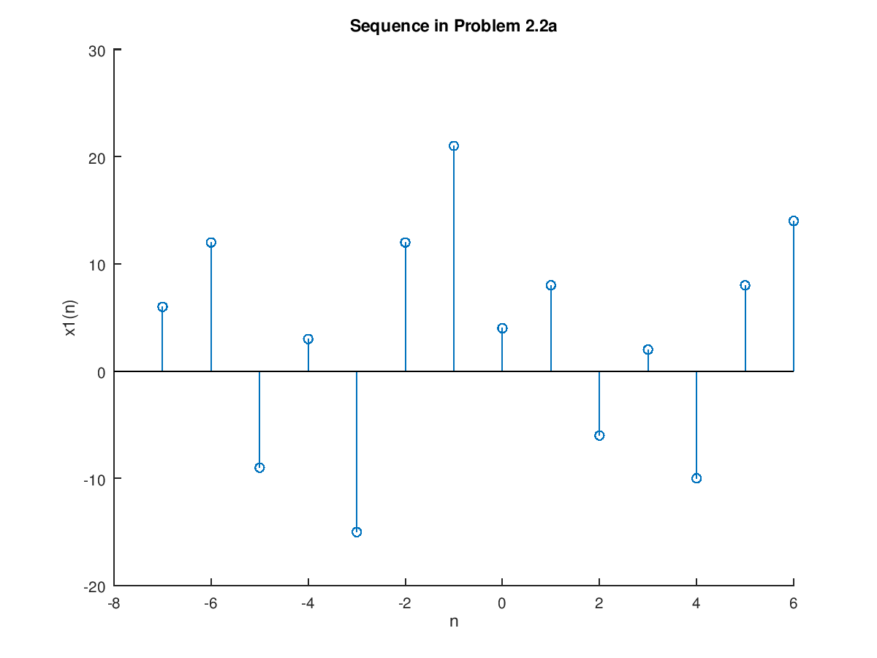

Ex 判斷是否為線性(Liner)

1. y=(n)=T[x(n)]=3x^2(n) ->非線性
2. y(n)=2x(n-2)+5 ->非線性
3. y(n)=x(n+1)-x(n-1)) ->線性