Ex 3.13 Determine the freq response of the system h(n)=(0.9)^n*u(n). Plot the magnitude and the phase responses

|  |
| --- |
| w = [0:1:500]*pi/500;  H = exp(j*w) ./ (exp(j*w) - 0.9*ones(1,501));  magH = abs(H); angH = angle(H);  subplot(2,1,1); plot(w/pi,magH); grid;  xlabel(' frequency in pi units '); ylabel('|H|');  title('Magnitude Response');  subplot(2,1,2); plot(w/pi,angH/pi); grid  xlabel(' frequency in pi units '); ylabel('Phase in pi Radians');  title('Phase Response'); |

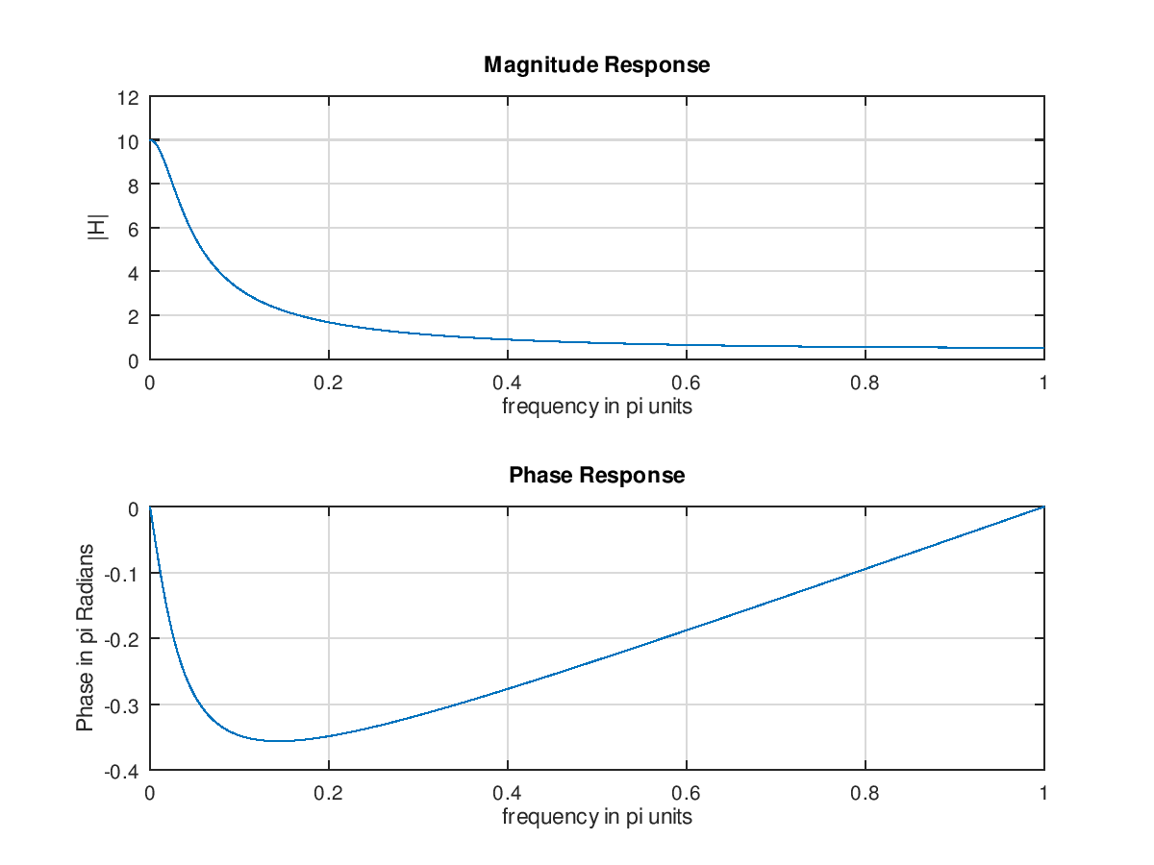

Ex –LTI system

H(n)=[(0.5)^n+(0.4)^n]*u(n)求其頻率響應H(e^jw)並畫出其大小(-pi<=w<=pi)

|  |
| --- |
| w=[-300:300]*pi/300;  H=(2-0.9*exp(-j*w))./(1-0.9*exp(-j*w)+0.2*exp(-j*2*w));  magH=abs(H);phaH=angle(H)*180/pi;  subplot(2,1,1);  plot(w/pi,magH,'LineWidth',1.5);  subplot(2,1,2);  plot(w/pi,phaH,'LineWidth',1.5); |

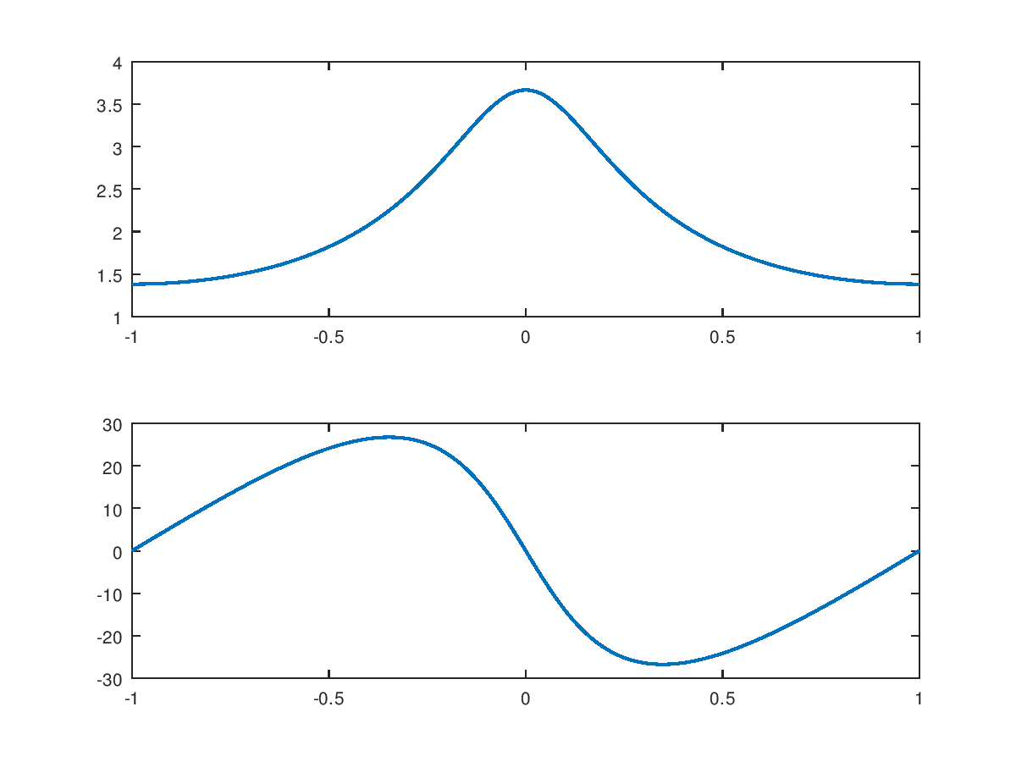

3.3.19

w=[-300:300]*pi/300;a=[1];b=[0.2 0.2 0.2 0.2 0.2]

H=freqresp(b,a,w);

magH=abs(H);phaH=angle(H)*180/pi;

%magH=abs(H);phaH=angle(H)*180/pi;

subplot(2,1,1);

plot(w/pi,magH,'LineWidth',1.5);

subplot(2,1,2);

plot(w/pi,phaH,'LineWidth',1.5);

