Ex x(n)=[3,11,7,0,-1,4,2] -3<=n<=3

h(n)=[2,3,0,-5,2,-1] -1<=n<=4

求y(n)=x(n) $*$ h(n)= $\sum_{k=-∞}^{∞}{x\left(k\right)h(n-k)}$

|  |
| --- |
| x=[3,11,7,0,-1,4,2,];nx=[-3:3];  h=[2,3,0,-5,2,1];nh=[-1:4];  [y,ny]=conv_m(x,nx,h,nh) |

Ex 2.11

x(n)= [1,1,0,1,1] -2<=n<=2

h(n)= [1,-2,-3,4] -3<=n<=0

求y(n)=x(n) $*$ h(n)

|  |
| --- |
| x=[1,1,0,1,1];nx=[-2:2];  h=[1,-2,-3,4];nh=[-3:0];  [y,ny]=conv_m(x,nx,h,nh) |

ex

|  |
| --- |
| n=[0:50];x=0.8.^n;h=(-0.9).^n;  y1=((0.8).^(n+1)-(-0.9).^(n+1))/(0.8+0.9);  subplot(1,3,1); Hs=stem(n,y1,'filled');  xlabel('n');ylabel('y(n)'); |

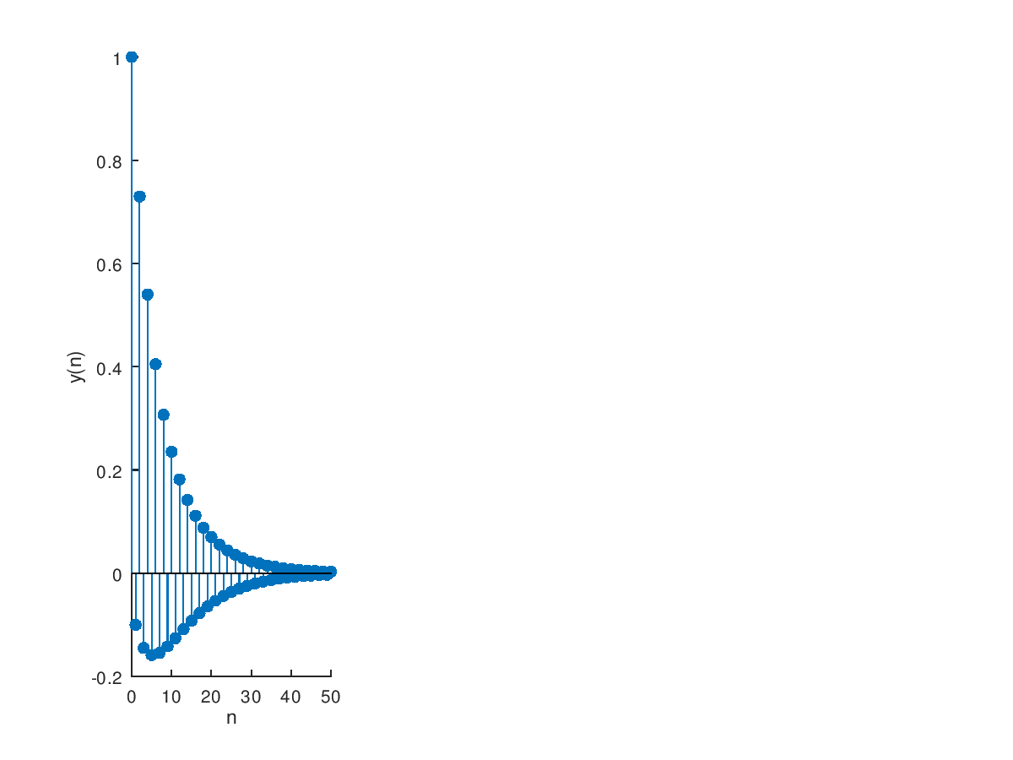

Ex 2.9 Given the difference equationy(n)-y(n-1)+0.9y(n-2)=x(n);

|  |
| --- |
| a=[1,-1,0.9];b=1; n=[-20:120];  [h,n]=impz(b,a);  subplot(2,1,1);stem(n,h)  axis([-20,120,-1.1,1.1])  title('Impulse Response');xlabel('n');ylabel('h(n)') |

|  |
| --- |
| n=[0:8];x=[1 1 1 1 1 1 1 1 1];h=(0.9).^n;  y1=((x.^(n)-(0.9).^(n-10))/(-1/9));  subplot(1,3,1); Hs=figure,stem(n,y1,'filled');  xlabel('n');ylabel('y(n)');  n=[0:50];x=[1 1 1 1 1 1 1 1 1];h=(0.9).^n;  y1=((x.^(n)-(0.9).^(-1))/(-1/9));  subplot(1,3,2); Hs=figure,stem(n,y1,'filled');  xlabel('n');ylabel('y(n)'); |

