DSP mid-term exam. Class:___電通三甲_____, Student ID:__04050290____, Name:____林思宇__

1. (a) Determine whether the system *y*(*n*)=*x*(2*n*) is linear.

(b) Determine whether the system is time-invariant.

1. An LTI system is described by the following difference equation.



Using the impz( ) (or the filter( ) ) function, plot the impulse response *h*(*n*) over

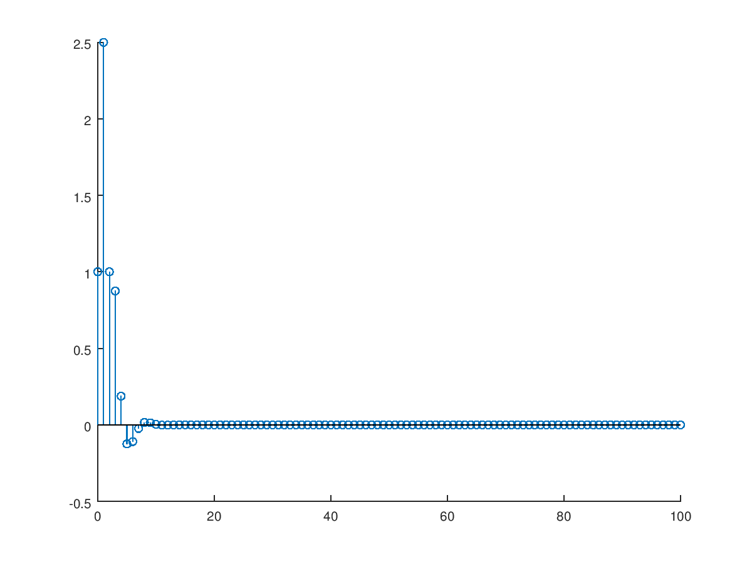

|  |
| --- |
| b=[1 2 0 1];  a=[1 -0.5 0.25];  [delta,n]=impseq(0,0,100);  h=filter(b,a,delta);  stem(n,h); |

3. (a) Determine the DTFT of $x\left(n\right)={(0.9)}^{n}, -10≤n≤10,$ by hand.

(b)Plot the magnitude, angle, of at 401 equispaced points between [-2π, 2π].

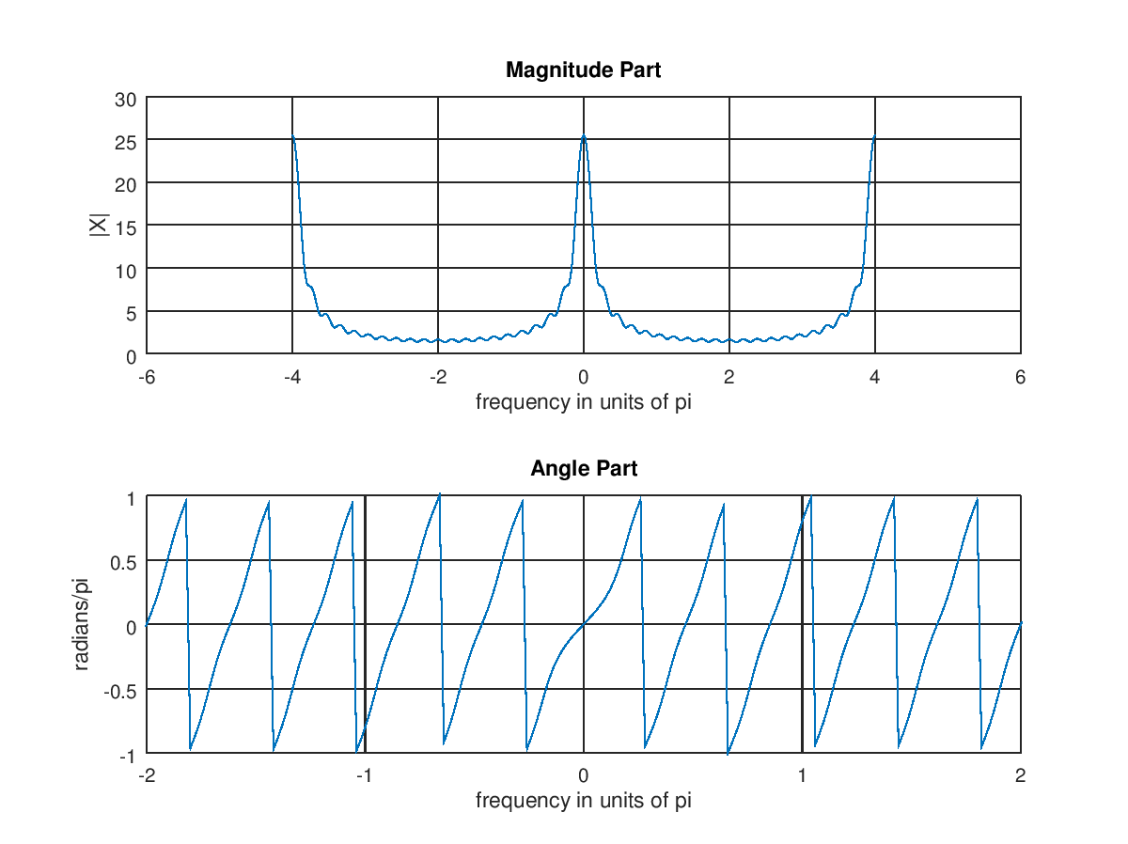

|  |
| --- |
| n =-10:10; x = (0.9).^n;  k = -200:200; w = (2*pi/100)*k;  X = x * (exp(-j*pi/100)) .^ (n'*k);  magX = abs(X); angX =angle(X);  subplot(2,1,1); plot(w/pi,magX);grid  xlabel('frequency in units of pi'); ylabel('|X|')  title('Magnitude Part')  subplot(2,1,2); plot(w/pi,angX/pi);grid  axis([-2,2,-1,1])  xlabel(' frequency in units of pi '); ylabel('radians/pi')  title('Angle Part') |

4. Determine the sequence *x*(*n*) corresponding to the following DTFTs:

5. An LTI system is specified by the difference equation

1. Determine.
2. If the input is, plot the output *y*(*n*), n=0, 1, …, 100

|  |
| --- |
| subplot(1,1,1)  b = 1; a = [1,-0.8];  n=[0:100];x = cos(0.05*pi*n);  y = filter(b,a,x);  subplot(2,1,1); stem(n,x);  xlabel('n'); ylabel('x(n)'); title('Input sequence')  subplot(2,1,2); stem(n,y);  xlabel('n'); ylabel('y(n)'); title('Output sequence') |

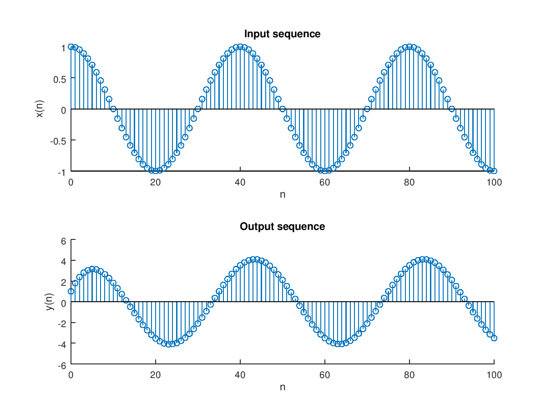

6. An LTI system is specified by the difference equation

1. Determine.
2. Plot its magnitude and phase

|  |
| --- |
| w=[-300:300]*pi/300;  h=0.2*(1+exp(-j*w)+exp(-2j*w)+exp(-3j*w)+exp(-4j*w));  mag=abs(h);  pha=angle(h);  subplot(2,1,1);  plot(w,mag);grid  subplot(2,1,2);  plot(w,pha);grid |

