Installation & Environment Setup Guide

How to read the commands. Every command block is labelled with the operating system it is for. Windows commands are for PowerShell, macOS commands are for Terminal (zsh), and Linux commands are for Ubuntu/Debian (bash). Type a command, press Enter, then compare the result with the Check line below it before moving on.
Contents
0. Background 2
0.1 The big picture 2
0.2 Programming, query and web languages 3
0.3 AI tools 3
0.4 Supporting tools 4
0.5 Installation order and requirements 4
1. Installations and Environment Setup 5
1.0 Before you start 5
1.1 Python 5
1.2 Visual Studio Code (VS Code) 8
1.3 Claude 9
1.4 Other tools 13
1.5 Final verification checklist 17
2. References 18
Appendix A — Troubleshooting 20

0. Background

0.1 The big picture
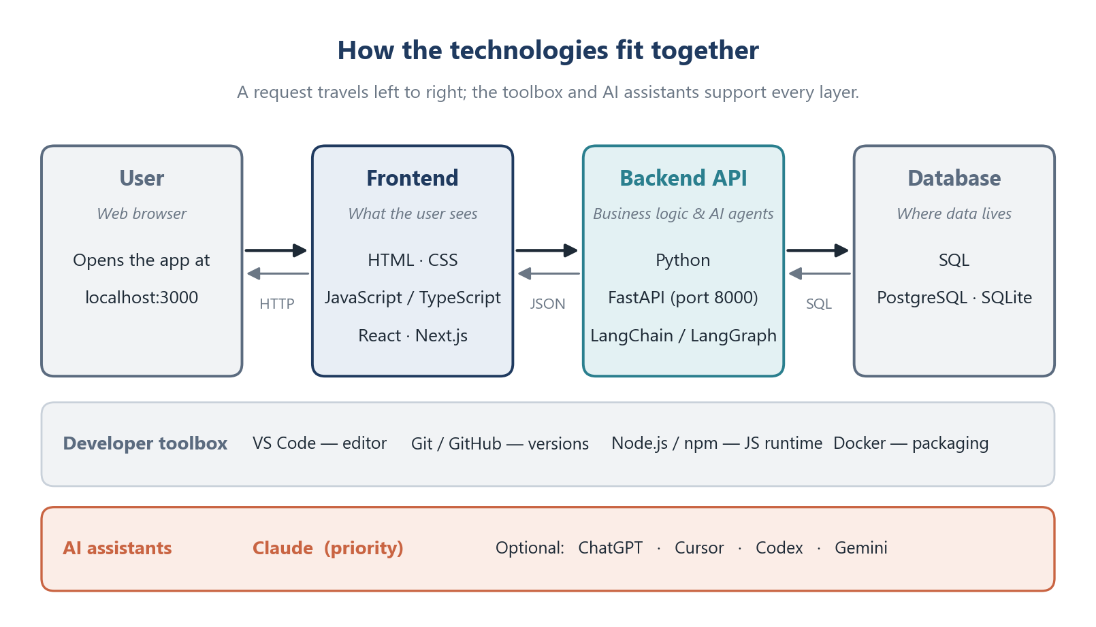
Figure 1. Main technologies.

0.2 Programming, query and web languages
Component | Main objective | Purpose in this project | Typical applications
Python | General-purpose language that is easy to read and write | Backend API (FastAPI), AI agents (LangChain/LangGraph), tests, scripts | Web backends, data analysis, machine learning, automation
JavaScript | The programming language of web browsers | Makes the web interface interactive | Interactive websites, web apps, browser extensions
TypeScript | JavaScript plus static types, compiled to JavaScript | Safer frontend code with Next.js/React; catches mistakes before running | Large web apps, team projects, Node.js services
SQL | Standard language to query and manage relational databases | Store and retrieve project data (PostgreSQL in production, SQLite in development) | Reporting, analytics, any application that stores records
HTML | Describes the structure of a web page (headings, forms, buttons) | Skeleton of every frontend page | Websites, emails, documentation
CSS | Describes the appearance of a web page (layout, colours, fonts) | Styling and responsive layout of the frontend | Visual design of websites and apps

In short: HTML gives the page its structure, CSS makes it look good, JavaScript/TypeScript make it interactive, Python does the work on the server, and SQL stores the results.

0.3 AI tools
Tool | Provider | Main objective | Best used for
Claude (Claude Code, Desktop app, VS Code extension) | Anthropic | AI assistant and agentic coding tool that reads your codebase, edits files, runs commands and works with Git | Building features, fixing bugs, explaining code, writing tests and documents
ChatGPT | OpenAI | General conversational assistant | Brainstorming, explanations, second opinions
Cursor | Anysphere | AI-first code editor based on VS Code | Inline AI completions and chat inside an editor
Codex | OpenAI | Coding agent for the terminal and cloud | Alternative coding agent for comparison
Gemini (app, Gemini CLI) | Google | General assistant and terminal coding agent | Alternative assistant; long-document questions

Note: for CLAUDE.md, .claude/, .cursor/, .codex/ and .gemini/ in the project root, plus shared rules in .agents/rules/. Each tool reads its own folder automatically, so the whole team gets the same rules.

0.4 Supporting tools
Tool | What it is | Why we need it
Visual Studio Code | Free code editor from Microsoft | One place to edit code, run a terminal and use Claude
Git | Version control system | Track every change and collaborate on branch ai4b_tur
Node.js / npm | JavaScript runtime and package manager | Required to build and run Next.js/React frontends
FastAPI | Python web framework | Builds the backend REST API with automatic /docs page
Docker | Container platform | Run the app the same way on every computer and in deployment
Next.js / React | Frontend frameworks | Build the user interface with reusable components

0.5 Installation order and requirements
Install the tools in the order below. Git comes first because Claude Code on Windows needs Git Bash, and Node.js comes before the frontend frameworks because they run on it.
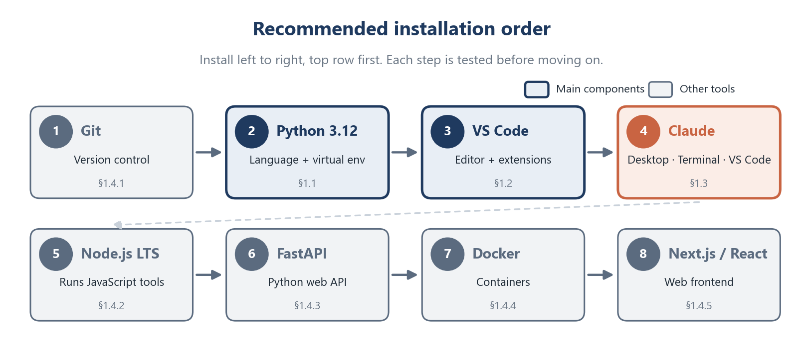
Figure 2. Recommended installation order. Dark blue and orange boxes are the main components; grey boxes are the other tools.
Requirement | Minimum
Operating system | Windows 10 (version 1809+) or 11 · macOS 13 Ventura or newer · Ubuntu 20.04+ / Debian 10+
Memory (RAM) | 4 GB (8 GB or more recommended when Docker is running)
Free disk space | About 10 GB for all tools and Docker images
Accounts | GitHub account with Write access to the repo · Claude Pro, Max, Team or Enterprise plan (or a Claude Console account) for Claude Code
Internet | Required for installing and for Claude

1. Installations and Environment Setup

1.0 Before you start

Step 1 — Open a terminal
A terminal is a window where you type commands.
OS | How to open it
Windows | Press Start, type PowerShell, press Enter
macOS | Press Cmd + Space, type Terminal, press Enter
Linux | Press Ctrl + Alt + T

Example with Windows:
- PowerShell: search > PowerShell
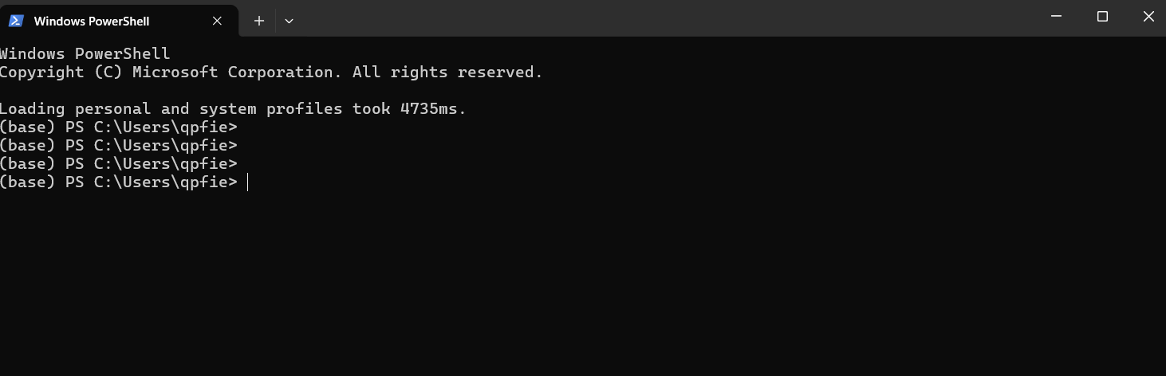
PowerShell Window
- Command prompt: search > cmd > Command Prompt (Run as Administrator)
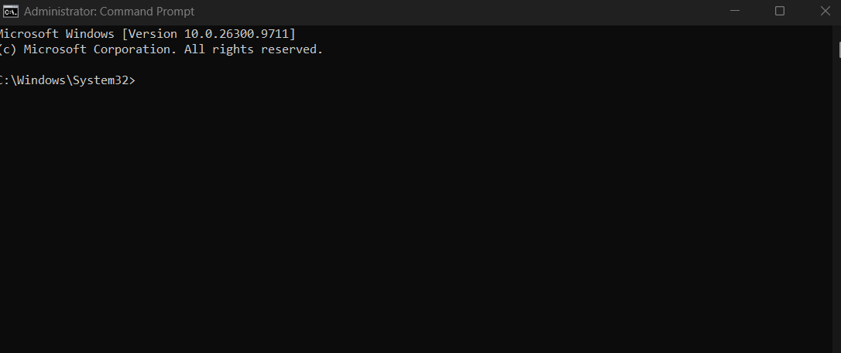

Step 2 — Get a package manager
A package manager installs software with one command. The commands in this guide use these.
Windows — winget is built into Windows 10/11. Check that it works:
winget --version
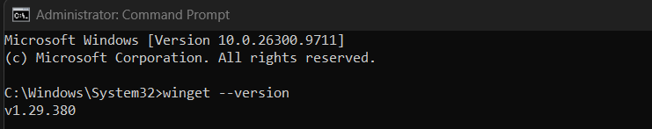
macOS — install Homebrew:
/bin/bash -c "$(curl -fsSL https://raw.githubusercontent.com/Homebrew/install/HEAD/install.sh)"
brew --version
Linux (Ubuntu/Debian) — apt is built in. Refresh the package list:
sudo apt update

Step 3 — Understand PATH (environment variables)
Environment variables are settings that every program can read. The most important one is PATH: a list of folders where the terminal looks for programs. When you see "command not found" or "is not recognized", the program is usually installed but its folder is not on PATH.
Windows (PowerShell) — show the folders on PATH:
$env:Path -split ';'
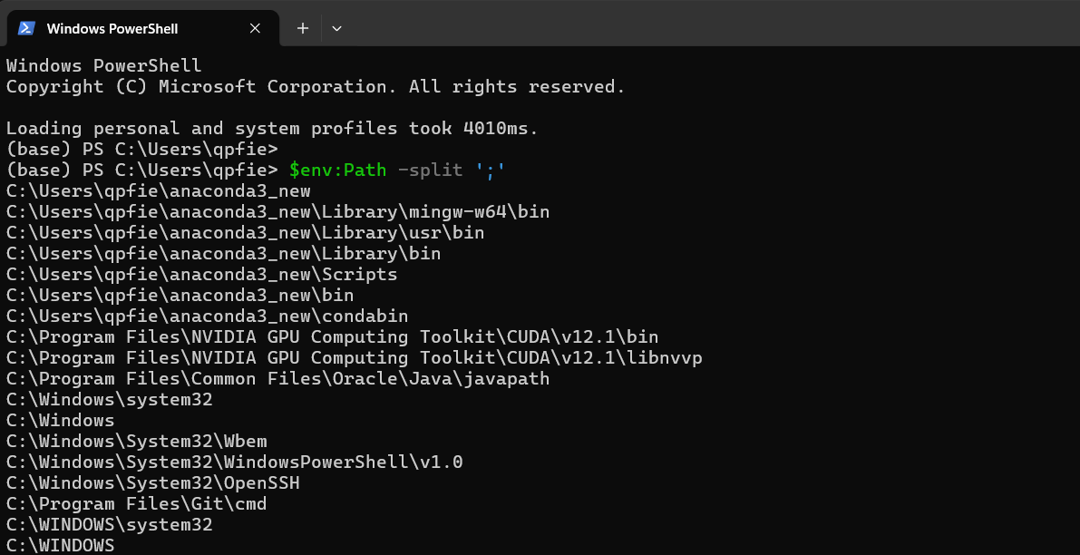

macOS / Linux — show the folders on PATH:
echo $PATH | tr ':' '\n'
Important: After installing a program or changing PATH, close and reopen the terminal (and VS Code). Open terminals keep the old value.

1.1 Python
Python 3.12 is recommended (3.11 also works).

Step 1 — Download and install
- Windows (PowerShell)
winget install -e --id Python.Python.3.12
- Or download the installer from python.org/downloads. On the first screen, tick "Add python.exe to PATH", then click Install Now.
- Test in terminal PowerShell:
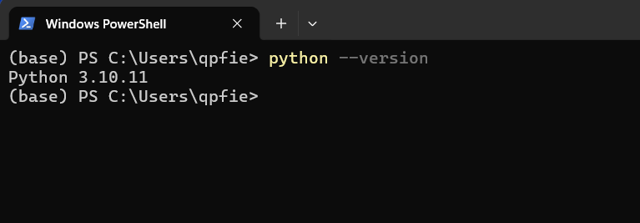
macOS (Terminal)
brew install python@3.12
Linux (Ubuntu 24.04 already ships Python 3.12)
sudo apt install -y python3 python3-venv python3-pip
On Ubuntu 22.04, add Python 3.12 from the deadsnakes repository:
sudo add-apt-repository ppa:deadsnakes/ppa
sudo apt update
sudo apt install -y python3.12 python3.12-venv

Step 2 — Set the environment variable (PATH)
Windows — if python is not found after installation (common error):
1. Press Start, type "Edit environment variables for your account", open it.
2. Select Path → Edit → New, and add these two lines (replace <you> with your user name):
C:\Users\<you>\AppData\Local\Programs\Python\Python312\ and C:\Users\<you>\AppData\Local\Programs\Python\Python312\Scripts\
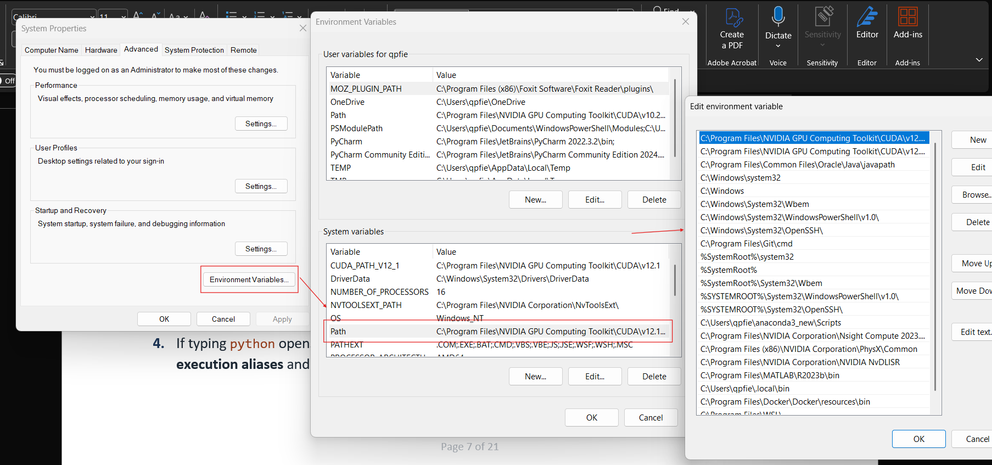
3. Click OK, then close and reopen PowerShell.
4. If typing python opens the Microsoft Store, open Settings → Apps → Advanced app settings → App execution aliases and switch off python.exe and python3.exe.
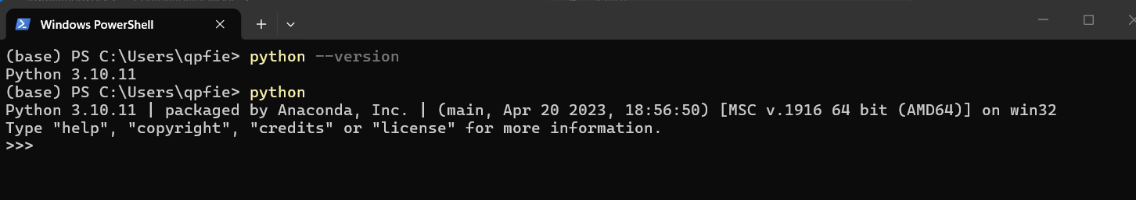
macOS / Linux — Homebrew and apt already put Python on PATH. To check which Python runs, and to add a folder to PATH permanently:
which python3
echo 'export PATH="$HOME/.local/bin:$PATH"' >> ~/.zshrc # macOS (zsh)
echo 'export PATH="$HOME/.local/bin:$PATH"' >> ~/.bashrc # Linux (bash)
Using Anaconda? If your prompt starts with (base), the Anaconda Python is active and may be a different version. Run conda deactivate before creating the project environment, or create the virtual environment with the exact version: py -3.12 -m venv .venv (Windows) or python3.12 -m venv .venv (macOS/Linux).

Step 3 — Test the installation
Windows (Terminal: PowerShell or Command Prompt)
python --version
python -m pip --version
python -c "print('Hello from Python')"
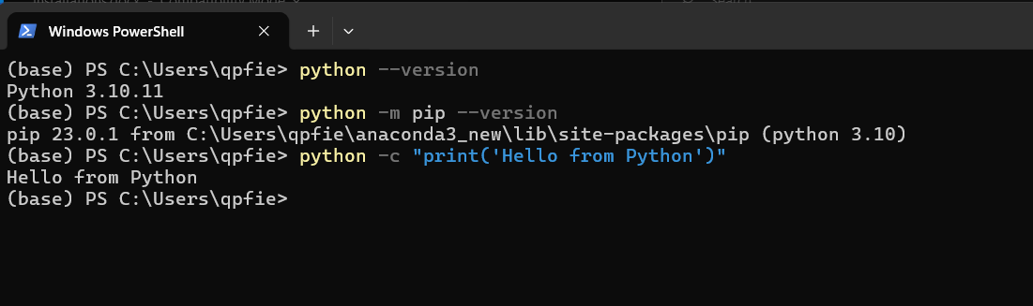
macOS / Linux
python3 --version
python3 -m pip --version
python3 -c "print('Hello from Python')"
Check: You see Python 3.12.x, a pip version, and Hello from Python.

Step 4 — Create a virtual environment for the project (recommended)
A virtual environment (.venv) is a private folder of Python packages for one project. It keeps this project's packages separate from every other project on your computer. Create it once, inside the project folder.
Windows (PowerShell)
cd C:\Users\<you>\PycharmProjects\AI_Tur\mt-01-the-odyssey
python -m venv .venv
.venv\Scripts\Activate.ps1
If PowerShell says "running scripts is disabled on this system", allow local scripts once, then activate again:
Set-ExecutionPolicy -ExecutionPolicy RemoteSigned -Scope CurrentUser
macOS / Linux
cd ~/path/to/mt-01-the-odyssey
python3 -m venv .venv
source .venv/bin/activate
Check: Your prompt now starts with (.venv). Run deactivate to leave the environment. Activate it again every time you open a new terminal.

Step 5 — Install the project packages and create .env (Important)
With (.venv) active, on any OS => In the terminal (PowerShell, Command Prompt):
python -m pip install --upgrade pip
pip install -r requirements.txt
Create your private settings file from the template.
Windows
Copy-Item .env.example .env
macOS / Linux
cp .env.example .env
Important: .env holds your API keys and is listed in .gitignore. Never commit .env and never paste its contents into a chat.

Step 6 — First run (recommended)
1. Create a file hello.py containing print("Hello, Odyssey!") and run it with python hello.py.
2. Start the project API (keep this terminal open).
macOS / Linux
make run
Windows (make is not installed by default, so run the same command directly)
uvicorn src.main:app --reload --host 0.0.0.0 --port 8000
3. Open http://localhost:8000/docs in your browser. You should see the Swagger UI page.
4. In a second terminal, check the health endpoint:
curl -s localhost:8000/health # macOS / Linux
curl.exe -s localhost:8000/health # Windows PowerShell
Check: The response contains "status":"ok". Press Ctrl + C in the first terminal to stop the server. Note: make test currently shows 2 passed, 3 errors. This is expected and is fixed in session 02 (see README.md).
Potential Project folders after this step
mt-01-the-odyssey/
├── .venv/ ← virtual environment (private, not committed)
├── .env ← your settings and keys (private, not committed)
├── .env.example ← template for .env (committed)
├── requirements.txt ← list of Python packages
├── Makefile ← shortcuts: make run, make test, make lint
├── src/
│ ├── main.py ← FastAPI entry point
│ ├── config.py ← reads settings from .env
│ ├── api/ models/ services/ agents/
├── tests/ ← automated tests (pytest)
└── docs/ ← course material and this guide

1.2 Visual Studio Code (VS Code)

Step 1 — Download and install
Windows
winget install -e --id Microsoft.VisualStudioCode
Or
If you use the installer from code.visualstudio.com/download, tick "Add to PATH" and "Add 'Open with Code' action".
macOS
brew install --cask visual-studio-code
Then open VS Code, press Cmd + Shift + P, and run "Shell Command: Install 'code' command in PATH".
Linux
sudo snap install code --classic
Or download the .deb file from code.visualstudio.com and run sudo apt install ./code_*.deb.

Step 2 — Test the installation
code –version
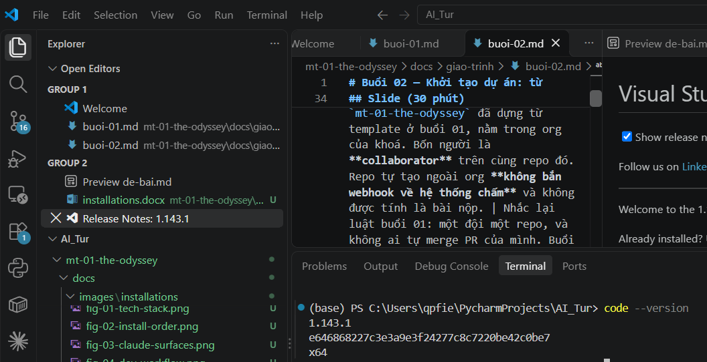
Check: A version number is printed. Inside the project folder, code . opens the whole folder in VS Code.

Step 3 — Install the recommended extensions
Extension | ID | Purpose
Python | ms-python.python | Run and debug Python, select the interpreter
Pylance | ms-python.vscode-pylance | Fast autocompletion and type hints
Ruff | charliermarsh.ruff | Lint and format Python (used by this repo)
Claude Code | anthropic.claude-code | Claude inside VS Code (see 1.3.3)
Docker | ms-azuretools.vscode-docker | Manage containers and Dockerfiles
ESLint | dbaeumer.vscode-eslint | Find problems in JavaScript/TypeScript
Prettier | esbenp.prettier-vscode | Format frontend code

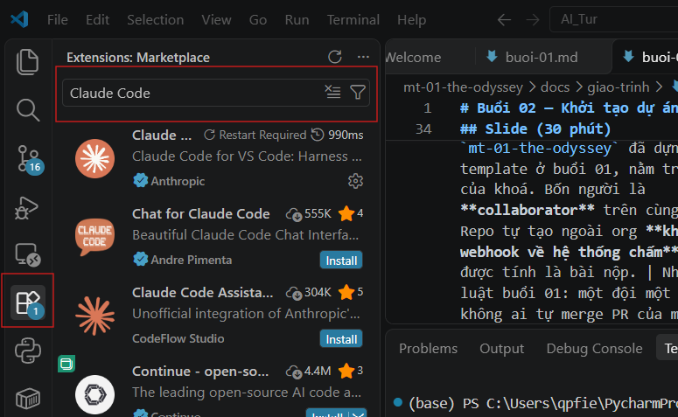
Or
Install them all at once from a terminal (same on every OS):
code --install-extension ms-python.python
code --install-extension ms-python.vscode-pylance
code --install-extension charliermarsh.ruff
code --install-extension anthropic.claude-code
code --install-extension ms-azuretools.vscode-docker
code --install-extension dbaeumer.vscode-eslint
code --install-extension esbenp.prettier-vscode

Step 4 — Open the project and select the Python interpreter
1. File → Open Folder… and choose mt-01-the-odyssey.
2. Press Ctrl + Shift + P (macOS: Cmd + Shift + P) → Python: Select Interpreter → choose the one inside .venv.
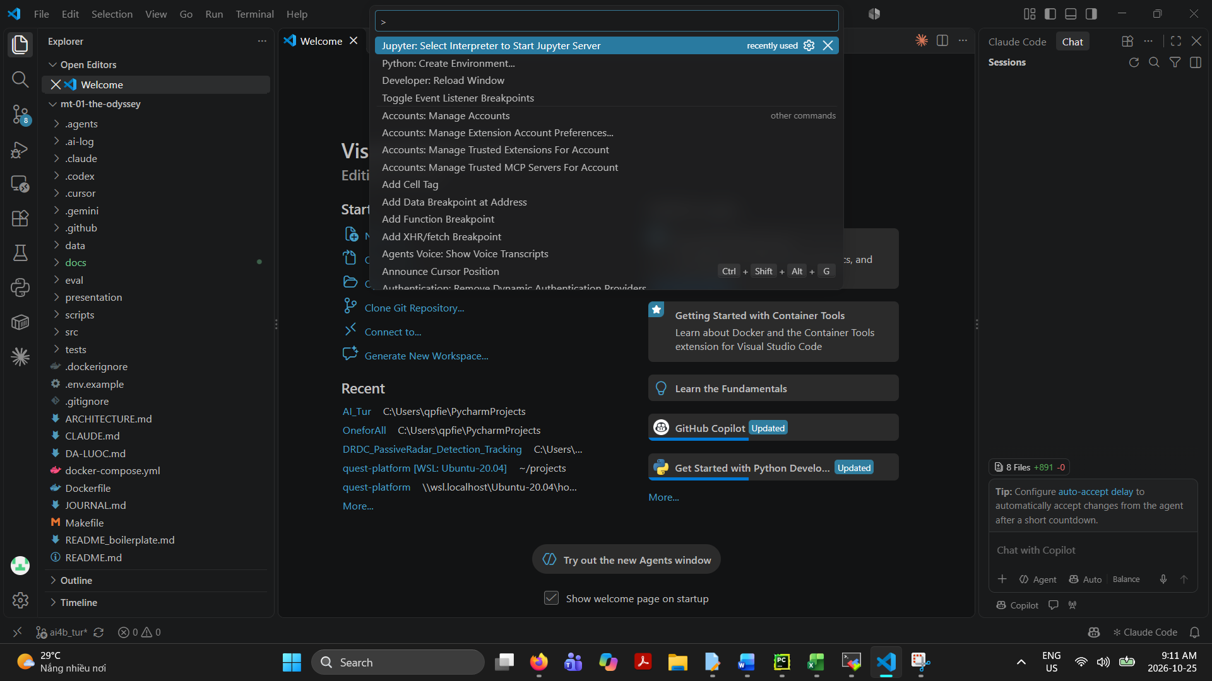
3. Open the built-in terminal with Ctrl + ` (backtick). It activates .venv automatically.

Step 5 — First run
1. Open hello.py.
2. Click the ▶ Run Python File button at the top right. The output appears in the terminal panel.
3. To debug, click to the left of a line number to set a red breakpoint, then press F5.
Or
Run in Terminal
Python hello.py
Tip: The .vscode/ folder is in .gitignore, so your personal editor settings are never pushed to the team.

1.3 Claude
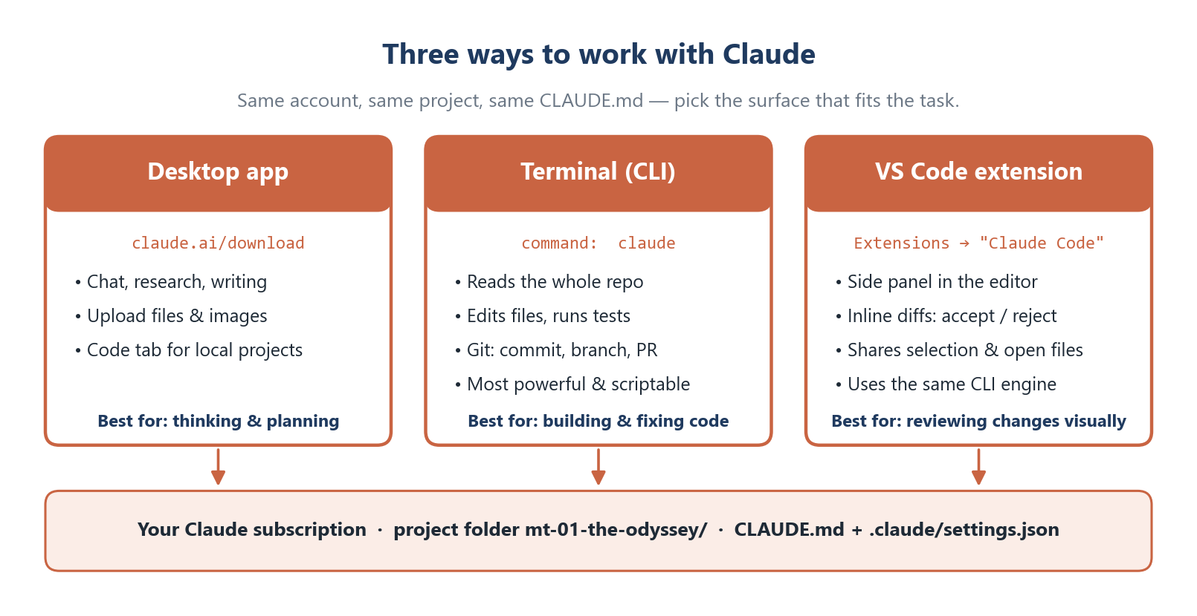
Figure 3. The three ways to use Claude and what each is best for.
Account: Claude Code needs a paid Claude Pro, Max, Team or Enterprise plan, or a Claude Console (API) account. Check the current plans at claude.com/pricing.

1.3.1 Claude Code in the terminal (most important)
Step 1 — Prerequisites. On Windows, install Git for Windows first (section 1.4.1). Claude Code uses Git Bash to run commands. Nothing extra is needed on macOS or Linux. (https://code.claude.com/docs/en/overview#vs-code)
Step 2 — Install. Use the native installer, which updates itself automatically.
Windows (PowerShell)
irm https://claude.ai/install.ps1 | iex
Windows (Command Prompt)
curl -fsSL https://claude.ai/install.cmd -o install.cmd && install.cmd && del install.cmd

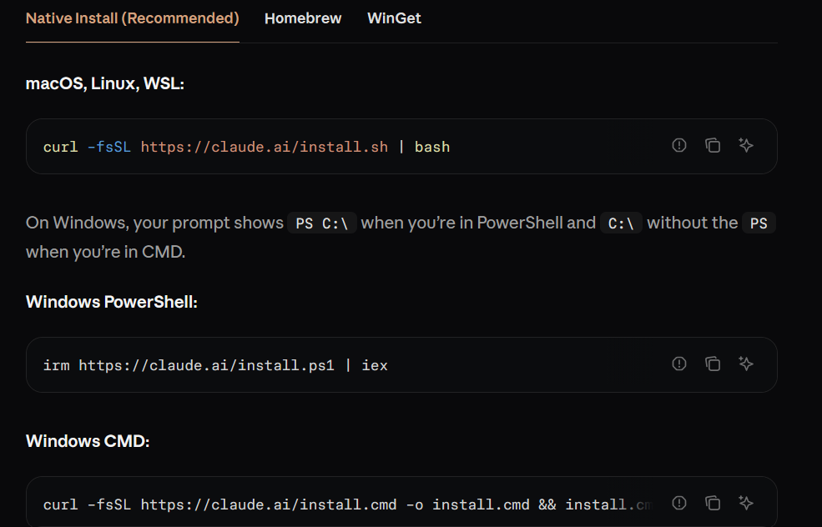
macOS / Linux / WSL
curl -fsSL https://claude.ai/install.sh | bash
Alternatives: brew install --cask claude-code (macOS), winget install Anthropic.ClaudeCode (Windows), or npm install -g @anthropic-ai/claude-code (any OS with Node.js 18+).
Step 3 — Environment variable (PATH). The native installer places the claude program in ~/.local/bin (Windows: %USERPROFILE%\.local\bin). If claude is not recognized, add that folder to PATH as shown in section 1.1 Step 2, then reopen the terminal.
Step 4 — Test the installation
claude --version
claude doctor

- Click on this symbol in the VSC to open the terminal block
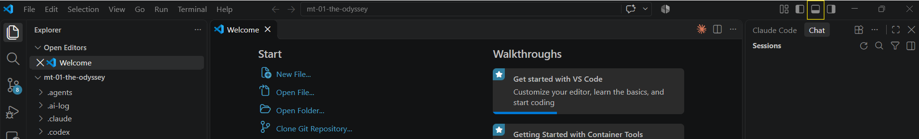
- Test the installation with above commands
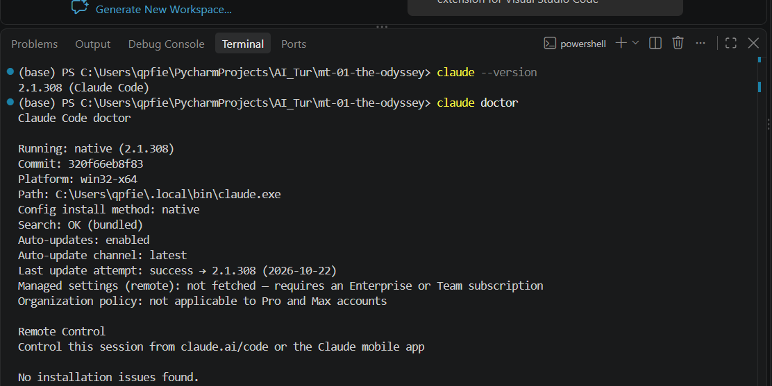
Check: A version number is printed, and claude doctor reports no errors.
Step 5 — First run and login
cd mt-01-the-odyssey
claude
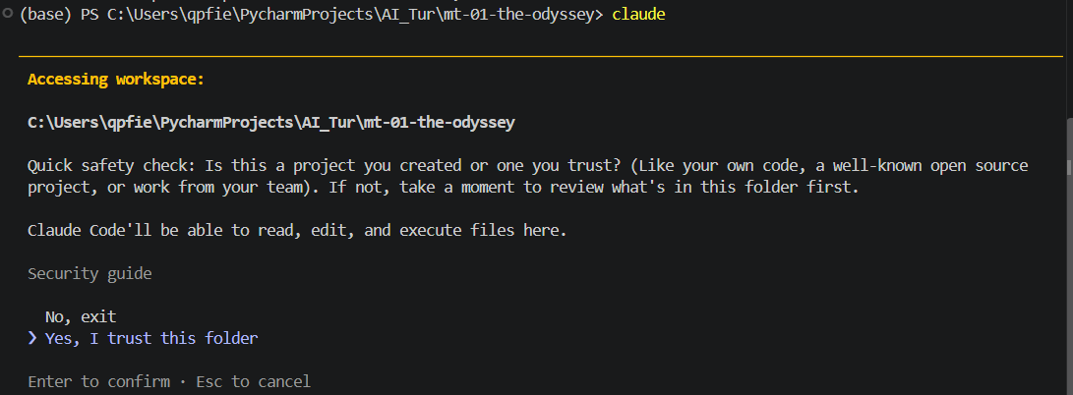
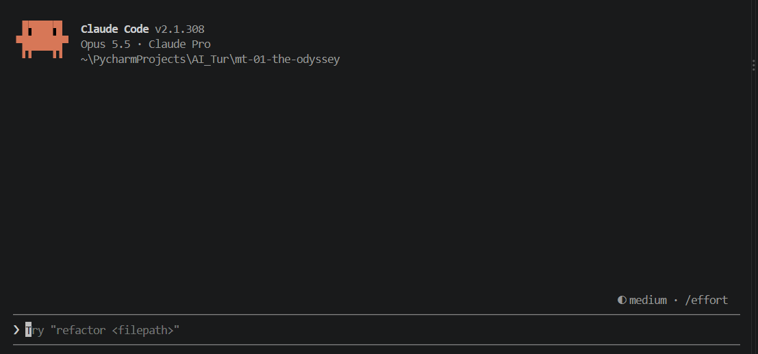
Ten Ten. We almost finished the set-up :D !!!
Note: For the new user, we need to choose a login method (your Claude subscription, or Console account). A browser window opens; sign in and approve.

Important: This repo already has a CLAUDE.md, so Claude follows the course rules automatically. Do not run /init here, because it would rewrite that file. Use /init only in a new project to generate a first CLAUDE.md.
Essential commands
Command / key | What it does
Claude | Start an interactive session in the current folder
claude "explain src/main.py" | Start a session with a first question
claude -p "summarise README.md" | One-shot answer, then exit (good for scripts)
claude -c | Continue the most recent conversation
claude -r | Pick an older conversation to resume
claude update | Update to the latest version
/help | List all commands
/clear | Start a fresh conversation (frees context)
/compact | Summarise the conversation to save context
/model | Choose the Claude model
/memory | Edit the CLAUDE.md memory files
/login · /logout | Switch account
@path/to/file | Point Claude at a specific file
!command | Run a shell command yourself; output goes into the chat
Shift + Tab | Switch permission mode (normal / auto-accept edits / plan)
Esc | Stop Claude; Esc Esc goes back to an earlier message

Files and folders Claude uses
mt-01-the-odyssey/
├── CLAUDE.md ← project instructions, shared with the team (committed)
├── .claude/
│ ├── settings.json ← shared project settings and hooks (committed)
│ ├── settings.local.json ← your personal overrides (not committed)
│ ├── commands/ ← optional custom slash commands
│ └── agents/ ← optional custom subagents
└── .agents/rules/ ← course rules referenced by CLAUDE.md
~/.claude/ ← your user folder (all projects)
├── settings.json ← personal global settings
└── CLAUDE.md ← personal instructions for every project
Note: .claude/settings.json in this repo runs AI-logging hooks with bash. On Windows these need Git Bash (installed with Git). Install the Git push hook once after cloning: bash scripts/setup_hooks.sh (macOS/Linux/Git Bash) or powershell -ExecutionPolicy Bypass -File scripts\setup_hooks.ps1 (Windows).

1.3.2 Claude Desktop app
Step 1 — Download and install.
- Windows: download the installer from claude.ai/download and run it.
- macOS: download the .dmg from claude.ai/download and drag Claude into Applications.
- Linux: there is no official desktop app. Use claude.ai in your browser together with Claude Code in the terminal.
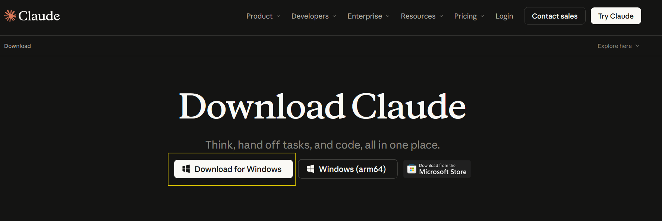
Step 2 — Sign in and test. Open Claude and sign in with the same account.
Step 3 — First run with the project. Use the chat for planning, explanations and documents; attach files with the paperclip icon. To work on code from the app, open the Code tab, choose the mt-01-the-odyssey folder, and describe the task. It runs the same Claude Code engine as the terminal.

1.3.3 Claude Code extension for VS Code
Step 1 — Install. In VS Code, open Extensions (Ctrl + Shift + X, macOS Cmd + Shift + X), search "Claude Code", check that the publisher is Anthropic, and click Install. From a terminal you can run:
code --install-extension anthropic.claude-code
Step 2 — Open and sign in. Click the Claude (spark) icon in the editor toolbar or sidebar, or press Ctrl + Shift + P → "Claude Code: Open". Sign in when asked.
Step 3 — First run.
1. Open src/main.py and select a few lines.
2. In the Claude panel, ask "Explain the selected code". Claude sees your selection automatically.
3. Ask for a small change, for example "Add a docstring to this function". Claude shows the change as a diff: review it, then Accept or Reject.
Tip: Running claude in the VS Code built-in terminal also connects to the editor, so diffs open in VS Code. Requires VS Code 1.98 or newer.

1.3.4 Which one should I use?
 | Desktop app | Terminal (CLI) | VS Code extension
Best for | Planning, research, writing | Building, testing, Git work | Reviewing changes visually
Reads project files | In the Code tab | Yes | Yes
Edits files / runs commands | In the Code tab | Yes | Yes
Start it with | Claude app icon | Claude | Spark icon in VS Code
=> Terminal is priority.

1.4 Other tools

1.4.1 Git
Step 1 — Download and install
Windows
winget install -e --id Git.Git
Keep the default options in the installer. They include Git Bash and Git Credential Manager.
Or
Download directly from the website: https://git-scm.com/install/
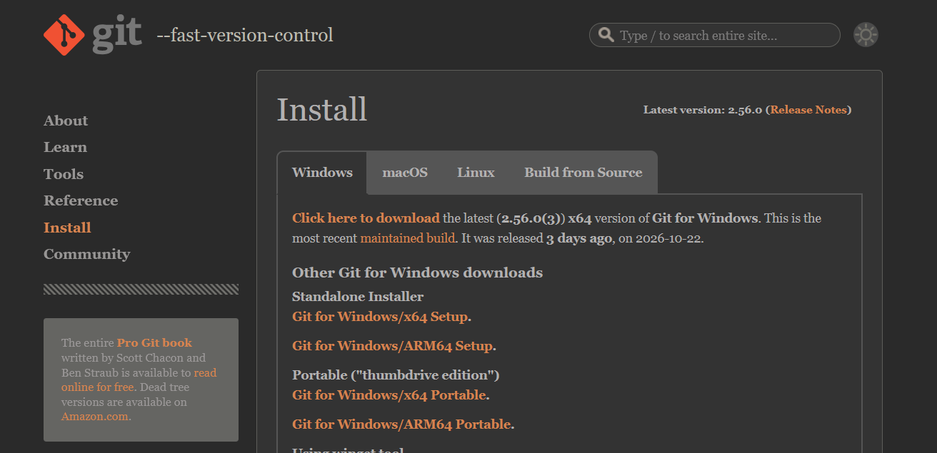
macOS
brew install git
Linux
sudo apt install -y git
Step 2 — Test and configure (once per computer)
git --version
git config --global user.name "Your Name"
git config --global user.email "you@example.com"
git config --global init.defaultBranch main

Open Git bash
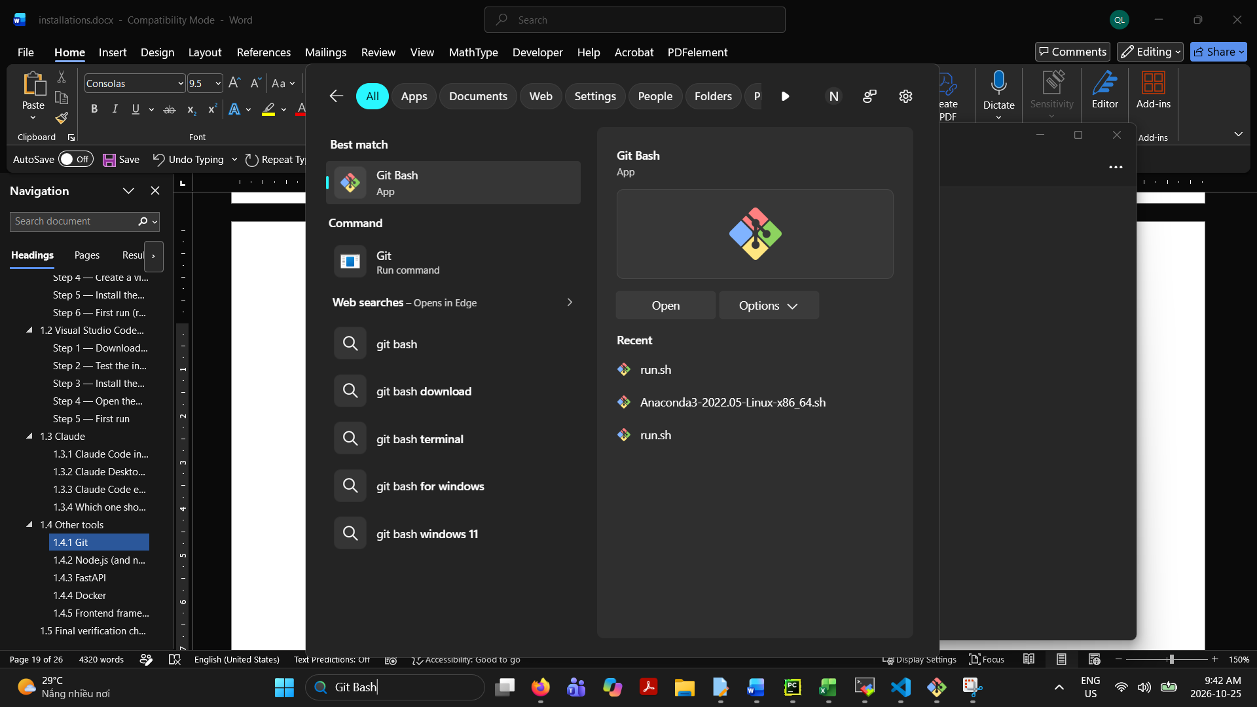
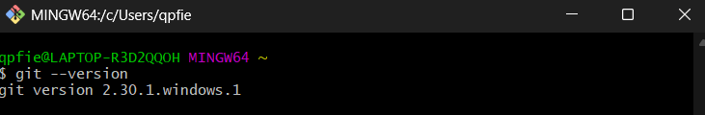
Check: git --version prints a version, and git config --global --list shows your name and email. Use the same email as your GitHub account.
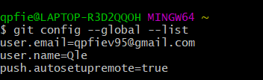
Step 3 — Connect to GitHub. The first git push opens a browser window to sign in to GitHub (Git Credential Manager). If it fails, install the GitHub CLI and sign in with it. When asked, choose GitHub.com → HTTPS → Login with a web browser.
winget install -e --id GitHub.cli # Windows
brew install gh # macOS
gh auth login # all systems
On Linux, follow the GitHub CLI install instructions at cli.github.com.
Error 403 "Permission denied": you signed in, but your account has no Write access. Accept the repository invitation on GitHub, or ask the owner to give you Write access.
Step 4 — First run: clone and work on the team branch
git clone https://github.com/UEH-ISB/mt-01-the-odyssey.git
cd mt-01-the-odyssey
git switch ai4b_tur # use the team branch
git pull # get the latest changes
# ... edit files ...
git status # see what changed
git add .
git commit -m "docs: describe your change"
git push
When the work is ready, open GitHub → Pull requests → New pull request, set base: main and compare: ai4b_tur, and ask a teammate to review and merge.
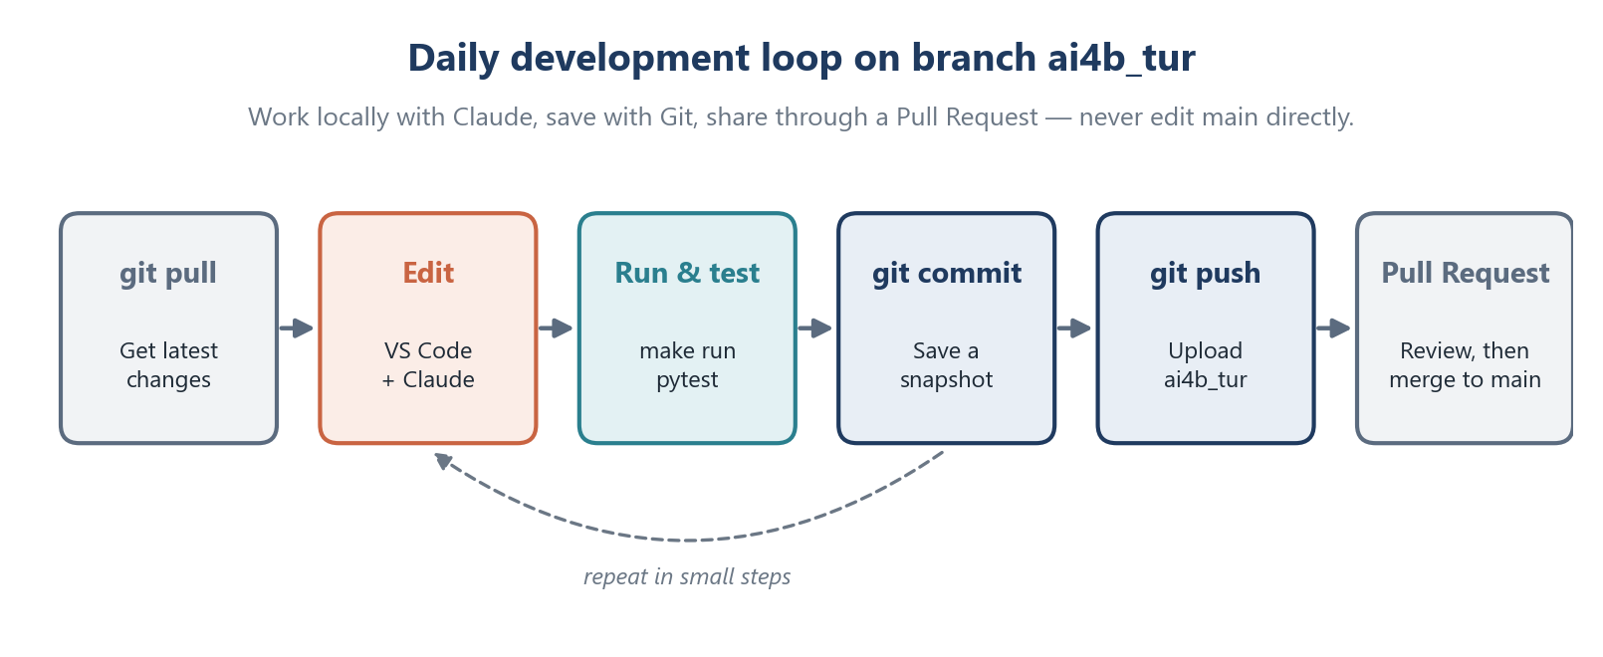
Figure 4. The daily development loop on the team branch.

1.4.2 Node.js (and npm)
Install the current LTS (Long-Term Support) version. Next.js needs Node.js 20.9 or newer.
Step 1 — Download and install
Windows
winget install -e --id OpenJS.NodeJS.LTS
macOS
brew install node
Linux (with nvm, the Node Version Manager)
curl -o- https://raw.githubusercontent.com/nvm-sh/nvm/v0.40.1/install.sh | bash
source ~/.bashrc
nvm install --lts
Step 2 — Test
node -v
npm -v
npx -v
Check: Three version numbers are printed (for example v22.x, 10.x, 10.x). On Windows, if npm is blocked by "running scripts is disabled", use the Set-ExecutionPolicy command from section 1.1 Step 4.
Step 3 — First run. Create hello.js containing console.log("Hello from Node.js"); and run node hello.js.

1.4.3 FastAPI
FastAPI is a Python package, so it is installed inside the virtual environment and the steps are the same on every OS. In this repo it is already listed in requirements.txt. The steps below show how to start a FastAPI app from scratch.
Step 1 — Install (with (.venv) active)
pip install "fastapi[standard]"
Step 2 — Test
python -c "import fastapi; print(fastapi.__version__)"
Step 3 — Create a first app in a file named main.py:
from fastapi import FastAPI
app = FastAPI()
@app.get("/")
def read_root():
return {"message": "Hello, Odyssey!"}
@app.get("/items/{item_id}")
def read_item(item_id: int, q: str | None = None):
return {"item_id": item_id, "q": q}
Step 4 — First run
fastapi dev main.py
Check: Open http://127.0.0.1:8000 to see {"message":"Hello, Odyssey!"}, and http://127.0.0.1:8000/docs to try the API interactively. For the project itself, use make run (or the uvicorn command in section 1.1 Step 6).

1.4.4 Docker
Step 1 — Download and install
Windows — Docker Desktop runs on WSL 2. Open PowerShell as Administrator:
wsl --install
winget install -e --id Docker.DockerDesktop
Restart the computer, open Docker Desktop, and accept the terms. Keep "Use WSL 2 based engine" turned on.
macOS — download Docker Desktop for your chip (Apple silicon or Intel) from docs.docker.com, open the .dmg, and drag Docker into Applications. Start Docker from Applications.
Linux — install Docker Engine and allow your user to run it without sudo:
curl -fsSL https://get.docker.com -o get-docker.sh
sudo sh get-docker.sh
sudo usermod -aG docker $USER
newgrp docker
Step 2 — Test
docker --version
docker compose version
docker run hello-world
Check: The last command prints "Hello from Docker!". On Windows and macOS, Docker Desktop must be running first (whale icon in the taskbar or menu bar).
Step 3 — First run with the project. The repo includes a Dockerfile and docker-compose.yml. Make sure .env exists (section 1.1 Step 5), then:
docker compose up --build
Open http://localhost:8000/health. Stop with Ctrl + C, then remove the containers with docker compose down.

1.4.5 Frontend frameworks: Next.js and React
Both need Node.js (section 1.4.2), and the commands are the same on Windows, macOS and Linux. Run them in the folder where you want the new app to be created.
Option A — Next.js (recommended, full-stack React framework)
npx create-next-app@latest frontend
Accept the recommended defaults: TypeScript, ESLint, Tailwind CSS, App Router. Then start it:
cd frontend
npm run dev
Check: Open http://localhost:3000 to see the Next.js start page. Edit app/page.tsx, save, and the page updates immediately.
Option B — React with Vite (lightweight single-page app)
npm create vite@latest frontend-react -- --template react-ts
cd frontend-react
npm install
npm run dev
Check: Open http://localhost:5173.
Typical Next.js folder structure
frontend/
├── app/
│ ├── layout.tsx ← shared page layout (HTML skeleton)
│ ├── page.tsx ← home page (React + TypeScript)
│ └── globals.css ← global styles (CSS / Tailwind)
├── public/ ← images and static files
├── package.json ← npm scripts and dependencies
└── .env.local ← NEXT_PUBLIC_API_URL=http://localhost:8000 (not committed)
Connecting to the backend: .env already allows the frontend addresses http://localhost:3000 and http://localhost:5173 in CORS_ORIGINS, so the browser may call the FastAPI backend on port 8000.

1.5 Final verification checklist
Run each command in a new terminal. Tick the box when the expected result appears.
# | Command | Expected result
1 | git --version | git version 2.x
2 | python --version (macOS/Linux: python3) | Python 3.12.x
3 | code --version | VS Code version number
4 | claude --version | Claude Code version number
5 | claude doctor | No errors reported
6 | node -v and npm -v | v20.9 or newer, and an npm version
7 | docker run hello-world | Hello from Docker!
8 | make run (Windows: uvicorn command) → open /docs | Swagger UI page loads
9 | curl localhost:8000/health (Windows: curl.exe) | "status":"ok"

Ports used in development
Port | Service
8000 | FastAPI backend (/docs, /health)
3000 | Next.js frontend
5173 | React + Vite frontend
5432 | PostgreSQL database (if used)

2. References
Claude
- Claude Code overview — https://code.claude.com/docs/en/overview
- Claude Code quickstart — https://code.claude.com/docs/en/quickstart
- Claude Code changelog — https://code.claude.com/docs/en/changelog
- Set up Claude Code (install, update, uninstall) — https://code.claude.com/docs/en/setup
- Claude Code in VS Code — https://code.claude.com/docs/en/vs-code
- Claude Code on desktop — https://code.claude.com/docs/en/desktop
- Memory and CLAUDE.md — https://code.claude.com/docs/en/memory
- Settings — https://code.claude.com/docs/en/settings
- CLI reference — https://code.claude.com/docs/en/cli-reference
- Common workflows — https://code.claude.com/docs/en/common-workflows
- Troubleshooting — https://code.claude.com/docs/en/troubleshooting
- Download the Claude apps — https://claude.ai/download
Python
- Downloads — https://www.python.org/downloads/
- Using Python on Windows — https://docs.python.org/3/using/windows.html
- venv — virtual environments — https://docs.python.org/3/library/venv.html
- Installing packages — https://packaging.python.org/en/latest/tutorials/installing-packages/
Visual Studio Code
- Setup overview — https://code.visualstudio.com/docs/setup/setup-overview
- Python in VS Code — https://code.visualstudio.com/docs/python/python-tutorial
Git and GitHub
- Git downloads — https://git-scm.com/downloads
- Pro Git book — https://git-scm.com/book/en/v2
- Set up Git (GitHub) — https://docs.github.com/en/get-started/git-basics/set-up-git
- About pull requests — https://docs.github.com/en/pull-requests
- GitHub CLI — https://cli.github.com/
Node.js
- Download Node.js — https://nodejs.org/en/download
- nvm (Node Version Manager) — https://github.com/nvm-sh/nvm
- npm documentation — https://docs.npmjs.com/
FastAPI
- FastAPI documentation — https://fastapi.tiangolo.com/
- Tutorial: first steps — https://fastapi.tiangolo.com/tutorial/first-steps/
Docker
- Get Docker — https://docs.docker.com/get-started/get-docker/
- Docker Desktop on Windows — https://docs.docker.com/desktop/setup/install/windows-install/
- Docker Desktop on Mac — https://docs.docker.com/desktop/setup/install/mac-install/
- Docker Engine on Ubuntu — https://docs.docker.com/engine/install/ubuntu/
- Linux post-install steps — https://docs.docker.com/engine/install/linux-postinstall/
- Install WSL — https://learn.microsoft.com/en-us/windows/wsl/install
Next.js and React
- Next.js installation — https://nextjs.org/docs/app/getting-started/installation
- Learn React — https://react.dev/learn
- Vite guide — https://vite.dev/guide/
Web languages and SQL
- HTML (MDN) — https://developer.mozilla.org/en-US/docs/Web/HTML
- CSS (MDN) — https://developer.mozilla.org/en-US/docs/Web/CSS
- JavaScript (MDN) — https://developer.mozilla.org/en-US/docs/Web/JavaScript
- TypeScript handbook — https://www.typescriptlang.org/docs/
- PostgreSQL documentation — https://www.postgresql.org/docs/
- SQLite documentation — https://www.sqlite.org/docs.html
Package managers and other AI tools
- winget — https://learn.microsoft.com/en-us/windows/package-manager/winget/
- Homebrew — https://brew.sh/
- ChatGPT help center — https://help.openai.com/
- OpenAI Codex — https://developers.openai.com/codex
- Cursor — https://cursor.com/
- Gemini CLI — https://github.com/google-gemini/gemini-cli

Appendix A — Troubleshooting
Read the ERROR line (or the last line of a Python Traceback) first, and ignore [notice] and WARNING lines. Paste the error as text, not as a screenshot, when asking a teammate or Claude for help.
Problem | Likely cause | Fix
python / claude / code is not recognized or command not found | Program folder not on PATH | Add the folder to PATH (1.1 Step 2), then reopen the terminal
Typing python opens the Microsoft Store | Windows app execution alias | Turn off the python aliases (1.1 Step 2)
Activate.ps1 cannot be loaded… running scripts is disabled | PowerShell execution policy | Set-ExecutionPolicy -ExecutionPolicy RemoteSigned -Scope CurrentUser
pip install puts packages in the wrong place | .venv not active | Activate .venv, then use python -m pip install …
make: command not found on Windows | make is not installed | Use the uvicorn … command from 1.1 Step 6
Address already in use / port 8000 busy | Another server is running | Stop it with Ctrl + C, or use --port 8001
git push → 403 Permission denied | No Write access to the repo | Accept the GitHub invitation or ask the owner for Write access
docker: Cannot connect to the Docker daemon | Docker is not running | Start Docker Desktop (or sudo systemctl start docker on Linux)
Claude Code hooks fail on Windows with bash errors | Git Bash missing | Install Git for Windows (1.4.1), then restart the terminal

