# The Hand of Noxus

Create a Web page (HTML5 + CSS3) that looks and behaves like the screenshot below:

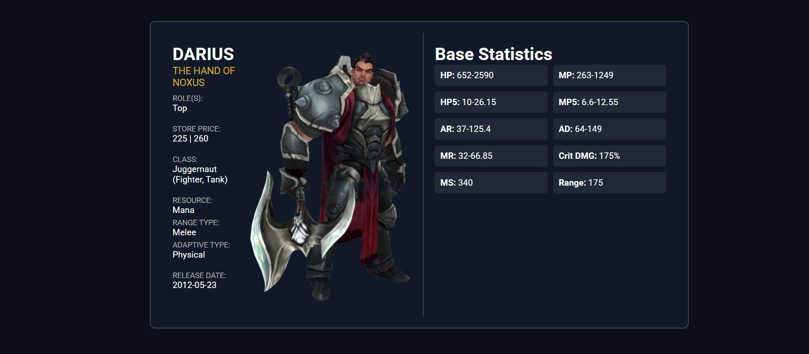

## Output

The output should be valid **HTML5** + **CSS3** + **images** that implement the above web page.

* Use the Google fonts **Roboto**- ([https://fonts.googleapis.com/css2?family=Roboto&display=swap](https://fonts.googleapis.com/css2?family=Margarine&display=swap))
* The site should open correctly in the **latest** version of **Chrome**