# 02.Wildlife Wonders

You are given an unresponsive website (**HTML** + **CSS** + images). Your task is to **make the site responsive**.

The site layout should change according to the browser viewport / screen size.

You need to implement 1 layout: **width <= 600p.** The figures below represent this layout:

* **width <= 600px (mobile)**

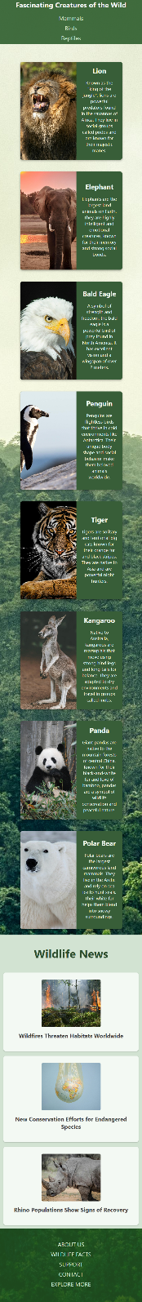

## Output

The output should be valid **HTML5** + **CSS3** + **images** that implement the above responsive site.

## Constraints

* You should write styles **only** in responsive.css file.
* The site should open correctly in the **latest** version of **Chrome**