# WanderSphere

Create a Web page (HTML5 + CSS3 + images) that looks and behaves like the screenshot below:

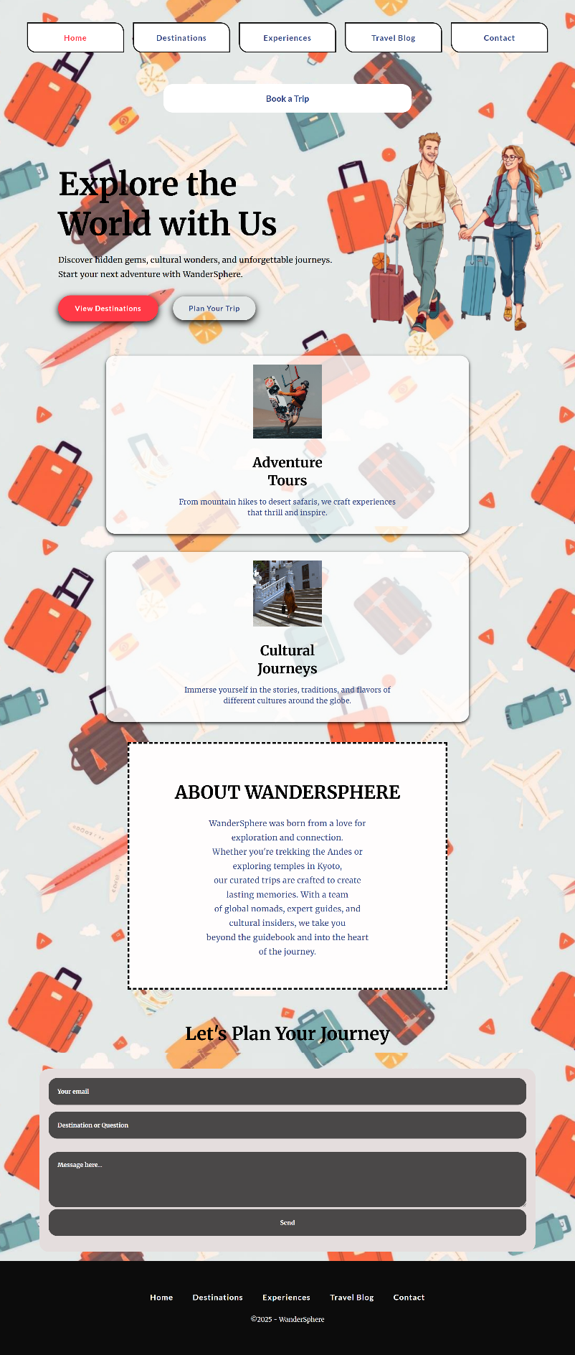

You are given the above screenshots + all required images.

## Output

The output should be valid **HTML5** + **CSS3** + **images** that implement the above web page.

## Constraints

* Use font 'Merriweather' for the text and font 'Lato' for the buttons – (https://fonts.googleapis.com/css2?family=Merriweather:wght@300;400;700&display=swap)  
  (https://fonts.googleapis.com/css2?family=Lato:wght@400;700&display=swap)
* The site should open correctly in the latest version of Chrome