Student Name | Student ID
Sudhir Joshi | 30101044
Chandan Plaha | 30096799

2013
Software Requirements Specification ( SRS)

Project: Flash Maze Game

Table of Contents
1 INTRODUCTION 4
2 PROJECT OVERVIEW 4
2.1 PURPOSE 4
2.2 CLIENT 4
2.3 Business Context 4
2.1 SCOPE 5
2.2 User Characteristics 5
2.3 Acceptance criteria - 5
3.0 Assumption, Dependencies, Constraints 5
3.1 Dependencies 6
3.2 Constraints 6
4.0 Abbreviations 6
5.0 HIGH CONCEPT STATEMENT 7
5.1 Features 7
5.2 Overview 8
Player Motivation 8
Genre 8
Target market 8
Competition 8
Unique Selling Points 8
Target Hardware 8
Design Goals 9
Visibility 9
Simplicity 9
Further Information 9
Sales pitch 9
6.0 Core storyline 10
7.0 Use Case Diagram 10
7.1 Use case – 1 Login and manage profile 11
7.2 UC-2: instructions 12
7.3 UC-3: Game menu and welcome message 13
Game Levels 14
7.4 UC-4: play game 14
7.5 UC-5: sound level 15
7.6 UC-6: contact us form 16
7.7 Use case-7 Administer level 16
8 FUNCTIONAL REQUIREMENTS 17
9 Functional requirements in details 18
10 Non-Functional Requirements 20
10.2 Non-functional Requirements 20
10.3 Performance Requirements 21
10.4 Logical Data Requirements 21
10.5 User Requirements 21
10.6 Information Management Requirements 21
10.7 Systems Requirements 22
Performance Requirement 22
Quality Requirements 22
Interfaces 22
Software Requirements 22
Client-side 22
Server-side 22
10.8 Database Requirements: 22
11 Data descriptions 23
11.2 Dataflow diagram 25
11.3 Data flow diagram (DFD-1) 25
11.4 Data flow diagram (DFD-2) 26
Software Requirements 27
Client-side 27
Server-side 27
11.5 Database Requirements: 28
8.2 Description of textures 28
12 Reference 30
13 Revision History 31

INTRODUCTION
The purpose of the project is to create a Flash maze game for kids, where in the idea is to provide personalized timetables to the students .As of now there will be three stages in game and before starting game player has to input their Names so that score will be stored .The game shall provide different facilities to the Player.
User have three level which they can choose by themselves or else user has to complete easy level and will moved to medium level and the final hard level. There will be time frame in which they have to complete. As game is based for kids, so the character we will be using will be cartoons. Main objective of game is to find the way out or else we can say have to reach final point from start on given time without crashing with any obstacles.

PROJECT OVERVIEW

PURPOSE
The purpose of this Software Requirements Specification (SRS) is to provide a design of Flash maze game for kids. This document will provide the Client and the user with a basic understanding about the game’s performance and its goals.

CLIENT
The audience of this document will be the client (Hari Kiran Vege) and its user (gamers).
Hari Kiran Vege Head of IT department of Australian Technical and Management College (ATMC) who have wide experience of Programming, Database and all.

Business Context
The development of this game is for the first project in Project 1 class at ATMC Melbourne (University of Ballarat)

SCOPE
We are developing Maze game in flash.
The project will be developed using Flash CSS with AS3.
We are going to program character to move through the mazes in the game.
Our final product will deliver requirement, design documents and user document, codes and an executable file.

User Characteristics
Devices: Keyboard
Game Mode: Single Player Mode.
Action: Walk, Win/Loose, Collect Gems, Hit and fail
Location: Maze

Acceptance criteria -
User should able to enter the name.
Have to complete first level in a given time frame

Assumption, Dependencies, Constraints

Dependencies
  - The speed of game will vary upon different CPU
  - Flash player or its plugins is necessary

Constraints
- A prototype presentation of the complete application must be delivered and operational at the end of the semester (week 12)

Abbreviations

SRS | System Requirement Specifications
PM | Project Manager
SCD | System Context Diagram
DFD | Data Flow Diagram
ERD | Entity Relationship Diagram
UC | Use Case
FR | Functional Requirements
NFR | Non Functional Requirements

HIGH CONCEPT STATEMENT

Family guy maze game is a challenging and addictive puzzler game that teases everybody’s brain. Strategically pop the character to find out a way through the maze, each character passes the level add one point. The strategy is complete given maze in the given time to compete in the next level.

Features
Family guy is a puzzle single player game that gives every player the thrill of creating a strategy in order to complete all the three levels
- The game has a pleasant view, as bright colors have been used
- It has 3 levels, with increased difficulty (demo version)
- The game starts with by entering a name of the player.
- score and will be added as the level increases
- if a given time frame finishes game finishes and player looses
- game can be played with a keyboard and also have mouse pointer interface
- • The strategy is very important in order to finish all the three levels
- The player gains score after each level
- once all the level finishes games finishes
- if player loses at level 3 game starts from scratch
- Home screen features cartoon jpeg images

Overview

Player Motivation
The player has to develop the right strategy in order to advance to the next level. As every level increase game time frame will be cut down. Player will be motivated by giving those scores.

Genre
Family guy game will be classified as a puzzle game, falling under the maze-logic subgenre,
As it is a brainteaser for every player. The game can be played by only one person at a
Time, and it is designed, like any other puzzle games, to fill the bits of free time from
People’s schedule (i.e. Commuting, breaks).

Target market
The target market for this game is very wide. It can be played by adults as well as by
Children’s, no matter their motor and cognitive skills, attention spans, or linguistic
Abilities. It targets any individual that enjoys playing this genre of game but it is mainly focused for the kids as this game is based on cartoon named Family Guy.

Competition
Family guy gives competition to same level flash games

Unique Selling Points
Version 1 will be free
Small size game
Even age level between 4 -6 can also play the game

Target Hardware
This game been developed mainly for windows which require flash plugins to play the game.

Design Goals
The graphic elements are made out of bright colors that can appeal to any age category (children and adults).On each level the player is welcomed by new scenery. The three cartoon images will include in the background of all three levels.

Visibility
The camera model, players being able to view the entire window. The graphical elements, specific to level they are playing, in the same frame.

Simplicity
Very simple control system, players need to touch the keyboard arrow they wish to move, making this an easy game to learn and play.

Further Information
Family guy Maze game is a linear, objective driven type of game. The player is lead through a fixed route, in which progress becomes harder and harder.

Sales pitch
First version of game will be free
Designed for kids
Brain exercise

Core storyline

Peter the name of character from the game family guy. Who has moved into a new town and while coming from his job he gets lost on the way, so he has to find a way to his home by going through series of maze (zig-zag)

Use Case Diagram

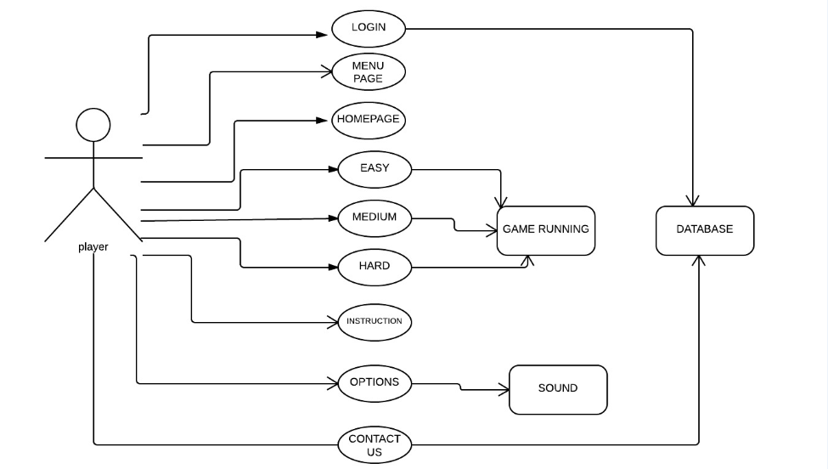

7.1 Use case – 1 Login and manage profile

Name | UC-1: Manage Profile
Summary | Player can change information into their profiles and Admin will allow them to make changes, which include player name and character
Actor | All Users
Pre-Condition | Profile and record must exist
Basic course of Event | - User opens the game in the flash player  - The system displays enter the name box  - User will input the necessary data into the box.  System will update the record .
Post- Condition | - User receives the notification that he has entered in the game

user

Enter the name

UC-2: instructions

Name | UC-2: instruction box
Summary | User can look for the instructions by clicking instruction button
Actor | User
Pre-Condition | Instruction box will be displayed
Basic course of Event | - User can memorize the controls  - User can go back to enter the name box
Post- Condition | Clicking on back button player will be left onto enter the name or manage profile box

User

Instructions provided

UC-3: Game menu and welcome message

Name | UC-3:welcome message and game menu
Summary | Player can check his profile name and game menu( image no-001 in appendix) will be displayed
Actor | Game
Pre-Condition | Player must choose the game level to play the game
Basic course of Event | - The player login to system and check status of his profile  - The system displays GUI for the game menu  - Player clicks on the game and start playing.  System will show all the game menu and options
Post- Condition | - Result successfully shown to player

User

Profile name & Menu

Game Levels

UC-4: play game

Name | UC-4: game levels
Summary | Player can compete in any level
Rationale | Player wants to complete given level
Actor | Player and a game itself
Pre-Condition | Employer must have a reasonable task
Basic course of Event | - Employer access the required level to play the game.  - System will show the appropriate time frames and scores.  - Player must compete in a given condition.  - System will save the scores.
Post- Condition | If user wins can continue another level if not can retry

User

Game play

UC-5: sound level

Name | UC-5: sound level
Summary | Player can change the sound settings.
Rationale | If sounds will be turn off game must turn off the sound and vice versa
Actor | Player
Pre-Condition | There must be a sound options button
Basic course of Event | - Player can turn on the sound  - Player can turn off the sound  - System must respond
Post- Condition | Sound setting will becomes effective

User

Sounds level

UC-6: contact us form

Name | UC-6: contact us and friends
Summary | Player can contact developers and his friends via contact us form
Actor | Player
Pre-Condition | Employer must enter a valid email address and message
Basic course of Event | - The user must open a contact us form  - Must enter a valid email address  - System will show the delivery status
Post- Condition | Player will see the message delivery status

User

Contact us form

Use case-7 Administer level

Name | Handle users
Summary | Admin have to store all scores in the database
Actor | Admin
Pre-Condition | Profile and record must records must be saved
Basic course of Event | 1-scores will be scored in the database  2-user can access scores  3-user can send scores to friends
Post- Condition | Player can access scores at any given time

FUNCTIONAL REQUIREMENTS

ACCESS TO GAME ENTER THE GAME APP

FLASH PLAYER
GAME APPLICATION
USER

ACCESS TO GAME RESPONSE

Functional requirements in details

Functional Requirement Id | Requirement Name | Details of requirement | Priority
FR01 | Enter your name to enter the game | The game will provide the user to enter the name to start the game | Optional
FR012 | Name entered or name not entered | If user will enter the name .user name will displayed in the welcome message otherwise friend will displayed as a welcome message | Essential
FR02 | Instruction | User must click on instruction link so that he can look at the keyboard controls | Essential
FR03 | Next | Player must click on next link so that he can enter the main game site and menu . | Essential
FR04 | Home | After logging into the game ..game must show user his name if he entered his name in functional id FR01 otherwise Hello,My friend, welcome to the Game Menu, Please choose one of the level and HAVE FUN! Will be displayed with game menu. | Essential
FR05 | Choose level | User must choose one of the levels from easy –medium-hard from a game menu | Essential
FR06 | Easy level | User must enter the game level easy to play the easy level game | Essential
FR061 | Level easy game | Player will be given 90 seconds time to compete in a level and will be given scores | Essential
FR08 | Level easy complete | If player complete level easy you winner will be displayed otherwise you looser will be displayed | Essential
FR09 | Retry | After completing level –easy user can retry by clicking on retry link for as many times he wants to play the game | optional
FR010 | Medium level | User must enter the game level medium to play the easy level game | Essential
FR011 | Level medium game | Player will be given 60 seconds time to compete in a level and will be given scores | Essential
FR012 | Level easy complete | If player complete level medium you winner will be displayed otherwise you looser will be displayed | Essential
FR013 | Retry |  | Optional
FR014 | Hard level | User must enter the game level hard to play the easy level game | Essential
FR015 | Hard level game | Player will be given 45 seconds time to compete in a level and will be given scores | Essential
FR016 | Hard level completes | If player complete level hard you winner will be displayed otherwise you looser will be displayed | Essential
FR017 | Retry | After completing level –medium user can retry by clicking on retry link for as many times he wants to play the game | Optional
FR018 | Sound Options | Player can on/off sound settings by going into options menu | optional
FR019 | Contact us form | User can any time login into contact us menu and access to message via email to save scores | Optional
FR020 | Submit button | Player must click on submit button to send the email or message | Essential
FR021 | Submit button clicked | Game must notify user by displaying message of message sent confirming | Essential
FR022 | Email a friend | Player can also email a friend his or her high scores | Optional

Non-Functional Requirements

Non-functional Requirements
Non functional requirements are defined as non-core requirements of the system.
Non-Functional Requirement ID | Non-Functional Requirement Title | Detail of requirement | Priority
NFR001 | Usability | Due to the nature of the players, the game needs to be as simply as be | Essential
NFR002 | Aesthetics | The look of the game should be simple and use highly contrasting colors for text. The game should be more innovative by looks. | Essential
NFR003 | Load time | Flash should be up to date and it any other system should play swf.files | Essential
NFR004 | Security | The system should be fully secured to keep data safe. | Essential
NFR005 | Privacy | Privacy will not be at highest priority as profile name and scores will be displayed to other users | Not essential
NFR006 | Ethics | The game should meet all the ethical requirements . | Essential

Performance Requirements
- No specified knowledge required
- Only built for flash versions

Logical Data Requirements
- Logical Data requirements are AS3 programming, boundary check, hit check and collision check.

User Requirements
- Use keyboard to control the main character.

Information Management Requirements
- Management requirements are Time count.

Systems Requirements

Performance Requirement

- Reliable CPU.
- Cpu with flash player or flash plugins.
- Must run on Window platform

Quality Requirements
- Describe requirements for the quality characteristics of the software

Interfaces
- Flash Player application.

Software Requirements

Client-side
- Any flash player capable of supporting flash files

Server-side
As the Server environment is already determined the software requirements listed are for versions of programs already being used by the hosting environment.
- Adobe css.
- MySQL is needed to store all data.
- Firewall To protect the application from illegal activities.
.

Database Requirements:
The main requirements of the database is to have all the scores and profile names.

Data descriptions

Dataflow diagram

Data flow diagram (DFD-1)
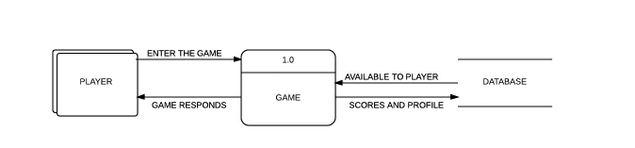
Basic data flow diagram at all the three levels

Data flow diagram (DFD-2)
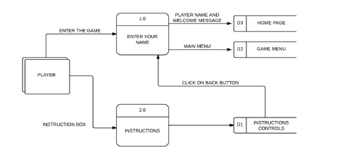
Data flow diagram at level -1 when player enters a game

Data flow diagram (DFD-2)
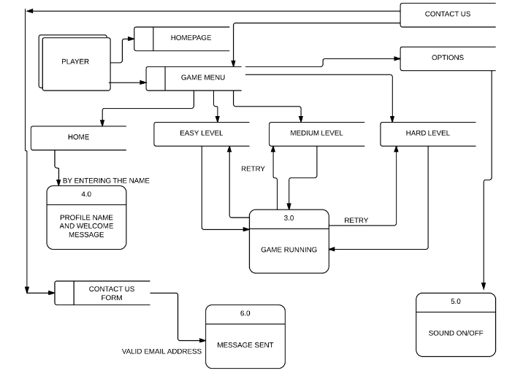
Data flow diagram of complete system

Software Requirements

Client-side
- Any Web Browser capable of supporting common web standards, e.g. CSS. This includes, but is not limited to: Mozilla Firefox, Microsoft Internet Explorer, Safari, Netscape and Opera.

Server-side
As the Server environment is already determined the software requirements listed are for versions of programs already being used by the hosting environment.
- PHP v4.3.1 is needed to process all PHP script for the system.
- MySQL is needed to store all data.
- Firewall To protect the application from illegal activities.
- UNIX is used as the UOB-community operating system.

Database Requirements:
The main requirements of the database is to have all the entities and a place to store data. These can be further will be explained by the ER diagrams and data scheme etc.

12.0 Description of textures

A texture map is applied to develop this game, to the surface. Multitexturing is the use of more than one texture at a time in a flash css. In conventional Flash games, in most of the time we use the PNG format for their textures, or JPG if they don't need transparency.
In maze game you can use those as well, of course. Through further stage , however, atf texture offer a great alternative to those formats: ATF textures. Compared to conventional file formats, they have several powerful advantages

Appendix



GAME CHARACTERS



MAIN MENU

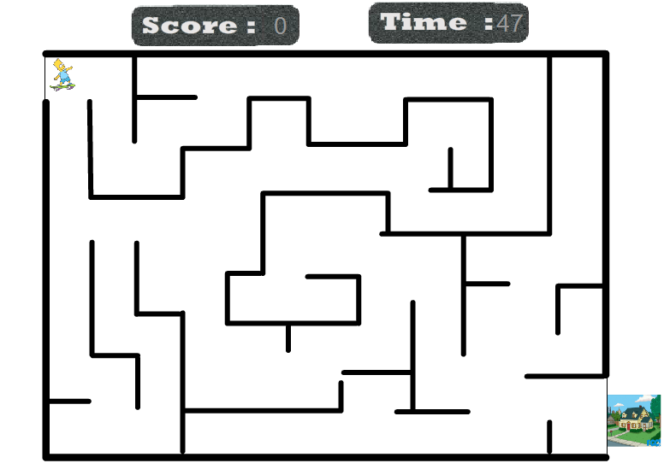
BASIC DESIGN

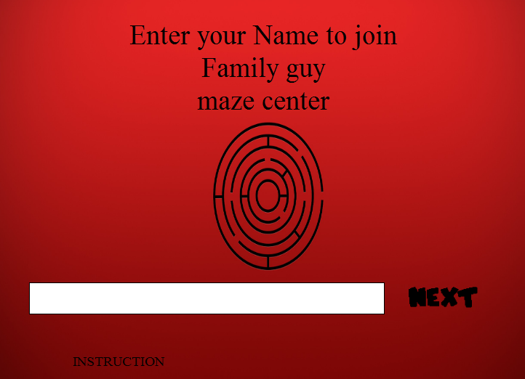

LOGIN AND INSTRUCTION PAGE
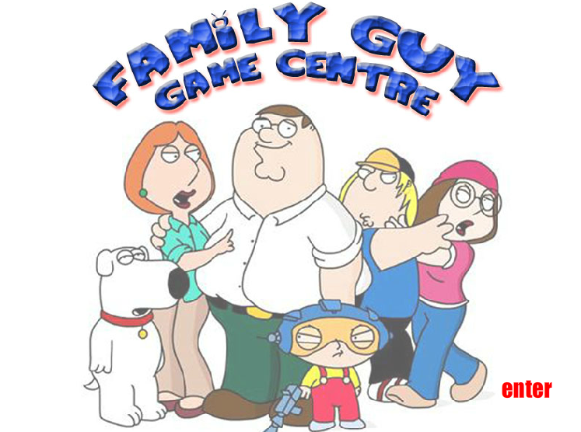

ENTERING THE GAME

Reference

John W. Satzinger, Robert B. Jackson, Stephen D. Burd (2004). System Analysis and Design in a Changing World (3rd ed.), Thomson Cource Technology, Boston, Massachusetts, USA.

Ludwig Consulting (2008). Templates and Guidance. Retrieved June 6, 2008, from http://www.jiludwig.com/Template_Guidance.html

Oregon Government (2008). Requirements Specification Template. Retreived June 6, 2008, from http://www.oregon.gov/DHS/admin/pmo/data/executing_templates/requirements_template_lite.doc

Schwalbe, K. (2006). Information technology project management, (4th Ed.). Cambridge, MA: Course Technology.

Stephen Cooper (2008). Software Requirements Specification. Retrieved June 6, 2008, from http://www.sju.edu/~scooper/spring01se/SoftwareRequirementsSpecification.htm

Revision History
Identify changes to the SRS.
Version | Date | Name | Description
1.0 | 10/09/2013 | SRS | Initialisation
2.0 | 18/09/2013 | SRS | Requirements update

