Examples of Test Scenarios and Test Cases
This document illustrates the concepts of test scenarios and test cases through a simple water boiler system (hardware + software), which should be tested.

Testing a Water Boiler
As a QA engineer, you are assigned to test a simple electrical water boiler. The water boiler consists of two parts:
- Electric water kettle with 1.0-liter capacity (1500 watts of power)
- Power base, used to plug on the boiler cordlessly
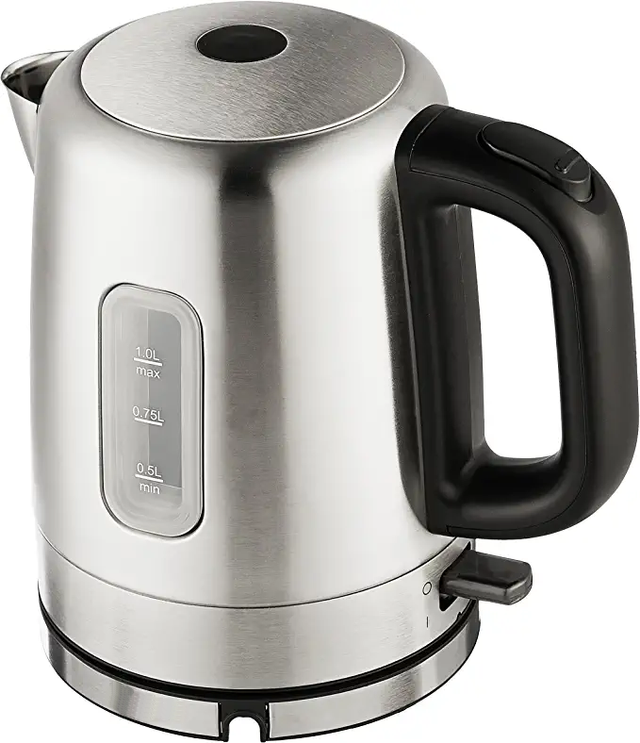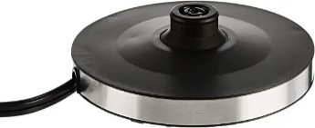
The boiler has two buttons:
- Mechanical button to open the lid. The lid is closed by hand, without any button.
- Switch on/off button to start boiling the water.
When the boiler is plugged-in the power base, and the power base is plugged in the electrical network, and the boiler holds enough water (at least 0.1 liters), the boiler starts boiling.
- It takes 2-3 minutes for the water to get hot. When the water gets hot, the boiler automatically stops (its start button gets into "off" state).
- When the water is hot and the boiler is switched on, it automatically switches off after 0.5-2 seconds.
- When the boiler is empty or almost empty (holding less than 0.1 liters) and the boiler is switched on, it automatically switches off after 0.5-2 seconds.
Your task is to think about the test scenarios and test cases to test the electrical water boiler. Describe the test scenarios and each test case in the following format:

Test Scenario: Boil a Water
Test case | Boil 1 liter of water success
Description | Put 1 liter of water, start the boiler, and wait until it gets hot.
Steps | - Fill 1 liter of cold water in the boiler and close the boiler lid.  - Plug the power base in the electrical network.  - Plug the boiler into the power base.  - Switch on the boiler.  - Wait until the water gets hot and the boiler automatically switches off (2-3 minutes).
Expected results | The brew process should complete in less than 4 minutes.  The water should get hot.  The boiler should automatically power off when the water gets too hot.  The boiler lid should stay closed.

Test case | Boil an empty boiler fail
Description | Try to boil an empty boiler (no water inside) and make sure the boiling stops (automatically switches off) almost immediately after starting.
Steps | - Empty the boiler (leave it without any water) and close the boiler lid.  - Plug the power base in the electrical network.  - Plug the boiler into the power base.  - Switch on the boiler.  - Wait until the boiler automatically switches off (1-2 seconds).
Expected results | The brew process should stop immediately after started (in 1-2 seconds).  The boiler should be in switched off state (to prevent overheating).  The boiler lid should stay closed.

Test case | Boil already boiled water success
Description | Boil some water and try to boil it again to ensure the boiler will stop automatically.
Steps | - Fill 1 liter of cold water in the boiler and close the boiler lid.  - Plug the power base in the electrical network.  - Plug the boiler into the power base.  - Switch on the boiler.  - Wait until the water gets hot and the boiler automatically switches off (2-3 minutes).  - Switch on the boiler again.  - Wait until the boiler automatically switches off (in 1-5 seconds).
Expected results | After the initial water boiling, the water should be hot.  After the second brew process is started, the boiler should be automatically switched off after < 5 seconds (to prevent overheating).  The boiler lid should stay closed all the time.

Test Scenario: Lid Test
Test case | Open the lid
Description | Check if the “open lid” button works as expected.
Steps | - Close the boiler lid.  - Click the “open lid” button.
Expected results | The boiler lid should open.

Test case | Close the lid
Description | Check if the “open lid” button works as expected.
Steps | - Open the boiler lid.  - Push it down to close it.
Expected results | The boiler lid should stay closed.

