Lab: Git Branching and Pull Requests
Lab for the DevOps for Developers module @ SoftUni

Using Git Commands
First, let's start by opening a CLI, for example PowerShell or Terminal.
After that, let's try to clone an existing Git repository. The full repo URL is below:
https://github.com/SUContent/playground
Use the following command:
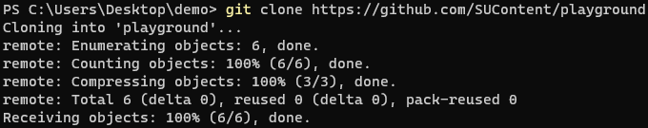
Now, let's try to make local changes. In order to do that, we'll make some changes in the Readme.md file.
After we are done with the changes, it's time to add (prepare) the files for commit. We'll do this using the following command:
After that, we should commit added files to the local repository using the command below:
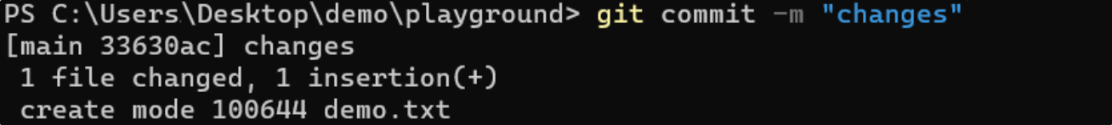
Finally, we should push all committed changes to the remote repository.
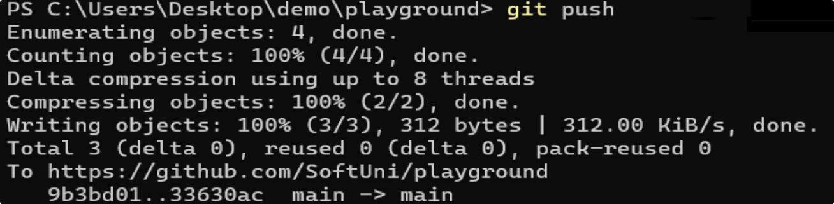

Git Conflict Scenario
Let's imagine that three developers work on a shared project with Git. All of them try to change and push the same file. By doing so, a conflict will occur on pushing the changes.




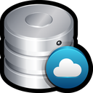


Maria
George
Peter
push
push
conflict
conflict

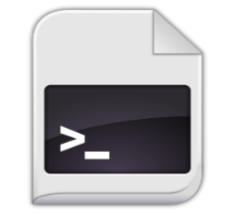

change
+ commit




change
+ commit

change
+ commit

push

To resolve a merge conflict caused by conflicting line changes, we must choose which changes to incorporate in a new commit.
There a several steps that we should follow:
- Open Git Bash
- Navigate into the local Git repository that has the merge conflict
- Display a list of the files affected by the merge conflict
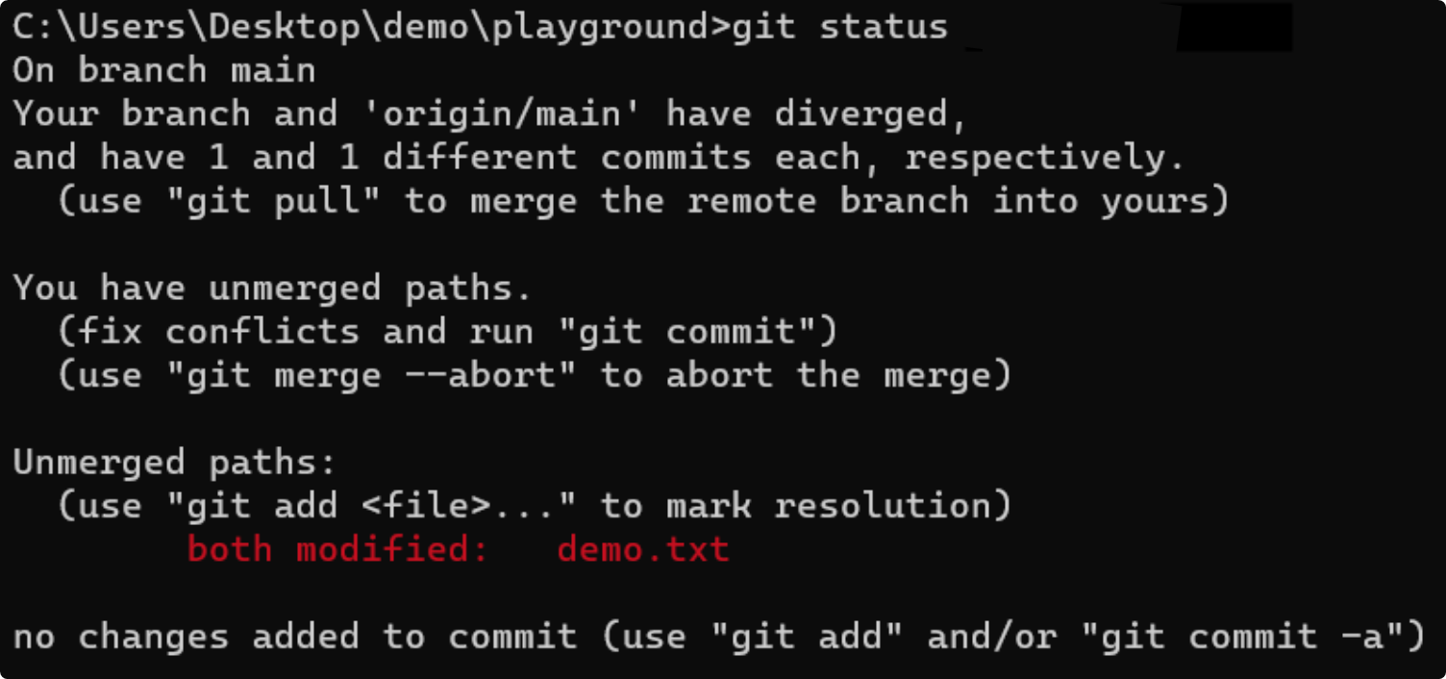
In the example above, the demo.txt file has a merge conflict.
- Open a text editor and navigate to the file with merge conflicts
- To see the beginning of the merge conflict in the file, search the file for the conflict marker <<<<<<<
  - You'll see the changes from the HEAD after the line <<<<<<< HEAD
  - Next, you'll see =======, which divides your changes from the changes in the other branch,
followed by >>>>>>> name
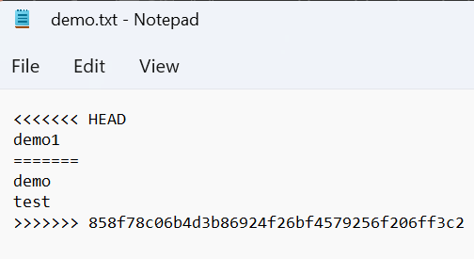
- Decide if you want to keep only your changes, keep only the other changes, or make a new change, which incorporates both changes.
- Delete the conflict markers <<<<<<<, =======, >>>>>>> and make the changes you want in the final merge
 → 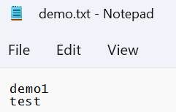
- Add or stage the changes
- Finally, commit the changes with a comment

Git Branches

Step 1: Create and Clone Repo
Create an empty GitHub repo and then clone the repo to work in it locally:
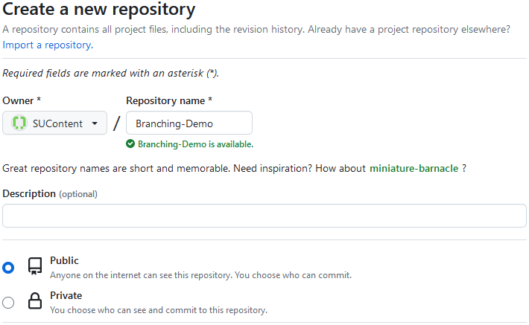

Step 2: Add and Commit Files
After that, add the files from the lab resources to the local repo folder. You can use git status to check the working directory state:
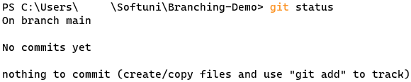
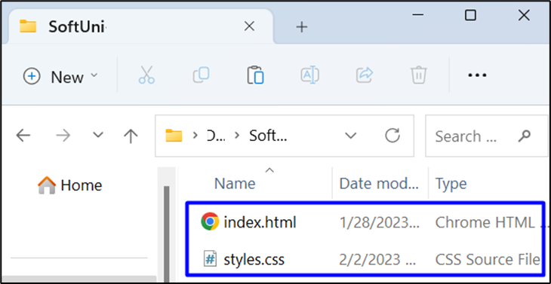
After that, add and commit all the chages with git add . and git commit: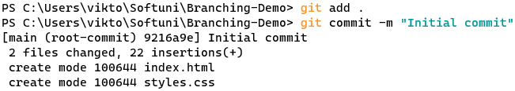

Step 3: Push to GitHub
Next step is to push to the remote repository, using git push:
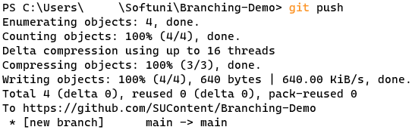
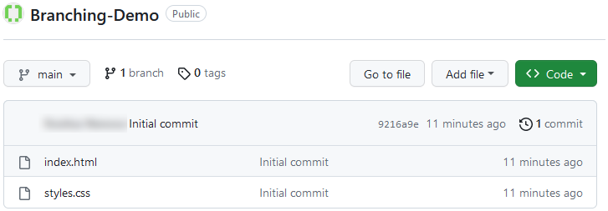

Step 4: Create a New Branch
Now it's time to create and switch to a new branch, called "add-title":
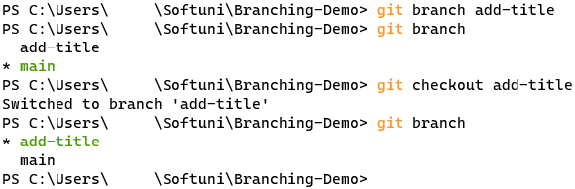
Make some changes in the index.html file (you can add an <h1> tag with title):
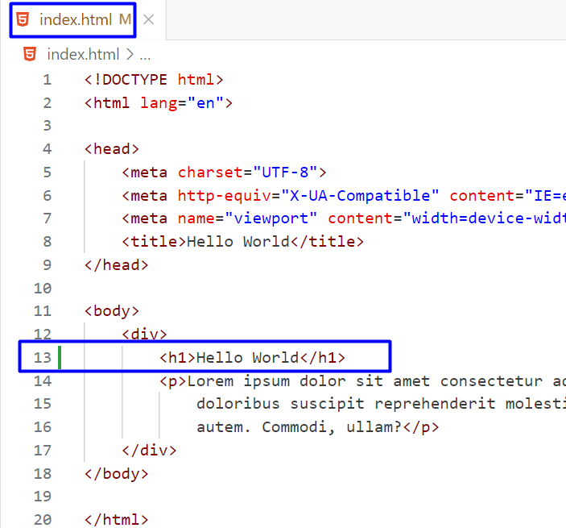

Step 5: Commit New Branch Changes
Add and commit to the local repo:
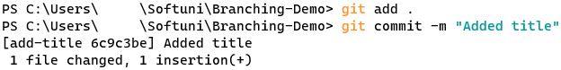
And then, push to the remote repo. An error should occur, as this branch is created only locally and you don't have it in your remote GitHub repo:
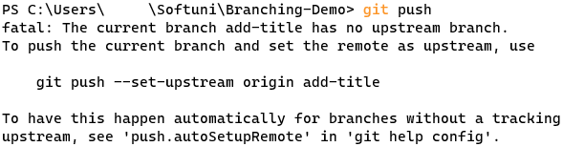

Step 6: Add Upstream and Push Changes
Now, add upstream and push again using this command:
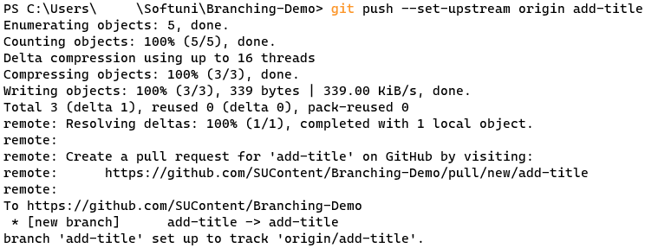
You should have your new "add-title" branch in the remote repo:
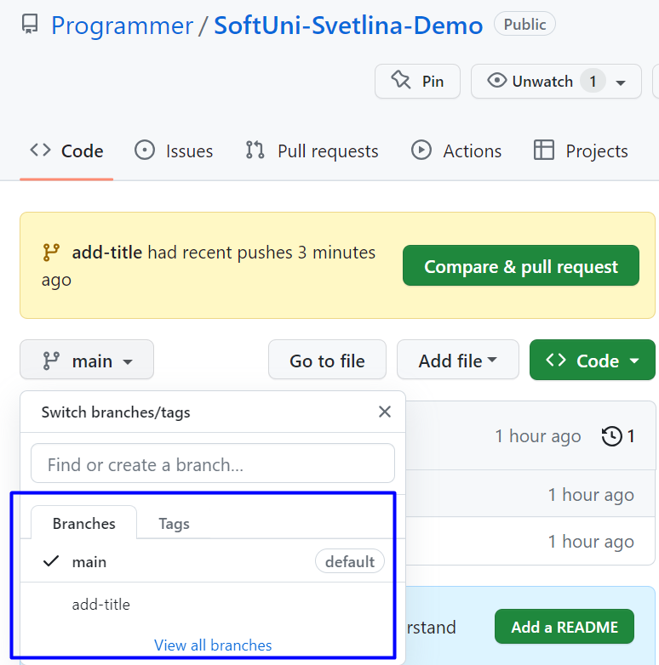

Step 7: Merge Branches
Now, switch to the "main" branch and merge it with "add-title"
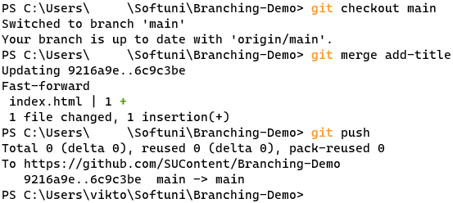

Step 8: Delete Branch
Delete the local branch:
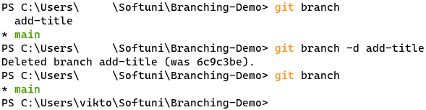
And delete the remote GitHub branch:

Creating a Pull Request

Step 1: Create Branch, Make Changes and Push
Like in the previous task, create a new branch "add-form":
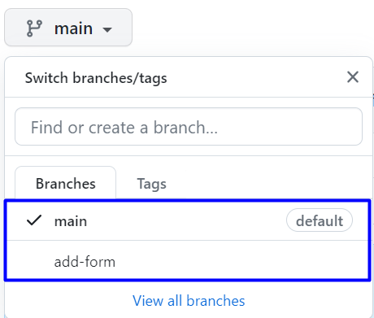
Now, add an HTML form in the index.html file, commit and push the changes to the remote GitHub repo:
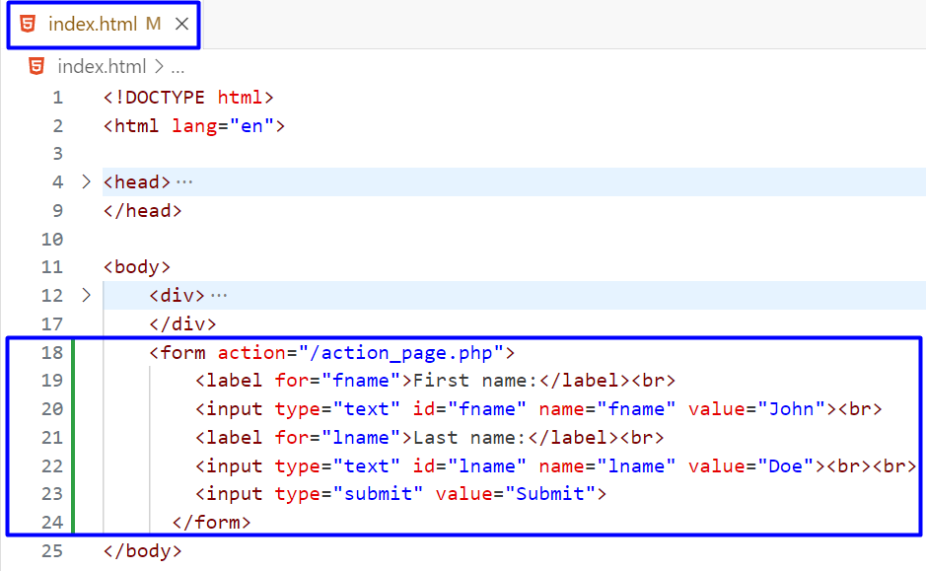

Step 2: Open a Pull Request in GitHub
Now it's time to open a pull request from the "main" to the "add-form" branch:
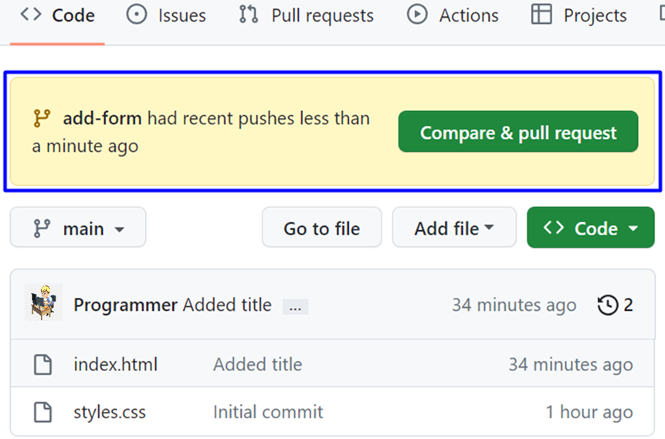
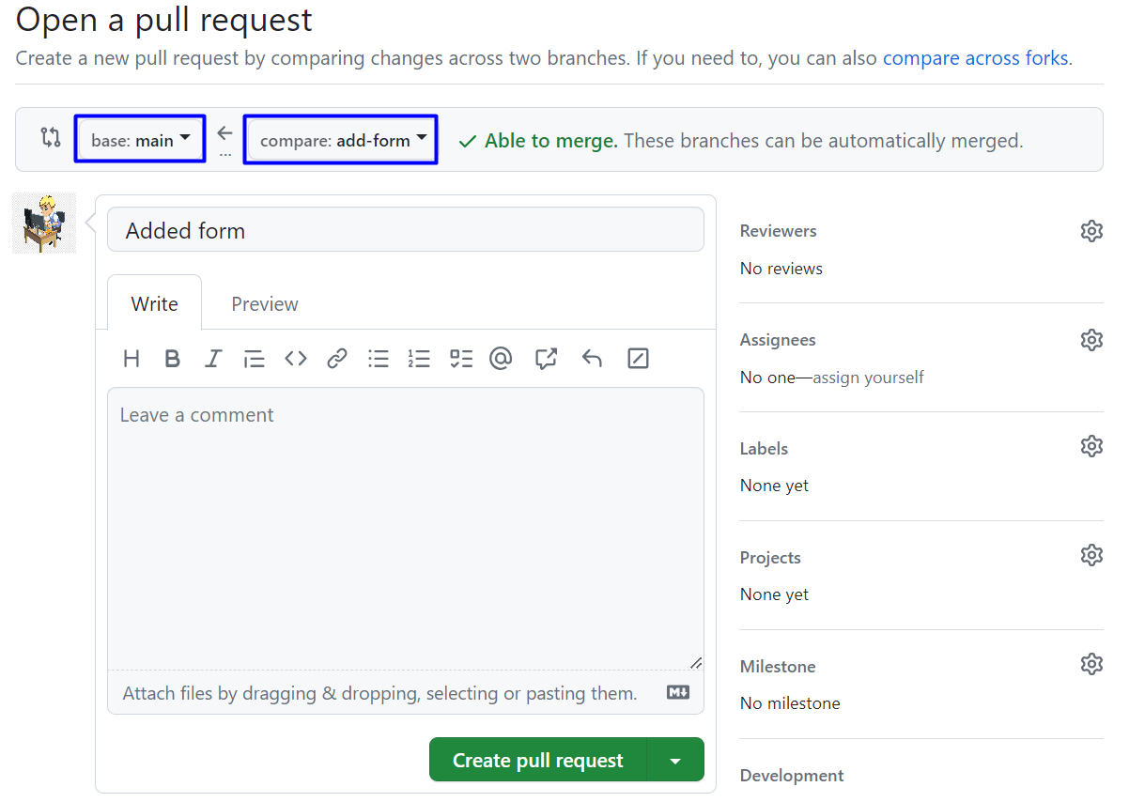

Step 3: Request a Review (Optional)
You have the option to request a review of your changes:
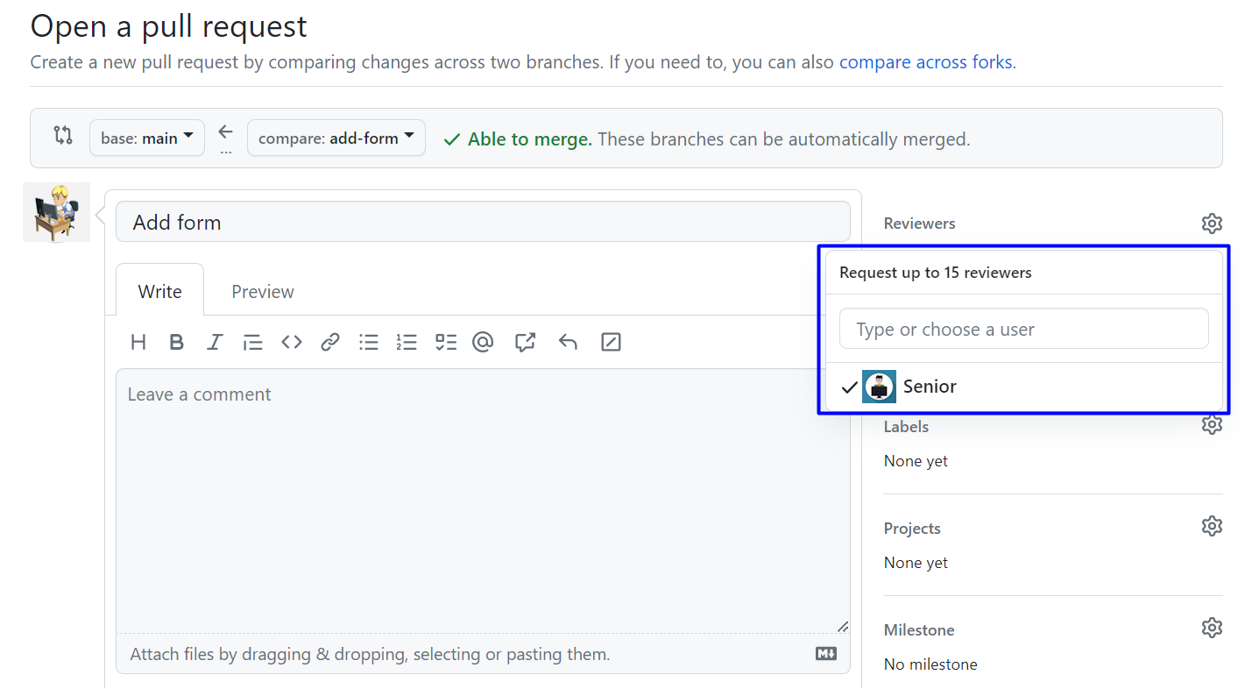

Step 4: Team Discussion
