Exercises: Git Branching and Pull Requests
Exercises for the DevOps for Developers module @ SoftUni

Note that for this exercise you should have a GitHub account.

The "Towns" Project
The "Towns" project provides a simple HTML and JavaScript based Web front-end interface to view, add, delete and shuffle a list of towns. The project is unfinished, so some of the functionality is already implemented (view and delete) and other functionality is to be implemented (add and shuffle towns + CSS styling). This is how the "Towns" project looks like at the beginning:
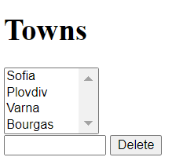
At the start, in the GitHub repo you will have 3 source code files: towns.html + towns.css + towns.js, and a README.md documentation file:
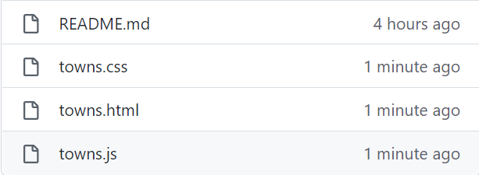

Roles Assignments
Your task is to work in teams of 3 students or work alone with several roles to simulate multi-user interaction, where each role follows the instructions for certain team member – Editor, Shuffler and Styler.
If you work in a team of 3 students, one of you should also take the role of the Team Leader.
If you work alone, you should work with a fourth role – the Team Leader.

Editor
The Editor should implement "add new town" functionality:
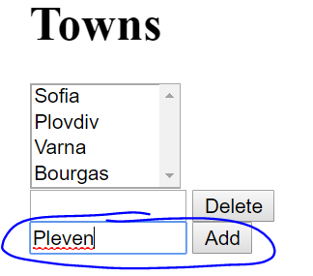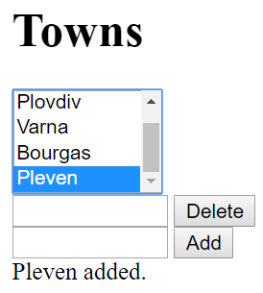

Shuffler
The Shuffler should implement "shuffle towns" functionality.
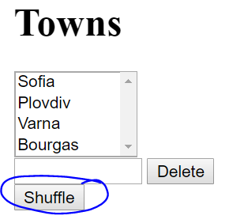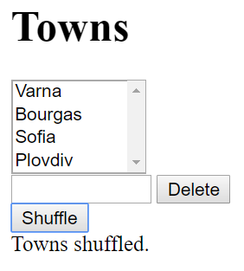

Styler
The Styler should add some CSS styling and improve the HTML UI.
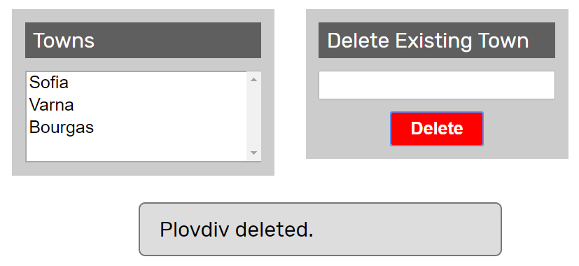

Fork the Repo
The team leader does the following:
Fork the "Towns" repo from GitHub: https://github.com/SUContent/Towns

Invite the Team Members
The team leader invites the other team members as collaborators in the new GitHub repo.
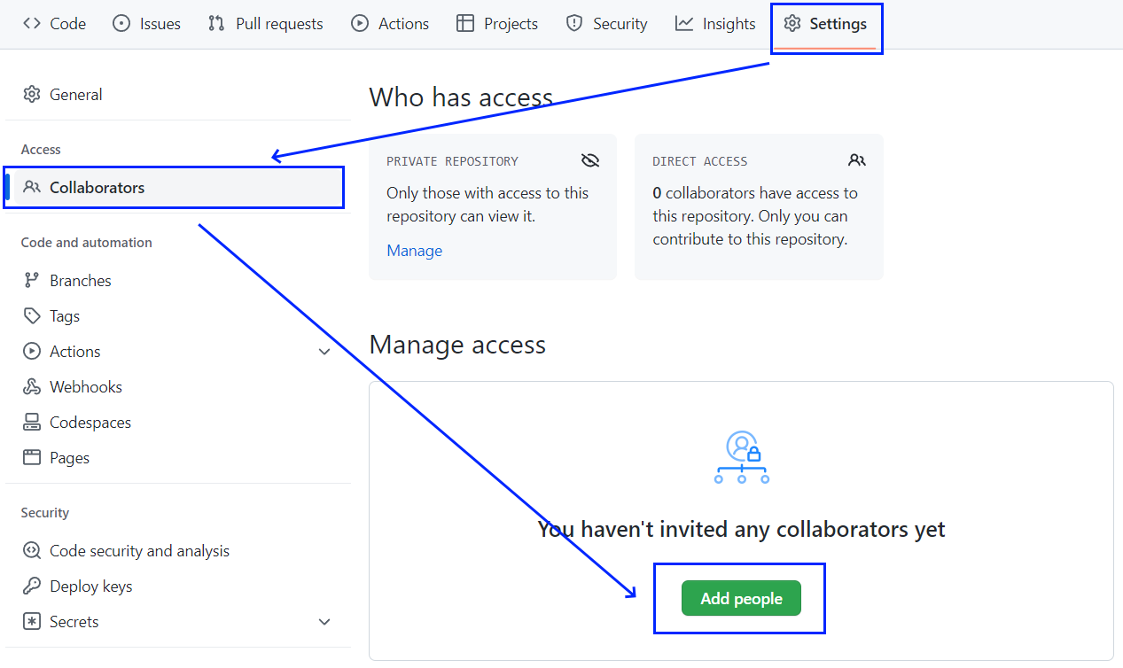
- An email invitation will be sent for each invited collaborator.

Team Members Should Clone the Project
Each team member clones the project from the team leader's GitHub repository:
git clone https://github.com/<team-leader-username>/Towns

Edit the Project Description
This step should be executed only after each team member have already cloned the project locally.
The team leader makes changes in README.md file from the GitHub's project Web site, to describe with a text which team member which role will take, e.g.,
# Roles
- {Name1} takes the role "Editor"
- {Name2} takes the role "Shuffler"
- {Name3} takes the role "Styler"

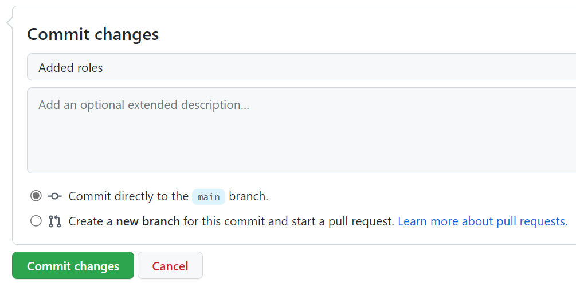

Implement Project Functionalities
Each team member implements different functionality locally (each member has its own instructions).
- Member #1: Editor's functionality (add town)
- Member #2: Shuffler's functionality (shuffle towns)
- Member #3: Styler's functionality (improve styling and CSS)
NOTE: If you are working alone, don't forget that you should fulfil the three roles simultaneously.

Editor
The Editor should already have cloned the forked repo.

Step 1: New Town Textbox + Button
Now, in towns.html, the editor should add a textbox + button for creating a new town:
<div>
<input type="text" id="townNameForAdd" />
<button id="btnAdd">Add</button>
</div>

Step 2: New Town JavaScript Code
In towns.js, the editor has to add a new function for adding a new town:
function addTown() {
let townName = $('#townNameForAdd').val();
$('#townNameForAdd').val('');
$('#towns').append($('<option>').text(townName));
$('#result').text(townName + " added.");
}
Also, the editor should add a code to attach an event handler to invoke the new function when the [Add] button is pressed. In the start of the JS code, he adds the code marked in blue below:
$(document).ready(function() {
…
$('#btnAdd').click(addTown);
});

Step 3: Test the Project functionality
Editor now should test the project functionality to see whether the styling and effects work correctly, as well as whether the entire project works as expected:


Step 4: Commit All Changes in the Local Repo
Editor adds and commits in Git all local changes:
git commit -a -m "Implemented functionality to add a new town"

Step 5: Push the Local Commits to GitHub
Editor pushes all the changes to Git:
git push

Step 6: Resolve Any Conflicts
git pull
Editor should edit all files and fixes the code in order to merge all concurrent changes correctly.
Then, Editor adds and commits in Git the merged files:
git commit -a -m "Implemented functionality to add a new town + merged the conflicting files"
Finally, Editor should push all his changes again to Git:
git push

Shuffler
The Shuffler should already have cloned the forked repo.

Step 1: New Town Textbox + Button
Now, in towns.html, the editor should add a textbox + button for shuffling the towns:
<div>
<button id="btnShuffle">Shuffle</button>
</div>

Step 2: New Town JavaScript Code
In towns.js, the editor has to add a new function for shuffling the towns:
function shuffleTowns() {
let towns = $('#towns option').toArray();
$('#towns').empty();
shuffleArray(towns);
$('#towns').append(towns);
$('#result').text("Towns shuffled.");

function shuffleArray(array) {
for (var i = array.length - 1; i > 0; i--) {
var j = Math.floor(Math.random() * (i + 1));
var oldElement = array[i];
array[i] = array[j];
array[j] = oldElement;
}
}
}
Also, the editor should add a code to attach an event handler to invoke the new function when the [Add] button is pressed. In the start of the JS code, he adds the code marked in blue below:
$(document).ready(function() {
$('#btnShuffle').click(shuffleTowns);
});

Step 3: Test the Project functionality
Shuffler now should test the project functionality to see whether the styling and effects work correctly, as well as whether the entire project works as expected:


Step 4: Commit All Changes in the Local Repo
Shuffler adds and commits in Git all local changes:
git commit -a -m "Implemented functionality to shuffle the existing towns"

Step 5: Push the Local Commits to GitHub
Shuffler pushes all the changes to Git:
git push

Step 6: Resolve Any Conflicts
git pull
Editor should edit all files and fixes the code in order to merge all concurrent changes correctly.
Then, Shuffler adds and commits in Git the merged files:
git commit -a -m "Implemented functionality to shuffle the existing towns + merged the conflicting files"
Finally, Shuffler should push all his changes again to Git:
git push

Styler
The Styler should already have cloned the forked repo.

Step 1: Improve the HTML Structure
Styler wants to style the site to look better but the HTML structure does not allow writing CSS, so they modifie towns.html and introduces a new way to structure the content as a sequence of articles holding headers and other elements after the header:
<article>
<header>Towns</header>
<select id="towns" size="4">
<option>Sofia</option>
<option>Plovdiv</option>
<option>Varna</option>
<option>Bourgas</option>
</select>
</article>

<article>
<header>Delete Existing Town</header>
<input type="text" id="townName" />
<button id="btnDelete">Delete</button>
</article>

Step 2: Write the CSS Code
Styler now rewrites the entire towns.css file from scratch:
@import url('https://fonts.googleapis.com/css?family=Rubik');

body {
font-family: 'Rubik', sans-serif;
}

* {
box-sizing: content-box;
}

article {
background: #CCC;
width: 180px;
padding: 10px;
margin: 10px;
display: inline-block;
vertical-align: top;
}

article>header {
background: #5F5F5F;
color: white;
margin: 0px 0px 10px 0px;
padding: 4px 6px;
}

article>header>h1 {
margin: 0px;
}

article>select {
width: 178px;
}

article>input {
width: 176px;
}

article>button {
display: block;
margin: 10px auto 0px auto;
border: none;
border-radius: 3px;
padding: 5px 15px;
background: green;
color: white;
font-weight: bold;
}

article>button:hover {
box-shadow: 0px 0px 10px white;
cursor: pointer;
}

button#btnDelete {
background: red;
}

#result {
display: none;
width: 50%;
margin: 10px auto;
padding: 10px 15px;
background: #DDD;
border-radius: 5px;
border: 1px solid #777;
}
The new CSS code assumes the HTML uses articles with headers for its major areas. It displays the articles in a nice-looking way. The CSS also hides by default the result info box and assumes it will be shown by the JS code later.

Step 3: Add "Auto Hide" Effect for the Info Messages
After a button is clicked (e.g. [Delete]), the result of the performed action is shown into an info box (#result). Styler modifies this behavior, so that the info box is by default hidden, then it displays a message for 3 seconds, then it disappears. First, he adds a JS library in towns.html to enable animation effects with jQuery:
<script src="http://ajax.googleapis.com/ajax/libs/jqueryui/1.8.5/jquery-ui.min.js"></script>
Next, he modifies the deleteTown() function in towns.js to display messages through a new function showMessage(msg):
function deleteTown() {
let townName = $('#townName').val();
$('#townName').val('');
let removed = false;
for (let option of $('#towns option')) {
if (option.textContent == townName) {
removed = true;
option.remove();
}
}
if (removed)
showMessage(townName + " deleted.");
else
showMessage(townName + " not found.");
}

function showMessage(msg) {
$('#result').text(msg).css("display", "block");
setTimeout(function () {
$('#result').hide('blind', {}, 500);
}, 3000);
}

Step 4: Test the Project Functionality
Styler now tests the project functionality to see whether the styling and effects work correctly, as well as whether the entire project works as expected:


Step 5: Commit All Changes in the Local Repo
Styler adds and commits in Git all local changes:
git commit -a -m "Improved styling and effects for the functionality to add a new town "

Step 6: Push the Local Commits to GitHub
Styler pushes all his changes to Git:
git push

Step 7: Resolve Any Conflicts
In case of conflict Styler pulls, merges, then pushes again:
git pull
Styler edits all files and fixes the code in order to merge all concurrent changes correctly.
Then, Styler adds and commits in Git the merged files:
git commit -a -m "Improved the UI: added CSS styles + HTML structure + JS effects"
Finally, Styler pushes all his changes again to Git:
git push

The "Hotel Reservation" Project

Create and Clone Repo
The project "Hotel Reservation" provides a simple HTML and JavaScript based Web front-end interface to create a reservation to family hotel. The project is unfinished, so some of the functionalities are already implemented ("Thank you" page) and other functionalities are to be implemented (Search Form, Search Result Form, Guest Details Form, Confirm Page). This is how the "Hotel Reservation" project looks like at the beginning:
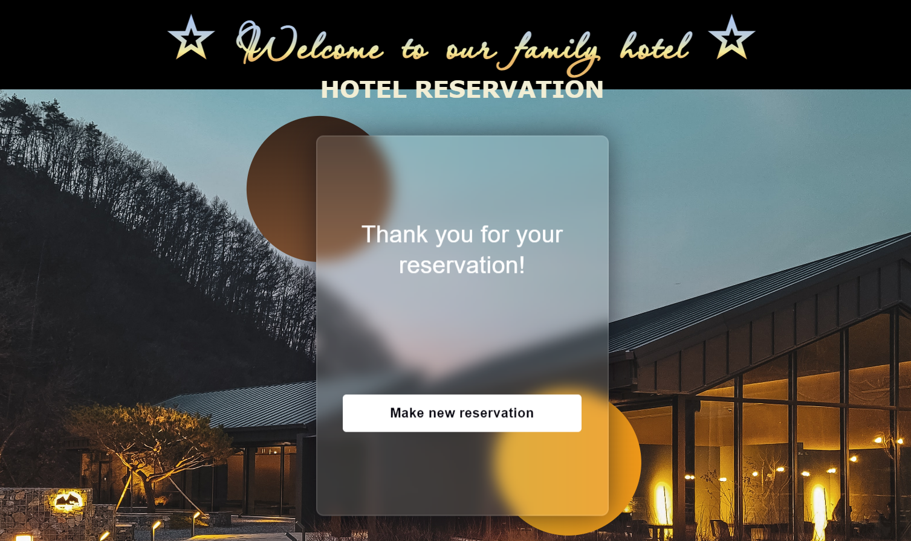
In the beginning you should create an empty GitHub repo and add the files from resources (index.html, solution.js, static folder).

Team Assignment – Overview
NOTE: You can work in in teams of 4 students or work alone with several roles to simulate multi-user interaction, where each role follows the provided instructions for the given team member.
Each team member chooses a role:
- Member #1: takes the role of Questioner.
- Member #2: takes the role of Offerer.
- Member #3: takes the role of Admin.
- Member #4: takes the role of Verifier.
One of the team members takes an additional role: team leader.
Questioner should implement the "Search Form" functionality. This feature will allow the inquirer to provide and manage offers through a special form for date and number of people. The provider should include this functionality in their application to improve the user experience.
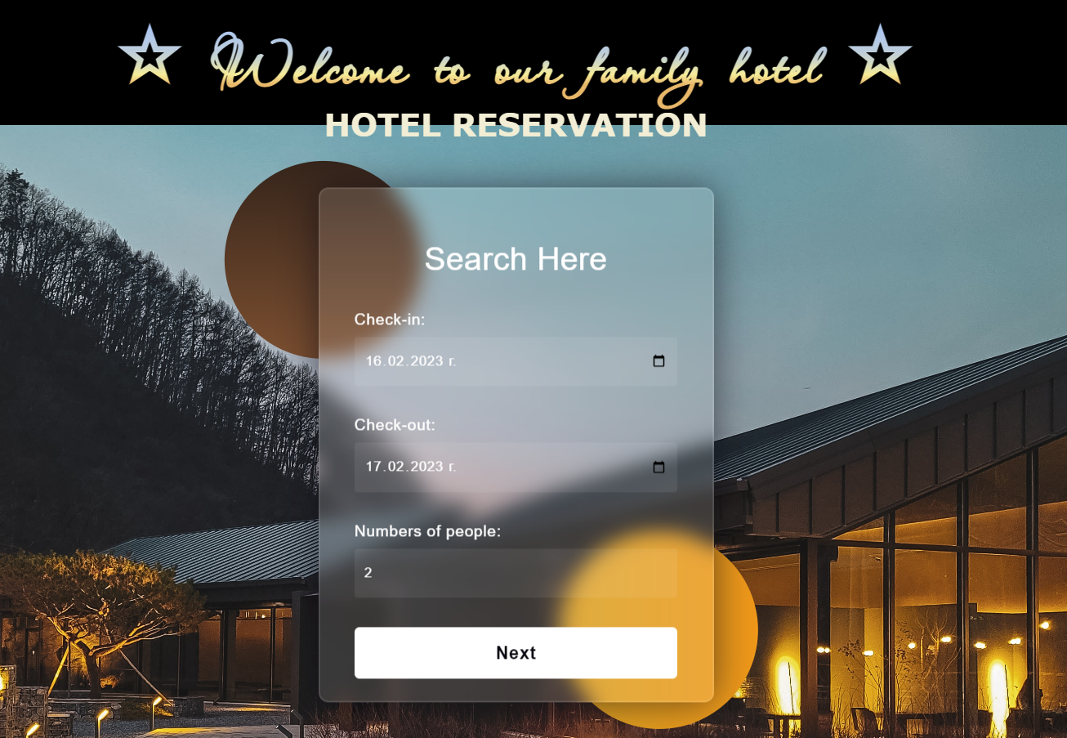
Offerer should implement the "Our Offers Form" functionality. This feature will enable the Offerer to provide and manage offers through a dedicated form. Offerer should incorporate this functionality into their application to enhance the user experience.
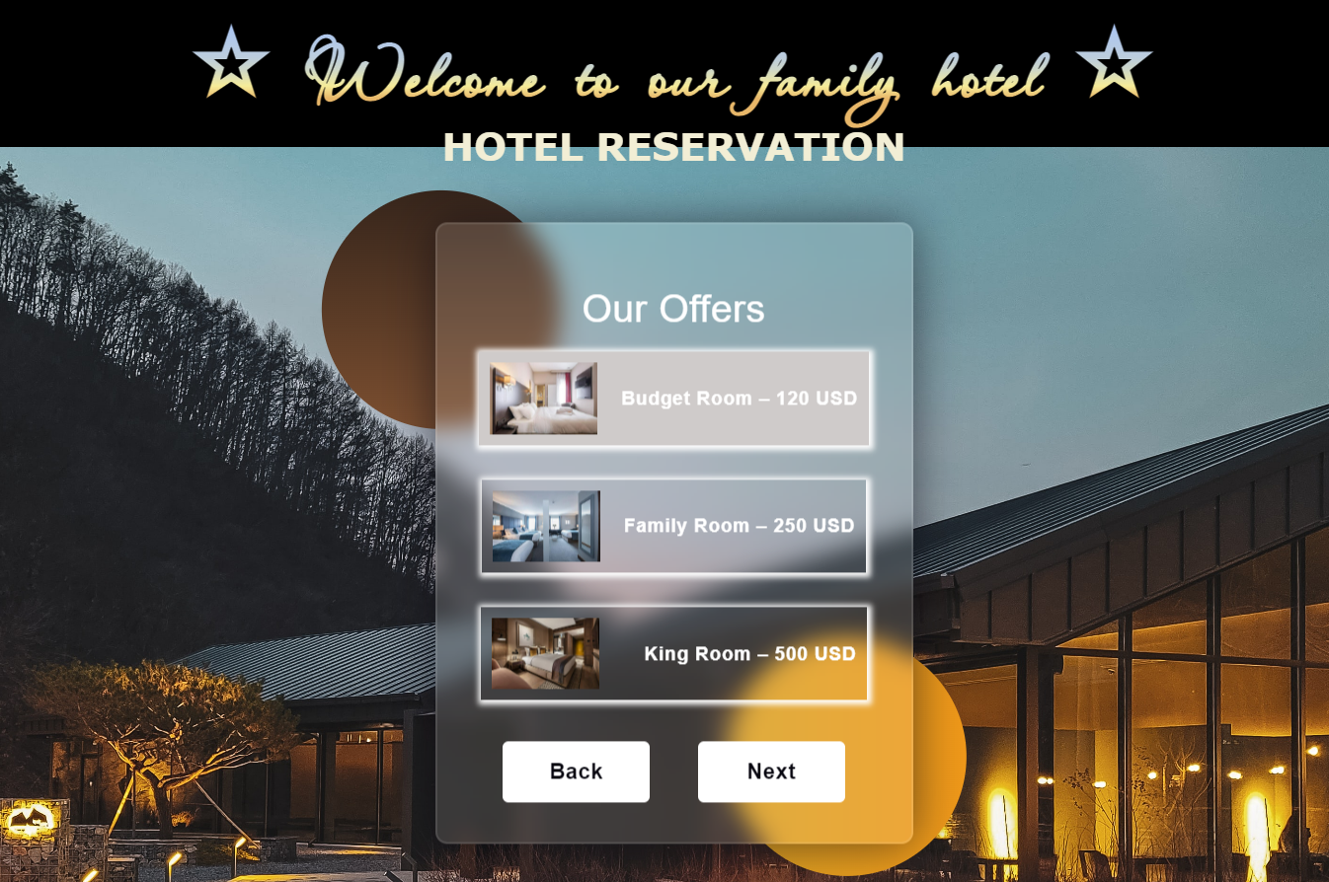
Admin should implement the "Guest Details Form" functionality. This feature will allow him to gather and manage guest information through a dedicated form. Admin should incorporate this functionality into their application to efficiently collect and handle guest details.
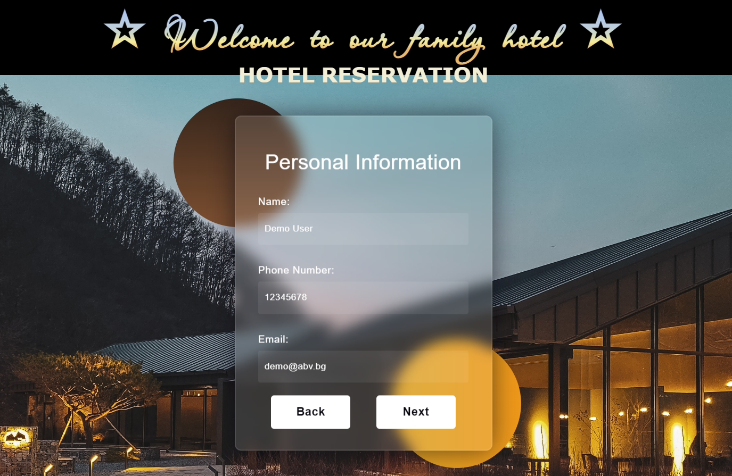
Verifier should implement "Confirm Reservation Form" functionality. This feature will enable him to confirm reservations through a dedicated form. Verifier should incorporate this functionality into their system to efficiently handle and validate reservation requests.
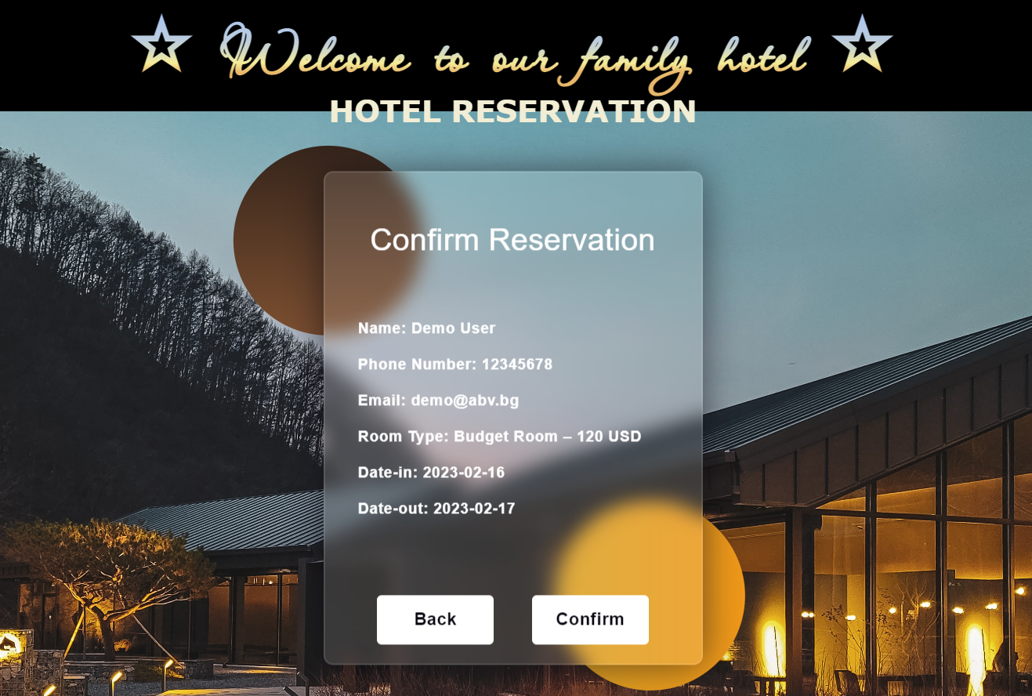

Step 1: Create the Repo
The team leader creates an empty GitHub repo and add the files from resources (index.html, solution.js, static folder).

Step 2: Invite the Team Members
The team leader invites the other team members as collaborators in the new GitHub repo.

An email invitation will be sent for each invited collaborator.

Step 3: Clone the Project
Each team member clones the project from the team leader's GitHub repository to a local folder:
git clone {GitHub repo URL}

Step 4: Implement Project Functionalities
Each team member implements different functionality locally (each member has its own document with instructions in the provided resources).
- Member #1: Questioner's functionality (Search Form)
- Member #2: Offerer's functionality (Our Offers Form)
- Member #3: Admin's functionality (Guest Details Form)
- Member #3: Verifier's functionality (Confirm Reservation Form)
You should have a separate branch in GitHub for each functionality, e.g., each member should have a branch of their own.

Questioner
Questioner should implement the "Search Form" functionality:
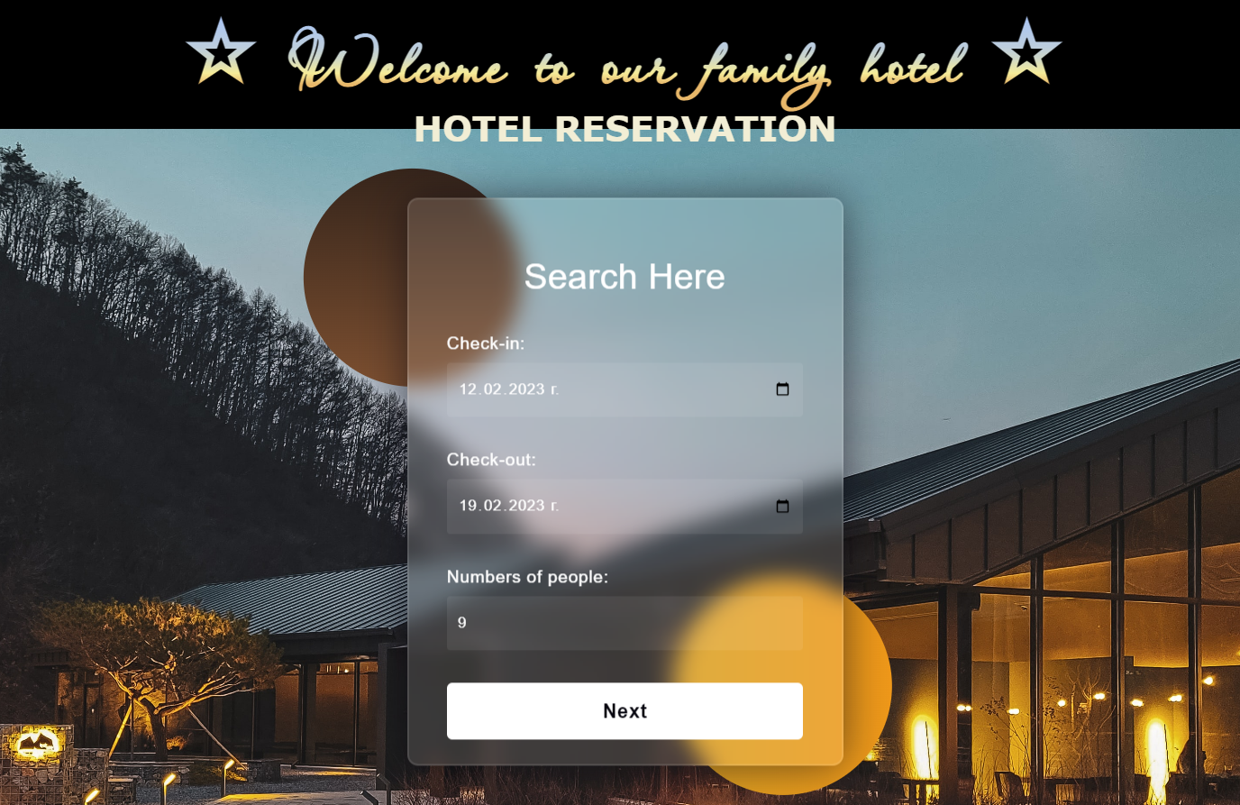
Searched form contains information about the check-in date, the check-out date, and the numbers of people accommodated.
Questioner clones the project repository, makes a sequence of changes in the source code files, commits locally in repository, then pushes the committed changes to GitHub.

Step 1: Clone the "Hotel Reservation" Repository
Questioner should already have cloned the repo.

Step 2: Create a Local Branch
We want to add some new features to our SPA app. We are working in our local repository, and we do not want to disturb or wreck the main project. So, we create a new local branch:
git branch search-form
We have two branches now: main and search-form.
Now we should check out the new branch, e.g., switch from the current branch to the new one.
git checkout search-form
We have moved our current workspace from the main branch, to the search-form branch.

Step 3: Search Form: HTML
In index.html, in div with class "site-content" they add some HTML (Questioner/index.html file from the resources) for the search form.

Step 4: Search Form: JavaScript Code
In solution.js, they adda a new function (Questioner/solution.js file from the resources) to the search form.

Step 5: Search Form: CSS
In styles.css, they add styles (Questioner/styles.css file from the resources) to the search form.

Step 6: Test the Project Functionality
Questioner now tests the project functionality to see whether SPA app works correctly, as well as whether the entire project works as expected:
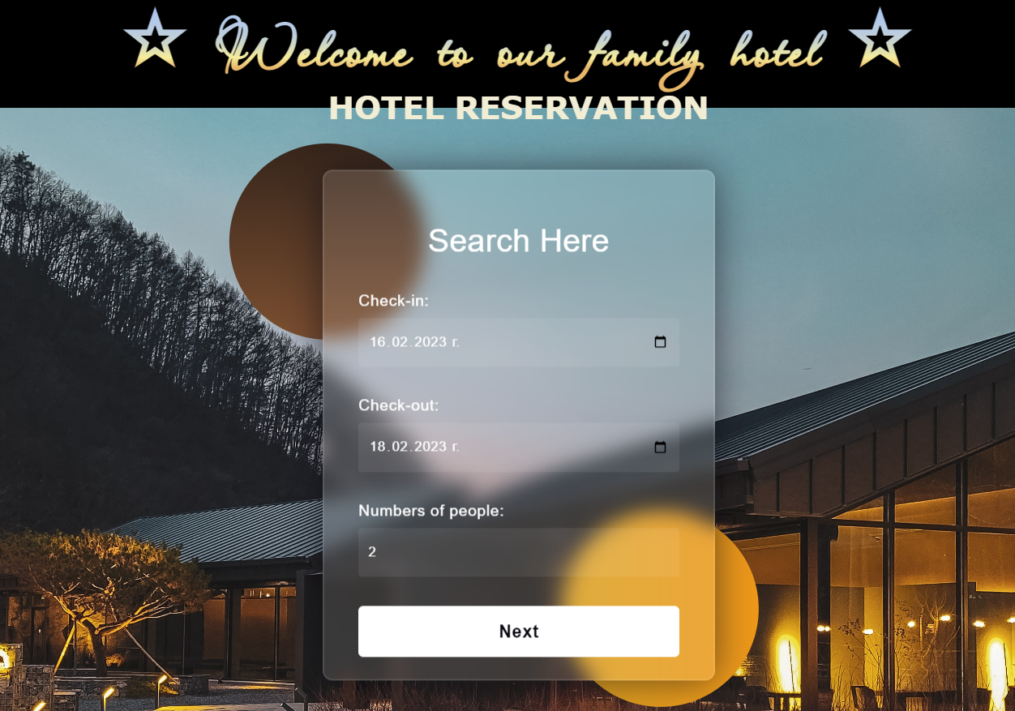
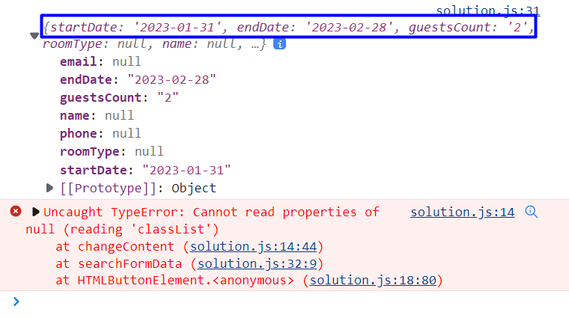
Don't worry about the error!

Step 7: Commit All Changes to the Local Branch
Questioner adds and commits in Git all local changes:
git commit -a -m "Implemented Search form functionality"
Now we have a new branch, that is different from main. If we now push to the repo, we will get an error because the search-form branch is local, not upstream, e.g., it is not in GitHub yet, only locally:
git push
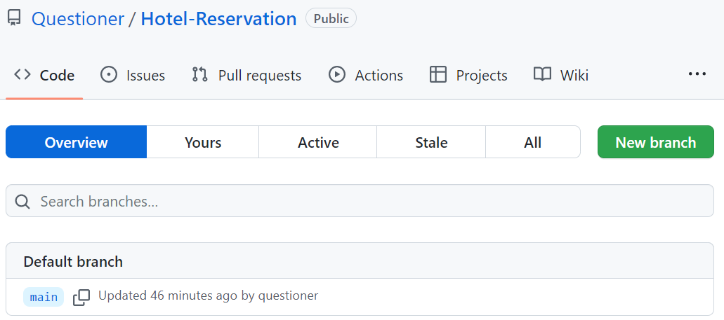
To fix this error we should run the following command.
git push --set-upstream origin search-form
The "--set-upstream" option is utilized to set the remote as the upstream directory and fix the above-encountered error.
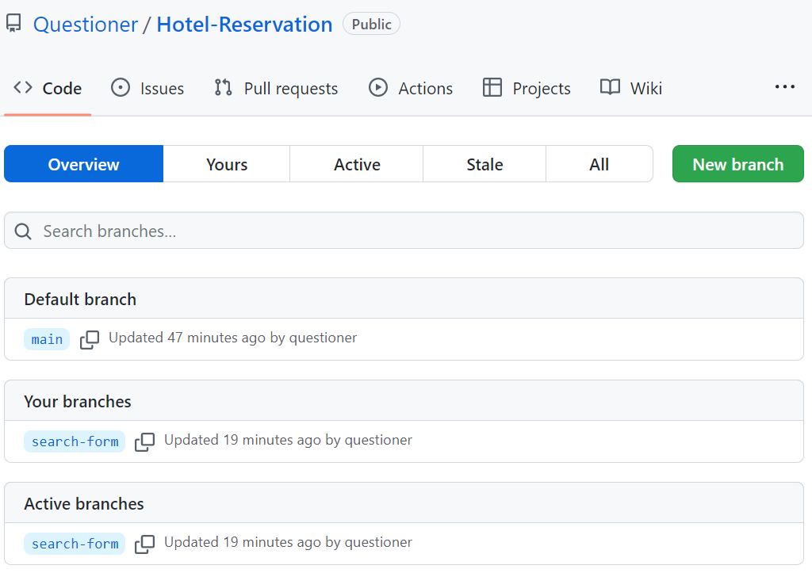
We have the upstream branch search-form.

Step 8: Create a Pull Request
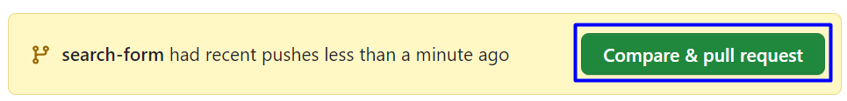
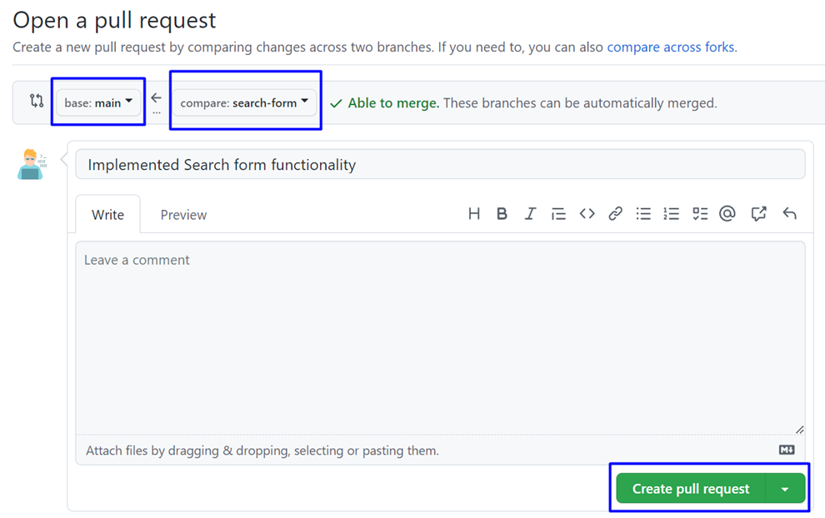
Don't forget to add a reviewer.
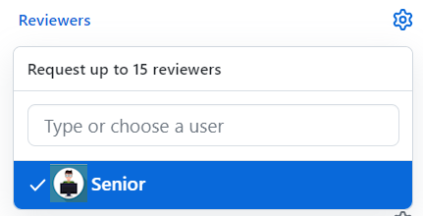
Add a title and create the pull request:
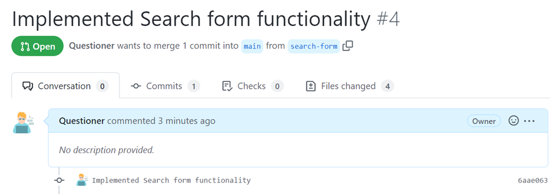

Step 9: Approve a Pull Request
Now you should approve one of your friend's pull requests. But before that, we should resolve the conflicts.
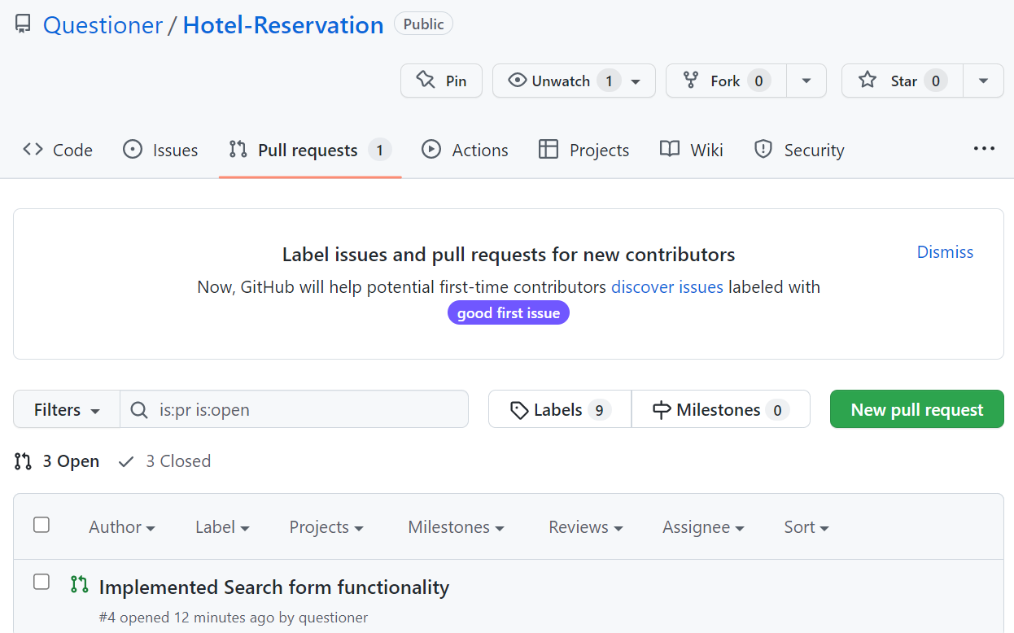
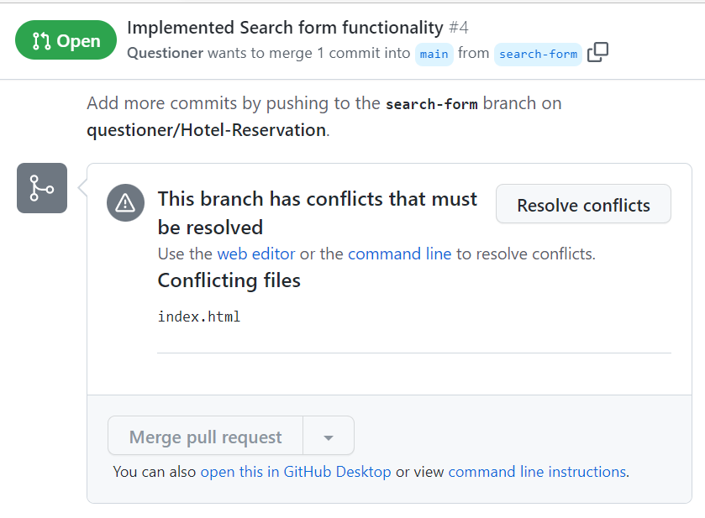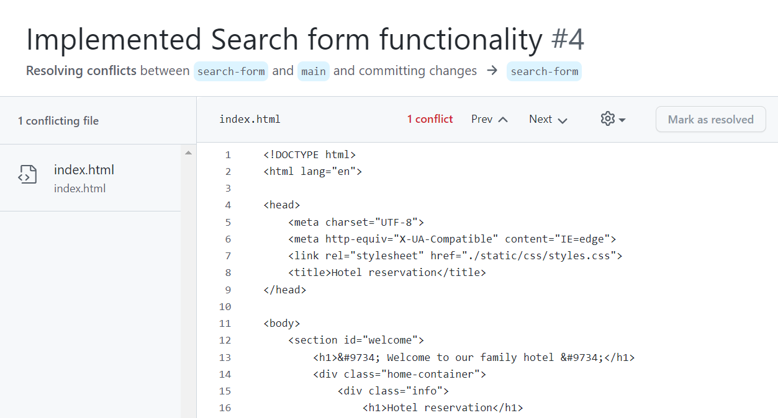
When conflicts are resolved, merge the changes:
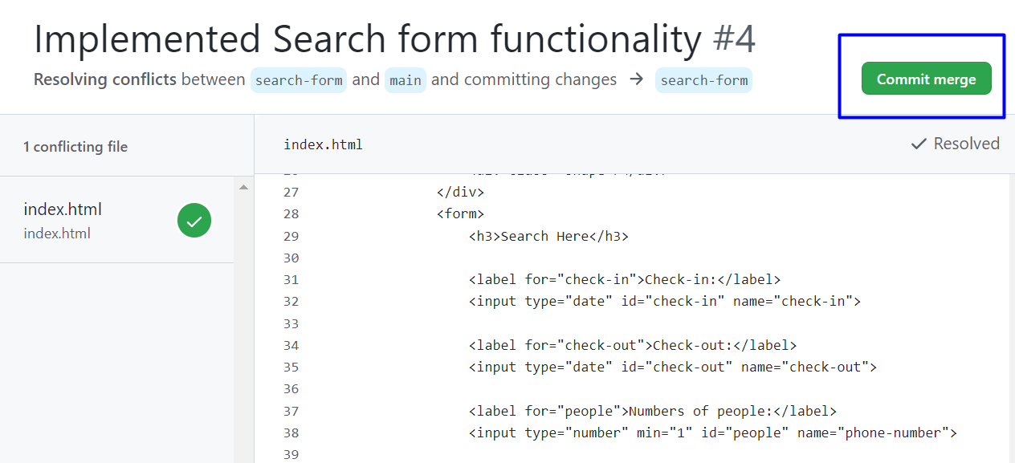

Step 10: Merge Pull Request
Merge the search-form branch into the main branch.
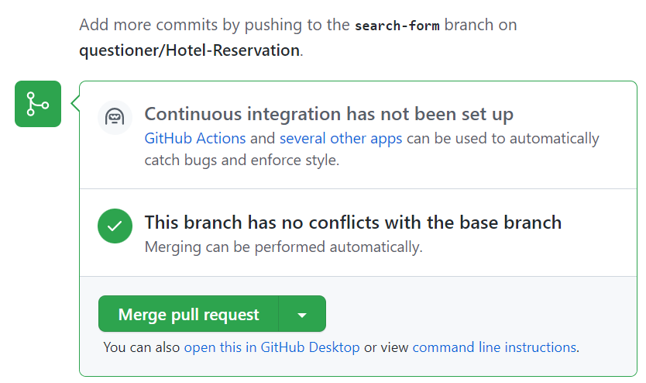
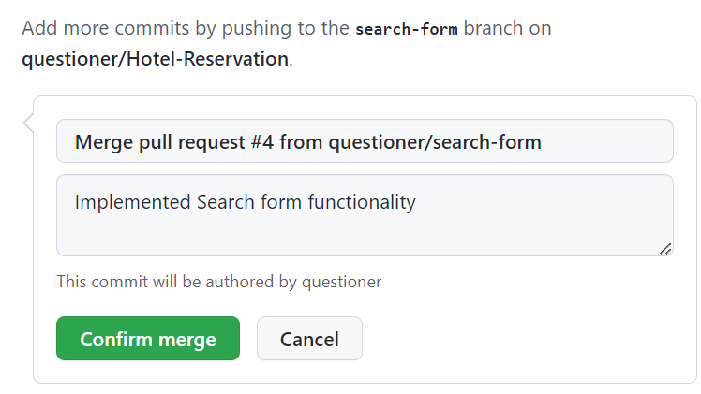
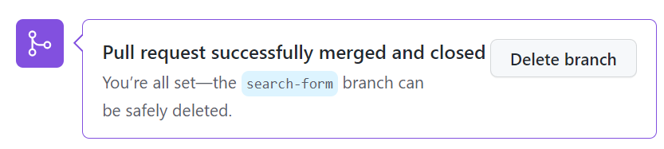

Offerer
Offerer should implement the "Our Offers Form" functionality:

The purpose of Offerer is to find out what kind of room our client prefers.
Offerer clones the project repository, makes a sequence of changes in the source code files, commits locally in his repository, then pushes the committed changes to GitHub.

Step 1: Clone the "Hotel Reservation" Repository
Offerer should already have cloned the repo.

Step 2: Create a Local Branch
We want to add some new features to our SPA app. We are working in our local repository, and we do not want to disturb or wreck the main project. So, we create a new local branch:
git branch our-offers-form
We have two branches now: main and our-offers-form.
Now we should check out the new branch, e.g., switch from the current branch to the new one.
git checkout our-offers-form
We have moved our current workspace from the main branch, to the our-offers-form branch.

Step 3: Search Form: HTML
In index.html, in div with class "site-content" he adds some HTML (Offerer/index.html file from the resources) for the offers form.

Step 4: Search Form: JavaScript Code
In solution.js, they add a new function (Offerer/solution.js file from the resources) to the offers form.
Use this code box only while testing functionality in your custom branch.
changeContent('search-result-form-content');

Step 5: Search Form: CSS
In styles.css, they add styles (Offerer/styles.css file from the resources) to the offers form.

Step 6: Test the Project Functionality
Offerer now tests the project functionality to see whether SPA app works correctly, as well as whether the entire project works as expected:
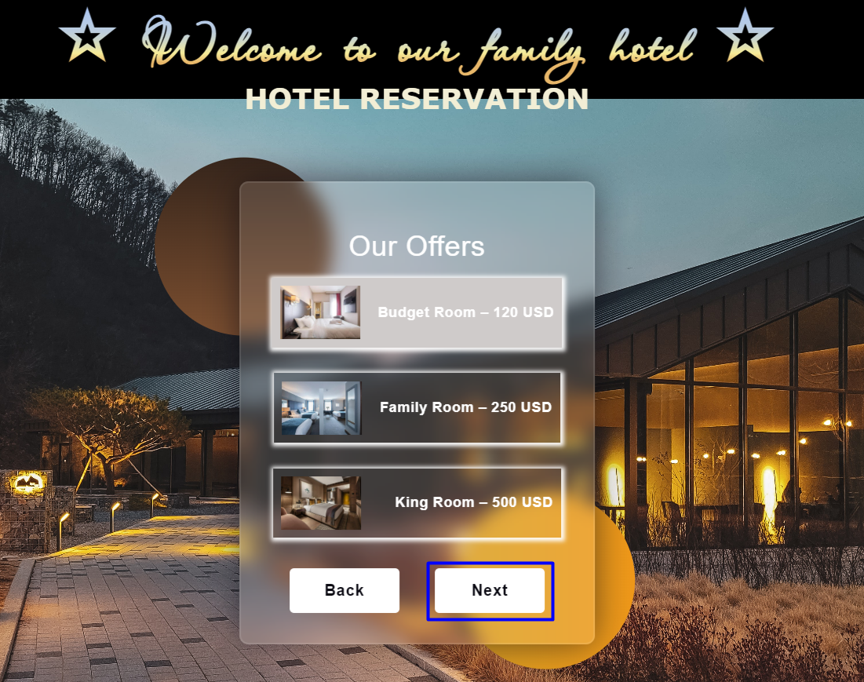
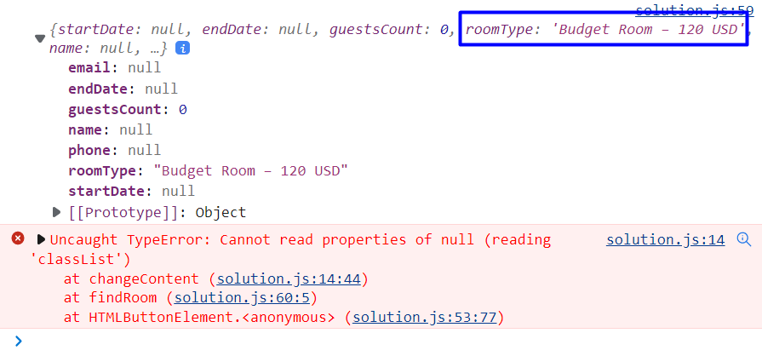
Don't worry about the error!

Step 7: Commit All Changes to the Local Branch
Offerer adds and commits in Git all local changes:
git commit -a -m "Implemented Our Offers form functionality"
Now we have a new branch, that is different from main. If we now push to the repo, we will get an error because the our-offers-branch branch is local, not upstream, e.g., it is not in GitHub yet, only locally:
git push
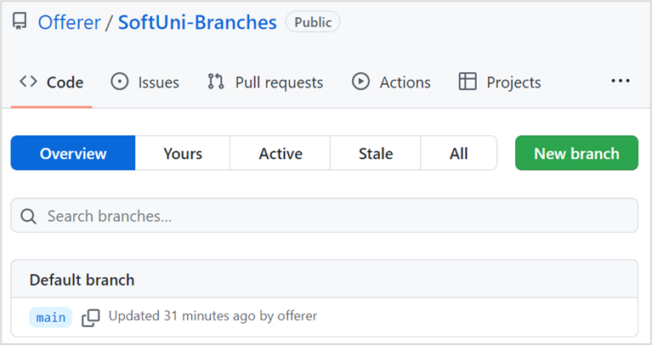
To fix this error we should run the following command.
git push --set-upstream origin our-offers-form
The "--set-upstream" option is utilized to set the remote as the upstream directory and fix the above-encountered error.
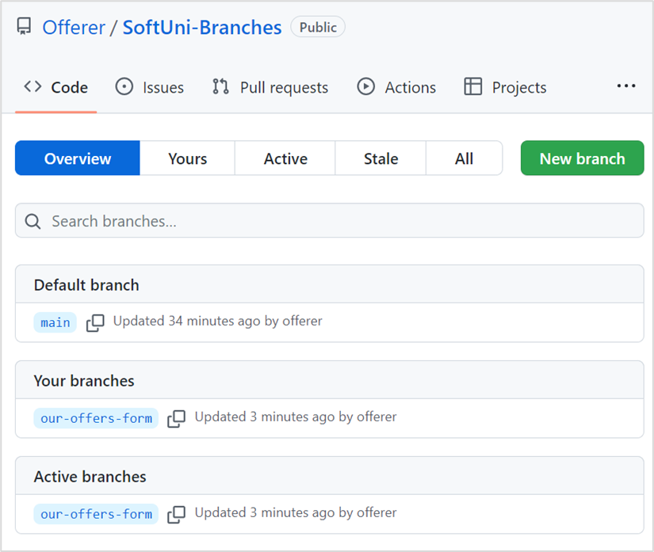
We have the upstream branch our-offers-form.

Step 8: Create a Pull Request
Now go to your GitHub repo and create a pull request for merge from the our-offers-form to the main branch:
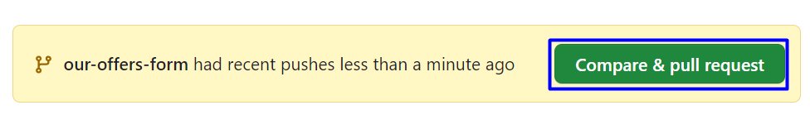
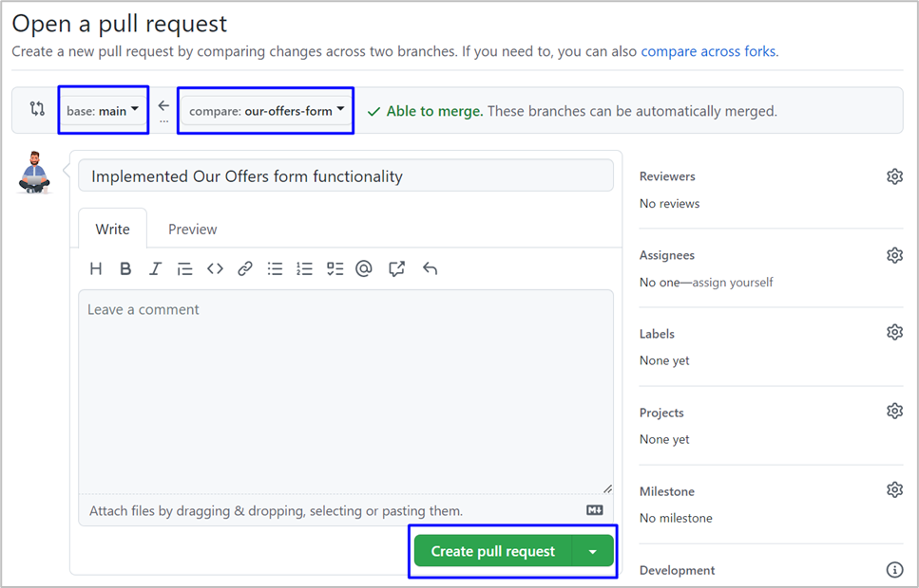
Don't forget to add a reviewer.

Add a title and create the pull request:
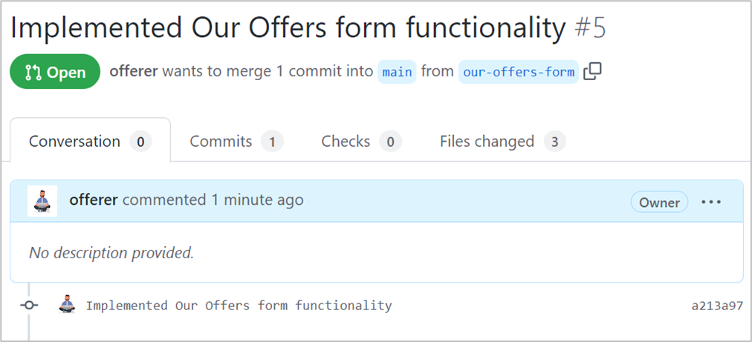

Step 9: Approve a Pull Request
Now you should approve one of your friend's pull requests. But before that, we should resolve the conflicts.


When conflicts are resolved, merge the changes:


Step 10: Merge Pull Request
Merge the search-form branch into the main branch.



Admin
The Admin should implement the "Guest Details Form" functionality:
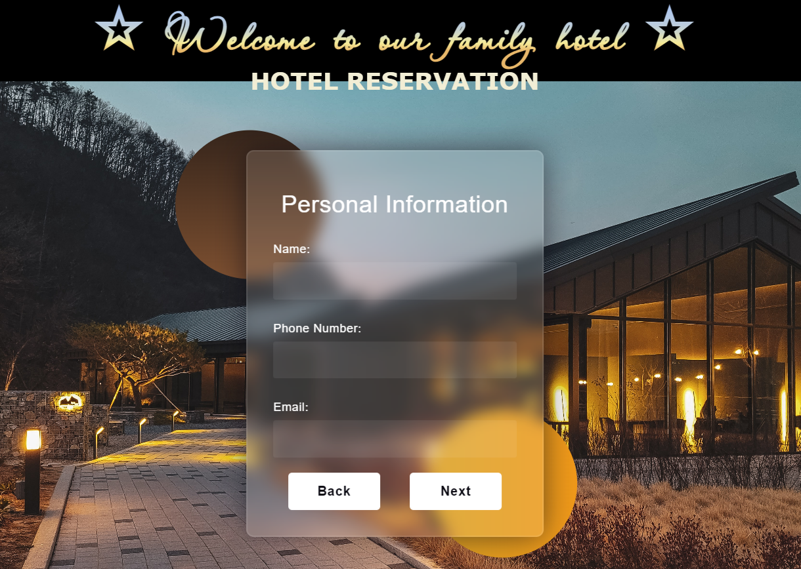
The Admin's task is to collect and store the data for each person (name, phone number and email).
The Admin clones the project repository, makes a sequence of changes in the source code files, commits locally in repository, then pushes the committed changes to GitHub.

Step 1: Clone the "Hotel Reservation" Repository
The Admin should already have cloned locally the main project repo.

Step 2: Create a Local Branch
We want to add some new features to our SPA app. We are working in our local repository, and we do not want to disturb or wreck the main project. So, we create a new local branch:
git branch guest-details-form
We have two branches now: main and guest-details-form.
Now we should check out the new branch, e.g., switch from the current branch to the new one.
git checkout guest-details-form
We have moved our current workspace from the main branch, to the guest-details-form branch.

Step 3: Search Form: HTML
In index.html, in div with class "site-content" he adds some HTML (Admin/index.html file from the resources) for the guest details form.

Step 4: Search Form: JavaScript Code
In solution.js, they add a new function (Admin/solution.js file from the resources) to the guest details form.
Use this code box only while testing functionality in your custom branch.
changeContent('guest-details-form-content');

Step 5: Search Form: CSS
In styles.css, they add styles (Admin/styles.css file from the resources) to the guest details form.

Step 6: Test the Project Functionality
The Admin now tests the project functionality to see whether SPA app works correctly, as well as whether the entire project works as expected:
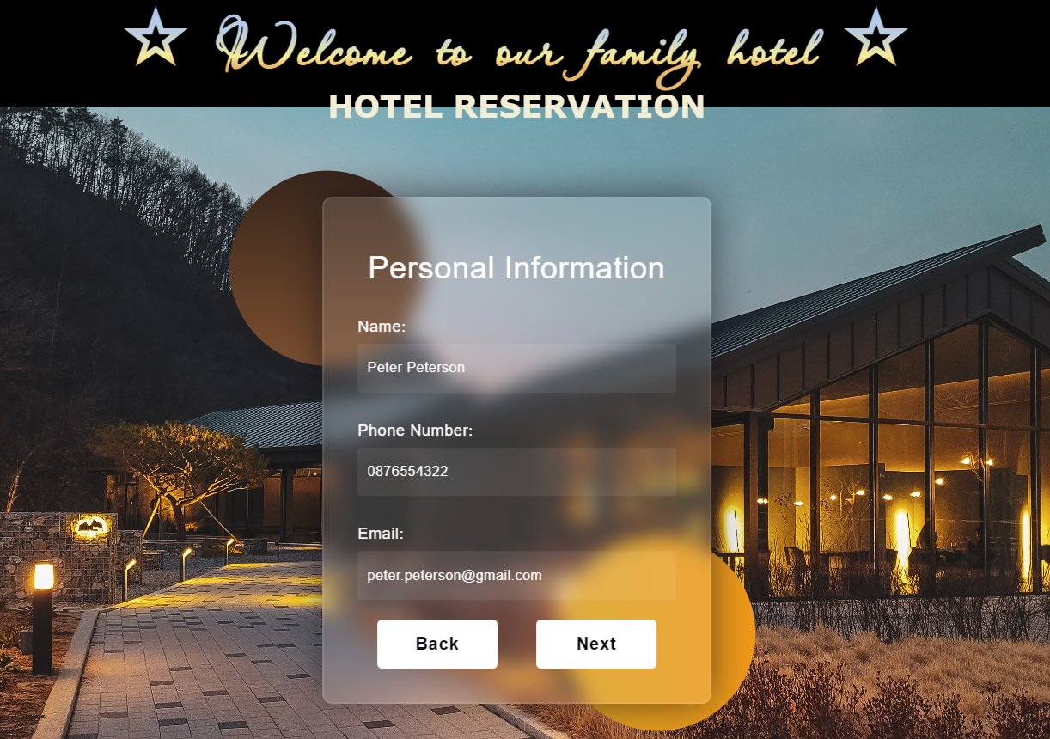
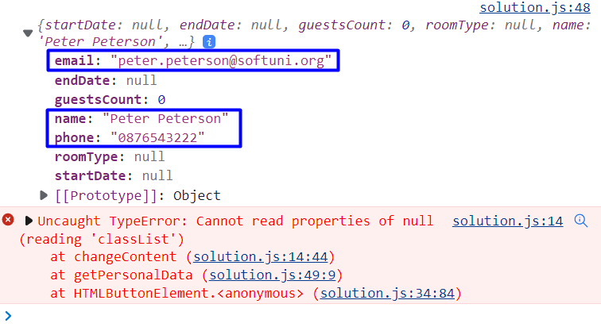
Don't worry about the error!

Step 7: Commit All Changes to the Local Branch
The Admin adds and commits in Git all local changes:
git commit -a -m "Implemented Guest Details form functionality"
Now we have a new branch, that is different from main. If we now push to the repo, we will get an error because the guest-details-form branch is local, not upstream, e.g., it is not in GitHub yet, only locally:
git push
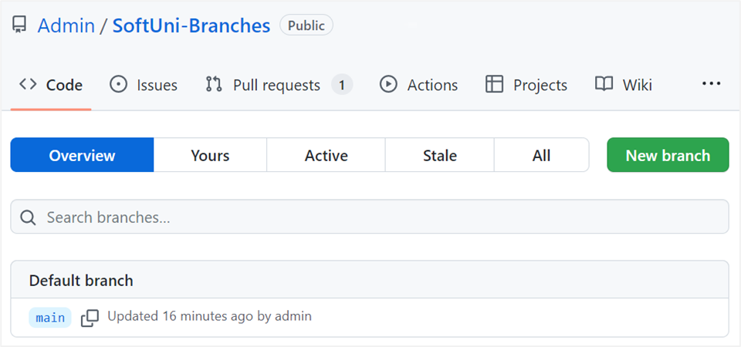
To fix this error we should run the following command.
git push --set-upstream origin guest-details-form
The "--set-upstream" option is utilized to set the remote as the upstream directory and fix the above-encountered error.
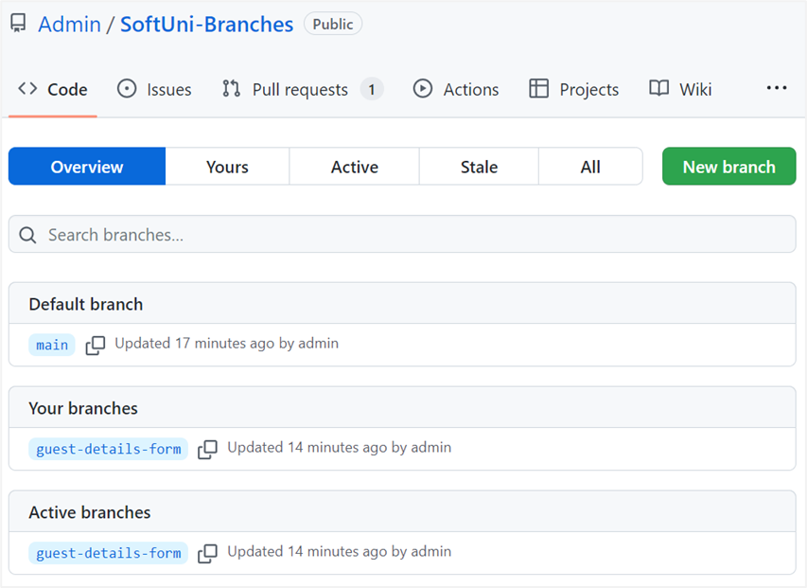
We have the upstream branch guest-details-form.

Step 8: Create a Pull Request
Now go to your GitHub repo and create a pull request for merge from the guest-details-form to the main branch:
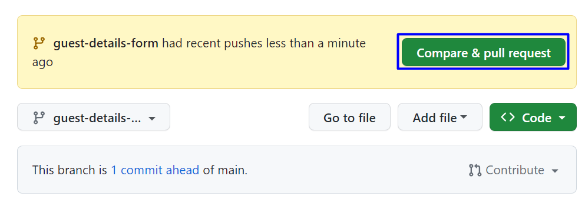
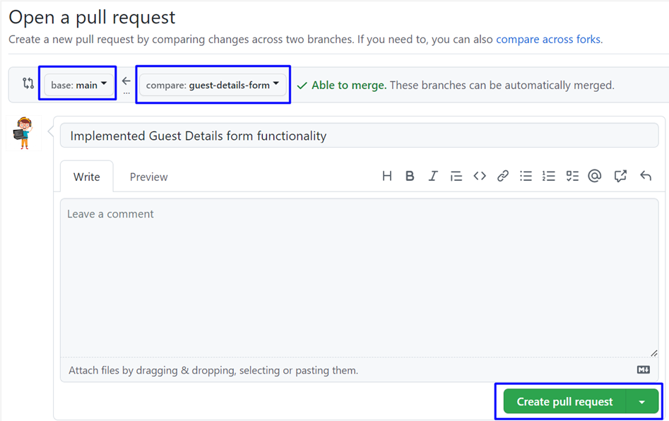
Don't forget to add a reviewer.


Step 9: Approve a Pull Request
Now you should approve one of your friend's pull requests. But before that, we should resolve the conflicts.


When conflicts are resolved, merge the changes:


Step 10: Merge Pull Request
Merge the search-form branch into the main branch.
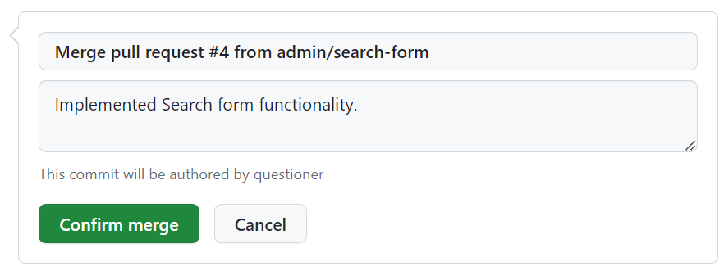


Verifier
Verifier should implement the "Confirm Reservation Form" functionality:
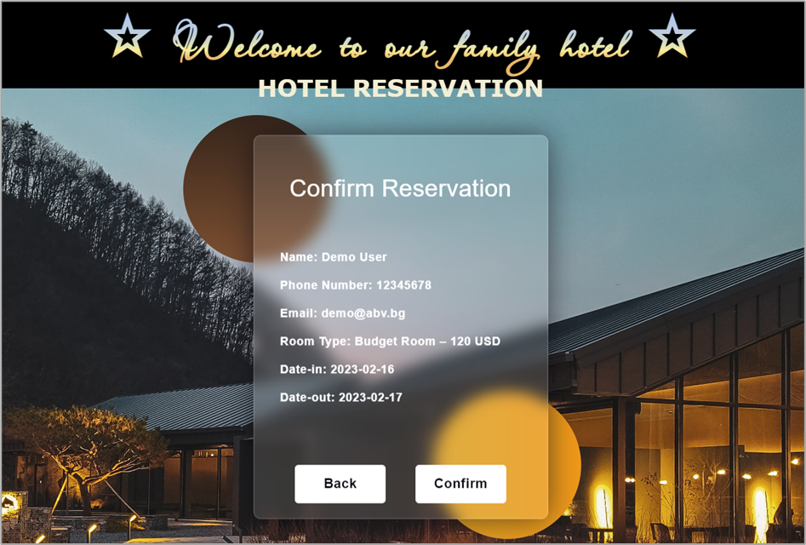
The Verifier's task is to confirm personal data.
Verifier clones the project repository, makes a sequence of changes in the source code files, commits locally in repository, then pushes the committed changes to GitHub.

Step 1: Clone the "Hotel Reservation" Repository
The Verifier should already have cloned locally the main project repo.

Step 2: Create a Local Branch
We want to add some new features to our SPA app. We are working in our local repository, and we do not want to disturb or wreck the main project. So, we create a new local branch:
git branch confirm-reservation-form
We have two branches now: main and confirm-reservation-form.
Now we should check out the new branch, e.g., switch from the current branch to the new one.
git checkout confirm-reservation-form
We have moved our current workspace from the main branch, to the confirm-reservation-form branch.

Step 3: Search Form: HTML
In index.html, in div with class "site-content" he adds some HTML (Verifier/index.html file from the resources) for the confirm reservation form.

Step 4: Search Form: JavaScript Code
In solution.js, he adds a new function (Verifier/solution.js file from the resources) to the confirm reservation form.
Use this code box only while testing functionality in your custom branch.
changeContent('confirm-reservation-content');

Step 5: Search Form: CSS
In styles.css, he adds styles (Verifier/styles.css file from the resources) to the confirm reservation form.

Step 6: Test the Project Functionality
Verifier now tests the project functionality to see whether SPA app works correctly, as well as whether the entire project works as expected:
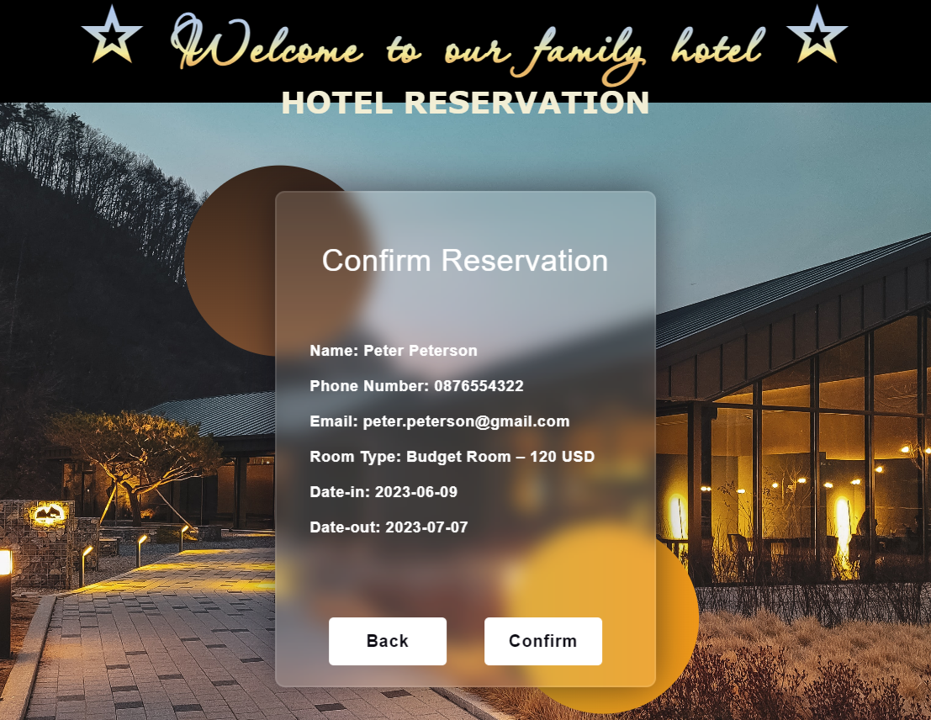
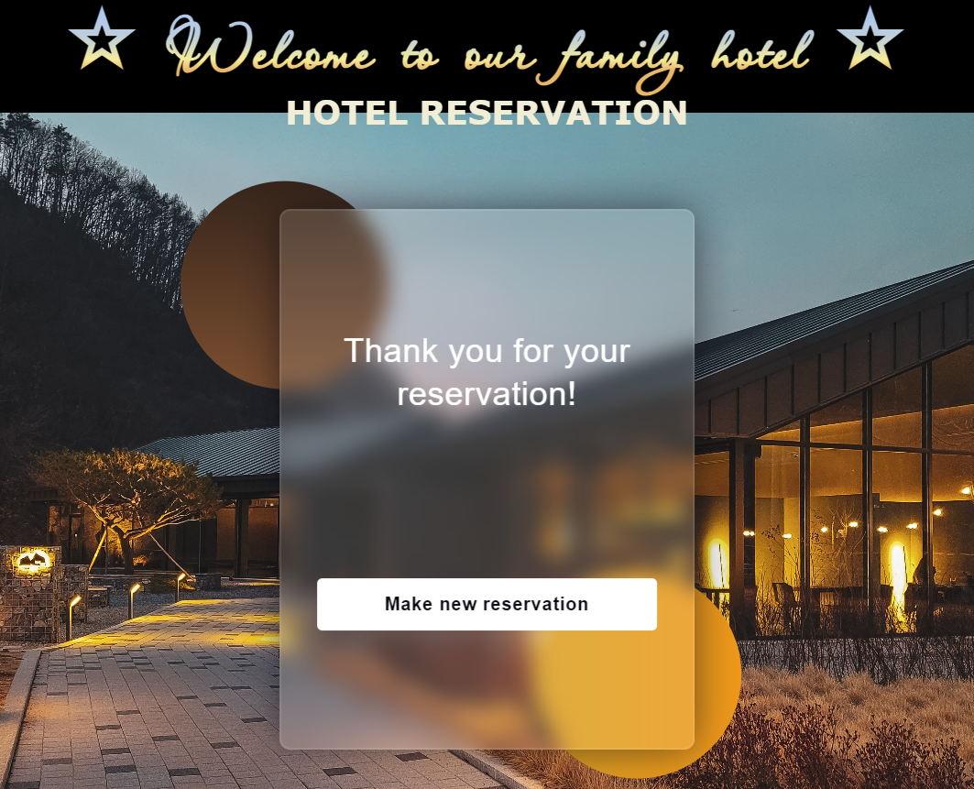

Step 7: Commit All Changes to the Local Branch
Verifier adds and commits in Git all local changes:
git commit -a -m "Implemented Confirm Reservation form functionality"
Now we have a new branch, that is different from main. If we now push to the repo, we will get an error because the confirm-reservation-form branch is local, not upstream, e.g., it is not in GitHub yet, only locally:
git push
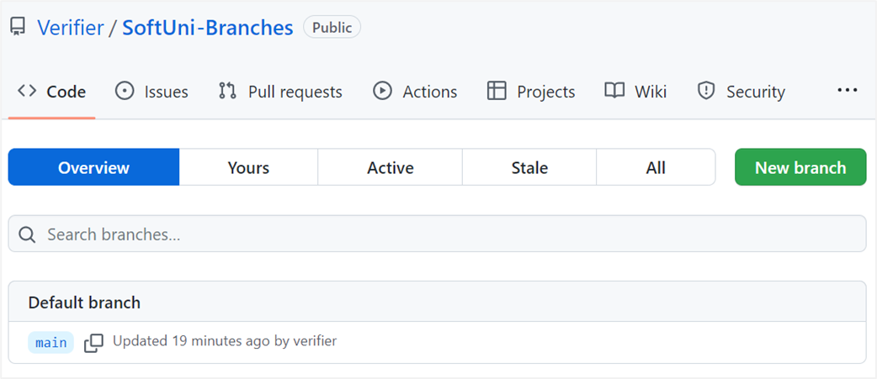
To fix this error we should run the following command.
git push --set-upstream origin confirm-reservation-form
The "--set-upstream" option is utilized to set the remote as the upstream directory and fix the above-encountered error.
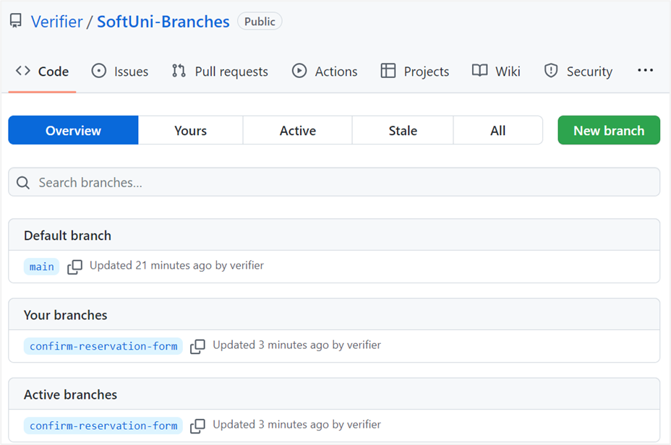
We have the upstream branch confirm-reservation-form.

Step 8: Create a Pull Request
Now go to your GitHub repo and create a pull request for merge from the confirm-reservation-form to the main branch:
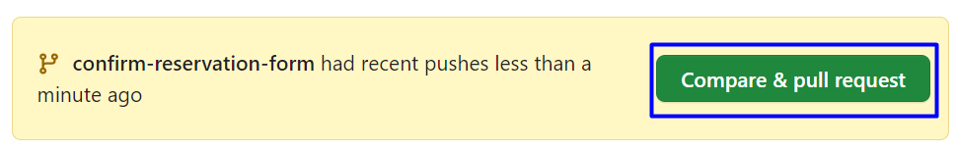
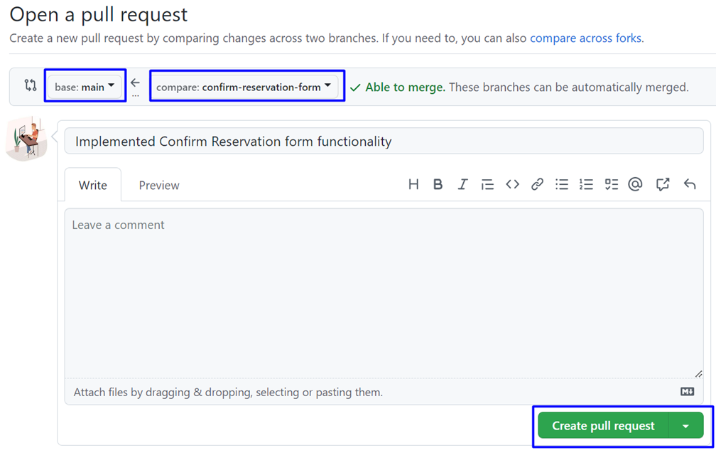
Don't forget to add a reviewer.

Add a title and create the pull request:
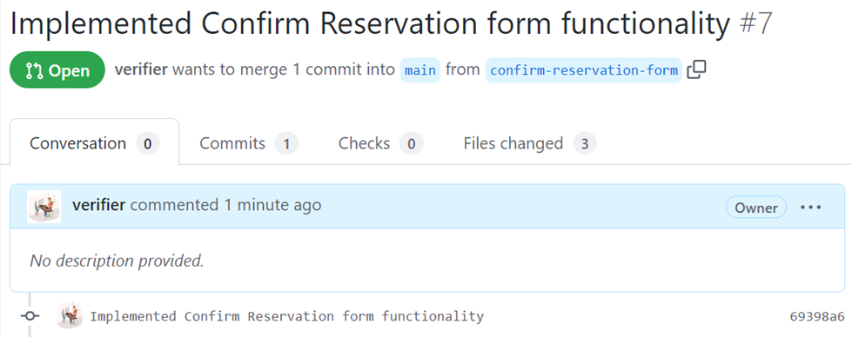

Step 9: Approve a Pull Request
Now you should approve one of your friend’s pull requests. But before that, we should resolve the conflicts.


When conflicts are resolved, merge the changes:


Step 10: Merge Pull Request
Merge the search-form branch into the main branch.


Step 5: Merge and Create / Approve Pull Requests
When done with their functionalities, each team member should merge their feature branch into the main branch of the GitHub repo.
- Each team member should create a pull request. When the pull request is approved and the branch is successfully merged, they should delete the feature branch.
- Each team member should accept one pull request of another collaborator.
You should also solve conflicts that appear on merge. At the end, all pull requests should be approved and all feature branches should be merged into main and deleted.

