Trello Authorization

In order to use the Trello API, we need to have an API Key and Token and use them in the variables. Trello API doesn't use passwords. In order to have API Key and Token we need to create Trello Power-Up. At its core a Power-Up is just a configuration. So just follow the next steps to generate all the attributes needed or you can read Trello documentation.
Go to https://trello.com/power-ups/admin
Agree to the Trello Developer Terms
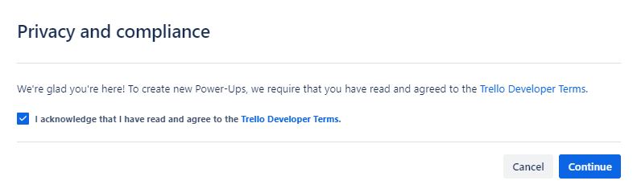
Create a New Power-Up
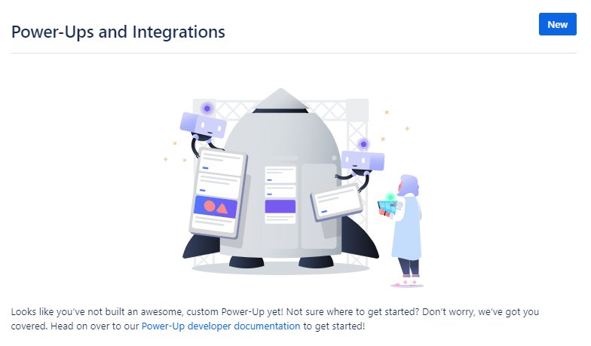
Fill in some data. Leave the red one as it is. We named our Power-Up "Postman", but feel free to
choose otherwise.
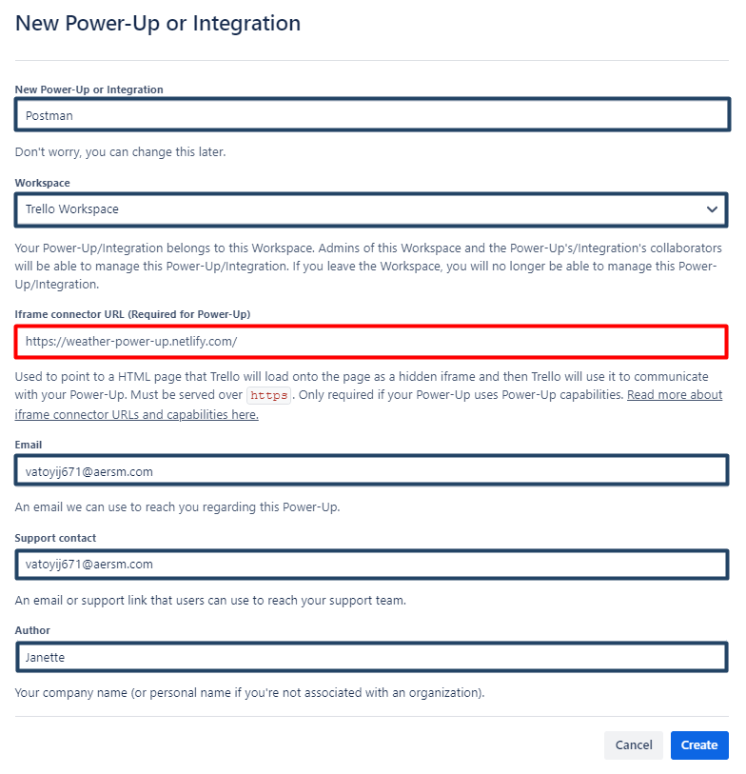
Click on "Generate a new API Key button"
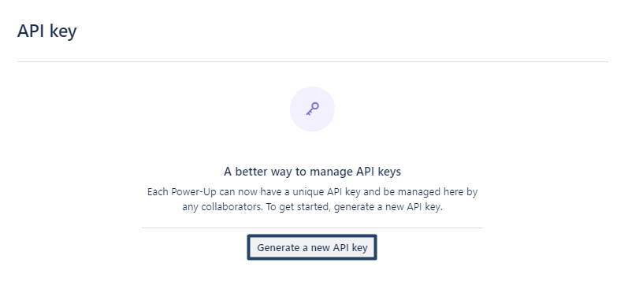
And then "Generate API key"
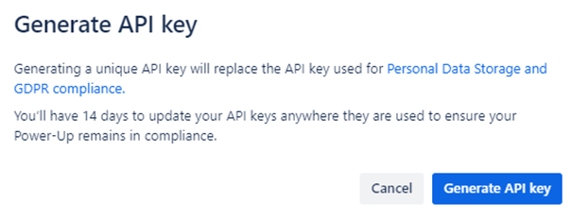
We need the API key. Forget the other options. Copy and paste your API Key somewhere safe, because we will need it in order to make requests and click on Token.
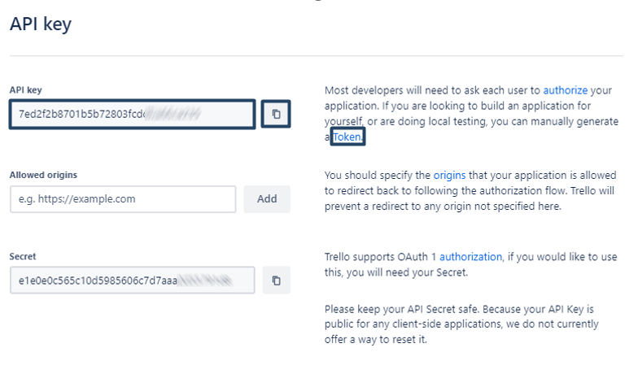
On the page that will open in a new tab, you have to give permission to your Power-Up (in our case, we named our Power-Up "Postman", remember?) to use your Trello Account.
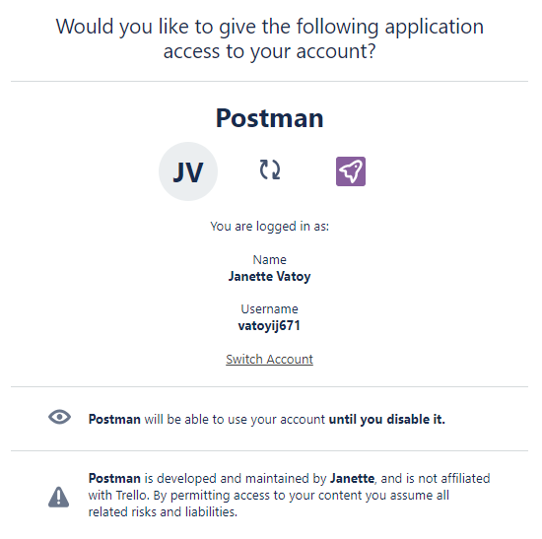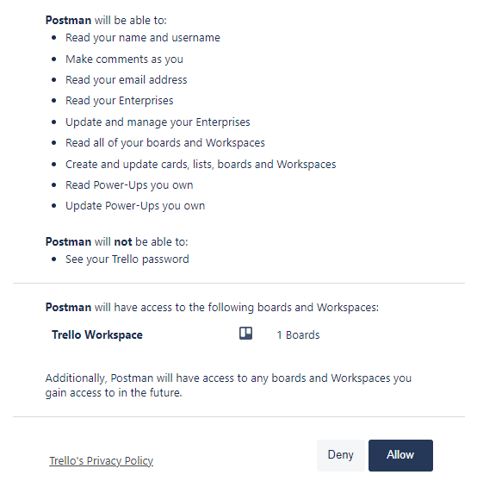
And it will generate your Token. Copy and paste this Token somewhere safe, because you will need it in your Postman requests.
