Exercise: Automated Testing
Exercises for the "Software Engineering and DevOps" module @ SoftUni

Postman and Newman

Postman Runner
 | For a long time, the Collection Runner was a free tool with no usage limits. However, starting in March 2023, Postman introduced significant restrictions on how many times you can use the Collection Runner each month. On the free plan, you're limited to 25 runs per month. A run counts each time you press the [Run] button, regardless of how many requests your collection has. As you approach this limit, you'll see a warning, and eventually, you'll reach a soft limit. If you keep using the tool beyond this point, you'll hit a hard limit. To avoid reaching the hard limit and making the Collection Runner unusable, try to minimize how often you execute your collections.  You can check how many runs do you have left from the [Upgrade] button:  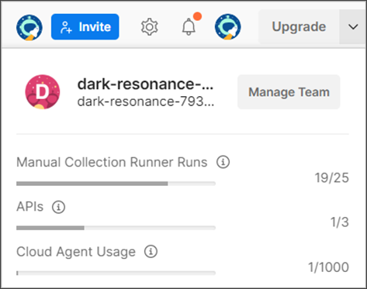
The Collection Runner is a tool that is built into Postman and allows us to execute the entire collection with just a single click instead of manually going over each individual request and clicking the send button. You can execute your API test collections within Postman by selecting the Run collection option from the collection menu.
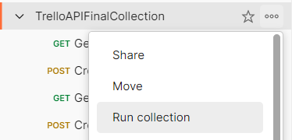
The Collection Runner opens in a separate tab. Notice the run order first, which shows how requests will be executed in the same sequence as they appear in the collection. If there's a request you prefer not to run, simply disable it. If you're not satisfied with the execution order, you can easily change it by dragging the request to a new spot. In our case, the current order is perfectly fine.
We have few options here:
- Run Manually
- Schedule runs
- Automate runs via CLI
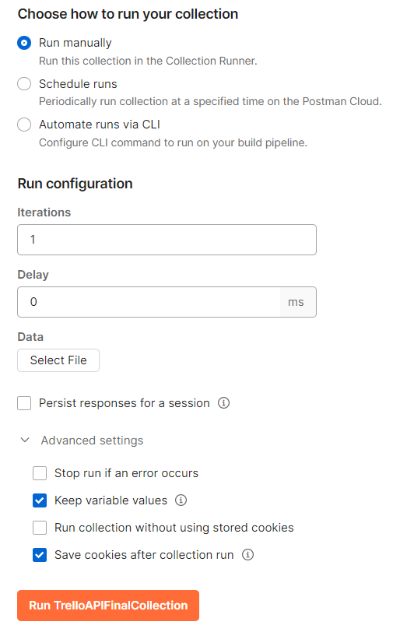

Running the Collection Manually


Iterations
Determines how many times the collection runs. If you input "2", the collection will run twice. Usually, one iteration sufficient.

Delay
Manages the timing between requests, like allowing time for a board to become available after creation, add a delay. This can prevent failures in subsequent requests.

Persist responses for a session
This saves the responses from your API requests until you close the session, helping you to check them later for any issues.

Keep variable values
This keeps the new values of any variables you change during the run for use later in the same session.

Run collection without using stored cookies
This runs your requests without any cookies saved before, making sure your tests are clean.

Save cookies after collection run
This saves new cookies from your run to use in future sessions or tests.
When you are running the collection:
- Utilize Postman Console for Troubleshooting
  - Before running the collection, clear any existing logs in the Postman console to streamline troubleshooting. Console logs are invaluable for debugging, showing executed requests and logged statements.
- Inspect Request Details
  - After running the collection, you can examine each request for additional insights, such as the request URL and response body. If certain details are missing, like the request body, refer to the Postman console for a complete overview.
- Review and Debug
  - The Collection Runner provides a preliminary step towards automation by offering a semi-automatic way to run collections. It generates a report detailing which requests succeeded or failed, aiding in troubleshooting.
- Ensure Collection Runs Smoothly Before Automating Further
  - Verify that your collection runs correctly with the Collection Runner before moving on to more advanced automation tools. If there are issues at this stage, it's easier to debug within Postman.

Schedule runs
To set up a scheduled run for a collection in Postman, which will run automatically without you needing to
click anything:
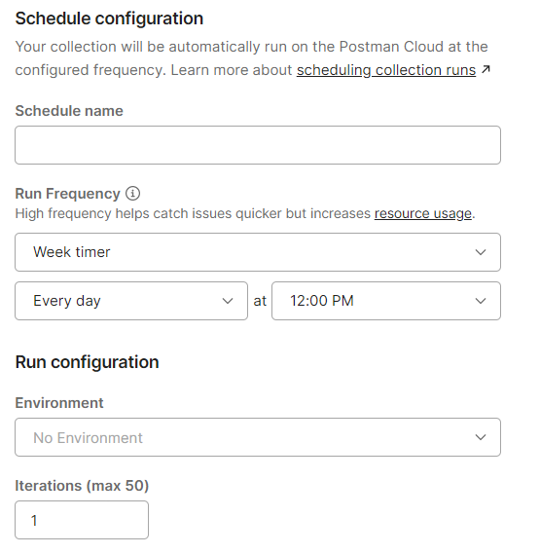
In Postman, the 'Schedule runs' feature is designed for automating collections to run at specified intervals:
- You can set up automation by choosing 'Schedule runs' in the collection options.
- This allows you to name your schedule, like 'Daily API Check', and pick the frequency, such as daily at noon.
- The automation executes on Postman's cloud, so your local machine's status won't affect it.
- To view or manage these runs, you'd navigate to the 'Runs' tab in the collection's settings.
- It's important that the scheduled runs are configured with the correct initial variable values since they depend on these for proper execution.
However, keep in mind that on the free plan, Postman limits you to 25 collection runs per month, so while setting this up, you should be cautious not to exhaust your allowed runs.

Postman CLI
The Postman CLI is an integrated tool within Postman that enables the automation of collection runs through
the command line.

Installation and Basic Usage
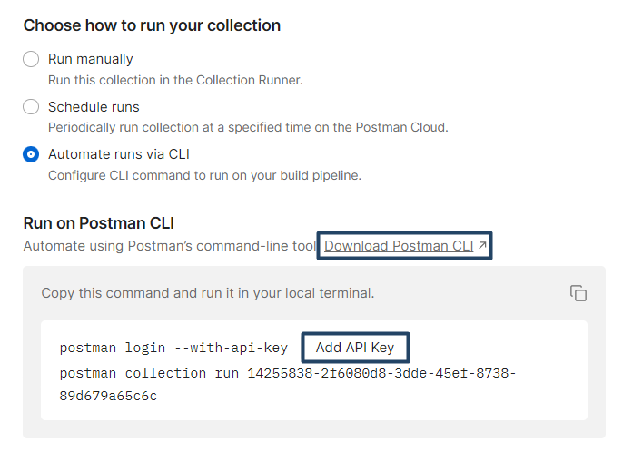
This will open a new tab. Choose your operation system and copy the command for your operating system in your terminal and this will install Postman CLI:
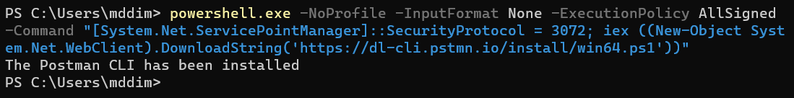
After the installation, you can simply type postman in your terminal and it will give you some ideas of how we can use Postman:
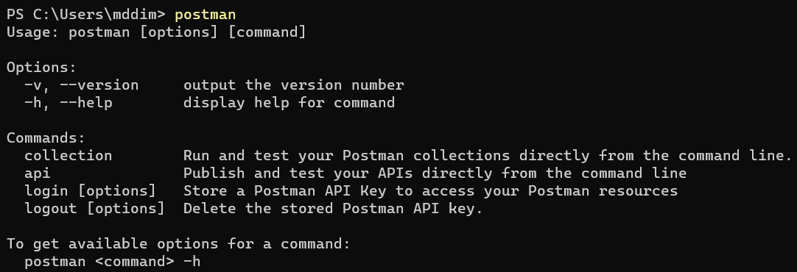
After installing Postman CLI, you'll need an API key to access your Postman collections. So, let's create one:
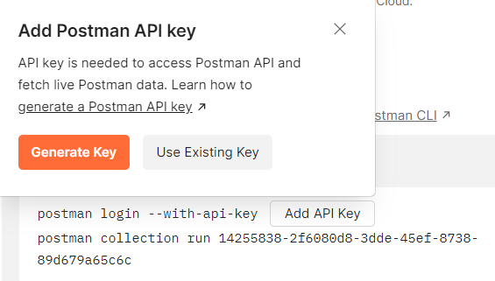
Name your API key, after that copy and paste it somewhere safe. It is shown only once:
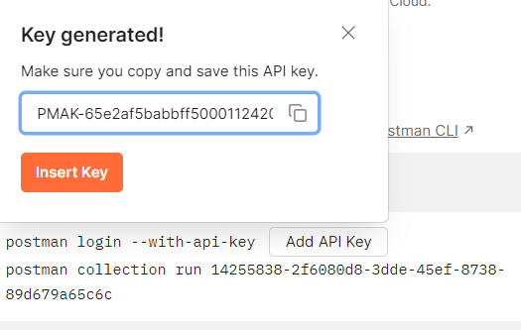
When you click the [Insert] button, it will add the API key to the command, so you need to copy the commands and run them in your local terminal:
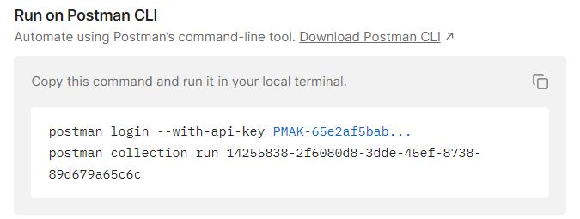
The first command logs you in with the API key and the second one runs the collection:
But all of our tests are failing. Why is that?
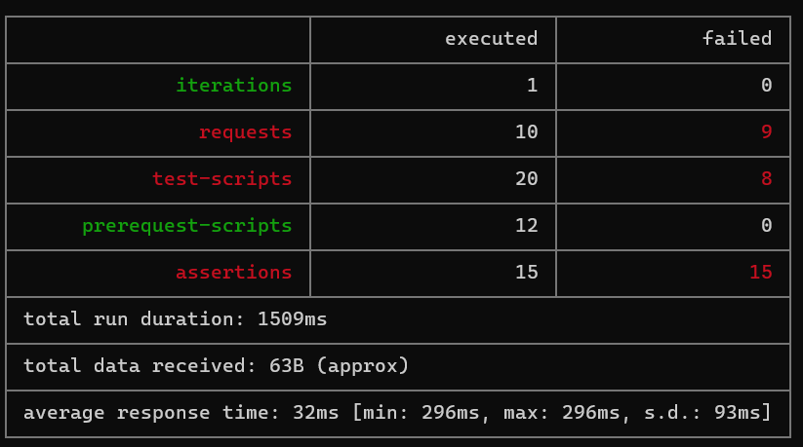
We can see here on our first request that Postman doesn't recognize what {{baseURL}} and doesn't have access to our trelloKey and trelloToken.
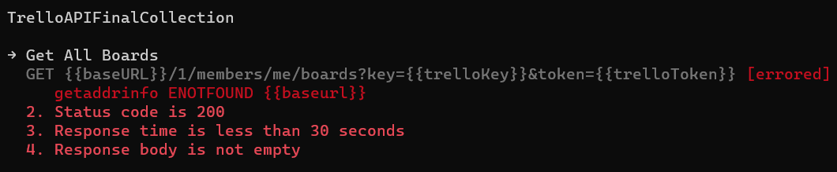
In general, Postman can't resolve our variables, because their initial value is hidden.
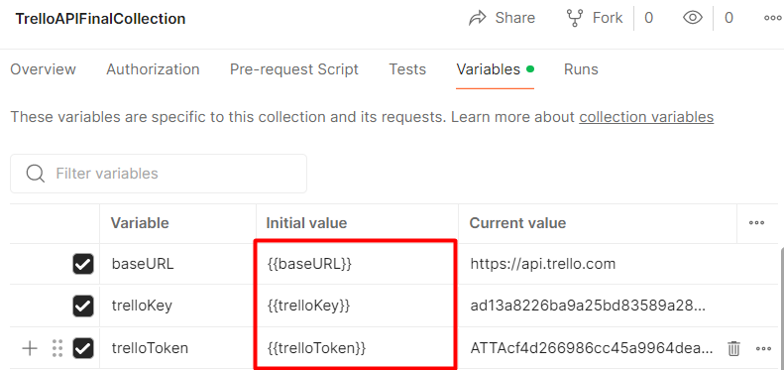
So go ahead to your collection and navigate to Edit Variables and "unhide" the initial value (copy and paste the current value to in the initial value). Don't forget to save the changes!
Go to the CLI and since you're already logged in, just run the second command:
And this time all our tests are passing.
 | Some useful commands for Postman CLI:  - postman login  - postman logout  - postman collection run {collection id}  - postman collection run {collection URL}  - postman collection run {JSON file}

 | Some additional options for the postman collection run command  - --bail option → stops the collection from running immediately if any test fails (works or collection id, collection URL and JSON file)  - --delay-request [number] → specifies a delay (in milliseconds) between requests  - -i [requestUID] or [folderUID] → Runs only the specified folder UID or request UID from the collection

Newman
Postman CLI lacks custom reporters and integrations with third party tools and services. This is where his older brother Newman comes to help. It is also created by Postman, but under an open-source model, which makes it easier to extend and create more advanced integrations.

Installation
Newman runs inside the Node.js runtime environment. So, this is why Node.js needs to be installed locally on your computer. To check if you have Node.js installed run the following command on your terminal:
node -v
It will show you the current version installed on your computer.
If you don't have Node.js installed, go to https://nodejs.org/en and install the LTS version.
Now, to install Newman, you need to run this command:
npm install -g newman
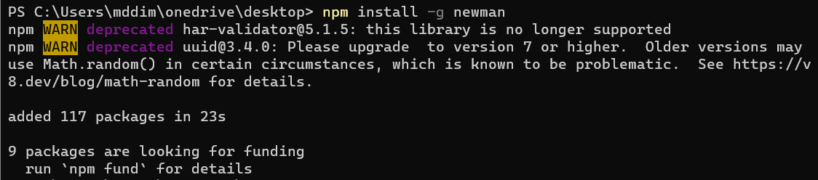

Running a Collection
The command we need to write to run a Postman collection in Newman is:
newman run (followed by a location where Newman can fetch that collection – this can be a local file or a remote URL)
You already have the JSON file with your collection, stored in your computer and you also have the URL of the collection, both from the exercises with Postman CLI. Go ahead and run the tests from the terminal. Pretty much it is the same as with Postman CLI, so what is so special about Newman? Newman has multiple reporters. Let's see what a reporter is.

Generating HTML reports

Step 1: Install HTMLEXTRA
The htmlextra Reporter is a plugin for Newman that generates comprehensive HTML reports for Postman collection runs. This tool is designed to provide an enhanced visualization of API test runs for better analysis and debugging​. You can find it here:
https://www.npmjs.com/package/newman-reporter-htmlextra
In order to install it you should run the following command:
npm install -g newman-reporter-htmlextra

Step 2: Using Newman with HTMLEXTRA
In order to use this reporter, specify htmlextra in Newman's -r or --reporters option. The following command will create a new report in the ./newman directory. If the directory does not exist, it will be created as part of the Newman run.
newman run {collection.json} -r htmlextra
For a few seconds, nothing happens and you might think that this doesn't work, but if you navigate to where your collection is stored in your computer you will find a folder called newman was created. In that folder, you'll have the HTML report. Go ahead and open it. It will open in your browser and it has pretty awesome features. Go ahead and take a look. Explore it. Click on Summary, Total Requests, Failed Tests, Skipped Tests. It contains a lot:
- A summary dashboard with the overview of the run
- Tabs for detailed request and response data
- Visual indicators for passed and failed tests
- Buttons or links for navigation within the report
- Options to view logs, headers, body data, and variables used during the run
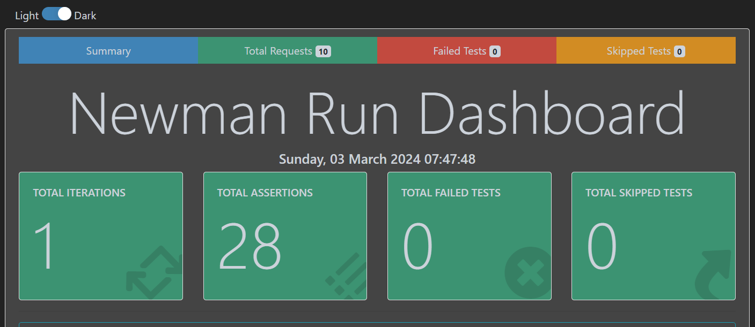
But what happened with the CLI report? Whenever we are writing -r in Newman, we are specifying a reporter and only that reporter will be used. You can specify as many reporters as you like. So, in order to see the CLI report on the console and create an HTML report via htmlextra, we can specify that, like this:
newman run {collection.json} -r 'cli,htmlextra'
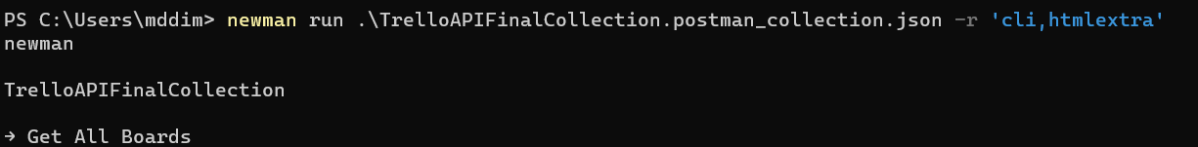
htmlextra is highly customizable, through command-line options, so we suggest to explore its documentation.
https://www.npmjs.com/package/newman-reporter-htmlextra

Selenium IDE

Selenium IDE
We have the "SeleniumIDE" solution in the resources which has some test projects already.
This Selenium test project automates the testing of a login process for the Sauce Demo website, focusing on the scenario where an invalid username is entered.
The test TC01IfUserIsInvalidTryAgainTest automates the process of testing if a user with invalid credentials is prompted to try again and then successfully logs in with valid credentials.
Key Steps

Setup
A Chrome browser instance is created (ChromeDriver) and the browser window is resized to specific dimensions. A JavaScript executor (IJavaScriptExecutor) is initialized to execute JavaScript within the test.

Test Logic
The test navigates to the Sauce Demo website (https://www.saucedemo.com/) and it simulates entering an invalid username (user123) and the correct password (secret_sauce). After submitting the form, it captures the error message shown on the page and checks if it matches the expected error.
In general, the test demonstrates how to handle login attempts with incorrect credentials, capture error messages, and retry with the correct information. It provides a good example for automated testing in cases where login functionality needs to handle both invalid and valid input.
Open Visual Studio and from there navigate to the Tools menu. Select NuGet Package Manager and select Package Manager Console:
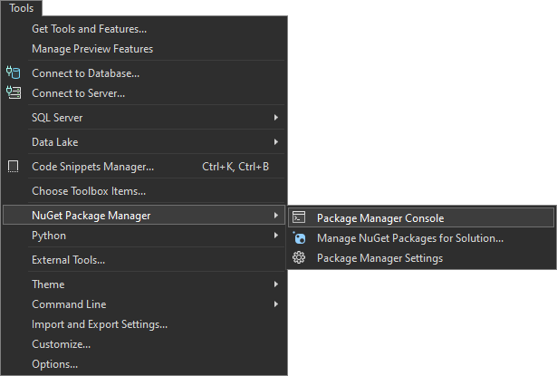
Let's first build the application by using the following command:
dotnet build
After you have ensured that the build was successful, you can run the tests, too, by using the command below or just by clicking on the [Run All Tests in View] button in the Text Explorer.
dotnet test

Selenium WebDriver

Chromedriver
Before exploring the solution, there is something very important that we must acknowledge ourselves with – the Chromedriver.

What is Chromedriver?
Chromedriver is a tool that enables automated testing of web applications in Google Chrome. It acts as a bridge between the Selenium automation framework and the Chrome browser. When running a Selenium test, Chromedriver communicates with the browser, sending commands (like navigating to a URL, clicking elements, or filling forms) and retrieving results (like checking if an element is visible or validating text on a page).

Why is Chromedriver important?
When automating browser interactions using Selenium, each browser requires its own driver to communicate with Selenium. For example, Firefox uses geckodriver, while Chrome uses chromedriver. Without it, Selenium cannot control Chrome or run any automated tests.
When Selenium wants to control a browser, it needs a driver that translates commands from Selenium to the browser. In this case, for Google Chrome, we need Chromedriver. It's like a remote control that makes sure Selenium can interact with the browser efficiently.
How to Download Chromedriver?

Step 1: Check Chrome Version
Before downloading Chromedriver, you need to know your installed Chrome version. To do this, open Chrome, click on the three-dot menu in the top-right corner, go to Help > About Google Chrome, and note the version number (e.g., 116.x.x).

Step 2: Download Chromedriver
Go to the official Chromedriver page: https://sites.google.com/chromium.org/driver. Find the Chromedriver version that matches your installed Chrome browser version. Download the appropriate version based on your operating system (Windows, Mac, Linux).

Step 3: Add Chromedriver to Your Project
Extract the downloaded file and place it in a directory accessible to your project (for example, a folder called drivers within your project structure). Explicitly provide the Chromedriver path when initializing the WebDriver in the project (as seen in the tests).

Selenium WebDriver
These tests automate real-world interactions with live web applications and validates that the system works as expected across different scenarios.
You can run the tests the same way you ran them for SeleniumIDE.

Playwright

Application Specifications
You are given a Web application (SPA) using JavaScript that has UI tests implemented. The application dynamically displays content, based on user interaction and supports user profiles and CRUD operations, using a REST service.

Navigation Bar
Guests (un-authenticated visitors) can see the links to the All Books, as well as the links to the Login and Register pages. The logged-in user navbar contains the links to All Books page, My Books page, the Add Book page, Welcome, {user's email address}, and a link for the Logout action.
User navigation example:
Guest navigation example:

Login User
The included REST service comes with the following premade user accounts, which you may use for development:
{ "email": "peter@abv.bg", "password": "123456" }
{ "email": "john@abv.bg", "password": "123456" }
The Login page contains a form for existing user authentication. By providing an email and password the app logins a user in the system, if there are no empty fields.
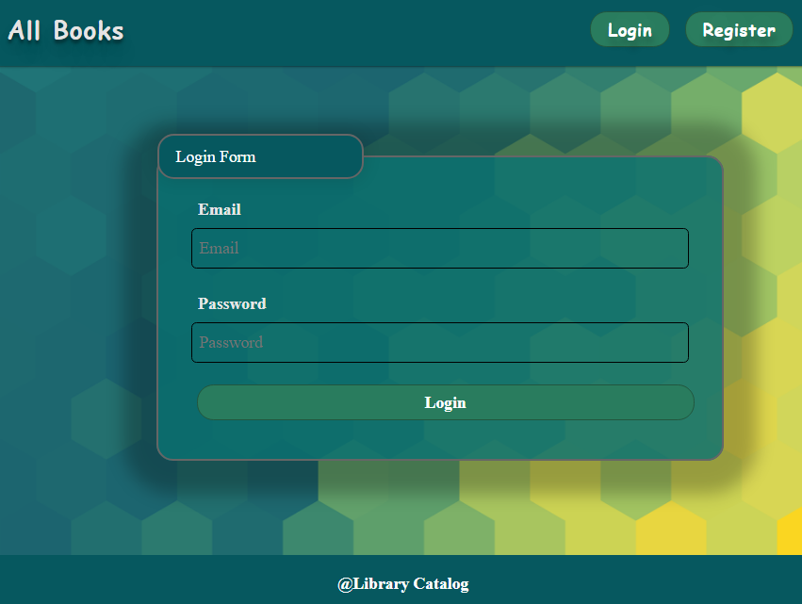
The following request is used to perform login:
Method: POST
URL: /users/login
The service expects a body with the following shape:
{
email,
password
}
Upon success, the REST service returns the newly created object with an automatically generated _id and a property accessToken, which contains the session token for the user – you are already storing this information using sessionStorage or localStorage, in order to be able to perform authenticated requests.
If the login is successful, the app redirects the user to the All Books/Dashboard page. If there is an error, or the validations don't pass, it displays an error message, using a system dialog (window.alert).

Register User
By given email and password, the app registers a new user in the system. All fields are required – if anyone of them is empty, the app displays an error.
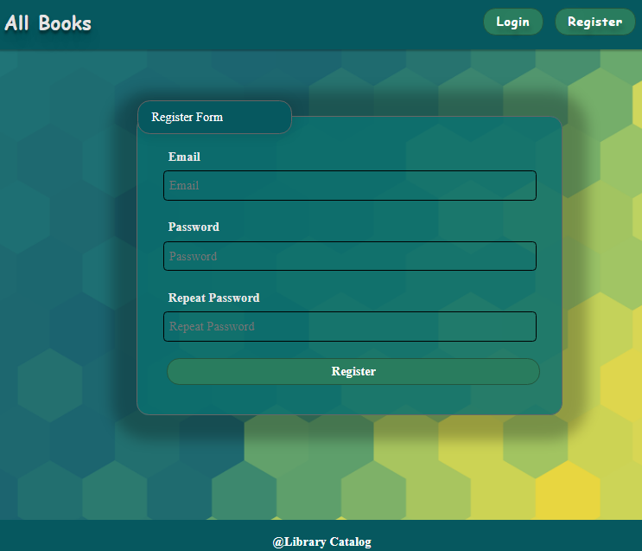
The following request is used to perform login:
Method: POST
URL: /users/register
The service expects a body with the following shape:
{
email,
password
}
Upon success, the REST service returns the newly created object with an automatically generated _id and a property accessToken, which contains the session token for the user – you are already storing this information using sessionStorage or localStorage, in order to be able to perform authenticated requests.
If the registration is successful, the app redirects the user to the All Books/Dashboard page. If there is an error, or the validations don't pass, it displays an error message, using a system dialog (window.alert).

Logout
The logout action is available to logged-in users. If the logout is successful, the app redirects the user to the All Books/Dashboard page.
The app sends the following request to perform logout:
Method: GET
URL: /users/logout

Add Book
The Add Book page is available to logged-in users. It contains a form for adding a new book. Checks if all the fields are filled before you send the request.
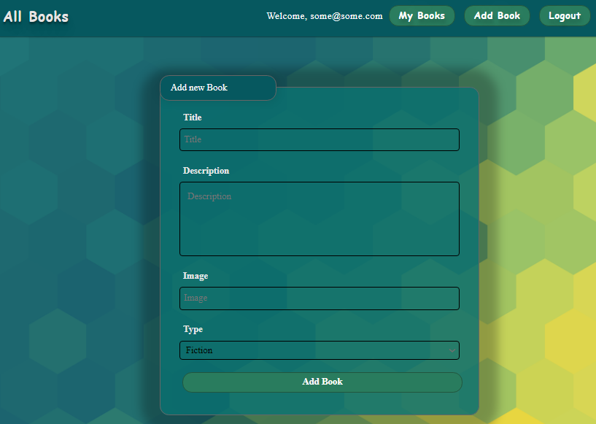
The following request is being sent:
Method: POST
URL: /data/books
The service expects a body with the following shape:
{
title,
description,
imageUrl,
type
}
The service returns the newly created record. Upon success, it redirects the user to the All Books/Dashboard page.

All Books
This page displays a list of all books in the system. Clicking on the details button in the cards leads to the details page for the selected book. This page should be visible to guests and logged-in users.
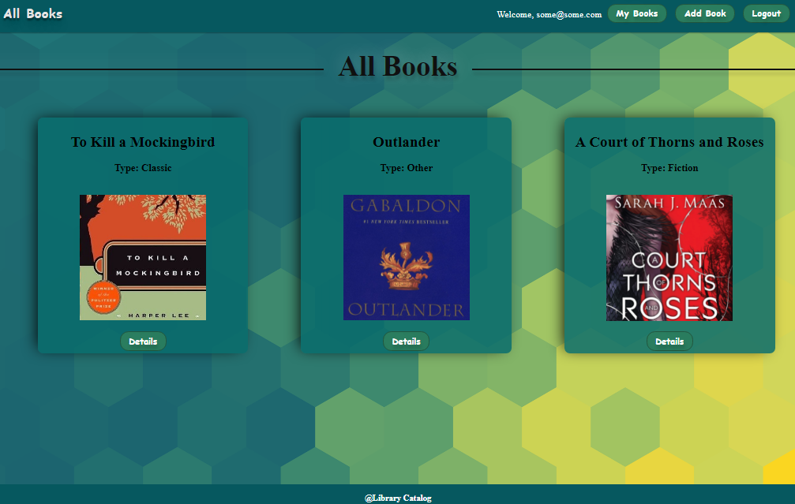
If there are no books, the following view is be displayed:
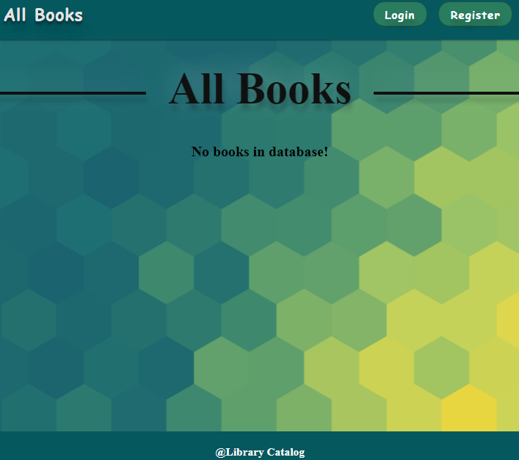
The following request is used to read the list of books:
Method: GET
URL: /data/books?sortBy=_createdOn%20desc
The service returns an array of books.

Book Details
All users are able to view details about books. Clicking the Details link in of a book card displays the Details page. If the currently logged-in user is the creator, the [Edit] and [Delete] buttons are displayed, otherwise they are not available.
The view for the creators looks like this:
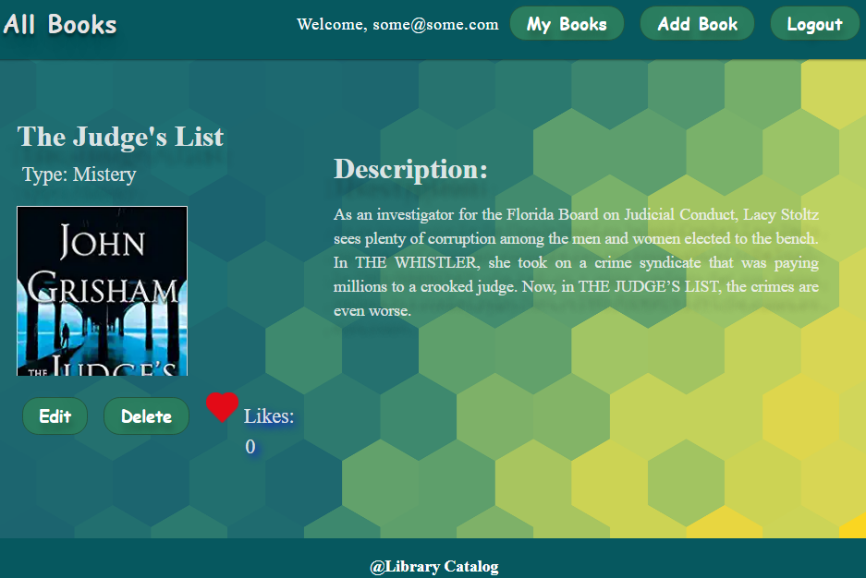
The view for the non-creators looks like this:
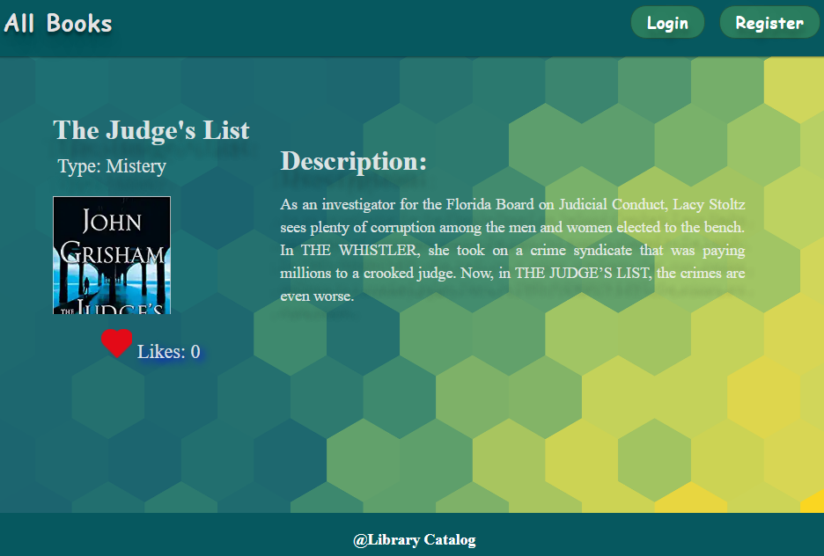
The following request is used to read a single book:
Method: GET
URL: /data/books/:id
id is the id of the desired book. The service returns a single object.

Edit Book
The Edit page is available to logged-in users and it allows authors to edit their own book. Clicking the Edit link of a particular book on the Details page displays the Edit page, with all fields filled with the data for the book. It contains a form with input fields for all relevant properties. Checks if all the fields are filled before you send the request.
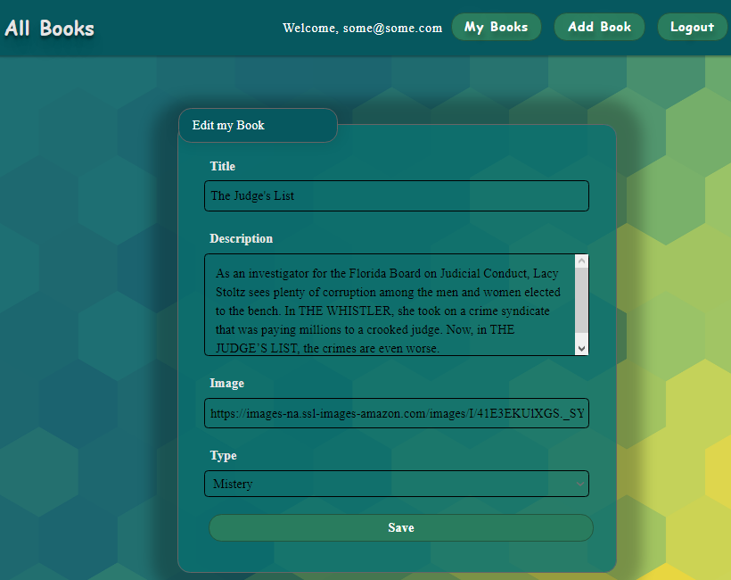
To edit a post, the app uses the following request:
Method: PUT
URL: /data/books/:id
id is the id of the desired card.
The service expects a body with the following shape:
{
title,
description,
imageUrl,
type
}
The service returns the modified record. Note that PUT requests do not merge properties and instead replace the entire record. Upon success, it redirects the user to the Details page for the current book.

Delete Book
The delete action is available to logged-in users, for books they have created. When the author clicks on the Delete action on any of their book, a confirmation dialog is displayed, and upon confirming this dialog, the book is deleted from the system and the user is redirect to the All Books/Dashboard page.
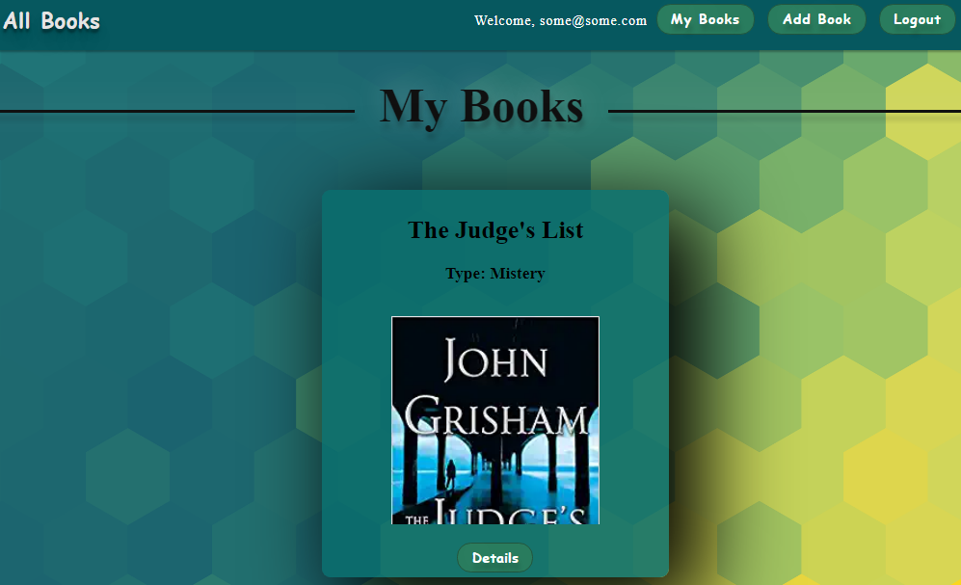
If there are no books, the following view is displayed:
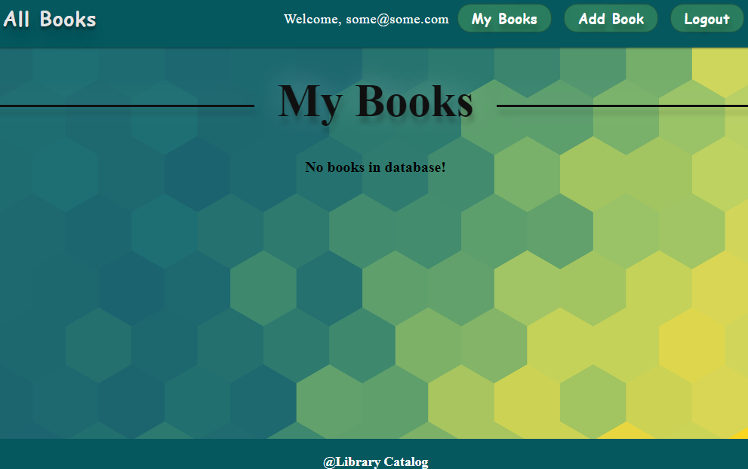
To delete a book, the following request is being used:
Method: DELETE
URL: /data/books/:id
id is the id of the desired book. The service returns an object, containing the deletion time. Upon success, it redirects the user to the All Books/Dashboard page.

My Books
Each logged-in user is able to view their own books by clicking [My Books]. Here are listed all books added by the current user.

If there are no books, the following view is displayed:

The following request is used to read the list of books:
Method: GET
URL: /data/books?where=_ownerId%3D%22{userId}%22&sortBy=_createdOn%20desc
Where {userId} is the id of the currently logged-in user. The service returns an array of books.

Like a Book
Every logged-in user is able to like other books, but not his own. By clicking on the [Like] button, the counter of each book increases by 1.
The view when the user did not press [Like] button looks like:

When the user liked the book, the [Like] button is not available and the counter is increased by 1.
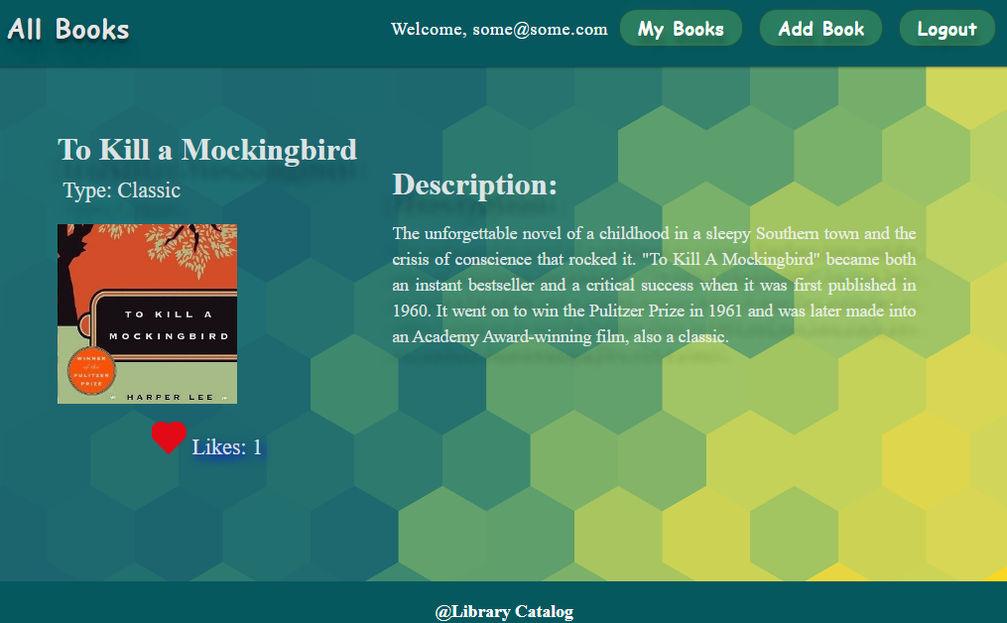
Creator is not able to see the [Like] button. The view looks like:
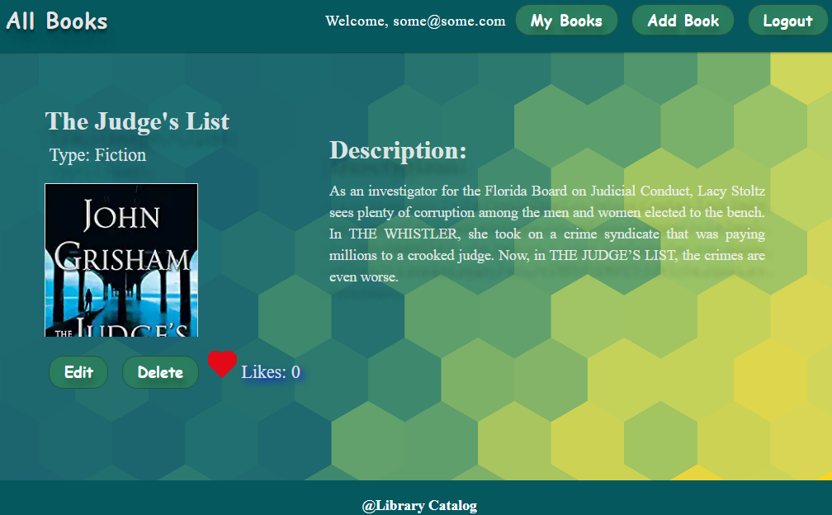
Guest are not able to see the [Like] button. The view for guests looks like:
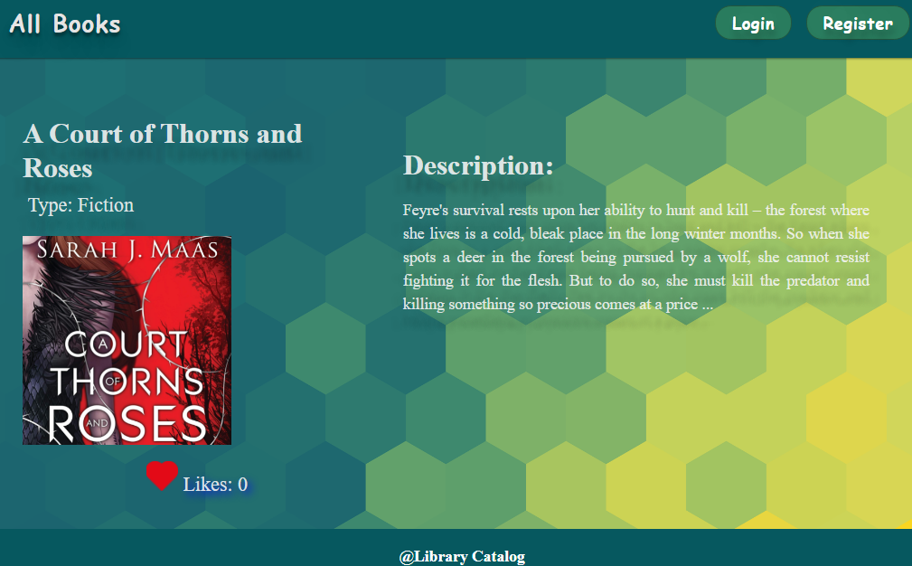
To add a like to a book, the following request is being used:
Method: POST
URL: /data/likes
The service expects a body with the following shape:
{
bookId
}
The service returns the newly created record.
The app uses the following request to get total likes count for a book:
Method: GET
URL: /data/likes?where=bookId%3D%22{bookId}%22&distinct=_ownerId&count
Where {bookId} is the id of the desired book. Required headers are described in the documentation. The service will return the total likes count.
The app uses the following request to get like for a book from specific user:
Method: GET
URL:/data/likes?where=bookId%3D%22{bookId}%22%20and%20_ownerId%3D%22{userId}%22&count
Where {bookId} is the id of the desired book and {userId} is the id of the currently logged-in user.
The service returns either 0 or 1. Depends on that result the [Like] button should be displayed or not.

Running the Tests
First, inspect the package.json file and take a look at the scripts and dependencies sections.
To initialize the SPA, execute the following commands in the Visual Studio Code terminal:
npm install
To install the playwright/test framework, write the following command:
npm install -D @playwright/test
npx playwright install
Then, start the server by using the following command:
npm run start
After that, a web browser should open and you should be able to see the home page of the app.
Then go to the server folder in the project directory, open a CLI there and type this command:
npm run server
To execute the command for running the Playwright tests, just open a new terminal in Visual Studio code and write the following:
npm run test
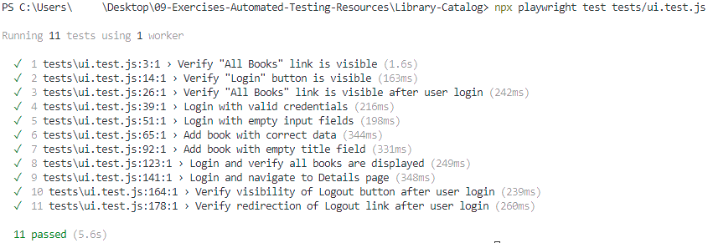

API Testing
You are given a simple API which executes simple CRUD operations over a collection of books. The application is a JS app and the API tests are written in Mocha and Chai.
Inspect the tests and run them by executing the command
npx mocha api.test.js
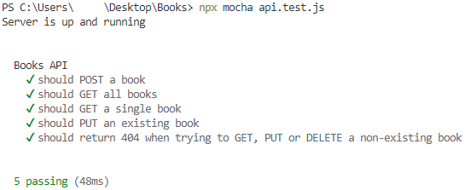

Integration Testing
LibroConsoleAPI is a console-based application built using .Net Core Framework that manages a collection of books.
It allows users to perform various operations, such as creating, reading, updating, deleting books in database in SQL Server.
The application has some xUnit and nUnit integration tests already included in the solution. Try running them separately and observe the results.

