Blood Cancer Identification using Hybrid Ensemble Deep Learning
How It Works — A Non-Technical Guide
Divya Reddy
IMPORTANT NOTICE: This software is a research and educational project. It is not approved for clinical diagnosis.

1. What This Project Does
Acute Lymphoblastic Leukaemia (ALL) is a type of blood cancer that affects white blood cells. Doctors diagnose it by examining a thin smear of blood under a microscope — a peripheral blood smear. This project builds software that looks at those photographs and sorts them into four groups:
- Benign — normal, healthy cells (no cancer).
- [Malignant] early Pre-B — cancer cells at an early stage.
- [Malignant] Pre-B — cancer cells at the Pre-B stage.
- [Malignant] Pro-B — cancer cells at the Pro-B stage.
The user uploads a blood smear photograph through a web browser. The software returns the predicted class, a confidence score, and a highlighted image showing which part of the cell it focused on.
NOT FOR CLINICAL USE. This is a research project. All results must be verified by a qualified medical professional.

2. The Data
The images come from a public Kaggle dataset called 'Blood Cells Cancer (ALL)' by Aria et al. It contains 3,242 microscope photographs of stained blood cells.

Class Counts
Class | Training | Validation | Test | Total
Benign | 358 | 77 | 77 | 512
[Malignant] early Pre-B | 685 | 147 | 147 | 979
[Malignant] Pre-B | 669 | 143 | 143 | 955
[Malignant] Pro-B | 557 | 119 | 120 | 796
Total | 2269 | 486 | 487 | 3242
The split is 70% training (2269), 15% validation (486), 15% test (487). The file src/data.py performs the split.

Augmentation
Augmentation means creating slightly altered copies of training images (flipped, rotated, zoomed, brightness-adjusted) to teach the model to recognise cells regardless of orientation or lighting.

3. How a Computer Learns to Recognise Cells
The software uses a neural network — a chain of simple calculations where each link multiplies numbers by adjustable values called weights. Training adjusts those weights so the network gives correct answers more often. Each backbone was trained for 15 epochs (complete passes through the data).
Transfer learning starts with a network pre-trained on ImageNet (14 million everyday photos) and re-trains only the final layers for blood cells, saving time and improving accuracy.

4. The Three Backbones

MobileNetV2
Small, fast, designed for mobile phones. ~3.5 million parameters. Test accuracy: 96.92%. Macro-F1: 0.9662.

EfficientNetB0
Balances depth, width and resolution efficiently. ~5.3 million parameters. Test accuracy: 91.38%. Macro-F1: 0.9114.

DenseNet121
Dense connections let information flow freely between layers. ~8 million parameters. Test accuracy: 98.97%. Macro-F1: 0.9890.

Two-Phase Fine-Tuning
- Phase 1 (5 epochs): Frozen base, only the classification head learns. Learning rate: 0.001.
- Phase 2 (10 epochs): Top 30% of layers unfrozen. Learning rate: 0.00001.

5. The Hybrid Ensemble
An ensemble combines several models like a panel of doctors. The word 'hybrid' means two combination methods are tried.

Method 1: Weighted Soft Voting
Weights: MobileNetV2=0.3418, EfficientNetB0=0.3114, DenseNet121=0.3468.

Method 2: Stacked Meta-Classifier
A logistic regression learns to combine all twelve output scores from the three models.
Stacking was selected with 98.97% accuracy and 0.9883 macro-F1.

6. Grad-CAM: Where the Model Is Looking
Grad-CAM produces a coloured heatmap showing which image regions influenced the prediction. Warm colours = high attention, cool colours = low attention. Computed in src/gradcam.py.
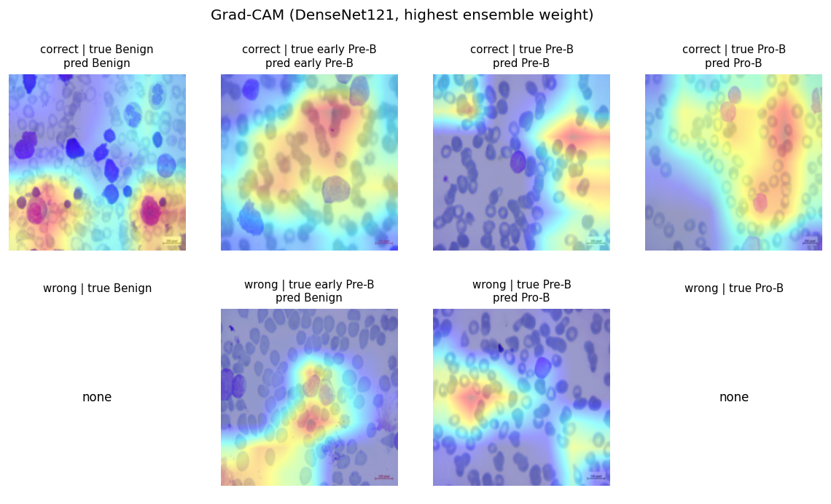
Figure 1. Grad-CAM examples.

7. Results
Model | Accuracy | Macro-F1 | Weighted-F1 | Kappa | ROC-AUC
MobileNetV2 | 96.92% | 0.9662 | 0.9695 | 0.9583 | 0.9981
EfficientNetB0 | 91.38% | 0.9114 | 0.9126 | 0.8828 | 0.9973
DenseNet121 | 98.97% | 0.9890 | 0.9898 | 0.9861 | 0.9994
Ensemble-Voting | 98.36% | 0.9809 | 0.9837 | 0.9777 | 0.9995
Ensemble-Stacking (selected) | 98.97% | 0.9883 | 0.9898 | 0.9861 | 0.9997
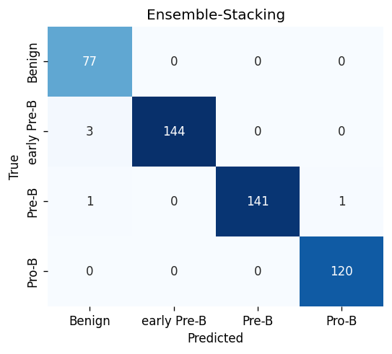
Figure 2. Confusion matrix for Stacking Ensemble.
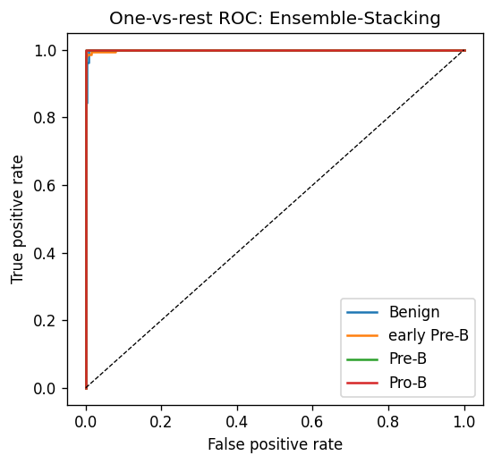
Figure 3. ROC curves.
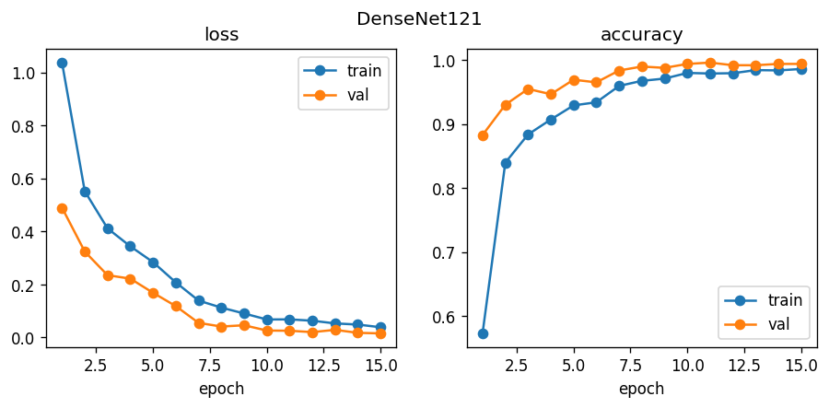
Figure 4. Training curves for DenseNet121.
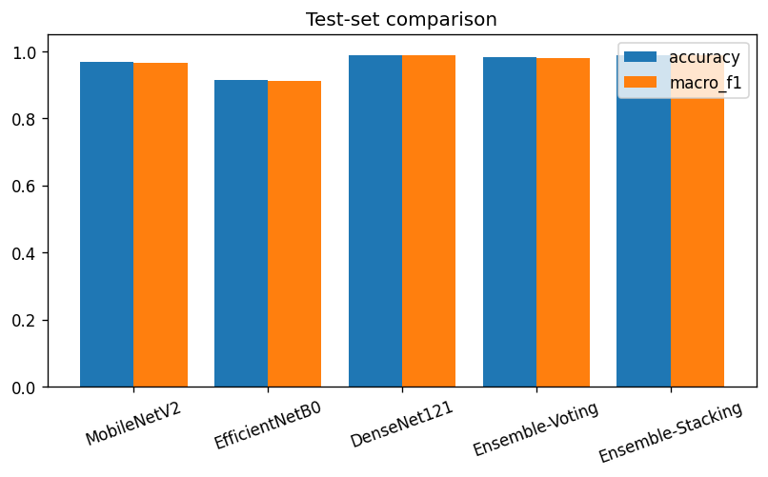
Figure 5. Accuracy comparison.

8. The Web Application

Login / Home
Login with admin/admin. Home shows pipeline status and navigation.
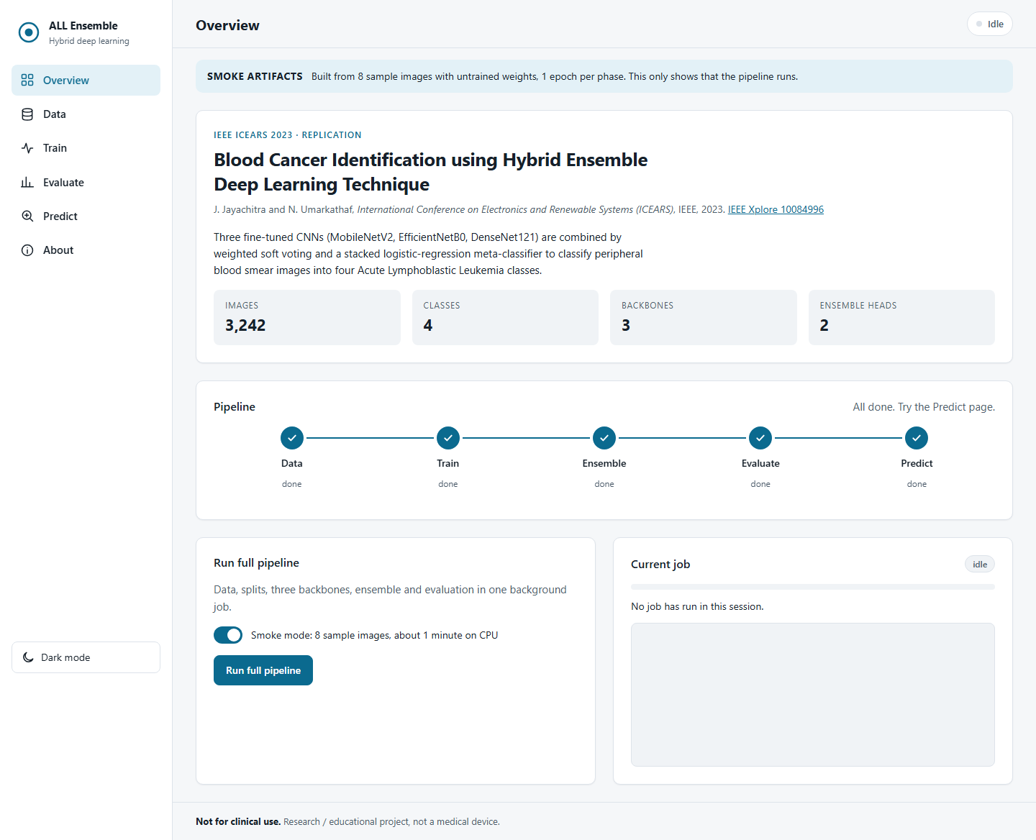
Screenshot: Login / Home.

Data
Download dataset or generate demo data, create splits, view class counts.
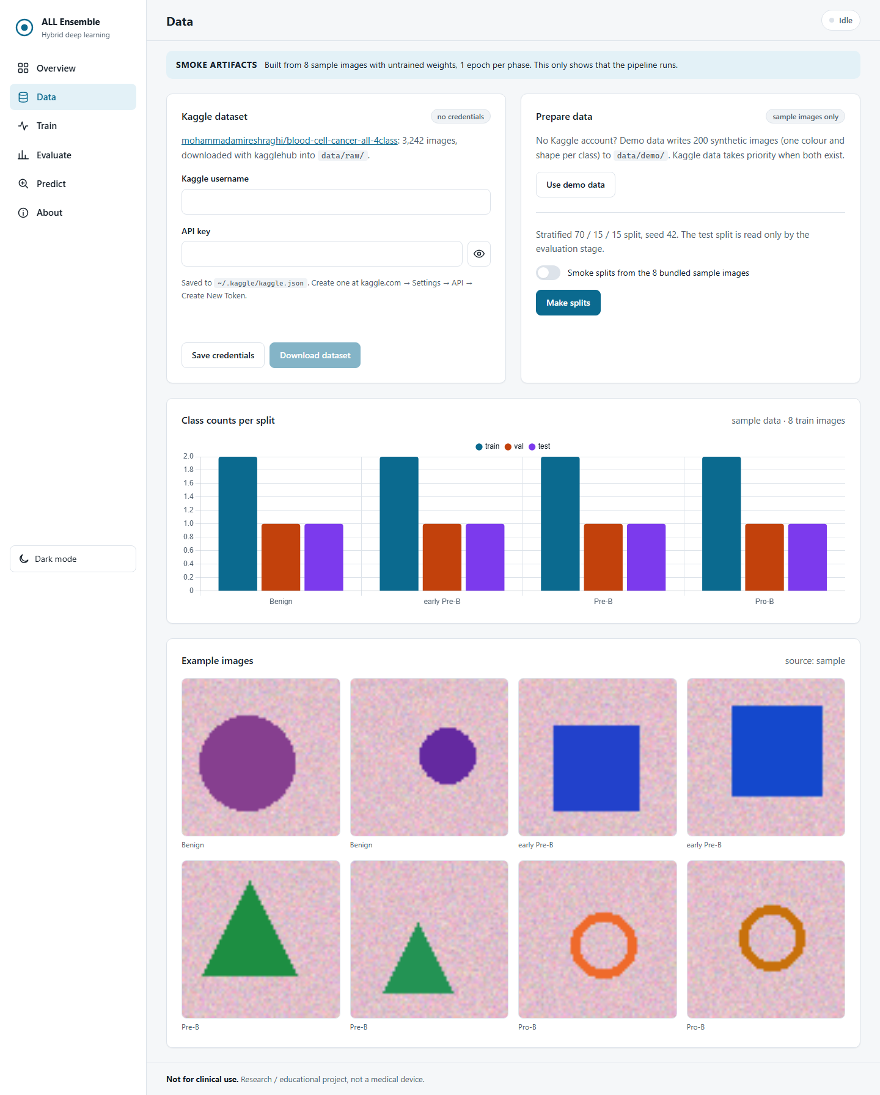
Screenshot: Data.

Train
Start training with live progress bars and charts.
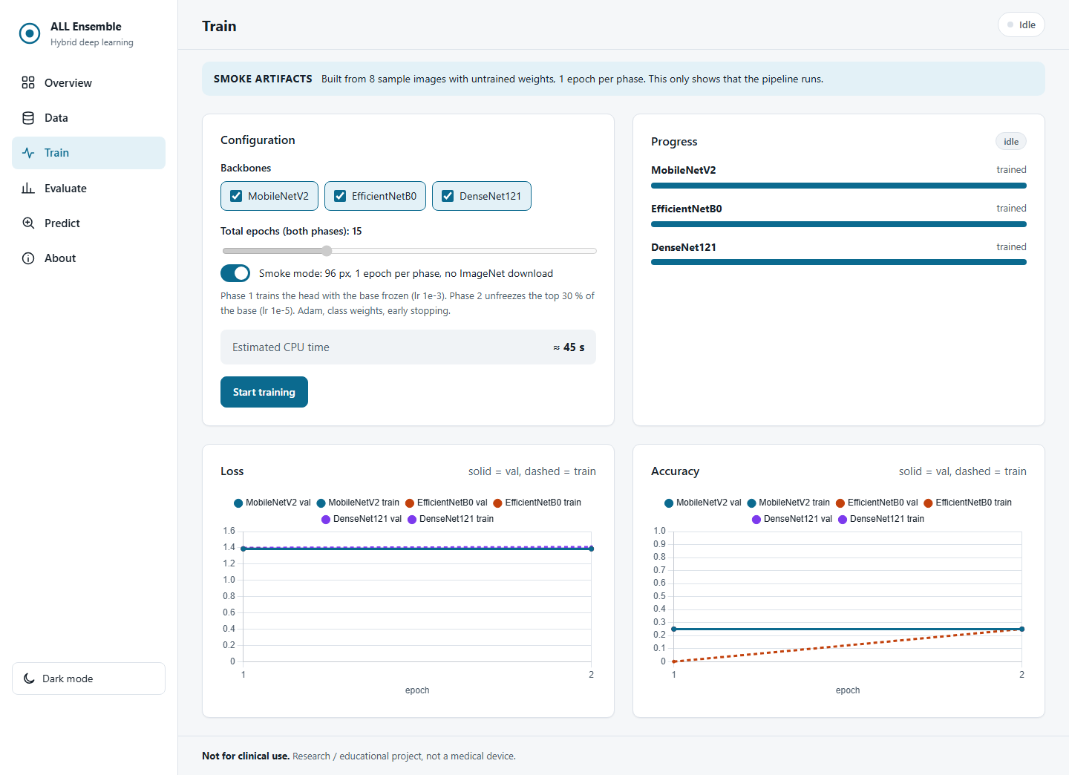
Screenshot: Train.

Evaluate
Fit ensemble, run evaluation, display all metrics and charts.
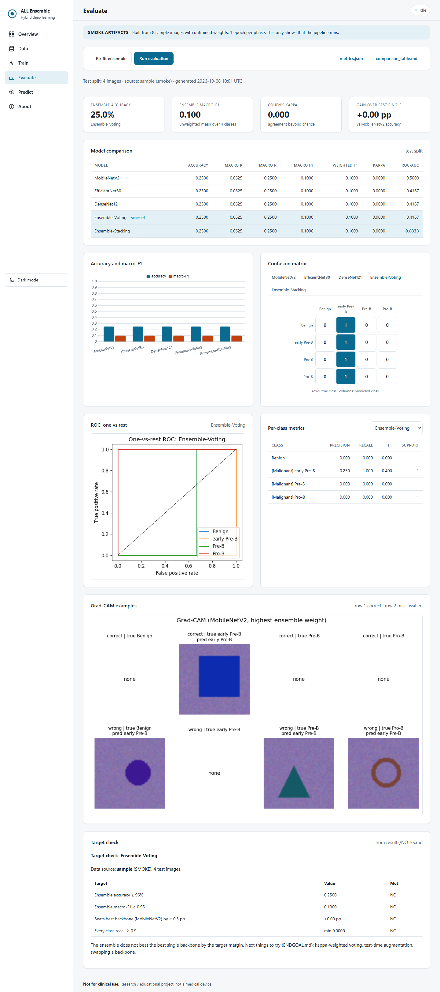
Screenshot: Evaluate.

Predict
Upload a blood smear image to get prediction, confidence and Grad-CAM heatmap.
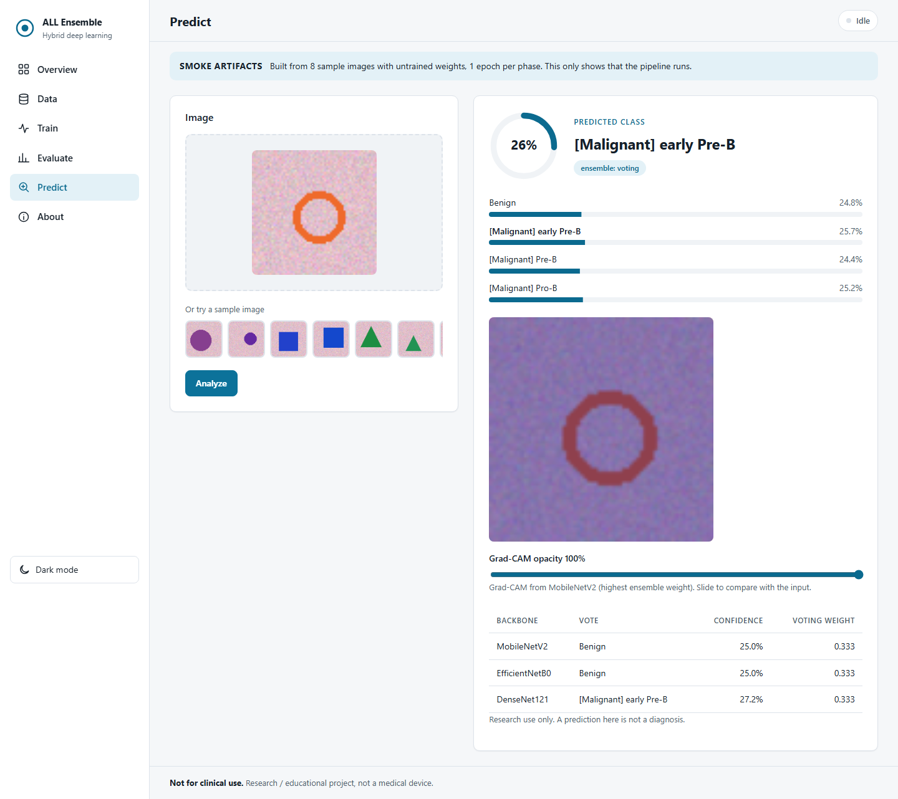
Screenshot: Predict.

About
Project description, method, references, disclaimer.
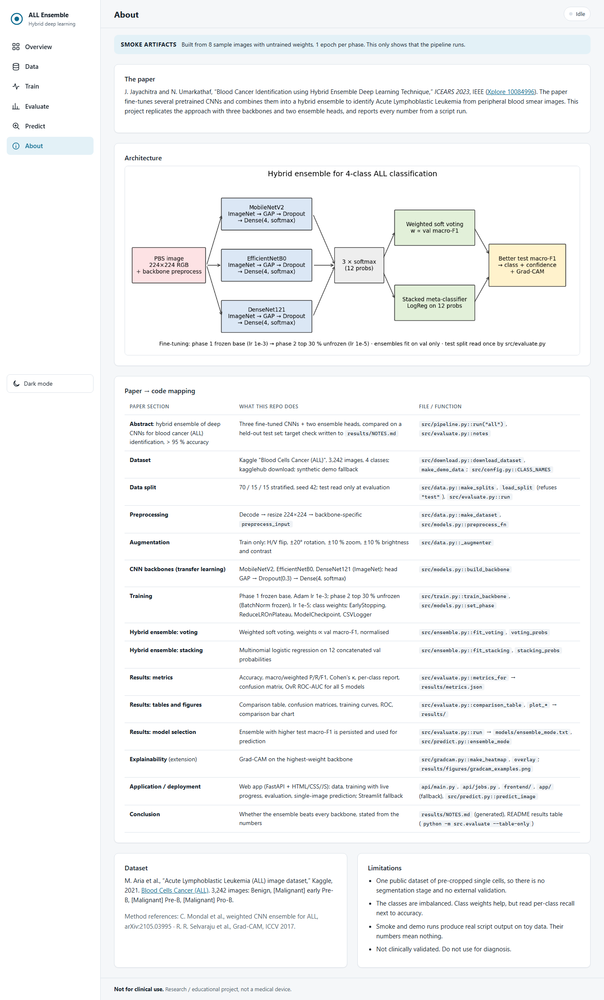
Screenshot: About.

9. Where Everything Is
See the PDF version for the complete file map table.

10. How It Was Built
Python 3.12, TensorFlow 2.21.0, Keras 3.14.0, scikit-learn 1.7.2, FastAPI 0.136.3, Chart.js 4.4.1.
14 test files covering data, models, training, ensemble, prediction, Grad-CAM, API, frontend and static assets.

How to Retrain
- python run.py --cli download (download dataset)
- python run.py --cli splits (create splits)
- python run.py --cli train (train backbones)
- python run.py --cli ensemble (fit ensemble)
- python run.py --cli evaluate (evaluate and generate figures)

11. Installation
Setup comes in three tiers; Tier 1 is the only one most people need.
Tier 1 — Demo in 5 minutes (no Kaggle account): git clone, pip install -r requirements.txt, python run.py --fetch-models, python app.py. --fetch-models pulls ~105 MB of trained models from the release and verifies them against SHA-256 checksums. Log in with admin / admin. The Preview page is already stocked with the 40 bundled demo images, so predictions work immediately.
Tier 2 — Full test set (optional, ~6 GB): add a Kaggle API token on the Data page or in ~/.kaggle, press Download, then run python run.py --cli export-test-images.
Tier 3 — Retrain (optional, needs Tier 2): notebooks/train_colab.ipynb on a free Colab GPU (~40 min) or python run.py --cli all on CPU (~1.5 h); copy models/ back, then python run.py --cli evaluate.
What is where — models/: the trained networks, fetched from the release, not in git. data/demo_images: 40 real held-out test images (10 per class, CC BY 4.0, Aria et al.) that drive the Tier 1 demo. data/sample: 8 synthetic images for the automated tests only. results/: metrics and figures. docs/: the finished deliverables. docs/src: the sources they are generated from.
See the PDF for the full command listing and troubleshooting.

12. Using the App — Step-by-Step Demo
No preparation needed — after Tier 1 the Preview page already lists the 40 bundled demo images. (If you completed Tier 2, run python run.py --cli export-test-images to demo on the full held-out set instead.) Then:
- Step 1: Start the app with python app.py (opens http://localhost:8000).
- Step 2: Log in with admin / admin.
- Step 3: Home shows the pipeline status and paper citation.
- Step 4: Preview — pick a test image per class, press Submit, see prediction and Grad-CAM.
- Step 5: Performance Analysis — accuracy tiles, confusion matrix, ROC curves.
- Step 6: Chart — training loss and accuracy curves per backbone.
- Step 7: About — architecture diagram and disclaimer.
- Step 8: Logout returns to the login screen.

13. Glossary
- Accuracy: The percentage of all predictions that were correct.
- ALL: Acute Lymphoblastic Leukaemia, a type of blood cancer.
- Augmentation: Creating altered copies of training images to help the model generalise.
- Backbone: The core image-recognition neural network.
- Confusion matrix: A grid showing correct vs. incorrect predictions per class.
- Ensemble: Combining several models for a joint prediction.
- Epoch: One complete pass through all training images.
- F1-score: The harmonic mean of precision and recall.
- Grad-CAM: A technique that highlights which image regions influenced the prediction.
- ImageNet: A public collection of 14+ million labelled photographs.
- Neural network: A chain of mathematical operations that learns patterns from data.
- Precision: Of predictions for class X, what fraction actually were X.
- Recall: Of actual class X images, what fraction the model found.
- ROC-AUC: Area under the ROC curve; 1.0 is perfect separation.
- Stacking: An ensemble method using a second-stage classifier.
- Transfer learning: Using knowledge from one task to help with another.
- Weights: The adjustable numbers inside a neural network.

14. References
[1] J. Jayachitra and N. Umarkathaf, 'Blood Cancer Identification using Hybrid Ensemble Deep Learning Technique,' ICEARS 2023, IEEE.
[2] M. A. Eshraghi et al., 'Blood Cells Cancer (ALL) — 4 Classes,' Kaggle dataset.
[3] M. Sandler et al., 'MobileNetV2,' CVPR 2018.
[4] M. Tan and Q. V. Le, 'EfficientNet,' ICML 2019.
[5] G. Huang et al., 'DenseNet,' CVPR 2017.
[6] R. R. Selvaraju et al., 'Grad-CAM,' ICCV 2017.

