Victor Wang

**ET 575 Final Plan and Proposal**

**index.html**

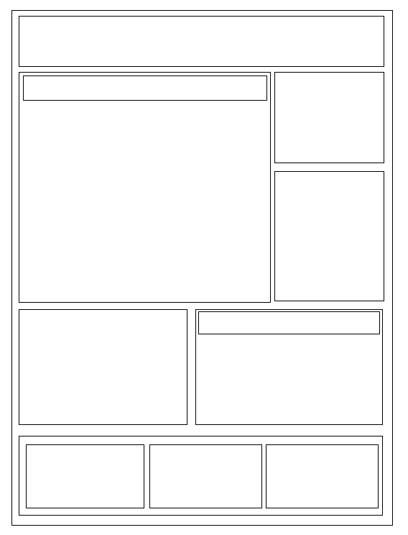

<Div class = “History/Mission info”>

<Div class = “History/Mission Title”>

”>

<IMG = QCC Engineering Tech Dep Logo>

<Div class = “Programs/Majors Title”>

<Div class = “Programs/Majors info”>

<Div class = “Image Slideshow”>

<IMG = Social Media 2>

<IMG = Social Media 1>

<Div class = “Contact”>

<Div class = “Staff”>

”>

<Div class = “Home”>

<Div class = “Buttons”>

”>

**programs.html**

-To feature scrolling between programs/major divs

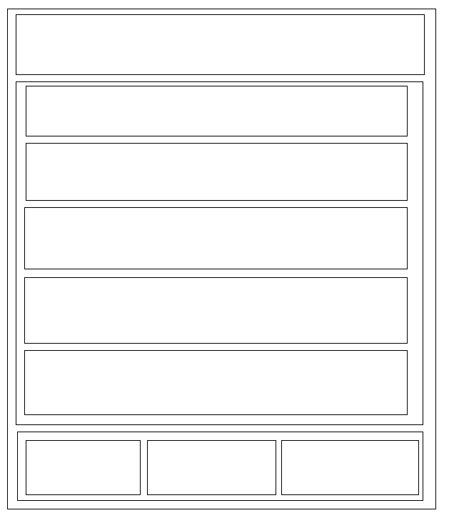

<Div class = “Programs/Majors 4”>

<Div class = “Programs/Majors 3”>

<Div class = “Programs/Majors 2”>

<Div class = “Home”>

<Div class = “Contact”>

<Div class = “Staff”>

”>

<IMG = QCC Engineering Tech Dep Logo>

<Div class = “Programs/Majors 1”>

<Div class = “Programs/Majors box”>

<Div class = “Programs/Majors Title”>

<Div class = “Buttons”>

”>

**history.html**

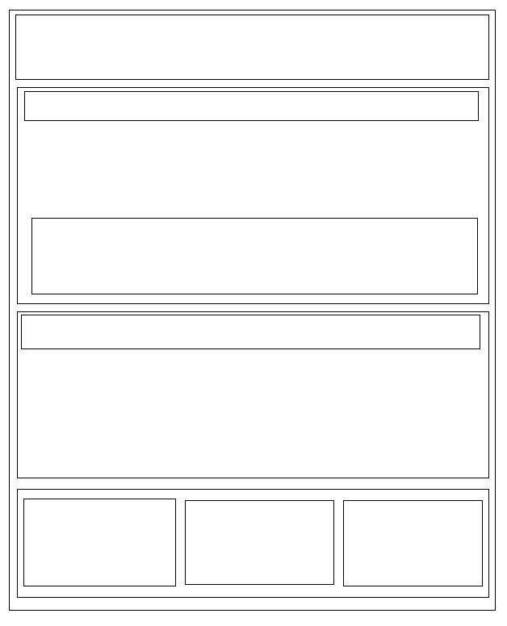

<Div class=”Mission box”>

<Div class=”History box”>

<IMG=Department Building>

<Div class=”Mission Title”>

<Div class=”History Title”>

<Div class = “Home”>

<Div class = “Staff”>

”>

<Div class = “Contact”>

<IMG = QCC Engineering Tech Dep Logo>

<Div class = “Buttons”>

”>

**contact.html**

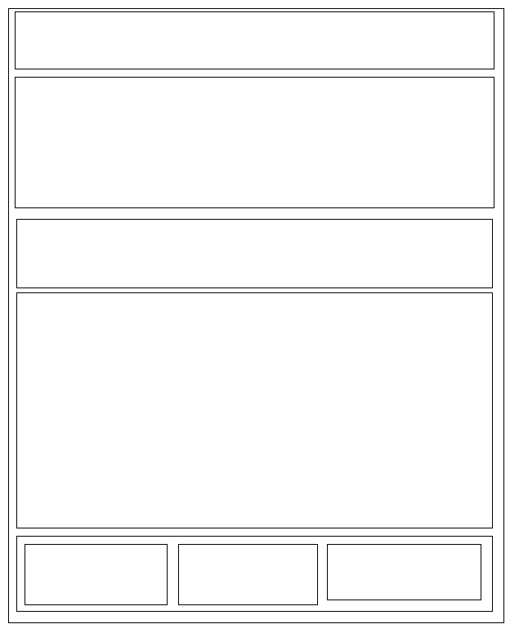

<IMG = QCC Engineering Tech Dep Logo>

<Div class= “Google Maps with Physical Address”>

<Div class = “Email animation 1”>

<Div class = “Contact Form”>

<Div class = “Home”>

<Div class = “Staff”>

”>

<Div class = “Contact”>

<Div class = “Buttons”>

”>

**formhaler.html**

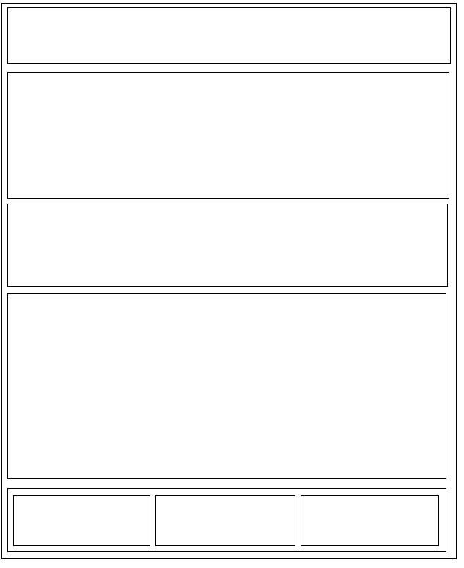

<IMG = QCC Engineering Tech Dep Logo>

<Div class= “Google Maps with Physical Address”>

<Div class = “Email animation 2”>

<Div class = “Contact Form Received Message”>

<Div class = “Home”>

<Div class = “Staff”>

”>

<Div class = “Contact”>

<Div class = “Buttons”>

”>