Testcases OMVIS
Test | Files | Comments | Reference
Pendulum1 | ./examples/pendulum_res.mat  ./examples/pendulum_visual.xml | -pendulum swings around z-axis | 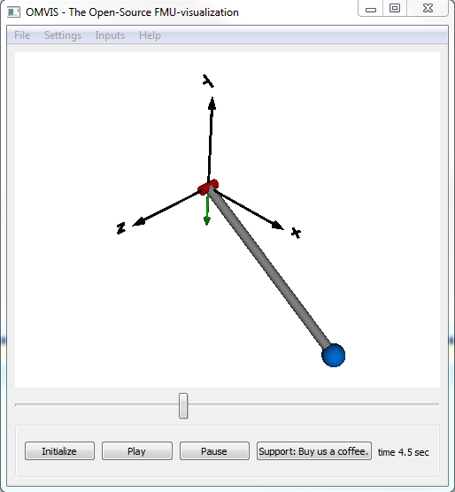
Crane – FMU | ./examples/cranes_crane_input5_visual.xml  ./examples/cranes_crane_input5.fmu | - pendulum can be moved along x-axis by pressing “w” or “a” (Don’t forget to click on the osg-viewer-widget, otherwise keyboard is not detected)  TODO: implement the reassignment of input-mapping (need an inverse mapping here to clean the old assignments, when reassigning) | 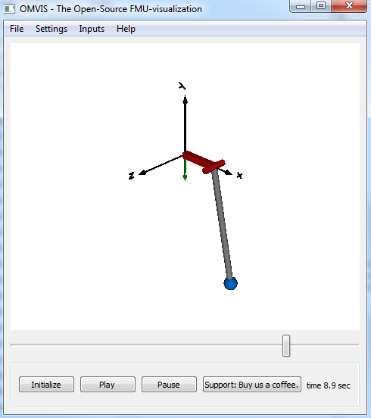
Excavator -FMU | ./examples/MH_City_RT_meca_Test_Gesamtmodell_Gesamtmodel_omc_workingGear2_visual.xml  ./examples/MH_City_RT_meca_Test_Gesamtmodell_Gesamtmodel_omc_workingGear2.fmu  ALL STL FILES IN:  ./examples/data/stl | - starts to move after 15sec  - set stepSize to 0.005 sec  and endTime to 30.0sec  TODO:  Obviously, some cylinders are directed wrong  The arrows are not supported and displayed as capsules | 