Problem 1: Recursive Function Implementation
Implement a recursive function to compute the sum of the first n positive integers, i.e., the sum 1 + 2 + 3 + ... + n. Test your function with a main program and include a screenshot of the output. Additionally, validate your function's output by comparing it with the formula for the sum of the first n integers from Discrete Mathematics.
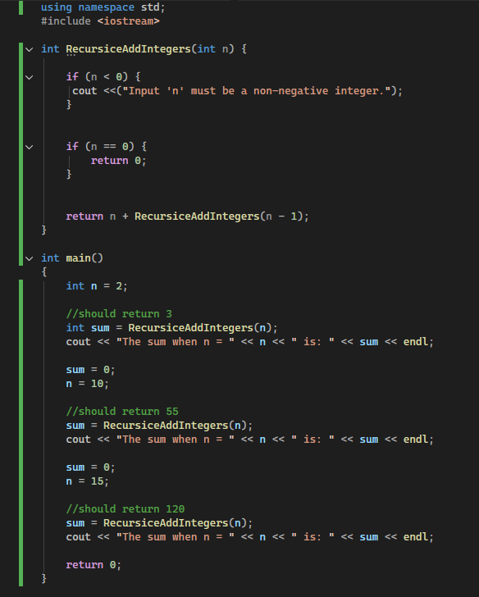

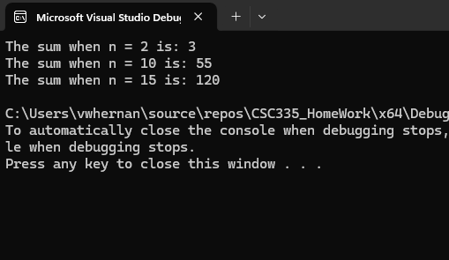
Sum = n(n+1)/2
N value | Formula: n(n+1) / 2 | Sum
2 | 2(2+1)/2 = 6/2 | 3
10 | 10(10+1)/2 = 110/2 | 55
15 | 15(15+1)/2 = 240/2 | 120

Problem 2: Binary Search Analysis (6 was supposed to be 9?)
Given a sorted array, apply the Binary Search algorithm to find the key 90. Document each step of the process, specifying the low, high, and mid indices.
a. Calculate the number of comparisons made before the key is found.
b. Discuss the maximum number of comparisons Binary Search would make for an input of size n.
c. For a sorted array of 5000 elements, determine the maximum comparisons required by the Binary Search algorithm.
0 | 1 | 2 | 3 | 4 | 5 | 6 | 7 | 8
9 | 12 | 17 | 23 | 38 | 45 | 77 | 84 | 90

2) Binary search steps
- Get the Mid point,
  - If mid point > than value to find search to the right
  - If mid point < than value to find search to the left
- Get Mid point of the right (38)
  - If mid point > than value to find search to the right
  - If mid point < than value to find search to the left
- Get Mid point of the right (77)
  - If mid point > than value to find search to the right
  - If mid point < than value to find search to the left
- Get Mid point of the right (84)
  - If mid point > than value to find search to the right
  - If mid point < than value to find search to the left
- Get Mid point of the right (90)
  - Since only one value left mid point is 90

- Number of comparisons 5
- Log₂(n) + 1 : Binary search works by repeatedly halving the search interval. The number of times you can divide n by 2 until the result is 1
c) Log2(5000) + 1 = 12.3 + 1 = 13 comparisons

Problem 3: Big O Notation
Suppose we have a sorted array of 5000 elements. What is the maximum number of comparisons done by the Binary Search algorithm? Show work.
- Max = Log₂(n) + 1
- Log2(5000) + 1 = 12.3 + 1
- 12.3 +1 = 13 comparisons
Problem 4: Time Complexity Analysis
Give the Big O notation for the following functions
f(n)=5n²+3n log⁡n+2n+5
f(n)=2n+100 log⁡n
Give the worst-case time complexity of the following code segments, show work, and provide reasoning.
i =1  while (i <= 2n) {  x = x + 1  i = i + 2  } | for j = 1 to 2n  for k = 1 to n  x = x + 1 | j = 2  while (j < n)  j = j²  x= x + 1

Problem 5: Sorting Algorithm Traces
Trace the execution of the following sorting algorithms on the provided arrays, documenting each step in detail:
- Quicksort: For the array [36, 14, 27, 12, 31, 17, 5], using the middle index as the pivot.
- Merge Sort: For the array [36, 14, 27, 12, 31, 17, 5], showing all partitioning and merging steps.
- Radix Sort: For the array [36, 14, 27, 40, 31, 17, 5], detailing each sorting pass.
- Shell Sort: For the array [36, 14, 27, 40, 31, 17, 5, 9, 38, 22, 11], explaining the choice of gap sequences and their effects.
Problem 6: Sorting Algorithm Implementation and Analysis
Implement the following sorting algorithms in C++: Insertion Sort, Merge Sort, and Quicksort. Compare their runtime efficiencies using randomly generated inputs of sizes 1000, 10000, 50000, 100000, 150000, 200000, 250000, and 300000. Utilize the rand() function for input generation and store the integers in a vector.
- Document your findings and include the results in a table. Analyze the data to explain the performance differences observed between the sorting algorithms for varying input sizes. Discuss factors that might affect the algorithms' performance, such as the nature of the input data (sorted, reverse-sorted, random) and the algorithm's complexity.
- For visual comparison, plot the runtimes against the input sizes for each algorithm using any plotting library available in C++. Ensure your plot is clear, labeled, and includes a legend to distinguish between the different sorting algorithms.
- Submit your C++ code, the data table, and the plot as part of your assignment. Your report should include a brief discussion of your findings, highlighting the efficiency of each algorithm under different conditions.
Note: For initial testing, use a small input size (e.g., 20 elements) and print the sorted list to verify that your implementation correctly sorts the data. This step is crucial for ensuring the accuracy of your implementations before proceeding to performance comparisons.

