Problem 1: Linked List Implementation
Utilize the Linked List code discussed in class. If you modify the provided code, document each change with a clear explanation. Implement the following additional member functions in the LinkedList class:
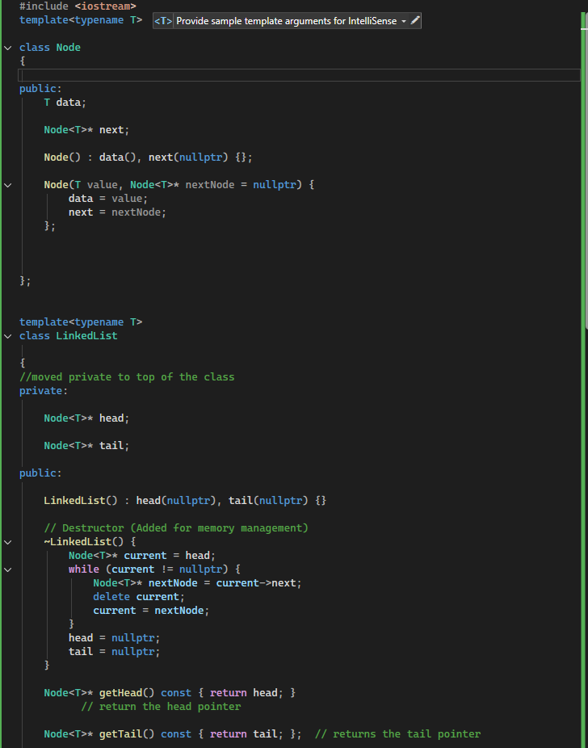

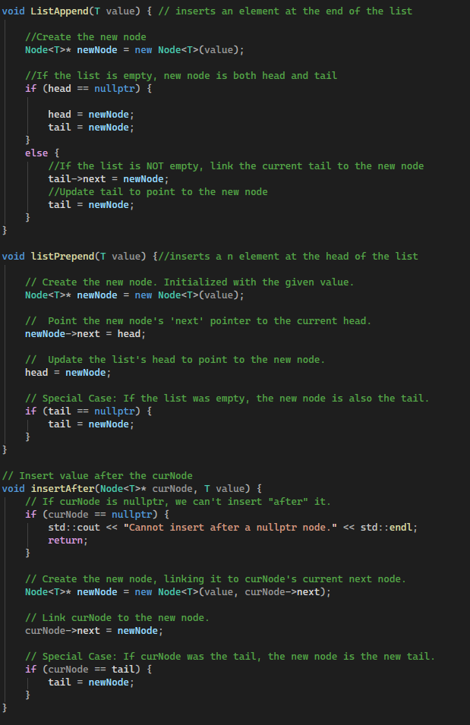
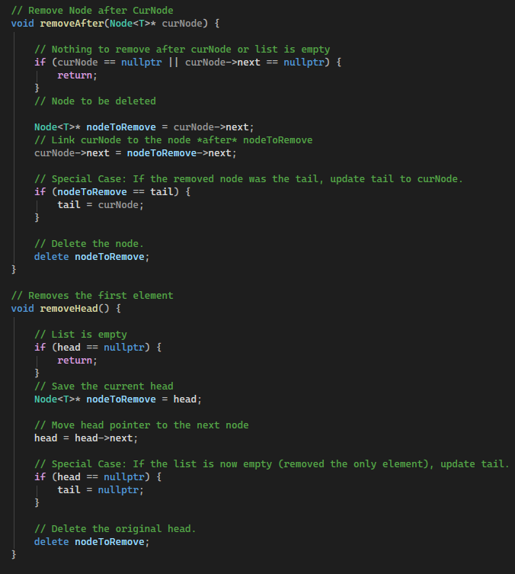

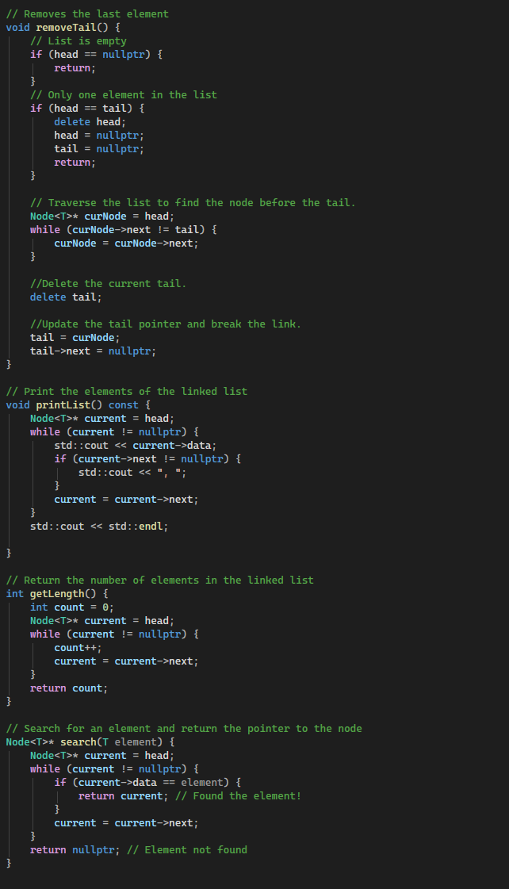
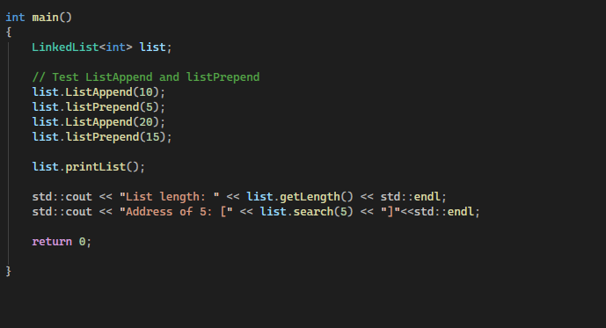
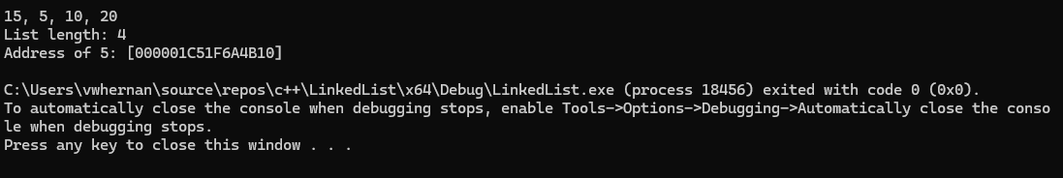

Problem 2: Doubly Linked List Class Definition
Define the Node class for a Doubly Linked List and a corresponding DoublyLinkedList class. Your DoublyLinkedList class should include:
- A default constructor.
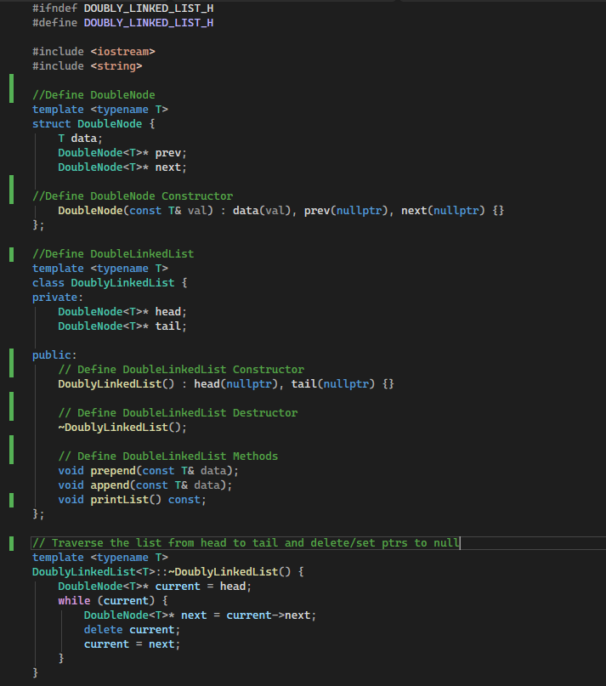
- Functions to append and prepend elements.
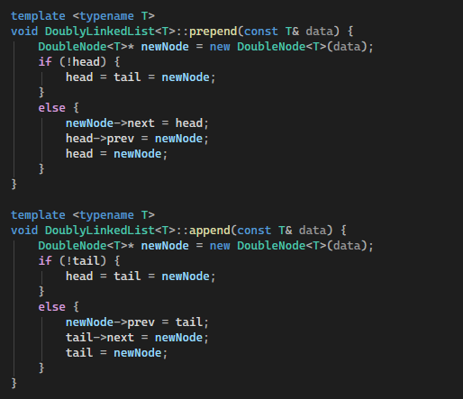
- A print function that displays all elements in the list. Write a main function to populate and print a DoublyLinkedList.
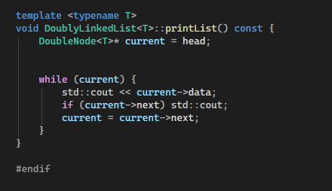
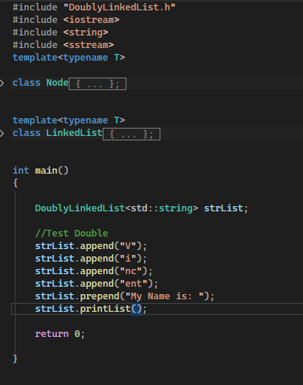
Problem 3: Hash Table Collision Computation
Write a program that computes the number of collisions when inserting 20 random integers (between 0 and 100) using:
- Linear probing
- Quadratic probing: The hash table size should be 31. Display the list of integers, the hash tables post-insertion, and the number of collisions for each strategy.
Problem 4: Hash Table Insertions and Collision Resolutions
Insert the following sequence of numbers: 4371, 1323, 6173, 4199, 4344, 9679, 1989 into a hash table of size 10 using the hash function h(x) = x % 10. Demonstrate the results using:
- Separate chaining
- Linear probing
- Quadratic probing
- Double hashing with the second hash function h_2(x) = 7 - (x % 7)
- Provide calculations and indicate if any number cannot be inserted.

