# CAPSTONE_PROJECT

# IDENTIFYING_AREAS_ACCORDING_TO_THEIR_NATURE

# ****Introduction/Business Problem****

The main aim of this project is to find the perfect area for all types of users in the city of Toronto.

The users find difficulty in finding the areas for residential and business purposes. This project guide them in providing solutions for the users.

# Data and Methodology

1.Where data of postal codes of Canada will be taken from Wikipedia.

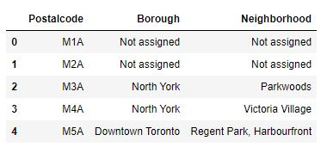

2. After cleaning of data

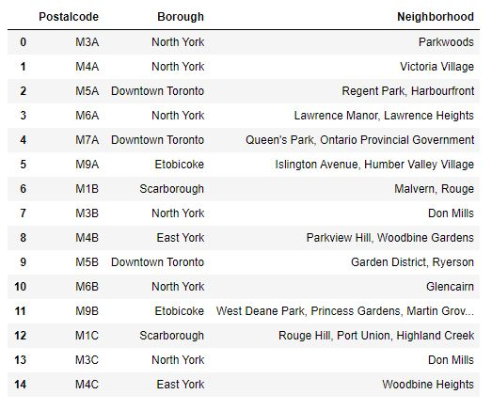

3. Geo spatial will be taken from ‘http://cocl.us/Geospatial_data’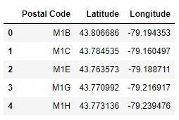

4. After merging of both the data

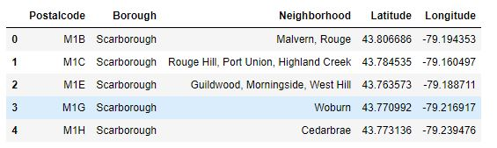

5. Plotting of the base data’s

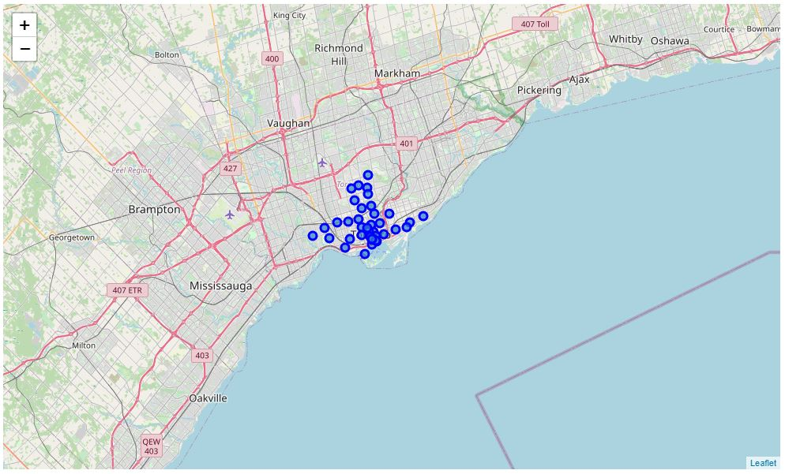

6. Venue data of the same has been obtain from foursquare ID

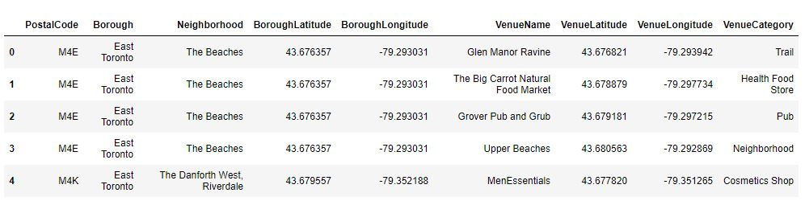

7. After cleaning the data

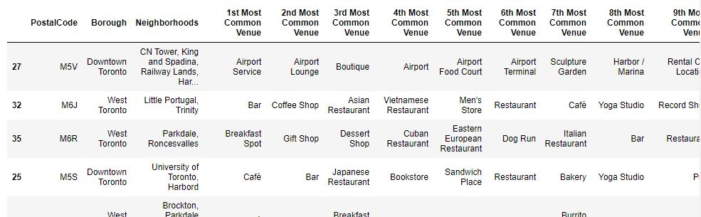

8. After Kmeans clustering

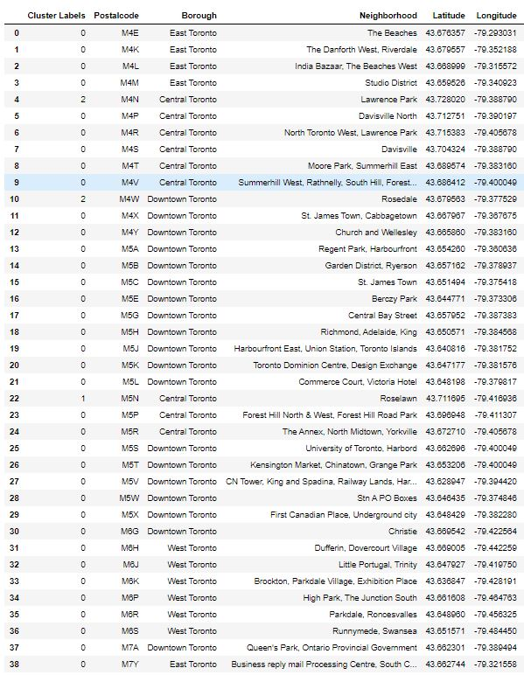

9. Result

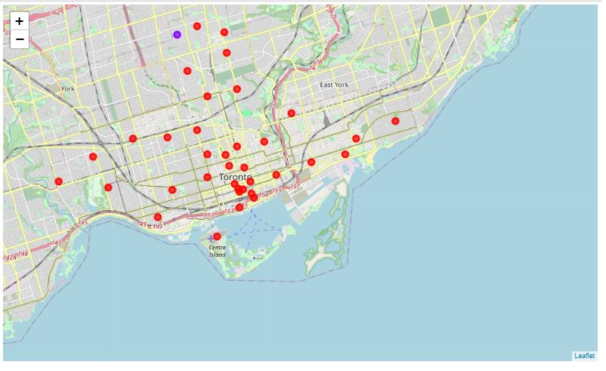

# Results

From the above analysis, residential area will be 0 cluster and business area will be 2 cluster

# Discussion

Availability of data can be more sufficient and reliable. Even the modelling can be done more efficiently

# Conclusion

The above project will be the basic prototype for the identification of areas.