Our group chose to visualize the crude death rates (per 1,00 people) for countries around the globe from 1960 - 2013. The data domain had death rates for over 180 countries from 1970 - 2013. Each country was labeled with a region (i.e. South Americas, Africa, Pacific, etc) and an income level (high, upper mid, low, etc).

We wanted to support viewing of hundreds of items throughout time and continuously make it available for people to see all results; hence, we decided to display our interactive visualization as a Starfield display at the beginning. Since the data supplied us with income levels and regions for each country, we wanted to create an interactive display where people can see the death trends for each region and filter their results by selecting which income level for each country they wanted to view. Dynamic query filtering will be used in our final visualization. Regions and income levels will be selected from a drop down menu and the range of years will be selected from a slider.

Initially we chose to use line chart to show the death trend throughout time, however, it was too busy due to the abundance of data and it was difficult to see the death rate for specific years (Figure 1).

Due to these problems, we decided to display our data domain in a scatterplot and encode each country by color instead (Figure 2). The scatterplot allows people to mouse over to a specific plot and see exactly what the death rate for the specific year was. Each country is encoded with different colors because it would be difficult to follow the line if countries were encoded with similar colors. With over a hundred countries, a lot of the colors overlapped. Also, since our screen size is relatively small with so many data points, it was very hard to distinguish the different countries.

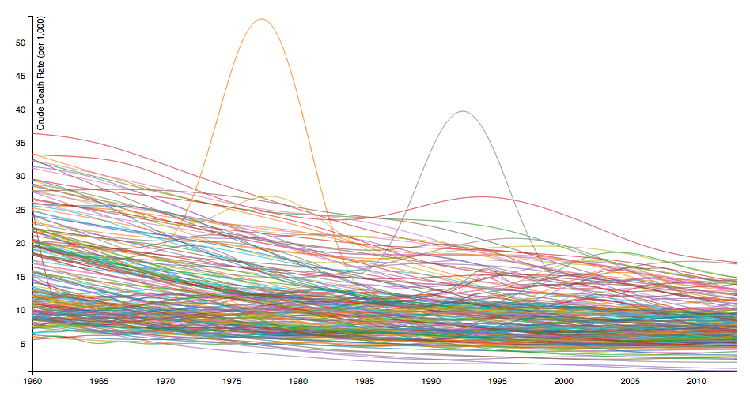

Figure 1

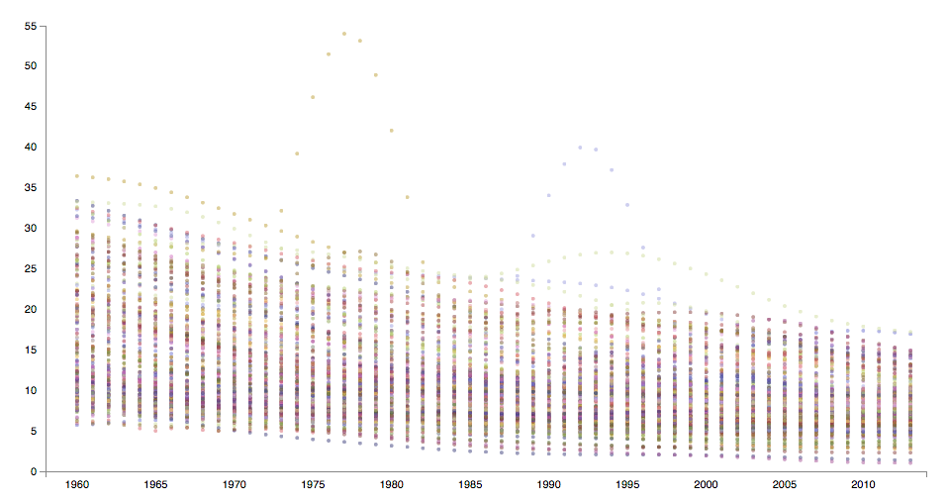

Figure 2

We made further changes to our implementation. Once our final implementation was completed, our final visualization had a few changes from our storyboard. We decided to omit the dropdown menu for the income level and change it to a slider. The slider allows people to choose more than one income at a time, which makes it easier for people to see if a region’s income level affected the death trend of each region. The slider for selecting the range of years was also omitted because we only had the death rate for each year and expanding the x-axis would not display any additional information.

Our final visualization allowed people to see an overview of all the death rates for each country from 1960-2013 at the beginning. The information is displayed as a scatterplot and people can mouse over to display the details related to that point. Afterwards, people can manipulate the data with dynamic query filters by using the dropdown menu and slider. The dropdown menu filters the region of the country so that the death rates for the corresponding countries to the region are only displayed. The slider filters the income levels for a specific region or all countries (Figure 3).

Our data was stored in a CSV file in a way that each country had 54 rows of data. We noticed the load time was a bit slow when we had over a hundred countries. Since it was also too cluttered to display all of the data at once, we decided to randomly select two or three countries from each of the seven regions. This way, our visualization and the interactions with the visualization loaded faster. It was also much easier to distinguish one country’s data from another.

This assignment began with us discussing what type of dataset we wanted to do our project on. We did not have much of a preference, so we decided to browse the Internet to see if anything caught our eyes. Once we had our dataset, we discussed what we wanted to display and how we wanted to do so. Then, we came up with ideas for interactions. Our group met up together to start the implementation together. Then, one of us focused on the dropdown selection, while the other focuses on the slider. We worked together again to troubleshoot any of the problems we encountered on our own. Finally, one of us worked on how the interactions would be displayed, while the other worked on stylizing our visualization with CSS.

We roughly spent X hours developing our application. Finding data and making sure it was formatted in a way we could work with the data was a lot more difficult than we expected. D3 is still a relatively new thing to our group, so we had to look at a lot of examples to understand how to use it. However, the aspect that took the most time was getting the different interactions to work.