Mobile Application: Cerebria

Ong Bee Lee
Chia Sheng Jie
Chow Wei Xiang
Ren Daxuan
Ng Jing Nee
Yao Yawen
Subspace
School of Computer Science and Engineering, Nanyang Technological University
Singapore

Contents

Executive Summary 3

Statement of Problem 4

Objectives X

Technical Approach X
Identifying Needs of Customers X
Identifying Target Specifications X
Generating Design Concepts X
Selecting Design Concept X

Project Management X
Deliverables X
Budget X
Communication and Coordination with Sponsor X
Team Qualifications X

Conclusion X

References X

Executive Summary

We propose a mobile application (an Android application) that is catered to patients suffering from dementia, a chronic neurological degenerative disorder. It is important to note that this project is not a cure, or close to being a cure; rather, it is meant to allow the patients to exercise their brains to slow the degenerative process and prolong their mental health.
In essence, the application is a simple video game, which consists of a series of mini-games, that can aid in keeping the user’s brain active, as well as quantifying the progress of dementia. The information obtained from the user’s gaming experience can be used by medical practitioners to advise the user on any further treatments for their ailment.
Due to the nature of our target audience, we understand that our application has to be highly intuitive, which can be achieved by applying the good Human-Computer Interface practices. The application must also be able to test the many facets of the human brain, such as reaction time, visual pattern recognition and multitasking.

Statement of Problem
Dementia is an illness that commonly affects the elderly. It is characterized by the gradual degeneration of the brain, sometimes due to the buildup of protein plaque that harms healthy brain cells, resulting in the slow decline of brain functions. Unfortunately there is no known cure for the problem. However, there are medications and treatments to reduce the rate at which the illness progresses.

In Singapore, an elderly above the age of 65 years have a 6.5% chance of being afflicted by the illness (“Understanding Dementia,” 2010). The actual number may be slightly higher as it takes a while for one to be diagnosed with dementia (“Major Neurological Disorder”), and there are cases in which a patient does not show any obvious symptoms due to the gradual nature of the illness.

Researches in digital games have discovered that cognitive, sensory-motor, emotional, personal and social competencies can be enhanced by playing digital games, regardless of age or gender [1]. As a type of digital games, serious games are a research field that develops games which help users to achieve a certain goal in an entertaining way. Pioneer studies have been done to explore the potential as well as downsides of the application of serious games in the area of health [2]. Moreover, recent studies have reported coginitive benefits of computer games for older adults [3]. Meanwhile, there is a study done which presented “consistent evidence from multiple trials that cognitive stimulation programmes benefit cognition in people with mild to moderate dementia” (Woods, Aguirre, Spector, Orrell 2012). With this as our inspiration and foundation, we wanted to design a simple, yet engaging mobile application that can aid dementia patients in their routine mental exercise.

Design Objectives
This document proposes the following design objectives:
- Intuitive game mechanics,
- Helpful to medical practitioners, and
- Robust, but flexible software architecture

Intuitive Game Mechanics
The application has to be highly intuitive, that is, it takes the user at most 10 minutes to be able to fully experience the gameplay without confusion. To make the gameplay easily understood, elements such as arrows and circles used as tapping targets on the screen can be employed. Popup hints can also be placed, when needed, to aid the users if they are unable to resume the gameplay.
Useful guidelines such as the 8 golden rules of usability will also be utilized to increase the user-friendliness of the application.

Helpful to Medical Practitioners
The scoreboard is a common sight in many game applications. However, the scores that the user obtained from playing the game is used to quantify the mental capabilities of the user. This information can supplement the diagnosis of the dementia patient who played the game.

Robust, but Flexible Software Architecture
Good object-oriented design principles will be applied to create an application that can be easily maintained and upgraded in the future. As the application will consist of many mini-games, the underlying game engine will have to allow non-destructive additions to the source code. Also, the design of the game engine should, as much as possible if not totally, remove the low-level rendering and object management from the game designer.

Technical Approach
This section discusses how you will obtain the objectives presented in the previous section. This plan should follow a logical sequence. Please make sure that you have a transition paragraph between the heading “Plan of Action” and the subheading “Identifying Customer Needs.”

Identifying User Needs
To help understand the needs of our end users, we have made observations during one of the Alzheimer’s Disease Association (Singapore) biweekly session for the elderly, in addition to literature reviews. Here are some of the needs we have identified:
- Intuitive interface
- Limited distractions
- Succinct communication
- Simple activities

Identifying Target Specifications
As previously stated, we defined our interface to be intuitive if “it takes the user at most 10 minutes to be able to fully experience the gameplay without confusion”. Appropriately placed game elements and helpful hints can be used to help the users as they play the game. Common icon scheme will also be used so that long term handheld phone users need not familiarize with a new scheme.

We understand that dementia patients may have difficulty in focusing on a task if there are numerous distractions. To increase the accuracy of our scoring system, we require that the user focuses their attention to the task at hand in the application. Although the game should be visually engaging, there should be limited visual “eye-candies” such that the main focus is still on the task presented.

Textual information conveyed should be succinct and clear. Useful information must be conveyed in as few words as possible, in easy-to-understand words.

Lastly, it is suggested that complex activities should be minimized, or be broken down into simpler tasks. With this in mind, our game will consist of simple mini-games, whose goals are easily achieved by simple gestures on screen (e.g.: a couple of taps; tilting the screen; or dragging an object).

Generating Design Concepts
Based on the requirements of the application design, the following are some of the software design concepts we can employ:
Concept | Description
Abstraction | A method to generalize a piece of information, and to hide irrelevant information from the higher levels of the software development hierarchy.
Modularity | As we are allowing more mini-games to be included in future releases, we require that our software be modular in nature, so the different parts and new parts of the same software can be combined together easily.
Structural Partitioning | To increase the efficiency of development, the software should be partitioned into, minimally, two parts: one for the game engine development which handles the low-level rendering procedures and game element/object management; and one for the game designer to create the game elements and arrange them logically on screen for user interaction.
Usability | Good HCI practices should be applied to make a highly intuitive application fit for a user within a spectrum of mental capability.

Selecting Design Concept
Here you would place paragraphs that explain how you selected the design concept. In addition, you should also identify what alternative design concepts you have selected for the project. Please indent all paragraphs and do not skip a line between paragraphs in the same section or subsection.

Project Management

This section presents the plan for managing the project. This plan should follow a logical sequence. Please make sure that you have a transition paragraph between the heading “Project Management” and the subheading “Deliverables.” That paragraph should introduce and explain your Gantt chart for the project. An example of such a chart appears in Figure 1.
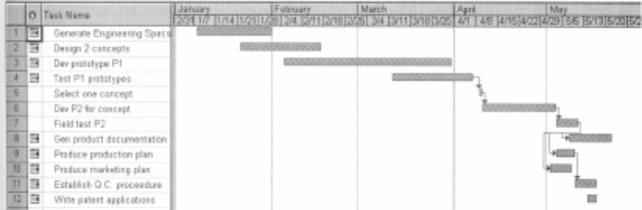

Figure 1: Gantt chart for the project. The solid bars indicate the portions of the tasks that we have accomplished.

Deliverables
The following lists the deliverables that will be presented to our end-user:
- Android Application
The application will be bundled in a standard file format (.apk) that can be recognized by any compatible Android device.

- Help Manual in the form of a Wiki
A Wiki page will be set up which will include descriptions on the gameplay and any advice for medical practitioners that are looking after dementia patients.

Budget
Here you would place a paragraph or paragraphs that explain the budget for the project. Include a table such as Table 1. Please indent all paragraphs and do not skip a line between paragraphs in the same section or subsection.
Table 1: Requested items and funds for initial design.
Item | Supplier | Catalog No# | Quantity | Unit Price | Total
Vacuum Pump | McMaster Carr | IJ-60825 | 1 | $183.47 | $188.72
Flow Pump | Northern Tool | CJX-689 | 1 | $139.99 | $156.62
Water Filter Whirlpool | Lowe's Hardware | WHER25 | 1 | $33.73 | $33.73
23/32" Plywood 4'x8' | Lowe's Hardware | none | 1 | $24.95 | $24.95
4" Ondine Rainmaker | Smartbargain.com | 129808 | 1 | $19.99 | $37.86
Acrylic Sheet 12"x24" | McMaster Carr | 8680K22 | 1 | $45.40 | $51.65
Acrylic Tubing 5' (OD 8") | McMaster Carr | 8486K626 | 1 | $236.70 | $250.95
"8" Flange (13" OD) | McMaster Carr | KD-ERW | 1 | $44.24 | $44.24
¾-10 x 10" Hex Bolt | Hout's & Son's Inc. | 3456 | 5 | $5.40 | $27.00
 |  |  |  | TOTAL | $$$$

Communication and Coordination with Sponsor
Here you would place paragraphs that explain how you will communicate and coordinate with your sponsor. Please indent all paragraphs and do not skip a line between paragraphs in the same section or subsection.

Team Qualifications
No. | Name | Qualifications/Experience
1 | Chia Sheng Jie | - Game Development
2 | Chow Wei Xiang
3 | Ng Jing Nee
4 | Ong Bee Lee | - Android Development  - Game Development
5 | Ren Daxuan
6 | Yao Yawen

Conclusion
[Conclusion here]

References

Woods, B., Aguirre, E., Spector, A. E., & Orrell, M. (2012). Cognitive stimulation to improve cognitive functioning in people with dementia. Cochrane Database of Systematic Reviews Reviews. doi:10.1002/14651858.cd005562.pub2
Major Neurocognitive Disorder. (n.d.). Retrieved August 18, 2016, from http://www.mdguidelines.com/dementia/definition
Understanding Dementia. (2010). Retrieved August 18, 2016, from http://www.alz.org.sg/about-dementia/understanding-dementia

