* **6115- MAHENDRA INSTITUTE OF ENGINEERING AND** **TECHNOLOGY**

**Traffic Mangement System**

**TEAM : PROJ_223283_TEAM_2**

**Team members:**

* **RAHUL R**
* **RAM KUMAR R**
* **SANJAY M**
* **VIGNESHWARN S**
* **VIJAY AKASH S**
* **PRAVEEN KUMAR R**

FACULTY MENTOR NAME**:**

**ARUNAA A**

**Features Of Engineering:**

The future of engineering traffic management is expected to involve innovative technologies and strategies to address growing urban congestion and promote sustainability. Some key trends and developments include.

1. Smart Traffic Management:

Utilizing sensors,cameras, and data analytics to monitor and optimize traffic flow in real time. This can lead to reduced congestion and improved safety.

2. Connected and Autonomous Vehicles (CAVs):CAVS can communicate with each other and traffic infrastructure to enhance traffic management. They may also reduce accidents and traffic jams.

3. Urban Planning: Focusing on creating more walkable and bike-friendly cities, along with improved public transportation, to educe the reliance on individual cars.

4. Electric and Sustainable Transportation: Encouraging the use of electric vehicles and investing in sustainable transportation options to reduce emissions and congestion.

5. Mobility as a Service (MaaS): Integrating various transportation modes, such as ridesharing, public transit, and bike-sharing, into a single, easy-to-use platform for commuters.

6. Predictive Analytics: Using data to predict traffic patterns, enabling authorities to proactively manage traffic and improve road safety.

7. Traffic Simulation and Modeling: Developing advanced simulation tools to test traffic management strategies and infrastructure changes before implementation.

8. Environmental Considerations: Traffic management will increasingly need to consider environmental impacts, leading to the development of greener solutions.

9. Public-Private Partnerships: Collaboration between governments and private companies to fund and implement innovative traffic management solutions.

10. Resilience and Disaster Management: Preparing for extreme weather events and other disruptions that can affect traffic flow.The future of traffic management is all about using technology, data, and sustainable practices to create more efficient and eco- friendly transportation systems while reducing congestion and improving safety.

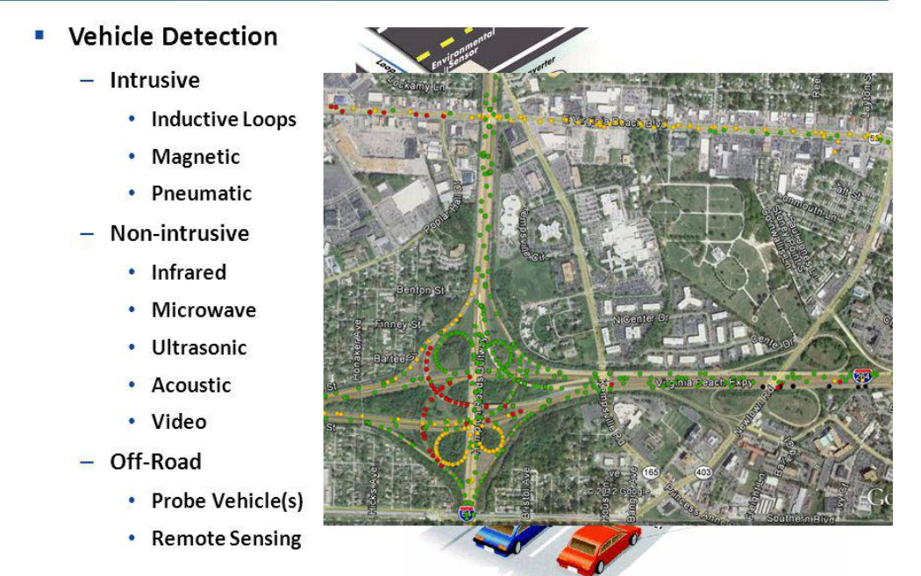

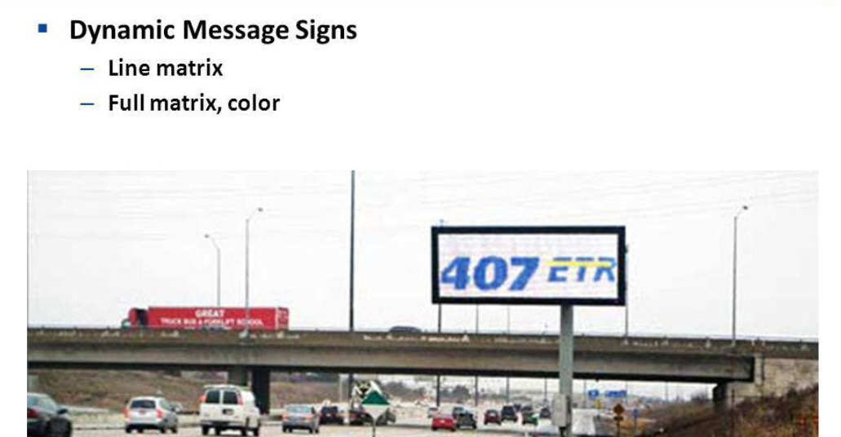

**Technologies Used:**

* Android, Microsoft .NET, SQLite, Bluetooth 4.0

**Model Training:**

Due to short period of time for the projects our team has prepared limited dataset are model to training the dataset for the implementation of Traffic management system

**Code:**

**Sample:1**

import RPi.GPIO as GPIO

import SimpleMFRC522

reader = SimpleMFRC522.SimpleMFRC522()

try:

print("Place an RFID tag near the reader...")

id, text = reader.read()

print("Tag ID: {}".format(id))

print("Tag Text: {}".format(text))

finally:

GPIO.cleanup()

**Sample:2**

import RPi.GPIO as GPIO

import SimpleMFRC522

import time

# Initialize the RFID reader

reader = SimpleMFRC522.SimpleMFRC522()

try:

while True:

print("Place an RFID tag near the reader...")

id, text = reader.read()

print("Tag ID: {}".format(id))

print("Tag Text: {}".format(text))

# Perform actions based on the tag data

if "access_granted" in text:

# Access granted, perform some action (e.g., unlock a door)

print("Access granted! Unlocking the door...")

elif "access_denied" in text:

# Access denied, perform a different action (e.g., sound an alarm)

print("Access denied! Sounding an alarm...")

else:

# Handle other tag data as needed

print("Unknown tag data, no action taken")

# Wait for a moment before checking the next tag

time.sleep(2)

finally:

GPIO.cleanup()

**Output :**

Reference for <https://i.stack.imgur.com/hi4Ll.jpg>

**Evaluation:**

The evaluation of traffic management is likely to focus on several key aspects to measureits effectiveness and impact on urban mobility and safety. Here's how traffic management might be evaluated in 2025.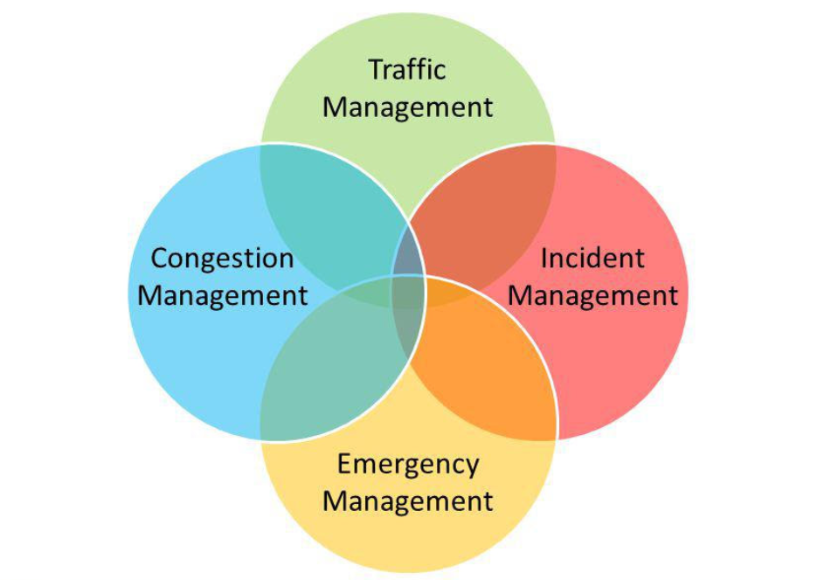

1. Traffic Flow and Congestion: An assessment of how well traffic management systems have improved the flow of traffic and reduced congestion in urban areas. Data on average commute times, peak-hour traffic, and congestion hotspots will be crucial.

2. Safety: Evaluation of the impact on road safety,including a reduction in accidents and fatalities. This assessment would also consider the effectiveness of measures such as speed limits,traffic signs, and traffic calming devices.

3.Environmental Impact: An analysis of how traffic management strategies have contributed to reduced emissions and improved air quality.This would involve measuring the adoption of electric and sustainable transportation options.

4. Public Transportation: An examination of the effectiveness of public transportation systems,including ridership numbers and ease of access, to determine if they have become more convenient and widely used.

5. Infrastructure Utilization: Assessment of the use of existing road infrastructure and its condition, including maintenance and potential expansion or upgrades.

6. Technology Integration: Evaluation of the integration and reliability of smart traffic management technologies, including real-time data collection and analytics,

7. Cost Efficiency: Analysis of the cost-of traffic management systems, considering both initial investment and ongoing maintenance.

8. Public Perception and Satisfaction: Measuring public satisfaction with traffic management improvements, taking into account surveys and feedback from commuters.

9. Accessibility and Inclusivity: Ensuring that traffic management considers the needs of all citizens, including those with disabilities, by assessing the availability of accessible transportation options.

10. Emergency Response and Disaster Preparedness: Evaluation of the efficiency of traffic management during emergencies and disasters, such as evacuation plans and adaptability to extreme weather events.

11. Future-Readiness: Assessing the adaptability of traffic management to future transportation trends, including the integration of autonomous vehicles and new mobility solutions.Overall, the evaluation of traffic management in 2025 will likely focus on creating more efficient, safe, and sustainable transportation systems while improving the quality of life for urban residents. Data-driven assessments will play a significant role in this process.

***”Thank you”***