* **6115- MAHENDRA INSTITUTE OF ENGINEERING AND** **TECHNOLOGY**

**Traffic Mangement System**

**TEAM : PROJ_223283_TEAM_2**

**Team members:**

* **RAHUL R**
* **RAM KUMAR R**
* **SANJAY M**
* **VIGNESHWARN S**
* **VIJAY AKASH S**
* **PRAVEEN KUMAR R**

FACULTY MENTOR

NAME**: ARUNAA**

**ABSTRACTION :**

Traffic management system is a cornerstone of a Smart city.

In the current problems of the world, urban mobility is one of the major problems, especially in metropolitan cities.

Previous traffic management systems are not capable enough to tackle this growth of traffic on the road networks. The purpose of this paper is to propose a smart traffic management system using the Internet of Things and a decentralized approach to optimize traffic on the roads and intelligent algorithms to manage all traffic situations more accurately.

This proposed system is overcoming the flaws of previous traffic management systems. The system takes traffic density as input from

cameras which is abstracted from Digital Image Processing technique and

sensors data, resultantly giving output as signals management. An algorithm is used to predicts the traffic density for future to minimize the traffic congestion. Besides this, RFIDs are also used to prioritize the emergency vehicles like ambulance, fire brigade etc.

By implementing RFID tags in such vehicles. In the case of emergency situations, such as fire explosion or burning of something, fire and smoke sensors are also deployed on the road to detect such situations. Moreover, a mobile application is connected to a centralized server which intimates to nearby rescue department about fire explosion with the location to take further action. In addition, the native user can ask about future traffic condition at a particular node. The proposed system is validated by constructing a prototype and deploying it in a city of Pakistan. A web application is also there to provide useful information in graphical formats to the higher authorities of the smart city which is fruitful in future road planning.

**INTRODUCTION**

Our intelligent Traffic Expert Solution for road traffic control System offers the ability to acquire real-time traffic information, .Traffic Expert enables operators to perform real-time data analysis on the information gathered. Traffic management measures are aimed at improving the safety and flow of traffic utilizing traffic capacity more effectively.

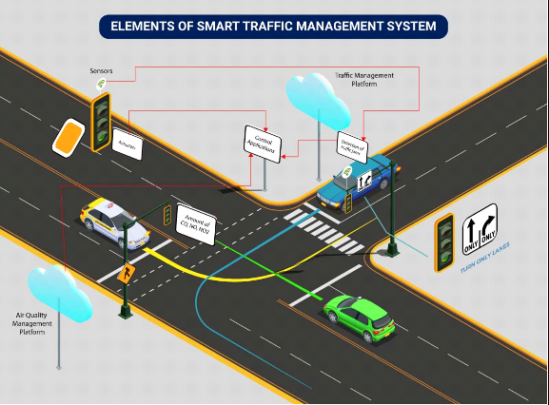

**Role of IOT in Traffic Management System:**

The role of IoT in traffic management is transformative, introducing a paradigm shift in how cities optimize and regulate their transportation systems.

By embedding sensors and connectivity into vehicles, roads, traffic lights, and other infrastructure, IoT enables the collection of real-time data on traffic patterns, congestion, vehicle movements, and more.

This data is then processed and analyzed to make informed decisions, dynamically adjusting traffic signals, rerouting vehicles, and improving overall traffic flow.

This intelligent management level enhances road safety, reduces congestion, lowers emissions, and creates more efficient and sustainable urban mobility systems.

**EXISTING SYSTEM:**

In general, our research cover the literature review from various sources based on traffic control and vehicle tracking.

This method examine the adaptive fine tuning algorithm to create a set of design parameters of two well defined mutually interacting modules of the trafficresponsive urban control(TUC)strategy for the large scale urban road network of the city of China, Greece.

Computer simulation outcome are given, demonstrating that the network performance in terms of the daily mean speed, which is attained by the proposed adaptive optimization methodology, is significantly better than the original TUC System in the case in which the-aforementioned design parameters are mutually fine-tuned to virtual perfection by the system operation [1].The system will develop the trafficlight configuration, which will be able to determine three street case (empty street case, normal street case and crowded street case) by using small associative memory.

The experiments presented provides promising results when the proposed approach was applied by using a program to monitor intersection in penesa island in Malaysia. The program could determine the street cases with different atmospheric conditions depending on the stream of images, which are extracted from the street video cameras[2]. To handle congestion in urban traffic flow through next generation artificial intelligence techniques is an important research area.

Various intelligent and approach have been developed using sot computing techniques to tackle with this problem. This paper is an attempt towards revisiting such approach in developing modern traffic control systems[3].

This study focus on the utilization of RFID as a way of traffic flow detection, which transmits collection information connected to traffic flow straight to a control system using an RS 232 interface, At the same time, the sensor analyzes and Judges the information using an extension algorithm designed to accomplish the subjective of controlling the flow of traffic.

In add-on, the traffic flow condition is also transmitted to a remote monitoring control system through ZigBee wireless network communication technology.

The traffic flow control system developed in this study can execute remote transmission and reduce traffic accidents. And it can also effectively control traffic flow while reducing traffic delay time andmaintain the smooth flow of traffic [4].

This system includes RFID technology and Lab view software. The RFID reader reads the Identification number from the related ambulance RFID tag and then it is sends the data to micro controller LPC 1768H, which is programmed, with the help of embedded C instructions. Those microcontroller is capable of communicating with input and output modules.

**PROPOSED SYSTEM :**

The solution we provide for Traffic management by reading the RFID tag of each car by a RFID reader at traffic junctions for real time traffic density calculation.

It also concentration on changing the traffic lights according to vehicle tightness on the road, thereby intent at reducing the traffic congestion on roads.

In turn, it'll reduce fuel consumption and waiting time. In case of emergency vehicle like ambulance Radio Frequency module will be used so that red traffic light signals will be turned to green in order to provide a clear way for the emergency vehicles.

It will also provide significant data which can help in future road planning and analysis. It is also used to detect or track stolen vehicle. It also alerts the owner of thevehicle to top up the credit which is used in toll booth.

In further time period multiple traffic lights are often synchronized with one another with an goal of even fewer traffic jam and free flow of traffic. The vehicles are detected by the system through RFID tag which is read by the RFID reader. RFID reader is present in some meters away from the signal and another RFID reader is placed alongside the traffic light. It will capture the number of vehicles in that particular lane.

RFID is a better technique to control the state change of the traffic light since RFID is mandatory for all the vehicles in India. It shows that it can decrease the traffic jam and avoids the nonce wasted by a green light on an empty road. It is also more certain in estimating vehicle existence.

**INSTALLATION:**

* Preassemble portals and other RFID and mounting hardware before arriving on site if possible
* An installer will need basic hand tools, power tools, tie wraps, beam clamps and fasteners, etc.
* Check equipment inventory – Hardware, cables, mounting devices
* Provide RFID Fixed Reader protection
* Using a NEMA-4
* Using only light plastic enclosures
* Reader embedded in a portal
* Verify cable lengths for antenna at each read point
* Confirm antenna, power and network cabling for each read point are correct
* Ensure reader accessibility for maintenance checks
* Verify multiplexing sequences of readers
* Network cabling/infrastructure must meet industry standards
* Ensure reader’s status indicator LEDs are easily visible to an operator
* Validate fixed reader status indicators: green for success, amber for on-going and red for failure

Check for environmental conditions (even though this has been done at the site survey, something could have changed or not have been accounted for)

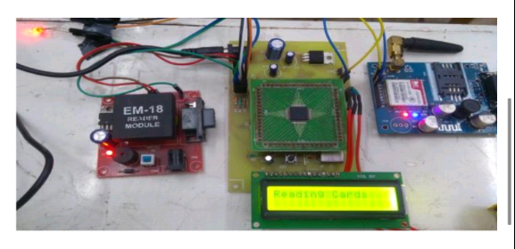

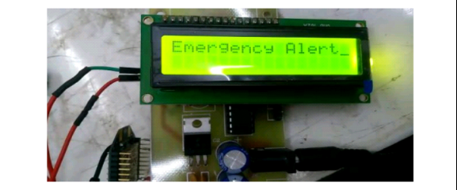

**COMPONENT OF RFID :**

RFID is a technology that enables digital data encoded in RFID tags (smart labels) is captured and read through radio waves.

Following are three components of RFID:

**1. RFID reader**

The RFID reader is the brain of the RFID system and it is necessary for a system to perform any function. The RFID reader transmits and receives radio waves to communicate the information with RFID tags.

The readers are of two types -

Mobile RFID - Mobile readers are handheld devices that allow flexible reading of RFID tags to communicate with a host computer or a device.

Fixed RFID - As the name suggests fixed RFID are placed in stationary point such as Tollbooth, Entry & exit points of Mall.

**2. Antenna**

An RFID antenna is used to convert RFID reader signal into RFID waves to send to RFID tags. They receive their power from RFID readers directly.

Without some type of RFID antennas, the reader won't be able to properly send and receive signals to RFID tags, either it is integrated or standing alone.

Also Read: How RFID transformed asset tracking in oil and gas industry?

**3. Transponders (RFID Tags**)

These transponders are making RFID innovation user-friendly and accurate. In the simplest form RFID tag constitute two parts -

Antenna - for transmitting and receiving signals

RFID Chip - for storing tags ID with other information

RFID tags do not have any battery, instead, they receive energy from the radio waves generated by the RFID reader.

It has 3 frequency range:

Low frequency (LF) - 125-134 kHz; range - up to 10 cm

High frequency (HF) - 13.56 MHz; range - up to 30 cm

Ultra-high frequency (UHF) - 856-960 MHz; range - up to 100 m

**PLANNING:**

**1. Navigation System**

The RFID tags are fixed on the roads' surface and know their own location. A vehicle estimates its position by obtaining the position of a tag while passing/crossing over the tag.

This RFID tag provides abundant information to the driver like:

* Traffic Direction
* Speed Limit

Lane Regulation, Lane Number, Lane Destination, Lane Condition, and other statistics related to that lane

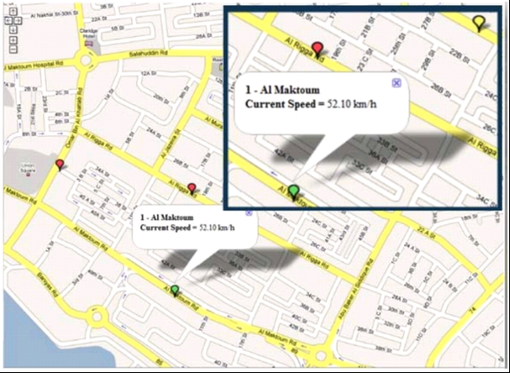

**Event Notification**

The user is benefited with real-time data of lane level navigation services which were not possible with the current Global Positioning System (GPS) as it used to provide low positioning accuracy.

**2. Electrical Traffic Control System**

Electrical Traffic Control System using RFID

According to the above-mentioned report, the breakdown of the traffic control system was also a major reason behind the road crashes. Following are the reasons, why traffic control had a negative impact:

* Failed Traffic Lights
* Non-Line-of-Sight
* Misleading Traffic Signs

Overcoming this problem electric traffic control system provides accurate and near real-time data of traffic control. The central database processing system has two parts:

Dynamic Database - It stores records of vehicles currently crossing the RFID tags, temporarily.

Permanent Database - It stores the records of all the vehicles that have crossed the RFID tags.

**Advantages of Intelligent Traffic Control System**

Traffic signals operate in accordance with the current volume of traffic. The system has the advantage of how the traffic volume is calculated.

Priorities assigned to vehicles like -

- Unrestricted passage - Ambulances, Fire Brigades, VIP Vehicles

- Higher Priority (during working hours of offices and schools) - Scooters and Cars

- Higher Priority at Night - Heavy Vehicles

E-Tolling of Vehicles

Stolen Vehicles can be tracked through the obtained time and direction of the vehicle

Traffic data can be generated for statistical purposes

Also Read: 5 Instances of Incredible Customer Experience via RFID Technology

**3. Unmanned Patrol System**

Many ill-mannered drivers commit certain violations that frequently occur but do not get registered or documented due to the absence of a patrol system. Therefore, the patrol is conducted on every site to detect all the violations without any exception.Considering the former traffic cameras and patrol systems were not able to deliver that level of surveillance. So, unmanned patrol systems implementation provided strength to the security of traffic regulations, providing 24*7 monitoring systems.Under the unmanned patrol system, the RFID reader sends the collected information to the On-Board Patrol (OBP) device. The OBP is observed through the authorities like Police Officers. OBP judges if the driver has violated any rules, based on the received information.

**Type of violation OBP can detect:**

* Speeding
* Turning Violations
* Failing to Stop
* Passing Violations, etc.

**4. Unmanned Ground Vehicles**

The unmanned ground vehicle is an idea in which everybody is reaming of years. Many governments, universities, and private companies have tried and worked on this project like Google's driverless car, General Motors, etc.

Following are the reasons why RFID system on Roads is an excellent system to support driverless vehicles:

RFID system on Roads is less expensive to provide similar functions as physical tracking.Flexible tag programming.Scalable with easy deployment and redeployment.Assist a set of other systems like navigation, traffic sign, parking, access control, and distance estimation.

**5. Vehicle Distance Estimation**

There should be a certain distance between two of the vehicles for safe driving and road journey. This is an important parameter that gets unnoticed for safe driving.Vehicle Distance Estimation using RFID It is required to get aware of the real-time distance of vehicles on the road so that the driver can maintain a safe distance and can take necessary action on time (if required).What people usually do is estimate the distance of any vehicle from their vision and experience, as a result, affects by visibility.The vehicle distance estimation totally depends on the time synchronization among the vehicles and fast speed RFID read & write operations.

**EXECUTION :**

There are The STCS (Smart traffic control System) is comprised of a group of two RFID readers, separated by along way , in each direction of a road crossing and have a central computing system (CCS) to regulate all of them. As a vehicle passes by a reader, it tracks the vehicle through the RFID tag affiliated to the vehicle and fetch its electronic product code (EPC) data. The EPC consists of the vehicular identification number (VIN).

The VIN is an industry standard and every automobile features a unique VIN. Through a table look-up procedure the VIN could also be matched against individual vehicle records and everyone details like type, weight, length, registration, pollution control status, and therefore the owner’s

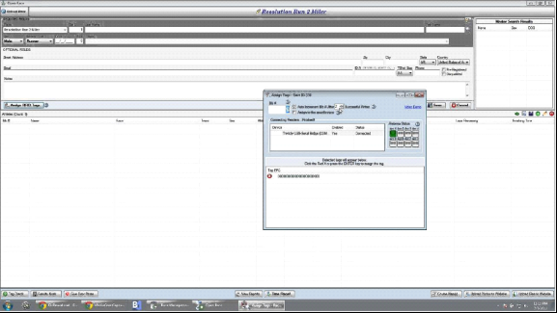



identification are often retrieved. The data obtained is then sent immediately to the CCS by wireless or wired channels, as found convenient at that location. The CCS contains a central database processing system (CDPS) for processing vehicular data and a choice making section (DMS) for controlling the traffic signals.

The volume of traffic is not calculated simply by the number of vehicles but by a complex set of equations that take into account predefined factors obtained by research) including:

Vehicle type —whether it is a small vehicle like a scooter or a car, or a large vehicle like a bus or a truck.Priority allotted to the vehicle — each type of vehicle is allotted a particular priority based on its size, frequency of that vehicle at the crossing, time of the day, and other factors.Priority assigned to the path of travel—this factor becomes essential when both the roads intersecting at the crossing are not of the same importance (e.g., the intersection of a national highway with an ordinary road). Time—the time of the day and day of the week. The volume of traffic takes into account the priority assigned to each vehicle at the present time of the day and also the priority allotted to the two roads intersection at the crossing.

**CONTROL :**

Traffic signals operate in accordance with the current volume of traffic. The system has the advantage of how the traffic volume is calculated. Priorities assigned to vehicles like - Unrestricted passage - Ambulances, Fire Brigades, VIP Vehicles- Higher Priority (during working hours of offices and schools) - Scooters and Cars- Higher Priority at Night - Heavy Vehicle E-Tolling of Vehicles Stolen Vehicles can be tracked through the obtained time and direction of the vehicle traffic data can be generated for statistical purposes.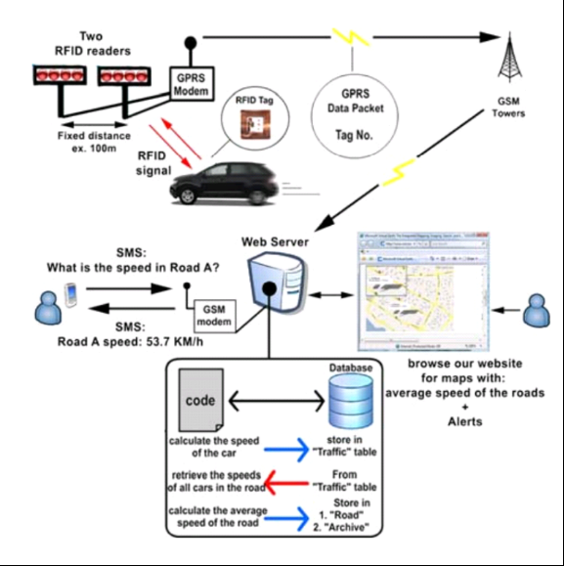

**Model Training:**

Due to short period of time for the projects our team has prepared limited dataset are model to training the dataset for the implementation of Traffic management system

**Code:**

**Sample:1**

import RPi.GPIO as GPIO

import SimpleMFRC522

reader = SimpleMFRC522.SimpleMFRC522()

try:

print("Place an RFID tag near the reader...")

id, text = reader.read()

print("Tag ID: {}".format(id))

print("Tag Text: {}".format(text))

finally:

GPIO.cleanup()

**Sample:2**

import RPi.GPIO as GPIO

import SimpleMFRC522

import time

# Initialize the RFID reader

reader = SimpleMFRC522.SimpleMFRC522()

try:

while True:

print("Place an RFID tag near the reader...")

id, text = reader.read()

print("Tag ID: {}".format(id))

print("Tag Text: {}".format(text))

# Perform actions based on the tag data

if "access_granted" in text:

# Access granted, perform some action (e.g., unlock a door)

print("Access granted! Unlocking the door...")

elif "access_denied" in text:

# Access denied, perform a different action (e.g., sound an alarm)

print("Access denied! Sounding an alarm...")

else:

# Handle other tag data as needed

print("Unknown tag data, no action taken")

# Wait for a moment before checking the next tag

time.sleep(2)

finally:

GPIO.cleanup()

**Output :**

Reference for <https://i.stack.imgur.com/hi4Ll.jpg>

**Evaluation:**

The evaluation of traffic management is likely to focus on several key aspects to measureits effectiveness and impact on urban mobility and safety. Here's how traffic management might be evaluated in 2025.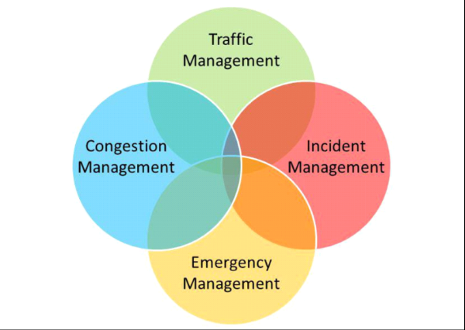

1. Traffic Flow and Congestion: An assessment of how well traffic management systems have improved the flow of traffic and reduced congestion in urban areas. Data on average commute times, peak-hour traffic, and congestion hotspots will be crucial.

2. Safety: Evaluation of the impact on road safety,including a reduction in accidents and fatalities. This assessment would also consider the effectiveness of measures such as speed limits,traffic signs, and traffic calming devices.

3.Environmental Impact: An analysis of how traffic management strategies have contributed to reduced emissions and improved air quality.This would involve measuring the adoption of electric and sustainable transportation options.

4. Public Transportation: An examination of the effectiveness of public transportation systems,including ridership numbers and ease of access, to determine if they have become more convenient and widely used.

5. Infrastructure Utilization: Assessment of the use of existing road infrastructure and its condition, including maintenance and potential expansion or upgrades.

6. Technology Integration: Evaluation of the integration and reliability of smart traffic management technologies, including real-time data collection and analytics,

7. Cost Efficiency: Analysis of the cost-of traffic management systems, considering both initial investment and ongoing maintenance.

8. Public Perception and Satisfaction: Measuring public satisfaction with traffic management improvements, taking into account surveys and feedback from commuters.

9. Accessibility and Inclusivity: Ensuring that traffic management considers the needs of all citizens, including those with disabilities, by assessing the availability of accessible transportation options.

10. Emergency Response and Disaster Preparedness: Evaluation of the efficiency of traffic management during emergencies and disasters, such as evacuation plans and adaptability to extreme weather events.

11. Future-Readiness: Assessing the adaptability of traffic management to future transportation trends, including the integration of autonomous vehicles and new mobility solutions.Overall, the evaluation of traffic management in 2025 will likely focus on creating more efficient, safe, and sustainable transportation systems while improving the quality of life for urban residents. Data-driven assessments will play a significant role in this process.

***”Thank you”***