**Click Charge**

Kameswararao Malla

Advanced Systems Project

Dec 09, 2017

**Revision History**

|  |  |  |  |
| --- | --- | --- | --- |
| **Date** | **Authors** | **Version** | **Change Reference** |
| 12/09/2017 | Kameswararao Malla | 0.1 | First Version |
|  |  |  |  |
|  |  |  |  |
|  |  |  |  |
|  |  |  |  |

**Participants**

**Authors**

|  |  |  |
| --- | --- | --- |
| **Name** | **Representing** | **Role** |
| Kameswararao Malla |  | Graduate Student |
|  |  |  |

**Reviewers**

|  |  |  |
| --- | --- | --- |
| **Name** | **Representing** | **Role** |
| Dr. Sam Ramanujan |  | Professor |
|  |  |  |

Table of Contents

**Project Description**4

**Use case**5

Use Case Description5-14

Use Case Diagram15

**E-R Diagram**16

**Class diagram** 17

**Sequence Diagram…………………………………………………………………………**18

**Conclusion…………………………………………………………………………………19**

**Project Description**

This website is mainly developed to provide support for all types of recharges at one place. In which the administration must take care of all recharges to be secured and provide hassle free payments. It will support not only Mobile networks also Internet networks and maintaining wallet. Users will have their accounts so once they login they can view their history of transactions, their saved contacts, issues they raised and few features related to their account. User can transfer wallet money to other users; they can add some amount to wallet for quick recharge process. They can apply offers to their transaction and receive offers when they use click charge wallet at other stores. There will be session for every user log in and it will expire once they logged out.

All the user accounts and their contacts, issues raised, transactions will be managed using SQL database. Website UI and functional coding will be programmed using ASP.NET. At this point of time, we have these below pages in thought and there can be more pages/functionalities depending on requirements and flexibility of website.

**In this website, there will be 5 major functionalities for User**

* Recharge the mobile network, Internet, Wallet and Transfer money to other accounts
* User can save contacts into their account and get the details when they do recharge
* Account holder can browse for available offers which they can use at stores
* User will send an issue when he face any errors during their usage
* Website will hold the history of orders and user can come back and check anytime about their recent transactions

**Major functionalities for Admin**

* Admin will add more networks for mobile or internet
* Updating offers and creates an expiry date for every offer
* Responding to the issues raised from users and resolving the same
* Admin will notify the registered email whenever user wallet balance goes below 20 from 20 or above
* Admin will set up new categories based upon season

**Use Cases**

This section includes use cases descriptions and use case diagram.

Use Case Description:

|  |  |  |  |
| --- | --- | --- | --- |
| **Use Case ID:** | UC-1 | | |
| **Use Case Name:** | User login in to the System | | |
| **Created By:** | Kameswararao Malla | **Last Updated By:** |  |
| **Date Created:** | 12/09/2017 | **Last Revision Date:** |  |
| **Actors:** | User who registered account earlier. | | |
| **Description:** | The system provides the ability for a User to sign in to the system through a login button on home page | | |
| **Trigger:** | Returning Customer : Wants to use any function provided in the home | | |
| **Pre Conditions:** | User is registered with the system | | |
| **Post Conditions:** | **Success:** The User is authenticated and the system displays a home page upon user logins.  **Failure:** User is unable to log in for one or more reasons. | | |
| **Normal Flow:** | 1. Enter Username and Password 2. Validate Username and Password. 3. View Home page 4. User able to see the navigational tabs | | |
| **Alternate Flow:** | 1. Invalid Username and Password 2. Re-enter the Username and Password 3. Reset the password 4. Normal flow continues | | |
| **Exceptions:** | * User not registered yet | | |
| **Includes:** | Logging in to the system and Includes the user login session time. | | |
| **Frequency of Use:** | On demand | | |
| **Special Requirements:** | Performance and security | | |
| **Assumptions:** | User understands English. | | |

|  |  |  |  |
| --- | --- | --- | --- |
| **Use Case ID:** | UC-2 | | |
| **Use Case Name:** | User tries to recharge mobile or internet network | | |
| **Created By:** | Kameswararao Malla | **Last Updated By:** |  |
| **Date Created:** | 12/09/2017 | **Last Revision Date:** |  |
| **Actors:** | Existing user | | |
| **Description:** | User has options to recharge any network either it is mobile or network | | |
| **Trigger:** | User use their Debit or Credit card | | |
| **Pre Conditions:** | Customer is registered with the system | | |
| **Post Conditions:** | **Success:** Recharge the network with valid details of payment.  **Failure:** User is unable to process transaction. | | |
| **Normal Flow:** | 1. Enter Mobile number and Network 2. Enter amount to be added 3. Enter payment details and option to use wallet money 4. Recharge successful | | |
| **Alternate Flow:** | N/A | | |
| **Exceptions:** | * Power goes off while entering username and password * User Computer Crashes * Server down * Network Issues * No enough balance in wallet * Credit or Debit card declined | | |
| **Includes:** |  | | |
| **Frequency of Use:** | On demand | | |
| **Special Requirements:** | Performance and security | | |
| **Assumptions:** | User understands English. | | |

|  |  |  |  |
| --- | --- | --- | --- |
| **Use Case ID:** | UC-3 | | |
| **Use Case Name:** | User wants to check recent history | | |
| **Created By:** | Kameswararao Malla | **Last Updated By:** |  |
| **Date Created:** | 12/09/2017 | **Last Revision Date:** |  |
| **Actors:** | Registered User | | |
| **Description:** | User is able to view the history of transactions made in recent 30 days and all transactions | | |
| **Trigger:** | User wants to record every transaction made | | |
| **Pre Conditions:** | 1. User should have done some recharge earlier 2. User should have an account. | | |
| **Post Conditions:** | **Success:** User Successfully able to view list of transactions. | | |
| **Normal Flow:** | 1. User logins with valid credentials 2. Go to Order Details Page 3. Choose the options: last 30days and all transactions 4. Able to see all the history upon option selected 5. Logout | | |
| **Alternate Flow:** | N/A | | |
| **Exceptions:** | * No recharges were made * Power goes off while submitting the transaction * Server down * Network Issues | | |
| **Includes:** |  | | |
| **Frequency of use:** | On demand | | |
| **Special Requirements:** | Performance and security | | |
| **Assumptions:** | User understands English. | | |

|  |  |  |  |
| --- | --- | --- | --- |
| **Use Case ID:** | UC-4 | | |
| **Use Case Name:** | Use the offers provide by click charge | | |
| **Created By:** | Kameswararao Malla | **Last Updated By:** |  |
| **Date Created:** | 12/09/2017 | **Last Revision Date:** |  |
| **Actors:** | Registered User | | |
| **Description:** | User can check for offers available to use at different stores. | | |
| **Trigger:** | User will look for offers in different categories like Food, Movies, Jewellery etc | | |
| **Pre Conditions:** | 1. There should exist some offers 2. All offers do not available all time , there will be expiry time for every offer | | |
| **Post Conditions:** | **Success:** User finds the offer and use at store | | |
| **Normal Flow:** | 1. User logins 2. Go to Offers Page 3. Select the category dropdown 4. Displays all the offers available based on expiry date 5. Logout | | |
| **Alternate Flow:** | N/A | | |
| **Exceptions:** | * Not a valid user * All the offers were expired * Power goes off * Server down * Network Issues | | |
| **Includes:** | Requesting the user transaction report, to check how much Loan amount user hold in his/her account.  Hold the user credit score for the future offers and Loan products | | |
| **Frequency of use:** | On demand | | |
| **Special Requirements:** | Performance and security | | |
| **Assumptions:** | User understands English. | | |

|  |  |  |  |
| --- | --- | --- | --- |
| **Use Case ID:** | UC-5 | | |
| **Use Case Name:** | Use wallet amount for recharge | | |
| **Created By:** | Kameswararao Malla | **Last Updated By:** |  |
| **Date Created:** | 12/09/2017 | **Last Revision Date:** |  |
| **Actors:** | Registered user | | |
| **Description:** | Click charge wallet is a special feature available for the user to use the amount for any transactions. This will not need any debit/credit transactions. | | |
| **Trigger:** | Amount added to wallet and use the same for further transactions | | |
| **Pre Conditions:** | 1. User recharged the wallet with some amount | | |
| **Post Conditions:** | **Success:** User uses the wallet balance for new transactions | | |
| **Normal Flow:** | 1. User logins 2. Go to Orders Page. 3. Check the wallet balance 4. If wallet balance exists, go to Recharge page 5. Try to recharge the network or transfer money 6. Check the option use wallet balance while submitting payment 7. Recharge successful 8. Logout | | |
| **Alternate Flow:** | N/A | | |
| **Exceptions:** | * No wallet balance exists * Power goes off while approving the Loan * Server down * Network Issues | | |
| **Includes:** |  | | |
| **Frequency of use:** | Only when user not able to pay with Debit or Credit card. | | |
| **Special Requirements:** | Performance and security | | |
| **Assumptions:** | User understands English agreed to terms and conditions. | | |

|  |  |  |  |
| --- | --- | --- | --- |
| **Use Case ID:** | UC-6 | | |
| **Use Case Name:** | User wants to report a issue | | |
| **Created By:** | Kameswararao Malla | **Last Updated By:** |  |
| **Date Created:** | 12/09/2017 | **Last Revision Date:** |  |
| **Actors:** | Registered user | | |
| **Description:** | Any problem faced during the access to website by user, he can report an issue which will reach the admin. | | |
| **Trigger:** | When user face error and go to issues face, brief the problem and submit | | |
| **Pre Conditions:** | 1. User face some trouble to access something | | |
| **Post Conditions:** | **Success:** Able to submit the issue | | |
| **Normal Flow:** | 1. User logins 2. User faces some trouble 3. Go to issues page 4. Submit the issue 5. Logout | | |
| **Alternate Flow:** | N/A | | |
| **Exceptions:** | * There are no problems faced * Power goes off while submitting the issue * Server down | | |
| **Includes:** |  | | |
| **Frequency of use:** | Not usual | | |
| **Special Requirements:** | Performance and security | | |
| **Assumptions:** | User faced some problem and wants to report the issue. | | |

|  |  |  |  |
| --- | --- | --- | --- |
| **Use Case ID:** | UC-7 | | |
| **Use Case Name:** | Admin wants to add more networks | | |
| **Created By:** | Kameswararao Malla | **Last Updated By:** |  |
| **Date Created:** | 12/09/2017 | **Last Revision Date:** |  |
| **Actors:** | Admin | | |
| **Description:** | There is scope to add more networks for mobile or internet , so admin wants to add new networks | | |
| **Trigger:** | Admin will look for adding new network or modify the existing network or delete | | |
| **Pre Conditions:** | 1. Modify button enables if network exists already | | |
| **Post Conditions:** | **Success:** Once admin add the network, user can use the network for a transactions | | |
| **Normal Flow:** | 1. Admin Logins 2. Go to networks page 3. Add/ Modify new network and name 4. Submit | | |
| **Alternate Flow:** | N/A | | |
| **Exceptions:** | * Same network exists | | |
| **Includes:** |  | | |
| **Frequency of use:** | On demand | | |
| **Special Requirements:** | Performance and security | | |
| **Assumptions:** | New networks are required | | |

|  |  |  |  |
| --- | --- | --- | --- |
| **Use Case ID:** | UC-8 | | |
| **Use Case Name:** | Notify the user when wallet balance goes below 20 from above 20 | | |
| **Created By:** | Kameswararao Malla | **Last Updated By:** |  |
| **Date Created:** | 12/09/2017 | **Last Revision Date:** |  |
| **Actors:** | User | | |
| **Description:** | User will notified if the wallet balance goes lower than 20 through an email. It’s an automated feature from the admin; user will receive email from the Admin. | | |
| **Trigger:** | User wants to get notified about his wallet activity | | |
| **Pre Conditions:** | 1. User must provide a valid email account when he registers 2. Wallet balance has to be below 20 3. Email will not be repeated if use wallet amount is already below 20 | | |
| **Post Conditions:** | **Success:** User received email when his wallet balance is less than 20 | | |
| **Normal Flow:** | 1. User logins 2. Go to Orders page 3. Use the wallet balance for any recharge purpose 4. Receive the email from admin notifying about the wallet balance | | |
| **Alternate Flow:** | N/A | | |
| **Exceptions:** | * Wallet balance is more than 20. * Email already sent when balance is below 20 * Network issues. | | |
| **Includes:** |  | | |
| **Frequency of use:** | On demand | | |
| **Special Requirements:** | Performance and security | | |
| **Assumptions:** | User registered with valid email id. | | |

|  |  |  |  |
| --- | --- | --- | --- |
| **Use Case ID:** | UC-9 | | |
| **Use Case Name:** | Admin wants to resolve the issue | | |
| **Created By:** | Kameswararao Malla | **Last Updated By:** |  |
| **Date Created:** | 12/09/2017 | **Last Revision Date:** |  |
| **Actors:** | Admin | | |
| **Description:** | Admin will resolve the issue submitted by user | | |
| **Trigger:** | Admin responds to the issue from inbox page | | |
| **Pre Conditions:** | 1. User writes a problem 2. Issue submitted successfully and received to admin inbox | | |
| **Post Conditions:** | **Success:** Admin received the issue from user | | |
| **Normal Flow:** | 1. Admin logins 2. Go to inbox page 3. Admin resolves the issue and write a reply to the message to the user | | |
| **Alternate Flow:** | N/A | | |
| **Exceptions:** | * No issues faced by user * Network issues. | | |
| **Includes:** |  | | |
| **Frequency of use:** | On demand | | |
| **Special Requirements:** | Performance and security | | |
| **Assumptions:** | User faces some issue | | |

|  |  |  |  |
| --- | --- | --- | --- |
| **Use Case ID:** | UC-10 | | |
| **Use Case Name:** | Admin add new offer | | |
| **Created By:** | Kameswararao Malla | **Last Updated By:** |  |
| **Date Created:** | 12/09/2017 | **Last Revision Date:** |  |
| **Actors:** | Admin | | |
| **Description:** | Admin submits new offer with expiry date | | |
| **Trigger:** | Once admin added the offer, user is able to see the offer | | |
| **Pre Conditions:** | 1. Click charge enables a new offer 2. Same offer is not existed | | |
| **Post Conditions:** | **Success:** User is able to view these offers in their dashboard | | |
| **Normal Flow:** | 1. Admin logins 2. Go to offers page 3. Create new offer 4. Select expiry date 5. Submit 6. Logout | | |
| **Alternate Flow:** | N/A | | |
| **Exceptions:** | * Same offer existed already in database | | |
| **Includes:** |  | | |
| **Frequency of use:** | Seasonal | | |
| **Special Requirements:** | Performance and security | | |
| **Assumptions:** | Same category existed in database before using offer | | |

**Use Case diagram**

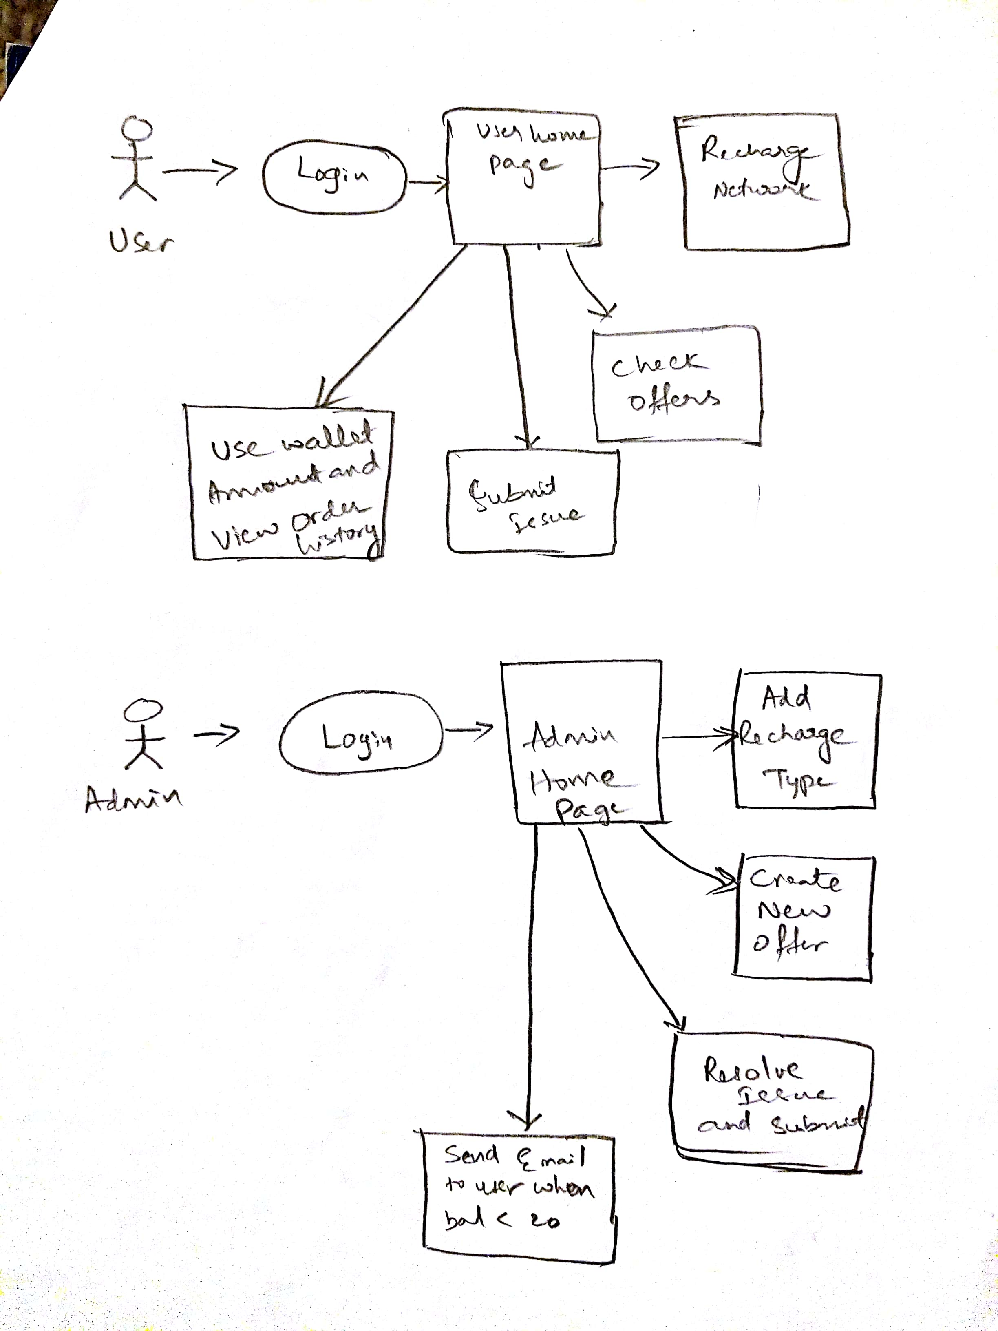

**Entity Relationship Diagram**

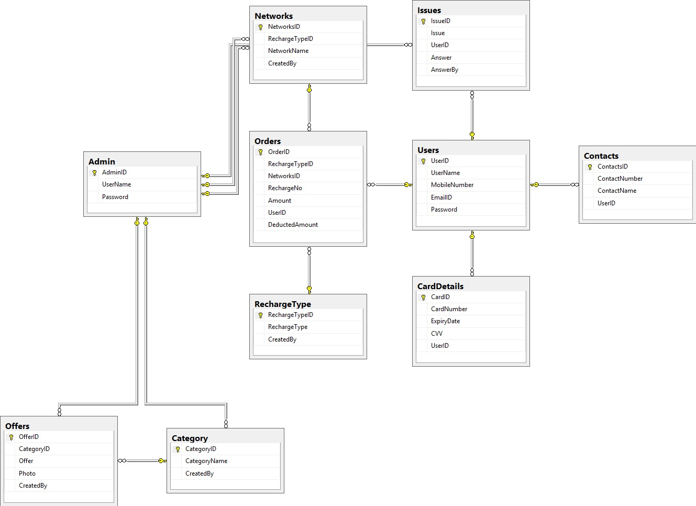

**Class Diagram**

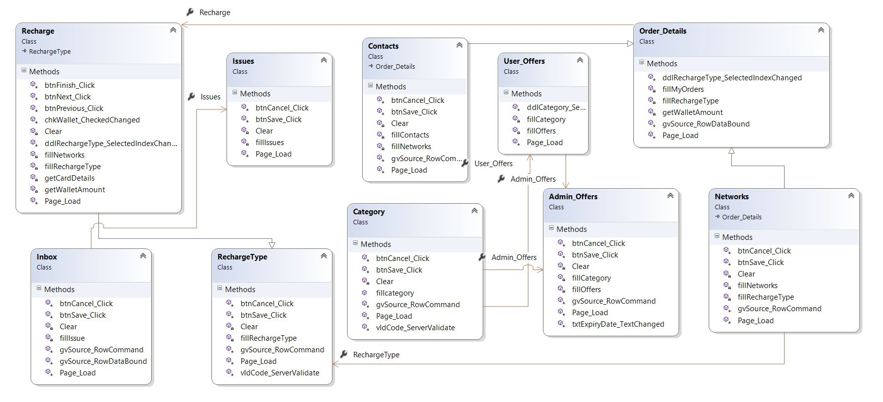

**Sequence Diagram**

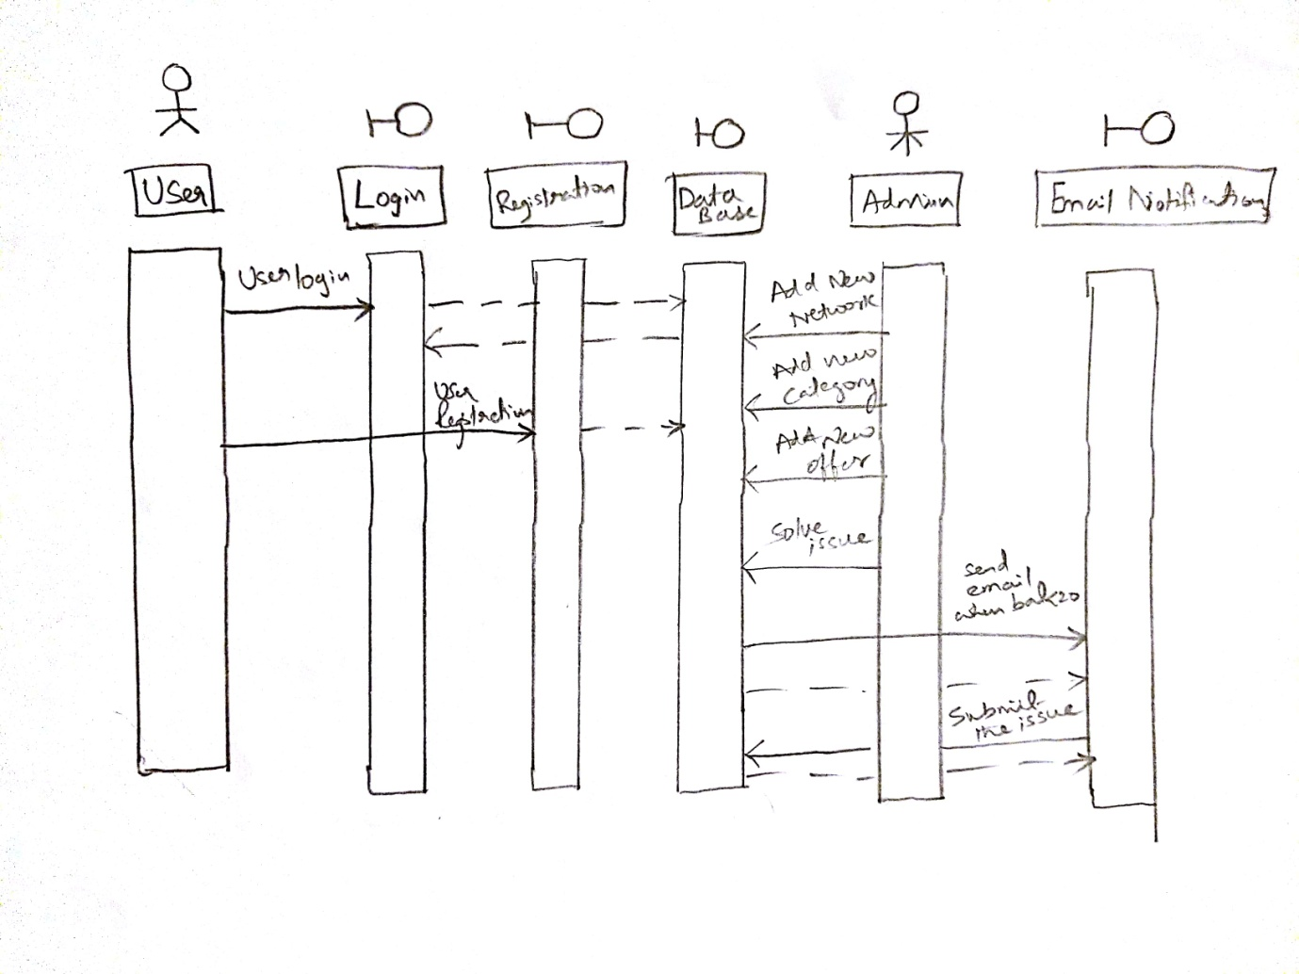

**Conclusion:**

Currently all networks use their internal website to recharge their carriers/networks, this system makes a common platform for customers who use multiple networks and to receive deals. This will become a third party for all networks relying on monthly transactions. Also with the wallet facility user can store credit card details and if a transaction failed at payment gateway their money is safe in their wallet. They don’t need to wait for refunds process.