**Trip Start**

Vinay kumar Kurva

700654332

Advanced Systems Project

**Participants**

**Authors**

|  |  |  |
| --- | --- | --- |
| **Name** | **Representing** | **Role** |
| Vinay Kumar Kurva |  | Graduate Student |
|  |  |  |

**Reviewers**

|  |  |  |
| --- | --- | --- |
| **Name** | **Representing** | **Role** |
| Dr. Sam Ramanujan |  | Professor |
|  |  |  |

**Project Description**3

**Use case**4-10

Use Case Description

Use Case Diagram11

**E-R Diagram**12

**Class diagram** 13

**Sequence Diagram…………………………………………………………………………14**

**Project Description**

This web application is mainly developed to provide lodging, rentals and hotel rooms including experiences. This application acts as broker between the host and the user where, host creates his account and registers for hosting his room where hosts can also add experiences and add additional charges. User’s can search for the available rooms or lodgings provided by the host and can book it but, they have to register in order to book room. After, user has booked room host has to approve room before user checks into room. And as soon as host approves the request user will get email which include booked dates. There is also facility to cancel room, it can be done by logging into the application.

User and host accounts and booking details are managed using Microsoft SQL server. Front-end part of the application is developed using Angular 2. ASP.net is used for back-end services and service calls are made from UI using Angular http module.

**Major Functionalities for USER**

* Search for the available rooms based on the location.
* Can go through his previous trips.
* User can edit his profile and update it.
* User can filter based on price requirement.
* User gets email confirmation for every booking.
* User can cancel his bookings by logging into application.
* User can write reviews about the rooms or experiences which he attended.

**Major Functionalities for Host**

* Host will receive have message if any user requests any room.
* Host can upload image and provide descriptions about the rooms he is hosting.
* Host can approve requests from user with one click and system will automatically send email to user.
* Host has ability to block his room at any interval of time.

**Use Cases**

|  |  |  |  |
| --- | --- | --- | --- |
| **Use Case ID:** | UC-1 | | |
| **Use Case Name:** | User login in to the System | | |
| **Created By:** | Vinay Kumar Kurva | **Last Updated By:** |  |
| **Date Created:** | 12/17/2017 | **Last Revision Date:** |  |
| **Actors:** | User who registered account earlier. | | |
| **Description:** | The system provides the ability for a User to sign in to the system through a login button on home page | | |
| **Trigger:** | Returning Customer : Wants to use any function provided in the home | | |
| **Pre Conditions:** | User is registered with the system | | |
| **Post Conditions:** | **Success:** The User is authenticated and the system displays a home page upon user logins.  **Failure:** User is unable to log in for one or more reasons. | | |
| **Normal Flow:** | 1. Enter Username and Password 2. Validate Username and Password. 3. View Home page 4. User able to see the navigational tabs | | |
| **Alternate Flow:** | 1. Invalid Username and Password 2. Re-enter the Username and Password 3. Normal flow continues | | |
| **Exceptions:** | * User not registered yet | | |
| **Includes:** | Logging in to the system and Includes the user login session time. | | |
| **Frequency of Use:** | On demand | | |
| **Special Requirements:** | Performance and security | | |

|  |  |  |  |
| --- | --- | --- | --- |
| **Use Case ID:** | UC-2 | | |
| **Use Case Name:** | User tries to book room | | |
| **Created By:** | Vinay Kumar Kurva | **Last Updated By:** |  |
| **Date Created:** | 12/17/2017 | **Last Revision Date:** |  |
| **Actors:** | Existing user | | |
| **Description:** | User has options to recharge any network either it is mobile or network | | |
| **Trigger:** | User has to click on book button | | |
| **Pre Conditions:** | Customer is registered with the system | | |
| **Post Conditions:** | **Success:** Host receives message to approve the booking.  **Failure:** Host has blocked room or room is already booked | | |
| **Normal Flow:** | 1. Enter Chick-in and Check-out date 2. Enter number of guests 3. Click on book button provided. 4. Booking successful. | | |
| **Alternate Flow:** | N/A | | |
| **Exceptions:** | * Power goes off while entering username and password * User Computer Crashes * Server down * Network Issues * Other user has already booked in that period. * Host has blocked room during that period. | | |
| **Includes:** |  | | |
| **Frequency of Use:** | On demand | | |
| **Special Requirements:** | Performance and security | | |
| **Assumptions:** | User understands English. | | |

|  |  |  |  |
| --- | --- | --- | --- |
| **Use Case ID:** | UC-3 | | |
| **Use Case Name:** | User wants to check his trip history | | |
| **Created By:** | Vinay Kumar Kurva | **Last Updated By:** |  |
| **Date Created:** | 12/17/2017 | **Last Revision Date:** |  |
| **Actors:** | Registered user | | |
| **Description:** | User has options to Check the recent history | | |
| **Trigger:** | User has to click on trips button | | |
| **Pre Conditions:** | Customer is registered with the system | | |
| **Post Conditions:** | **Success:** User has list of all previous bookings | | |
| **Normal Flow:** | 1. Enter Username and password 2. Click on trip button 3. View List | | |
| **Alternate Flow:** | N/A | | |
| **Exceptions:** |  | | |
| **Includes:** |  | | |
| **Frequency of Use:** | On demand | | |
| **Special Requirements:** | Performance and security | | |
| **Assumptions:** | User understands English. | | |

|  |  |  |  |
| --- | --- | --- | --- |
| **Use Case ID:** | UC-4 | | |
| **Use Case Name:** | User Reviews | | |
| **Created By:** | Vinay Kumar Kurva | **Last Updated By:** |  |
| **Date Created:** | 12/17/2017 | **Last Revision Date:** |  |
| **Actors:** | Registered user | | |
| **Description:** | User can write review and submit which is visible to every user | | |
| **Trigger:** | User has to write and submit | | |
| **Pre Conditions:** | User has to have previous history of staying in room | | |
| **Post Conditions:** | **Success:** review is submitted.  **Failure:** Text area will be disabled if he has no previous history of staying. | | |
| **Normal Flow:** | 1. Enter Username and password 2. Click on the item image. 3. Click on reviews. 4. Write review and submit | | |
| **Alternate Flow:** | N/A | | |
| **Exceptions:** | * User has no history of staying in room | | |
| **Includes:** |  | | |
| **Frequency of Use:** | On demand | | |
| **Special Requirements:** | Performance and security | | |
| **Assumptions:** | User understands English. | | |

|  |  |  |  |
| --- | --- | --- | --- |
| **Use Case ID:** | UC-5 | | |
| **Use Case Name:** | User Cancel room | | |
| **Created By:** | Vinay Kumar Kurva | **Last Updated By:** |  |
| **Date Created:** | 12/17/2017 | **Last Revision Date:** |  |
| **Actors:** | Registered user | | |
| **Description:** | User can cancel room | | |
| **Trigger:** | User has to go into trips and click on cancel button. | | |
| **Pre Conditions:** | User can cancel only rooms which are approved by host. | | |
| **Post Conditions:** | **Success:** Room will be canceled and deleted from trips tab. | | |
| **Normal Flow:** | 1. Enter Username and password 2. Click on the trip link. 3. Click on cancel button, 4. Trip will bill be canceled. | | |
| **Alternate Flow:** | N/A | | |

|  |  |  |  |
| --- | --- | --- | --- |
| **Use Case ID:** | UC-6 | | |
| **Use Case Name:** | User become host | | |
| **Created By:** | Vinay Kumar Kurva | **Last Updated By:** |  |
| **Date Created:** | 12/17/2017 | **Last Revision Date:** |  |
| **Actors:** | Registered user | | |
| **Description:** | User can become host and advertise his rooms | | |
| **Trigger:** | User has to click on become host link. | | |
| **Pre Conditions:** | User has to be registered. | | |
| **Post Conditions:** | **Success:** User can upload required images with description and advertise. | | |
| **Normal Flow:** | 1. Enter Username and password 2. Click on the become host link. 3. Sign up as host | | |
| **Alternate Flow:** | Host can directly sign up as host and advertise. | | |

|  |  |  |  |
| --- | --- | --- | --- |
| **Use Case ID:** | UC-7 | | |
| **Use Case Name:** | Host blocking room | | |
| **Created By:** | Vinay Kumar Kurva | **Last Updated By:** |  |
| **Date Created:** | 12/17/2017 | **Last Revision Date:** |  |
| **Actors:** | Registered user | | |
| **Description:** | Host wants to block room for particular period of time. | | |
| **Trigger:** | Host has to give blocking period and click block room. | | |
| **Pre Conditions:** | Host has to login | | |
| **Post Conditions:** | **Success:** Host can be able to block room for that period. | | |
| **Normal Flow:** | 1. Enter Username and password 2. Click on the block room tab. 3. Enter block in and block out dates 4. Click in block room button. | | |
| **Alternate Flow:** | N/A | | |

|  |  |  |  |
| --- | --- | --- | --- |
| **Use Case ID:** | UC-8 | | |
| **Use Case Name:** | Host blocking room | | |
| **Created By:** | Vinay Kumar Kurva | **Last Updated By:** |  |
| **Date Created:** | 12/17/2017 | **Last Revision Date:** |  |
| **Actors:** | Registered user | | |
| **Description:** | Host wants to block room for particular period of time. | | |
| **Trigger:** | Host has to give blocking period and click block room. | | |
| **Pre Conditions:** | Host has to login | | |
| **Post Conditions:** | **Success:** Host can be able to block room for that period. | | |
| **Normal Flow:** | 1. Enter Username and password 2. Click on the block room tab. 3. Enter block in and block out dates 4. Click in block room button. | | |
| **Alternate Flow:** | N/A | | |

|  |  |  |  |
| --- | --- | --- | --- |
| **Use Case ID:** | UC-9 | | |
| **Use Case Name:** | Sending e-mail after host approves | | |
| **Created By:** | Vinay Kumar Kurva | **Last Updated By:** |  |
| **Date Created:** | 12/17/2017 | **Last Revision Date:** |  |
| **Actors:** | Registered Host | | |
| **Description:** | User will receive e-mail about booking confirmation and dates | | |
| **Trigger:** | Host has to click on approve check box. | | |
| **Pre Conditions:** | Host has to login | | |
| **Post Conditions:** | **Success:** Host can see the status of room changed to true and room will not be available in that period for any other user. | | |
| **Normal Flow:** | 1. Enter Username and password 2. Click on the respective tab. 3. Click on approve check box. | | |
| **Alternate Flow:** | N/A | | |

|  |  |  |  |
| --- | --- | --- | --- |
| **Use Case ID:** | UC-10 | | |
| **Use Case Name:** | Host Notifications | | |
| **Created By:** | Vinay Kumar Kurva | **Last Updated By:** |  |
| **Date Created:** | 12/17/2017 | **Last Revision Date:** |  |
| **Actors:** | Registered Host | | |
| **Description:** | Host will receive notification after user books any room | | |
| **Trigger:** | Host has to click on messages link on top to view notifications | | |
| **Pre Conditions:** | Host has to login | | |
| **Post Conditions:** | **Success:** Host can see the notification provided with booking ID | | |
| **Normal Flow:** | 1. Enter Username and password 2. Click on the messages link. 3. Click on booking ID. 4. It will be navigated to the booking row. | | |
| **Alternate Flow:** | N/A | | |

**Use Case diagram**

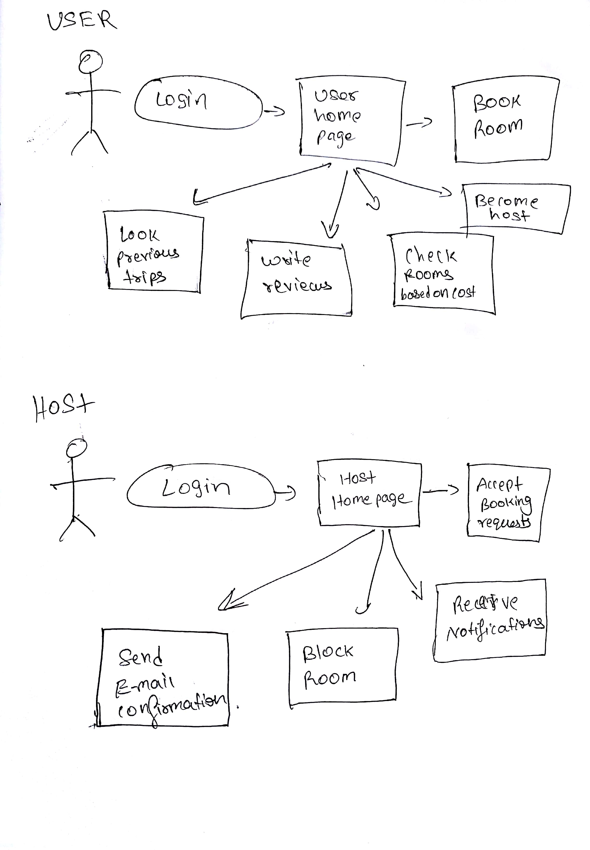

**Entity Relationship Diagram**

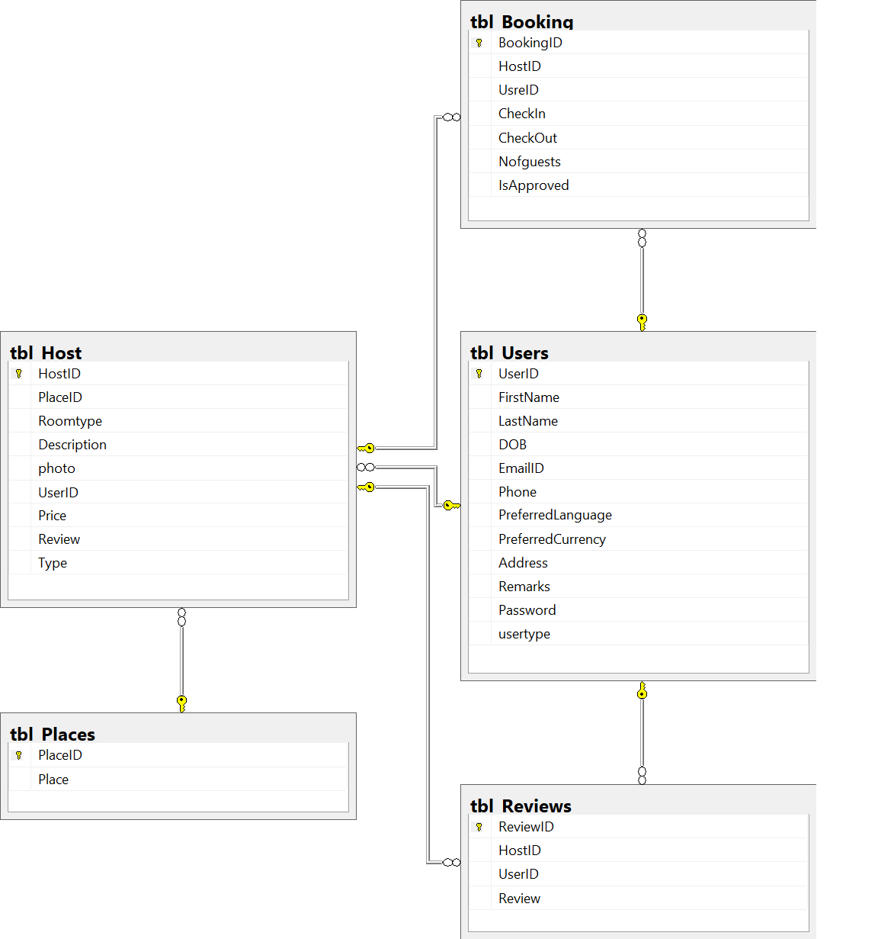

**Class Diagram**

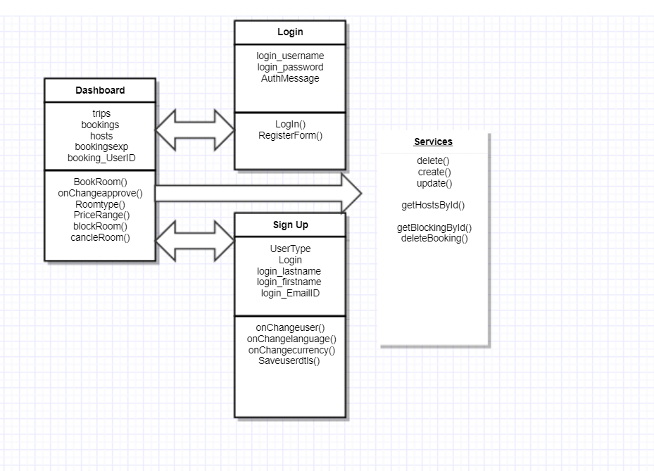

**Sequence Diagram**

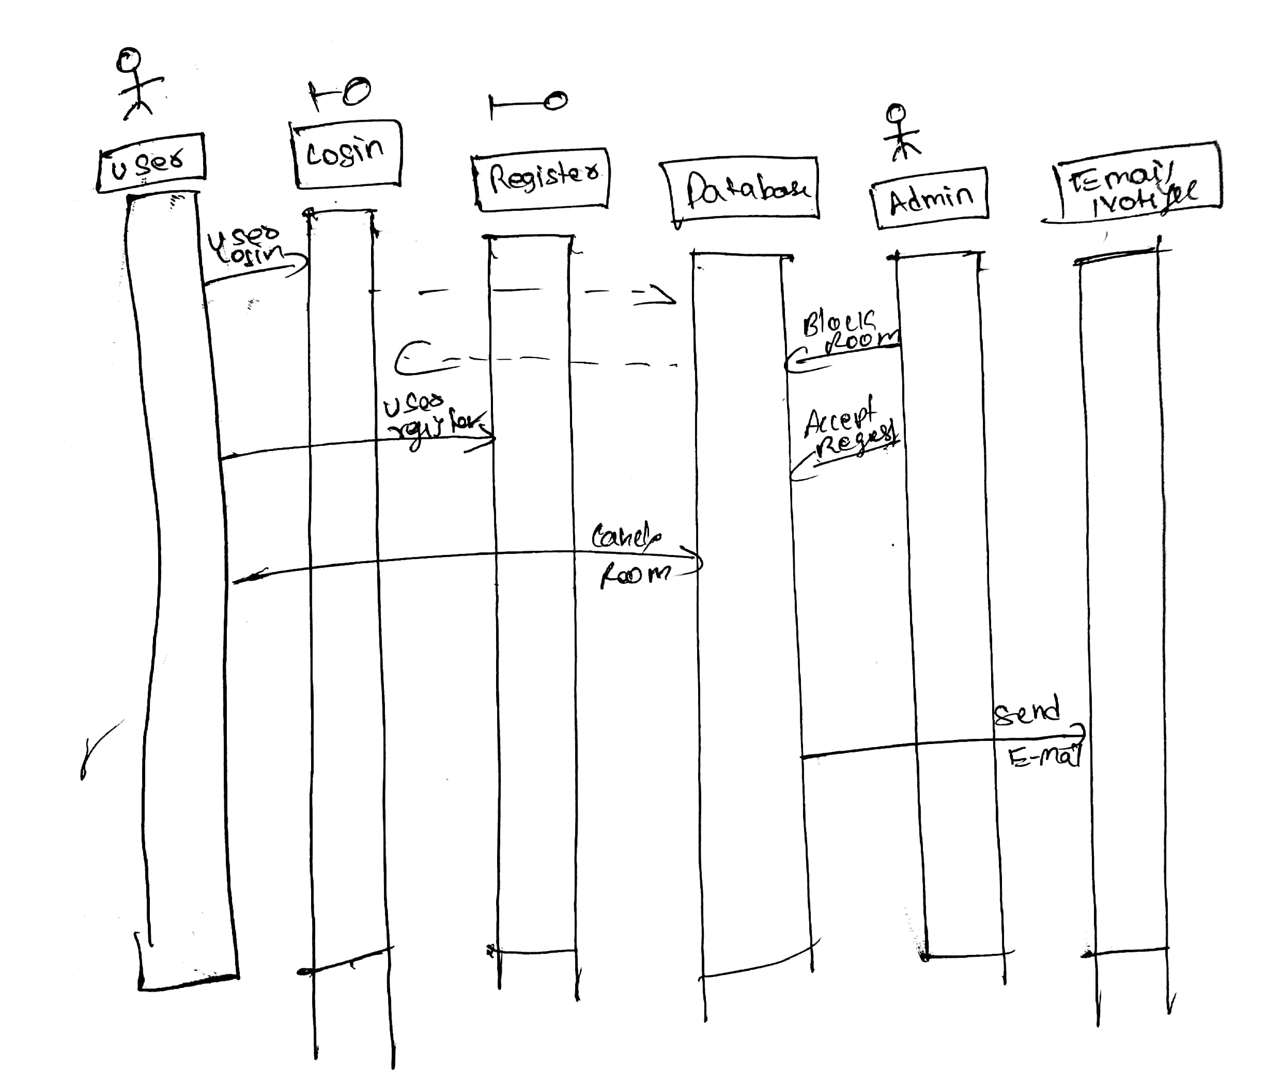

**Conclusion:**

This Application helps the various users to choose their trip based on their requirements instead of staying in hotels with expensive rates. Even various hosts can host their personal rooms with their own costs and charge extra for other experiences. This application just acts as a broker between user and hosts. With cancelation facilities benefit various users and providing blocking facility to user also benefits Host.