Zaki Ahmed

Prof. Narayanasami

CS 3354.007

19 February 2025

Homework 03

**Functional Requirements**

1. Starship shall allow UTD students, staff and faculty to use their delivery service.
   1. Starship will be accessed through the Starship Deliveries app.
2. Starship shall autonomously drive to specified locations within its range.
   1. Starship shall detect obstacles and reroute accordingly.
   2. Starship shall be remotely controlled by a human if any issues are to occur.
3. Starship shall deliver food to paying customers.
   1. Starship shall deliver food based on the user selected pinned location.
   2. Starship shall consistently notify user of its location once an order is placed.
   3. Starship shall send a notification to the user once it has arrived to the designated location.
   4. Starship shall hand off order once user uses app to unlock its contents.
   5. Starship shall verbally thank user.
4. Starship shall be able to deliver orders for 18 hours.
   1. Starship shall be recharged in specified charging area if battery is too low.
5. Starship shall allow users to submit help tickets if any issues occur in the order process.

**Nonfunctional Requirements**

1. Starship shall deliver orders within 60 minutes.
2. Starship shall have a maximum speed of 4 miles per hour.
3. Starship shall have a maximum weight capacity of 20 pounds.

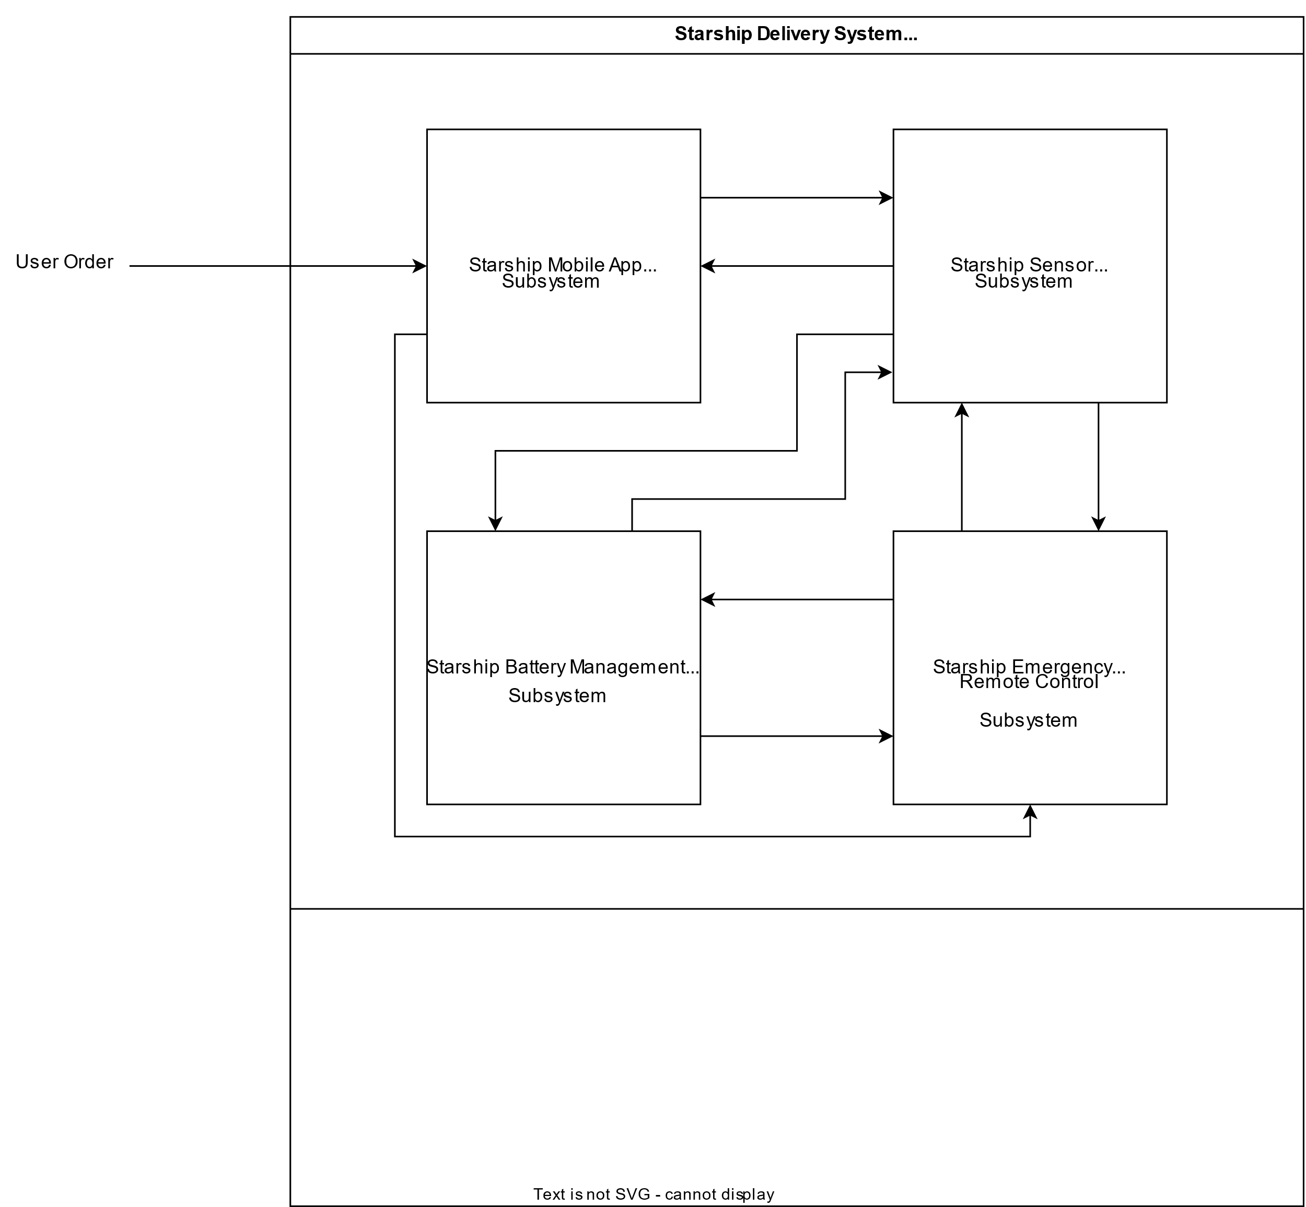

|  |  |  |  |  |
| --- | --- | --- | --- | --- |
|  | Mobile App Subsystem | Sensor Subsystem | Battery Mgmt Subsystem | Remote Control Subsystem |
| R1 |  |  |  |  |
| R1.1 | X |  |  |  |
| R2 |  |  |  |  |
| R2.1 |  | X |  |  |
| R2.2 |  | X | X | X |
| R3 |  |  |  |  |
| R3.1 | X |  |  |  |
| R3.2 | X | X |  | X |
| R3.3 | X | X |  |  |
| R3.4 | X | X |  |  |
| R3.5 | X | X |  |  |
| R4 |  |  |  |  |
| R4.1 |  | X | X | X |
| R5 | X |  |  | X |
| R6 | X | X |  | X |
| R7 |  | X | X | X |
| R8 |  | X | X |  |