Zaki Ahmed

Prof. Narayanasami

CS 3354.007

24 March 2025

Homework 6

|  |  |  |  |  |
| --- | --- | --- | --- | --- |
| **Expanded Use Case Step** | **System Display** | **Information Displayed** | **User Input** | **User Actions** |
| 0 | Website Home Page | * Website About Information * Login Button * Register Button |  |  |
| 2 | Login Form | * Email textbox * Password textbox * Forgot Password button * Exit button * Submit button |  | * User clicks login button |
| 4 | Authentication Setup Form | * “First Time Users must set up authentication questions in case password is forgotten.” * 5 Drop-down Boxes containing predefined authentication questions * Blank Textboxes below each drop-down * Submit button | * User email * User password | * Types in valid email and password combination * Clicks submit button |

|  |  |  |  |  |
| --- | --- | --- | --- | --- |
| 6 | Authentication Setup Message | * “Authentication questions have been validated. Now logging in…” | * Chosen questions * User-specific answers | * Selects what questions they want * Types in their answer for each question * Clicks submit button |
| 8 | Reset Password User Form | * Textbox prompting for valid user email * Confirm button * Exit button |  | * User clicks forgot password button |
| 10 | Reset Password Answer Form | * Drop-down box containing user-selected authentication questions * Blank textbox for user answer * Confirm button * Exit button | * User email | * User enters valid email * User clicks confirm button |
| 12 | New Password Setup | * Masked input textbox containing new user password * Masked input textbox to reenter password * Password strength indicator with various required fields * Confirm button | * User-specific answer | * Types in their answer for the question * Clicks confirm button |

|  |  |  |  |  |
| --- | --- | --- | --- | --- |
| 14 | New Password Confirmation Message | * “Password has been successfully reset.” | * User-specific password | * Types in their new password * Clicks confirm button |
| 16 | Login Confirmation Message | * “Login Successful” or “Login Unsuccessful” | * User email * User password | * Types in their email * Types in their password * Clicks submit button |

Figma File Link: <https://www.figma.com/design/0YS7JhNtAcbqmshMfq9GCC/HW6-System-Displays?node-id=3-304&p=f>

0. Website Home Page

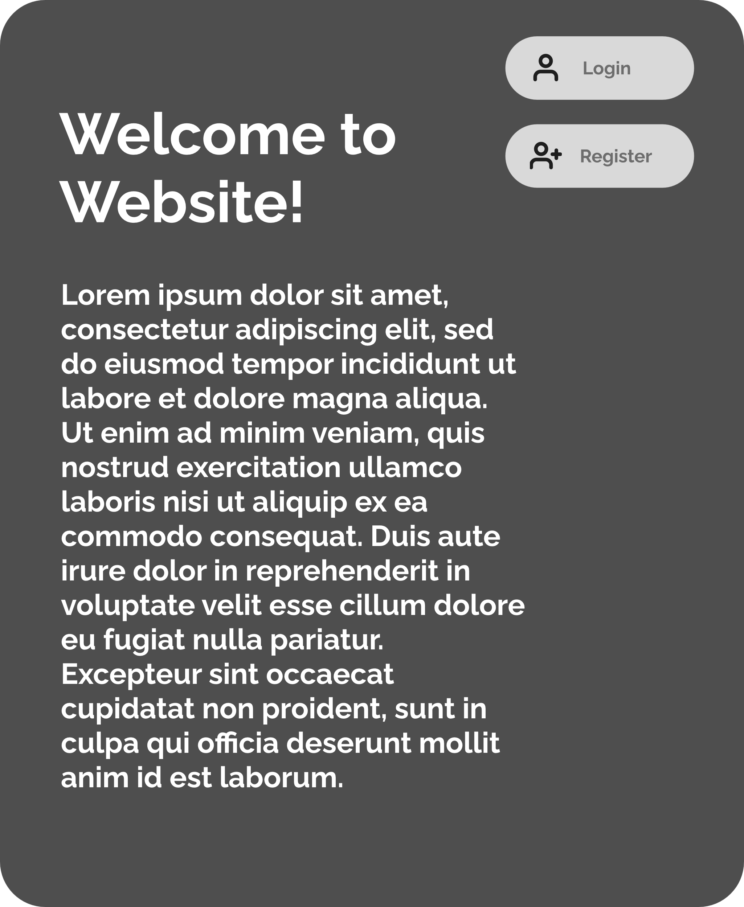

2. Login Form

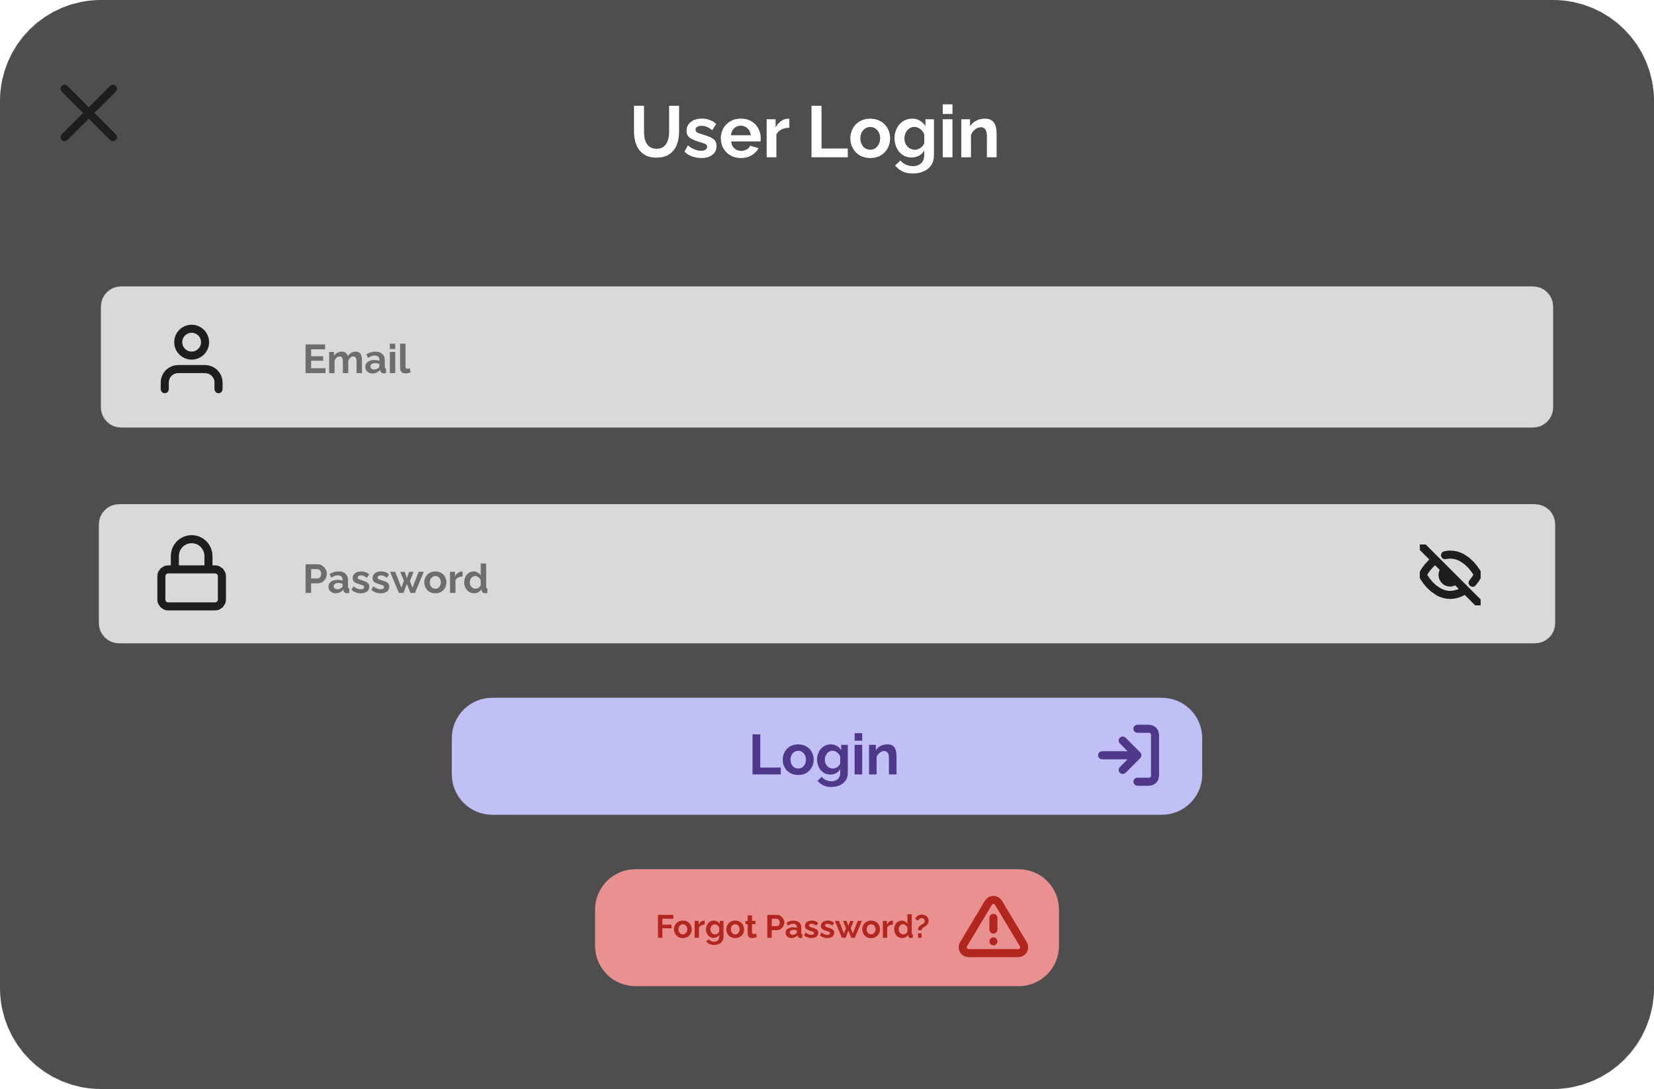

4. Authentication Setup Form

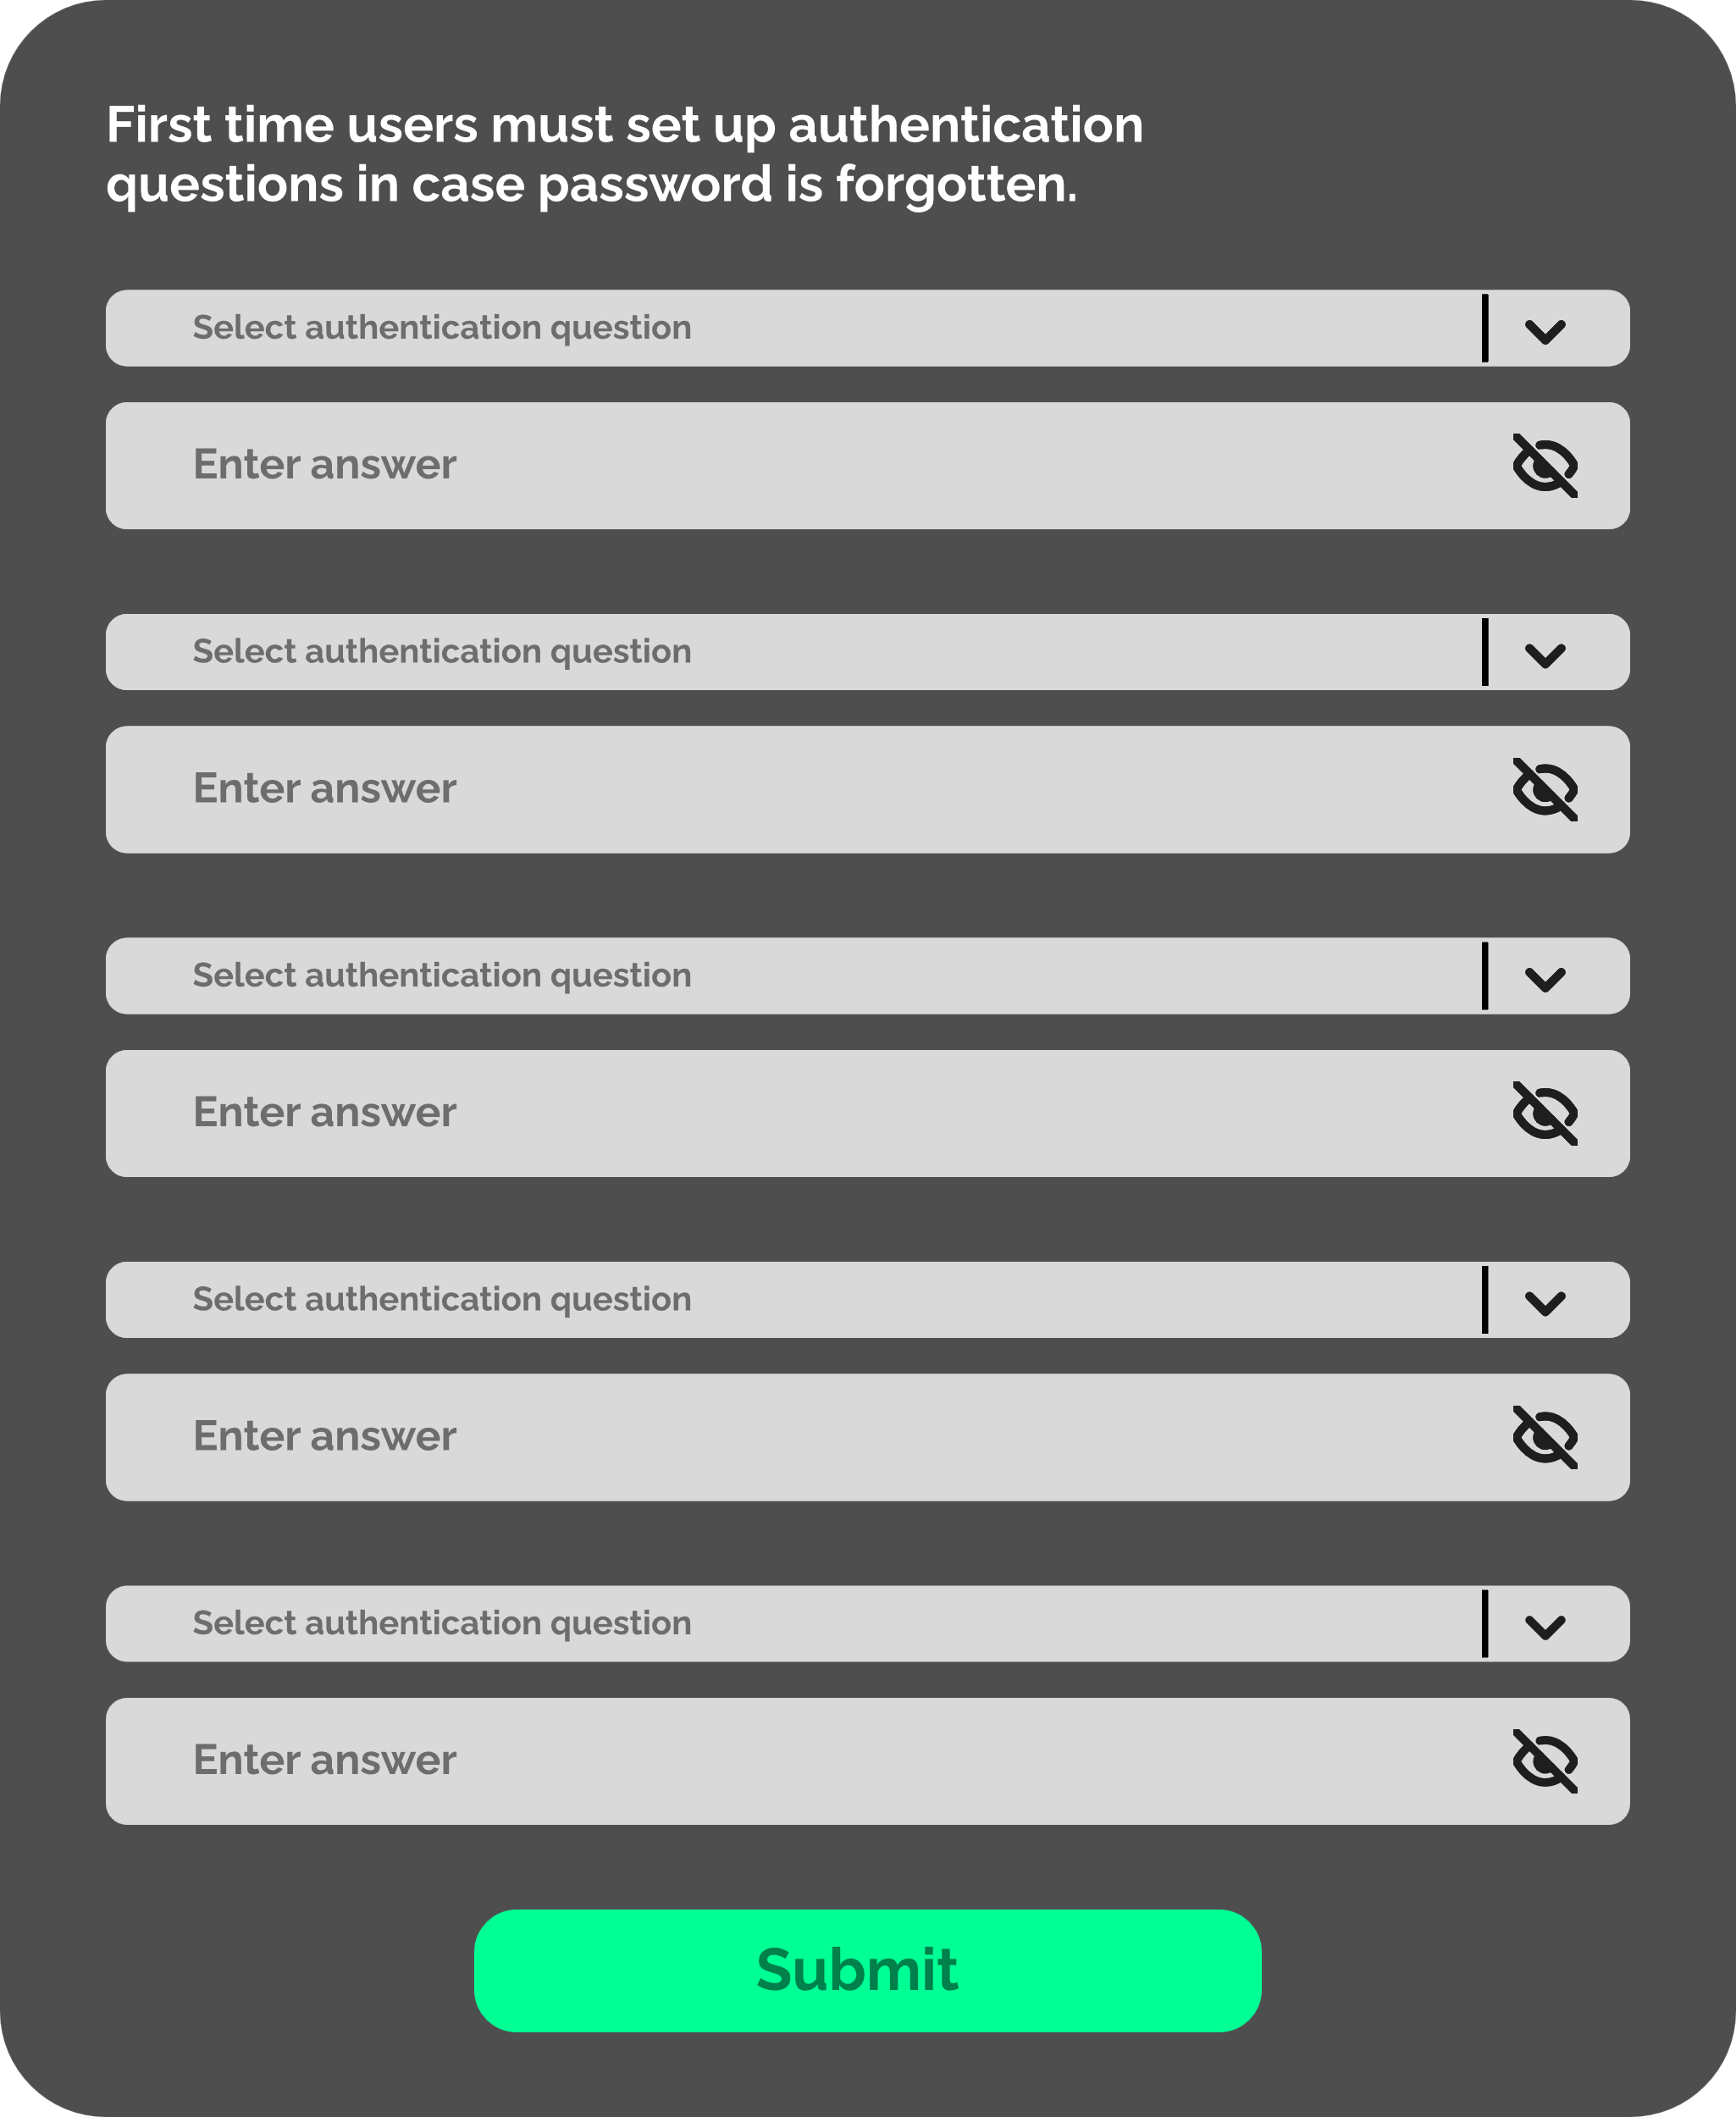

6. Authentication Setup Message

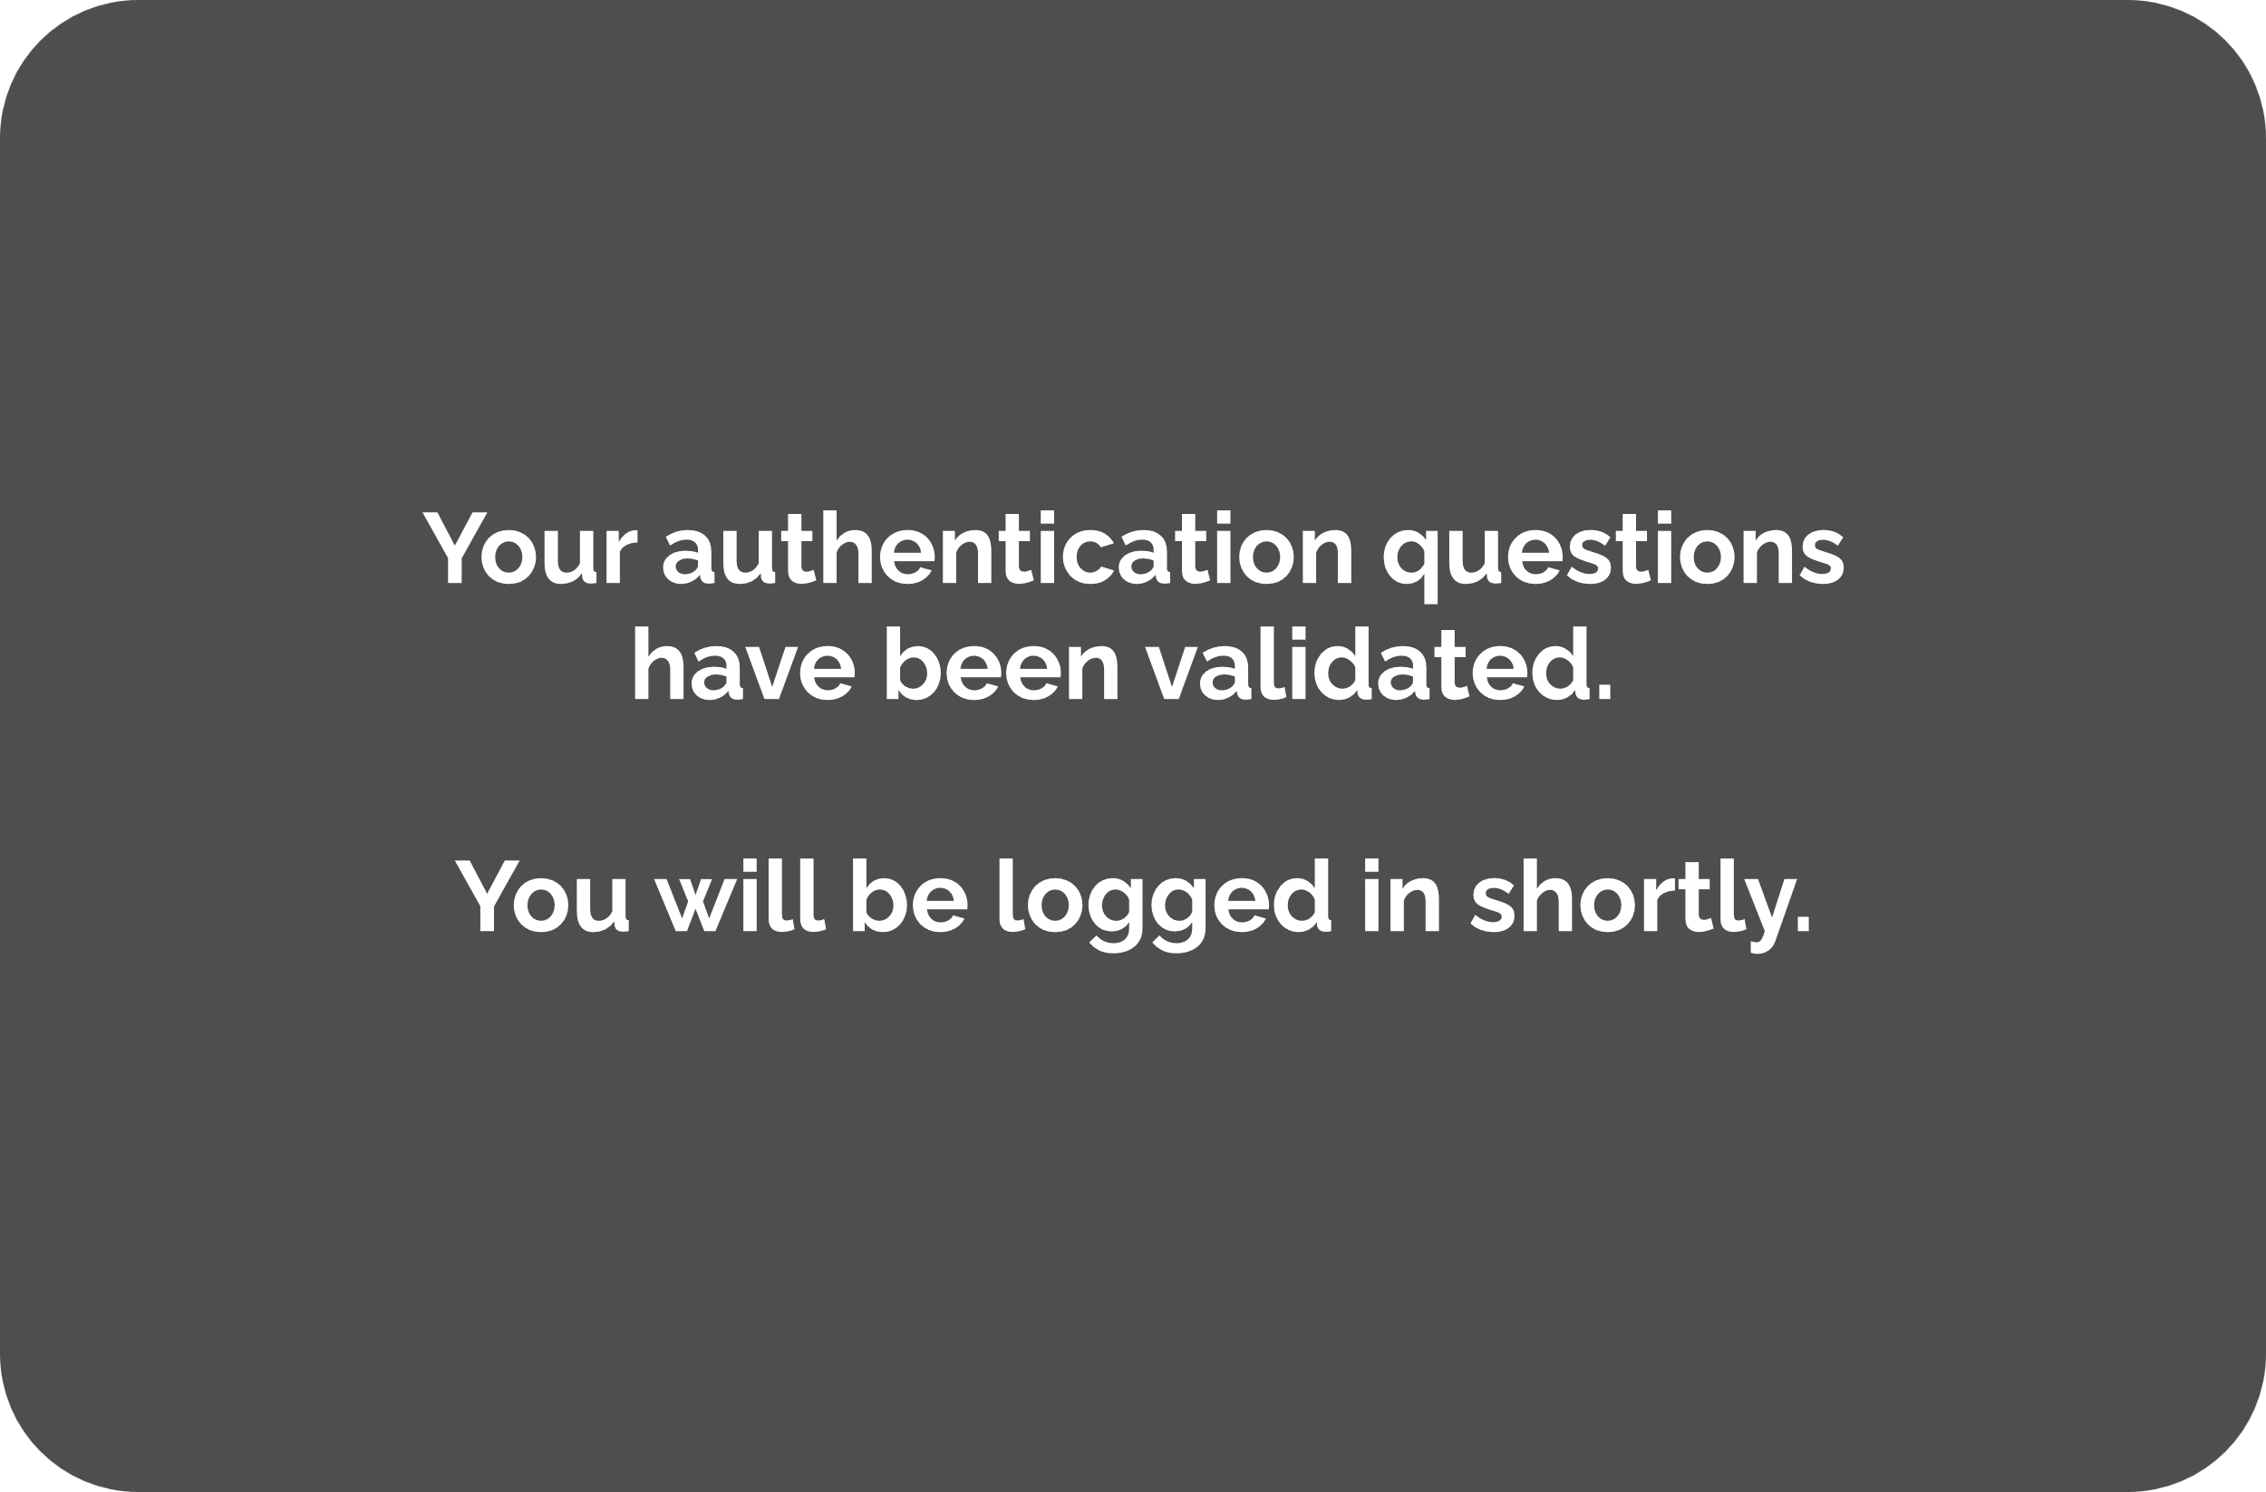

8. Reset Password User Form

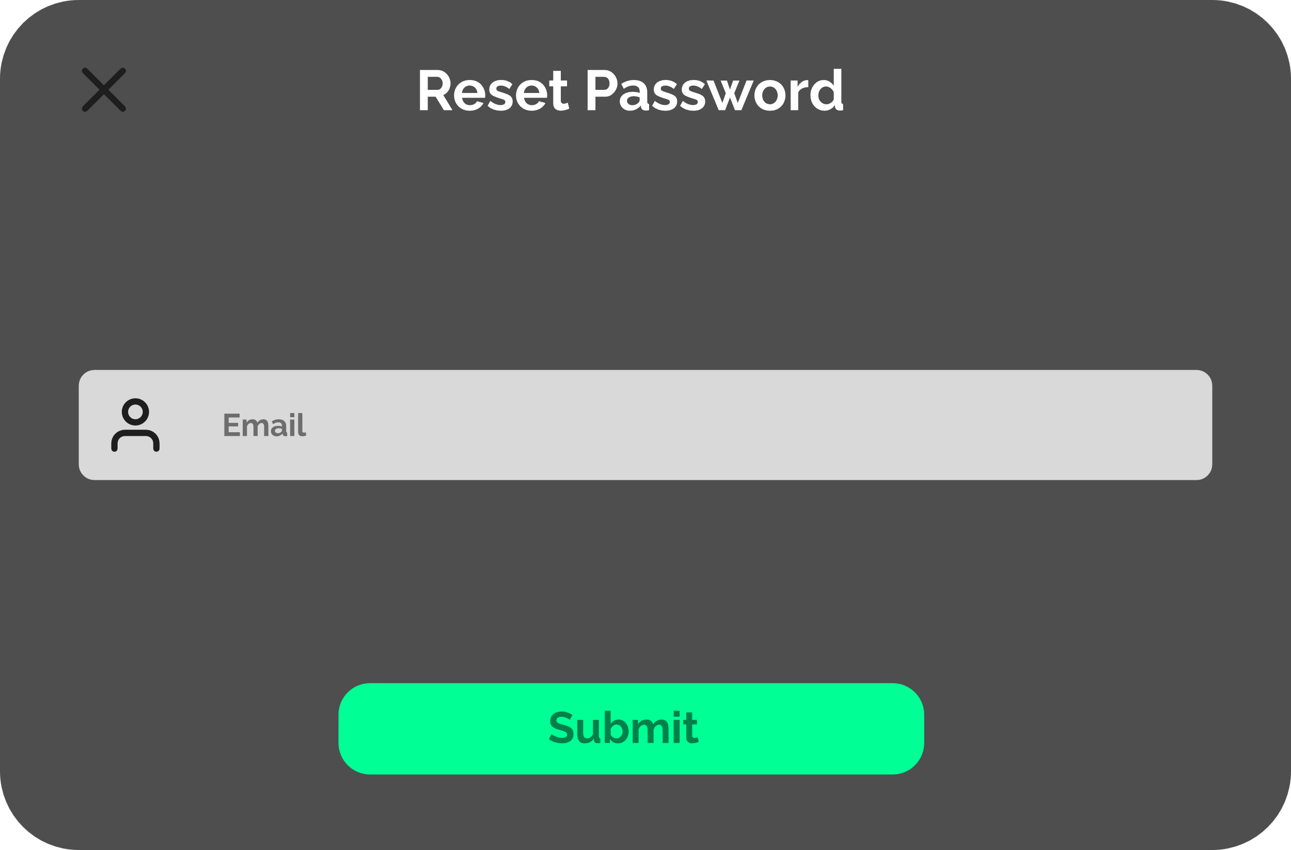

10. Reset Password Answer Form

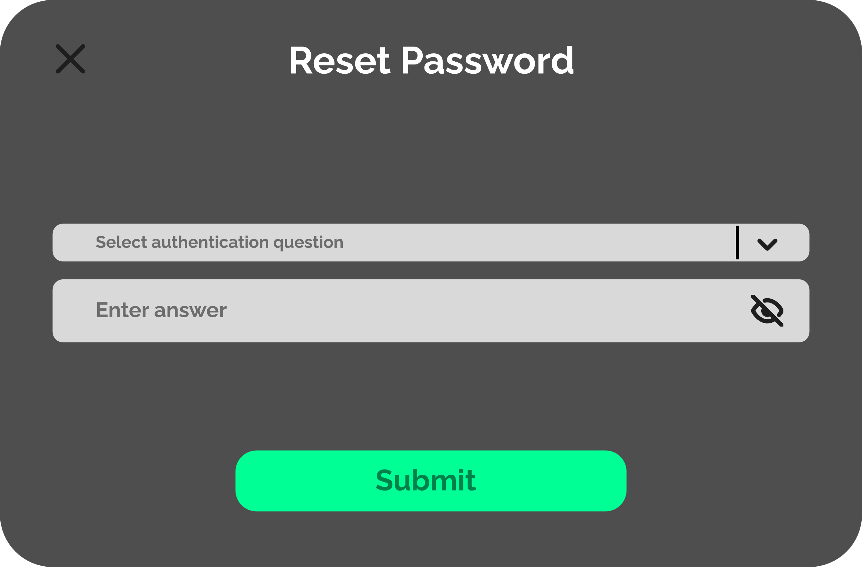

12. New Password Setup

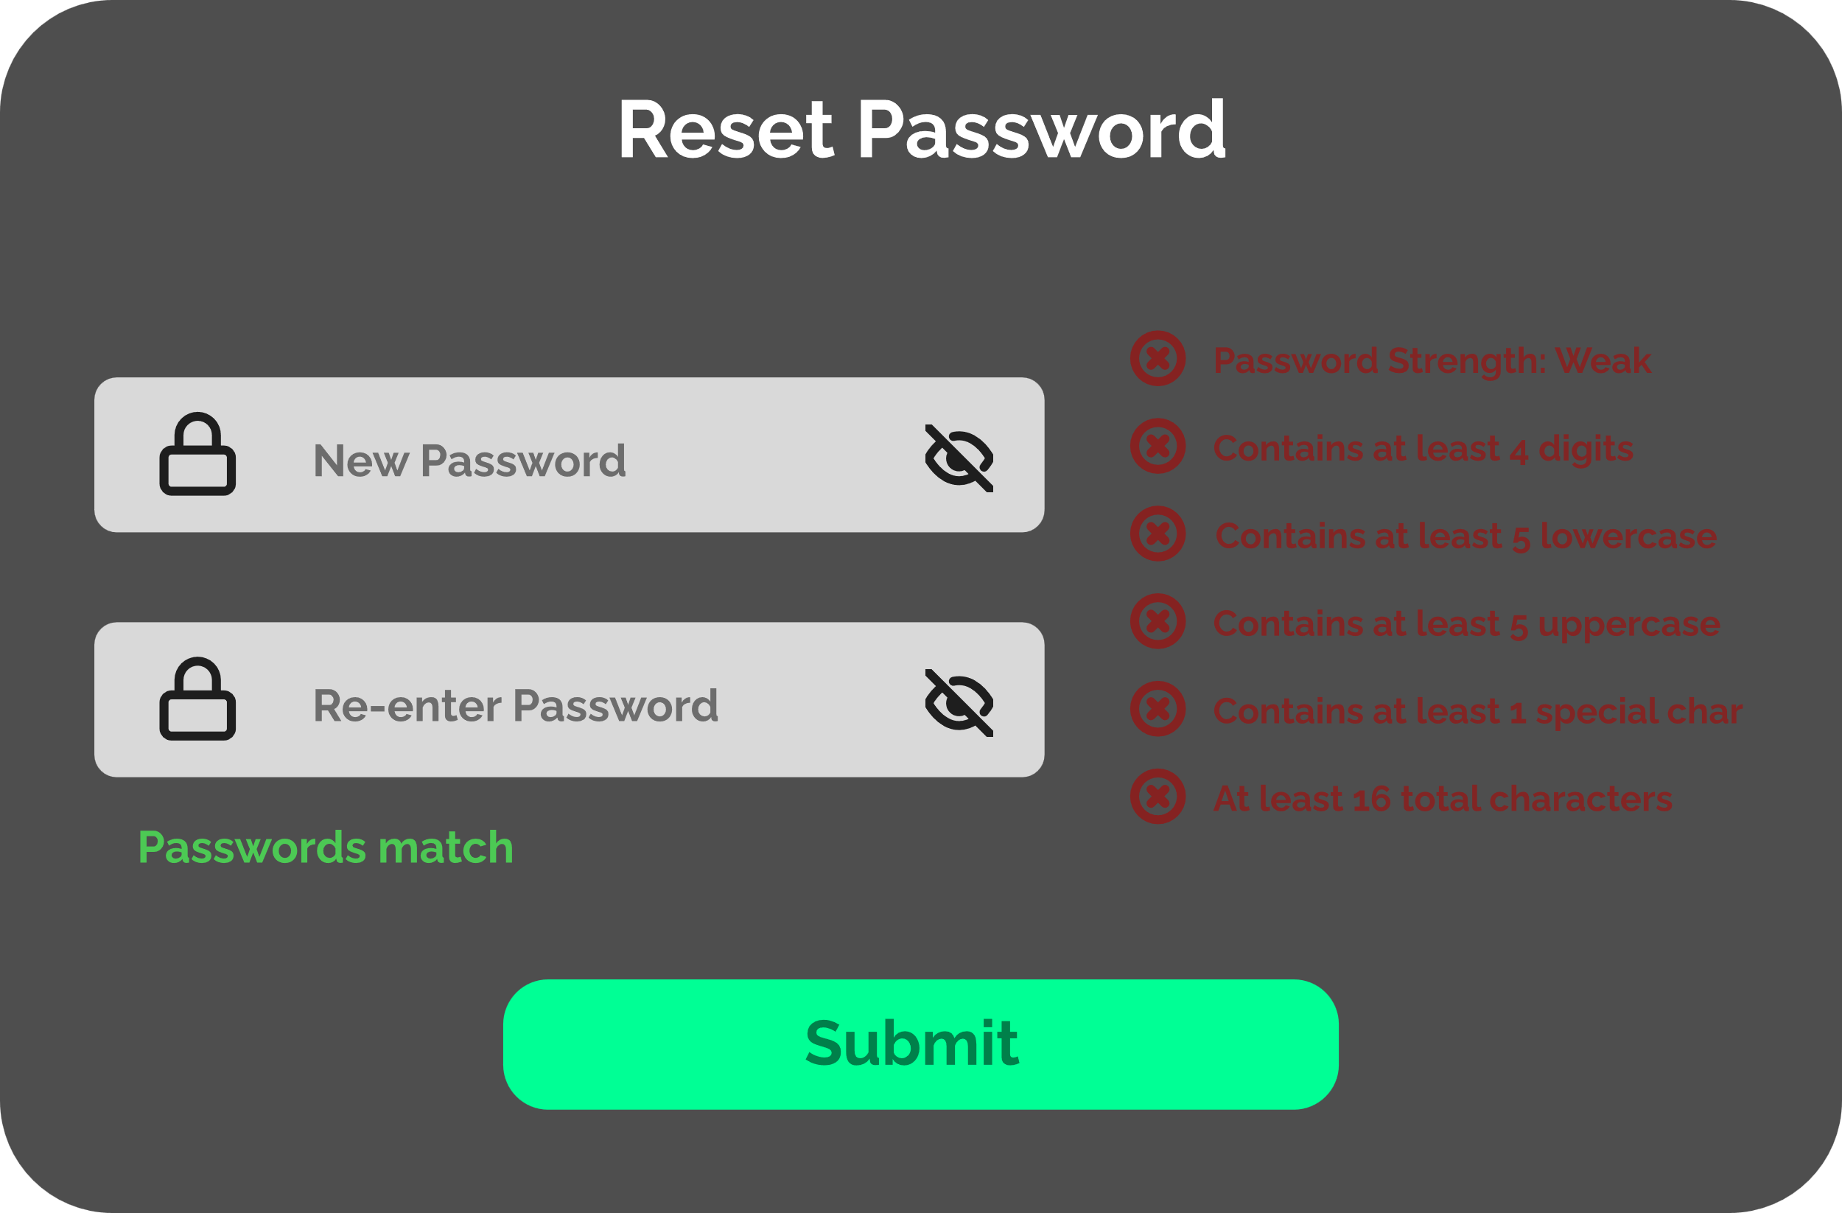

14. New Password Confirmation Message

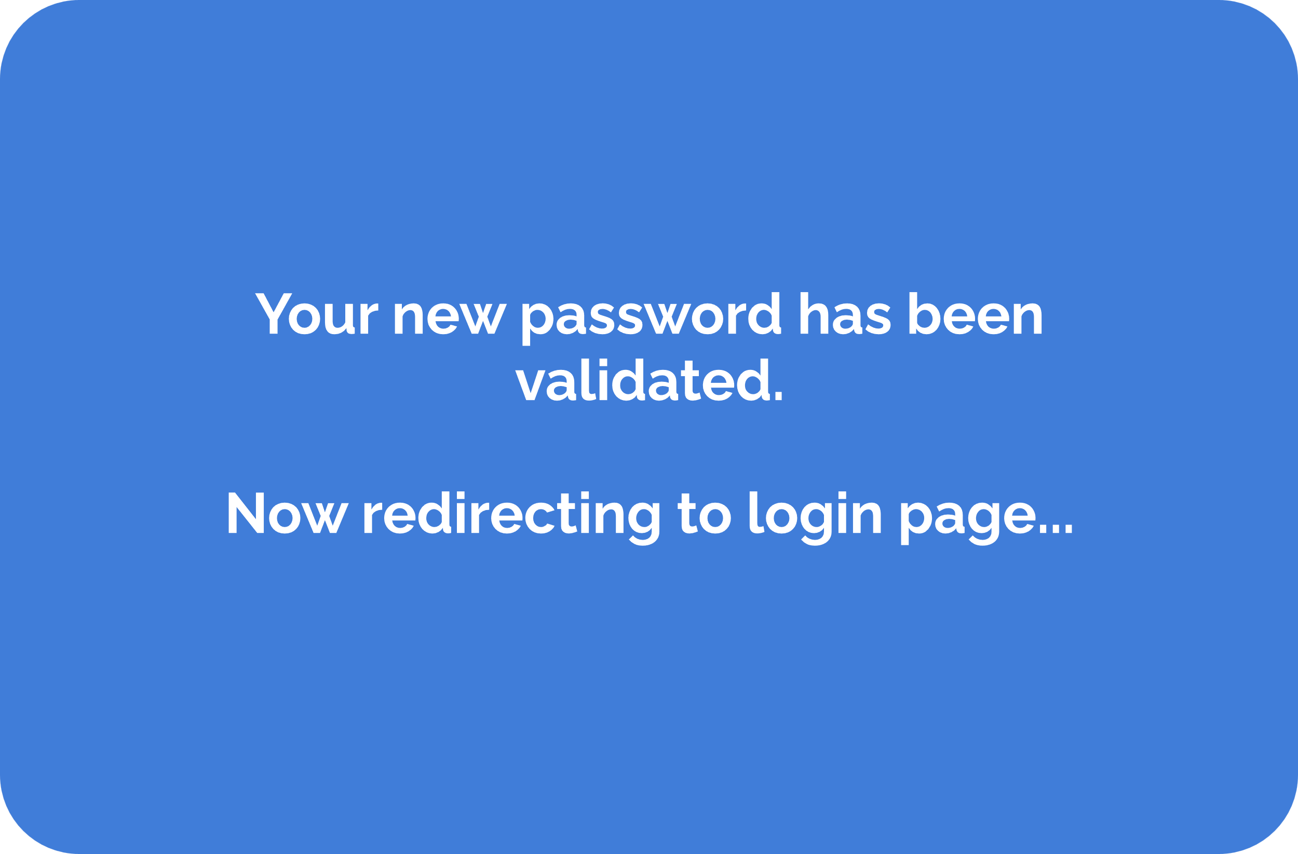

16. Login Confirmation Message



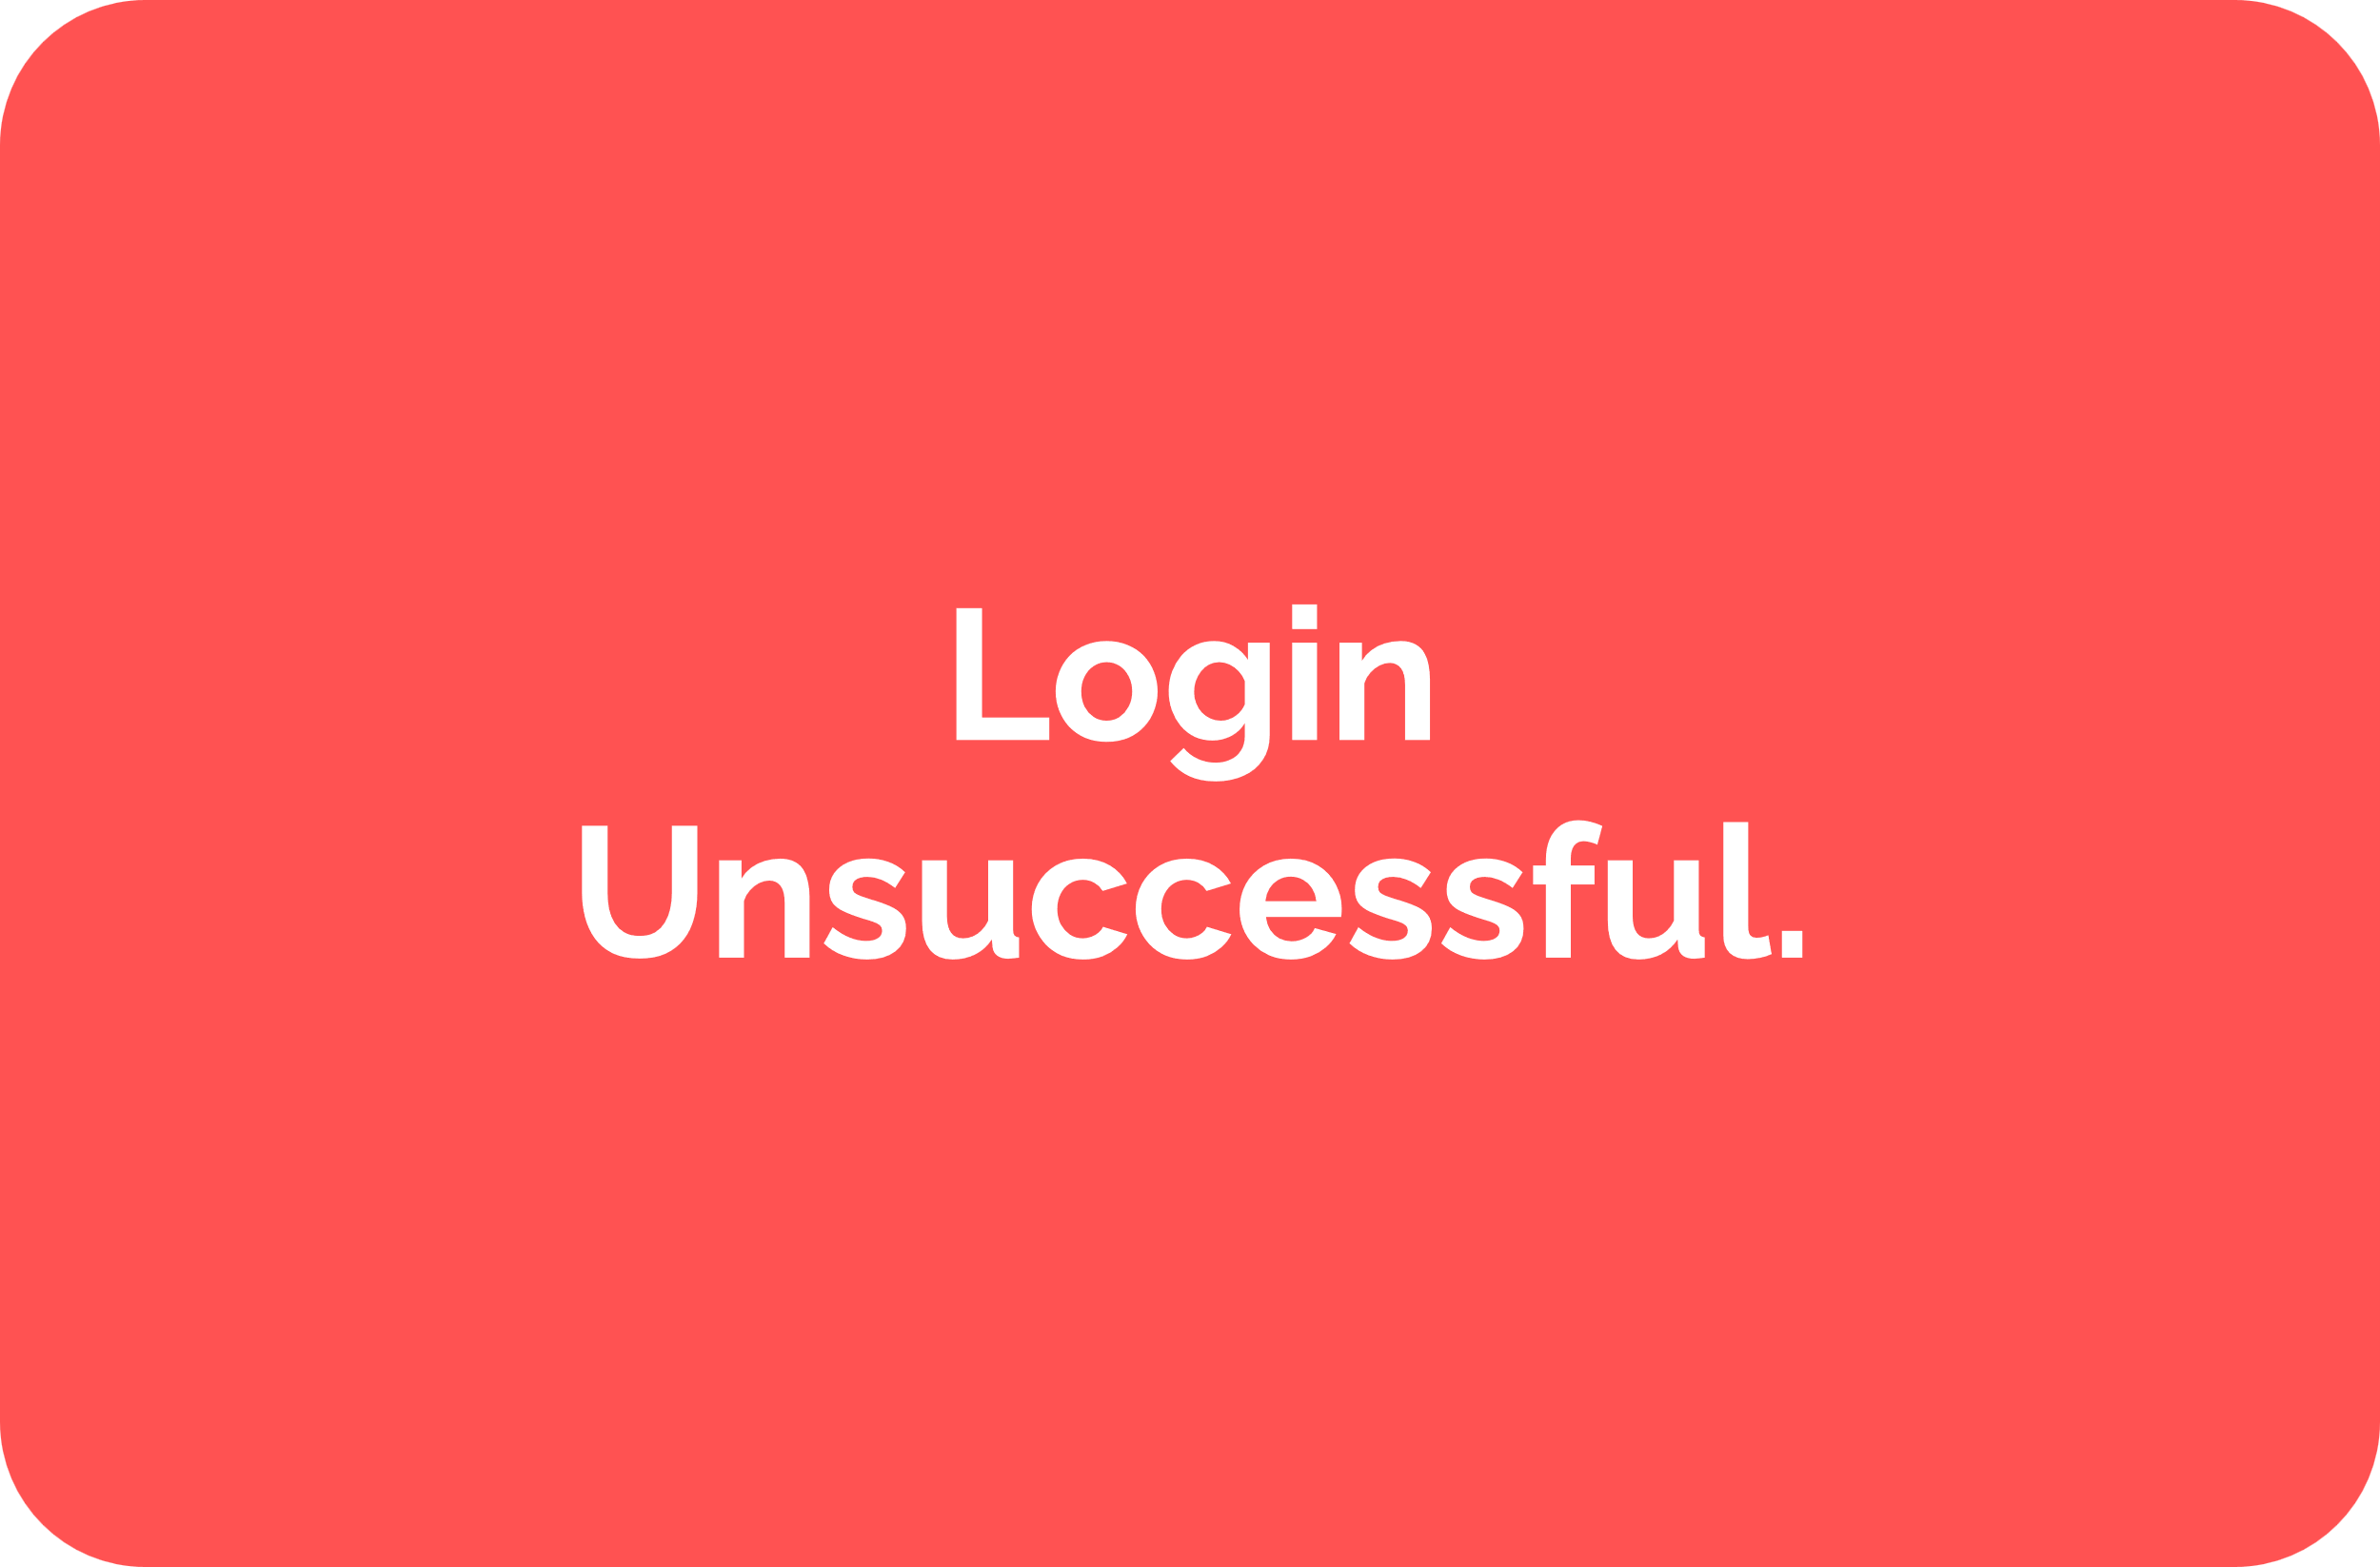

Interaction Behavior Model

