Brown University

March 2008

VoxGIS Software Documentation
J.L Mundy, Isabel Restrepo, Gamze Tunali

TABLE OF CONTENTS

- Introduction

- Auxiliary Libraries
  - Brown Relational Database: brdb
  - Brown Process Basics Library: bprb
  - Brown Statistics Library: bsta

- BVXM: Brown Voxel –something- Modeling Library
  - BVXM Basics
    - Memory Structure
    - Utility Classes
    - The voxel world
    - The appearance model processors
    - Multiscale
  - BVXM Pro
  - Using LIDAR information

- BVXM_BATCH

- Additional Information

- Version Control

- Introduction
This document describes in detail bvxm, Brown Volumentric Appereance Model library, and its dependency to existing VXL libraries.
- Auxiliary Libraries

- Brown Relational Database Library: brdb (vxl/contrib/brl/bbas/brdb)

The purpose of this library is to provide the necessary classes and the interface to generate an in memory SQL database, and to perform standard SQL operations.
One of the functionalities of the database is its ability to save itself. Therefore, any object that is stored in the database must implement VXL I/O streaming methods; vsl_b_write and vsl_b_read.
Class Diagram:

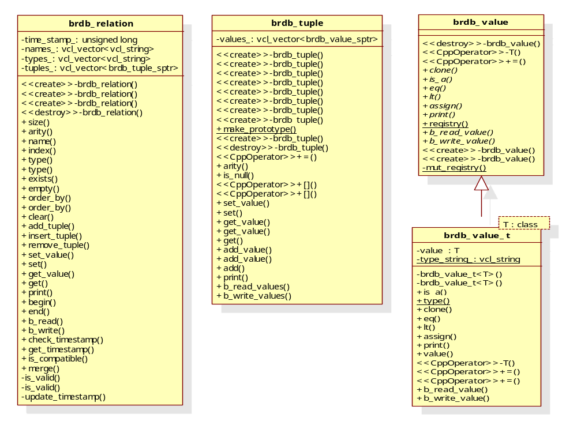
Figure 1. Database Objects; Relations, tuples and value
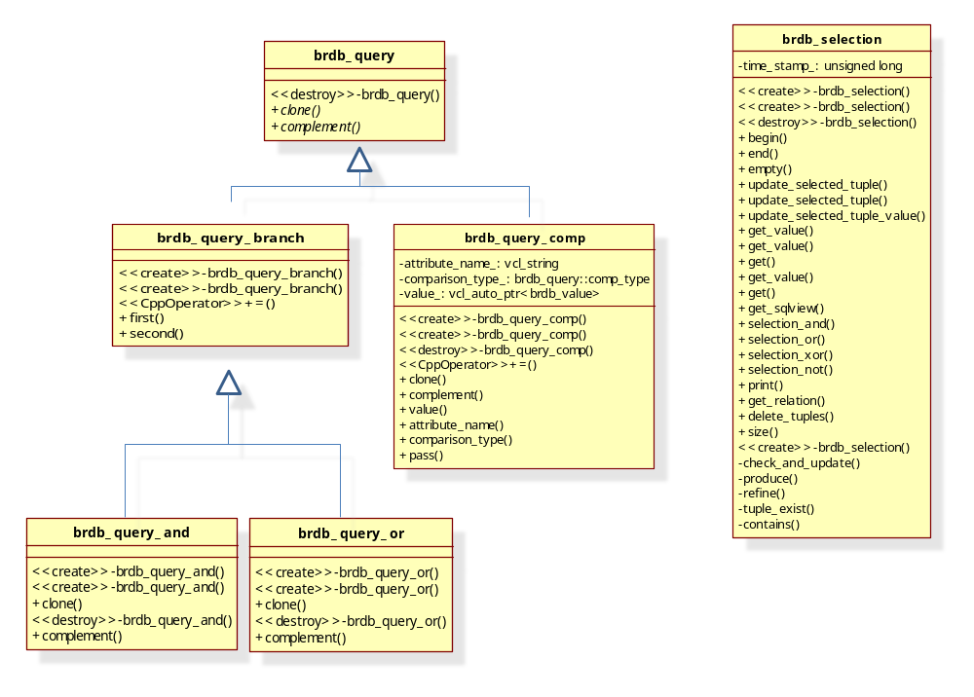
Figure 2: Data Manipulation Language (DML): Insert, select, update,
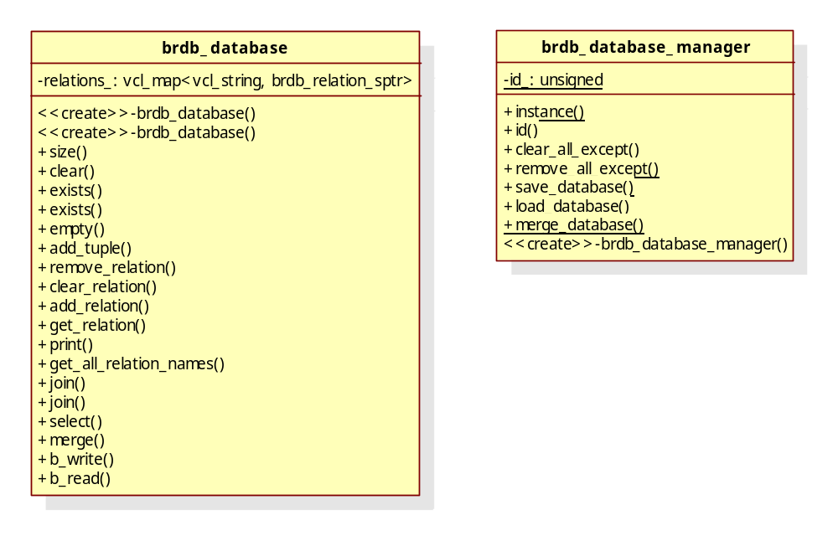
Figure 3. Data Definition Language (DDL): Create, save, load
- Brown Process Basics Library: brpb (vxl/contrib/brl/bpro/bprb)
Brown Process Basics library provides a framework to create and execute processes. bprb consists of :
- Two process managers:
  - bprb_process_manager
  - bprb_batch_process_manager
- A process
  - bprb_process
- Process parameters related classes
  - bprb_parameter
  - bprb_param
  - bprb_param_type
Class Diagram: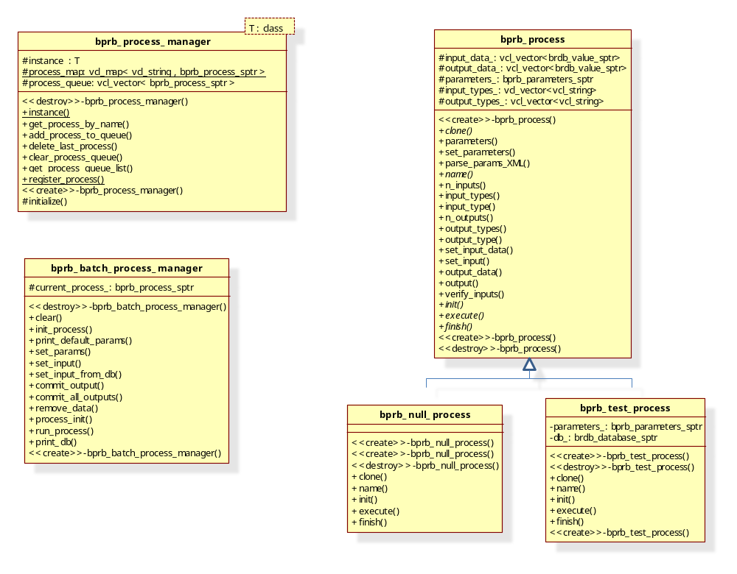
Figure 4 : bprb Process Managers Figure 5: bprb Processes
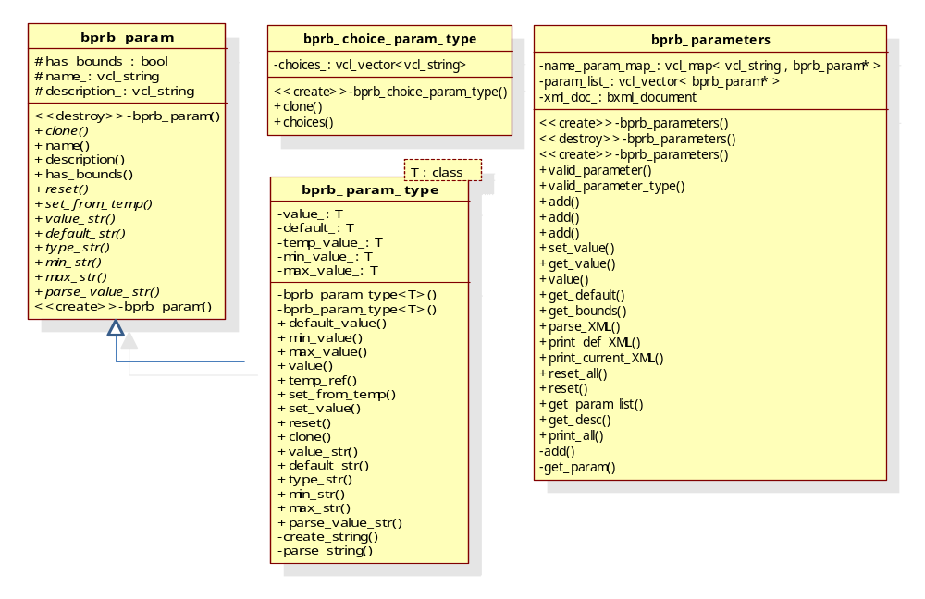
Figure 6: bprb Parameters Family

Detailed Description

- bprb_process: Is an abstract class that manages its inputs and outputs by an in-memory database library: brdb, which keeps smart pointers to the data that the process uses/produces. Also, a process receives parameters which are defined in an XML file. The default values for the parameters are defined in the constructor of the process; and the current values are parsed from the XML file using XML parsing library bxml. The XML format expected for the parameters is the following:

<?xml version="1.0" encoding="utf-8" ?>

<ProcessName>

<Param1 type=”type1” desc=”description of param1” value=”10.0”/>

<Param2 type=”type2” desc=”description of param2” value=”x”/>

</ProcessName>

In addition to methods to set and get inputs, output and parameters, the process class has three fundamental methods: init(), execute() and finish(). These methods are virtual and they are expected to be implemented by the inheriting classes of bprb_process. init() should do the necessary initializations before the process is executed. Finish() should do the clean up or final steps execution. The execute() method is the heart of the process where the main processing is done.
- prb_param: Is an abstract class that defines the parameter’s name, description and boundaries. It has methods to access and change those values.

- bprb_param_type: A templated class to accommodate any type of parameter. It inherits from bprb_param and defines value_, default_, temp_value_, min_value_ and max_value_ members. Other than getters and setters, it converts the values to string and parses them from string.

- bprb_choice_param_type: A parameter class for handling multiple choice parameters. It inherits from bprb_param_type<unsigned> and keeps a vector of strings as choices.

- bprb_parameters: Keeps a list of type of parameters as bprb_param pointers. Rapid access to these parameters is achieved by maintaining a map from parameter names to the parameters. It provides methods to add parameters, set and get their values, descriptions, defaults and currents. Using parse_XML, the parameters can also be set from a given XML file whose format was defined earlier. It also provides methods to write the parameters (default and current) to XML files (print_def_XML(…) and print_current_XML(…)) and to the output stream.

- Brown Statistics Library: bsta
This is a comprehensive and flexible library. It provides fundamental distributions and statistical methods. Most of its classes are templated, allowing probability distributions and methods to be as generic as possible. In VoxGIS software, this library is used to maintain the mixture of Gaussians appearance model. Since this library is far more extensive that what needs to be understood for VoxGIS software, only a brief description of its classes is presented below:
- bsta_gauss: 1-d and 2-d Gaussian smoothing for Parzen window calculations
- bsta_histogram: A simple histogram class. Supports entropy calculations
- bsta_joint_histogram: A simple joint_histogram class
- bsta_k_medoid: Form k clusters using distance to representative objects (medoids)
- bsta_otsu_threshold: Implements Otsu's threshold method for 1D distribution and 2 classes
- bsta_int_histogram_1d: 1D integer Histograms with bucket width = 1
- bsta_int_histogram_2d: 1D and 2D integer Histograms with bucket width = 1
- bsta_distribution: A base class for probability distributions
- bsta_gaussian : A Gaussian distribution for use in a mixture model
- bsta_gaussian_full: A Gaussian distribution with a full covariance matrix
- bsta_gaussian_indep: A Gaussian distribution, independent in each dimension
- bsta_gaussian_sphere: A (hyper-)spherical Gaussian distribution (i.e. single variance)
- bsta_mixture: A mixture of distributions
- bsta_mixture_fixed: A mixture of distributions of fixed size
- bsta_basic_functors:
- bsta_prob_density_functor: A functor to return the probability density at a sample
- bsta_probability_functor: A functor to return the probability integrated over a box
- bsta_mean_functor: A functor to return the mean of the Gaussian
- bsta_var_functor: A functor to return the variance of the Gaussian
- bsta_diag_covar_functor: A functor to return the variance of the Gaussian
- bsta_det_covar_functor: A functor to return the determinant of the covariance of the Gaussian
- bsta_weight_functor: A functor to return the weight of the component with given index
- bsta_mixture_functor: A functor to apply another functor to one distribution in the mixture
- bsta_mixture_data_functor: A functor to apply another functor with data to one distribution in the mixture
- bsta_weighted_sum_functor: A functor to apply another functor to each distribution and produce a weighted sum
- bsta_weighted_sum_data_functor: A functor to apply another functor with data to each distribution and produce a weighted sum
- bsta_mixture_size_functor: A functor to count the number of components in the mixture
- bsta_detector_gaussian: Designed to include detectors applying to Gaussians. Currently it has one detector: bsta_g_mdist_detector, a simple Mahalanobis distance detector for a Gaussian
- bsta_detector_mixture: Designed to include detectors applying to mixtures. Currently it has two detectors:
- bsta_top_weight_detector: applies a detector to each component in order while the total weight is below a threshold
- bsta_mix_any_less_index_detector: applies a detector to each component in order while the total weight is below a threshold

- BVXM: Brown Voxel -something- Modeling Library

Library architecture:

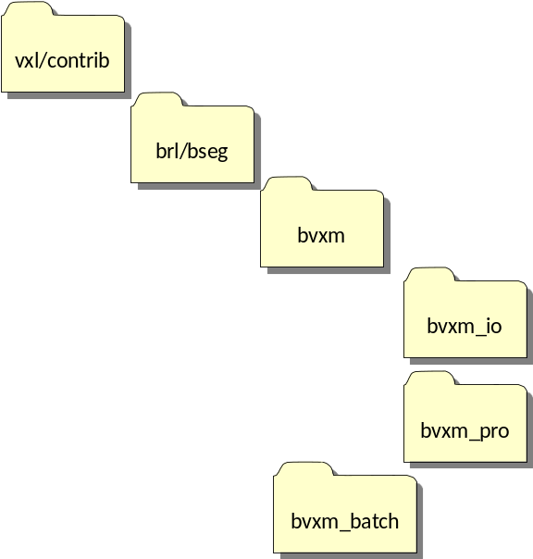

Figure 7: bvxm library architecture

- bvxm: This library contains basic classes to support volumetric data structures, processors and memory management.
  - bvxm/io: A library of classes managing I/O parsing of any bvxm_parameter or I/O of any bvxm class that needs to be stored in the database.
  - bvxm/pro: A library of processes to be applied to bvxm structures.

- BVXM Basics:

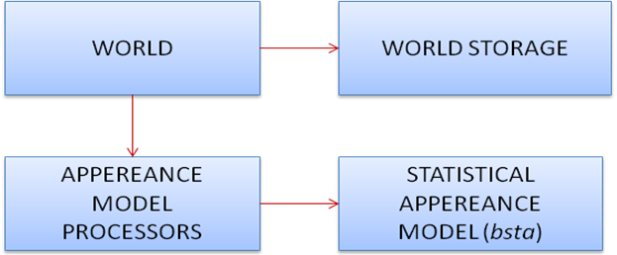

Figure 8: BVXM Basics architecture diagram

World Storage: A memory family
- bvxm_memory_chunk: Block of data on the heap. It inherits from vbl_ref_count to keep a count of its references.
- bvxm_voxel_slab: A 3-D slab of data of any type, with data stored on the heap (via an associated bvxm_memory_chunk. This class is a generic template class that provides access to the data through bvxm_voxel_slab_iterator<T> and “()” operators.
- bvxm_voxel_grid: A 3-D container for voxel data of generic type T. A voxel grid is meant to store an entire voxel grid, giving access to chunks via objects of type bvxm_voxel_slab<T>.
- bvxm_voxel_storage: An abstract class for storing and providing access to voxel data.
- bvxm_voxel_storage_disk: Stores voxel data in a single file on disk, this file remains opened until the storage object goes out of scope.
- bvxm_voxel_storage_mem: Stores the voxel data on the heap. Basically, this class is a wrapper around a bvxm_memory_chunck
Class Diagram 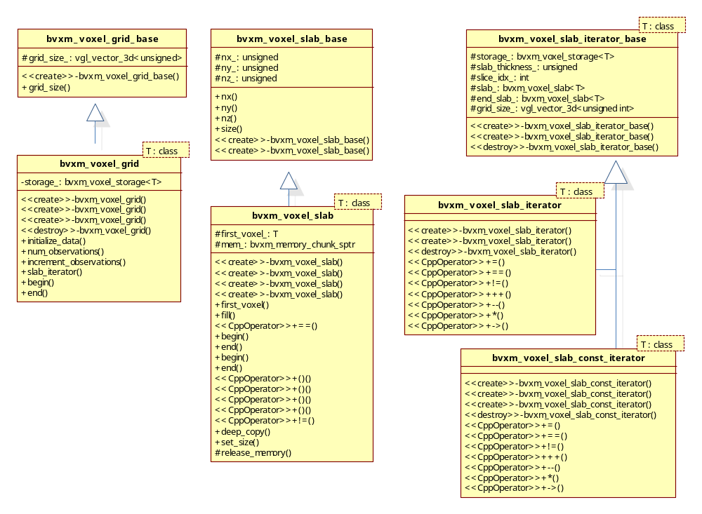
Figure 9: High-level bvxm storage
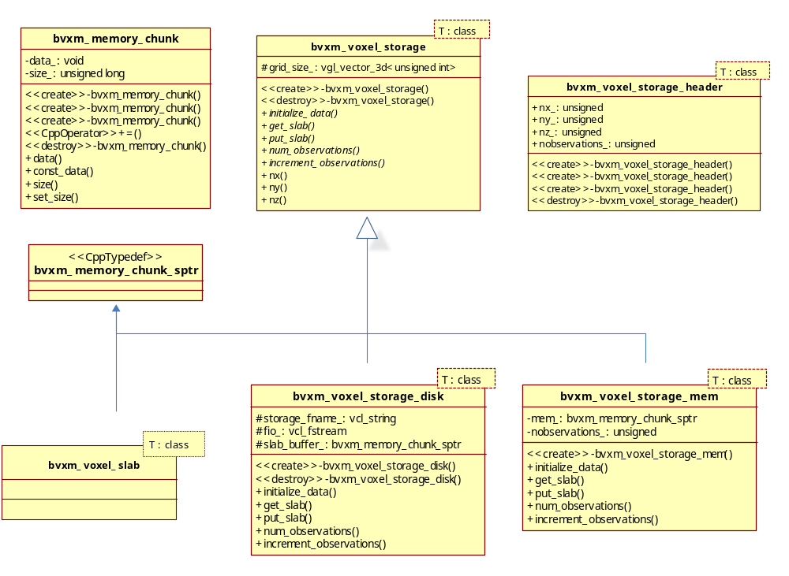
Figure 10: Low-level bvxm memory management

Important Classes used by bvxm_voxel_world

Before describing the voxel world, it is important to understand the main classes that bvxm_world uses to obtain parameters, data and data types
- The World Parameters: bvxm_world_params.h
This class contains all the parameters necessary for the generation of bvxm_voxel_world.

Class Diagram
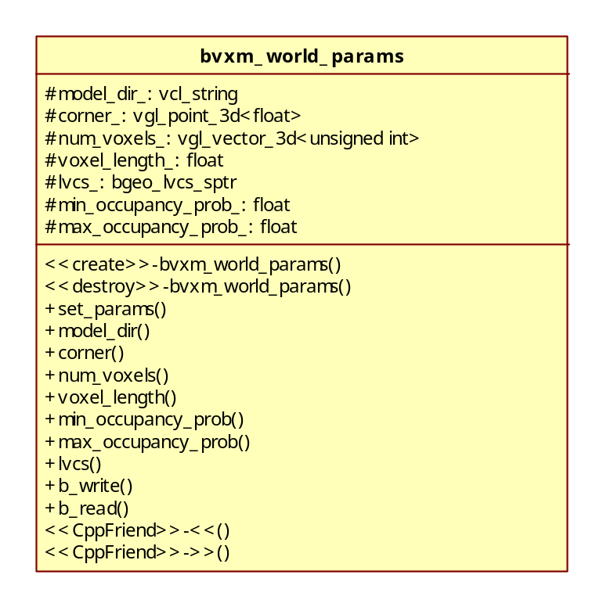
Figure 11: bvxm_world_params class

Detailed Description:
- model_dir_: The directory where the model data, like images, resides. This directory is also used for temporary and output data.
- corner_: The coordinates of the corner (minimum point) of the voxel world in local coordinate system.
- num_voxels_: Number of voxel in x, y and z directions
- voxel_length_ : the dimensions of voxel in meters (uniform in each direction, x, y, and z)
- lvcs_: the local vertical coordinate system that ties the voxel world positioning and measurements to the geographical coordinate system (please refer to the section on bgeo_lvcs)
- min_occupancy_probability_: lower boundary of the occupancy probabilities, the lower values than this will always be adjusted to accommodate this value
- max_occupancy_probability_: upper boundary of the occupancy probabilities, the higher values than this will always be adjusted to accommodate this value

The following diagram illustrates the voxel world that is defined by the world parameters:
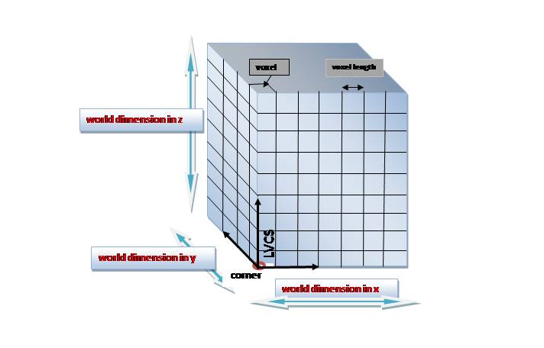
Figure 12: Voxel World

Pixel Traits: bvxm_pixel_traits.h

This class contains important definitions that are unique to each voxel type. The first structure found in this class, enumerates the supported voxel types that can be stored in a voxel grid. This structure is shown below:

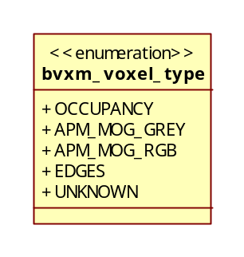
Figure 13: Voxel type enum

Following the voxel type definition, the class bvxm_voxel_traits is declared and implemented. bvxm_voxel_traits is templated over bvxm_voxel_type. Each specialization of this class contains appropriate data type definitions that are specific to a given bvxm_voxel_type e.g float, mixture of Gaussians.
The following piece of code shows bvxm_voxel_traits and some of its specializations.
//: Pixel properties for templates.
template <bvxm_voxel_type>
class bvxm_voxel_traits;

template<>
class bvxm_voxel_traits<OCCUPANCY>
{
public:
//:Datatype of the occupancy probabilities
typedef float voxel_datatype;

static inline vcl_string filename_prefix(){ return "ocp"; }
static inline bool is_multibin() { return false; }
static inline voxel_datatype initial_val() { return 0.01f; }

};

template<>
class bvxm_voxel_traits<APM_MOG_RGB>
{
public:
//:Datatype of the occupancy probabilities
typedef bvxm_mog_rgb_processor appearance_processor;
typedef bvxm_mog_rgb_processor::apm_datatype voxel_datatype;
typedef bvxm_mog_rgb_processor::obs_datatype obs_datatype;
typedef bvxm_mog_rgb_processor::obs_mathtype obs_mathtype;

static inline vcl_string filename_prefix(){ return "apm_mog_rgb"; }
static inline bool is_multibin() { return true; }
static inline voxel_datatype initial_val()
{
voxel_datatype init_val;
return init_val;
}

};
…

- BVXM utilities: bvxm_util.h

When operating on the world, it is necessary to perform different types of operations on slabs and images. bvxm_util.h provides such methods.

Class Diagram
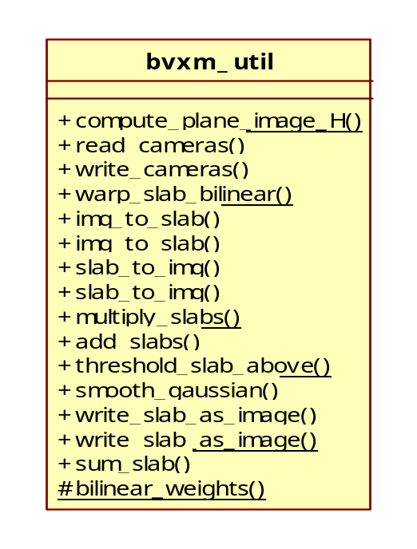
Figure 14: bvxm_util class

Detailed Description;
- compute_plane_image_H: Computes homographies from voxel planes to image coordinates and vice-versa.
- read_cameras: Reads vpgl_cameras from a file.
- write_cameras: Writes vpgl_cameras to a file.
- warp_slab_bilinear: Backprojects the image onto a voxel plane given the plane-image homography. The warping is computed using bilinear interpolation.
- image_to_slab, slab_to_image: Convert images to slabs and vice-versa. This class is template over the dimension of the data. Currently gray scale and color are supported but extension to any other dimension should be trivial.
- multiply_slabs: Multiplies two given slabs
- smooth_gaussian: Applies a Gaussian smoothing.
- write_slab_as_image: Saves a slab in an image file, mainly used for debugging purposes
- sum_slab: Adds the elements of a slab.

The World: bvxm_voxel_world

bvxm_voxel_world is probably the most important class of voxGIS software. It has been implemented to be flexible, dynamic and efficient. bvxm_voxel_world can simultaneously maintain different types of voxel grids i.e. a mixture of Gaussian appearance model grid, a floating point occupancy grid or a grid containing edge information. It also provides the functions that operate on the grids i.e. update, obtain expected image, detect changes etcetera.

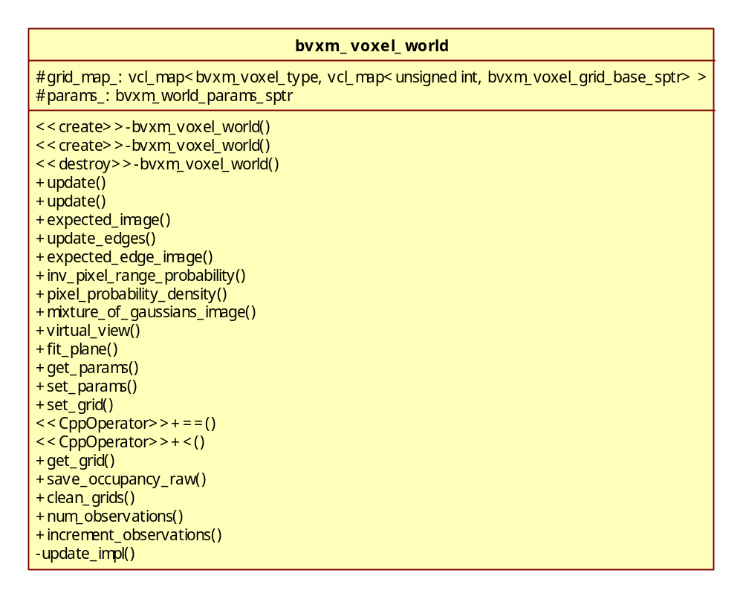
Figure 15: bvxm_voxel_world class

Detailed Description:

Constructor & Destructor Documentation

bvxm_voxel_world::bvxm_voxel_world ()

bvxm_voxel_world::bvxm_voxel_world (bvxm_world_params_sptr params): Construct a voxel world give a set of parameters.

bvxm_voxel_world::~bvxm_voxel_world ()

Member Variables Documentation:
- The Grid Map:
vcl_map<bvxm_voxel_type, vcl_map<unsigned int, vcl_map<unsigned int, bvxm_voxel_grid_base_sptr> > > grid_map;

The voxel world can hold different types of grids at the same time. These grids are kept in a vcl_map where the key of the map must be one of the following bvxm_voxel_type :

enum bvxm_voxel_type
{
OCCUPANCY = 0,
APM_MOG_GREY,
APM_MOG_RGB,
EDGES,
UNKNOWN,
};

The entry corresponding to each key is another vcl_map containng one or more bvxm_voxel_grid_sptr, each stored at a different bin i.e. if each bin contains a mixture of gaussian, the result is a multiple mixture of Gaussians model.
Any entry of the local map, is created the first time the user requestes it via the member function get_grid. This function is templeted over bvxm_voxel_type and it needs a bin numer (default 0) to acces the appropiate voxel grid.

//: Returns the voxel_grid that corresponds to a given bvxm_voxel_type and a bin number
template<bvxm_voxel_type VOX_T>
bvxm_voxel_grid_base_sptr bvxm_voxel_world::get_grid(unsigned bin_index)
{
//retrieve map for current bvxm_voxel_type
//if no map found create a new one
if (grid_map_.find(VOX_T) == grid_map_.end())
{
//create map
vcl_map<unsigned, bvxm_voxel_grid_base_sptr> bin_map;

// look for existing appearance model grids in the directory
vgl_vector_3d<unsigned int> grid_size = params_->num_voxels();
vcl_string storage_directory = params_->model_dir();

vcl_stringstream grid_glob;
vcl_string fname_prefix = bvxm_voxel_traits<VOX_T>::filename_prefix();
grid_glob << storage_directory << "/" << fname_prefix << "*.vox";

//insert grids
for (vul_file_iterator file_it = grid_glob.str().c_str(); file_it; ++file_it) {
vcl_string match_str = file_it.filename();
unsigned idx_start = match_str.find_last_of('_') + 1;
unsigned idx_end = match_str.find(".vox");
vcl_stringstream idx_str;
idx_str << match_str.substr(idx_start,idx_end - idx_start);
int idx = -1;
idx_str >> idx;
if (idx < 0) {
vcl_cerr << "error parsing filename " << file_it() << vcl_endl;
} else {
// create voxel grid and insert into map
bvxm_voxel_grid_base_sptr grid =
new bvxm_voxel_grid<bvxm_voxel_traits<VOX_T>::voxel_datatype>(file_it(),grid_size);
bin_map.insert(vcl_make_pair((unsigned)idx, grid));
}
}

grid_map_.insert(vcl_make_pair(VOX_T, bin_map));
}

//retrieve map containing voxel_grid
vcl_map<unsigned, bvxm_voxel_grid_base_sptr> voxel_map = grid_map_[VOX_T];

//retrieve voxel_grid for current bin
//if no grid exists at bin location create one filled with default values
if (voxel_map.find(bin_index) == voxel_map.end())
{
vgl_vector_3d<unsigned int> grid_size = params_->num_voxels();
vcl_string storage_directory = params_->model_dir();

vcl_stringstream apm_fname;
vcl_string fname_prefix = bvxm_voxel_traits<VOX_T>::filename_prefix();
apm_fname << storage_directory << "/" << fname_prefix << "_" << bin_index << ".vox";

typedef bvxm_voxel_traits<VOX_T>::voxel_datatype voxel_datatype;
bvxm_voxel_grid<voxel_datatype> *grid =
new bvxm_voxel_grid<voxel_datatype>(apm_fname.str(),grid_size);

// fill grid with default value
if (!grid->initialize_data(bvxm_voxel_traits<VOX_T>::initial_val())){
vcl_cerr << "error initializing voxel grid" << vcl_endl;
return bvxm_voxel_grid_base_sptr(0);
}

//Insert voxel grid into map
bvxm_voxel_grid_base_sptr grid_sptr = grid;
grid_map_[VOX_T].insert(vcl_make_pair(bin_index, grid_sptr));
}

return grid_map_[VOX_T][bin_index];

}

Member Function Documentation:

An example: pixel_probability_density

Many functions of the voxel_world are templated over the type of appearance model i.e. mixture of Gaussians grey scale, APM_MOG_GREY, or mixture of Gaussians color, APM_MOG_RGB. This makes the code generic and easy to expand to future appearance models. The following example illustrates this generic behavior.

template<bvxm_voxel_type APM_T>
bool bvxm_voxel_world::pixel_probability_density (bvxm_image_metadata const & observation, vil_image_view< float > & pixel_probability, unsigned bin_index = 0)
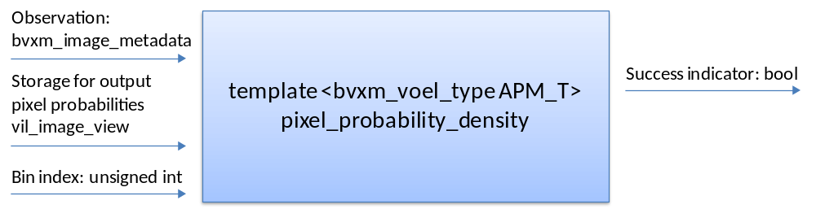

Figure 16: An example of member function of the bvxm_voxel_world

template<bvxm_voxel_type APM_T>
bool bvxm_voxel_world::pixel_probability_density(bvxm_image_metadata const& observation,
vil_image_view<float> &pixel_probability, unsigned bin_index)
{
// datatype for current appearance model
typedef bvxm_voxel_traits<APM_T>::voxel_datatype apm_datatype;
typedef bvxm_voxel_traits<OCCUPANCY>::voxel_datatype ocp_datatype;
typedef bvxm_voxel_traits<APM_T>::obs_datatype obs_datatype;

// the appearance model processor
bvxm_voxel_traits<APM_T>::appearance_processor apm_processor;

// check image sizes
…
if ( (observation.img->ni() != pixel_probability.ni()) || (observation.img->nj() != pixel_probability.nj()) ) {
vcl_cerr << "error: observation image size does not match input image size. " << vcl_endl;
}

vgl_vector_3d<unsigned int> grid_size = params_->num_voxels();
ocp_datatype min_vox_prob = params_->min_occupancy_prob();
ocp_datatype max_vox_prob = params_->max_occupancy_prob();

// compute homographies from voxel planes to image coordinates and vise-versa.
vcl_vector<vgl_h_matrix_2d<double> > H_plane_to_img;
vcl_vector<vgl_h_matrix_2d<double> > H_img_to_plane;
{
vgl_h_matrix_2d<double> Hp2i, Hi2p;
for (unsigned z=0; z < (unsigned)grid_size.z(); ++z)
{
bvxm_util::compute_plane_image_H(observation.camera,params_,z,Hp2i,Hi2p);
H_plane_to_img.push_back(Hp2i);
H_img_to_plane.push_back(Hi2p);
}
}

// convert image to a voxel_slab
bvxm_voxel_slab<obs_datatype> image_slab(observation.img->ni(), observation.img->nj(), 1);
bvxm_util::img_to_slab(observation.img,image_slab);

...

// slabs for holding backprojections of visX
bvxm_voxel_slab<float> visX(grid_size.x(),grid_size.y(),1);

bvxm_voxel_slab<obs_datatype> frame_backproj(grid_size.x(),grid_size.y(),1);

// Pass 1: Get the color probabilities and compute total color and
// weight probabilities.
...

//get appereance model grid
bvxm_voxel_grid_base_sptr apm_grid_base = this->get_grid<APM_T>(bin_index);
bvxm_voxel_grid<apm_datatype> *apm_grid = static_cast<bvxm_voxel_grid<apm_datatype>*>(apm_grid_base.ptr());

bvxm_voxel_grid<ocp_datatype>::const_iterator ocp_slab_it = ocp_grid->begin();
bvxm_voxel_grid<apm_datatype>::iterator apm_slab_it = apm_grid->begin();

for (unsigned z=0; z<(unsigned)grid_size.z(); ++z, ++ocp_slab_it, ++apm_slab_it)
{
vcl_cout << ".";

if ( (ocp_slab_it == ocp_grid->end()) || (apm_slab_it == apm_grid->end()) ) {
vcl_cerr << "error: reached end of grid slabs at z = " << z << ". nz = " << grid_size.z() << vcl_endl;
return false;
}

// backproject image onto voxel plane
bvxm_util::warp_slab_bilinear(image_slab, H_plane_to_img[z], frame_backproj);

...

// calculate PI(X)
bvxm_voxel_slab<float> PI = apm_processor.prob_density(*apm_slab_it, frame_backproj);

...

// warp PIPX back to image domain
bvxm_util::warp_slab_bilinear(PIPX, H_img_to_plane[z], PIPX_img);

...

// fill pixel_probabilities with preX_accum
vil_image_view<float>::iterator pix_prob_it = pixel_probability.begin();
bvxm_voxel_slab<float>::const_iterator preX_accum_it = preX_accum.begin();
for(; pix_prob_it != pixel_probability.end(); ++pix_prob_it, ++preX_accum_it) {
*pix_prob_it = *preX_accum_it;
}

return true;
}

The Update Functions:

There are several updating functions contained in the voxel world. These functions are used to update the occupancy probability, as well as, the appearance model of the voxel world based on the information provided by spectral images, LIDAR information or edges.

The updating principle:

An accurate discussion of updating equations of the voxel world can be found in Thomas Pollard and Joseph L. Mundy. Change detection in a 3-d world. In CVPR, 2007.

The occupancy probability of the voxel world is based on Bayes rule and it is given by

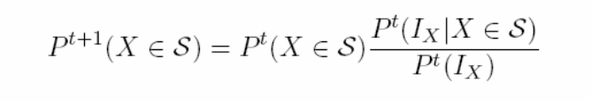
Equation 1

Where the term multiplying 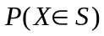 becomes:

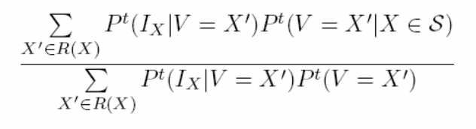
Equation 2

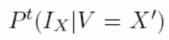 is computed by the appearance model processors explained in the following section.

In the case of LIDAR, the updating principle is very similar. However, no information is provided about the appearance of the world by the LIDAR images. Only the occupancy grid is updated whenever LIDAR is passed to the voxel world. LIDAR information is treated as it was an ‘image” where bvxm_lidar_processor is in charge of providing correct updated probability values. A more extensive explanation of the equations used to update the world with LIDAR is presented in the Section iii) under: Using Lidar.

Other Member Functions:
- update: This function is templated over appearance model type. It updates each voxel’s Gaussian mixture and surface probability values with data from an image-camera pair.
- update_lidar: Updates the occupancy grid with data from a LIDAR-camera pair.
- update_edges: Updates the EDGE-type voxel grid with data from image/camera pair and return the edge probability density of pixel values.
- expected_image: Calculates an expected image of the world from given viewing and illumination directions.
- expected_edge_image: Calculate the expected image of a world containing an EDGE voxel grid
- inv_pixel_range_probability: Returns the probability that the observed pixels were not produced by a voxel in the grid.
- pixel_probability_density: Sum along the corresponding ray of voxels that the observation was produced by the voxel. This is based on algorithm published in Pollard + Mundy 06. The returned values are approximate samples of a probability density, with the pixel values being the independent value.
- mixture_of_gaussians_image: Generates the mixture of Gaussians slab from the specified viewpoint. The slab should be allocated by the caller.
- virtual_view: Produces a view of a video frame from a given viewpoint. Used for 3-D registration
- fit_plane: Returns a planar approximation of the world.
- get_params: Sets the world parameters equal to the given input.
- set_params: Returns the world’s parameters.
- set_grid: Sets voxel grid equal to the given input.
- get_grid: Returns the voxel grid
- save_occupancy_raw: Saves the occupancy grid in a ".raw" format readable by Drishti volume rendering software.
- clean_grids: Removes al voxel data from disk
- num_observations: Gets the observation count of a voxel type at a specific bin
- increment_observations: Increments the observation count of a voxel type at a specific bin
The Appearance Model Processors

There exist two processors in charge of performing probabilistic functions at the low level. The philosophy of the design is to have the processor traversing voxel slabs and calling a bsta_functor at each data unit. At the functor level, is where probabilities are calculated, updated etcetera.
Two processors have been implemented
- bvxm_mog_grey_processor: Manages a mixture of Gaussians appearance model for gray scale images.
- bvxm_mog_rgb_processor: Manages for a mixture of Gaussians appearance model for color images.
Because processors are being used in a generic manner by bvxm_voxel_world, each processor must provide the following definitions:

typedef T apm_datatype; //e.g. bsta mixture of gaussian
typedef T obs_datatype; //e.g. float
typedef T obs_mathtype; //e.g. math type of the bsta mixture of gaussian

Where T is specific to each processor

Example of how bsta_functors are being utilized:

//: Update with a new sample image
bool bvxm_mog_grey_processor::update( bvxm_voxel_slab<mix_gauss_type> &appear,
bvxm_voxel_slab<float> const& obs,
bvxm_voxel_slab<float> const& weight)

{
// the model
…
bsta_gauss_f1 this_gauss(0.0f, init_variance);

// the updater: bsta functor
bsta_mg_grimson_weighted_updater<mix_gauss> updater(this_gauss,
this->n_gaussian_modes_,g_thresh,min_variance);

//check dimensions match
assert(appear.nx() == obs.nx());
assert(appear.ny() == obs.ny());
assert(updater.data_dimension == appear.nz());
//the iterators
bvxm_voxel_slab<mix_gauss_type>::iterator appear_it;
bvxm_voxel_slab<float>::const_iterator obs_it = obs.begin();
bvxm_voxel_slab<float>::const_iterator weight_it = weight.begin();

for(appear_it = appear.begin(); appear_it!= appear.end(); ++appear_it, ++obs_it, ++weight_it)
{
if (*weight_it > 0)
updater(*appear_it, *obs_it, *weight_it);
}
return true
Class Diagram
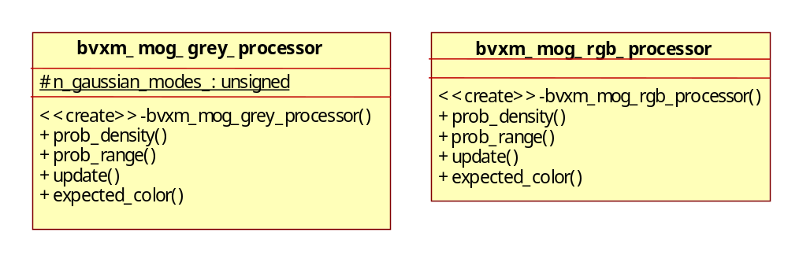
Figure 17: Appereance model processors

The MultiScale

The multiscale voxel world facilitates reconstruction of the voxel world using inputs such as images, LIDAR, etc. at different resolutions. The multiscale voxel world is required to avoid errors by updating a higher resolution voxel grid with a lower resolution image. To illustrate the above point consider a high resolution image with two adjacent pixels having black and white intensity respectively. Now the pixel at a lower resolution would be gray which is different from black or white.
The bvxm library has multiscale built in all the basic functionality and can be used when required and otherwise can be forgotten. Each of the grids (occupancy, intensity) is stored at multiple resolution or scales which varies from finest (0) to coarsest (n, typically n is 2,3). If the scale of an incoming image is detection be s, where 0£s<n, then we update the grids of the same resolution as well as the coarser grids and the finer grids are not touched. On the other hand, in order to detect changes only the grid of the same resolution is used. All the processes have a scale parameter so as to compute the desired things at different results which would be explained further in BVXM Pro.
The user needs to input the dimensions of the finest grid as well as number of scales as the coarser grids are formed by reducing the resolution by 2.

- BVXM Pro:
The Process Architecture : bvxm_pro
In this section, the high-level capabilities of the VoxGIS software are described. The modules presented in this section are processes managed by a singleton class: bprb_process_manager. Processes communicate via memory smart pointers that are managed by the in-memory data base: brdb_database. The output of one process can be applied to the next process via retrieval from the database, where data items are tagged by a unique database id. The overall scheme is shown in the figure bellow.

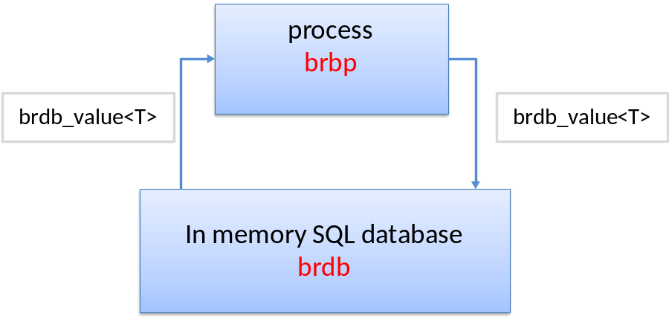
Figure 18: Process arquitecture

Inputs and parameters:

Every process in bvxm_pro inherits from bprb_process (see brpb descrption in section II). Therefore, processes can have inputs and parameters. Inputs for a process reside in the database, whether parameters are specified in an xml file. The modules presented in the following section, show (on the left) what inputs must be passed to each process. Failure to do so will cause an error. On the other hand, if a parameter file is required, it is shown on the top of the module and in some cases an example of the parameter file will be given.

BVXM processes

Create the 3-d voxel world

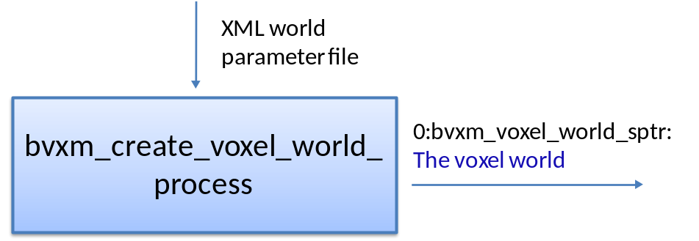
Figure 19: bvxm_create_voxel_world_process
This module takes no inputs. It creates the 3-d voxel world from scratch, based on a world parameter file. An example parameter file is shown below:

<?xml version="1.0" encoding="utf-8" ?>
-<bvxmCreateVoxelWorldProcess>
<input_directory type="string" value="D: " />
<corner_x type="float" value="100" />
<corner_y type="float" value="100" />
<corner_z type="float" value="20" />
<voxel_dim_x type="unsigned" value="200" />
<voxel_dim_y type="unsigned" value="200" />
<voxel_dim_z type="unsigned" value="50" />
<voxel_length type="float" value="1.0" />
<lvcs type="string" value="./world_model_params_lvcs.txt" />
<apm_type type="unsigned" value="1" />
<min_ocp_prob type="float" value="0.001" />
<max_ocp_prob type="float" value="0.99" />
<max_scale type="unsigned" value="3" />
</bvxmCreateVoxelWorldProcess>

Figure 20: World Parameters example XML file
The voxel world is geographically defined by a local vertical coordinate frame (LVCS). The parameters XML file expects a text file path for the LVCS. LVCS class (bgeo_lvcs) has a read (file) method that parses the parameters. A typical text file for the LVCS is shown below; please refer to the section on bgeo_lvcs for class details and input file format:

world_model_params_lvcs.txt
wgs84
meters
degrees
32.7242 -117.156 39.0
0 0
0 0 0

Figure 21: LVCS parameters
The world parameters which are defined in the xml file (Figure 19) have the following defaults (the defaults are used if the current value is not defined in the parameter file):

parameter | Default value
input_directory | “./”
corner_x | 0.0
corner_y | 0.0
corner_z | 0.0
voxel_dim_x | 10
voxel_dim_y | 10
voxel_dim_z | 10
voxel_length | 1
lvcs | “./”
min_ocp_prob | 1e-5f
max_ocp_prob | 1-1e-5f
max_scale | 1

Figure 22: World Parameters
Initialize the incoming image region of interest
The main module in this step is bvxm_roi_init_process. However, before defining the region of interest, the desired rational camera needs to be loaded into the database. Currently, there are two processes available for loading rational cameras: vpgl_load_rational_camera_process and vpgl_load_rational_camera_nitf_process. The first one gives the user the flexibility to load a camera file (e.g a manually corrected camera); the latter extracts the rational camera from the NITF header. These two processes reside in vxl/contrib/brl/bpro/core/vpgl_pro and are illustrated bellow.

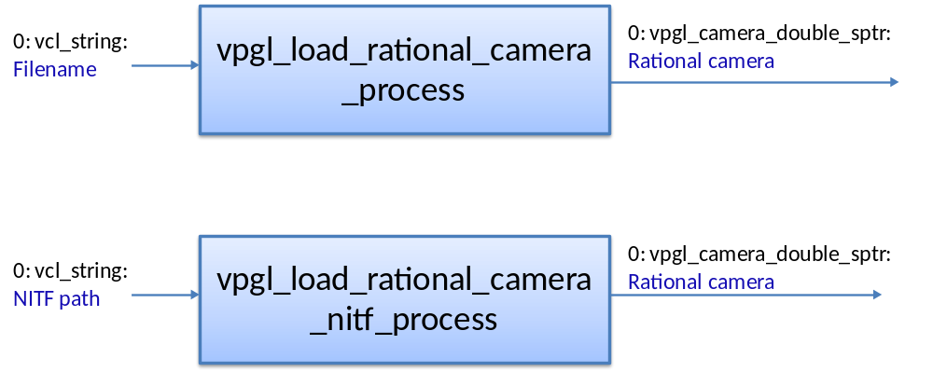
Figure 23: vpgl processes to load rational cameras

Once the rational camera has been loaded into the database, it can be used as an input for the following process:
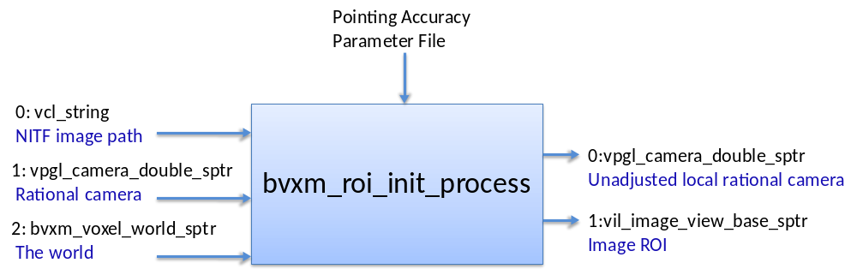

Figure 24: bvxm_roi_init_process

This module takes an existing voxel world, an NITF image path and the camera associated with the image. It produces the following two outputs:
1) A clipped image which is guaranteed to span the projection of the voxel world in the image. It is assumed that the input image will be significantly larger than the size used in the experiments.
2) A modified camera class instance (RPC) that reflects the offset due to clipping. The specialized type is vpgl_local_rational_camera<double>* where it utilizes the local vertical coordinate system of the voxel world.
The execute method of bvxm_roi_init_process creates rational cameras in the pointing accuracy span to project the voxel world onto the image plane. The pointing accuracy (e) span is defined as a box around the camera offset (c) where min point is (c.x-e, c.y-e, c.z-e) and max point is (c.x+e, c.y+e, c.z+e). Each camera, at the corners of the box, projects the voxel world and the end result is the bounding box of the union of these individual 2D regions. The clipped image is reduced to the pixel format byte with the same number of planes of the original image.
Detect the scale of an incoming image.

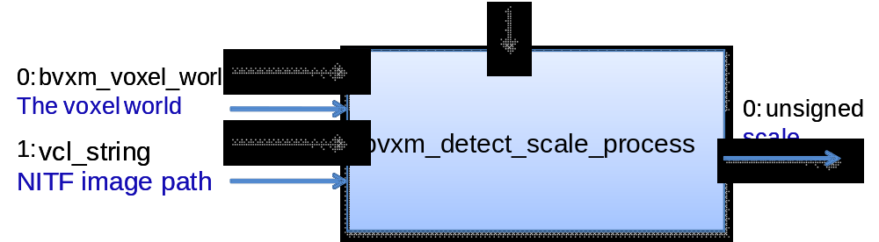

Figure 21: bvxm_detect_scale_process

This process detects the scale of the input image as per the finest grid voxel world. The scale is an unsigned number which is used as an input for most of the processes.

Register the new image by a translation of the image

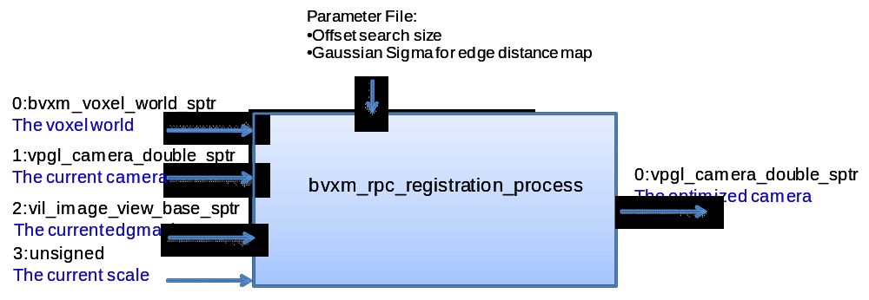
Figure 25: bvxm_rpc_registration_process
This process is designed to correct rational camera offsets by using a 3D voxel model and binary edge images created by “bvxm_generate_edge_map_process”. The voxel model used here keeps the probability of each voxel being occupied by a 3D edge. This process has two independent steps. The first step is the correction of rational camera offsets of the new image. An expected edge probability image is calculated by projecting the edge probability voxel model to the new image. This is followed by a simple optimization procedure to estimate the correct image offsets by maximizing the probability of observing the new edge image given the expected edge probability image. The second step is to update the voxel model using the new edge image and the corrected rational camera. This is done by projecting each voxel onto the new image and updating the voxel edge probability using the pixel edge probability in the new image.
The process has 2 parameters:
- cedt_image_gaussian_sigma (2.0): gaussian sigma for the edge distance map
- offset_search_size (20): maximum expected error in the rpc image offset

Find the Edges in the Image
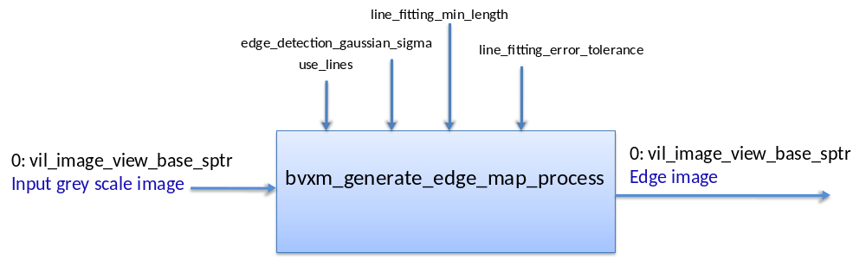
Figure 26: : bvxm_generate_edge_map_process
This process is an interface for creating a binary edge image from an input grayscale image. There are two execution modes for this process. In the first execution mode, edges are detected using Van Duc's Canny edge detection method and then contours are formed (by edge following) in order to construct a topological network. The second mode detects the edges using the same approach, but it also detects 2D line segments in the edges using an incremental line fitting method.
Determine appropriate Gaussian mixture for updating

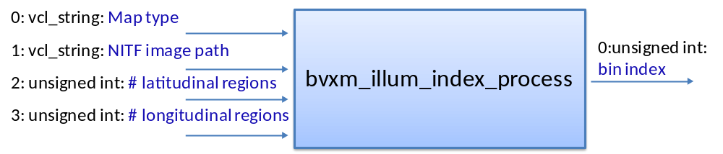
Figure 27: bvxm_illum_index_process
Since image appearance in EO is strongly dependent on image illumination direction, the current update algorithm maintains a number of different Gaussian mixtures that are active for a particular range of azimuth and elevation of the sun. The Gaussian mixtures are indexed by a bin number output by this process.
There are two types of algorithm to discretize the illumination sampling space, one of these options must be specified in the input field Map Type:
- 10bins_radial_1d: This algorithm discritizes, in 10 radial regions, the ellipse obtained by projecting the hemisphere containing all illuminations directions onto the xy-plane.
- equal_area: In this algorithm, the number of bins is determined by the user. It uses a hemisphere as the space where all possible illumination directions are distributed. Such space is discretized in equal area regions based on the number of longitudinal and latitudinal section given in the input
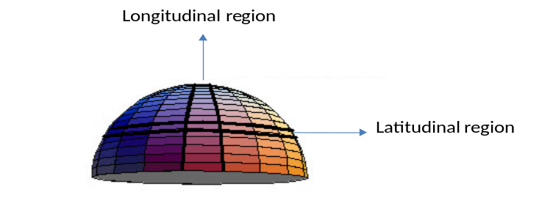

Figure 28: Illumination Grid
Image normalization
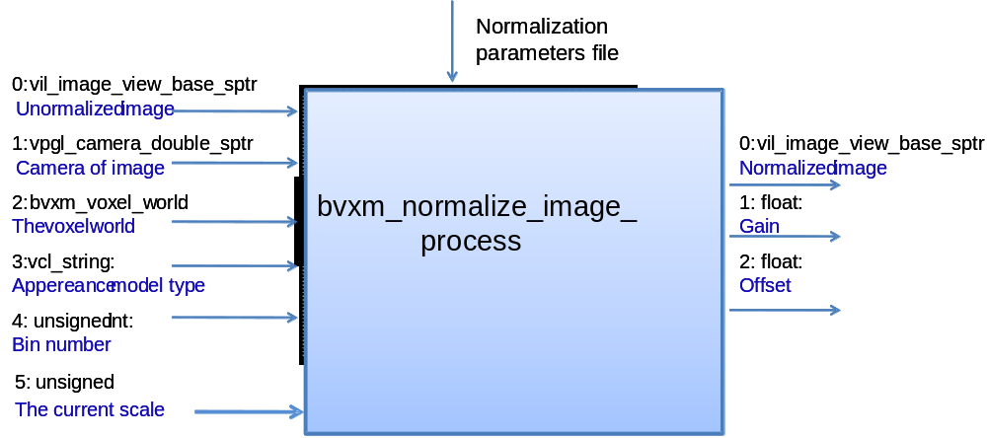

Figure 29: : bvxm_normalize_image_process
There can be considerable variation in EO image appearance due to haze and other atmospheric effects. To reduce this source of variability, each image is adjusted in gain and offset to produce as nearly similar global appearance of the image as possible. The gain and offset parameters are found by maximizing the total probability of the image, with respect to the current appearance states of the voxels.
The appearance model type must be one of the following:
- bvxm_apm_mog_grey
- bvxm_apm_mog_rgb

The bin_index has to be specified. If multiple illumination directions are not used, the bin number should be zero.

The output is a radiometrically normalized image.

Update the appearance distributions in each voxel

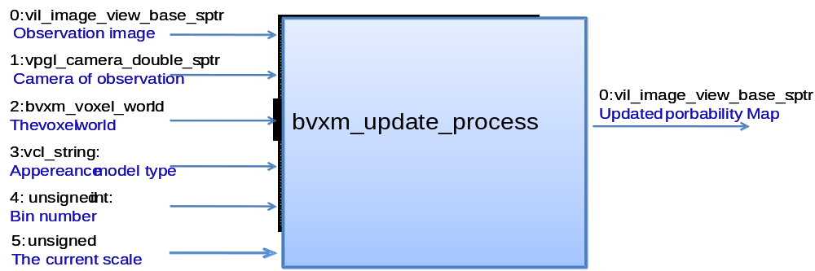

Figure 30: bvxm_update_process
This process is the key step in the learning process. It accepts a normalized and registered image and updates each voxel’s Gaussian mixture and surface probability values. It is necessary to specify what type of appearance model should be used by the updater with one of the following strings:
- bvxm_apm_mog_grey
- bvxm_apm_mog_rgb
In addition the bin index of the model needs to be specified. If multiple illumination directions are not used, the bin number should be zero.

Change detection
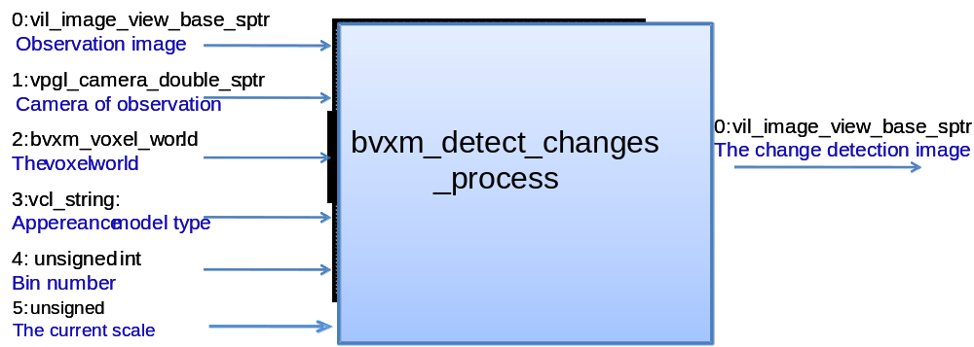

Figure 31: bvxm_detect_changes_process

After the voxel world has been updated with the training images, this module is used to detect changes. It takes an observation image, the voxel world and it outputs an image containing the probability of change
The appearance model type must be one of the following:
- bvxm_apm_mog_grey
- bvxm_apm_mog_rgb
The bin_index has to be specified. If multiple illumination directions are not used, the bin number should be zero.

Produce the change detection result
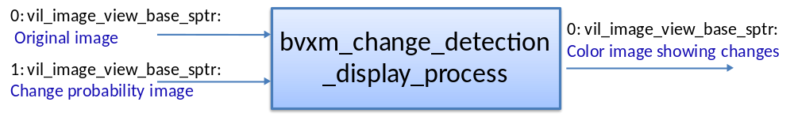
Figure 32: bvxm_change_detection_display_process
This module is the final process in the overall chain. It takes an image representing the probability of change at each pixel and transforms it into a red coded change image that is somewhat similar to two-color multi-view.

Miscellaneous processes to visualize output

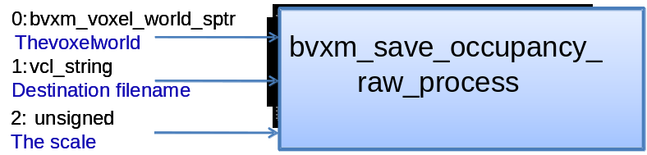
Saving the occupancy grid

Figure 33: bvxm_save_occupancy_raw_process
This process saves the voxel world occupancy grid in a binary format that is readable by the Drishti volume rendering program (http://anusf.anu.edu.au/Vizlab/drishti/)

Rendering the expected image

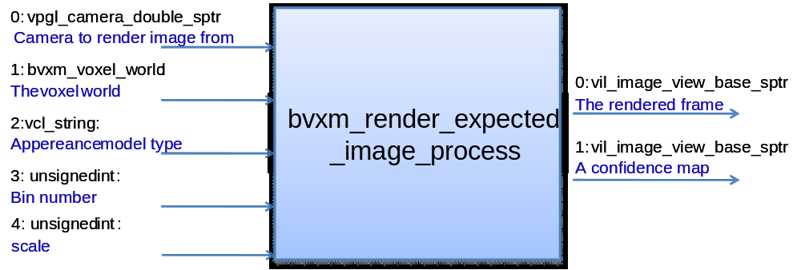

Figure 34: bvxm_render_expected_image_process
This process renders an expected image of the world from given viewing and illumination directions.

Rendering a virtual view: 3-D Registration tool
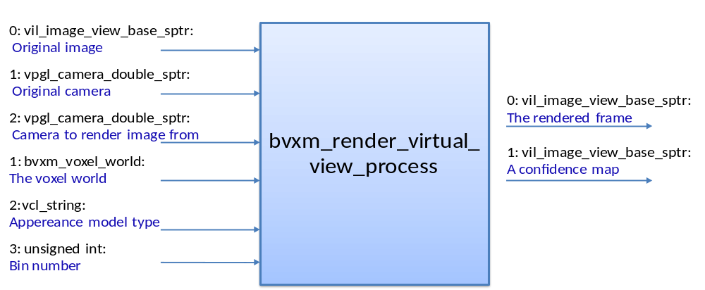
Figure 35: bvxm_render_virtual_view_process
This process was created as a 3-D registration tool that allows rendering a video frame from a given viewpoint.
- Using LIDAR information:

This section discusses the methods, processes and theoretical matters of how the vxel world can be updated using LIDAR information. This section is self-contained in other to present a clear procedure of how to use LIDAR images in VoxGIS Software.

  - The BVXM Lidar Camera: bvxm_lidar_camera.h

Lidar Images are used to determine the elevation distribution of the 3D area of interest. A Lidar image is a GEOTIFF file which is basically a TIFF file with additional geographic information.

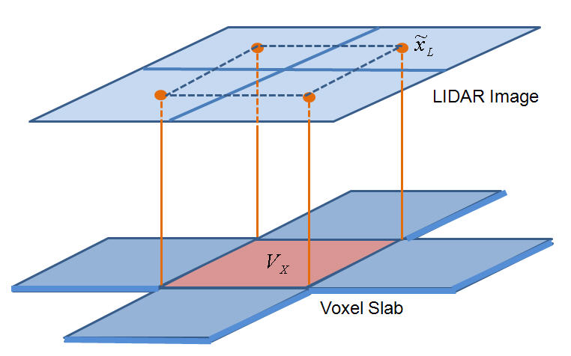
Figure 36 The LIDAR GEOTIFF file can be considered as an image with a vertical projection (along the z axis).

As shown in Error: Reference source not found, the LIDAR image can be considered to have an implicit camera that defines an orthographic projection along the vertical direction. The LIDAR pixels, 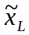map into the voxel slab at x, y locations defined by the camera matrix, which accounts for scale, rotation and translation of the LIDAR coordinate system with respect to the voxel coordinate frame. The LIDAR image pixel values are the z coordinates of the LIDAR points. These z coordinates are mapped appropriately into the height coordinates of the voxel grid. Note that only the first return LIDAR image is used in the current implementation.

bvxm_lidar_camera class is designed as a vpgl_camera so that we could use it as a regular camera when updating the voxel world. It has project() and backproject() methods, as any vpgl_camera, to find the corresponding image position for a given (x,y,z) in local coordinate system and vice-versa. Currently, only PCS_WGS84_UTM format is accepted as geotiff model type.

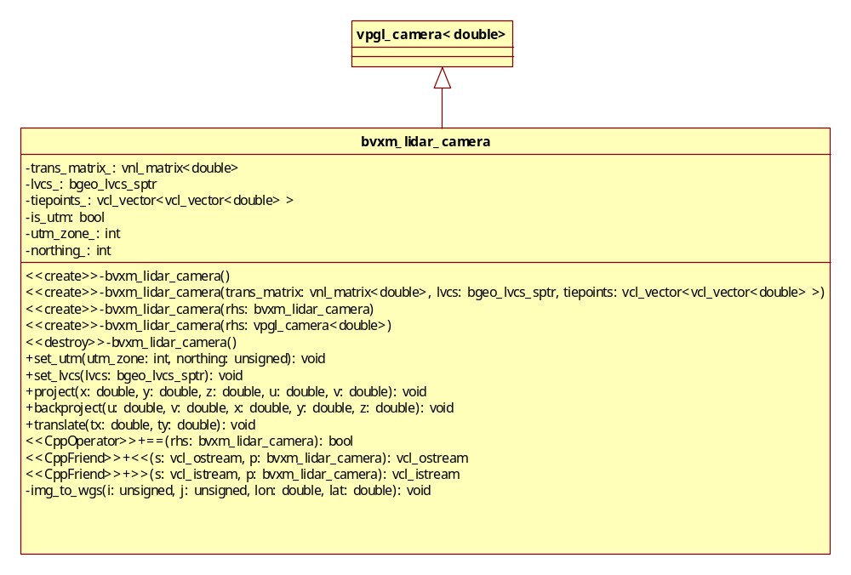
Figure 37: bvxm_lidar_camera class diagram

Detailed Description:
set_LVCS: lidar camera is passed the voxel world’s LVCS information to be consistently using the same voxel positions at updates.
set_utm:it is assumed that we use PCS_WGS84_UTM format, so the zone number and hemisphere information is set in the camera.
project: finds the corresponding image position (u, v) for a given (x, y, z) in local coordinate system.
backproject: finds the corresponding local position (x, y, z) given the image position (u, v).
translate: sets the translation (x, y) in the image origins after the original lidar image is cut into a roi section where voxel world projects to.
img_to_wgs: a private method to find the (lon, lat) values corresponding to the pixel position (i, j)

  - The Initialization Process:
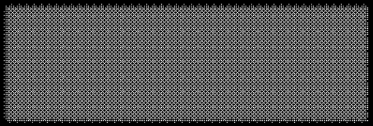
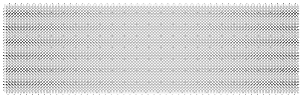
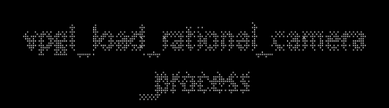
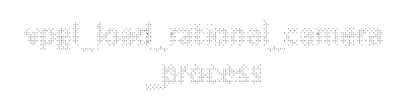

bvxm_lidar_init_process
0: vpgl_camera_double_sptr
1: vcl_string
2: bvxm_voxel_world_sptr
1: vil_image_view_base_sptr
2: vil_image_view_base_sptr
3: vil_image_view_base_sptr
0: vcl_string
threshold
Figure 38: bvxm_lidar_init_process

Input:
Image path for the first return geotiff file (required)
Image path for the last return geotiff file (it can be non-existent)
A pointer to the voxel world (either empty or already updated)
Output:
Local lidar camera
Region of interest in first return
Region of interest in last return (if input 1 is supplied)
Mask (specifies pixels not to use from lidar)
Parameter:
Threshold (default: 10 meters)
The process bvxm_lidar_init_process reads the geotiff header and generates a transformation matrix for the Lidar camera. It also passes the LVCS from voxel word (input 2) and a bgeo_utm object deduced from geotiff header. It finds the region of interest on the Lidar images by projecting the voxel world onto the image for both first and last return (if supplied) Lidar images. It also generates a mask which indicates pixel positions where the first return and last return values are too different (the difference is bigger than parameter “threshold”).
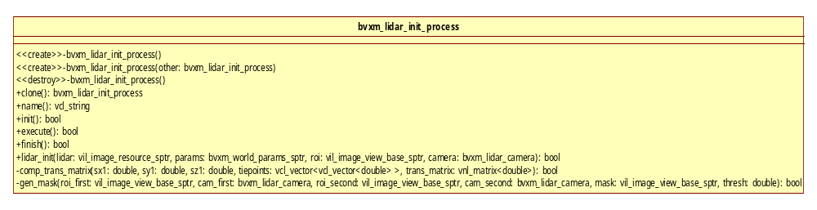

  - The LIDAR updating process
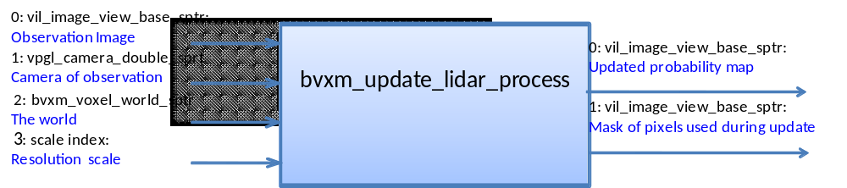
Figure 39: bvxm_update_lidar_process

This is the process that must be used when updating the voxel world with a LIDAR image. It accepts a LIDAR image in the form of a vil_image_view_base_sptr and a bvxm_lidar_camera in the form of a vpgl_camera_double_sptr. This process calls the update_lidar() method of the voxel world and updates only the surface probability values at each voxel. In addition, this process needs to know what resolution scale should be updated.

  - bvxm_lidar_processor
This class computes a three dimensional Gaussian probability density for a given voxel position.

In general, one will have to consider all combinations of hypothesized LIDAR point configurations being assigned to a given voxel. However, a much simpler solution is obtained by considering the probability that a voxel does not explain any observed LIDAR points. In this approach, a neighborhood 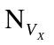is defined, including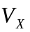, that defines the feasible set of observed points. For example if the closest observation is more than 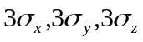away from the voxel boundary then there is no significant probability that can explain any observations. As above, the probability that can account for an observed LIDAR point,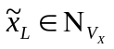, is given by 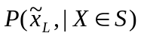. Conversely the probability that is not the source of the observed LIDAR point is given by the integral everywhere else, 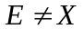, of

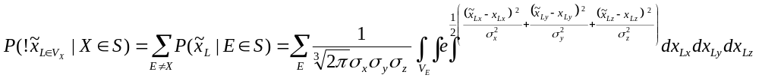
Equation 3

But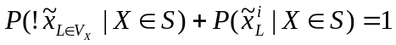, since the density, 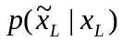, must integrate to one over the entire space. The probability that no observed LIDAR point is accounted for by is given by,
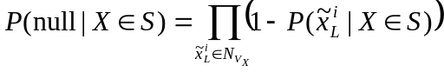
Equation 4
Finally, the probability that did scatter one or more LIDAR points is just
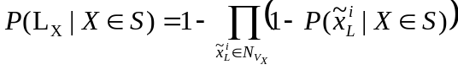
Equation 5
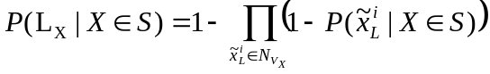
Equation 6
The current implementation of the update_lidar method of bvxm_voxel_world only selects a 2x2 neighborhood on the voxel slab around the voxel to be updated, and projects the voxel area onto the Lidar image. The bounding box projected onto Lidar image includes the pixel positions that P is computed (both fully and partially included pixels).
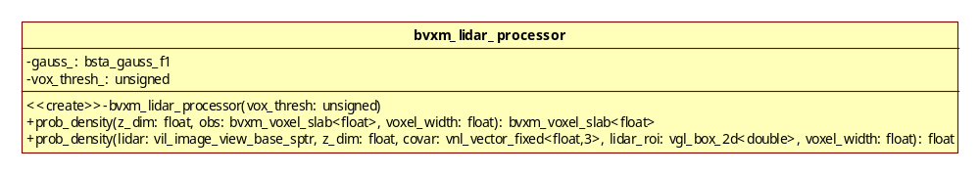
Figure 40: bvxm_lidar_processor class diagram

- BVXM_BATCH

This library provides a flexible interface for running bvxm processes in batch mode. bvxm_batch uses Python as the scripting language. Therefore, a set of Python wrappers have been implemented to allow interpretive execution of the modules via calls to the brpb_batch_process_manager.

There are two classes:

- batch_bvxm: This is where all Python’s external declarations reside.
- reg_bvxm: All processes and data types need to be registered in order to be recognized by the bprb_batch_process_manager. Registration takes care of creating instances of each process defined, as well as a database relation for different data type registered. Therefore if we run the simple python commands

import bvxm_batch
bvxm_batch.register_processes();
bvxm_batch.register_datatypes();
bvxm_batch.print_db();

We will observe the following empty relations in the database.

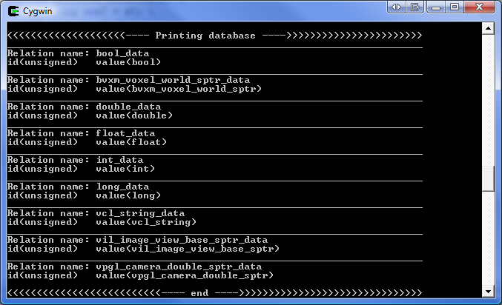
Figure 41: Example of script of database print() method

bvxm_batch methods:

These functions are the interface between Python and c++. Once the user imports bvxm_batch into Pyhton, all of these functions become accessible.

- register_processes(): Createa instances of each defined process
- register_datatypes(): Insert tables in the database for each type
- init_process(string “ProcessName”): Creates a new process instance by the name specified in “ProcessName”
- set_input_bool(unsigned i, bool input): Sets input i on current process to a bool value.
- set_input_string(unsigned i, string input): Sets input i on current process to a string value.
- set_input_int(unsigned i, int input): Sets input i on current process to an int value.
- set_input_long(unsigned i, long input): Sets input i on current process to a long value.
- set_input_float(unsigned i, float input): Sets input i on current process to a float value.
- set_input_double(unsigned i, double input): Sets input i on current process to a double value.
- process_print_default_params(string “ProcessName”, string “ParamName”): Prints the default values of the process by name.
- set_params_process(string “XMLpath”): Sets the parameter values of the current process from the XML file
- run_process(): Runs the current process
- commit_output(unsigned i): Puts output i in the database
- set_input_from_db(unsigned i, unsigned id): Sets input i of the current process to data base id value
- print_db(): Prints the database
- clear(): Clears the database tables

Running bvxm pipeline

VoxGIS software can be run from a Python executable. bvxm_batch has been configured to be importable as a python module (.py file). Therefore, once inside python the first step consists of importing bvxm_batch module with the command:

import bvxm_batch

After this command is executed, all bvxm_batch methods are accessible
The following Python script accompanied by explanations serves as an outline of the entire bvxm pipeline.

- Import bvxm_batch module and register data types and processes needed for VoxGIS software

import bvxm_batch
bvxm_batch.register_processes();
bvxm_batch.register_datatypes();
bvxm_batch.print_db();

- Create the voxel world: This is the first process in the pipeline. It creates a voxel world with the parameters given in world_model_params.xml. After the process is initialized by name and the parameter are set form file, the process is executed and the output (bvxm_voxel_world) is committed to the database under the id voxel_world_id. This id, is “kept around” inside the script to be passed as an input in future processes.

print("Creating Voxel World");
bvxm_batch.init_process("CreateVoxelWorldProcess");
bvxm_batch.set_params_process("./world_model_params.xml");
bvxm_batch.run_process();
voxel_world_id = bvxm_batch.commit_output(0);

- Retrieve image filenames as well as cameras filenames

f=open('./full_hiafa_images.txt', 'r')
image_fnames=f.readlines();
f.close();

f=open('./full_hiafa_cam.txt', 'r')
cam_fnames=f.readlines();
f.close();

- For all desired images, run the processes of VoxGIS software to either update the world or detect changes

i=0;
for fname in image_fnames[0:25]:

- Get camera name

image_filename=fname[:-1];
cam_name=cam_fnames[i];
cam_name=cam_name[:-1];

- Load rational camera using vpgl_load_rational_camera_process. Alternatively, the user could load the rational camera directly from the NITF header using vpgl_load_rationa_camera_nitf_process (see figure 19 for details on this process).

print ("Load Camera");
bvxm_batch.init_process("LoadRationalCameraProcess");
bvxm_batch.set_input_string(0,cam_name);
bvxm_batch.run_process();
cam_id = bvxm_batch.commit_output(0);

- Initialize region of interest base on the parameters specified in roi.params.xml for the current image/camera pair and voxel world

print("Initializing ROI");
bvxm_batch.init_process("bvxmRoiInitProcess"); bvxm_batch.set_params_process("./roi_params.xml"); bvxm_batch.set_input_string(0,image_filename); bvxm_batch.set_input_from_db(1,cam_id); bvxm_batch.set_input_from_db(2,voxel_world_id);
bvxm_batch.run_process();
cam_id = bvxm_batch.commit_output(0);i
mage_id = bvxm_batch.commit_output(1);
curr_image_id=image_id;
curr_cam_id=cam_id;

- Save roi image for debugging processes

print("Saving Image");
bvxm_batch.init_process("SaveImageViewProcess"); bvxm_batch.set_input_from_db(0,image_id); bvxm_batch.set_input_string(1,"./ini"+str(i)+".png"); bvxm_batch.run_process();

- Only after a certain number of training images (in this case two) camera correction is performed using edge detection.

if i>2:

- Generate the edge map of current image and save it to disk

print("Edge Detection"); bvxm_batch.init_process("bvxmGenerateEdgeMapProcess");
bvxm_batch.set_params_process("./edge_map_params.xml");
bvxm_batch.set_input_from_db(0,image_id);
vxm_batch.run_process();
edge_map_id = bvxm_batch.commit_output(0);

print("Saving Edgemap");
bvxm_batch.init_process("SaveImageViewProcess");
bvxm_batch.set_input_from_db(0,edge_map_id);
bvxm_batch.set_input_string(1,"./emap.png");
bvxm_batch.run_process();

- Correct rational camera offset

print("RPC Correction");
bvxm_batch.init_process("bvxmRpcRegistrationProcess"); bvxm_batch.set_params_process("./rpc_registration_parameters.xml");
bvxm_batch.set_input_from_db(0,voxel_world_id); bvxm_batch.set_input_from_db(1,cam_id); bvxm_batch.set_input_from_db(2,edge_map_id); bvxm_batch.run_process();
corrected_cam_id = bvxm_batch.commit_output(0);

- Obtain the clipped image containing projection of voxel world as well as the camera reflecting the offset changes.

print("Get Corrected ROI"); bvxm_batch.init_process("bvxmRoiInitProcess"); bvxm_batch.set_params_process("./corrected_roi_params.xml");
bvxm_batch.set_input_string(0,image_filename); bvxm_batch.set_input_from_db(1,curr_cam_id); bvxm_batch.set_input_from_db(2,voxel_world_id);
statuscode=bvxm_batch.run_process();
if statuscode:
curr_cam_id = bvxm_batch.commit_output(0);
orig_image_id = bvxm_batch.commit_output(1); print("Saving Image"); bvxm_batch.init_process("SaveImageViewProcess"); bvxm_batch.set_input_from_db(0,orig_image_id); bvxm_batch.set_input_string(1,"./ini"+str(i)+".png"); bvxm_batch.run_process(); curr_image_id=orig_image_id;

- At this stage of the pipeline, cameras and images have been corrected. This step obtains the illumination bin number, based on the elevation and azimuth in the NITF header, and the number of regions given by the user.

map_type="eq_area";
print("Illumination Index");
bvxm_batch.init_process("bvxmIllumIndexProcess");
bvxm_batch.set_input_string(0,map_type); bvxm_batch.set_input_string(1,image_filename); bvxm_batch.set_input_unsigned(2,8);
bvxm_batch.set_input_unsigned(3,0);b
vxm_batch.run_process();
bin_id = bvxm_batch.commit_output(0);a
pp_type="apm_mog_grey";

- Normalize image intensity

print(" Normalizing Image "); bvxm_batch.init_process("bvxmNormalizeImageProcess"); bvxm_batch.set_params_process("./normalize.xml"); bvxm_batch.set_input_from_db(0,curr_image_id); bvxm_batch.set_input_from_db(1,curr_cam_id); bvxm_batch.set_input_from_db(2,voxel_world_id); bvxm_batch.set_input_string(3,app_type); bvxm_batch.set_input_from_db(4,bin_id); bvxm_batch.run_process();
normalized_img_id = bvxm_batch.commit_output(0); float1_id = bvxm_batch.commit_output(1);
float2_id = bvxm_batch.commit_output(2);

- Update the world with the current image. If instead of updating the voxel world, the user whishes to detect changes, the process bvxm_detect_changes should be called here.

print("Updating World");
bvxm_batch.init_process("bvxmUpdateProcess"); bvxm_batch.set_input_from_db(0,curr_image_id); bvxm_batch.set_input_from_db(1,curr_cam_id); bvxm_batch.set_input_from_db(2,voxel_world_id); bvxm_batch.set_input_string(3,app_type); bvxm_batch.set_input_from_db(4,bin_id);
bvxm_batch.run_process();
out_img_id = bvxm_batch.commit_output(0);
mask_img_id = bvxm_batch.commit_output(1);

- Display Changes

print("Display changes");
bvxm_batch.init_process("bvxmChangeDetectionDisplayProcess");
bvxm_batch.set_params_process("./change_display_params.xml");
bvxm_batch.set_input_from_db(0,orig_image_id); bvxm_batch.set_input_from_db(1,out_img_id); bvxm_batch.set_input_from_db(2,mask_img_id);
bvxm_batch.run_process();
change_img_id = bvxm_batch.commit_output(0);

print("Saving Image");
bvxm_batch.init_process("SaveImageViewProcess"); bvxm_batch.set_input_from_db(0,change_img_id); bvxm_batch.set_input_string(1,"./change"+str(i)+".png"); bvxm_batch.run_process();

- Save occupancy probability of the world. This step is optional.

print("Writing World"); bvxm_batch.init_process("bvxmSaveOccupancyRaw"); bvxm_batch.set_input_from_db(0,voxel_world_id); bvxm_batch.set_input_string(1,"./world.raw"); bvxm_batch.run_process();

- Run processes on next image
i = i + 1;
reply

- Additional Documentation
Tests
Testing code has been written for all the libraries described above. Under each library there is a folder containing testing code for all the classes. This tests programs guarantee the proper functioning of classes and serve as a good example of how classes are used.

VXL libraries

In addition to the libraries just discussed there are dozens more that need to be mastered in order to fully understand the code base. The following is a list of some of the key libraries. Many of these libraries are documented in the VXL “book” on the VXL website: http://vxl.sourceforge.net/
- vcl – compatibility library; allows seamless use of C++ across a patchwork quilt of compilers and operating systems
- vbl – basics; ref counting and smart pointers
- vnl – numerics library; vector, matrix and numerical computations, optimization, linear algebra…
- vil – image library; read, write, process images, templated over pixel type
- vgl – geometry and projective transformations of geometry (vgl/algo)
- vpgl – photogrammetry library; camera classes, rational polynomial model, back-projection.
- bsta – statistics; general distributions, Gaussian, Gaussian mixture, probability functors
- bsta/algo – algorithms using distributions
- bbgm – normalcy modeling using bsta. (This library is not directly involved in the delivery but is a 2-d version of the 3-d voxel world and has many similarities to the code being developed for the voxel model). Understanding how this library works using functor-style programming, will provide valuable insight into the code to be delivered.

The best way to learn is to download the latest (bleeding edge) version of VXL and build the libraries and test cases and then modify the test cases to get them to do something different to test your understanding. It is advised to check out the dashboard to be sure there isn’t a lot of compile problems. Here is what the dashboard looks like right now (all green compilations which is good).
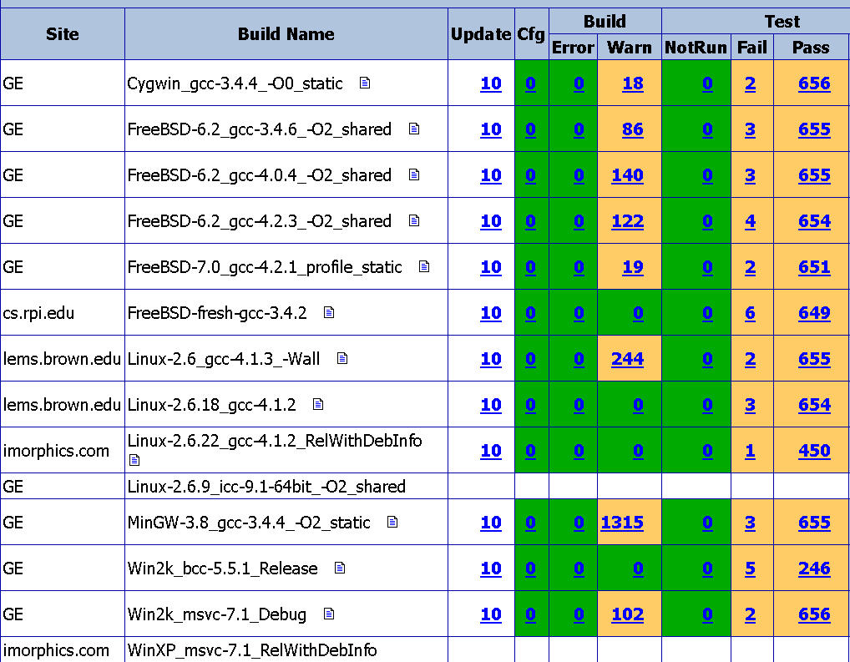

Figure 42: Snapshot of VXL dashboard

- Version Control

- Version 1.0 – 03/16/2008: Created by Isabel Restrepo, Gamze Tunaly and Joseph Mundy.
The first version of bvxm resembles the methods and equations initially proposed by Thomas Pollard
- Version 1.1 – 7/14/2008: Modifications by Vishal Jain, Gamze Tunaly, Joseph Mundy and Isabel Restrepo.
This version documents the following new features:
- The voxel world can be updated using LIDAR information
- The data structure of the software has been modified to manage multiple resolutions. The voxel world can be updated with information from imagery that has different resolutions.

