This document serves as a preliminary guideline to perform camera correction for satellite (NITF) images
using vxl/contrib/brl/ bbas/bwm/bwm_main

Created by: Isabel Restrepo.
Please feel free and encouraged to modify and contribute!

Steps:
- Need to calibrate a site: Camera calibration using 4 images should be ok.
  - Select: Site->Create Site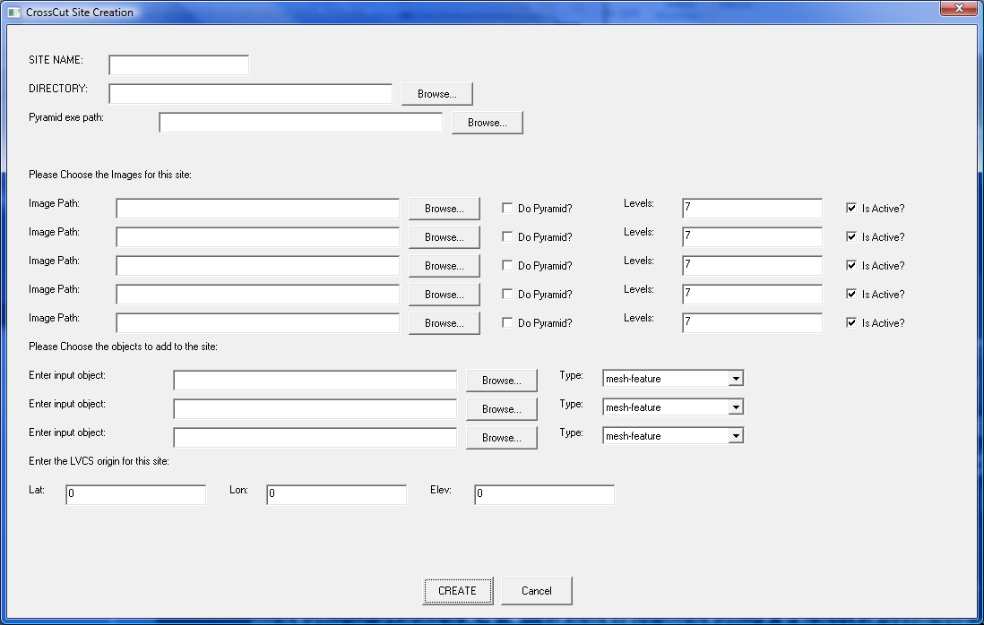

- Site Name: Anything
- Directory: Where you wish to keep the site
- Pyramid exe path: C:\Projects\vxl\build\contrib\brl\bseg\sbin\debug\generate_tiff_rset.exe
- Image path: Browse for NITF file and double click. Without double click the actual file name doesn’t get included in the path.
- Select do pyramid if images are very large

- Select correspondences: Right click on an image. In image display there are feature to zoom to fit and to change the range map view (color planes)
  - Select: Processes-> Start correspondence
  - Shift + left Click selects a correspondence (CTRL + middle scrolls) (CTRL +left zooms in) (CTRL + right zooms out)
  - Select: Processes -> Record Correspondences
  - Select: Processes -> Adjust Cameras
  - Select: Site -> Save site
Note: Camera correction doesn’t take place until the site has been saved.
Sites are saved to the folder specified when the site was created, with different version numbers. To use the latest site, verify its created date.
Corrected cameras are created in the same folder where the original .RPB files reside. They are saved using the same name as the original camera and a “_vXXX.RPB” additional string.

- Load remaining images:
  - Edit site: The first step consists of turning 3 out of the 4 images from the site inactive. This can be performed either by modifying the xml file for the site or by selecting Site->Edit site. The only thing that needs to be done at this point is replacing active by inactive.
  - Load an additional image: This can also be done in two different ways. First through Site->Edit Site, then browse for the desired image.
  - The other way is by selecting Site-> Load camera tableau. Load an image and its corresponding camera.
  - After the image has been loaded:
    - Select: Processes-> Start correspondence
    - Shift + left Click selects a correspondence (CTRL + middle scrolls) (CTRL +left zooms in) (CTRL + right)
    - Select: Processes -> Record Correspondences
    - Right click on the image -> Registration -> Register to world point.
    - Save site
    - To add the next image, it is possible to remove selected table from the Site menu, then repeat steps c and d.
Note: The fist way of loading images will create new folders within the site folders where the images are copied from the original path and the new camera will be saved there.
In the second way, no copies are made and the corrected cameras are located in the same folder as the original.

