Tyler Small

1.2

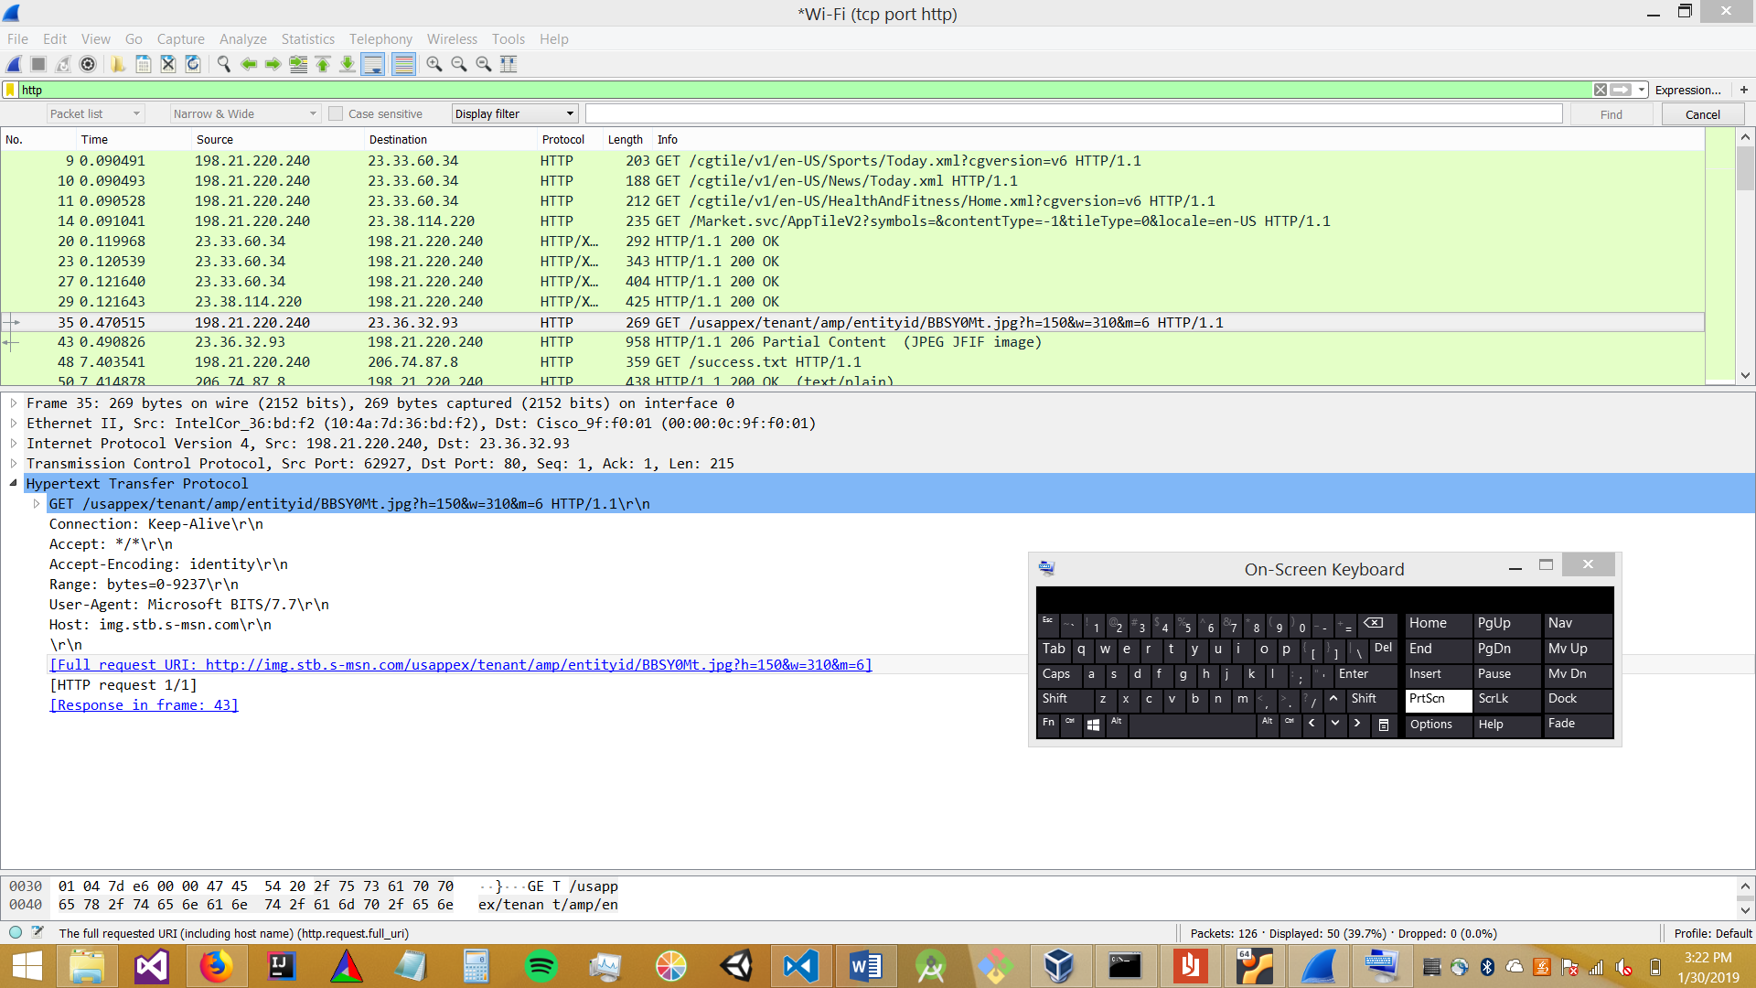

1.3

1. What is the full URL of the object requested by the web browser? (include both the server name and document path)

[Full request URI: <http://img.stb.s-msn.com/usappex/tenant/amp/entityid/BBSY0Mt.jpg?h=150&w=310&m=6>]

2. What version of HTTP is the browser using for this request? What version of HTTP is the webserver using for the response?

Request Version: HTTP/1.1

Response Version: HTTP/1.1

3. Is this HTTP connection persistent or non-persistent?

Connection: keep-alive is in the request header, implying it is persistent.

4. What kind of web browser sent this request? Why does the server (potentially) need to know this information?

User-Agent: Mozilla/5.0 (Windows NT 6.3; Win64; x64; rv:64.0) Gecko/20100101 Firefox/64.0\r\n

If the user is on an outdated browser the page may need to be displayed differently.

5. What operating system was the web browser running on?

Win64

6. What kind of web server answered the request?

Server: Microsoft-IIS/10.0\r\n

7. Did the server successfully produce the requested document? What type of document did the server say it is?

File Data: 6570 bytes

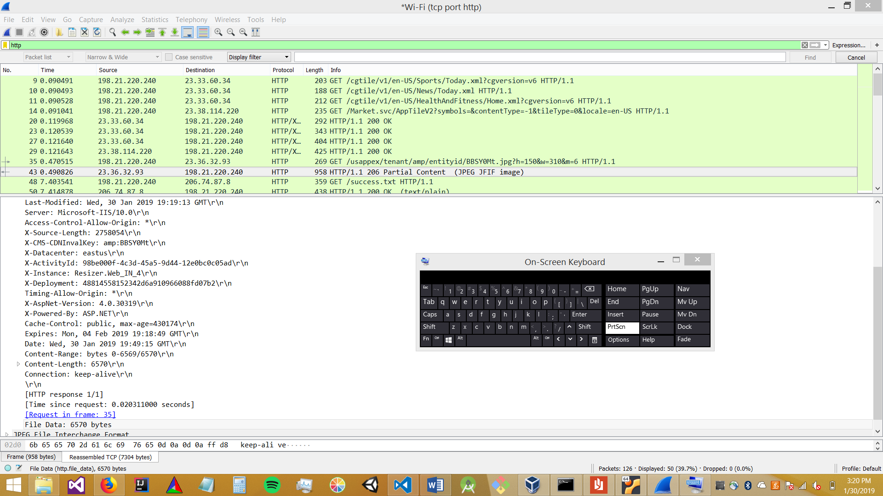

The next request was a success message, so I assume the image was fetched successfully.

File type : image/jpeg

2

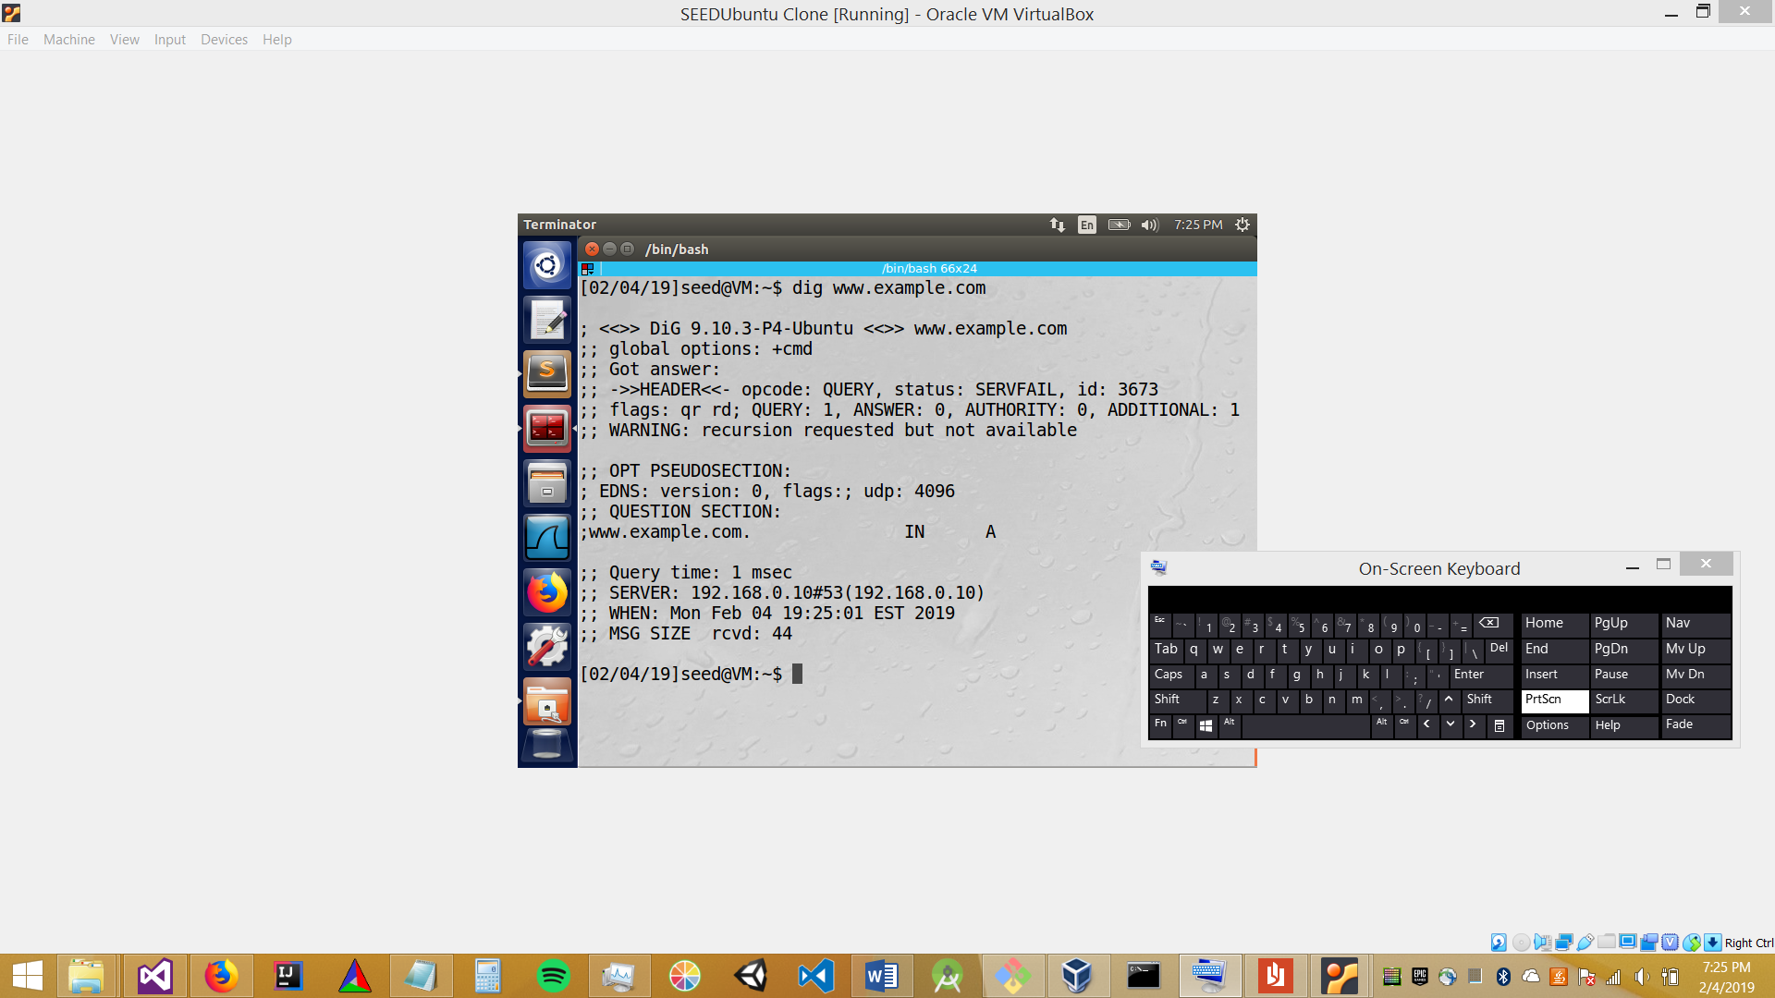

Temp

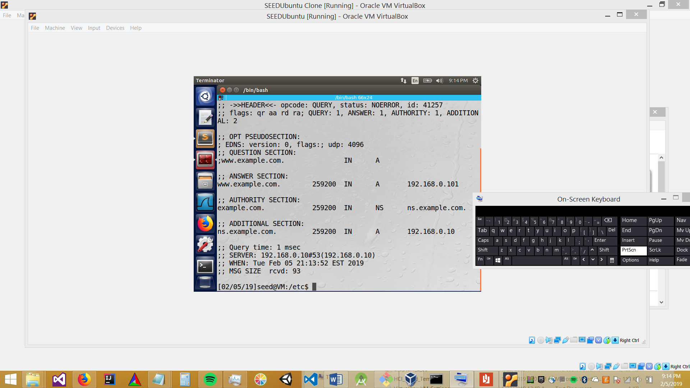

Working 2.1

2.2

