SHELFCAT ENTERPRISE
Authoritative Architecture & Technical Specification
Deterministic Edge Intelligence • Policy Authority • Cryptographic Evidence • Multi-Vertical Deployment

Prepared for ShelfCat Solutions LLC
Alan Lee Vines, Founder & Chief Architect
Birmingham, Alabama
22 September 2026

Document Control
Field | Authoritative Value
Document | ShelfCat Enterprise Architecture & Technical Specification
Version | 1.0
Status | Authoritative architecture baseline
Effective date | 2026-09-22
Owner | ShelfCat Solutions LLC
Architecture authority | ShelfCat Solutions LLC / designated technical authority
Source corpus | ShelfCat_Full_Platform_Workbook.xlsx; three uploaded ShelfCat architecture diagrams
Precedence | This specification and the accompanying authoritative workbook supersede conflicting wording in the source diagrams.
Change control | Material architecture, policy-authority, cryptographic, tenancy, or claims changes require versioned review and an entry in the reconciliation log.
Architecture thesis — AI may propose what it observes; it does not become the authority that decides whether the observation satisfies policy. RustGate is the deterministic policy authority. The Evidence layer commits provenance, signatures, hashes, and replay metadata after the decision.

1. Scope, Intent & Source Precedence
This document converts the uploaded workbook and architecture diagrams into one internally consistent enterprise architecture. It separates production requirements from illustrative concepts and separates measured evidence from targets or unvalidated claims.
- The workbook is the structured source for component, policy-pack, vertical, integration, evidence, and commercial-model definitions.
- The diagrams are source concepts for workflow, gating, operational layers, and sector positioning. Where diagram text conflicts with deterministic-systems, security, data-governance, or validation principles, this specification records the correction.
- Normative language uses MUST, SHOULD, and MAY in the conventional engineering sense: mandatory, recommended, and optional respectively.
- Externally published claims MUST be traceable to a test profile, model, or source record.

2. Architecture Invariants
- Perception is probabilistic. Vision, OCR, embeddings, speech, sensor fusion, and other model outputs are candidate observations with uncertainty.
- Policy is deterministic. RustGate evaluates a normalized observation against a pinned policy/version and returns an explicit outcome.
- Consequential actions are gated. A model output alone cannot authorize actuation, compliance status, access, safety interlock, or other governed outcome.
- Evidence is cryptographically bound. Authoritative records carry hashes, signatures, provenance, policy identity, engine identity, timestamps, and chain references as required by profile.
- Failure is not silent. A rejected payload may be discarded or quarantined, but minimum rejection/decision metadata remains auditable.
- Verticals extend; they do not fork the core. Domain classes, registries, thresholds, integrations, and actions vary; the Observation Envelope, RustGate mechanics, provenance, evidence, and quality-gate framework stay shared.
- Determinism is not model accuracy. Replay reproducibility and predictive accuracy are measured separately.

3. Logical Architecture
Layer | Responsibility | Typical Technology | Authoritative?
Capture | Acquire image/audio/sensor/metadata; run local quality checks | Swift/iOS, Android, cameras, sensors | No
Perception | Detection, classification, OCR, embeddings, geometry, sensor fusion | Python/FastAPI, CV/ML runtimes | No
Normalization | Canonicalize observations and validate schema/freshness | Rust/Python boundary contract | No
Policy Authority | Evaluate versioned deterministic policy | RustGate | Yes — policy outcome
Enforcement | Translate authorized outcome into alert, task, access, stop/allow, etc. | EdgeGuard / integration adapter | Only within delegated policy scope
Evidence | Commit signed/hash-chained decision records and evidence references | Evidence service, Key Vault/HSM, ledger | Yes — audit record
State & Workflow | Tenant state, policy metadata, cases, jobs, integrations | PostgreSQL, event bus, APIs | No
Operations | Metrics, logs, traces, SLOs, incident alerts | Azure Monitor / Application Insights | No
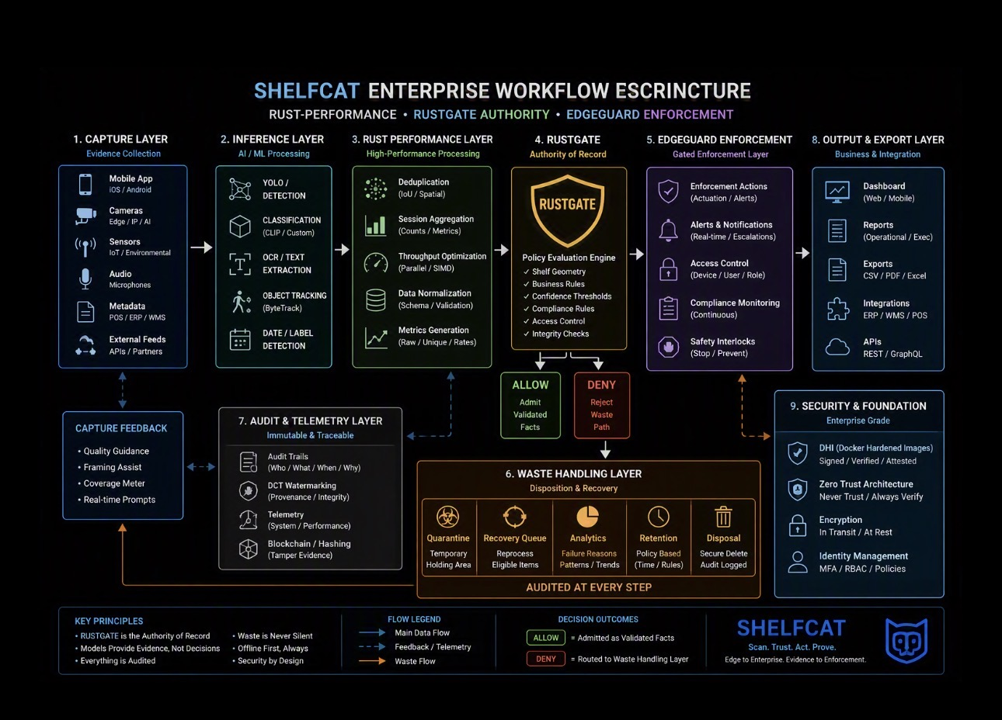
Figure 1. Source workflow concept. The normative corrections in this specification supersede any conflicting labels inside the source image.

4. Azure Enterprise Reference Deployment
The production reference profile uses Azure services as a deployment implementation, not as the product boundary. Equivalent customer-approved services may be substituted while preserving the trust boundaries and contracts below.
Zone | Reference Components | Requirement
Public edge | Azure Front Door + WAF | Default global ingress for web/mobile APIs, TLS termination, routing, and WAF.
Identity | Microsoft Entra ID | Human and workload identity; RBAC/claims; managed identity where supported.
API / tenant routing | API ingress + tenant context service | Authenticate, authorize, derive tenant server-side, and route to services.
Compute | AKS + ACR | Run signed containerized services; admission controls SHOULD enforce image provenance.
AI Brain | Python/FastAPI + model runtimes | Generate structured observations only.
Policy authority | RustGate service/sidecar/edge binary | Evaluate pinned policy; return deterministic outcome.
Transactional state | Azure Database for PostgreSQL | Shared tenancy SHOULD use Row-Level Security; stronger isolation profiles may use schema/database separation.
Evidence objects | Azure Blob Storage | Use immutable/WORM controls when retention requirements justify them.
Keys | Azure Key Vault / Managed HSM | Protect authority keys, rotation metadata, and signing operations.
Events | Service Bus/Event Grid or equivalent | Decouple authoritative decision from downstream workflows.
Observability | Azure Monitor / Application Insights | Operational telemetry; never the authority of record.
Regional/private ingress | Application Gateway, optional | Use when regional/private Layer-7 integration adds value; do not insert it by default merely because Front Door is present.

5. Core Data Contracts

5.1 Observation / Fact Envelope
The normalized envelope is the contract between perception and deterministic policy. Exact serialization MUST be canonicalized before hashing or replay verification.
Field | Type / Example | Requirement
sequence | uint64 / monotonic | Required within scoped stream or ledger.
candidateID | string/UUID | Required candidate identity.
sourceID | device/sensor/source identifier | Required.
timestampMs | integer epoch milliseconds | Required; policy may reject stale observations.
entity | domain object / class | Required.
confidenceScore | 0.0–1.0 | Optional where no probabilistic model is used; otherwise required and non-authoritative by itself.
bbox / geometry | coordinates / spatial model | Optional by vertical; normalized coordinate frame MUST be identified.
rawAudioRMS / sensor features | numeric feature(s) | Optional by modality.
payloadHash | SHA-256 digest | Required when payload/evidence binding applies.
policyID / policyVersion | identifier + immutable version | Required at evaluation/commit.
deviceKeyID | key fingerprint / ID | Required for signed device facts.
parentFactHash | 32-byte hash | Required for chained profiles; genesis value governed by profile.
signature | device signature, e.g. P-256 DER | Required when the profile mandates device attestation.

5.2 Decision Envelope
Field | Purpose
decisionID | Stable decision identifier.
observationHash | Binds the decision to canonical normalized input.
policyID / policyVersion / policyHash | Pins the exact rule artifact evaluated.
engineVersion / buildHash | Pins the RustGate implementation/build used.
outcome | ALLOW, DENY, REVIEW, QUARANTINE, or domain-mapped equivalent.
reasonCodes | Machine-readable rules/conditions that determined the outcome.
decisionTimestamp | Commit time.
parentDecisionHash / sequence | Links the scoped decision history when chaining is enabled.
authoritySignature / keyID / algorithm | Authenticates the committed decision record.
evidenceRefs | References to retained evidence objects; optional if policy is metadata-only.

6. Determinism Contract
ShelfCat determinism applies to the policy evaluation boundary, not to the upstream probabilistic model. Reproducibility requires more than repeating the same raw image.
- RustGate MUST receive a canonical normalized observation, pinned policy artifact, pinned engine/build identity, and the configuration values that influence policy execution.
- The evaluator MUST avoid unseeded randomness, wall-clock dependent logic without an explicit timestamp input, nondeterministic iteration that changes semantic results, or hidden remote dependencies.
- A replay is valid when the same canonical decision inputs yield the same outcome and reason codes under the same evaluator semantics.
- Model outputs can vary between model versions or hardware/runtime profiles; therefore model accuracy, calibration, robustness, and drift are separate validation domains.
- “Same input → same output” is acceptable shorthand only when “input” means the complete deterministic decision envelope, not merely the source media.
Corrected claim — Do not express determinism as “≥99.5% validation accuracy.” Determinism is a reproducibility property. Accuracy is an empirical property of a classifier, detector, OCR model, or the end-to-end workflow against labeled ground truth.

7. Policy Pack Lifecycle & Governance
- Draft policy from customer/domain requirements and explicit thresholds.
- Compile/validate schema and reject ambiguous or incomplete rules.
- Run golden-vector tests, boundary tests, malformed-input tests, and replay tests.
- Assign immutable policy ID, semantic version, hash, owner, approval status, and effective date.
- Sign/publish the policy pack to the approved registry.
- Deploy by explicit promotion; never silently mutate a deployed policy version.
- Rollback by activating a prior signed version while preserving the original decision history.
- Retire policy while preserving artifact metadata required to replay historical decisions.

8. Cryptographic Evidence & Provenance
Cryptographic evidence is layered. Device authenticity and authority-of-record signing serve different purposes and SHOULD use distinct keys and lifecycle controls.
Mechanism | Authoritative Treatment
SHA-256 hashing | Bind canonical payloads, policies, builds, and parent references. Algorithm identifier/version SHOULD be explicit.
Device signing | On iOS, P-256 Secure Enclave signing is an appropriate device provenance mechanism; other platforms use equivalent hardware-backed keys where available.
RustGate / authority signing | Ed25519 is suitable for an authority-signing profile when governed, rotated, and protected; enterprise deployments may define an alternative approved algorithm.
Key custody | Server authority keys SHOULD reside in Key Vault/Managed HSM or equivalent. Private keys MUST NOT be embedded in application images or source repositories.
Hash chain | Parent hash + monotonic sequence provides tamper-evident lineage within a scoped ledger. External anchoring is optional.
DCT watermarking | Supplemental provenance/tamper signal only. It MUST NOT replace hashes/signatures.
Blockchain | Not a core requirement. Use a signed hash-chained ledger unless a customer requirement justifies external distributed anchoring.
PQC | Crypto-agility and post-quantum migration readiness are roadmap items; do not represent PQC as a current retail production prerequisite without validated implementation.

9. Multi-Tenancy, Data Isolation & Retention
Area | Baseline | Stronger Profile
Tenant state | Shared PostgreSQL with tenant IDs and Row-Level Security; service authorization enforces tenant scope. | Schema-per-tenant or database-per-tenant when contractual/regulatory isolation requires it.
Blob evidence | Tenant-scoped container/prefix + access policy + encryption. | Dedicated storage account/container, customer-managed keys, private endpoints.
Keys | Per-environment or governed per-tenant derivation/profile. | Dedicated customer key hierarchy/HSM partition as required.
Raw media | Metadata-only/local-first when workflow permits; upload only under explicit policy. | Immutable evidence retention with defined legal hold/retention schedule.
Deletion | Policy-driven retention, disposal log, and access control. | Regulated retention/legal hold controls.

10. Edge, Offline & Synchronization Semantics
- Edge nodes MAY perform capture quality, inference, normalization, RustGate evaluation, and local evidence commit where the deployment profile allows.
- Offline operation MUST distinguish “locally authorized” from “cloud-confirmed” state. The audit record records which authority context was used.
- Synchronization MUST be idempotent. Duplicate events are rejected or de-duplicated without changing the authoritative decision.
- Stale policies, stale sensor data, clock uncertainty, chain discontinuity, or missing required signatures MUST produce an explicit policy outcome rather than implicit success.
- Local deterministic decisioning removes dependency on round-trip cloud latency; it does not mean zero compute latency.

11. Security Architecture
Control Plane | Requirement
Identity | Entra ID/OIDC for users; managed identities/workload identities for services; least privilege RBAC.
Transport | TLS 1.2+ baseline; prefer current approved TLS profile; no SSLv2/SSLv3/TLS 1.0.
Secrets | No long-lived secrets in code/config repositories; use secret stores and rotation.
Container provenance | Scan images, sign releases, verify provenance before deployment; pin immutable image digests.
Network | Private endpoints/network policies for data stores where required; ingress/egress explicitly controlled.
Application authorization | Authorization is server-side and tenant-aware; do not trust client role/tenant assertions without verification.
Fail-closed paths | Malformed, stale, unsigned (when required), or unverifiable decision inputs route to DENY/REVIEW/QUARANTINE per policy.
Audit | Security-relevant policy changes, key events, deployment promotions, and failed verification attempts are retained as governed events.

12. Observability & SLO Model
Operational telemetry measures health; it does not determine policy truth. Metrics SHOULD be tagged by deployment profile, engine version, policy version, device class, and tenant without exposing sensitive content.
Metric Family | Examples | Interpretation
Latency | capture→observation, inference, normalization, RustGate eval, commit, downstream actuation | Report component and percentile; avoid collapsing unrelated timings.
Reliability | packet loss, sync retries, queue depth, error rate | Separate network transport from decision correctness.
Determinism | replay match rate, golden-vector pass rate | Should be 100% for a controlled deterministic replay suite; any mismatch is an integrity defect.
Model quality | precision/recall, OCR CER/WER, calibration, false reject/accept | Separate from policy determinism.
Evidence integrity | signature verify rate, chain continuity, hash mismatch count | Cryptographic/evidence health.
Security | auth failures, denied cross-tenant access, image verification failures | Detect control-plane violations.

13. Product & Vertical Boundaries
Program | Domain | Shared Core | Vertical-Specific Content
ShelfCat Retail | Retail shelf operations | Observation Envelope, quality gates, RustGate, evidence, sync | SKU/planogram classes, shelf geometry, OOS rules, ERP/POS/WMS actions
ShelfCat Lens | Voice/vision ingestion gate | Quality-gate mechanics, provenance, RustGate where policy applies | VAD/acoustic gates, camera quality, STT/vision routing; separate from Retail naming
MedEdge / Sentinel | Healthcare operational safety | Shared core and evidence | PPE/room/equipment operational checks; not diagnostic unless separately validated/regulated
UtilitySight / PowerSave | Utilities/buildings/energy | Shared core | Asset/OCR/thermal/occupancy rules, BMS/EMS/SCADA/GIS integrations
RoboGate | Robotics | Shared core | Motion envelope, obstacle/state telemetry, zone/action authorization
FinSight | Finance/collateral operations | Shared core | Asset identity, condition evidence, chain of custody, loan/risk workflow integration

14. Claims & Evidence Discipline
The uploaded sector comparison diagram contains useful positioning but mixes measured metrics, modeled benefits, and unsupported universal claims. The following register is authoritative until stronger evidence is attached.
Claim | Classification | Authoritative Wording / Action
Retail 95–120 ms end-to-end | Measured example | Use only with the referenced hardware/load/test profile and percentile definition.
Robotics mesh 18.7 ms avg; 32.4 ms P95 | Measured example | Describe as mesh latency in the referenced test, not total action latency.
2.8 ms RustGate policy evaluation | Measured example | Describe as an observed run/profile; expand validation across policies/hardware before generalization.
~98% network reduction | Modeled/example until benchmark attached | State that event-first/local filtering can materially reduce upstream data; publish a percentage only with dataset and byte accounting.
≥99.5% deterministic validation accuracy | Invalid framing | Replace with deterministic replay reproducibility plus separate model/workflow accuracy metrics.
No raw data transmission | Overbroad | State metadata-only/local-first is supported; raw evidence upload is policy controlled.
40–90% device energy reduction by sector | Unverified | Do not publish as universal. Require device, workload, duty-cycle, and baseline power measurement.
9,500–27,800 kWh/year facility savings | Unverified/modelled | Do not call typical without site baseline and measurement & verification method.

15. Validation & Release Gates
Gate | Minimum Exit Criteria
Schema contract | Canonical serialization tests; backwards-compatibility decision; malformed input rejection.
Determinism | Golden vectors replay identically across repeated runs on the certified runtime profile.
Policy correctness | Boundary-condition tests, deny/allow/review reason-code verification, version-pinning tests.
Model quality | Labeled validation set with task-appropriate metrics, confidence calibration, drift baseline.
Security | SAST/dependency/container scan; key/secret checks; authz and cross-tenant negative tests.
Evidence | Hash/signature verification, chain-break detection, key rotation test, replay reconstruction.
Performance | Latency percentiles and resource use under defined hardware, concurrency, and load.
Resilience | Offline mode, sync retry/idempotency, stale policy/data, clock skew, degraded dependency tests.
Operational readiness | Dashboards, alerts, incident runbook, rollback, release provenance, support ownership.
Domain acceptance | Customer/domain authority signs off thresholds and action mapping where consequential.

16. Deployment Profiles
Profile | Use | Characteristics
A — Edge Autonomous | Intermittent/low-latency sites | Local perception + RustGate + local evidence; sync later; explicit offline authority policy.
B — Edge + Cloud | Default enterprise hybrid | Local quality/inference/gating where useful; cloud state, evidence, analytics, and integrations.
C — Cloud-Centric | Connected, lower-consequence workflows | Capture/quality at edge; central inference/RustGate/evidence.
D — Dedicated Enterprise | High isolation/security customers | Dedicated network/data/compute/key profile; private endpoints; customer-specific retention and identity.
E — OEM Embedded | Robots/cameras/gateways | RustGate and selected perception/evidence components embedded into vendor device/software.

17. Reconciliation Decisions
Conflict / Gap | Decision
“Retail Lens” naming | Use ShelfCat Retail for shelf enforcement; reserve ShelfCat Lens for the voice/vision ingestion product.
AI authority ambiguity | AI proposes observations; RustGate authorizes against policy.
“Validation accuracy = determinism” | Rejected. Determinism and empirical accuracy are separate validation axes.
“No raw data transmission” | Replaced with policy-controlled raw-media handling and metadata-only/local-first profiles.
Waste/purge path | Payload may be purged; minimal rejection metadata remains auditable.
DCT watermark as integrity proof | Supplemental only; hashes/signatures remain trust root.
Blockchain dependency | Removed from baseline; signed hash-chain is sufficient core mechanism.
Azure cloud topology missing | Added Front Door/WAF, Entra ID, tenant routing, AKS/ACR, PostgreSQL, Blob, event bus, Key Vault/HSM, Monitor.
Schema-per-tenant as “isolation” | Replaced with enforceable tenancy model: RLS baseline; stronger isolation by profile.
PQC as present requirement | Moved to future crypto-agility/readiness track.

18. Priority Implementation Backlog
- Freeze and publish JSON Schema / protobuf-equivalent definitions for Observation Envelope and Decision Envelope, including canonical serialization rules.
- Create RustGate deterministic golden-vector suite and cross-platform replay harness; include malformed/stale/duplicate/signature-failure cases.
- Formalize policy-pack manifest: ID, semantic version, hash, signer, owner, effective date, status, compatible engine range, rollback target.
- Implement tenant isolation tests against PostgreSQL RLS and service authorization; document stronger-isolation deployment profiles.
- Split device provenance keys from authority signing keys; document P-256 device signing and Ed25519/server signing verification chain.
- Add evidence-chain verifier and exportable replay bundle format.
- Create a claims-evidence registry that ties every public metric to test artifact, hardware profile, date, dataset, and calculation method.
- Instrument latency by stage and percentiles; do not mix mesh latency, policy-eval latency, and end-to-end action latency.
- Define raw-media retention modes: local-only, transient upload, retained evidence, legal hold; make them tenant policy.
- Keep PQC work in a separate cryptographic agility roadmap until implementation and interoperability are validated.

Appendix A — Source Architecture Diagrams
These images are preserved as source concepts. Where text inside an image differs from Sections 1–18, the written normative specification controls.
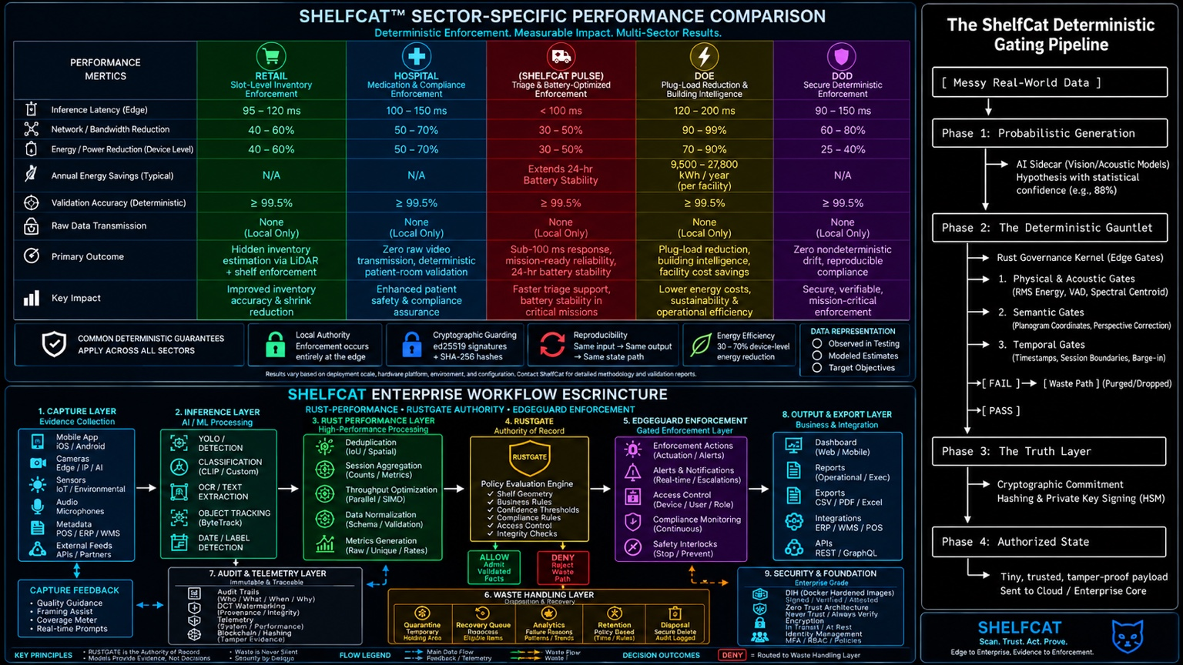
Figure A-1. Sector comparison + deterministic gating pipeline + enterprise workflow source diagram.

Figure A-2. Enterprise workflow source diagram.

Appendix B — Authoritative Terminology
Term | Meaning
AI Brain | Probabilistic perception/orchestration layer.
RustGate / Policy Authority | Deterministic evaluator and authority of record for policy outcome.
EdgeGuard | Enforcement/adapter layer that executes only authorized actions within delegated scope.
Observation Envelope | Normalized candidate fact presented to policy.
Decision Envelope | Committed policy result with provenance and cryptographic binding.
Evidence Vault | Logical capability for immutable/tamper-evident evidence, not necessarily one physical database.
Waste / rejection path | Rejected/quarantined payload handling plus retained minimum decision metadata.
Determinism | Replay reproducibility under pinned normalized inputs, policy, engine, and configuration.
Model accuracy | Empirical predictive quality measured on ground truth; not synonymous with determinism.

