BTVN – CSS area selector

1. Site url: https://www.booking.com/

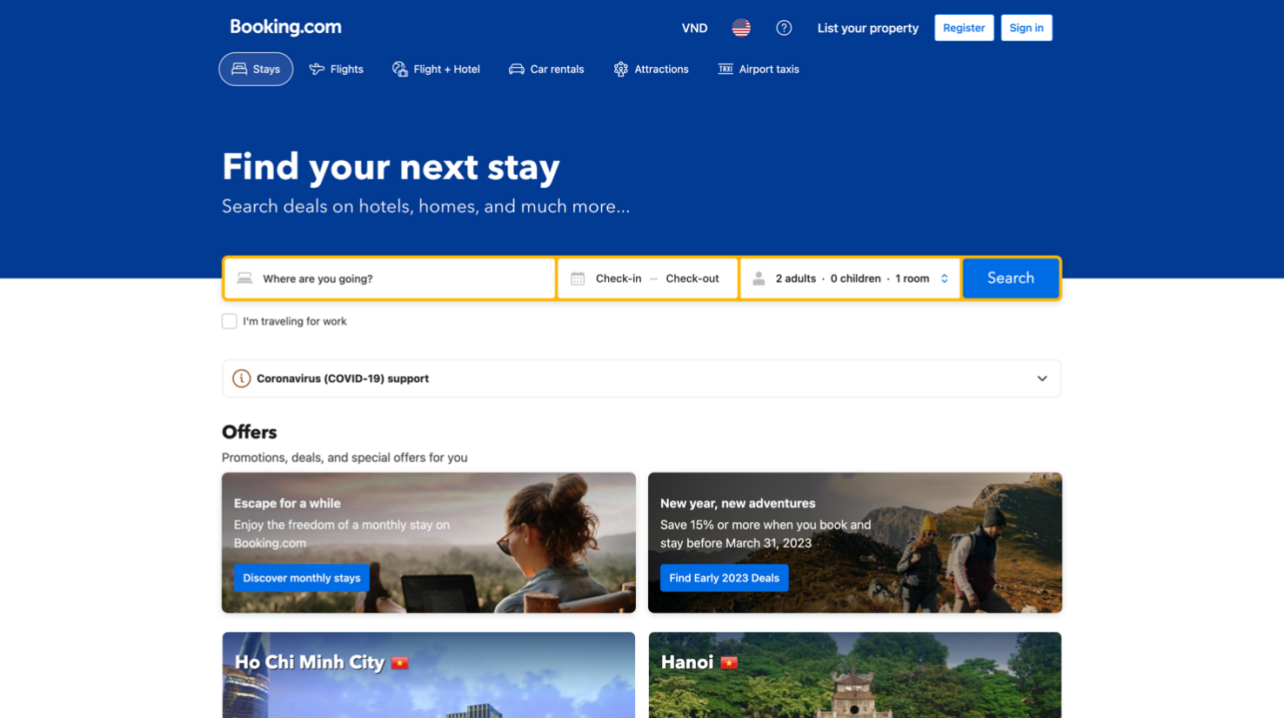

1. Booking.com : .a945757098 svg
2. Register button: a.fc63351294.a822bdf511.e2b4ffd73d.f7db01295e.c334e6f658.a9a04704ee.js-header-login-link (.a1b3f50dcd > a.fc63351294.a822bdf511.e2b4ffd73d.f7db01295e.c334e6f658.a9a04704ee.js-header-login-link)
3. Sign In button: a.fc63351294.a822bdf511.e2b4ffd73d.f7db01295e.c334e6f658.a9a04704ee.js-header-login-link (.bb0b3e18ca a.fc63351294.a822bdf511.e2b4ffd73d.f7db01295e.c334e6f658.a9a04704ee.js-header-login-link)
4. Stays : a#fc63351294.fa030f4cc2.f44d43bbc4.d4e373d880 (a#accommodations)
5. Flights: a#flights.fc63351294.fa030f4cc2.d4e373d880
6. Find your next stay : .e0ff951c3e
7. Where are you going: .ce45093752
8. Check-in : button.d47738b911.e246f833f7.fe211c0731 (.b91c144835 > button.d47738b911.e246f833f7.fe211c0731:nth-child(2))
9. Check-out: button.d47738b911.e246f833f7.fe211c0731 (.b91c144835 > button.d47738b911.e246f833f7.fe211c0731:last-child)
10. Search button: button.fc63351294.a822bdf511.d4b6b7a9e7.cfb238afa1.c938084447.f4605622ad.aa11d0d5cd
11. I’m travelling for work : .db29ecfbe2.f0d4d6a2f5
12. Offers : .e1f827110f.f0d4d6a2f5.fda3b74d0d (#basiclayout > div:nth-child(2) .e1f827110f.f0d4d6a2f5.fda3b74d0d)
13. <https://www.vietnam-visa.com/>

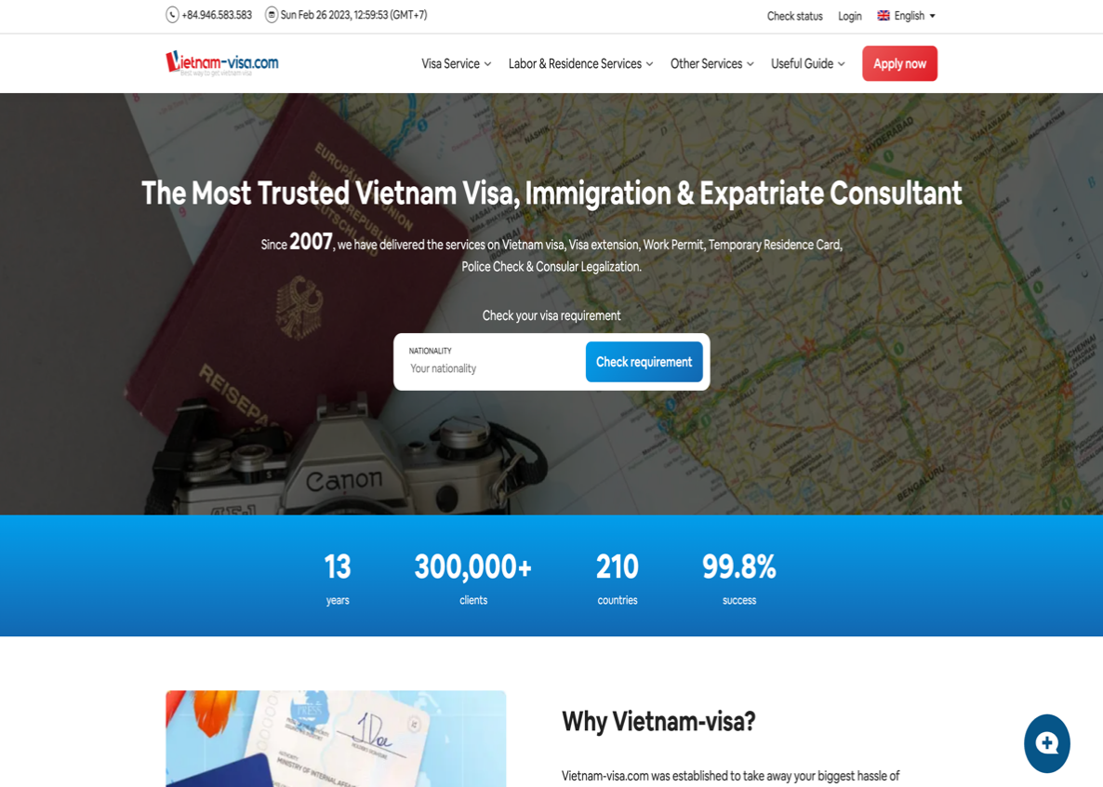

# This site can’t be reached

WEB LOI ROI AK

1. Icon call in the top of the website (+84.946583.583)
2. Check status
3. Login
4. Vietnam-visa.com (logo)
5. Labor & Residence Services
6. Apply now
7. 2007 (at Since 2007, we have …)
8. Check requirement button
9. Input (your nationality)
10. Clients (300,000+)