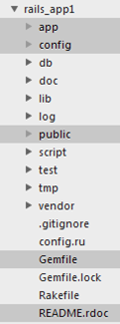
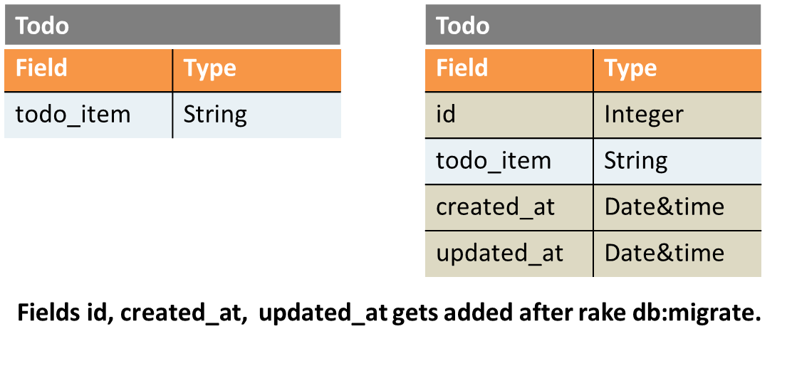
Understanding Rails Directory Structure

The 4 most important files and directories.
Figure: Rails application directory structure.
- public/index.html is the file that gets rendered when you see the output of the default Rails application in App Outputtab. Other publicly accessible files resides inside public directory. Rails do not process these files & they are accessible as is from the browser.
- Gemfile contains the gems (Rails libraries) needed for your Rails application. These gems are fetched & installed by runningbundle install command.
Note Any inclusion/exclusion of gems in the file would need you to run bundle install again for the changes to take effect.
- app/ directory contains all application related files - the models, controllers and views. This is the heart of your application where all the magic happens. More about it in the subsequent modules.
- config/ directory contains files related to the application configuration.
Note Any changes in the configuration file would require you to restart Rails server for the changes to take effect.

3 important things about Gemfile.
- A gem is a self-contained module of Ruby code. Somebody else has created it and you use it. It is like a self-contained external library.
- When you run bundle install, it goes through the gems listed in Gemfile one by one, fetches them, installs them locally & include them in the app.
- Every gem can have an optional version information. For example, gem 'rails', '3.2.6' instructs 'bundle install' command to fetch Rails version 3.2.6

Add here

The rails generate controller command created a lot of files and directories. We are interested in two of them for now :-
- app/controllers/todos_controller.rb
- app/views/todos/index.html.erb
Inside Rails application, the controller file is placed inside app/controllersdirectory. In Rails every file has its place and it is uniform across all rails applications.
app/controllers/todos_controller.rb
class TodosController < ApplicationController
def index

end
end
The TodosController is a class. There is an empty method index inside the class. The method is also called index action in the Todos controller.
This action serves the url /todos/index when accessed. Even though the index action is an empty method, it fetches the file /apps/views/todos/index.html.erb and displays it on the browser.
Note The file app/views/todos/index.html.erb is referred to as view file in Rails. This is part of the Views in Rails MVC architecture.

- ← Previous
- Next →
- Ruby On Rails Tutorial /

- 2. Desigining a Ruby on Rails example app/
- 3. Model to store/fetch todos

Module 2 - Lesson 3

Rails models - create, migrate, rollback and destroy
In the last lesson - Todos from controller, we learned to use controllers to show data on the view. But the data was essentially static.
A real world application needs dynamic content. You need to be able to store the dynamic content, be able to retrieve it and display it. Typically a database is used to store the dynamic data.
In this lesson, we will learn to use models to store todos in a database through Rails Console and then fetching the same via controller to display it on the view.

Generating Todo model
Rails interact with the database through models. According to design as perDesigning to-do list app, our model is named Todo.
Lets start with just one field todo_item of type string for the model Todo. Thetodo_item holds the name of the todo like 'Buying Milk'.
The way to generate a model in Rails is by using rails generate model command :-
Terminal
rails generate model Todo todo_item:string
invoke active_record
create db/migrate/20120802113330_create_todos.rb
create app/models/todo.rb
invoke test_unit
create test/unit/todo_test.rb
create test/fixtures/todos.yml
Convention When you create a model, the name is singular and the name starts with capital letter. Todo, instead of Todos.
If you end up doing a mistake you can always undo the creation of a model.
Terminal
rails destroy model Todo
invoke active_record
remove db/migrate/20120802113330_create_todos.rb
remove app/models/todo.rb
invoke test_unit
remove test/unit/todo_test.rb
remove test/fixtures/todos.yml
The destroy command removes the files it has created previously, leaving no trace whatsoever.

Introducing Migration
The 'rails generate model' command also creates a migration filedb/migrate/20120802113330_create_todos.rb.
Note The exact name of the file would be different for you. Look at the rails generate model command output to get the right name
db/migrate/20120802113330_create_todos.rb
class CreateTodos < ActiveRecord::Migration
def change
create_table :todos do |t|
t.string :todo_item

t.timestamps
end
end
end
The migration file is like schema which defines the database table structure. The table name is todos with two fields todo_item and timestamps . We will understand what timestamps does in a while.
rake db:migrate pushes the database changes from the migration file to the actual database. In Rails the default database is sqlite.
Terminal
rake db:migrate
== CreateTodos: migrating ====================================================
-- create_table(:todos)
-> 0.0022s
== CreateTodos: migrated (0.0024s) ===========================================
One of the purpose of Rails model is to shield us from dealing directly with sql database. Writing sql queries for every database task is tedious and rails handles all that for us.
Tip You would hardly need to refer to the actual table by the name todos. You would only be accessing the data through the model Todo.
How can you undo a model creation? You can use rails destroy (don't do this here) to destroy the model. However if you have executed rake db:migrate, you need to execute rake db:rollback as shown below.
Terminal
rake db:rollback
This will remove the table and all the data from your database as well.

Exploring the Models inside Rails console
You used rails console in last lesson to learn a little Ruby. In this lesson, we will use it to explore the database tables. Type rails console in the Codelearn Terminal, followed by the enter key to enter Rails console.
Terminal
rails console

Todo structure
Entering the model name Todo will display the structure of the database table
Rails console
1.9.3p194 :002 > Todo
=> Todo(id: integer, todo_item: string, created_at: datetime, updated_at: datetime)
As you see, it has the fields
- id - Automatically added by rails. Every new table row gets a new id (autoincrement). All tables have id.
- todo_item, type string, holds actual todos, entered by us when creating the Todo model.
- created_at & updated_at both of type datetime, created by rails for all tables.created_at stores time of creation of table, updated_at stores time when table was last updated.
Figure: When the model Todo gets added to db by rake:db migrate, additional fields get added.

Fetching all todos
Todo.all displays all the rows of the database table. In this case, the result is empty string [].
1.9.3p194 :004 > Todo.all
Todo Load (0.3ms) SELECT "todos".* FROM "todos"
=> []

Creating new todos
Follow the steps below to create a new todo
- Use t = Todo.new to create an empty row in the Todo table and stores it in t
Rails console
- 1.9.3p194 :001 >t = Todo.new
=> #
- t.todo_item = "pick up milk" populates values into the fields of the row.
Rails console
- 1.9.3p194 :002 > t.todo_item = "pick up milk"
=> "pick up milk"
- t.save saves the row into the database table
Rails console
- 1.9.3p194 :003 > t.save
- (0.1ms) begin transaction
- SQL (33.3ms) INSERT INTO "todos" ("created_at", "todo_item", "updated_at") VALUES (?, ?, ?) [["created_at", Sat, 18 Aug 2012 09:28:24 UTC +00:00], ["todo_item", "pick up milk"], ["updated_at", Sat, 18 Aug 2012 09:28:24 UTC +00:00]]
- (89.0ms) commit transaction
=> true
When you do t.save, the row gets a id and the created_at and updated_at also get populated. This is when the row actually gets stored into the database.
Notice the line "commit transaction", means row is getting stored to database. At this stage created_at and updated_at have the same value.
Todo.all displays all rows in the table, in this case just one row. The rails convertsTodo.all into SELECT "todos".* FROM "todos"
Rails console
1.9.3p194 :004 > Todo.all
Todo Load (0.2ms) SELECT "todos".* FROM "todos"
=> [#<Todo id: 5, todo_item: "pick up milk", created_at: "2012-08-18 09:28:24", updated_at: "2012-08-18 09:28:24">]

Creating todo using create method
You can also create a row using Todo.create, no need of t.save in this case. Notice "commit transaction" line again here.
Rails console
1.9.3p194 :005 > Todo.create(:todo_item => "Pay internet bill")
(0.1ms) begin transaction
SQL (0.6ms) INSERT INTO "todos" ("created_at", "todo_item", "updated_at") VALUES (?, ?, ?) [["created_at", Sat, 18 Aug 2012 09:55:33 UTC +00:00], ["todo_item", "Pay internet bill"], ["updated_at", Sat, 18 Aug 2012 09:55:33 UTC +00:00]]
(339.1ms) commit transaction
=> #<Todo id: 6, todo_item: "Pay internet bill", created_at: "2012-08-18 09:55:33", updated_at: "2012-08-18 09:55:33">

Selectively fetching todos
- You can find the first row in database using Todo.first, last row Todo.last
- You can find a row with a particular id, Todo.find(1) - row with id = 1,Todo.find(2) - row with id = 2, and so on
- Searching for a row with a field content is also possible -Todo.find_by_field_name("field_value")
for example - Todo.find_by_todo_item("pick up milk").
Rails console
1.9.3p194 :001 > Todo.first
Todo Load (0.2ms) SELECT "todos".* FROM "todos" LIMIT 1
=> #
1.9.3p194 :003 > Todo.find(5)
Todo Load (0.2ms) SELECT "todos".* FROM "todos" WHERE "todos"."id" = ? LIMIT 1 [["id", 5]]
=> #
1.9.3p194 :008 > Todo.find_by_todo_item("pick up milk")
Todo Load (0.2ms) SELECT "todos".* FROM "todos" WHERE "todos"."todo_item" = 'pick up milk' LIMIT 1
=> #

Deleting todos
- Deleting a row in database is fairly easy t = Todo.first, t.delete
- You can delete all rows of a table using Todo.delete_all
Rails console
1.9.3p194 :009 > t= Todo.first
Todo Load (0.2ms) SELECT "todos".* FROM "todos" LIMIT 1
=> #
1.9.3p194 :010 > t.delete
SQL (157.8ms) DELETE FROM "todos" WHERE "todos"."id" = 5
=> #
1.9.3p194 :011 > Todo.delete_all
SQL (139.3ms) DELETE FROM "todos"
=> 1
1.9.3p194 :012 > Todo.all
Todo Load (0.3ms) SELECT "todos".* FROM "todos"
=> []
1.9.3p194 :013 >

Exiting from the Rails console
Once done you can exit from the Rails console by typing 'exit' followed by enter.
Rails console
1.9.3p194 :009 > exit
user_1@codelearn:~/shared_todo_app$
You will be back to the Linux terminal.

