

Philippine Insurance Industry Outlook 2025
Growth Opportunities and Challenges

Executive Summary

The Philippine insurance market in 2025 remains underpenetrated at approximately 1.89% of GDP. However, it demonstrates strong growth potential, with real premium growth signaling a gradual structural market deepening. This expansion is fueled by product innovation, new distribution formats, and targeted financial inclusion programs.
High-Growth Areas: Microinsurance and health riders are expanding rapidly, especially in rural and low-income segments.
Key Enablers: Regulatory reforms, aggressive bancassurance expansion, and insurtech innovations are unlocking new growth pathways.
Positive Outlook: Despite challenges like regional disparities and climate risks, a young population, urbanization, and embedded finance trends support a positive medium- to long-term outlook.

Market Overview & Key Metrics

The market has shown consistent growth in total premiums, though penetration as a percentage of the rapidly growing nominal GDP has seen a slower climb. This

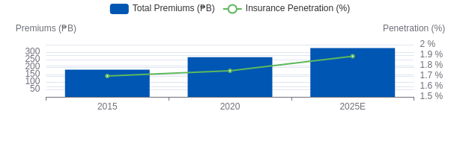
indicates a healthy, expanding market with significant room for further deepening.

Key Quantitative Highlights (2015 → 2025E)

Metric | 2015 | 2020 | 2025E | CAGR (2015–  25)
Nominal GDP (₱ T) | 13.05 | 18.15 | 27.95 | 8.1%
Total Premiums (₱ B) | 182 | 266 | 327 | 6.1%
Insurance Penetration (% GDP) | ~1.70% | ~1.75% | 1.89% | +0.19 pp
Microinsurance Lives Covered (M) | 18 | 35 | 56 | 12.1%

Market Segmentation (2025E)

The market is predominantly led by the Life insurance segment, which constitutes nearly two-thirds of total premiums. Non-Life is driven by the motor vehicle sector, while Microinsurance, despite its small premium share, has an extensive social reach, covering over 50 million lives.

Life Insurance
Non-Life Insurance Microinsurance
Insurance Market Share (2025E)
B} Premium Volume

Microinsurance

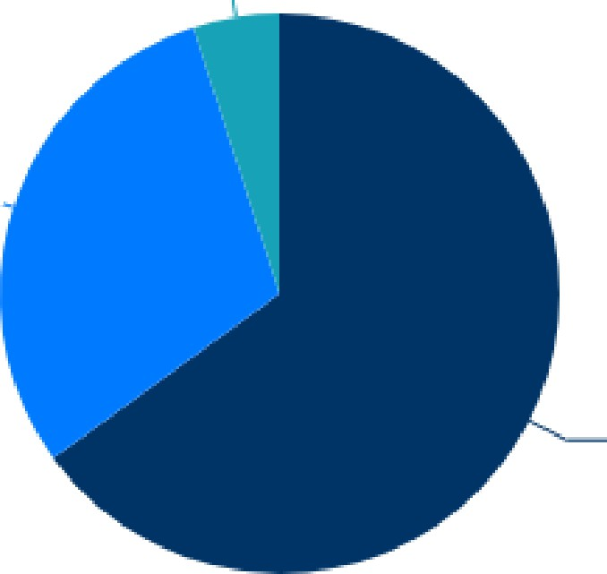
Non-Life Insurance

Life Insurance

Non-Life Sub-Segment Breahdown (2025E)
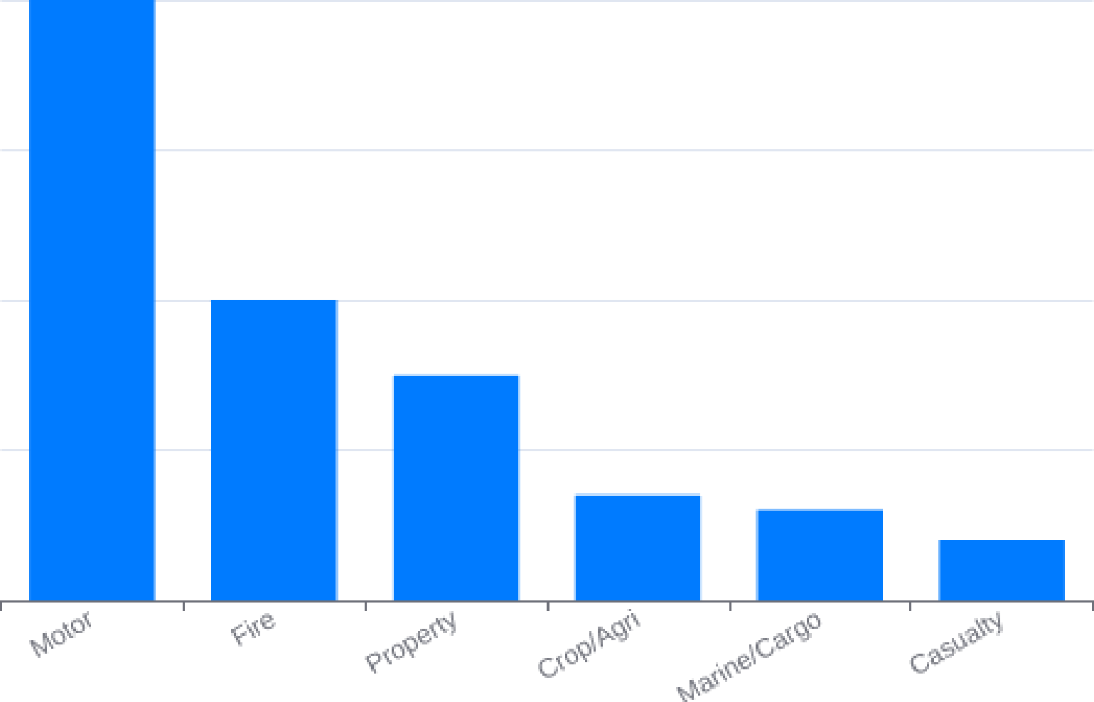
Whale of Non-Life Piemiums

Key Growth Drivers

Digitization & Embedded Distribution

The legalization of digital policy issuance in 2022 has been a game-changer. Embedded insurance in e-commerce and telco partnerships grew ~35-40% YoY in 2024, fundamentally altering the distribution landscape.

Financial Inclusion Expansion

Bank account ownership has surged from 34% in 2017 to 56% in 2024. This, combined with national ID (PhilSys)-linked microinsurance programs, is bringing millions of unbanked and underbanked Filipinos into the formal financial system.

Resilience & Climate Risk Awareness

Following major climate events like Typhoon Odette (2021), demand for non-life catastrophe premiums has spiked. Increased government subsidies for agriculture insurance further underscore a growing awareness of climate-related financial risks.

Distribution Channel Evolution

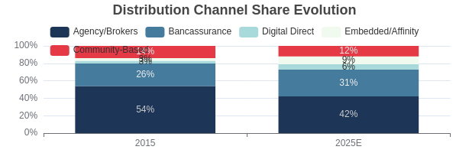
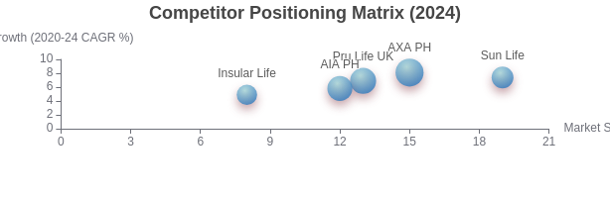
While traditional agency and broker channels still command the largest share of the market, their dominance is gradually eroding. Bancassurance has surged to become the second-largest channel, while digital and embedded models are the fastest-growing, reshaping customer acquisition and engagement.

Competitive Landscape

The Philippine life insurance market is consolidating, with the top 5 players commanding a significant and growing market share. Competition is driven by innovation in bancassurance, digital-first offerings, and targeted segment strategies. Sun Life and AXA lead in market share, while AXA demonstrates strong growth momentum.


Sun Life PH: Market Leader Profile

As the long-standing market leader, Sun Life Philippines has built a formidable presence through brand trust and a vast distribution network. However, its leadership is challenged by the need to innovate and expand its reach beyond traditional urban markets.

Strengths

Market Dominance: Commands a 19% market share, making it the largest insurer in the Philippines by a significant margin.
Brand Trust: Established in 1895, its long history fosters high brand recognition and consumer trust.
Strong Distribution: Boasts an extensive network of financial advisors and powerful bancassurance partnerships.

Weaknesses

Rural Penetration Gaps: While dominant in urban centers, the company faces challenges in effectively reaching remote and rural populations.
Digital Adaptation Pace: Faces pressure from agile, digital-first insurtechs, requiring continuous innovation to maintain its competitive edge.

Sun Life PH: Product Portfolio & Strategy

Sun Life's strategy focuses on a diverse product portfolio that caters to different life stages and financial needs, from wealth accumulation to health protection. This approach allows them to capture a broad customer base.
Variable Universal Life (VUL) Insurance: A core offering that combines investment opportunities with life insurance protection, highly popular among the growing middle class.
Traditional Life Insurance: Provides foundational protection products focused on securing the future of Filipino families.
Health Solutions: A comprehensive suite of health and wellness products, including critical illness riders and hospital income benefits, addressing rising healthcare costs.
OFW-Tailored Programs: Specialized insurance and investment plans designed to meet the unique needs of Overseas Filipino Workers (OFWs) and their families back home.

Strategic Opportunities & Challenges

Strategic Opportunities (2025-2028)

Urban Digital Insurance: Target 10-12M working-age adults with bank access but no policy, ideal for bundled health/life products.
Rural Microinsurance: Address the needs of 12-14M uninsured adults in high-disaster zones with crop and property catastrophe covers.
Gig & Freelancer Protection: Serve the 2.3M+ uninsured platform workers with disability and income-loss products.
OFW Segment: A high-value segment with an estimated premium pool of
₱90-100B/year, demanding both domestic and offshore products.
Takaful (Islamic Insurance): An untapped ₱3-5B potential market, primarily in Mindanao, for the ~6% Muslim population.

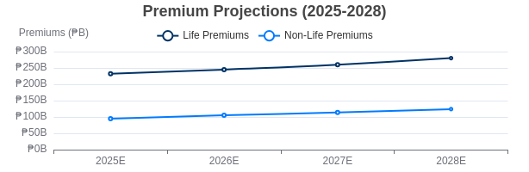
Key Challenges & Risks

Climate Event Frequency (High): The Philippines is the #1 disaster-prone country, leading to high claims volatility and worsening reinsurance terms.
Reinsurance Cost Spikes (High): Global catastrophe losses are squeezing margins and increasing policy costs for consumers.
Inflation Resurgence (Medium): High inflation can dampen demand for long-term savings products like VUL, though microinsurance remains resilient.
Digital Trust Gap (Medium): A significant gap in internet access and financial literacy between urban (93%) and rural (58%) areas hinders digital adoption.

Future Outlook (2025-2028)

The market is projected to continue its steady growth trajectory, driven by strong fundamentals. The focus will be on bridging the urban-rural divide and leveraging technology to serve new and emerging customer segments.

Key Projections for 2028:

Insurance penetration to reach ~2.07% of GDP.
Life insurance premiums projected to grow to ~₱280 Billion. Non-life insurance premiums expected to reach ~₱124 Billion.
Microinsurance coverage to expand to over 60 Million lives.
Generated on: 2025-08-14. This analysis is based on the provided "PH.md" document.

